**HOUSING BUY VS RENT**

DECISION SUPPORT TOOL

# Team Members

Rana Hamdan

Deepa Palariya

Aswini Sivakumar

# Executive Summary of the Final Project

Deciding between buying and renting a home is a complex process that involves significant financial and personal considerations. It's crucial to understand when owning a home is financially advantageous and when it's not. Mortgage calculators may underestimate monthly payments by only considering principal and interest payments, but there are additional expenses to account for, such as homeowners insurance, property taxes, mortgage insurance, association fees, and maintenance costs. This decision support tool can help you evaluate the financial trade offs of renting versus buying based on your specific financial circumstances and the duration of homeownership.

This decision support tool provides the user with two options: By entering a zip code, the user can access the average buying and renting prices for that area based on the gathered data. Alternatively, for a more personalized experience ,the user can input their desired buying and renting prices, which will be used to calculate the present value benefit of owning versus renting a home.

# Target Users or Analysis Consumers

This decision support tool is primarily aimed at individuals who are residents of the United States and are over 18 years of age. Its target audience includes those who are interested in purchasing or renting a home.

# Technical Summary

For our project, we primarily utilized spreadsheet modeling, incorporating all the techniques and tools that we have learned thus far in the course. This involved using formulas and functions in excel, including the index and match function to match user-entered zip codes with acquired data, and the PMT function to calculate the payment for a loan. Additionally, we also employed a one-way data table to showcase how interest rates affect the viability of purchasing a house compared to renting. This information was then used to produce a graph for better visualization of the results.

The main page of this tool allows the user to choose the zip code and the values for purchase price and Cost of renting a similar home is populated by matching the chosen zip code with data in a raw data worksheet. Users can also input their desired % down payment and interest rate, as well as the principal amortization years. Other parameters like property tax rate, annual insurance, annual appreciation of the house, marginal income tax rate, general inflation, rental price inflation, and assumed annual return on cash are taken into account in the model.

The main page has a "Clear Contents" button that clears existing calculations, and "Buying Scenario" and "Renting Scenario" buttons that run VBA subroutines to calculate necessary parameters. The calculations are done till the end of the loan period for every month, with formulas defined for the first month and used by changing the column-value till the end. The tool also has a "Show me the decision button" that gives a message on the final decision.

The tool makes a decision by taking into account the total expenses per month if the user owns the home and compares it with the cost of renting a similar home, along with an average of 8% return by investing the amount that can be used for making the down payment.

If the net value of selling the house after 10 years exceeds the savings from renting a similar home over the same period, the tool suggests that the user should consider buying the house in the selected zip code. However, if this is not the case, the tool suggests that the user should opt to rent a similar home instead.

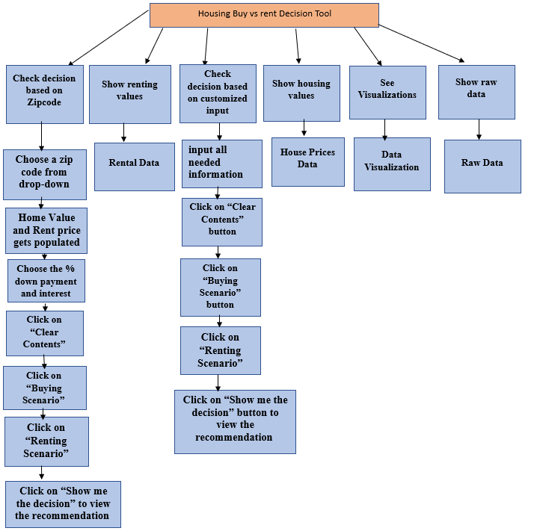

This tool has numerous significant and minor enhancements and repairs that could be implemented too.

* Unable to acquire a bigger dataset to utilize for creating visualizations.
* Ideally, maintenance expenses would vary with the age of the house, but since the dataset does not contain information on the age of the house, we applied a general rule of 1% of the home value.
* The tool is restricted to 125 zip codes in MI, but can be employed for other zip codes beyond the existing dataset once the necessary data is obtained.

# Data Needs and Sources

The data for this project is directly from [zillow website](https://www.zillow.com/research/data/). We used the data for home values and rentals based on zip codes of Michigan as of February 2023. We then identified only the matching zip codes from both the list and consolidated to have - zip code, purchase price and rent ( of a similar home).

The values for inflation rate, interest rate, property tax, annual maintenance, home insurance and annual appreciation of the home to build the home purchase model were obtained from multiple real estate and US government websites.

# Outputs

Describe the key outputs of your models, analysis, tools, or system. Whatever it is you did, what were the primary outputs produced and how would they be used by your target users. Highlight the Excel techniques and data visualization principles used for your various outputs.

The tool generates several outputs, including:

* Present value benefit of owning versus renting for ten years based on the user's individual situation.
* Estimated savings when renting according to their specific scenario.
* A recommendation on whether to rent or buy based on the data provided.
* A graph illustrating how interest rates affect the feasibility of buying a home versus renting.
* Computation of the future value of a property by taking into account variables such as purchase price, interest rates, and annual appreciation.
* A list of the top ten zip codes in terms of buying price and renting in Michigan.

# Benefits to Target Audience

Our project’s primary outcomes will empower the target audience to make well-informed choices about whether to buy or rent a home, taking into account the advantages linked with each option. Additionally, our model allows for personalization of inputs to cater to individual situations. This feature will aid the target audience in effectively managing their finances, which is often a challenging task in today's world.

# Challenges

Designing a model that accurately captures the complexities of the decision-making process for loans, home equity, and mortgages was a challenging task that required a profound comprehension of underlying concepts. It involved thorough planning and testing to ensure accuracy. In addition, acquiring accurate and dependable data is crucial for the tool to generate valuable outcomes, making data gathering and cleaning a significant challenge that was quite time-consuming. Obtaining data from credible sources was difficult, but not impossible, particularly when utilizing authentic websites. Finally, we faced challenges while working with VBA programming to create custom functions and macros that would automate repetitive tasks and enhance the tool's functionality. This was mainly because we were all beginners in this area and had limited expertise in VBA programming.

# Personal Learning

The decision support tool project enabled us to acquire new skills in various analytical techniques, tools, approaches, and benefits, including data analysis, such as cleaning, organizing, and summarizing data, as well as creating charts and graphs. Additionally, we developed our skills in VBA programming, enabling us to program custom functions and macros to automate repetitive tasks and enhance the tool's functionality.

# Closing Thoughts

Initially, the concept of creating this project appeared unclear and overwhelming. However, through the skills acquired during the course and the collaboration of all team members, the project was successfully developed. This was a challenging yet a very interesting and worthwhile project that will be of real help to the users who struggle to make an informed decision as to buy or rent a house. In addition, if in future the user wants to use this file to analyze the rent/buy price of houses for other countries, it can be done easily by just inputting the numbers in the respective cells and everything else will be pre calculated because of our dynamic VBA code.