EASY:
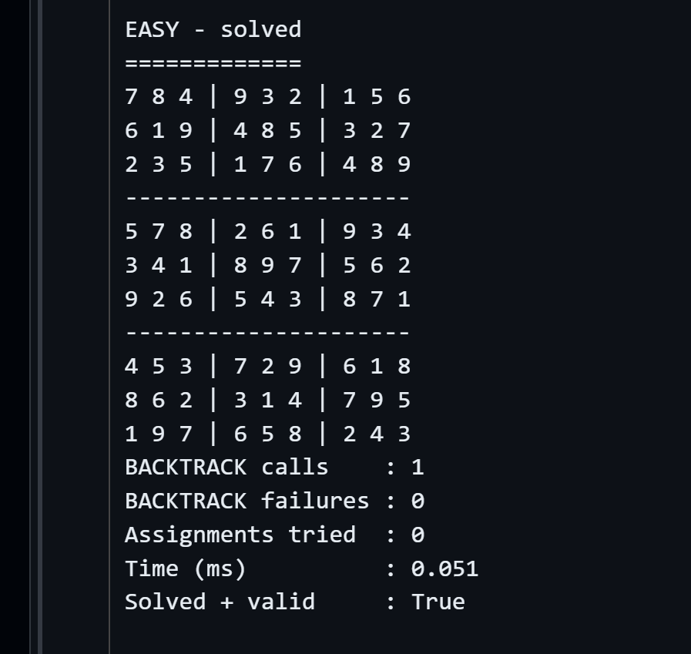

Medium
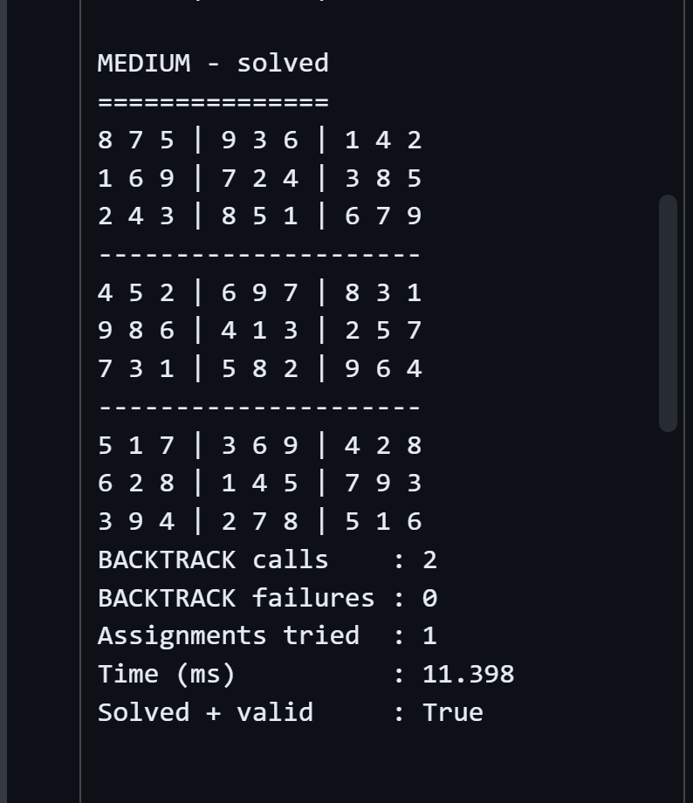

HARD:
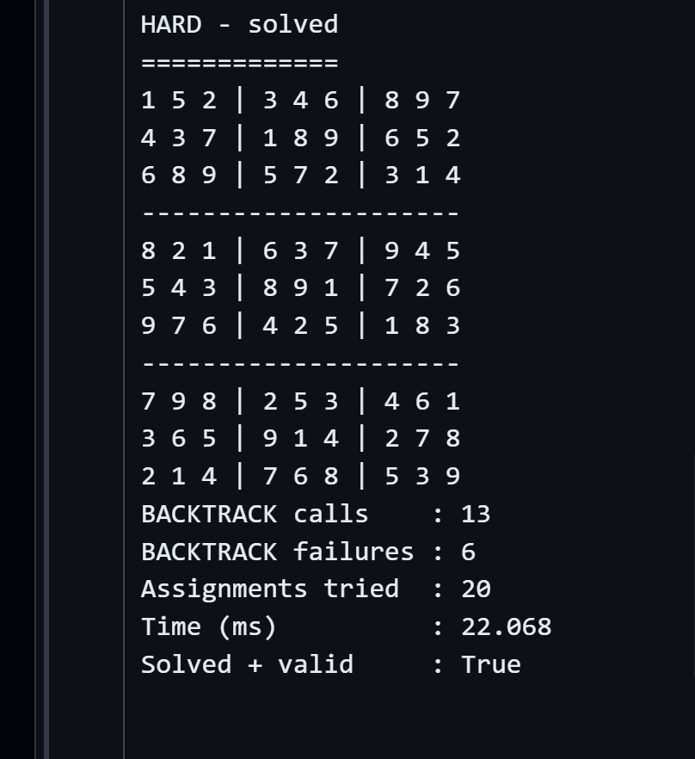

VERY HARD:
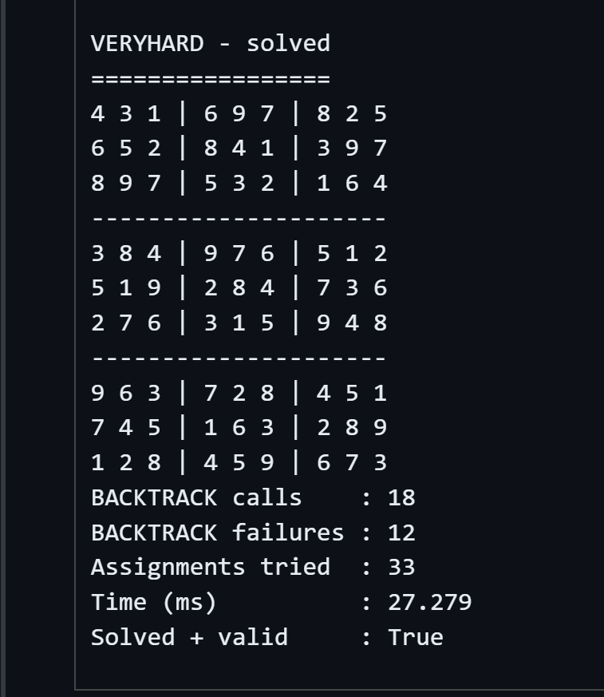

Summary
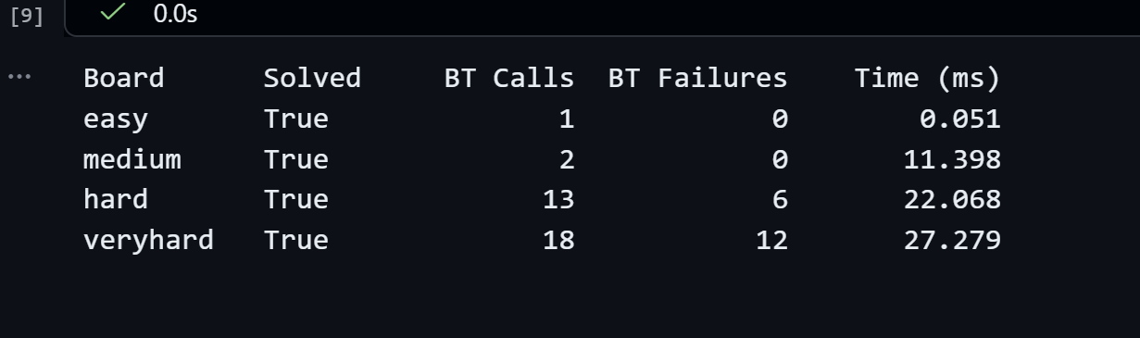

easy: Only 1 BACKTRACK call and 0 failures. The puzzle is highly constrained and solved almost directly with propagation.
medium: 2 BACKTRACK calls and 0 failures. Still solved with very little search; constraints prune most choices early.
hard: 13 BACKTRACK calls and 6 failures. More branching is needed, and several attempted assignments lead to dead ends.
veryhard: 18 BACKTRACK calls and 12 failures. This board requires the most trial-and-error, so search effort is highest.

LINK : https://github.com/ranahusain/Sudoku-Boards-CSP

