USER 1 Hussain ADDED:

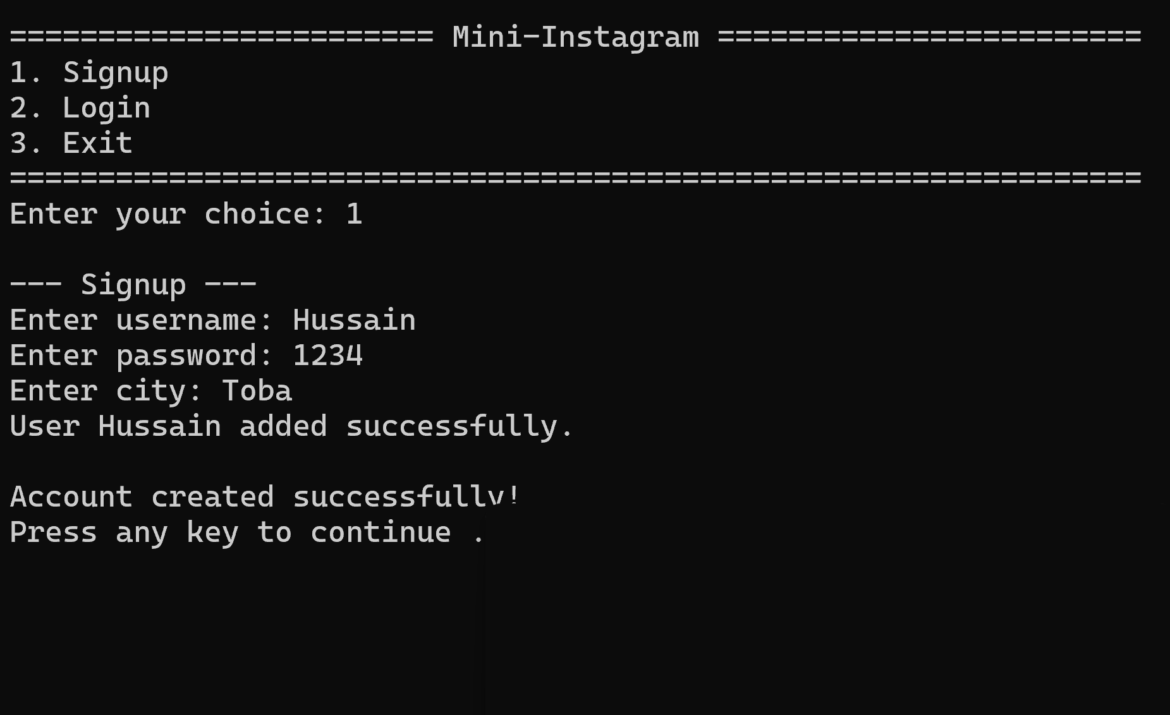

USER 2 Naina ADDED:

First it searched if it exits or not

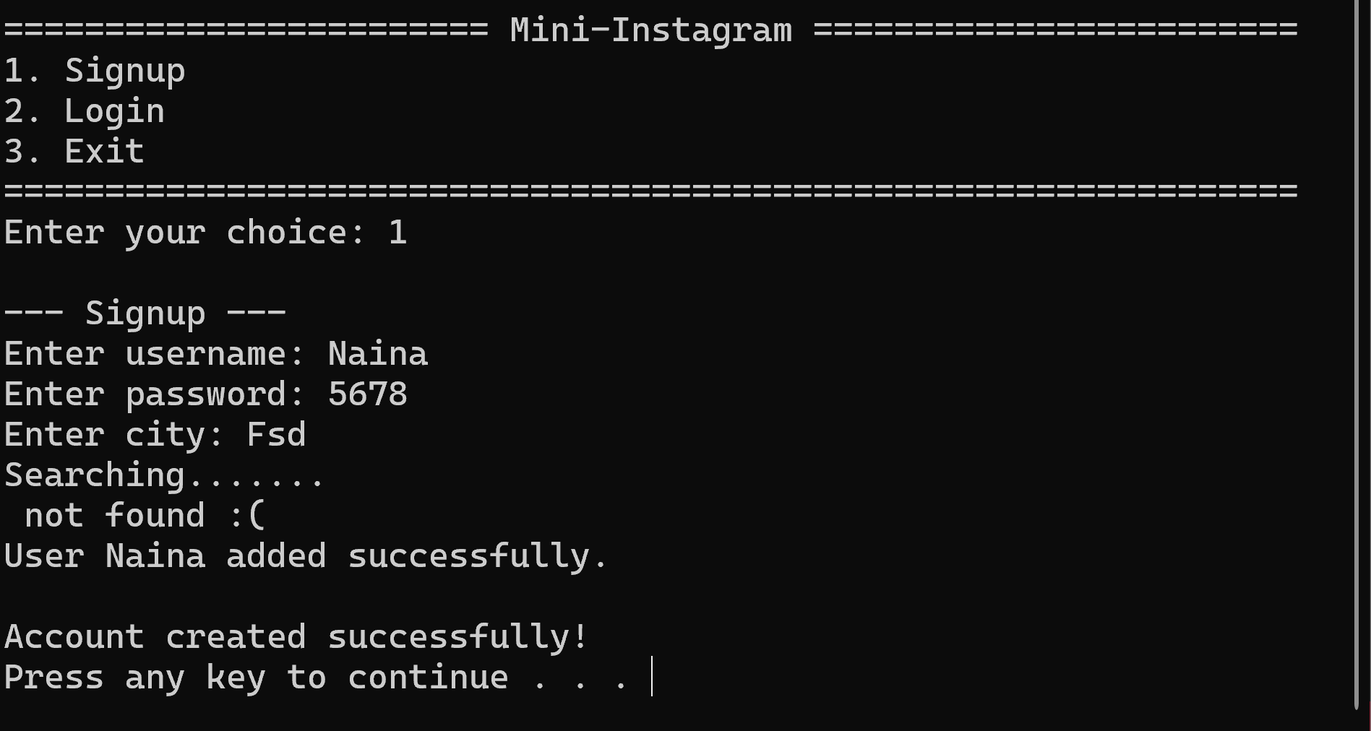

HUSSAIN LOGED IN:

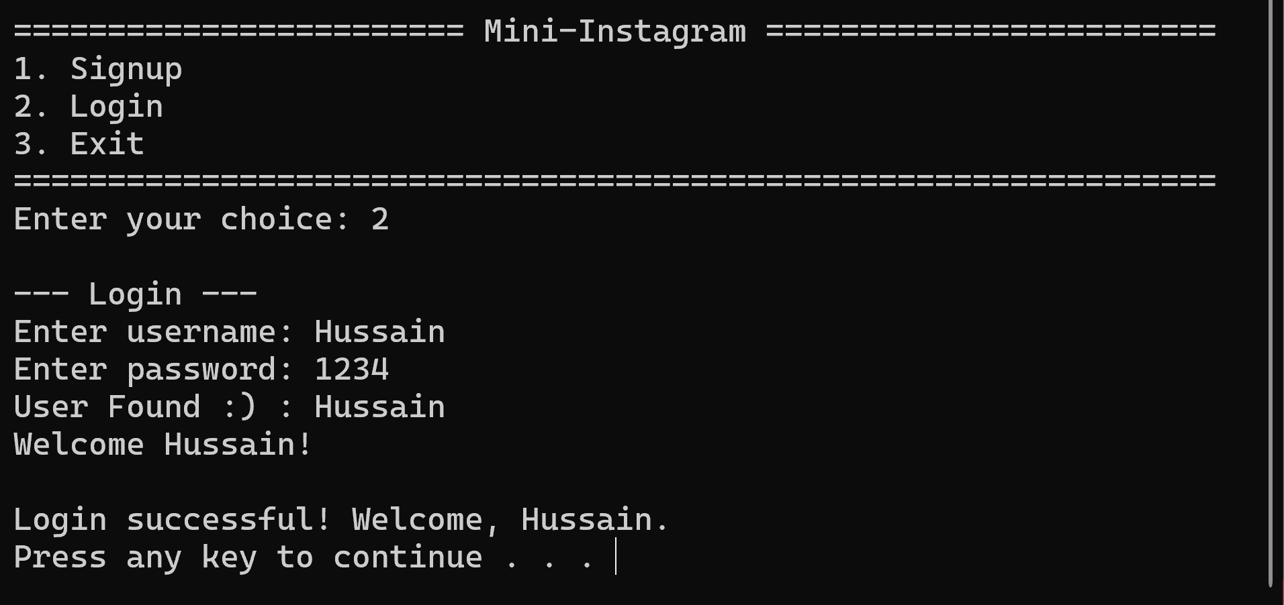

FREIND REQUEST SENT TO NAINA:

POST ADDED:

MESSAGE SENT TO NAINA:

NEWSFEED(PERSONAL POST)

SEARCH USER:

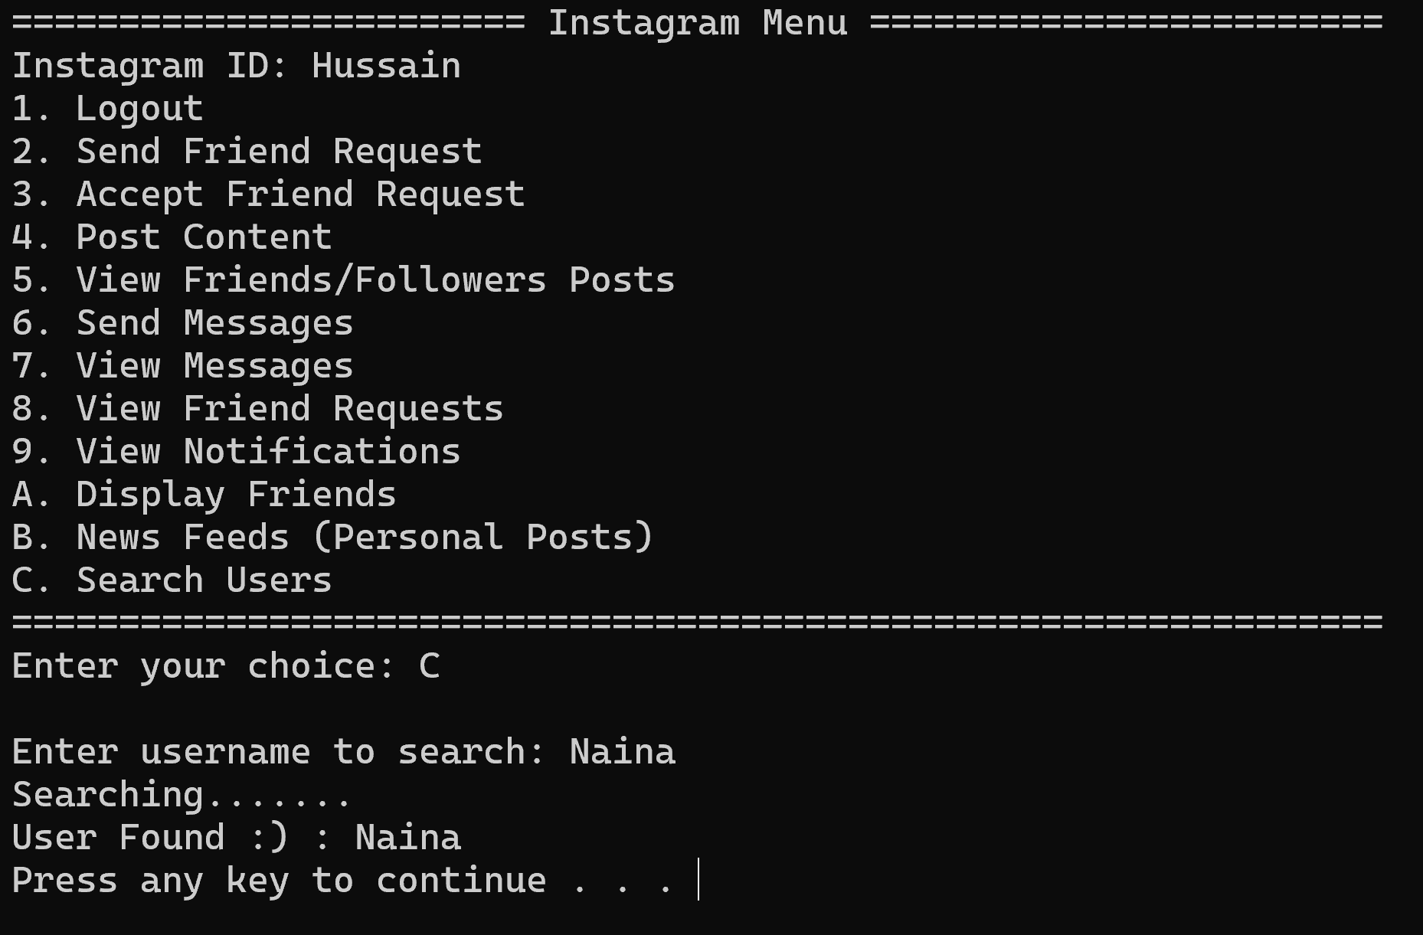

LOGED OUT :

NAINA LOGED IN:

VIEW FREIND REQUEST AND MESSAGES:

ACCEPTING FREIND REQUEST:

NAINA VIEWING HUSSAIN’S POST:

FREINDS OF NAINA:

EXITING:

