**Objective Questions**

**Q1. What is the total no. of tables present in the data?**

Ans. Total no. of tables present in the data is 1158 (Using Pivot Table or CountIF function : =COUNTIF('Raw Data'!M3:M9553,"Yes"))

**Q2. What is the total no. of attributes present in the data?**

Ans. Total no. of Attributes present in the data is 21 (Using CountA function : =COUNTA('Raw Data'!1:1))

**Q3. How many categorical columns are there in the data?**

Ans. There are 11 Categorical columns – City, CountryCode, CountryName, Cuisines, Currency, Has-Table-booking, Has-Online-delivery, Is-delivering-now, Switch-to-order-menu, Price-range, Rating.

**Q4. The data consists of some inconsistent and missing values so ensure that the data used for further analysis is cleaned?**

Ans. Date Column using the **find and replace** in that column, and Filled the Missing Value with **Data Missing.**



**Q5. Using the LookUp functions, fill up the countries in the original data using the country code?**

Ans. Filled the CountryName using the Original Data using the LOOKUP function. =VLOOKUP(C2,'country description'!$A$2:$B$16,2,0).

**Q6. Create a table to represent the number of restaurants opened in each country?**

Ans. 

**Q7. Also, the management wants to look at the number of restaurants opened each year, so provide them with something here?**

Ans.



**Q8. What is the total number of restaurants in India in the price range of 4?**

Ans. We can execute this with filter and COUNTIFS also =COUNTIFS('Raw Data'!$D$2:$D$9552,"India",'Raw Data'!$Q$2:$Q$9552,"<4").

**Q9. What is the average number of voters for the restaurants in each country according to the data?**Ans.  


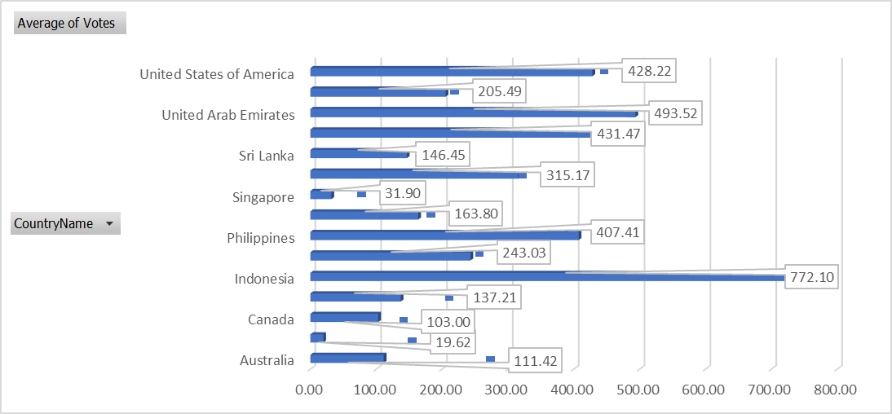

**Q10. Calculate the average rating for all the restaurants that have price_range < 4 and provide online delivery. Use only the “IF” function, Logical Operators, and Aggregation functions to solve this problem. [Note: Don’t use Conditional aggregation in this question.]**

Ans. Created New Column (Average Rating) to use Logical Operation in order to calculate the Average Rating of the Restaurant.

=IF(AND(Q2<4,N2="Yes"),U2,"") To filter the column having price range less than 4 and providing online delivery.

=AVERAGE('Raw Data'!$W$2:$W$9552) To get the Average Rating 3.27381151

**Q11. Using Conditional formatting highlight the rows of restaurants that are located in the countries or cities that you’ve suggested to the management for opening new restaurants.**

**Ans.** HOME -> Conditional formatting -> New Rule -> Use a formula only cells that contain

=India, Singapore, Canada, Australia, Sri Lanka, United Arab Emirates, Indonesia.

In this I select entire row whose Country Name= India, Singapore, Canada, Australia, Sri Lanka, United Arab Emirates, Indonesia.



**Q12. Create a new customized price column that consists of the abbreviation/symbol of the currency along with the Average_cost_for_two value. [Use string operations to do this task]**

Ans. Created a new column Average_Cost and using the concatenate and string function executed the formula=CONCATENATE(S3," ",MID(L3,FIND("(",L3)+1,FIND(")",L3)-FIND("(",L3)-1))

**Q13. How can you create an array formula in Excel or Google Sheets to count the number of restaurants listed that do not offer online delivery, are in the lowest price range, and have an average cost for two people less than or equal to 250 Indian Rupees?**

Ans. {=COUNTIFS('Raw Data'!$N$2:$N$9552,"No",'Raw Data'!$Q$2:$Q$9552,1,'Raw Data'!$S$2:$S$9552,"<=250")}

Where N is Has-Online-delivery,

Q is Price-Range and

S is Average-cost-for-two.

**Subjective Questions**

**Q1. Suggest a few countries where the team can open newer restaurants with lesser competition. Which visualization/technique will you use here to justify the suggestions?**

**Ans.** 



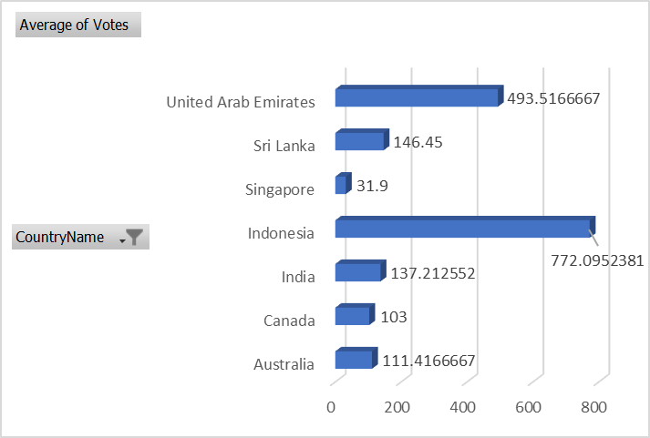

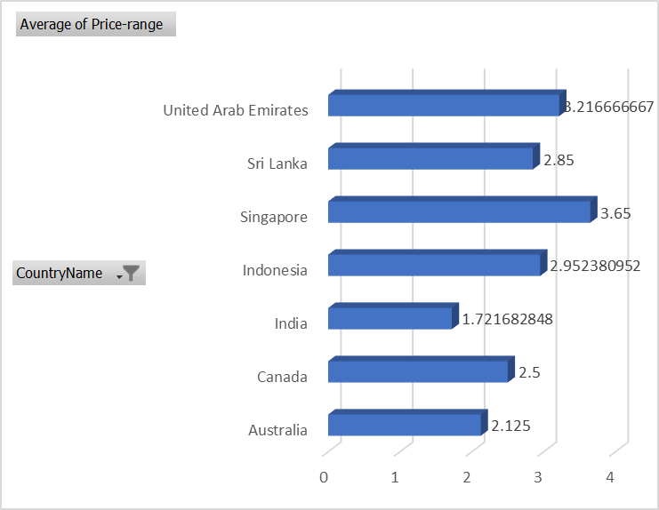

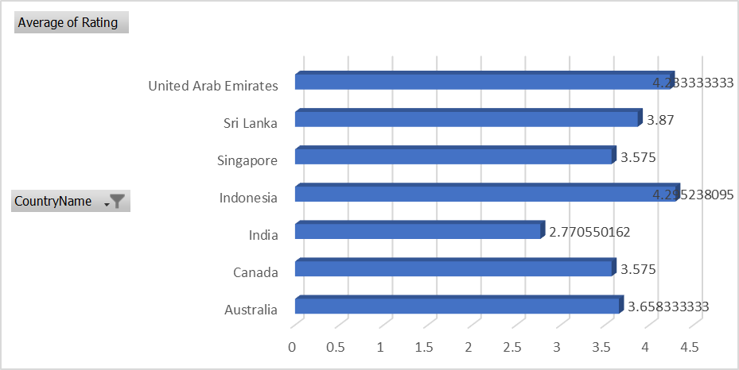

* **Considered RestaurantID count, Average of Votes, Average of Price Range, Average of Rating.**

**Description :**

1. To check the no. of restaurants opened in each country.
2. Rows have CountryName and Values have Count of RestaurantID, Average of Votes, Average of Price-Range, Average of Rating.
3. Sorted the data according to Count of RestaurantID to check the no. of restaurants with less no. of restaurants opened. So, the countries are Canada, Singapore, Sri Lanka, Indonesia, Australia, United Arab Emirates, South Africa.
4. The Average of Average of Votes is 267, So I will pick 2 countries where people with high votes want new restaurants to be opened. We will Select Indonesia and United Arab Emirates (Because the Average Price-Range is high).
5. The Average of Average of Price-Range is 2.91 so I have marked the rows as red and yellow. Red indicates Average of Price of that country is less than 2.91 whereas Yellow indicates Average of Price of that country is greater than 2.91. We will select India and Singapore because the review is lesswhich means the society need better quality. So, We can conclude that opening new restaurants focusing on the quality would be in our favour.
6. The Average of Average of Review is 3.95 so I have marked the rows as red which has value Less than 3.95. Srilanka, Australia, Singapore, India are country which has very less reviews which indicate for opening new restaurants with better quality or as per the demand of the customers.
7. My final choice of Countries are Canada, Indonesia, United Arab Emirates, India, Singapore, Australia, Srilanka.

**Q2. Come up with the names of States and cities in the suggested countries suitable for opening restaurants.**

Ans.



**Q3. According to the countries you suggested, what is the current quality regarding ratings for restaurants that are open there?**

**Ans.**

**INSIGHT**

With the help of column chart it is very clear about the insights of Current quality regarding ratings of restaurants are lowest in India whereas Better in Indonesia and Moderate in all other countries. Need to improve Quality more in India than Other Countries.

Insight: A critical need for targeted improvement efforts within India's restaurant sector, aimed at enhancing quality standards to align more closely with global benchmarks observed in other countries



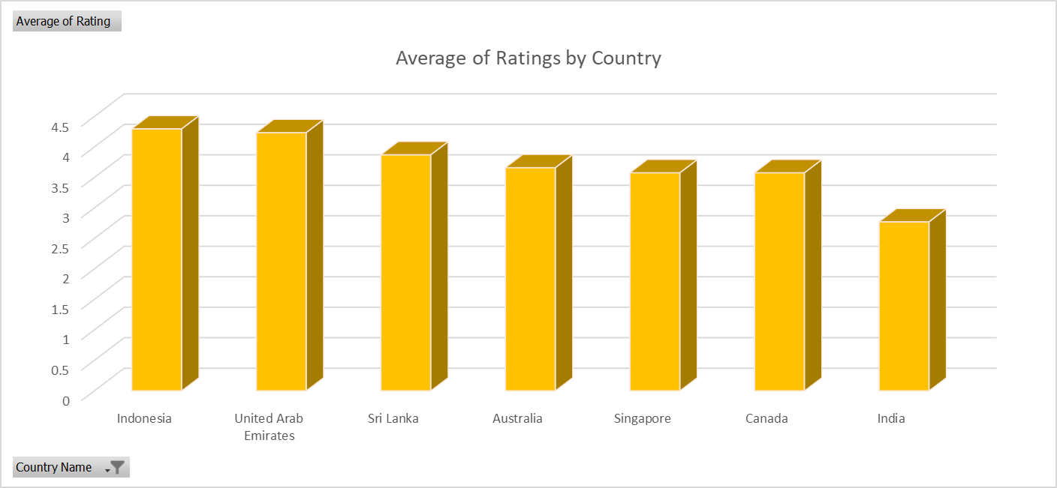

**Q4. Also, what is the current expenditure on food in the suggested countries, so we can keep our financial expenditure in control?**

**Ans. INSIGHT: India is the highest in term current expenditure on food and Canada is the lowest.**

1. India is the largest consumer in terms of food expenditure, with a high restaurant count and elevated average costs. This indicates that the dietary quality in India is quite low, potentially leading to more health issues among its population. Therefore, it would be prudent to open restaurants that focus more on quality. India is spending the most on restaurant food.
2. Canada and Sri Lanka is the smallest consumer in term of food expenditure.
3. Singapore and United Arab Emirates is having the highest expenditure on food as per capita.



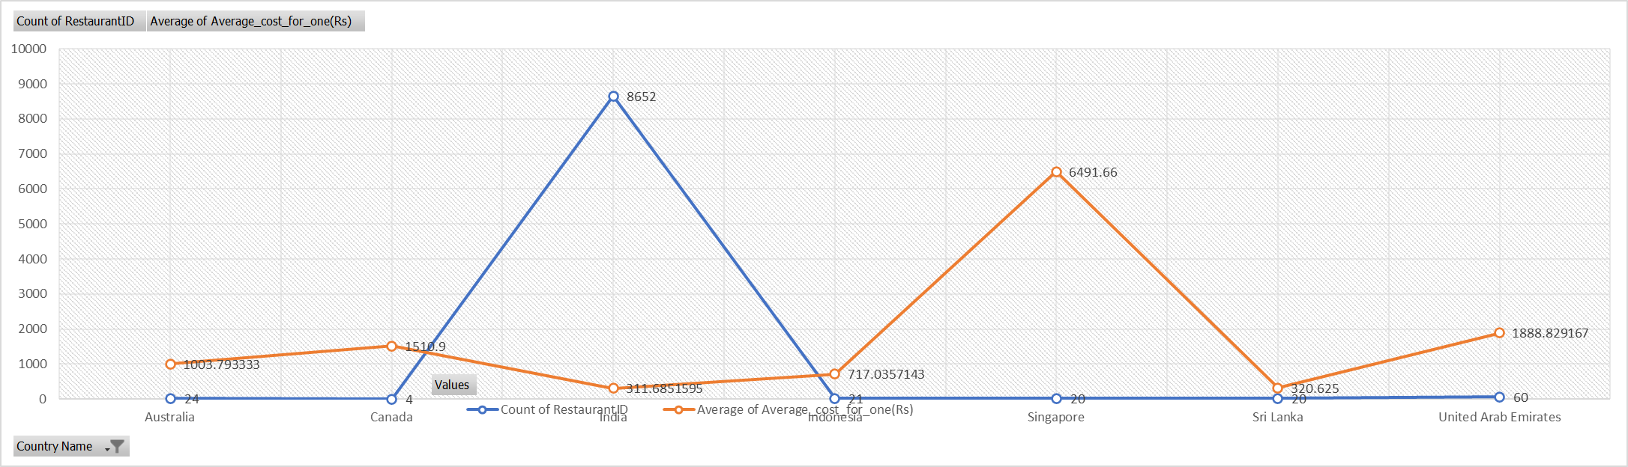

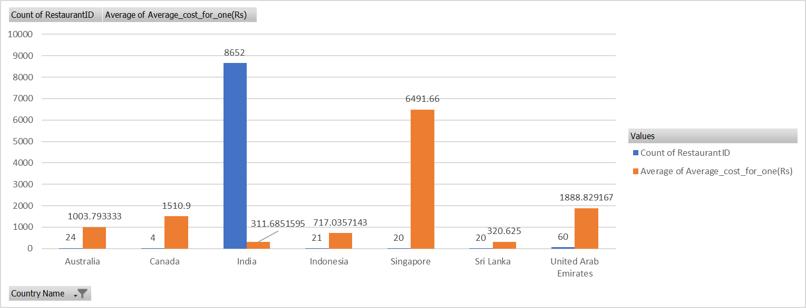

**Q5. Come up with the names of restaurants from the recommended states that are our biggest competitors and also those that are rated in the lower brackets, i.e. 1-2 or 2-3.**

**Ans. INSIGHT : These are restaurants names that would be the biggest competitor as per the City or State.**



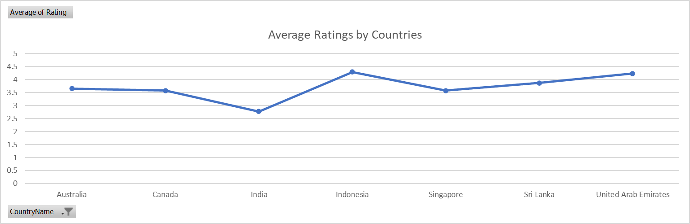







**Q6. Which cuisines should we focus on in the newer restaurants to get better feedback? Does the choice of cuisines affect the restaurant ratings?**

**Ans.**

**INSIGHT: To get better feedback we should consider and focus on different different cuisines as per the country.**

The cuisine offered by a restaurant significantly impacts its overall revenue, as certain cuisines are rated higher or lower depending on the region or country. Different countries have varying taste preferences, so adapting the menu to fit local tastes can be highly beneficial. For instance, Indian food is highly rated in India but may not receive the same level of appreciation in other countries.

|  |  |
| --- | --- |
|  | **Count of Cuisines** |
| **India** | **8652** |
| **United States of America** | **434** |
| **United Kingdom** | **80** |
| **Brazil** | **60** |
| **South Africa** | **60** |
| **United Arab Emirates** | **60** |
| **New Zealand** | **40** |
| **Turkey** | **34** |
| **Australia** | **24** |
| **Philippines** | **22** |
| **Indonesia** | **21** |
| **Sri Lanka** | **20** |
| **Singapore** | **20** |
| **Qatar** | **20** |
| **Canada** | **4** |
| **Grand Total** | **9551** |



**Q7. According to our current data, should we go for online delivery and table booking? Does that affect the customer’s ratings?**

**Ans.**

**Yes, Online Delivery and Table Booking do affect the customer’s ratings and may have Positive and Negative Impact Too:**

**Positive Impact:**

**Convenience and Efficiency:** Both services add convenience and efficiency, which can lead to higher satisfaction and positive ratings.

**Professionalism:** Offering modern amenities like online booking and delivery can enhance the brand's image of restaurants as professional and customer-focused.

**Error Reduction:** Digital systems can reduce errors in orders and reservations, leading to a smoother customer experience.

**Negative Impact (If not managed):**

**Service Quality:** Poor execution (e.g., late deliveries, booking errors) can lead to dissatisfaction and negative ratings.

**Technical Issues:** Problems with the online systems (e.g., website/app crashes) can frustrate customers.

**Inconsistent Experience**: If the online experience does not match the in-person service quality, it can lead to negative feedback**.**

**ONLINE DELIVERY**

**INSIGHT: According to current data we can suggest that customers are taking interest in Online Delivery. It would be better to go for Online Delivery.**

**Convenience: Customers would appreciate the ability to order from the comfort of their homes, especially during bad weather or busy schedules.**

**Expanded Reach: We can reach customers who may not be able to visit your location physically.**

**Increased Sales: Can boost your sales by catering to a larger audience.**

**Customer Data: Online orders can help you gather data on customer preferences and behavior, which can be useful for marketing and improving services.**



**ONLINE TABLE BOOKING:**

**INSIGHT: According to current data we can suggest that customer are taking interest in Table Booking. It would be better to go for Table Booking.**

**Efficiency: Help to manage and streamline customer flow, reducing waiting times and improves overall dining experience.**

**Planning: Allows for better planning and resource allocation, ensures to handle peak times efficiently.**

**Customer Satisfaction: Customers appreciate the assurance of having a table reserved, especially during busy hours or special occasions.**

**Personalization: Enables you to personalize the dining experience (example: preparing special requests in advance).**



**Q8. Should the team keep the rate of cuisines higher? Will that affect the feedback? According to our data are the rates of cuisines and ratings, correlated?**

**Ans.**

**=CORREL('Raw Data'!W2:W9552,'Raw Data'!U2:U9552)**

**There is a weak correlation between price of cuisines and customers rating. So based on this correlation factor alone, it may not be advisable for the team to focus on keeping higher rates of cuisines to get better ratings.**

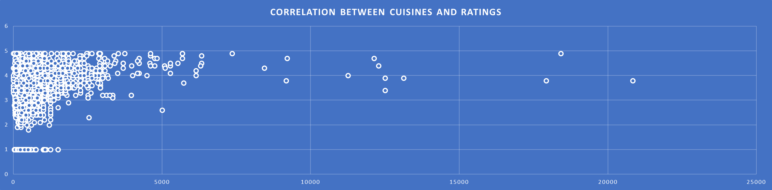

**Q9. What is the distribution of the number of restaurants of different price ranges in all the countries?**

**Ans.**



|  |  |
| --- | --- |
| Range Type | Total |
| 0-1 | **4444** |
| 1-2 | **3113** |
| 2-3 | **1408** |
| 3-4 | **586** |

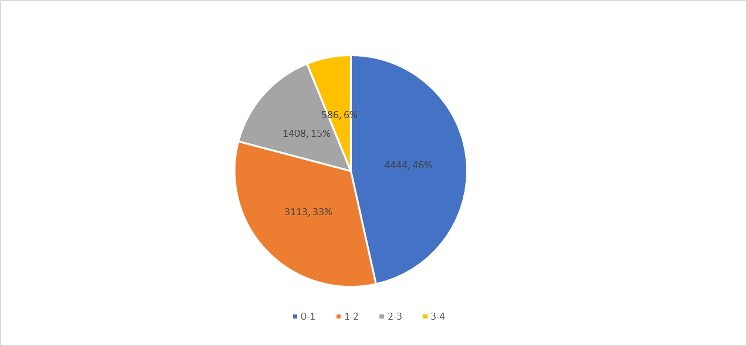

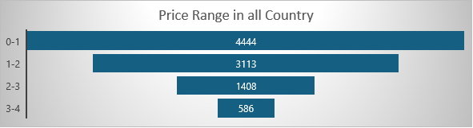

**Q10. Explain your approach in brief for suggesting countries/cities in order to open new restaurants, if the objective and subjective questions would have not been given to assist you. [you have to give bullet pointers in order to answer this question]**

**Ans.**

* Considering the country having rating less than the average rating of all the countries.
* Selecting the cities having more votes than the average votes for each country.
* Selecting the cities having more than the average votes for each country.
* Considering the countries and cities having more votes.
* Online Delivery and Table Booking Availability
* Opening restaurants in Countries and Cities which are having less price and not high price with better quality or better ratings.
* Opening restaurants in countries and cities which are having more price and not less price with better quality or better ratings.
* Easy and friendly of online delivery culture.
* Google rating is affect allot.
* Availability of most selling and buying cuisines.
* Table booking system is available with no extra charge.



**Australia**

 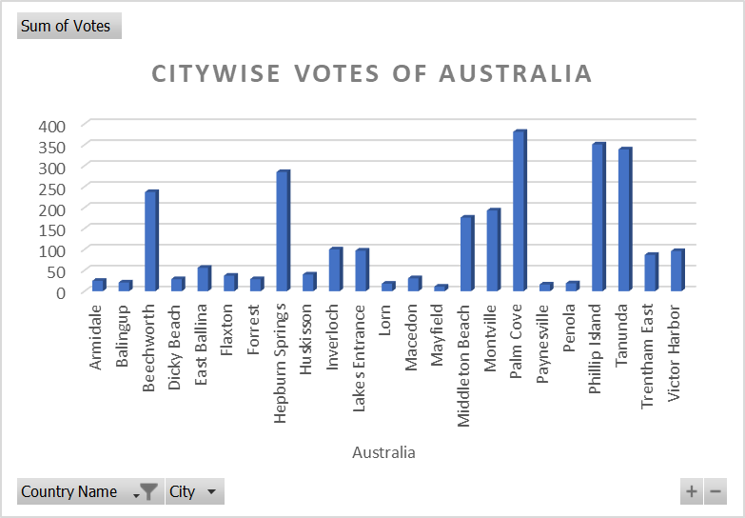



**Canada**

 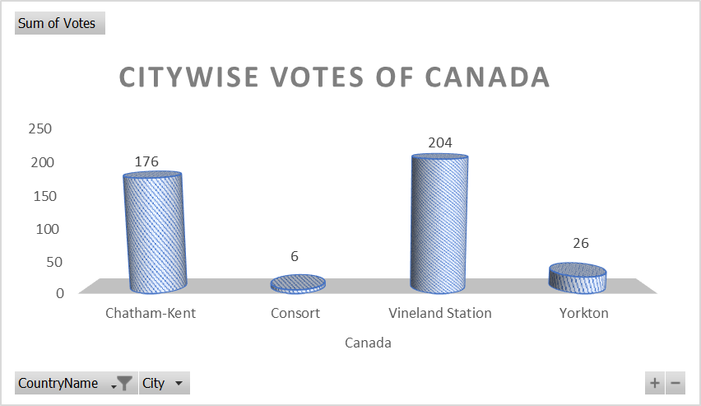



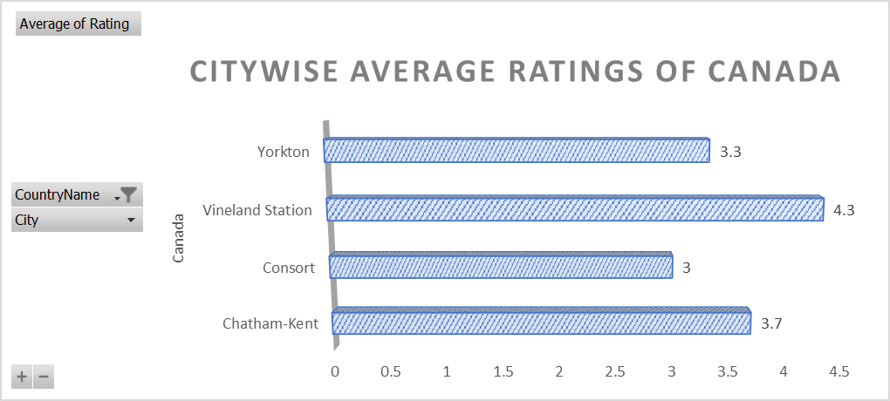

**Indonesia**



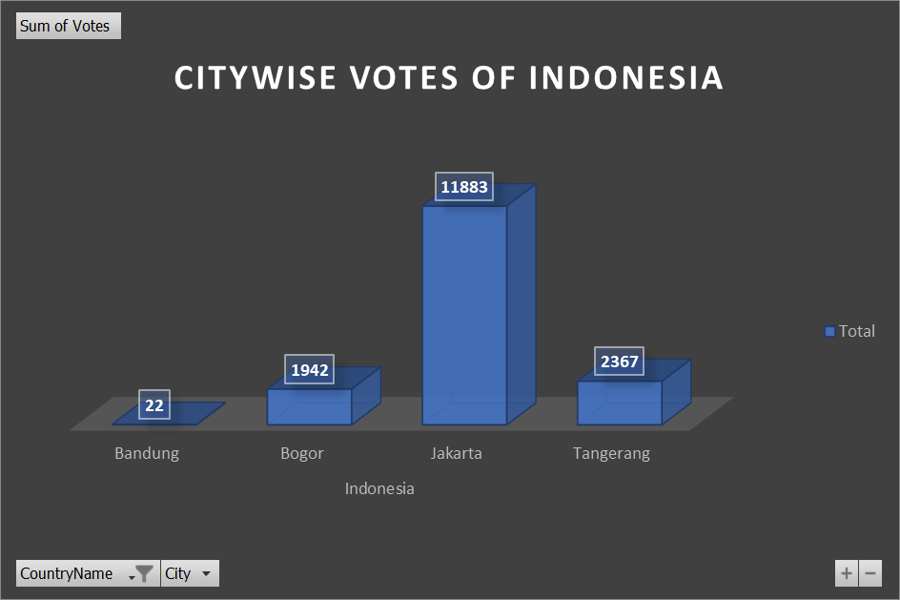



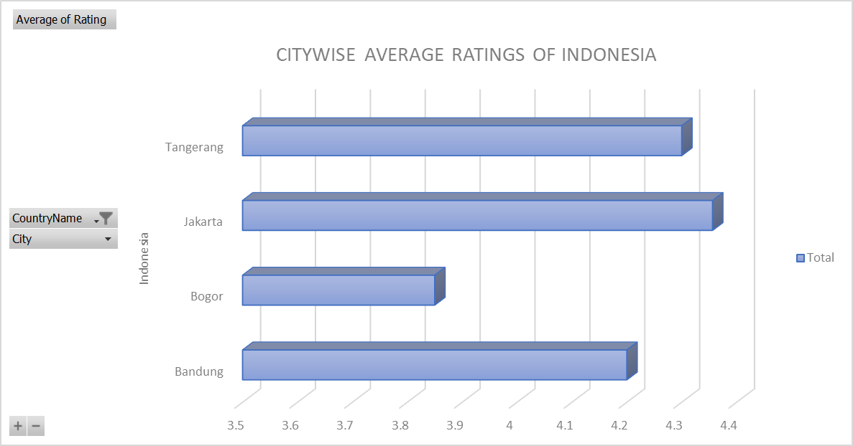

**Singapore**



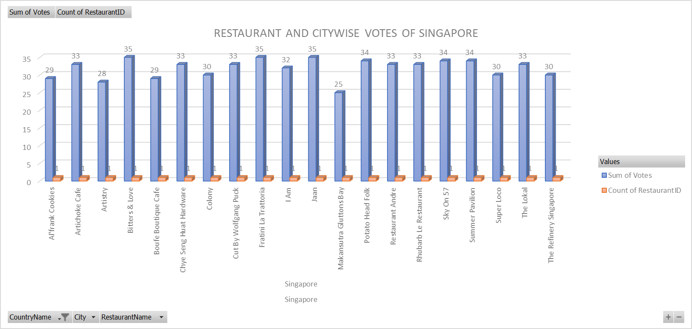



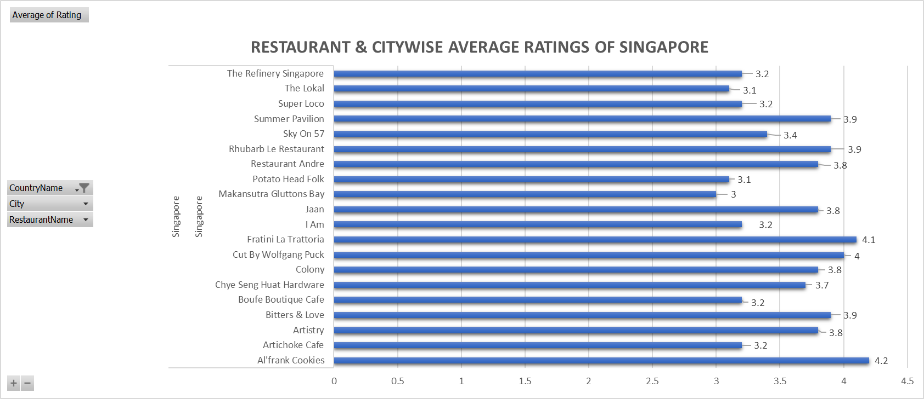

**Sri Lanka**



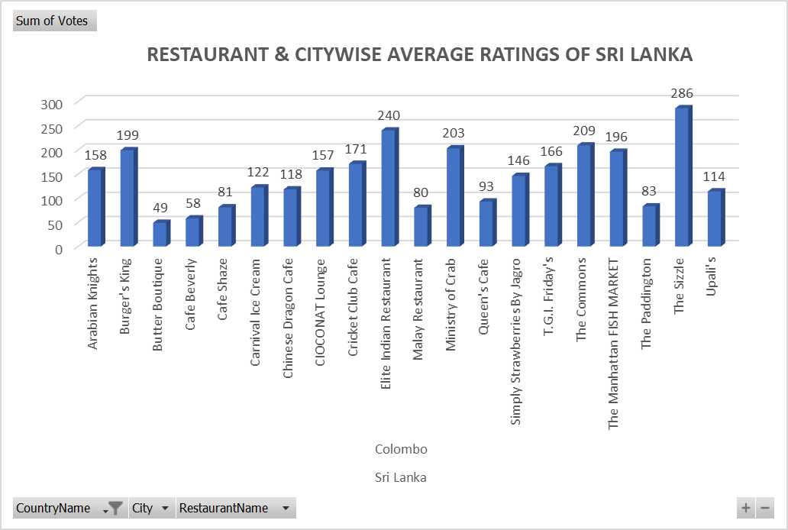



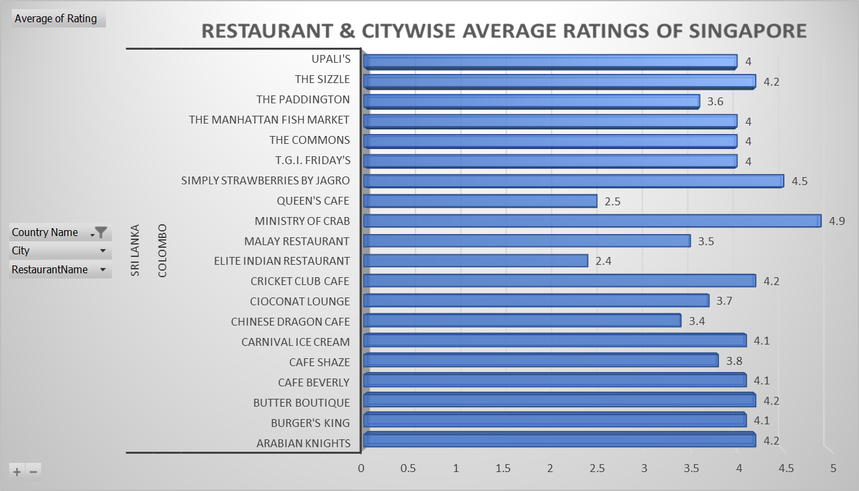

**UNITED ARAB EMIRATES**



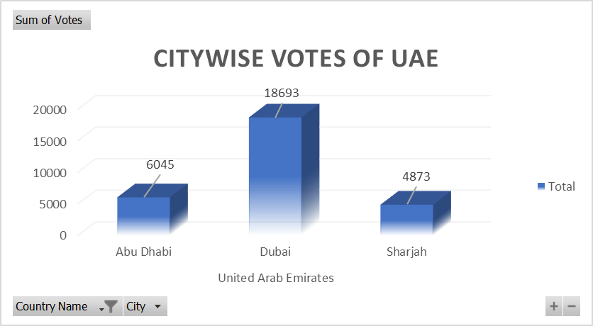



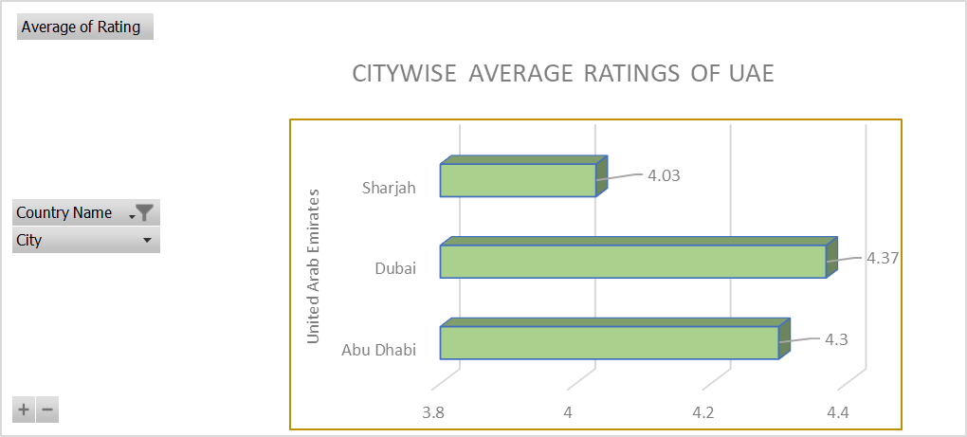

**INDIA**



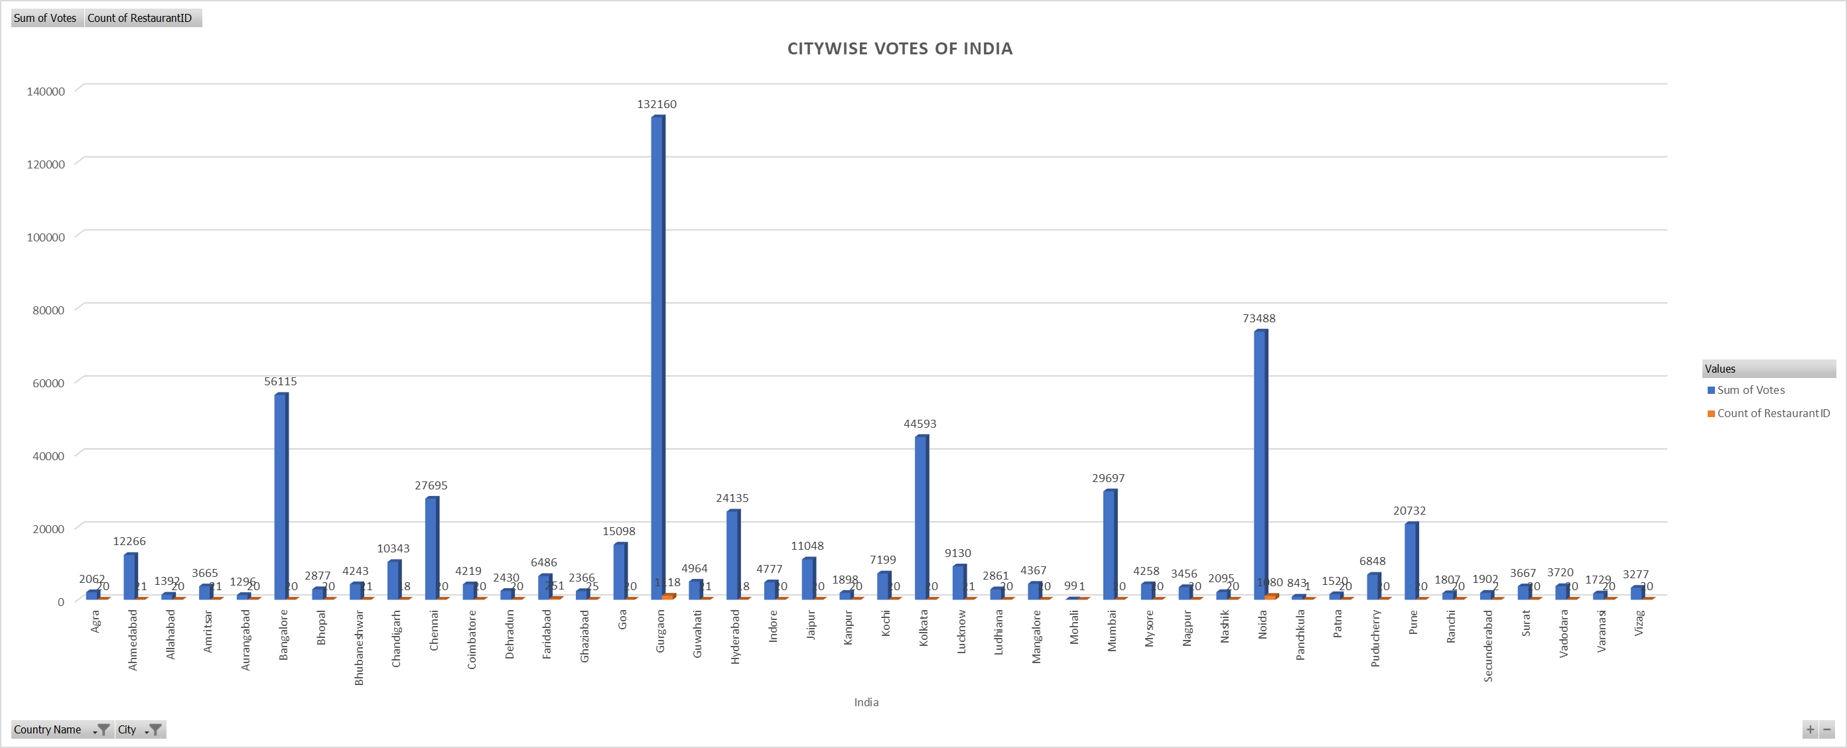



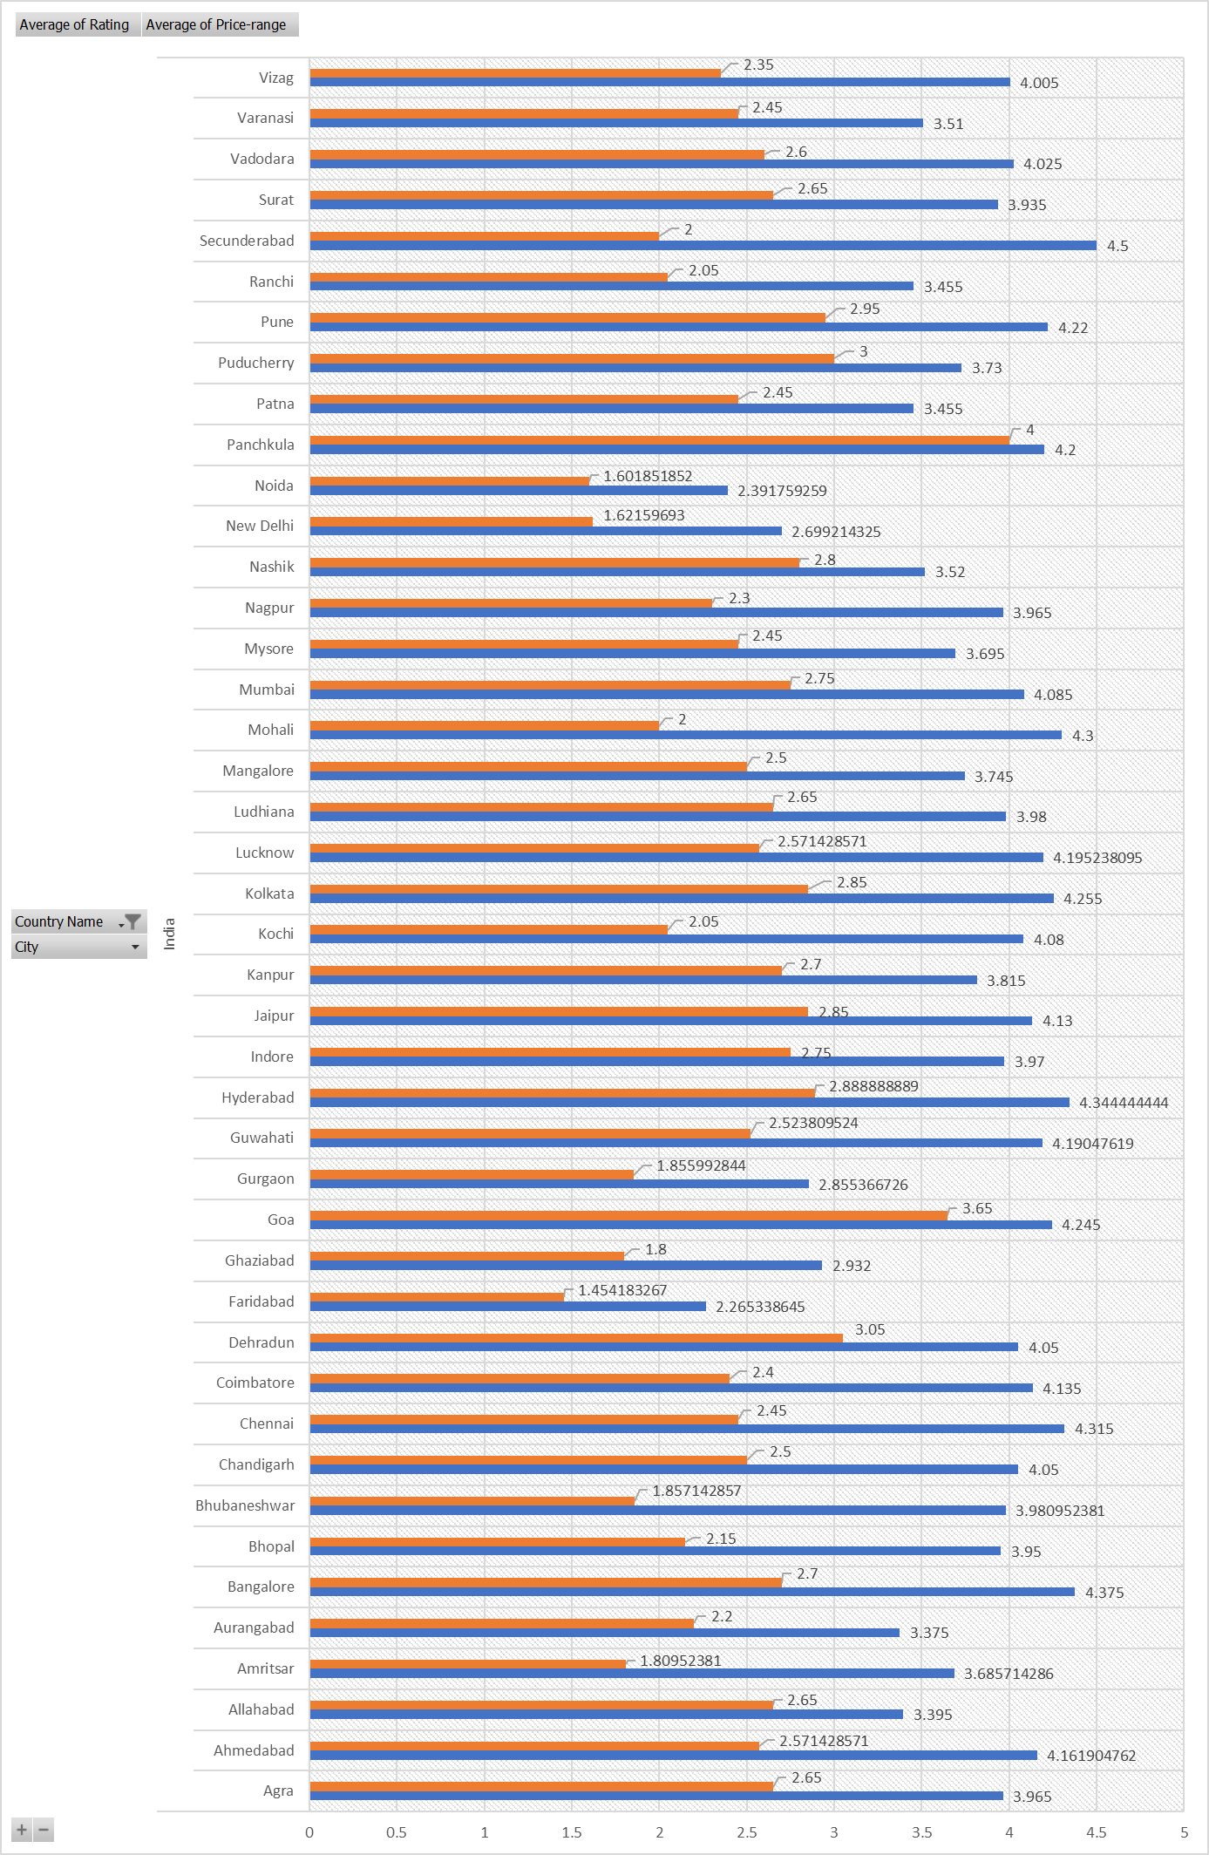



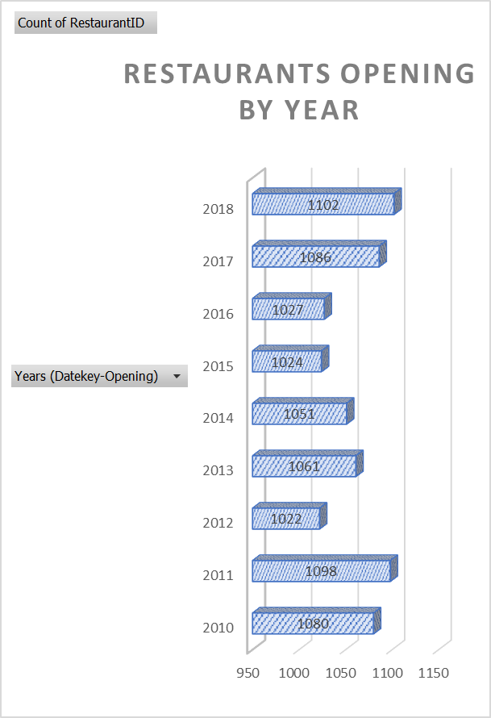



|  |  |
| --- | --- |
| **Row Labels** | **Count of Has-Table-booking** |
| No | 8393 |
| Yes | 1158 |
| **Grand Total** | **9551** |