PREFIX rdf: <http://www.w3.org/1999/02/22-rdf-syntax-ns#>

PREFIX owl: <http://www.w3.org/2002/07/owl#>

PREFIX rdfs: <http://www.w3.org/2000/01/rdf-schema#>

PREFIX xsd: <http://www.w3.org/2001/XMLSchema#>

PREFIX uri: <http://www.semanticweb.org/vip/ontologies/2022/3/untitled-ontology-2#>

SELECT ?Person ?Name ?Age ?National_ID

WHERE {

?Person a uri:Adults .

?Person uri:Name ?Name .

?Person uri:Age ?Age .

FILTER REGEX (?Name , "n", "i") .

OPTIONAL {?Person uri:National_ID ?National_ID .}

}

ORDER BY ?Age

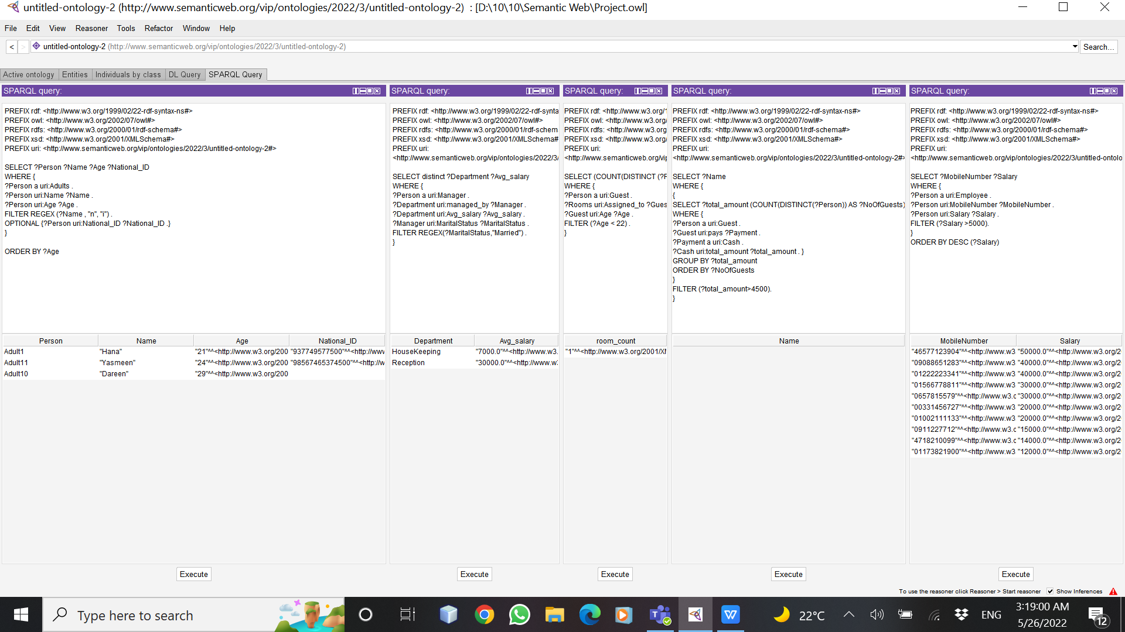

PREFIX rdf: <http://www.w3.org/1999/02/22-rdf-syntax-ns#>

PREFIX owl: <http://www.w3.org/2002/07/owl#>

PREFIX rdfs: <http://www.w3.org/2000/01/rdf-schema#>

PREFIX xsd: <http://www.w3.org/2001/XMLSchema#>

PREFIX uri: <http://www.semanticweb.org/vip/ontologies/2022/3/untitled-ontology-2#>

SELECT distinct ?Department ?Avg_salary

WHERE {

?Person a uri:Manager .

?Department uri:managed_by ?Manager .

?Department uri:Avg_salary ?Avg_salary .

?Manager uri:MaritalStatus ?MaritalStatus .

FILTER REGEX(?MaritalStatus,"Married") .

}

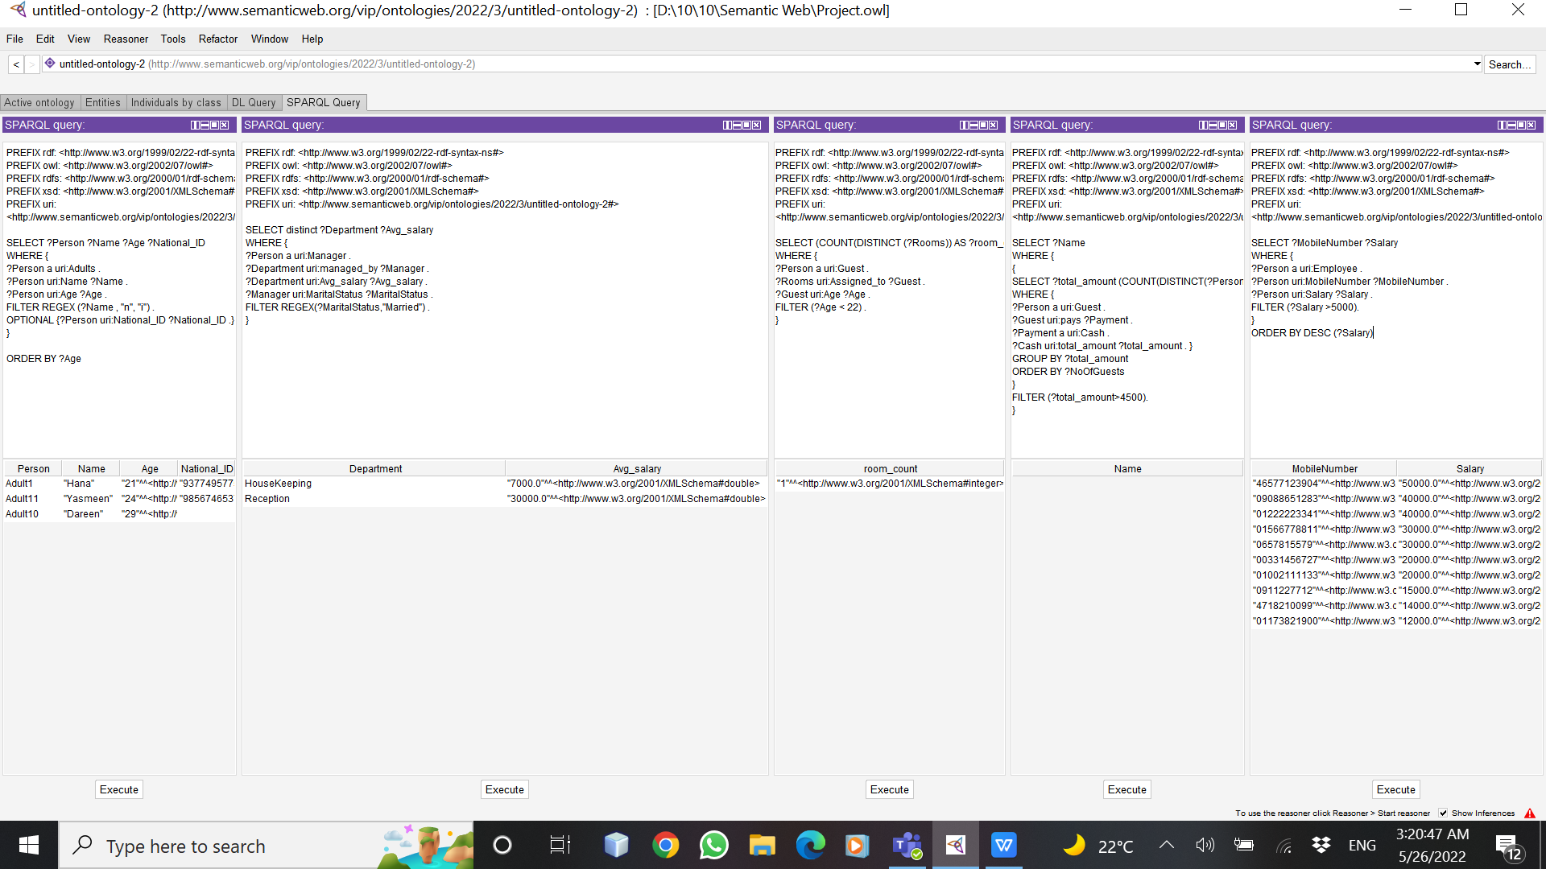

PREFIX rdf: <http://www.w3.org/1999/02/22-rdf-syntax-ns#>

PREFIX owl: <http://www.w3.org/2002/07/owl#>

PREFIX rdfs: <http://www.w3.org/2000/01/rdf-schema#>

PREFIX xsd: <http://www.w3.org/2001/XMLSchema#>

PREFIX uri: <http://www.semanticweb.org/vip/ontologies/2022/3/untitled-ontology-2#>

SELECT (COUNT(DISTINCT (?Rooms)) AS ?room_count)

WHERE {

?Person a uri:Guest .

?Rooms uri:Assigned_to ?Guest .

?Guest uri:Age ?Age .

FILTER (?Age < 22) .

}

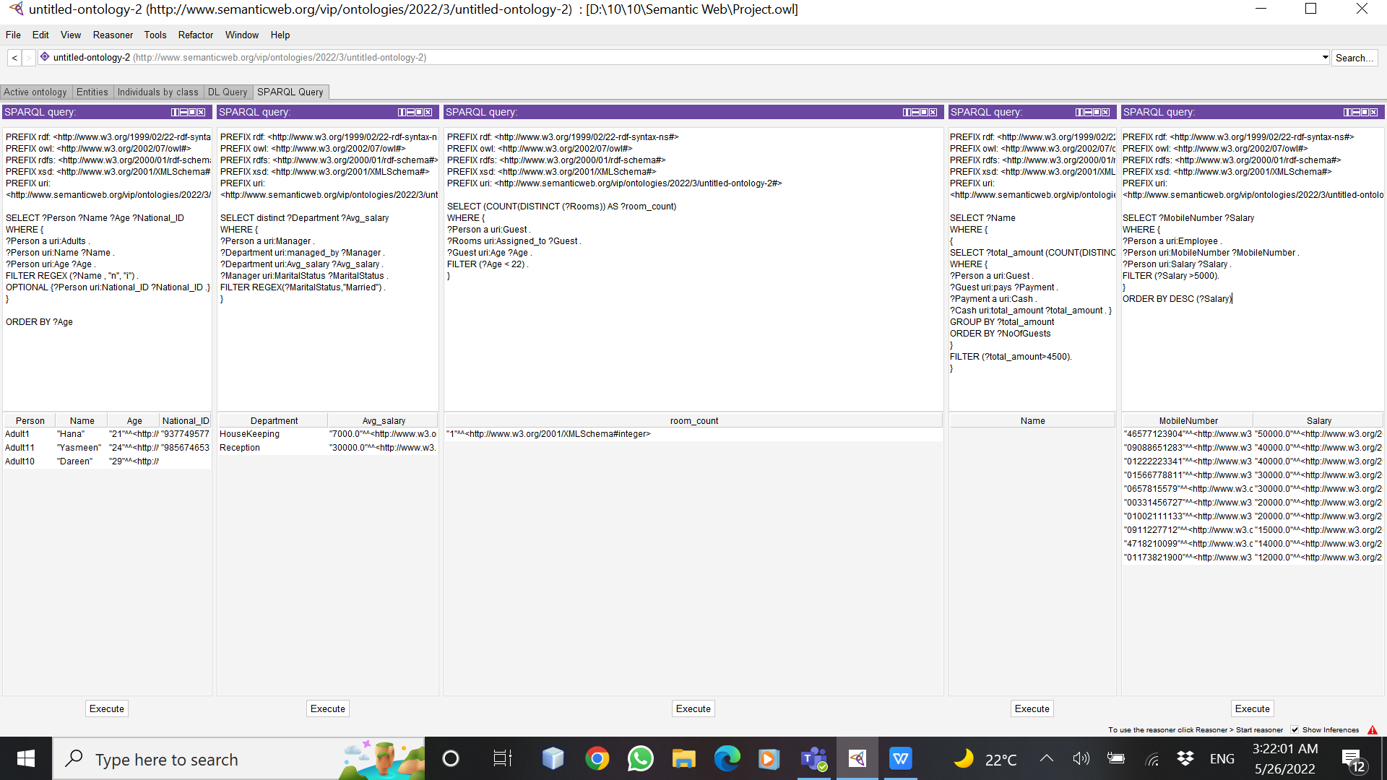

PREFIX rdf: <http://www.w3.org/1999/02/22-rdf-syntax-ns#>

PREFIX owl: <http://www.w3.org/2002/07/owl#>

PREFIX rdfs: <http://www.w3.org/2000/01/rdf-schema#>

PREFIX xsd: <http://www.w3.org/2001/XMLSchema#>

PREFIX uri: <http://www.semanticweb.org/vip/ontologies/2022/3/untitled-ontology-2#>

SELECT ?MobileNumber ?Salary

WHERE {

?Person a uri:Employee .

?Person uri:MobileNumber ?MobileNumber .

?Person uri:Salary ?Salary .

FILTER (?Salary >5000).

}

ORDER BY DESC (?Salary)

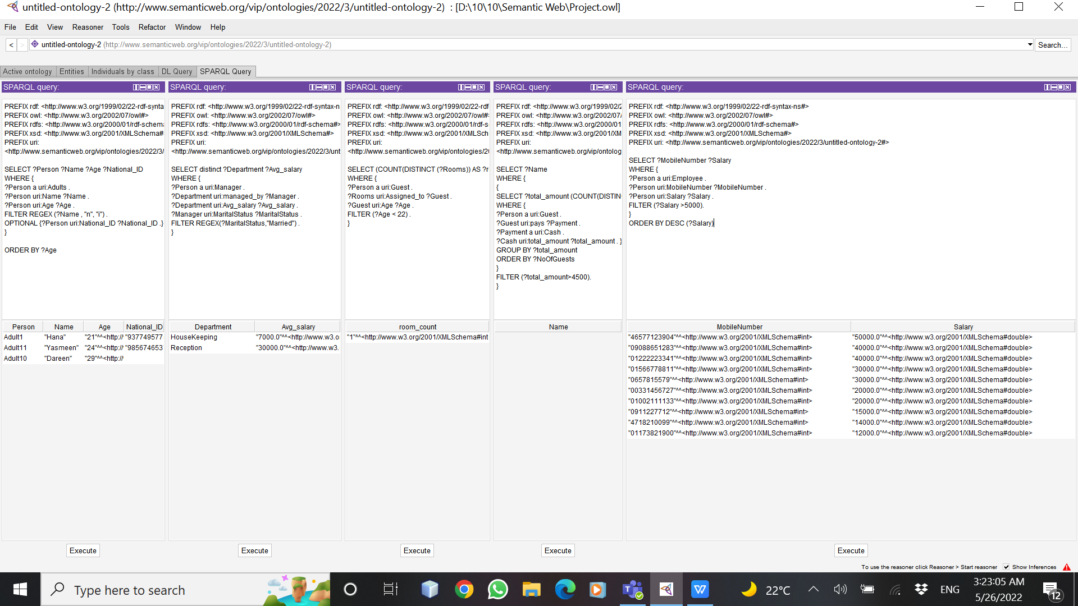

PREFIX rdf: <http://www.w3.org/1999/02/22-rdf-syntax-ns#>

PREFIX owl: <http://www.w3.org/2002/07/owl#>

PREFIX rdfs: <http://www.w3.org/2000/01/rdf-schema#>

PREFIX xsd: <http://www.w3.org/2001/XMLSchema#>

PREFIX uri: <http://www.semanticweb.org/vip/ontologies/2022/3/untitled-ontology-2#>

SELECT (COUNT(DISTINCT(?Person)) AS ?GuestsEscortAdults)

WHERE {

?Person a uri:Guest .

?Guest uri:Escort ?Adults .

}

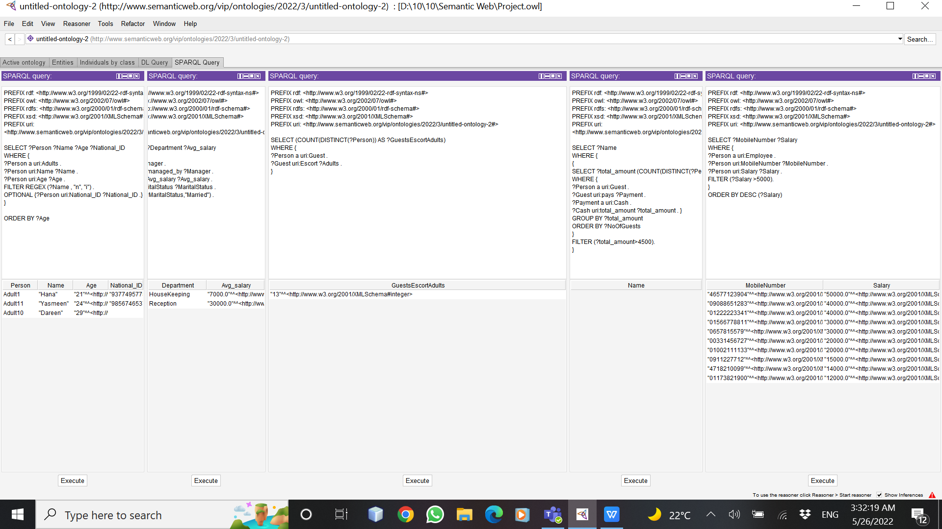

PREFIX rdf: <http://www.w3.org/1999/02/22-rdf-syntax-ns#>

PREFIX owl: <http://www.w3.org/2002/07/owl#>

PREFIX rdfs: <http://www.w3.org/2000/01/rdf-schema#>

PREFIX xsd: <http://www.w3.org/2001/XMLSchema#>

PREFIX uri: <http://www.semanticweb.org/vip/ontologies/2022/3/untitled-ontology-2#>

SELECT ?MaritalStatus

WHERE {

?Person a uri:Manager .

?Person uri:MaritalStatus ?MaritalStatus .

}

LIMIT 2

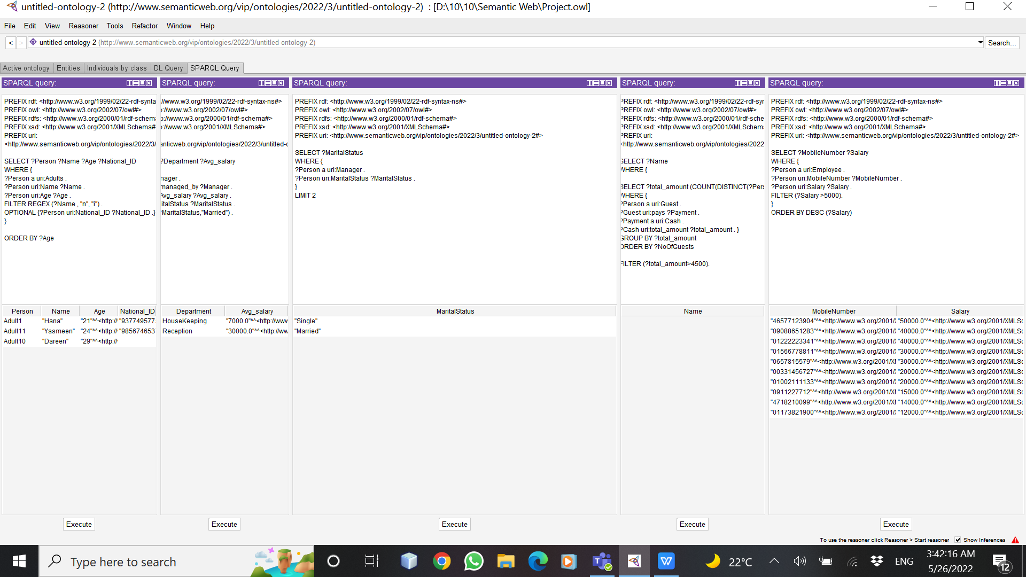

PREFIX rdf: <http://www.w3.org/1999/02/22-rdf-syntax-ns#>

PREFIX owl: <http://www.w3.org/2002/07/owl#>

PREFIX rdfs: <http://www.w3.org/2000/01/rdf-schema#>

PREFIX xsd: <http://www.w3.org/2001/XMLSchema#>

PREFIX uri: <http://www.semanticweb.org/vip/ontologies/2022/3/untitled-ontology-2#>

SELECT ?wifi_password

WHERE {

?Hotel uri:Amenities ?wifi .

?wifi uri:wifi_password ?wifi_password .

}

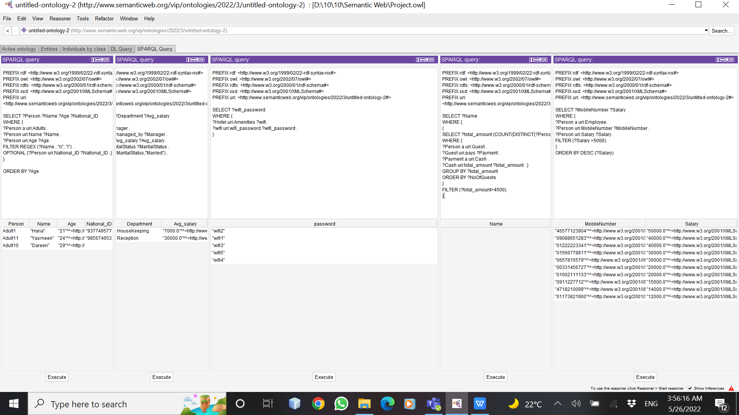

PREFIX rdf: <http://www.w3.org/1999/02/22-rdf-syntax-ns#>

PREFIX owl: <http://www.w3.org/2002/07/owl#>

PREFIX rdfs: <http://www.w3.org/2000/01/rdf-schema#>

PREFIX xsd: <http://www.w3.org/2001/XMLSchema#>

PREFIX uri: <http://www.semanticweb.org/vip/ontologies/2022/3/untitled-ontology-2#>

SELECT ?Name

WHERE {

{

SELECT ?total_amount (COUNT(DISTINCT(?Person)) AS ?NoOfGuests)

WHERE {

?Person a uri:Guest .

?Guest uri:pays ?Payment .

?Payment a uri:Cash .

?Cash uri:total_amount ?total_amount . }

GROUP BY ?total_amount

ORDER BY ?NoOfGuests

}

FILTER (?total_amount>4500).

}