Exploratory Data Analysis

Md Rana Mahmud

9/4/2020

data("mtcars")

plot(mtcars$mpg, mtcars$cyl)

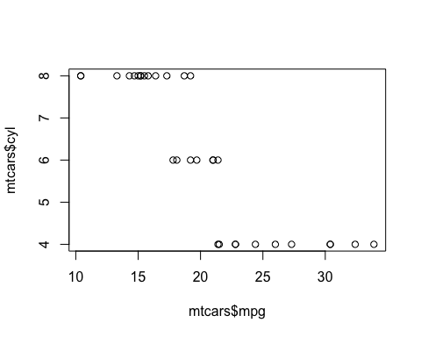 From the plot we can see there is a negative relationship.

# pander  
# apatables  
library(pander)  
library(apaTables)

t.test(mpg~vs, data = mtcars)

##   
## Welch Two Sample t-test  
##   
## data: mpg by vs  
## t = -4.6671, df = 22.716, p-value = 0.0001098  
## alternative hypothesis: true difference in means is not equal to 0  
## 95 percent confidence interval:  
## -11.462508 -4.418445  
## sample estimates:  
## mean in group 0 mean in group 1   
## 16.61667 24.55714

pander(t.test(mpg~vs, data = mtcars))

Welch Two Sample t-test: mpg by vs (continued below)

|  |  |  |  |
| --- | --- | --- | --- |
| Test statistic | df | P value | Alternative hypothesis |
| -4.667 | 22.72 | 0.0001098 * * * | two.sided |

|  |  |
| --- | --- |
| mean in group 0 | mean in group 1 |
| 16.62 | 24.56 |