
BRAINWARE UNIVERSITY
School of Engineering
Department of Computer Science & Engineering – Cyber Security & Data Science
398, Ramkrishnapur Road, Barasat, North 24 Parganas, Kolkata – 700 125
PROJECT-BASED LEARNING
VLANs | Trunking | Inter-VLAN Routing | DHCP | DNS | Web | Guest Wi-Fi
Course Code | Course Name
BTY59116 | Network Fundamentals and Practical Applications Lab

Title
Design and Simulation of a Secure Hotel Network Using Cisco Packet Tracer

SUBMITTED BY
Sl. No. | Name of the Candidate | Student Code | Signature
1 | RANANJAY SARKAR | BWU/BCC/24/029
2 | SOHAN SARKAR | BWU/BCC/24/027
3 | SOUVIK PARAMANIK | BWU/BCC/24/030
4
5

Under the supervision of
Dr. SUPARNA PANCHANAN
Assistant Professor, CSE-CS & DS
Date of Submission | Marks Obtained & Remarks
05-11-2026

1. Contents
1 Contents
2 Question Paper
3 Solution
3.1 Proposed Solution
3.2 Hotel Departments and VLAN Design
3.3 Network Addressing Plan
4 Framework / System Working
4.1 Network Topology
4.2 VLAN Creation
4.3 Access Port Assignment
4.4 Trunk Configuration
4.5 Inter-VLAN Routing
4.6 DHCP Configuration
4.7 DNS and Web Server
4.8 Guest Wireless
4.9 Guest Security ACL
4.10 Verification
5 Observations
6 Conclusion
7 Future Scope
8 References

2. Question Paper
Design and simulate a complete secure hotel network in Cisco Packet Tracer using a router, managed switch, server, wireless access point and end devices.
- Create separate VLANs for hotel departments and guest wireless users.
- Assign suitable IP addresses and subnet masks to each VLAN.
- Configure trunk and access ports on the switch.
- Configure Inter-VLAN routing using Router-on-a-Stick.
- Configure DHCP for automatic IP assignment.
- Configure a DNS/Web server for the hotel portal.
- Configure secure wireless access for hotel guests.
- Apply basic access-control rules to isolate guest devices from internal hotel systems.

3. Solution

3.1 Proposed Solution
The proposed design is a segmented hotel network simulated in Cisco Packet Tracer. The supplied configuration evidence shows a Cisco 2911 router, Catalyst 2960 switch, Hotel Server, guest wireless access point, guest laptop and five wired departmental PCs. The switch configuration uses VLANs 10, 20, 30, 40, 50, 60, 70 and 80, together with VLAN 999 as the native VLAN on the router uplink. Router sub-interfaces provide Inter-VLAN routing and DHCP services. The hotel server is intended to provide DNS and HTTP services.
VLANs | Router | Switch | Server | Wireless clients
9 configured VLAN IDs | Cisco 2911 | Catalyst 2960 | Server-PT | Guest laptop(s)

- A separate VLAN and IP subnet are used for each department or service group.
- The switch-to-router link is an 802.1Q trunk.
- Router sub-interfaces provide the default gateways for all VLANs.
- DHCP supplies client addressing and DNS server information.
- Guest Wi-Fi is placed in its own VLAN and restricted from internal hotel networks.

3.2 Hotel Departments and VLAN Design
VLAN ID | VLAN Name | Purpose | Endpoint
10 | RECEPTION | Guest check-in and front desk | Reception PC (Fa0/2)
20 | ADMIN | Administrative operations | Admin PC (Fa0/3)
30 | HOUSEKEEPING | Housekeeping operations | Housekeeping PC (Fa0/4)
40 | RESTAURANT | Restaurant / billing | Restaurant PC (Fa0/5)
50 | MANAGEMENT | Hotel management office | Management PC (Fa0/6)
60 | SERVERS | Hotel DNS and Web services | Hotel Server (assign an access port)
70 | GUEST_WIFI | Guest wireless network | Guest laptop via AP (Fa0/7)
80 | CCTV_IOT | CCTV and IoT devices | Reserved for future devices
999 | NATIVE | Native VLAN for trunk link | Trunk native VLAN; no end devices

3.3 Network Addressing Plan
Department | VLAN | Network / Prefix | Subnet Mask | Gateway | DHCP Pool
Reception | 10 | 192.168.10.0/24 | 255.255.255.0 | 192.168.10.1 | RECEPTION
Admin | 20 | 192.168.20.0/24 | 255.255.255.0 | 192.168.20.1 | ADMIN
Housekeeping | 30 | 192.168.30.0/24 | 255.255.255.0 | 192.168.30.1 | HOUSEKEEPING
Restaurant | 40 | 192.168.40.0/24 | 255.255.255.0 | 192.168.40.1 | RESTAURANT
Management | 50 | 192.168.50.0/24 | 255.255.255.0 | 192.168.50.1 | MANAGEMENT
Servers | 60 | 192.168.60.0/24 | 255.255.255.0 | 192.168.60.1 | Static
Guest Wi-Fi | 70 | 192.168.70.0/24 | 255.255.255.0 | 192.168.70.1 | GUEST_WIFI
CCTV / IoT | 80 | 192.168.80.0/24 | 255.255.255.0 | 192.168.80.1 | Optional / static
Native VLAN | 999 | No user IP subnet | — | — | Not applicable

Hotel Server static address: 192.168.60.10/24; gateway 192.168.60.1; DNS server 192.168.60.10; DNS name www.hotel.local.

4. Framework / System Working

4.1 Network Topology
Figure 1 shows the actual physical topology created by the student. The router connects to the central switch; the Hotel Server and guest access point are connected to the switch, and the guest laptop associates wirelessly with the access point. Five wired PCs represent Reception, Admin, Housekeeping, Restaurant and Management. The following configuration evidence shows VLAN membership, trunk settings, DHCP pool information and successful wireless association.
Device | Model | Role
Router | Cisco 2911 | Inter-VLAN routing and DHCP
Switch | Catalyst 2960 | VLANs, access ports and trunk
Server | Server-PT | DNS and hotel web portal
Access Point | AccessPoint-PT | Guest wireless access
End devices | PC-PT / Laptop-PT | Hotel staff and guest clients

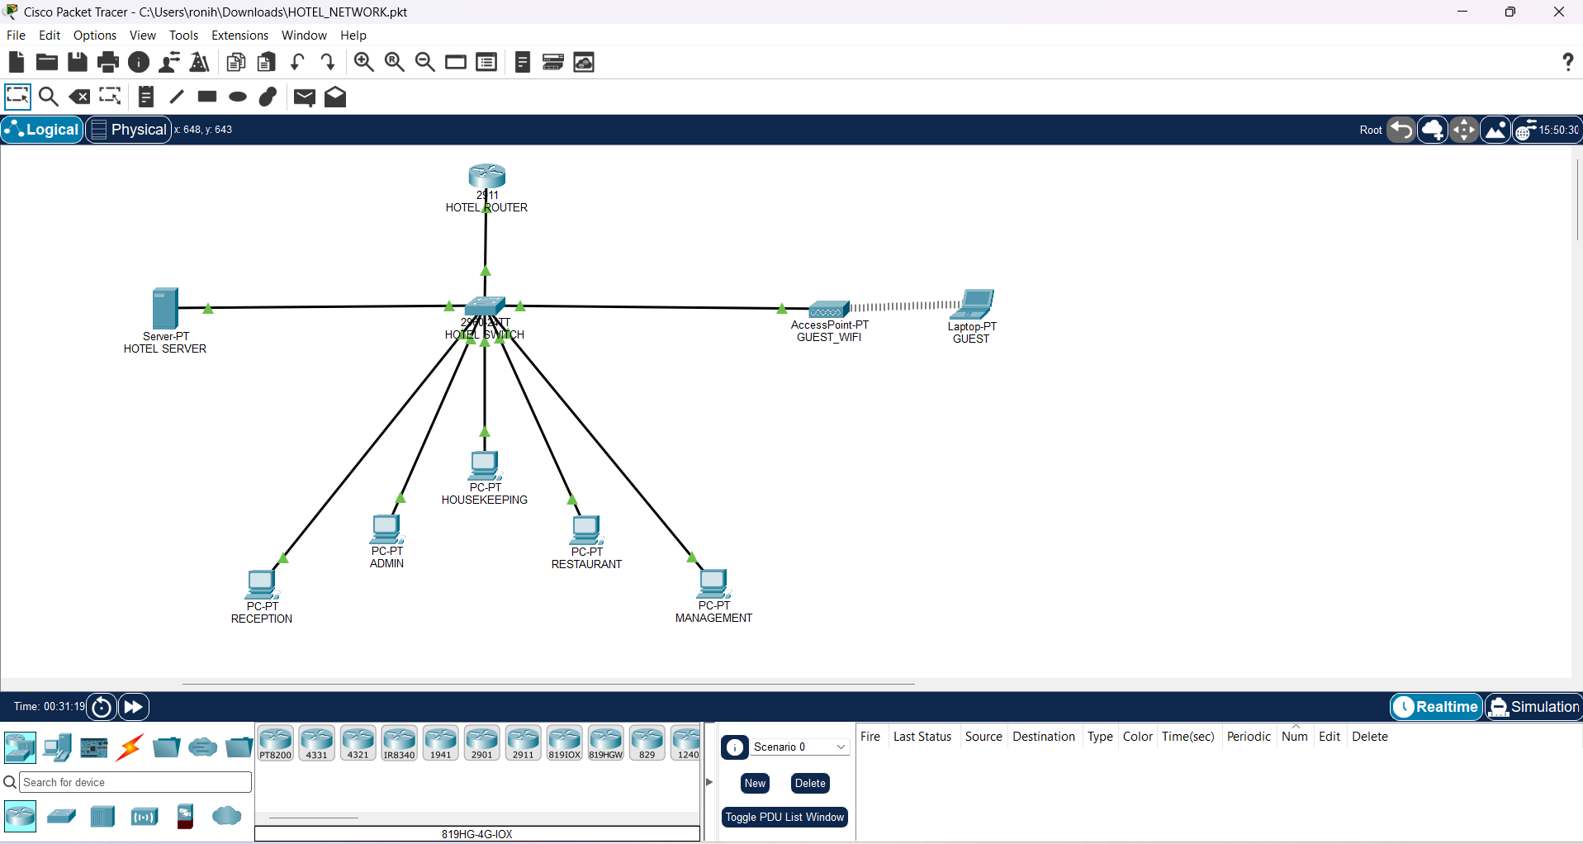
Figure 1: Actual hotel network topology created in Cisco Packet Tracer.

Suggested port mapping
Suggested switch port | Connected device | VLAN | Mode
Fa0/2 | Reception PC | 10 | Access
Fa0/3 | Admin PC | 20 | Access
Fa0/4 | Housekeeping PC | 30 | Access
Fa0/5 | Restaurant PC | 40 | Access
Fa0/6 | Management PC | 50 | Access
Fa0/1 (verify) | Hotel Server | 60 | Access
Fa0/7 | Guest Access Point | 70 | Access
Gi0/1 | Router uplink | 10,20,30,40,50,60,70,80,999 | 802.1Q trunk; native 999
Unused / future | CCTV / IoT endpoints | 80 | Access

Note: These port numbers are a suggested allocation, not confirmed from the screenshot. Check the actual cable endpoints in Packet Tracer and change the interface commands to match.

4.2 VLAN Creation
Switch> enable
Switch# configure terminal
vlan 10
name RECEPTION
vlan 20
name ADMIN
vlan 30
name HOUSEKEEPING
vlan 40
name RESTAURANT
vlan 50
name MANAGEMENT
vlan 60
name SERVERS
vlan 70
name GUEST_WIFI
vlan 80
name CCTV_IOT
vlan 999
name NATIVE
end
show vlan brief
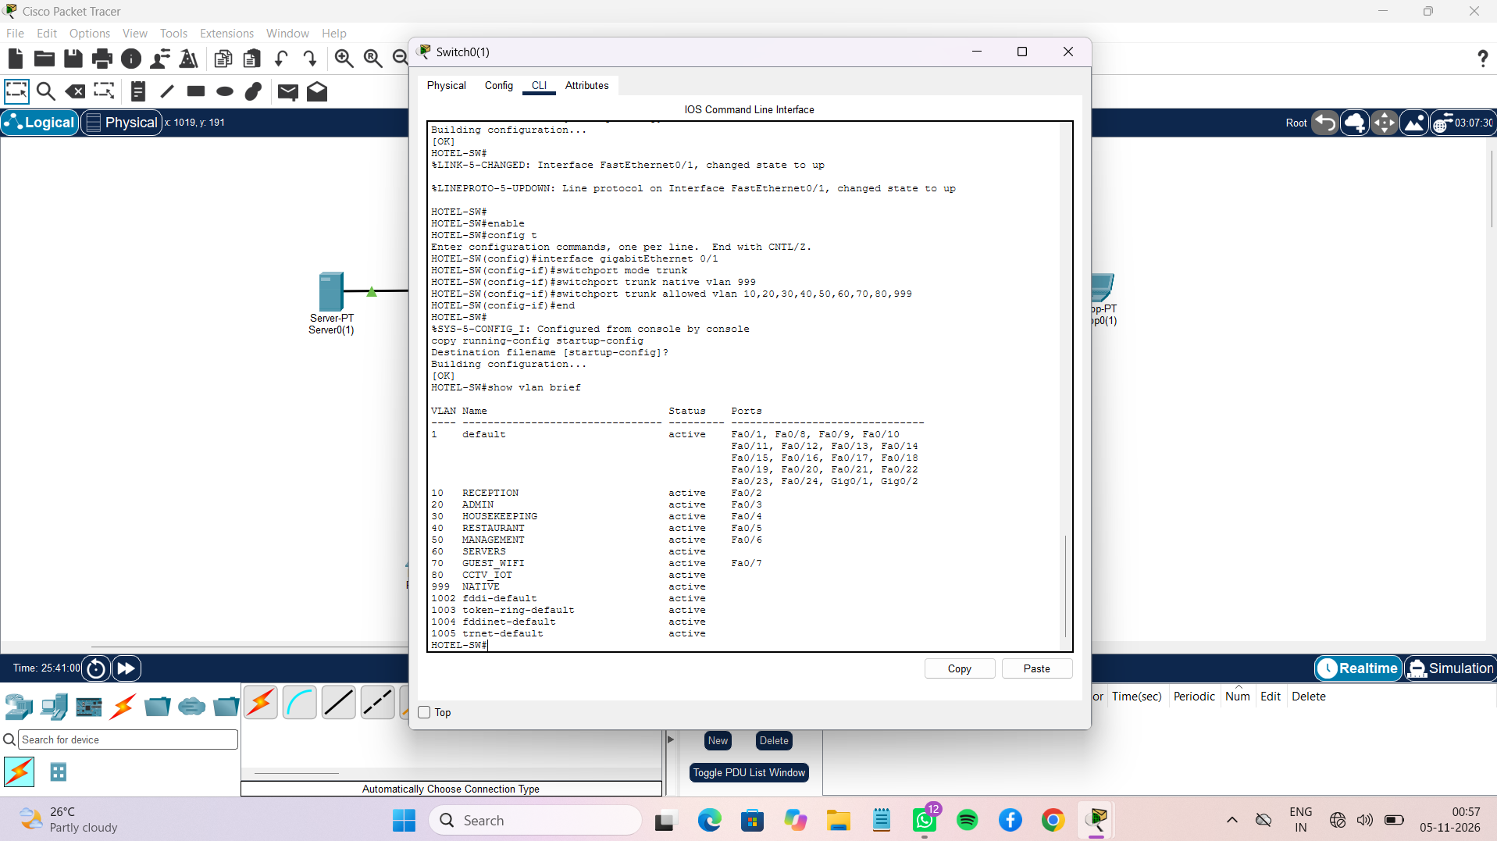
Figure 2: Switch CLI output showing the configured VLANs and access-port membership.

4.3 Access Port Assignment
! Port assignments visible in the supplied VLAN output
interface fa0/2
switchport mode access
switchport access vlan 10
interface fa0/3
switchport mode access
switchport access vlan 20
interface fa0/4
switchport mode access
switchport access vlan 30
interface fa0/5
switchport mode access
switchport access vlan 40
interface fa0/6
switchport mode access
switchport access vlan 50
! Fa0/1 appears to be an unused/default port in the screenshot;
! verify that the Hotel Server is connected here before assigning VLAN 60.
interface fa0/1
switchport mode access
switchport access vlan 60
interface fa0/7
switchport mode access
switchport access vlan 70

4.4 Trunk Configuration
! Router uplink shown as GigabitEthernet0/1
interface gigabitEthernet0/1
switchport mode trunk
switchport trunk native vlan 999
switchport trunk allowed vlan 10,20,30,40,50,60,70,80,999
no shutdown
end
show interfaces trunk
Figure 3: Switch CLI configuration showing the trunk port, native VLAN 999 and allowed VLAN list.

4.5 Inter-VLAN Routing
! Router-on-a-Stick: use the router port physically connected to switch Gi0/1
interface g0/0/0
no shutdown
interface g0/0/0.10
encapsulation dot1Q 10
ip address 192.168.10.1 255.255.255.0
interface g0/0/0.20
encapsulation dot1Q 20
ip address 192.168.20.1 255.255.255.0
interface g0/0/0.30
encapsulation dot1Q 30
ip address 192.168.30.1 255.255.255.0
interface g0/0/0.40
encapsulation dot1Q 40
ip address 192.168.40.1 255.255.255.0
interface g0/0/0.50
encapsulation dot1Q 50
ip address 192.168.50.1 255.255.255.0
interface g0/0/0.60
encapsulation dot1Q 60
ip address 192.168.60.1 255.255.255.0
interface g0/0/0.70
encapsulation dot1Q 70
ip address 192.168.70.1 255.255.255.0
interface g0/0/0.80
encapsulation dot1Q 80
ip address 192.168.80.1 255.255.255.0
interface g0/0/0.999
encapsulation dot1Q 999 native
no ip address
end
show ip interface brief

4.6 DHCP Configuration
! DHCP pool evidence in the screenshot includes RESTAURANT (.40)
! and GUEST_WIFI (.70). Configure remaining pools to match your VLAN plan.
ip dhcp excluded-address 192.168.10.1 192.168.10.20
ip dhcp excluded-address 192.168.20.1 192.168.20.20
ip dhcp excluded-address 192.168.30.1 192.168.30.20
ip dhcp excluded-address 192.168.40.1 192.168.40.20
ip dhcp excluded-address 192.168.50.1 192.168.50.20
ip dhcp excluded-address 192.168.60.1 192.168.60.20
ip dhcp excluded-address 192.168.70.1 192.168.70.20
ip dhcp pool RECEPTION
network 192.168.10.0 255.255.255.0
default-router 192.168.10.1
dns-server 192.168.60.10
ip dhcp pool ADMIN
network 192.168.20.0 255.255.255.0
default-router 192.168.20.1
dns-server 192.168.60.10
ip dhcp pool HOUSEKEEPING
network 192.168.30.0 255.255.255.0
default-router 192.168.30.1
dns-server 192.168.60.10
ip dhcp pool RESTAURANT
network 192.168.40.0 255.255.255.0
default-router 192.168.40.1
dns-server 192.168.60.10
ip dhcp pool MANAGEMENT
network 192.168.50.0 255.255.255.0
default-router 192.168.50.1
dns-server 192.168.60.10
ip dhcp pool GUEST_WIFI
network 192.168.70.0 255.255.255.0
default-router 192.168.70.1
dns-server 192.168.60.10
end
show ip dhcp pool
show ip dhcp binding
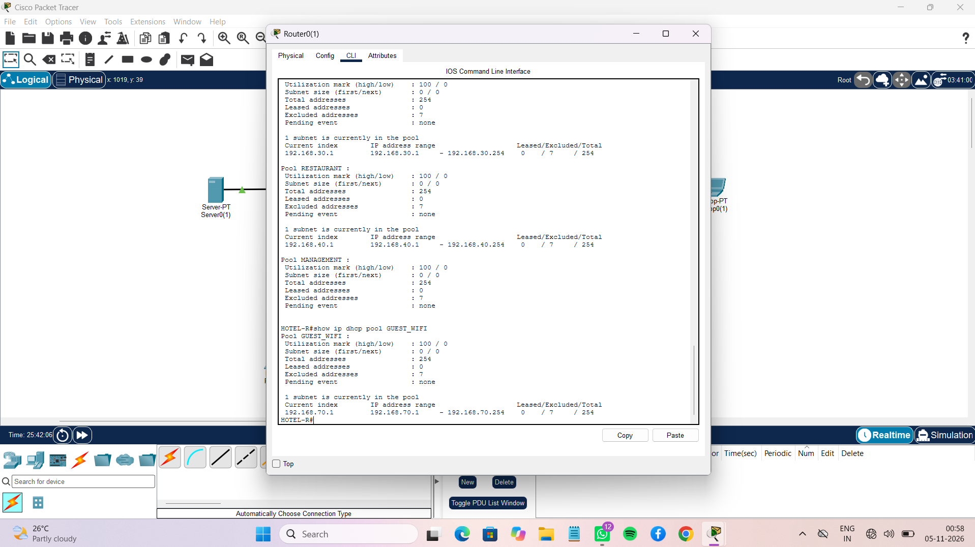
Figure 4: Router CLI DHCP pool summary showing the configured address ranges.

On every PC, select Desktop → IP Configuration → DHCP. The server VLAN uses a static address to keep hotel services at a predictable IP.

4.7 DNS and Web Server
- Open HOTEL SERVER → Desktop → IP Configuration; set IP 192.168.60.10, mask 255.255.255.0, gateway 192.168.60.1 and DNS 192.168.60.10.
- Open Services → DNS and turn it On. Add the A record www.hotel.local pointing to 192.168.60.10.
- Open Services → HTTP and turn it On. Edit the index page to show hotel name, rooms, facilities and contact details.
- From a client browser, open http://www.hotel.local.

4.8 Guest Wireless Configuration
- Open the AccessPoint-PT configuration and set SSID to HOTEL-GUEST.
- Enable WPA2-PSK if the selected access point model supports it and set a strong lab password.
- Keep the AP connected to the switch access port assigned to VLAN 70.
- Connect the guest laptop to HOTEL-GUEST and select DHCP. The planned guest network is 192.168.70.0/24; verify the laptop receives a 192.168.70.x address.
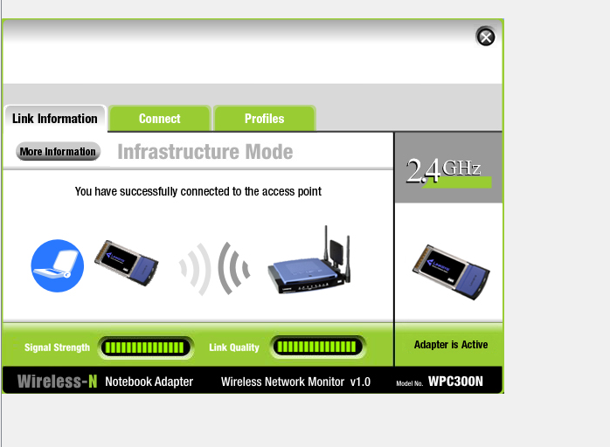
Figure 5: Wireless Network Monitor confirming successful connection to the access point in Infrastructure Mode.

4.9 Guest Network Isolation Using ACL
ip access-list extended GUEST-IN
permit udp 192.168.70.0 0.0.0.255 host 192.168.60.10 eq 53
permit tcp 192.168.70.0 0.0.0.255 host 192.168.60.10 eq 53
permit tcp 192.168.70.0 0.0.0.255 host 192.168.60.10 eq 80
deny ip 192.168.70.0 0.0.0.255 192.168.0.0 0.0.255.255
permit ip 192.168.70.0 0.0.0.255 any
interface g0/0/0.70
ip access-group GUEST-IN in
end
show access-lists

Apply the ACL only after DHCP, DNS and web access work. This is a teaching-lab example, not a complete production firewall policy.

4.10 Verification Commands
Command | Device | Purpose
show vlan brief | Switch | Check VLANs and access ports
show interfaces trunk | Switch | Check trunk and allowed VLANs
show ip interface brief | Router | Check sub-interfaces
show ip route | Router | Check connected VLAN networks
show ip dhcp binding | Router | Check DHCP leases
show access-lists | Router | Check guest ACL
ping 192.168.70.10 | PC / Laptop | Test server reachability
http://www.hotel.local | Web browser | Test DNS and HTTP

5. Observations
- Eight service VLANs are configured for reception, administration, housekeeping, restaurant, management, servers, guest Wi-Fi and CCTV/IoT. VLAN 999 is additionally configured as the native VLAN for the trunk link.
- Each VLAN has a dedicated /24 network and router gateway.
- Access ports connect end devices to their respective VLANs and the router uplink carries VLAN tags over an 802.1Q trunk.
- DHCP provides automatic IP configuration to wired and wireless clients.
- The server resolves www.hotel.local and hosts the hotel website.
- The guest wireless adapter screenshot confirms that the laptop successfully connected to the access point in Infrastructure Mode. The DHCP pool summary also shows a GUEST_WIFI pool using the 192.168.70.0/24 network; a client lease should be checked separately.
- The guest ACL is a proposed security control in this report; the submitted screenshots do not yet prove that it has been applied or tested.
The evidence is presented in implementation order: Figure 1 shows the complete physical topology; Figure 2 shows VLAN creation and port membership; Figure 3 shows trunk configuration; Figure 4 shows DHCP pool information; and Figure 5 confirms the guest wireless association. Additional evidence should be added for router sub-interface status, DNS/HTTP server settings, actual DHCP client leases and guest isolation tests.

6. Conclusion
The project demonstrates a segmented hotel network design in Cisco Packet Tracer. The submitted switch evidence shows departmental VLANs, a native VLAN and a trunk allowed-VLAN list. The DHCP pool screenshot shows pool information for hotel networks, including RESTAURANT and GUEST_WIFI. The wireless monitor confirms that the guest adapter connected successfully to the access point. Router sub-interface routing, DNS/HTTP services and guest ACL operation should be verified with additional tests before claiming full end-to-end functionality.

7. Future Scope
- Add a dedicated firewall and more detailed least-privilege ACL policies.
- Deploy additional access points for full hotel wireless coverage.
- Use WPA3-Enterprise and 802.1X for staff wireless authentication.
- Add CCTV and IoT VLANs if the hotel design requires them.
- Introduce redundant routers, switches and links for higher availability.
- Add monitoring using SNMP, Syslog and intrusion detection.

8. References
- Cisco Networking Academy – https://www.netacad.com
- Cisco Systems – https://www.cisco.com
- Cisco Packet Tracer – https://www.netacad.com/courses/packet-tracer
- J. F. Kurose and K. W. Ross, Computer Networking: A Top-Down Approach.
- IEEE 802.1Q – Bridges and Bridged Networks.
- RFC 1918 – Address Allocation for Private Internets.
- RFC 2131 – Dynamic Host Configuration Protocol.
- RFC 1034 and RFC 1035 – Domain Names.

8. GITHUB LINK :- https://github.com/rananjaysarkar0110/NETWORKING_PBL

