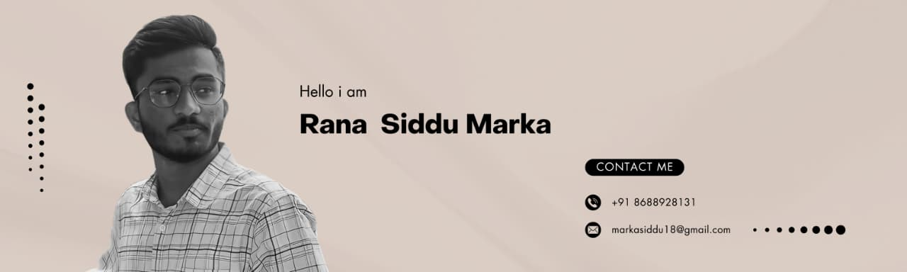
Hello.. ,

PCB Design | Verilog HDL | Python Programming | Aspiring RTL Design Engineer | AI Enthusiast

 ABOUT ME

Pursuing BTECH in ECE at VIDYA JYOTHI INSTITUTE OF TECHNOLOGY(VJIT).
Aspiring VLSI Design Engineer.
 Upskilling PCB Design, Verilog HDL.
Completed hands on projects in PCB Design.

CERTIFICATIONS IN
- PCB Design – Altium Education.
- VLSI Design – Internshala Trainings,NSDC,Skill India.
- Python Essentials 2 – Cisco Networking Academy.
- Introduction to Iot and Digital Transformation - – Cisco Networking Academy.

Tech Stack
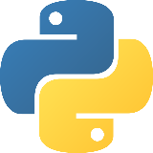

Contact
https://www.linkedin.com/in/rana-siddu-marka-b271141a4
 markasiddu18@gmail.com

