MINI PROJECT REPORT
ON
“Himalayan Ride and Care Relational Database Design and MySQL Stored Programs”
Submitted in partial fulfilment of the requirements of
Advanced Database Management System (ADBMS)
Submitted By:
Ayush Rana, UID 26MCI10020
Class/Section/Group:
____________________________
Under the Guidance of:
Prof. Shruti Sharma
____________________________
University Institute of Computing
Chandigarh University, Mohali, Punjab


CERTIFICATE
This is to certify that Ayush Rana (UID 26MCI10020), a student of the Master of Computer Applications programme, has prepared the project report titled “Himalayan Ride and Care Relational Database Design and MySQL Stored Programs” in partial fulfilment of the requirements of Advanced Database Management System (ADBMS) at the University Institute of Computing, Chandigarh University, Mohali, Punjab.
The report presents the design, implementation and academic study of the Himalayan Ride and Care system. The project details and results are described for review by the project guide and department.

____________________________
Prof. Shruti Sharma
Project Guide / Supervisor
University Institute of Computing
Date: ____________________
Place: Chandigarh University, Mohali, Punjab

ACKNOWLEDGEMENT
I thank my project guide and the faculty of the University Institute of Computing for their instruction and guidance. The ADBMS course topics of relational modelling, keys, constraints, transactions, cursors, functions, procedures, exception handling and triggers shaped the database work in this project. I also acknowledge the supplied Himalayan Ride and Care case study and course syllabus.

Date: ____________________
Place: Chandigarh University, Mohali, Punjab

Ayush Rana
UID 26MCI10020

ABSTRACT
Himalayan Ride and Care is a relational information system for motorcycle rentals, destinations, payments and roadside support. This ADBMS report describes the six core relations used by the web application, their keys and relationships, integrity rules and practical SQL workflows.
The project uses MySQL 8.0. Customers, motorcycles, destinations, rental bookings, payment records and assistance requests are connected through primary and foreign keys. Additional service-parts and wallet tables support stored-program exercises: minimum-balance validation, an explicit low-stock cursor, a discount function, stock-order processing, guarded funds transfer and a balance-audit trigger.
The supplied case study mentions Oracle SQL and PL/SQL, while the requested implementation database is MySQL. Therefore, the included routines use MySQL stored-program syntax. They demonstrate similar database concepts but are not Oracle PL/SQL scripts and cannot be run unchanged in Oracle.

TABLE OF CONTENTS
1. Introduction and Objectives 1
2. Requirements and Scope 1
3. Database Design 2
4. Database Implementation 3
5. Testing, Results and Outputs 4
6. Conclusion and Limitations 7
References 7

1. Introduction and Objectives
A motorcycle-rental business produces related records: a customer requests a vehicle for dates, staff confirm and complete the rental, payments are recorded against the booking, and a roadside request may refer to the same trip. A relational database makes these connections explicit and helps staff maintain consistent records. This project models those operations for the Himalayan Ride and Care case study.
The database has two connected academic areas. The core schema supports rental operations. A separate ADBMS practical schema models service-part stock and wallet accounts so the project can demonstrate the cursor, function, procedure, transaction, exception and trigger concepts listed in the supplied syllabus.
Objectives:
- Organize the case-study data into tables with primary keys and foreign keys.
- Represent one-to-many relationships among customers, bookings, motorcycles, payments and assistance cases.
- Enforce valid ranges, dates, statuses and identifiers with constraints and server-side checks.
- Use SQL queries to inspect operational records and summaries.
- Demonstrate the six ADBMS practical concepts using MySQL stored-program objects.

2. Requirements and Scope
The core database must preserve customer contact details, motorcycle rates and status, destinations, booking periods, pickup and return readings, payment entries and assistance progress. Each booking belongs to an existing customer and motorcycle; it may reference a destination. Each payment belongs to one booking. An assistance request belongs to a customer and may optionally link to a booking.
The prototype scope includes six operational tables and five supplementary practical tables. The core schema is `customers`, `motorcycles`, `destinations`, `rental_bookings`, `payment_records` and `assistance_requests`. The ADBMS exercise schema adds `service_parts`, `part_orders`, `wallet_accounts`, `wallet_transfers` and `wallet_balance_audit`. The wallet examples are isolated database practicals; they do not implement the web application's recorded payments.
The business rules include positive rental rates and payment amounts, nonnegative odometer values, ordered rental dates, allowed status values, unique motorcycle registration numbers, and valid foreign-key references. The Java service checks booking overlaps and valid state transitions. Real payment processing, live GPS and emergency dispatch remain outside scope.

3. Database Design

3.1 Entity relationships
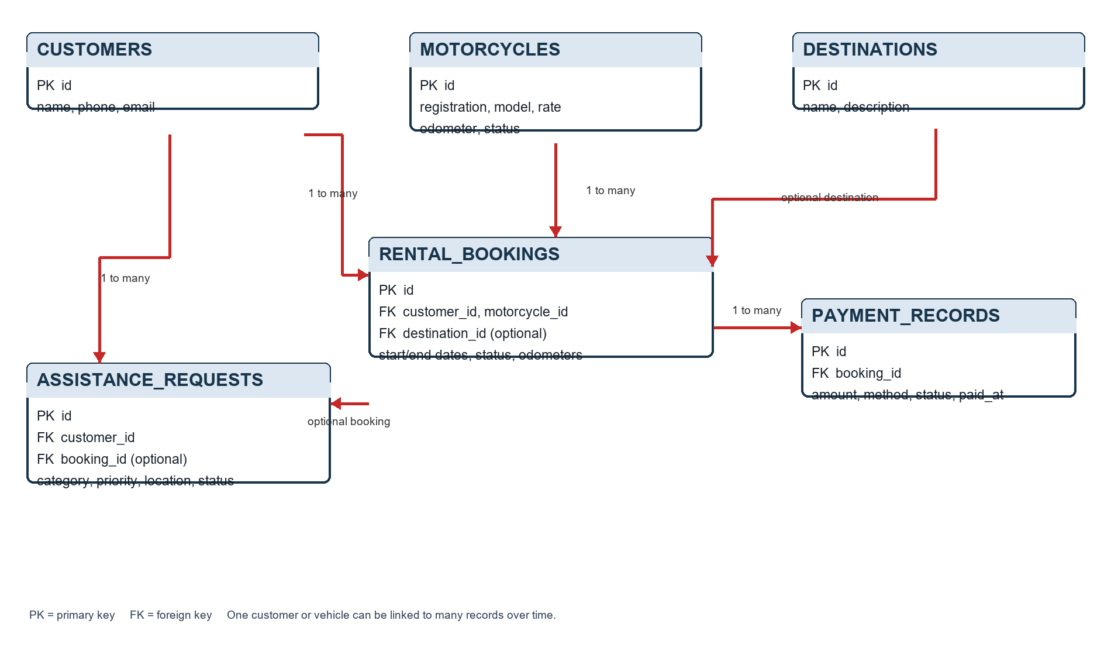
Figure 1: Core case-study entity relationships and foreign-key links
The figure shows the operational core. A customer may have many bookings and assistance requests. A motorcycle may participate in many bookings at different times. A booking may have multiple payment records. Destination and booking links on the optional relationships may be absent when the user does not select a destination or when an assistance report is not tied to a specific trip.

3.2 Relational schema
Table | Key design and purpose
customers | PK id; name and phone are required; e-mail is optional and unique.
motorcycles | PK id; registration_number is unique; daily_rate and odometer are nonnegative; status is constrained.
destinations | PK id; destination name and description.
rental_bookings | PK id; FK customer_id, motorcycle_id and optional destination_id; dates, status and odometer readings.
payment_records | PK id; FK booking_id; positive amount, method, status and timestamp.
assistance_requests | PK id; FK customer_id and optional booking_id; issue category, priority, location, responder and status.

3.3 Keys, constraints and normalization
Each relation has a surrogate integer primary key. Foreign keys connect dependent records to valid parent rows, reducing orphaned rental, payment and assistance data. UNIQUE constraints protect motorcycle registration numbers and customer e-mails. CHECK constraints reject invalid rates, amounts, odometers, date order, priorities and status values. Required attributes use NOT NULL; optional destination and assistance-to-booking links allow NULL.
The schema separates customers, vehicles, destinations, bookings, payments and incidents so each table describes one main subject. Contact details are stored with customers rather than repeated in each booking; vehicle model and rate are stored with motorcycles; a payment has its own row and booking key. The surrogate key in each table is a single attribute, so there is no partial dependency on part of a composite key. These choices support a normalized relational design for the recorded scope.

4. Database Implementation

4.1 Schema creation and sample data
`database/schema.sql` creates the `himalayan_ride_care` database using UTF-8 character encoding. `database/case_study_schema_mysql.sql` selects that database, creates the six operational tables with keys and checks, and inserts sample customers, motorcycles and destinations. The Java application can also create or update entity tables at local startup through Hibernate's schema-update setting.
Useful inspection queries include:
USE himalayan_ride_care;
SELECT id, name, phone FROM customers;
SELECT registration_number, model, status FROM motorcycles;
SELECT b.id, c.name, m.registration_number, b.start_date, b.end_date, b.status
FROM rental_bookings b JOIN customers c ON c.id=b.customer_id
JOIN motorcycles m ON m.id=b.motorcycle_id ORDER BY b.id;

4.2 Syllabus practicals implemented in MySQL
The two ADBMS add-on files create support tables and routines. The following mapping uses MySQL names and syntax to implement the database concepts from the supplied practical sheet:
Syllabus practical | MySQL object | Database behavior
Minimum opening balance before account insert | create_wallet_account | Rejects a starting balance below 500.00 or a blank customer name; returns the generated ID.
Explicit cursor for low-stock inventory | report_low_stock | Fetches each part at or below its reorder level into a temporary report.
User-defined discount function | calculate_discount | Returns 0%, 5%, 10% or 15% according to the subtotal tiers.
Process an order and adjust stock | process_part_order | Locks the part row, checks available quantity, computes discount, inserts the order and deducts stock.
Fund transfer with exception handling | transfer_wallet_funds | Validates accounts and balance, updates both balances in a transaction and rolls back on error.
Audit balance changes | trg_wallet_balance_audit | An AFTER UPDATE trigger inserts old and new balances into the audit table.

4.3 Transactions and error handling
The order and transfer procedures use an explicit transaction. The stock-order routine locks its service-parts row with `FOR UPDATE` before checking and reducing stock, so the update and order record are treated as one unit. The transfer routine checks that account IDs differ, the amount is positive, both accounts exist and the source has enough funds. An SQL exception invokes a rollback handler and is re-raised to the caller.
The trigger runs after a wallet balance update. It compares OLD.balance with NEW.balance and records the account ID and both values when they differ. This audit example demonstrates how a database trigger can preserve a change record automatically. It is supplementary to the rental application and does not audit payment-record updates.

4.4 MySQL and Oracle PL/SQL distinction
The case-study narrative refers to Oracle SQL and PL/SQL. The working project uses MySQL, so `DELIMITER`, `SIGNAL SQLSTATE`, MySQL procedure declarations, cursors and triggers appear in the included scripts. The procedural purpose follows the ADBMS practical sheet, but the code syntax is MySQL-specific and cannot be pasted unchanged into Oracle SQL Developer. An Oracle submission would require translating and validating the scripts in an Oracle database.

5. Testing, Results and Outputs
The MySQL Workbench execution output confirms that `schema.sql` created or selected `himalayan_ride_care`, the six core case-study tables were created, and the sample customer, motorcycle and destination inserts ran. One informational deprecation warning appeared for MySQL's `VALUES()` function in an `ON DUPLICATE KEY UPDATE` sample insert; the statement completed and the warning did not stop schema setup.
The running web application later established a MySQL connection through its connection pool, and embedded Tomcat started on port 8080. A separate Workbench cleanup successfully deleted the trial payment, assistance and booking rows while preserving the rest of the schema. The provided run logs do not confirm that each add-on stored procedure and trigger was individually invoked, so those practical outputs should be captured during the final database demonstration.
Verification item | Observed evidence
Core database and tables | Workbench reported successful CREATE DATABASE and CREATE TABLE statements.
Sample data | Customer, motorcycle and destination inserts completed; one deprecated syntax warning only.
Application database connection | Hikari connection pool started successfully in the Spring Boot log.
Test-data cleanup | Workbench deleted 10 payment, 3 assistance and 6 booking rows successfully.
Stored routine demonstrations | Scripts are included; individual CALL/trigger output is not present in the supplied run log.

5.1 Results and application outputs
These screenshots show browser outputs backed by the Himalayan Ride and Care relational data: the dashboard counts, five motorcycle rows, a confirmed rental linked to a customer, vehicle and destination, and payment and assistance sections. They make visible several values represented by the customers, motorcycles, rental_bookings, payment_records and assistance_requests tables. The payment and support screens show available forms; only the visible recorded transaction line is treated as existing output. The screenshots complement the database scripts and Workbench results; they are not substitutes for direct SQL query output.

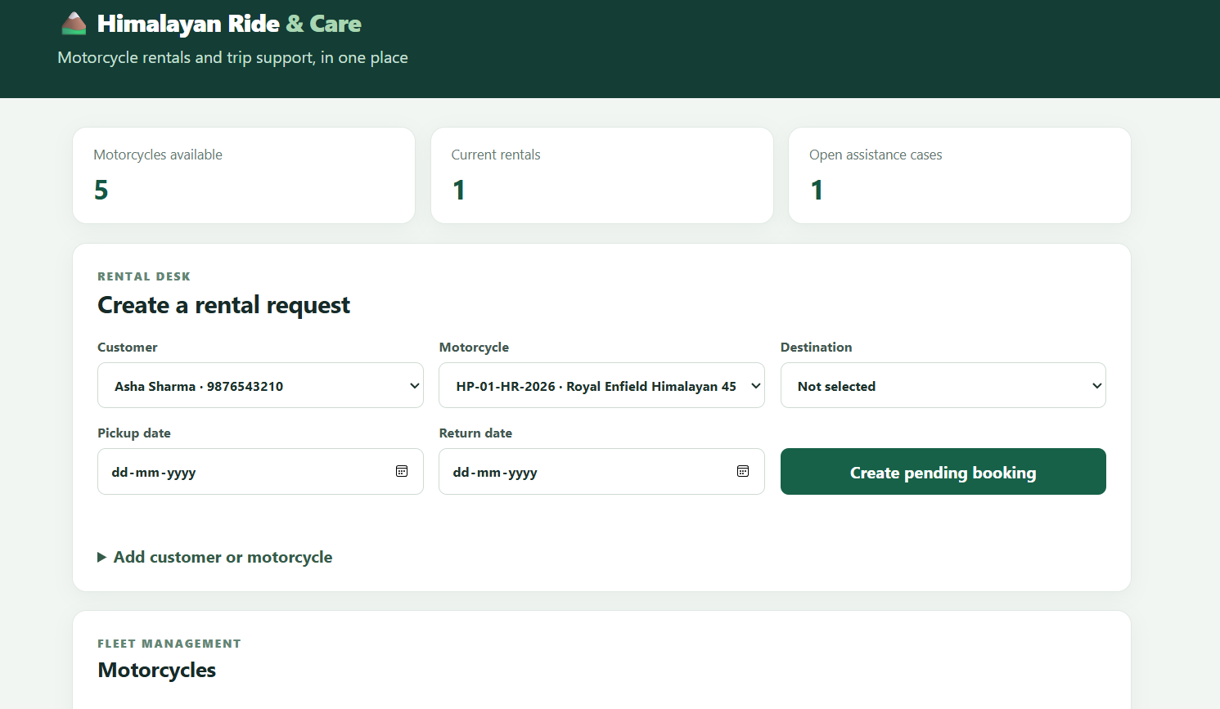
Figure 2: Dashboard counts and rental request fields backed by application records.

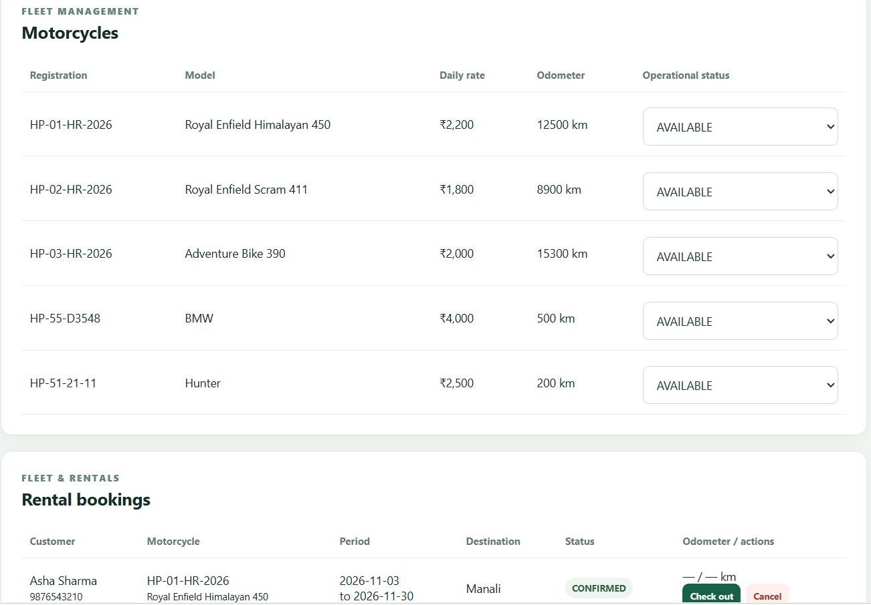
Figure 3: Motorcycle rows displaying registration, model, rate, odometer and status.

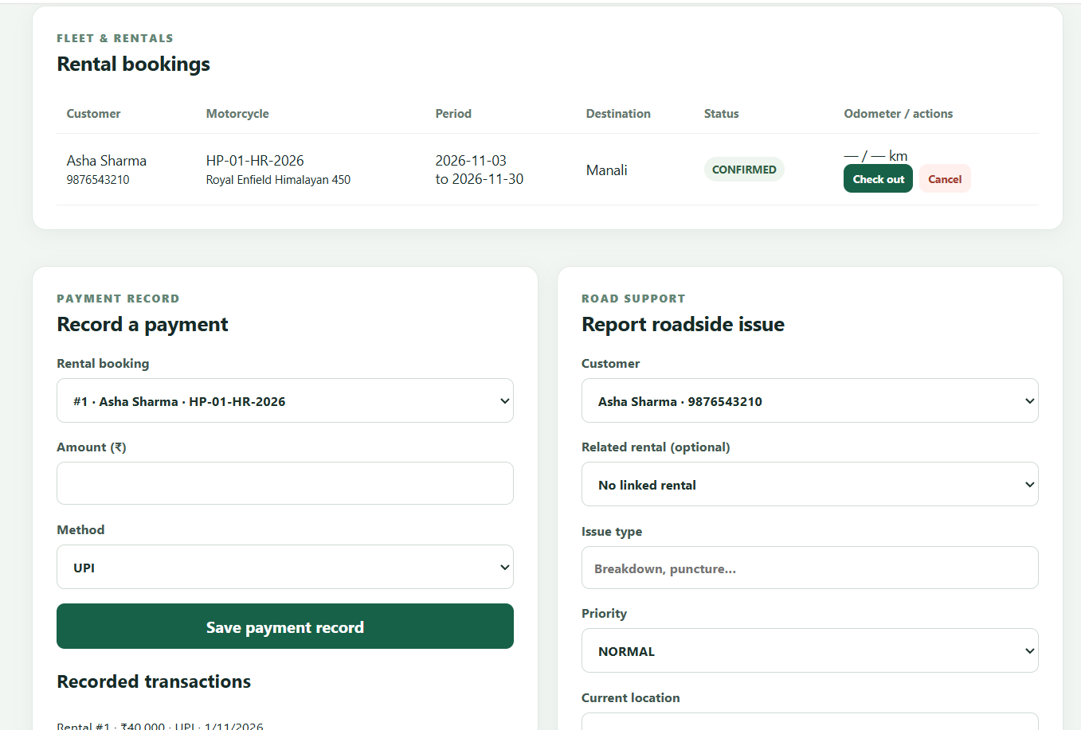
Figure 4: Confirmed rental and payment and assistance outputs linked to core relations.

6. Conclusion and Limitations
The database design links the principal rental and support records through relational keys and applies constraints to common invalid values. The supplementary MySQL procedures, function, cursor and trigger demonstrate the ADBMS practical concepts using the chosen database engine. The successful schema execution and application connection confirm that the core database is available to the web project.
Limitations: routine execution evidence should be recorded separately; the procedures use MySQL syntax rather than Oracle PL/SQL; the wallet objects are academic examples and not a payment product; no external payment service, GPS, emergency dispatch, role permissions, late-return rules or detailed maintenance history are implemented. Future work can add a transaction-history report, an indexed date/status report, role-based access and a verified Oracle version if the course requires Oracle syntax.

References
[1] Advanced Database Management System syllabus supplied for this project.
[2] A Case Study on Himalayan Ride & Care, supplied project case study.
[3] MySQL 8.0 Reference Manual, CREATE TABLE and constraints. https://dev.mysql.com/doc/refman/8.0/en/create-table.html
[4] MySQL 8.0 Reference Manual, stored routines. https://dev.mysql.com/doc/refman/8.0/en/stored-routines.html
[5] MySQL 8.0 Reference Manual, triggers. https://dev.mysql.com/doc/refman/8.0/en/triggers.html
[6] Spring Data JPA Reference Documentation. https://docs.spring.io/spring-data/jpa/reference/

