|  |  |
| --- | --- |
| TEAM ID | PNT2022TMID13869 |
| PROJECT NAME | SMART FASHION RECOMMENDER SYSTEM |
| DEVELOPING A CHATBOT | BUILDING CHATBOT AND INTEGRATE IN HTML |

**BUILDING A CHATBOT:**

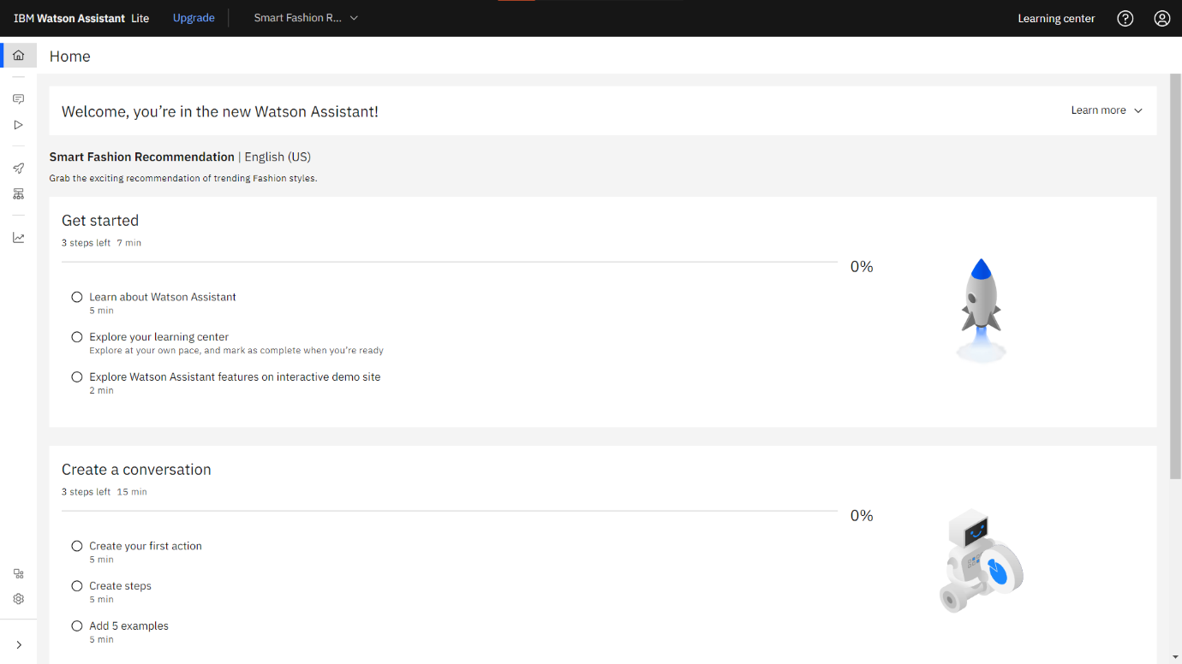

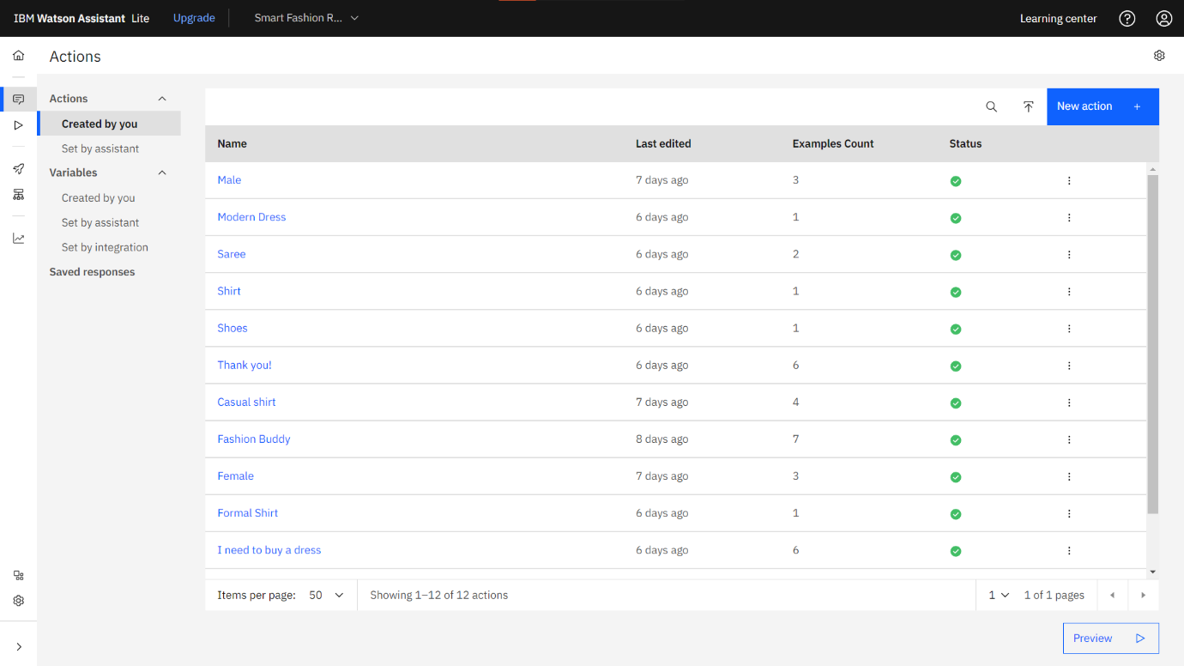

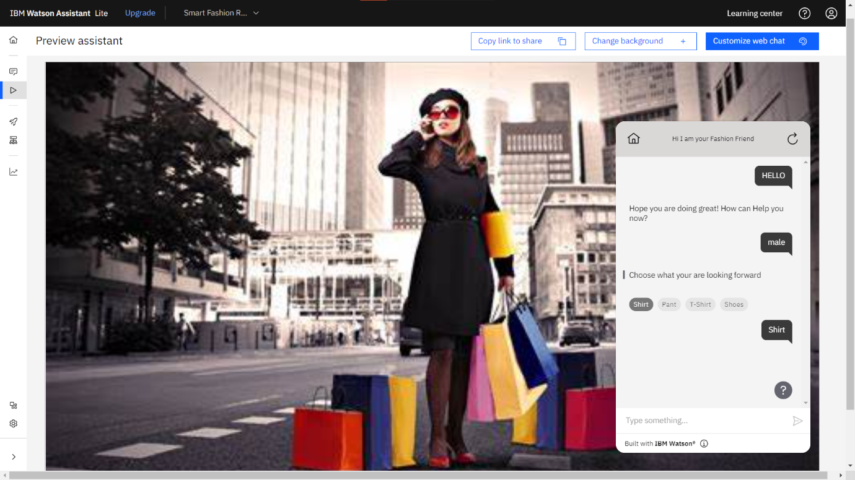

**INTEGRATE CHATBOT IN HTML:**

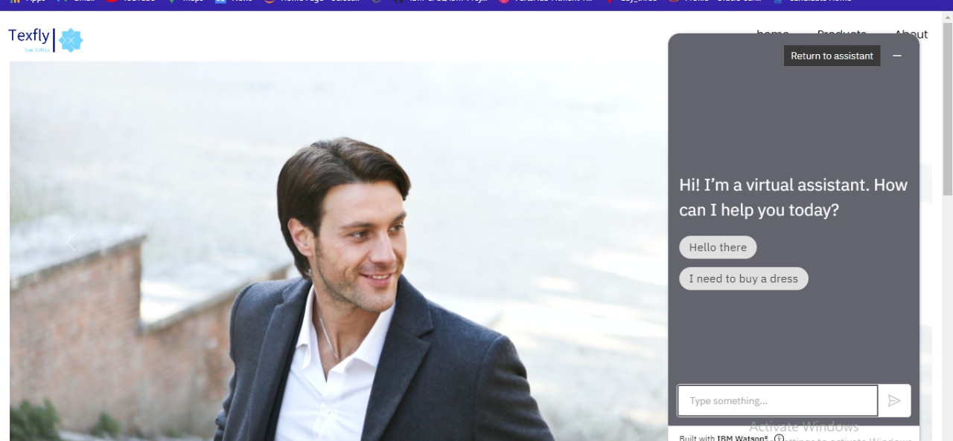

**CONNECTING SCRIPT CODE:**

<script>

window.watsonAssistantChatOptions = {

integrationID: "40072d56-fb6c-4240-9c90-f6e2bbcd9cd3", // The ID of this integration.

region: "eu-gb", // The region your integration is hosted in.

serviceInstanceID: "365c5c99-5dd0-4a84-9ec2-24ba6029e35e", // The ID of your service instance.

onLoad: function(instance) { instance.render(); }

};

setTimeout(function(){

const t=document.createElement('script');

t.src="https://web-chat.global.assistant.watson.appdomain.cloud/versions/" + (window.watsonAssistantChatOptions.clientVersion || 'latest') + "/WatsonAssistantChatEntry.js";

document.head.appendChild(t);

});

</script>//