Statistics: The Science of Decisions Project Instructions

Background Information

In a Stroop task, participants are presented with a list of words, with each word displayed in a color of ink. The participant’s task is to say out loud the color of the ink in which the word is printed. The task has two conditions: a congruent words condition, and an incongruent words condition. In the congruent words condition, the words being displayed are color words whose names match the colors in which they are printed: for example RED, BLUE. In the *incongruent words* condition, the words displayed are color words whose names do not match the colors in which they are printed: for example PURPLE, ORANGE. In each case, we measure the time it takes to name the ink colors in equally-sized lists. Each participant will go through and record a time from each condition.

Questions for Investigation

**1. What is our independent variable? What is our dependent variable?**

* The independent variable in this experiment is the condition (congruent or incongruent) in which a set of words are displayed.
* The dependent variable in this experiment is the time it takes to name the ink colors of an equally sized list of words from each condition.

**2. What is an appropriate set of hypotheses for this task? What kind of statistical test do you expect to perform? Justify your choices.**

We will test a null hypothesis that the mean difference between the time taken to name the ink color under congruent and incongruent condition is zero. In other words, the mean time it takes to name the ink colors of two different but equal sized lists of words with one list from congruent condition and the other from incongruent condition is the same.

If we get a statistically significant result, we can reject the null hypothesis that there are no differences between the means in the population and accept the alternative hypothesis that there are differences between the means in the population. We can express this as follows

H0: µC = µIHA: µC ≠ µI

where,

* µC is the population mean time it takes to name the ink colors in congruent condition;
* µI is the population mean time it takes to name the ink colors in incongruent condition

The two samples are dependent since the same subjects have taken the tests under two different conditions with a sample size of less than 30. Hence it seems most appropriate to use **dependent t-test for paired samples**.

**3. Report some descriptive statistics regarding this dataset. Include at least one measure of central tendency and at least one measure of variability.**

|  |  |  |  |
| --- | --- | --- | --- |
| **Sample Mean - Congruent Condition (C)** | 14.05 | **Sample Mean – Incongruent Condition (I)** | 22.02 |
| **Sample Standard Deviation - Congruent Condition (SC)** | 3.559 | **Sample Standard Deviation – Incongruent Condition (SI)** | 4.797 |
| **Mean of Differences (D)** | -7.96 | **Standard Deviation of Differences (SD)** | 4.865 |

**4. Provide one or two visualizations that show the distribution of the sample data. Write one or two sentences noting what you observe about the plot or plots.**

Following Box Plot provides an insight on the time taken under congruent and incongruent condition:

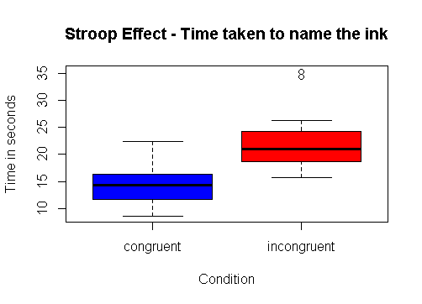

We can see some evidence that on an average the time taken under congruent condition is less than that in incongruent condition.

Let’s now draw the density function for both the conditions.

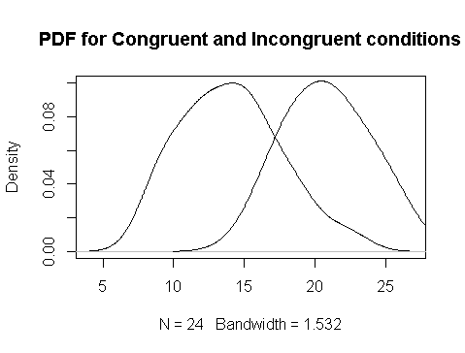

Again looking at the plot, there seems to be some evidence of mean time under congruent condition being lower than that under Incongruent. We will however perform a paired t-test to test the hypothesis.

**5. Now, perform the statistical test and report your results. What is your confidence level and your critical statistic value? Do you reject the null hypothesis or fail to reject it? Come to a conclusion in terms of the experiment task. Did the results match up with your expectations?**

We will perform a 2-sided paired t-test at alpha level of 0.05. This test seems most appropriate since:

* sample size is less than 30; and
* Two different conditions were applied on the same sample.

Following is a summary of the results from the t-test:

|  |  |  |
| --- | --- | --- |
| **n** | 24.00 |  |
| **Degrees of Freedom** | 23.00 |  |
|  |  |  |
| **tstatistic** | -8.02 |  |
| **α** | 0.05 |  |
| **tcritical** | -2.07 |  |
| **Cohen's d** | -1.64 |  |
| **p-value** | 0.00000004103 |  |
|  |  |  |
|  | **Min** | **Max** |
| **CI for mean poulation difference** | -5.91 | -10.02 |

Detailed Calculation and code can be found at the following location:

|  |  |
| --- | --- |
| **Artifact** | **Location** |
| Spreadsheet calculation | <https://github.com/ranata/Udacity_DAND/blob/master/p1/stroopdata.xlsx> |
| R Code for plots and t-test | <https://github.com/ranata/Udacity_DAND/blob/master/p1/Stroop_effect_hypothesis_test.R> |

It is clear from the test that t-statistic (-8.02) is less than the t-critical (-2.07) value. Consequently we reject the null hypothesis and conclude that mean difference in the time to name the ink is significantly lower under congruent condition as compared to time under incongruent condition. Based on the confidence interval, we could also conclude that on average, users will take 10 to 5 fewer seconds in a congruent condition compared to an incongruent condition.

This result is not surprising since some evidence was seen in the boxplot and the pdf functions for the time taken under the two conditions.

**6. Optional: What do you think is responsible for the effects observed? Can you think of an alternative or similar task that would result in a similar effect? Some research about the problem will be helpful for thinking about these two questions!**

Human brain has been conditioned to recognize color and words since childhood and that has been the foundation for identifying a words or color. When the test is performance under a congruent condition, there is no contradiction between the colors or the words with the preexisting knowledge that human brain has. Hence, there is no conscious effort or attention required to recognize and name the color. However, under an incongruent condition, there is a contradiction between the color and the word with the pre-existing knowledge in the brain. The brain requires a controlled attention and time to recognize the contradiction and process the information based on rules.

A similar example that comes to my mind that could have similar effect is the typographic emphasis on words whose names represent the typography emphasis. For example, **BOLD**, UNDERLINE, *ITALICS* could represent congruent condition and *BOLD*, ITALICS, **UNDERLINE** could be under incongruous condition. While these are just three examples of typographic emphasis, we could add many more to conduct a test (CAPITAL, lowercase etc).

***References:***

<https://www.youtube.com/watch?v=yD6aU0fY2lo>  
<http://www.r-tutor.com/elementary-statistics/inference-about-two-populations/population-mean-between-two-matched-samples>  
<https://www.youtube.com/watch?v=t72WrQFuixA>  
<https://en.wikipedia.org/wiki/Student%27s_t-test>  
<https://en.wikipedia.org/wiki/Stroop_effect>