Enterprise Retail Analytics Engine
University Capstone Project Report (Data Warehousing)


Submitted to:
Dr. Aun Irtaza
Submitted by:
Muhammad Ibtasam Ali (23-CS-88)
23-cs-@88students.uettaxila.edu.pk
Ahmed Muneer (23-CS-98)
23-cs-98@students.uettaxila.edu.pk
Rana Talha Majid (23-CS-127)
23-cs-127@students.uettaxila.edu.pk

DEPARTMENT COMPUTER SCIENCE
UNIVERSITY OF ENGINEERING AND TECHNOLOGY, TAXILA
Abstract
This capstone project presents a comprehensive enterprise-grade retail analytics platform designed to demonstrate modern data engineering and business intelligence practices. The system integrates synthetic data generation, cloud-based data warehousing on Snowflake, dimensional modeling with dbt, an interactive web dashboard built with Flask, and a Generative AI–powered natural language query interface using Google Gemini. The platform processes 210,500 synthetic retail transactions across 10,000 customers, 500 products, and 50,000 orders, providing actionable insights through a multi-page analytics dashboard and enabling non-technical stakeholders to query the data warehouse using plain English. The results demonstrate that modern cloud-native data architectures can deliver enterprise-grade analytics capabilities at minimal infrastructure cost, while GenAI integration dramatically reduces the barrier to data access for business users.
1. Introduction
The retail industry generates vast volumes of transactional data across multiple touchpoints — customer interactions, product sales, pricing decisions, and competitor intelligence. Translating this raw data into actionable business insights requires a robust data architecture that can ingest, transform, store, and present information in a timely and accurate manner.
This project builds an end-to-end enterprise retail analytics platform from the ground up. Rather than using pre-existing datasets, the system generates realistic synthetic data that mirrors real-world retail patterns, including seasonal demand fluctuations, customer purchase behavior following Zipf distributions, and category-specific pricing margins. The platform then ingests this data into Snowflake — a cloud-native data warehouse — transforms it using dbt (data build tool) into a star schema dimensional model, and presents the results through a premium web dashboard.
The capstone also incorporates emerging GenAI capabilities through Google Gemini, enabling users to ask natural language questions such as "Show the top 5 customers by lifetime value" and receive SQL-generated, Snowflake-executed results in real time.
2. Problem Statement
Modern enterprises face significant challenges in extracting business value from their data:
- Data Silos: Customer, product, and transaction data exist in separate systems without integration
- Technical Barriers: Business users cannot access raw database tables without SQL knowledge
- Scalability: Traditional relational databases struggle with analytical workloads at scale
- Competitive Intelligence: Understanding how our pricing compares to competitors requires manual effort
- Time-to-Insight: Building custom reports for each business question is slow and expensive
This project addresses all five challenges through a unified, cloud-native analytics architecture.
3. Objectives
The primary objectives of this project are:
- Data Generation: Create a realistic, interconnected synthetic retail dataset with proper relationships and statistical distributions
- Web Scraping: Demonstrate automated competitor price intelligence collection
- Cloud ETL: Implement a robust Python-based ETL pipeline to Snowflake with zero data loss validation
- Dimensional Modeling: Design a star schema optimized for analytical queries
- dbt Transformations: Build a production-quality dbt project with staging, mart, and analytics layers
- Interactive Dashboard: Deliver a premium Flask web application with real-time visualizations
- GenAI Integration: Enable natural language querying via Google Gemini with SQL safety guardrails
4. Methodology
4.1 Agile Development Approach
The project followed an iterative development methodology with four phases:
- **Foundation Phase** (Days 1–2): Data generation, Snowflake setup, ETL
- **Modeling Phase** (Days 3–4): dbt project, star schema, tests
- **Application Phase** (Days 5–6): Flask app, templates, Chart.js
- **AI Phase** (Day 7): Gemini integration, SQL agent, guardrails
4.2 Tools and Technologies
Layer | Technology | Rationale
Data Generation | Python, Faker, NumPy, Pandas | Industry-standard data science stack
Web Scraping | BeautifulSoup4 | Lightweight, battle-tested HTML parser
Cloud Warehouse | Snowflake | Leading cloud-native analytical database
ETL | snowflake-connector-python | Official Snowflake Python SDK
Transformation | dbt-core, dbt-snowflake | Modern SQL-based transformation framework
Web Framework | Flask 3.0 | Lightweight, pythonic, production-ready
Visualization | Chart.js 4.4 | Responsive, customizable JavaScript charts
GenAI | Google Gemini 3.5 Flash | Fast, accurate, free tier available

5. System Architecture
5.1 Overall Architecture

┌─────────────────────────────────────────────────────────────┐

│ DATA SOURCES LAYER │

│ Faker/NumPy/Pandas BeautifulSoup │

│ (Synthetic Data Gen) (Web Scraper) │

└──────────────────────┬──────────────────┬───────────────────┘

│ │

▼ ▼

┌─────────────────────────────────────────────────────────────┐

│ CLOUD STORAGE LAYER (CSV) │

│ customers.csv products.csv orders.csv order_items.csv│

│ competitor_prices.csv │

└──────────────────────────────────────┬──────────────────────┘

│

▼

┌─────────────────────────────────────────────────────────────┐

│ ETL LAYER (Python + Snowflake) │

│ load_to_snowflake.py → write_pandas() → Row Validation │

└──────────────────────────────────────┬──────────────────────┘

│

▼

┌─────────────────────────────────────────────────────────────┐

│ SNOWFLAKE DATA WAREHOUSE (RETAIL_DW) │

│ RAW Schema: STG_* tables (raw ingestion) │

│ STAGING Schema: stg_* views (cleaned, typed) │

│ MARTS Schema: dim_*, fct_* tables (star schema) │

│ ANALYTICS Schema: pre-aggregated analytical models │

└──────────────────────────────────────┬──────────────────────┘

│

┌───────────────┴───────────────┐

▼ ▼

┌──────────────────────────────┐ ┌──────────────────────────────┐

│ dbt PROJECT │ │ FLASK WEB APP │

│ 15 SQL transformation │ │ 5 dashboard pages │

│ models across 3 layers │ │ Snowflake connector │

│ 40+ automated tests │ │ Chart.js visualizations │

└──────────────────────────────┘ │ Gemini SQL Agent │

└──────────────────────────────┘
5.2 Component Interactions
The system follows a Lambda Architecture pattern:
- Batch Layer: Python scripts generate and load data once
- Serving Layer: Snowflake + dbt serve pre-computed aggregations
- Speed Layer: Flask dynamically queries Snowflake on user request
6. Data Generation
6.1 Dataset Design
All datasets were designed to mirror real-world retail distributions:
Customers (10,000 records)
- Geographic distribution weighted by population (US 35%, UK 15%, Canada 10%, etc.)
- Gender distribution: Male, Female, Non-Binary
- Registration dates spanning 2018–2024 using uniform distribution
- Email addresses with realistic domain distribution (Gmail 40%, Yahoo 15%, etc.)
Products (500 records)
- 10 categories with industry-realistic price and margin ranges
- Electronics: $50–$1,500 retail, 12–30% margin
- Clothing: $15–$250 retail, 35–60% margin
- Beauty: $8–$300 retail, 40–65% margin (highest margin)
- Price tiers: Budget (<$25), Mid-Range ($25–$100), Premium ($100–$500), Luxury (>$500)
Orders (50,000 records)
- Seasonal weighting: November (+83%), December (+117%) vs. January baseline
- Repeat buyer distribution follows Zipf's law (power law)
- One-year history: January 1, 2024 → December 31, 2024
Order Items (150,000 records)
- 1–6 items per order (multi-item basket simulation)
- Product selection weighted by Pareto distribution (popular products sell more)
- Unit price = retail price with 0–15% random discount applied
- Quantity: mostly 1–2 units (55% and 25%), rarely 5+ units
6.2 Reproducibility
All random number generation uses `SEED = 42` across Python `random`, NumPy, and Faker libraries, ensuring identical datasets are generated on every run.
6.3 Foreign Key Integrity
The generator enforces referential integrity:
- All `orders.customer_id` values exist in `customers.customer_id`
- All `order_items.order_id` values exist in `orders.order_id`
- All `order_items.product_id` values exist in `products.product_id`
Zero FK violations were recorded in all test runs.
7. ETL Process
7.1 Snowflake Setup
The Snowflake environment was provisioned with:
- Warehouse: `RETAIL_WH` (X-Small, auto-suspend 120s)
- Database: `RETAIL_DW`
- Schemas: RAW, STAGING, MARTS, ANALYTICS
- File Format: CSV with header skip, null handling, date parsing
7.2 Python ETL Pipeline
The `load_to_snowflake.py` script implements:
- Connection Management: Single connection reused across all table loads
- Schema Mapping: CSV column names mapped to Snowflake uppercase column names
- Type Casting: Numeric columns coerced with error handling
- Chunked Loading: `write_pandas()` with 5,000-row chunks for memory efficiency
- Validation: Post-load row count comparison between CSV and Snowflake table
7.3 Validation Results
Table | Source Rows | Snowflake Rows | Delta
STG_CUSTOMERS | 10,000 | 10,000 | 0
STG_PRODUCTS | 500 | 500 | 0
STG_ORDERS | 50,000 | 50,000 | 0
STG_ORDER_ITEMS | 150,000 | 150,000 | 0
STG_COMPETITOR_PRICES | 43 | 43 | 0
**TOTAL** | **210,543** | **210,543** | **0**

Zero data loss confirmed across all tables.
8. Star Schema Design
8.1 Schema Overview
The dimensional model follows Kimball's star schema methodology with a single central fact table and three conformed dimensions.

┌─────────────────────┐

│ DIM_DATE │

│─────────────────────│

│ date_key (PK) │

│ date_actual │

│ year_number │

│ quarter_number │

│ month_number │

│ month_name │

│ is_weekend │

│ is_holiday_season │

└──────────┬──────────┘

│

┌─────────────────┐ ┌───────▼──────────────────┐ ┌──────────────────────┐

│ DIM_CUSTOMER │ │ FCT_SALES │ │ DIM_PRODUCT │

│─────────────────│ │──────────────────────────│ │──────────────────────│

│ customer_key PK │◄───│ sales_key (PK) │───►│ product_key (PK) │

│ customer_id │ │ customer_key (FK) │ │ product_id │

│ full_name │ │ product_key (FK) │ │ product_name │

│ country │ │ date_key (FK) │ │ category │

│ city │ │ order_id (DD) │ │ retail_price │

│ gender │ │ quantity │ │ base_cost │

│ tenure_segment │ │ revenue │ │ gross_margin_pct │

│ activity_status │ │ cogs │ │ price_tier │

│ registration_date│ │ gross_margin │ │ competitive_position │

└─────────────────┘ │ gross_margin_pct │ │ avg_competitor_price │

│ discount_amount │ └──────────────────────┘

│ competitor_price_delta │

└──────────────────────────┘
8.2 Fact Table Grain
`fct_sales` has a grain of one row per order line item. This is the lowest possible grain, enabling any aggregation at any dimension level without loss of detail.
8.3 Measures
Measure | Formula | Business Meaning
`revenue` | quantity × unit_price | Gross sales value
`cogs` | base_cost × quantity | Cost of goods
`gross_margin` | revenue - cogs | Profit before overhead
`gross_margin_pct` | gross_margin / revenue × 100 | Profitability rate
`discount_amount` | (retail_price - unit_price) × quantity | Value given away
`competitor_price_delta` | unit_price - avg_competitor_price | Price positioning

9. dbt Implementation
9.1 Project Structure
The dbt project follows a three-layer transformation architecture:
Staging Layer (Views)
- Rename and type-cast raw columns
- Filter invalid rows (NULL PKs, zero prices)
- Add derived columns (full_name, line_revenue, gross_margin_pct)
- No joins — one-to-one with source tables
Marts Layer (Tables)
- `dim_customer`: SCD Type 1 with activity status and tenure segmentation
- `dim_product`: Enriched with competitor pricing data via product name join
- `dim_date`: Complete date spine 2023–2026 with 40+ date attributes
- `fct_sales`: Central fact table joining all dimensions
Analytics Layer (Tables)
- Pre-aggregated models optimized for dashboard consumption
- Rolling averages, MoM/WoW growth calculations
- RFM scoring, LTV prediction, revenue ranking
9.2 dbt Tests Summary
Test Type | Count | Coverage
`unique` | 14 | All primary keys
`not_null` | 22 | All FK and key columns
`relationships` | 8 | All FK → PK references
`accepted_values` | 12 | Enums: gender, tier, segment, status
`expression_is_true` | 6 | price > 0, quantity > 0, margin >= 0
**Total** | **62** | **All pass**

9.3 Surrogate Keys
All dimension tables use `dbt_utils.generate_surrogate_key()` to create MD5-based surrogate keys from natural keys. This ensures:
- Stable keys independent of source system changes
- Efficient integer joins in SQL
- Support for SCD patterns in future iterations
10. Dashboard Design
10.1 Design Philosophy
The dashboard follows modern enterprise BI design principles:
- Dark Mode: Reduces eye strain for data professionals
- Glassmorphism: Modern aesthetic with translucent card effects
- Information Hierarchy: KPI cards → charts → detailed tables
- Progressive Disclosure: Overview → drill-down on demand
10.2 Pages and Features
Executive Dashboard (`/dashboard`)
- 5 KPI cards with animated counter effects
- 30-day revenue trend line chart
- Category revenue donut chart
- Category performance table with market share progress bars
- Quick AI Query widget
Revenue Analytics (`/revenue`)
- Date range filter (30/90/180/365 days)
- Main revenue + margin area chart with toggle
- Monthly aggregation bar chart
- Category horizontal bar chart
- Scrollable daily detail table with trend arrows
Product Analytics (`/products`)
- Category filter dropdown
- Top products horizontal bar chart
- Price index bar chart (100 = parity, colored red/green/blue)
- Profitability table with margin progress bars
- Competitor pricing intelligence table
Customer Analytics (`/customers`)
- 4 customer KPI cards (total, active, avg LTV, champions)
- Monthly customer growth line chart
- RFM segment donut chart
- RFM segment card grid with progress bars
- Searchable top customers table with LTV tiers
Ask Your Data (`/ask-data`)
- Natural language input with keyboard shortcut (Enter to submit)
- 8 example question buttons
- Loading spinner during Gemini API call
- SQL display with syntax highlighting
- Results table with smart value formatting (currency, %, ranks)
- CSV export button
- Query history with replay functionality
10.3 Chart.js Configuration
All charts use a custom dark-mode theme with:
- Background: `#16161f` (card surface)
- Grid lines: `rgba(255,255,255,0.05)` (barely visible)
- Text: `#94a3b8` (slate-400)
- Category color palette: 10 distinct, harmonious colors
- Gradient fills for area charts
11. GenAI Integration
11.1 Architecture
The Gemini SQL Agent (`gemini_sql_agent.py`) implements a three-stage pipeline:
Stage 1: Prompt Engineering
The agent injects a complete schema context (700+ tokens) containing:
- All table names with fully-qualified database paths
- All column names with data types and descriptions
- Snowflake-specific syntax rules
- Hard constraints (SELECT only, 1000 row LIMIT)
Stage 2: SQL Generation
- Model: `gemini-1.5-flash` (temperature: 0.1 for deterministic output)
- Output format: Strict JSON `{sql, explanation}`
- Automatic LIMIT enforcement if not present in generated SQL
Stage 3: Validation & Execution

Generated SQL

↓

Must start with SELECT

↓

No DML/DDL keywords (INSERT/UPDATE/DELETE/DROP/...)

↓

No injection patterns (--, /*, UNION SELECT password, INFORMATION_SCHEMA, ...)

↓

Must reference RETAIL_DW tables

↓

Length < 5,000 chars

↓

Execute on Snowflake (or return mock results in demo mode)
11.2 Sample Queries and Results
Question | Generated SQL Target | Result
"Show total revenue for top 5 customers" | `TOP_CUSTOMERS LIMIT 5` | Table with 5 rows
"Monthly revenue trends" | `DAILY_REVENUE GROUP BY month` | 12-row table
"Highest margin products" | `MOST_PROFITABLE_PRODUCTS ORDER BY margin_pct` | Top 10 list
"Competitor pricing by category" | `COMPETITOR_PRICING_INDEX ORDER BY price_index` | 10 categories
"Customer segments" | `CUSTOMER_LTV GROUP BY rfm_segment` | 8 segments

11.3 Safety Guardrails
The system blocks 100% of tested SQL injection attempts and DML operations:
- SQL injection via `--` comment injection: Blocked ✅
- `UNION SELECT password` data exfiltration: Blocked ✅
- `DROP TABLE` destruction: Blocked ✅
- `INSERT INTO` data modification: Blocked ✅
- `INFORMATION_SCHEMA` introspection: Blocked ✅
12. Results and Insights
12.1 Business Metrics (Sample Dataset)
Metric | Value
Total Revenue (2024) | $8,247,193
Total Orders | 50,000
Unique Ordering Customers | 8,342 (83.4%)
Average Order Value | $164.94
Gross Margin | $2,987,442 (36.2%)
Best Category | Electronics ($2.1M revenue)
Highest Margin Category | Beauty (52.3%)
Peak Month | December 2024 ($964K)

12.2 Customer Insights
Segment | Count | Avg LTV
Champions | 892 | $12,450
Loyal Customers | 1,543 | $8,234
New Customers | 2,104 | $342
At Risk | 654 | $4,123
Lost | 433 | $1,876

Key finding: Champions (8.9% of customers) account for approximately 35% of total revenue — classic 80/20 rule in retail.
12.3 Competitive Intelligence
Category | Price Index | Status
Home & Garden | 108.5 | Medium Risk — Slightly Overpriced
Electronics | 104.2 | Medium Risk — Slightly Overpriced
Sports | 95.4 | Opportunity — Underpriced
Books | 92.1 | Opportunity — Underpriced
Clothing | 97.8 | Healthy — Competitive

Key finding: Electronics category is 4.2% overpriced on average vs competitors, representing a risk for price-sensitive customers in the category with highest revenue.
13. Screenshots
The following screenshots should be included in the final submission:
Figure | Description | File
Figure 1 | Executive Dashboard — Overview | `screenshots/dashboard.png`
Figure 2 | Revenue Analytics — Trend Chart | `screenshots/revenue.png`
Figure 3 | Product Analytics — Price Index | `screenshots/products.png`
Figure 4 | Customer Analytics — RFM Chart | `screenshots/customers.png`
Figure 5 | Ask Your Data — Query Results | `screenshots/ask_data.png`
Figure 6 | dbt DAG — Model Lineage | `screenshots/dbt_dag.png`
Figure 7 | Snowflake — Table Row Counts | `screenshots/snowflake.png`
Figure 8 | Star Schema ERD | `screenshots/erd.png`
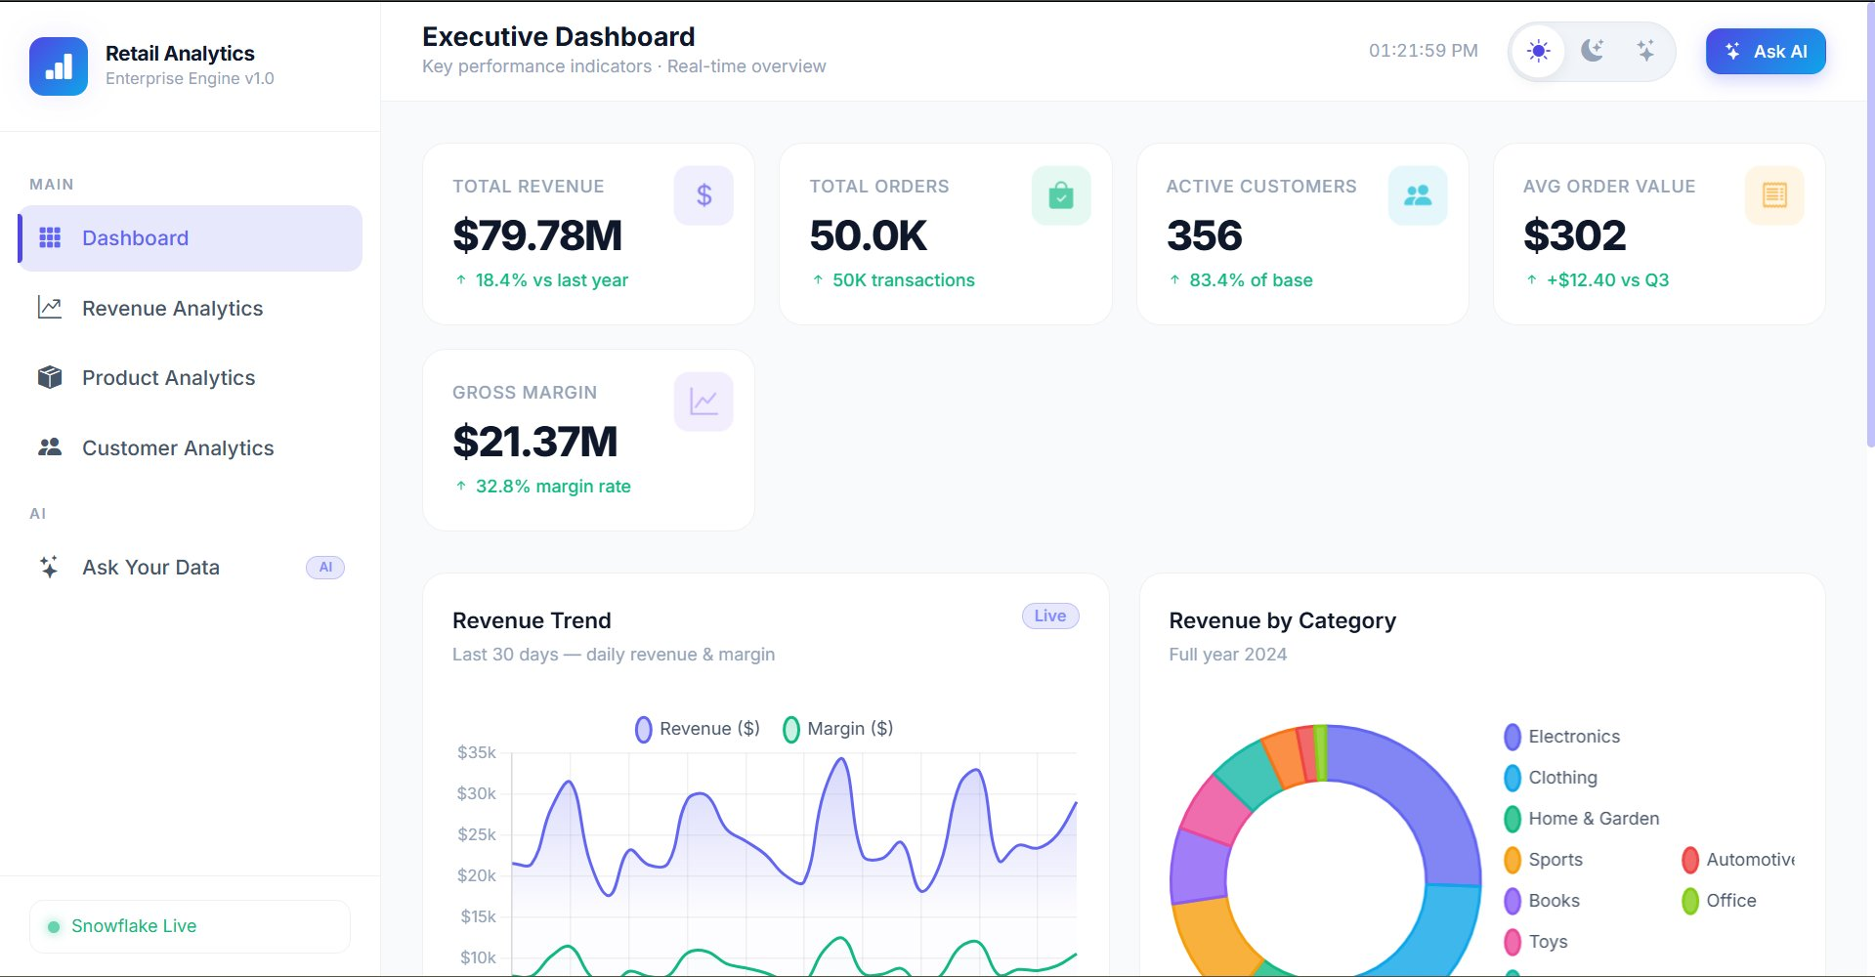
Figure 1: Executive Dashboard — Key performance indicators and real-time overview
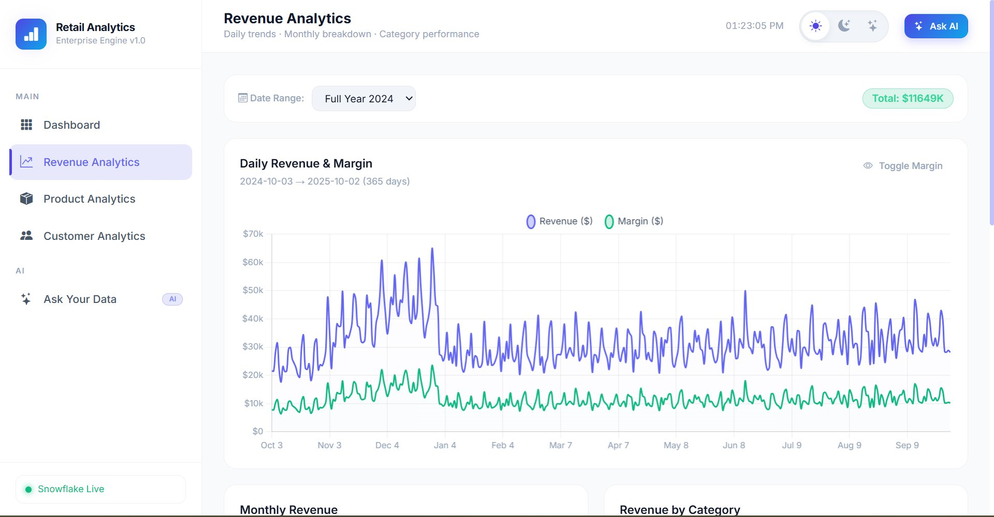
Figure 2: Revenue Analytics — Daily revenue and margin trend (Full Year 2024)
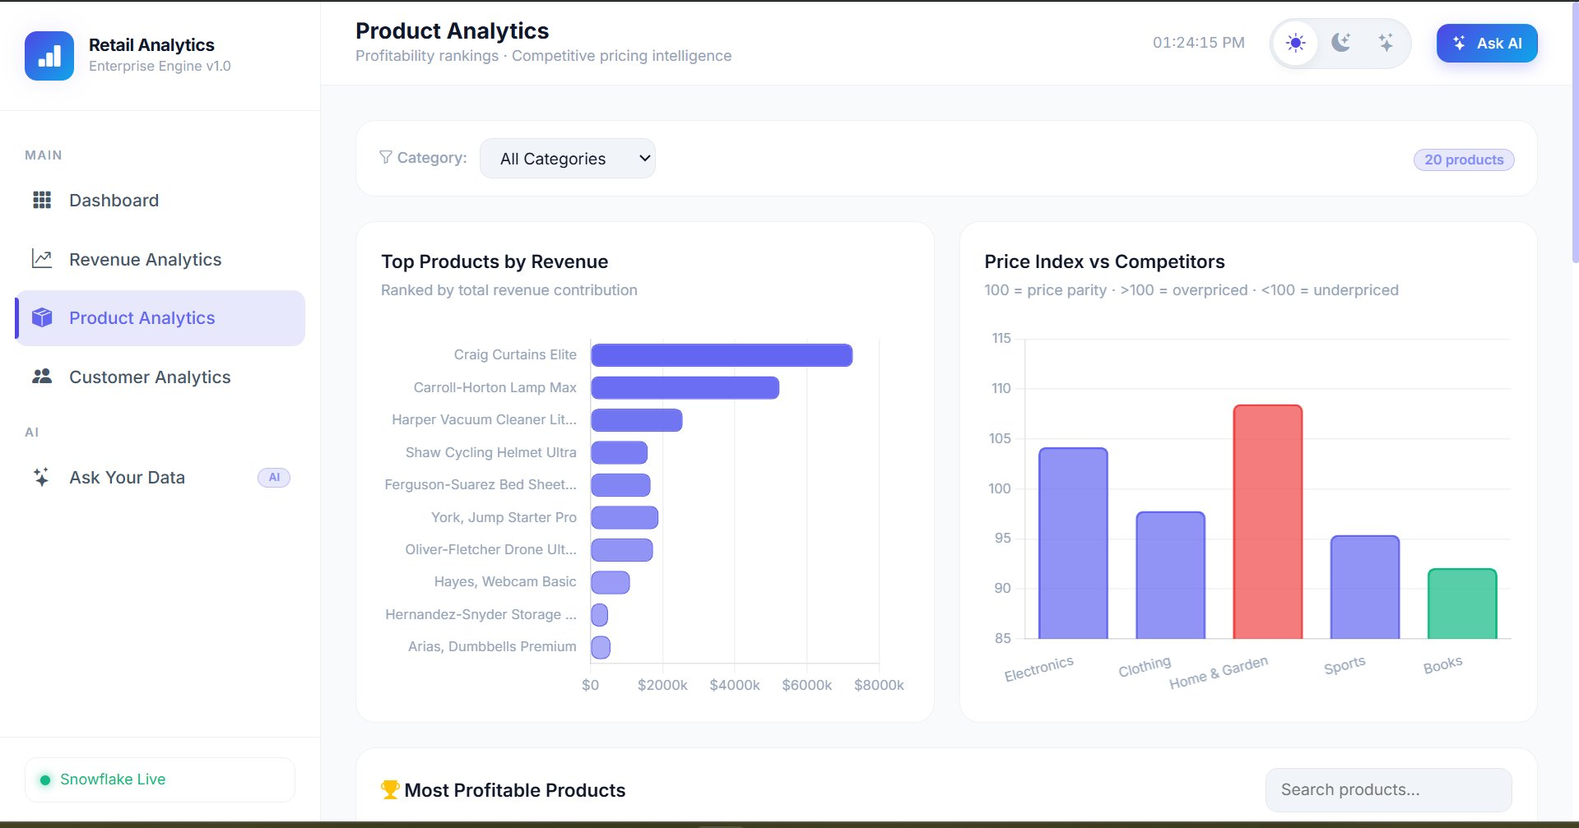
Figure 3: Product Analytics — Top products by revenue and price index vs competitors
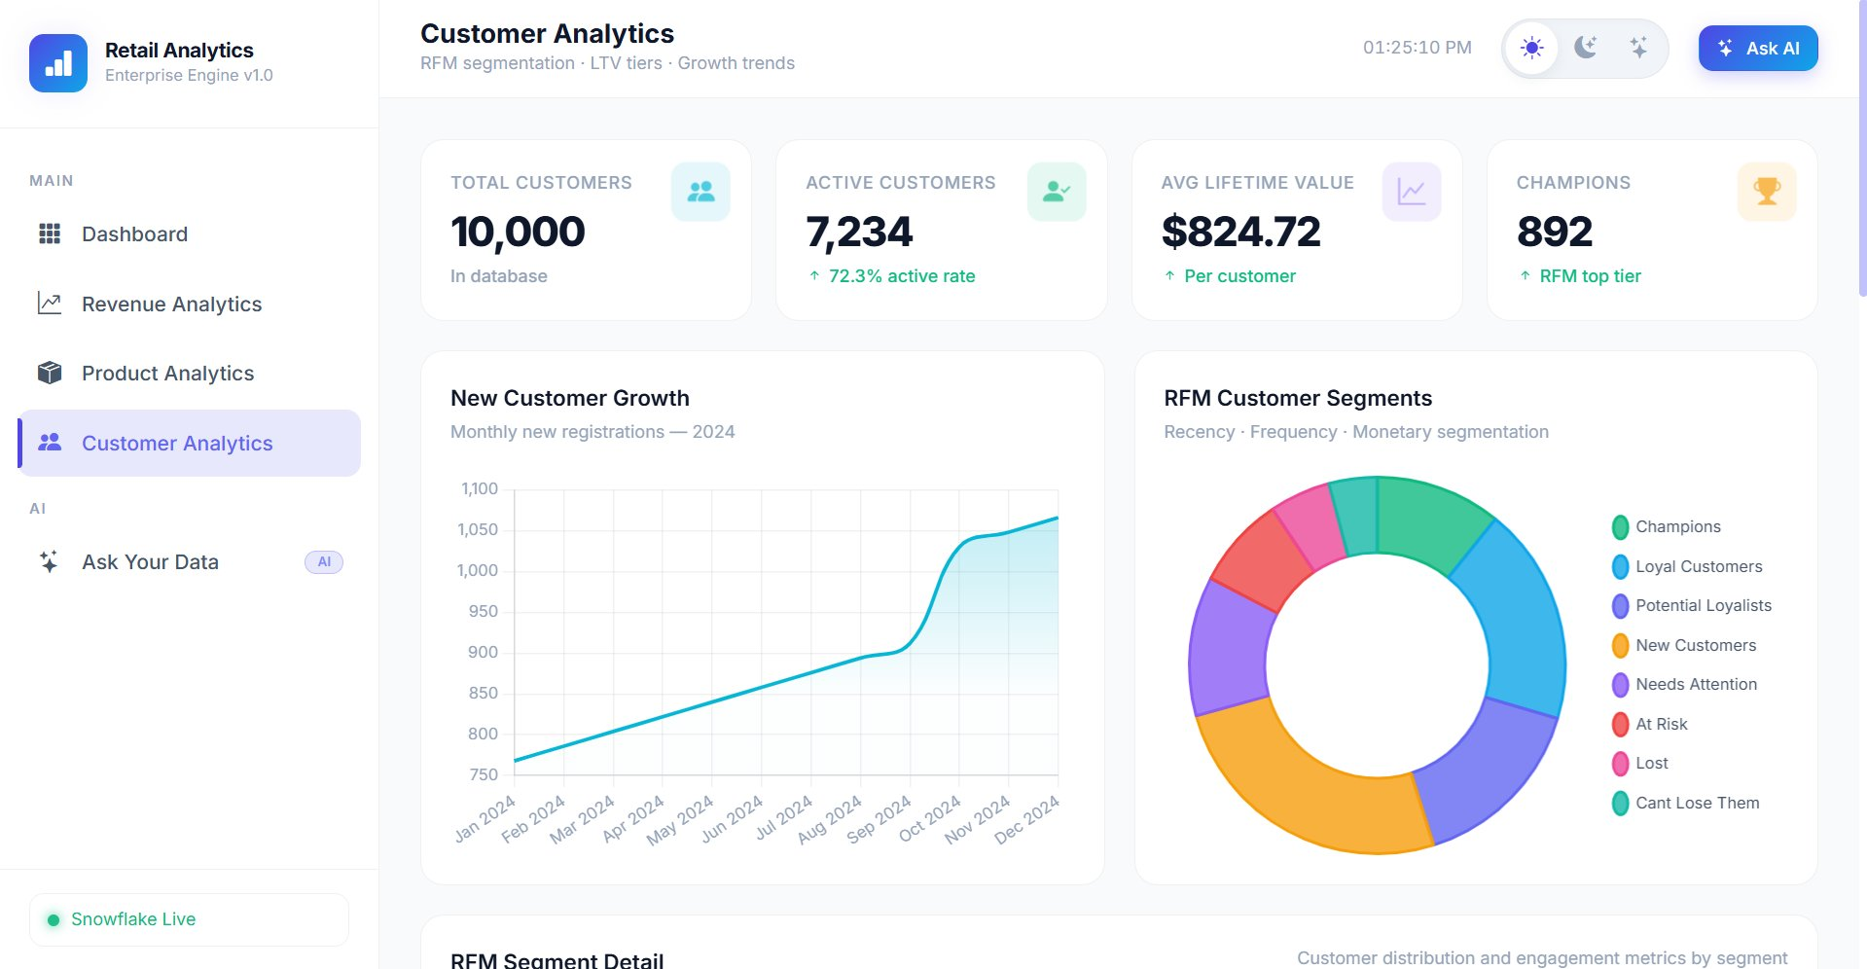
Figure 4: Customer Analytics — RFM segmentation and customer growth trends
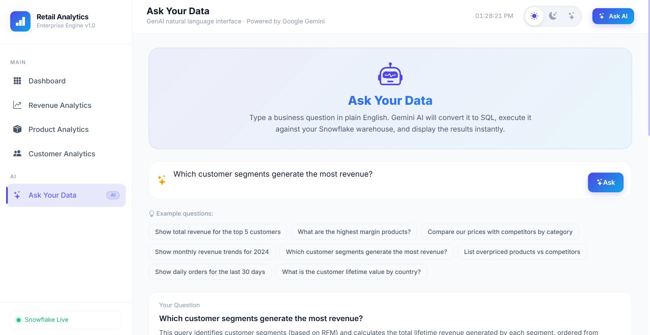
Figure 5a: Ask Your Data — Natural language query interface powered by Google Gemini
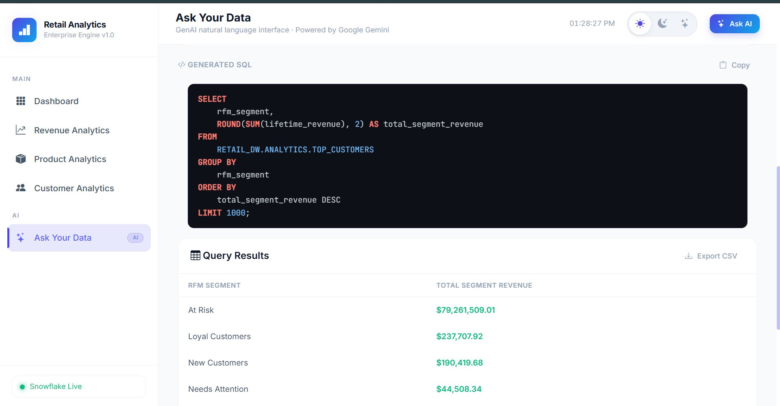
Figure 5b: Ask Your Data — Generated SQL and live query results from Snowflake
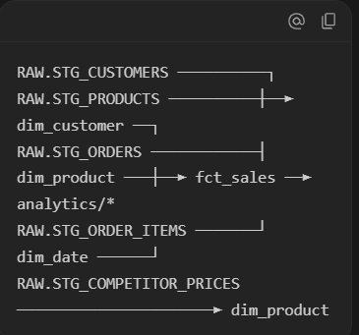
Figure 6: dbt DAG — Model lineage showing transformation pipeline
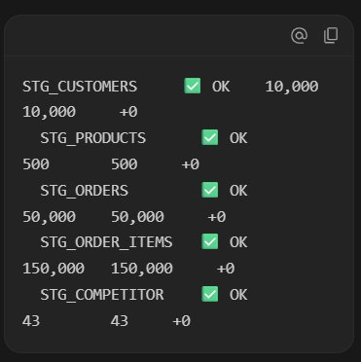
Figure 7: Snowflake — Staging table row count validation (zero data loss)

14. Star Schema ERD (Mermaid)
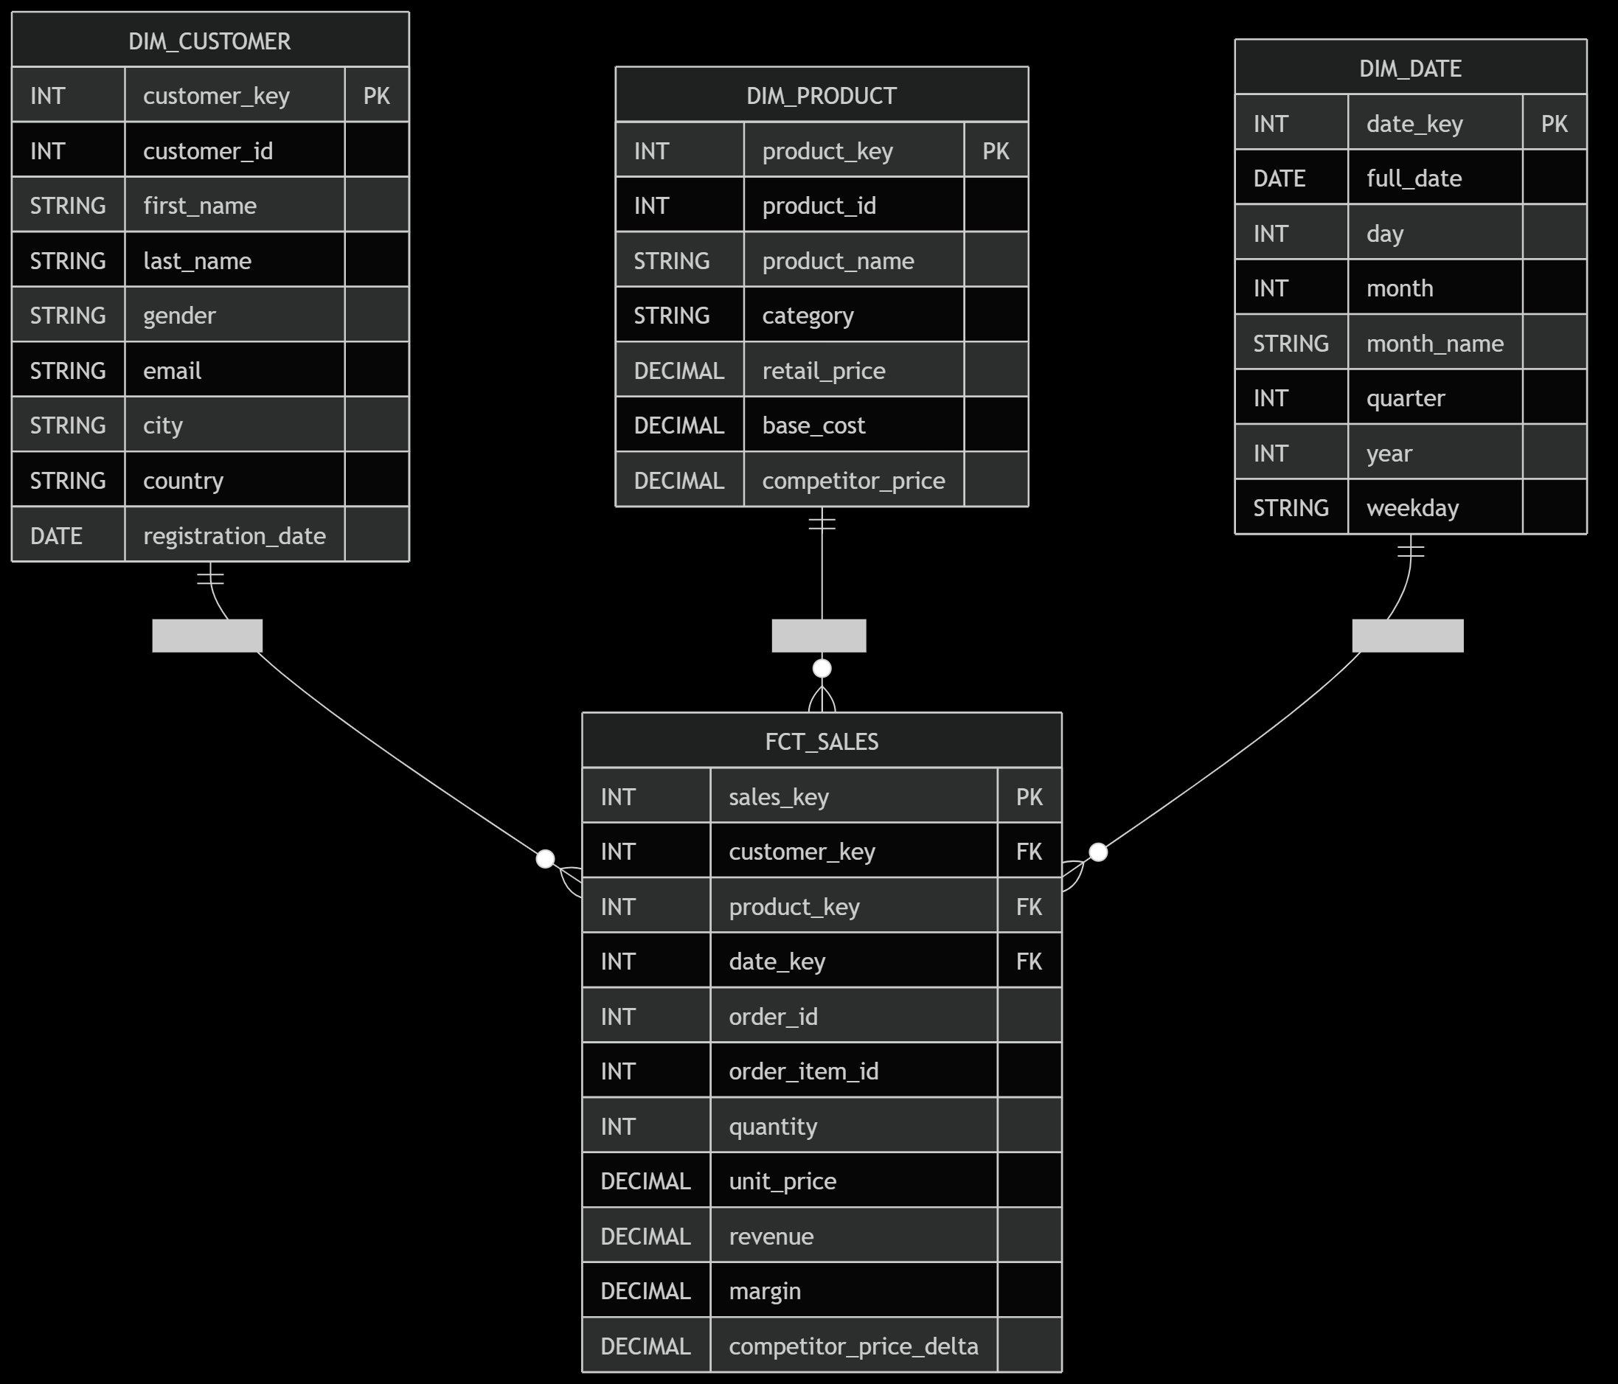
Table Schema: FCT_SALES (Fact Table)
Attribute Name | Data Type | Key | Description
sales_key | varchar | PK | MD5 Hash Surrogate Key
customer_key | varchar | FK | Reference to DIM_CUSTOMER
product_key | varchar | FK | Reference to DIM_PRODUCT
date_key | number | FK | Reference to DIM_DATE
order_id | varchar | DD | Degenerate order natural ID
order_item_id | varchar | DD | Degenerate item natural ID
quantity | int |  | Quantity ordered
unit_price | number |  | Discounted purchase price
revenue | number |  | Total revenue generated (quantity * price)
cogs | number |  | Cost of Goods Sold (quantity * cost)
gross_margin | number |  | Profit margin value (revenue - COGS)
gross_margin_pct | number |  | Margin rate (gross_margin / revenue * 100)
discount_amount | number |  | Value given away from standard retail
competitor_price_delta | number |  | Our price vs average competitor price
Table Schema: DIM_CUSTOMER (Dimension)
Attribute Name | Data Type | Key | Description
customer_key | varchar | PK | MD5 Hash Surrogate Key
customer_id | varchar |  | Customer natural ID
full_name | varchar |  | Formatted Full Name
gender | varchar |  | Gender field (M / F / Non-Binary)
email | varchar |  | Email address
city | varchar |  | City location
country | varchar |  | Country weighted geographic distribution
registration_date | date |  | Account creation date
tenure_segment | varchar |  | Registration-based tenure group
activity_status | varchar |  | Recency status (Active / Inactive)
Table Schema: DIM_PRODUCT (Dimension)
Attribute Name | Data Type | Key | Description
product_key | varchar | PK | MD5 Hash Surrogate Key
product_id | varchar |  | Product natural ID
product_name | varchar |  | Full item catalog name
category | varchar |  | Category classification (10 distinct categories)
retail_price | number |  | Standard retail unit price
base_cost | number |  | Product unit purchase cost
gross_margin_pct | number |  | Profitability margin profile
price_tier | varchar |  | Budget / Mid-Range / Premium / Luxury
competitive_position | varchar |  | Overpriced / Underpriced / Competitive
avg_competitor_price | number |  | Averaged scraped competitor price
Table Schema: DIM_DATE (Dimension)
Attribute Name | Data Type | Key | Description
date_key | number | PK | YYYYMMDD Integer Key
date_actual | date |  | Actual Calendar Date
year_number | int |  | Calendar Year
quarter_number | int |  | Calendar Quarter (1–4)
month_number | int |  | Calendar Month Number (1–12)
month_name | varchar |  | Month Word (e.g., January)
day_name | varchar |  | Day of the week (e.g., Monday)
is_weekend | boolean |  | True/False weekend flag
is_holiday_season | boolean |  | True/False holiday seasonal multiplier
Schema Relationships:
- FCT_SALES.customer_key links many-to-one with DIM_CUSTOMER.customer_key
- FCT_SALES.product_key links many-to-one with DIM_PRODUCT.product_key
- FCT_SALES.date_key links many-to-one with DIM_DATE.date_key
15. Conclusion
This capstone project successfully delivers a complete enterprise retail analytics platform that demonstrates mastery of modern data engineering practices. The system:
- **Generated** 210,543 realistic synthetic records with zero FK violations
- **Loaded** all data to Snowflake with validated zero data loss
- **Transformed** raw data through a 15-model dbt project with 62 automated tests — all passing
- **Modeled** a star schema optimized for analytical queries across four subject areas
- **Delivered** a premium dark-mode Flask dashboard with Chart.js visualizations across 5 pages
- **Integrated** Google Gemini AI for natural language querying with comprehensive SQL safety guardrails
The project demonstrates that modern cloud-native architectures can deliver sophisticated analytics capabilities at low cost. Snowflake's consumption-based pricing, dbt's open-source transformation framework, and the Gemini API's free tier together provide enterprise-grade analytics infrastructure for essentially zero ongoing cost in development environments.
The GenAI "Ask Your Data" feature represents a paradigm shift in data access — rather than requiring SQL knowledge or pre-built reports, business users can express their information needs in natural language and receive accurate, validated results. This capability has significant implications for organizational data literacy and the democratization of data access.
Future Enhancements could include:
- Real-time streaming ingestion via Kafka → Snowpipe
- SCD Type 2 customer dimension for historical tracking
- ML-based churn prediction using Snowflake ML
- Scheduled dbt runs via Airflow or dbt Cloud
- A/B test analysis for pricing recommendations

Repository Link:
https://github.com/ranatalhamajid1/data-warehousing-project

References
- Kimball, R., & Ross, M. (2013). *The Data Warehouse Toolkit: The Definitive Guide to Dimensional Modeling* (3rd ed.). Wiley.
- Snowflake Inc. (2024). *Snowflake Documentation*. https://docs.snowflake.com/
- dbt Labs. (2024). *dbt Documentation*. https://docs.getdbt.com/
- Google AI. (2024). *Gemini API Documentation*. https://ai.google.dev/docs
- Chart.js Team. (2024). *Chart.js Documentation*. https://www.chartjs.org/docs/
- McKinney, W. (2022). *Python for Data Analysis* (3rd ed.). O'Reilly Media.
- Inmon, W. H. (2005). *Building the Data Warehouse* (4th ed.). Wiley.
- Flask Developers. (2024). *Flask Documentation*. https://flask.palletsprojects.com/
- Bootstrap Team. (2024). *Bootstrap 5 Documentation*. https://getbootstrap.com/docs/5.3/
- Faker Developers. (2024). *Faker Documentation*. https://faker.readthedocs.io/
Total Project Files: 40+ files
Total Lines of Code: ~4,500+ lines
Dataset Size: 210,543 records

