DECOUPLING

INTRODUCTION:
Permanent Magnet Synchronous Motors (PMSMs) are widely used in electric vehicles due to their high efficiency, torque density, and controllability. However, PMSM dynamics are nonlinear because the d-axis and q-axis currents affect each other. This creates a coupling effect that makes precise torque and flux control difficult.
To overcome this, a decoupling block is used. My part of the project implements exactly this decoupling logic.

WHY DECOUPLING IS NEEDED
• PMSM has two control currents:
– id controls magnetic flux.
– iq controls torque.
• In an ideal scenario, id and iq should work independently.
• But in real motors, changing id unintentionally affects iq and vice versa.
• This coupling leads to errors in torque production and unstable control.
• Decoupling removes these unwanted cross-interactions.

UNDERSTANDING THE d-q REFERENCE FRAME
• ABC currents (three-phase) are sinusoidal → difficult to control.
• Clarke and Park Transformation convert these into:
– d-axis: aligned with rotor flux.
– q-axis: perpendicular to rotor flux.
• In dq-frame:
– Motor behaves like a DC system.
– Control becomes simple.
– Flux and torque can be independently regulated.

EQUATIONS BEING IMPLEMENTED
The PMSM voltage equations in dq-frame:
vd = Rs * id + Ld * did/dt − ωs * Lq * iq
vq = Rs * iq + Lq * diq/dt + ωs * (Ld * id + φ)

The terms highlighted below represent coupling:
• − ωs * Lq * iq ⟶ coupling term in vd
• + ωs * Ld * id ⟶ coupling term in vq
• + ωs * φ ⟶ back EMF term in vq

The PID controller provides linear voltages vdl and vql.
The decoupler adds back the missing coupling terms.

MATLAB FUNCTION IMPLEMENTATION
code:
function [vd,vq]= decouple(ws,vdl,vql,iq,id)
Ld = 1e-4;
Lq = 1e-3;
phi = 0.23;
vd = -ws*Lq*iq + vdl*Ld;
vq = ws*phi + ws*Ld*id + vql*Lq;

Explanation:
• ws = electrical speed of PMSM.
• vdl, vql = linear voltages created by PID controllers.
• iq, id = currents from motor.
• Ld, Lq = inductances.
• φ = permanent magnet flux.
What the function does:
1. Computes vd coupling term: −ω * Lq * iq
2. Computes vq coupling terms: ωφ + ω * Ld * id
3. Adds them to the linear voltages.
4. Outputs corrected voltages vd and vq.
BLOCK DIAGRAM FLOW (SUBSYSTEM)
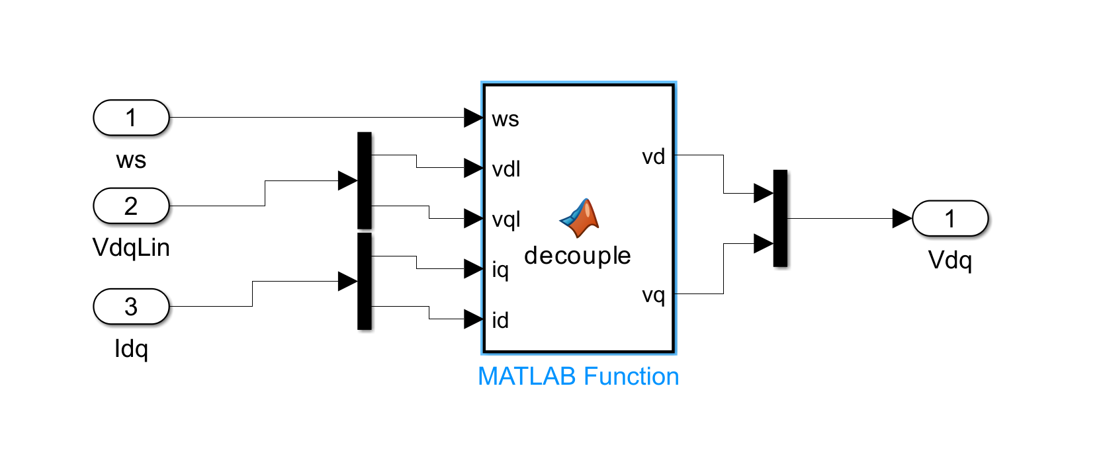
Inputs:
• ws (speed)
• VdqLin (linear voltages: vdl, vql)
• Idq (currents: id, iq)
Steps:
1. Demux VdqLin → vdl & vql
2. Demux Idq → id & iq
3. MATLAB Function “decouple” computes:
– corrected vd
– corrected vq
4. Mux → final Vdq vector
5. Output to PMSM block

WHY THIS BLOCK IS IMPORTANT
• Ensures torque produced = torque demanded.
• Removes unwanted motor dynamics.
• Makes control smooth, stable, predictable.
• Allows EV to accelerate/decelerate safely.
• Essential for field-oriented control (FOC).

