Capstone Project Report

# Dynamic Pricing for Urban Parking Lots

Capstone Project - Summer Analytics 2025  
Hosted by Consulting & Analytics Club × Pathway

## 1. Project Overview

Urban parking spaces are limited and high in demand. Static pricing models often lead to inefficiencies like overcrowding or underutilization. This project builds a real-time dynamic pricing engine for 14 parking lots using data such as occupancy, queue length, vehicle type, traffic levels, and event indicators.

## 2. Tech Stack

- Python (Google Colab)  
- Pandas, NumPy (for data processing and model logic)  
- Pathway (for real-time data ingestion and simulation)  
- Bokeh (for real-time visualizations)

## 3. System Architecture

The system is designed to simulate real-time pricing updates for parking spaces. The data pipeline is as follows:  
1. Data Ingestion via Pathway  
2. Real-time Feature Extraction  
3. Application of Pricing Models  
4. Output to Visualization Dashboard  
Each pricing model improves on the previous in terms of demand sensitivity and responsiveness to environmental signals.

## 4. Pricing Models

### Model 1: Baseline Linear Model

A simple linear model that adjusts the next price based on current occupancy:  
Price(t+1) = Price(t) + α × (Occupancy / Capacity)  
This model acts as a benchmark to assess the effectiveness of more advanced models.

### Model 2: Demand-Based Model

In this model, a composite demand function is constructed using occupancy, queue length, traffic level, special day indicator, and vehicle type. The pricing formula is:  
  
Demand = α × (Occupancy / Capacity) + β × QueueLength − γ × Traffic + δ × IsSpecialDay + ε × VehicleTypeWeight  
  
Then the price is updated as:  
Price(t) = BasePrice × (1 + λ × NormalizedDemand)  
This allows smoother and bounded pricing behavior (between 0.5x and 2x base price).

## 5. Assumptions

- Base price starts at $10  
- Maximum price = 2x base; Minimum = 0.5x base  
- All features are normalized for fairness  
- Special days are flagged and have a positive effect on demand

## 6. Visualizations

Real-time price plots are generated using Bokeh to compare prices across different parking lots. These visualizations help in justifying the pricing decisions and analyzing the performance of each lot.

For Model 1: 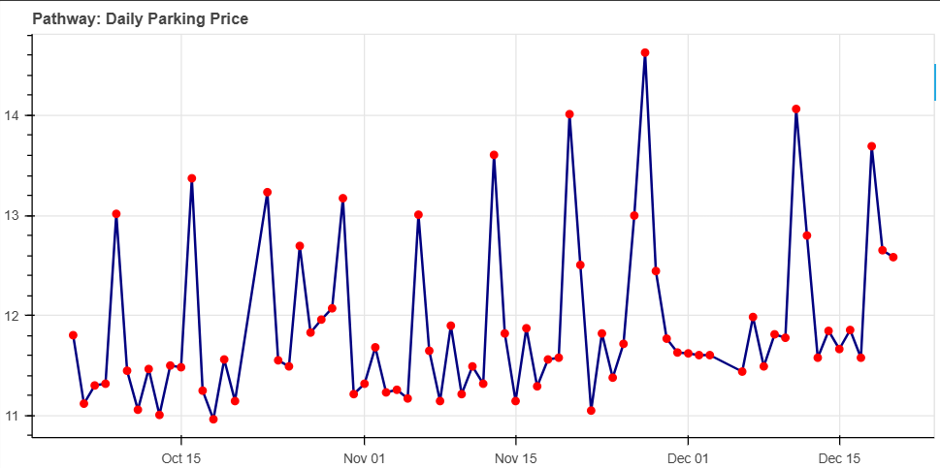For Model 2: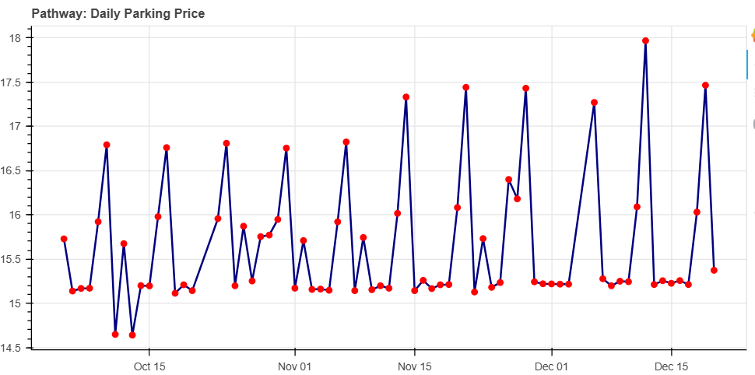

## 7. Conclusion

This project successfully implements two robust models for real-time dynamic pricing of urban parking lots. Using features like occupancy, traffic, and events, the system effectively adjusts prices to optimize lot utilization. The implementation was done in a Google Colab environment with real-time streaming and visualization support.