Software Engineering Web Application

Project Report - Phase 1

Cheng Chen cc1447, Chenfan Xiao cx61, Jianing Xu jx121, Xinyu Li xl344, Yuwei Jiang yj221

Introduction

This phase requires us to write a program which is able to download stock information including Symbol, Price, Time, and Volume for each stock, and store it into a relational database. After analyzing the main databases used nowadays, we choose to use MySQL. We made this decision for the following reasons: 1) It is efficient and convenient especially for a small website which contains not much data; 2) It is pretty compatible with main languages used in web development such as PHP and Python; 3) It is open source and has strong community; 4) It is widely used thus is easy for further maintenance.

For the phase 1, we have the system plot as shown in figure 1. Basically speaking, there is a backend program written in PHP periodically request and retrieve the information, and check if the local database need to be updated. If so, the program will update the database.

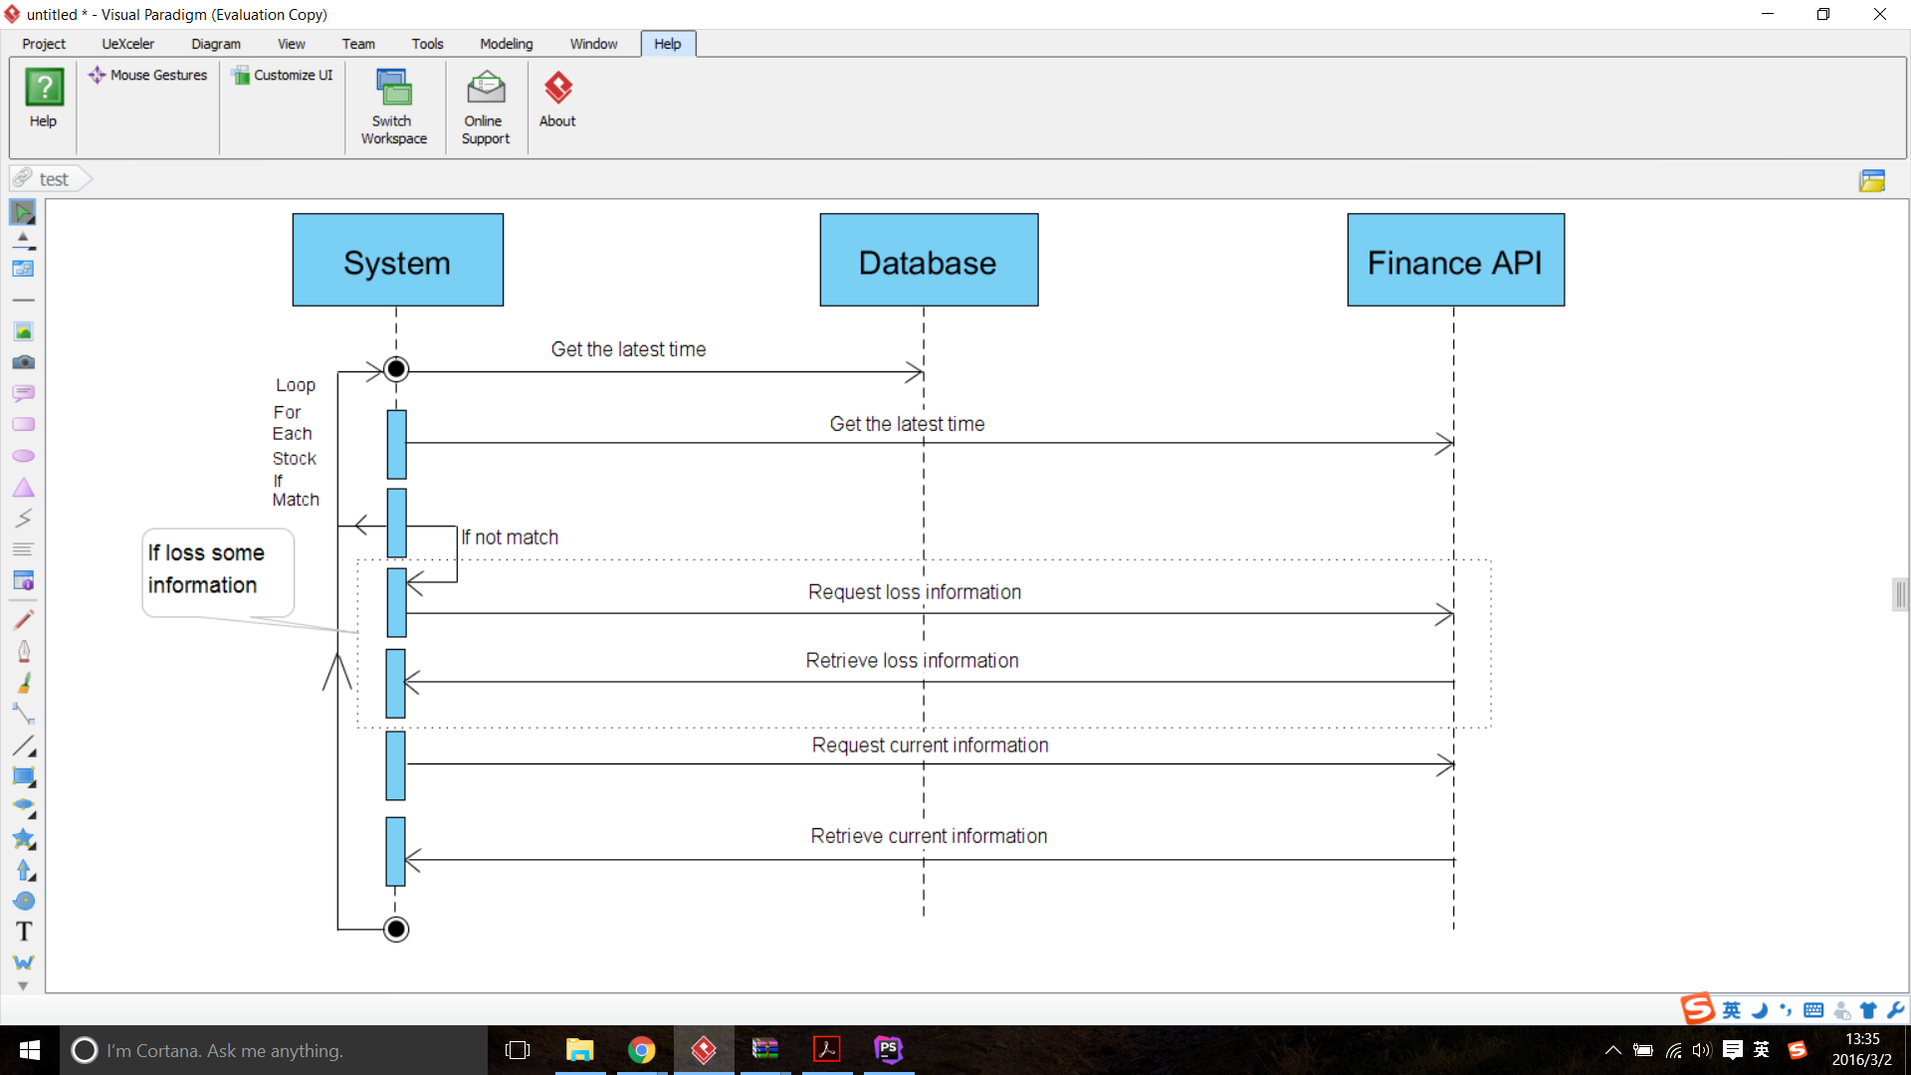

Figure 1

The scheme of the database is shown in figure 2. For each stock, the real-time information and historical information are stored in three entities for future use. Entity Stocks stores the basic information of the stock including the StockID and the company name. StockID is the primary key to identify each entry in it. CurrentPrice stores the real-time price of the the stocks with StockID as the primary key. HistoricalPrice stores the history stock price information including the open, high, low, etc. The primary key for it is Date and StockID. One stock has only one current price which means stocks has a one to one relationship with CurrentPrice. One stock can have different price history for different date. So it has one to many relationship with the HistoricalPrice entity. 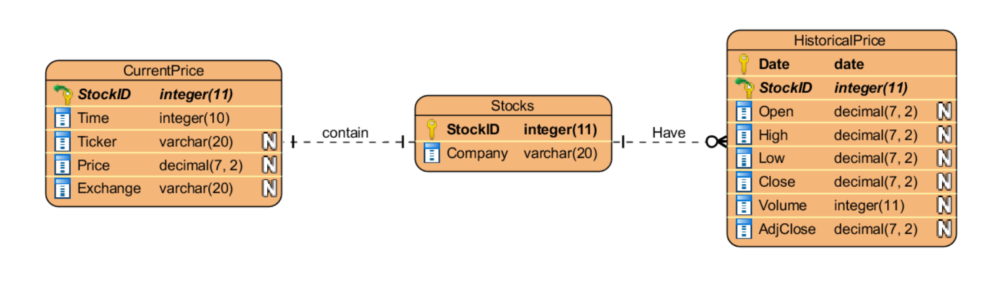

Figure 2

Process

From the system design plot we can easily figure the process of retrieving information of each stock. The process can be divided into two main parts. First, two databases are created. One for real-time information and one for history information. The structure of these two databases are shown in figure 2. Second, for the real-time database, after retrieving the previous prices of the day, the real-time prices will be requested and recorded every 30 seconds. For the history database, the information of the previous one year will be requested and recorded, after which the information will be updated every day.

The update process will be held on the server even if the client close the connection, which will make sure the information of the stocks will be updated timely. It has two functions: updating real-time-price information and updating historical information of each stock. The real-time-price update process will first check if one stock existing in the database. If it does not exist, the process will insert one with current price; if it exists, the process will check if the latest information is recorded and if not, the process will insert a new entry.

For convenience, each entry in real-time database will have a unique stock ID, which can be used to track each state of each stock easily.

Breakdown of individual contributions

The Phase1 of the project mainly includes two sections, coding the program and design report.

The first diagram shows the brief pattern of breakdown and the second gives a detailed individual contributions.

