A Sample Toulmin Argument: “Les Habitants”

Data |  | Qualifier | Claim
The Montreal Canadiens have won
24 Stanley Cups championships, the most of any team in the history of the NHL.
 |  | So, without a doubt, | the Montreal Canadiens are the greatest team in the history of the NHL.
 | Warrant | Rebuttal | 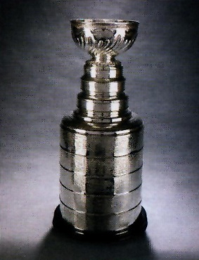
 | A pro team with the most championships is the greatest team in the history of that league. | unless other criteria are used to determine the greatest team (e.g., most recent Cup wins)
 | Backing
The Stanley Cup, the NHL’s highest honor, is the trophy
awarded to the playoff champion at the end of each season.

