# MEMO

**To:** Anonymous trader

**From:** Team # 2200296

**DATE: 2022/2/20**

**SUBJECT:** Portfolio Strategy and Returns

Dear Sir or Madam,

In accordance with your requests, we have designed a model called ***Greedy Prophet*** to give suggestions on whether you should buy, sell, or hold your assets in your portfolio. You’ve asked that only historical price data can be used and that we only have an initial capital of 1000 USD. Despite such strict limits, we are proud and excited to inform you that with the help of ***Greedy Prophet***, you can become a millionaire on 2021/9/10—your total assets will be worth **1,533,432** USD at that time! The figure below depicts your cumulative wealth, which almost keeps increasing over time.

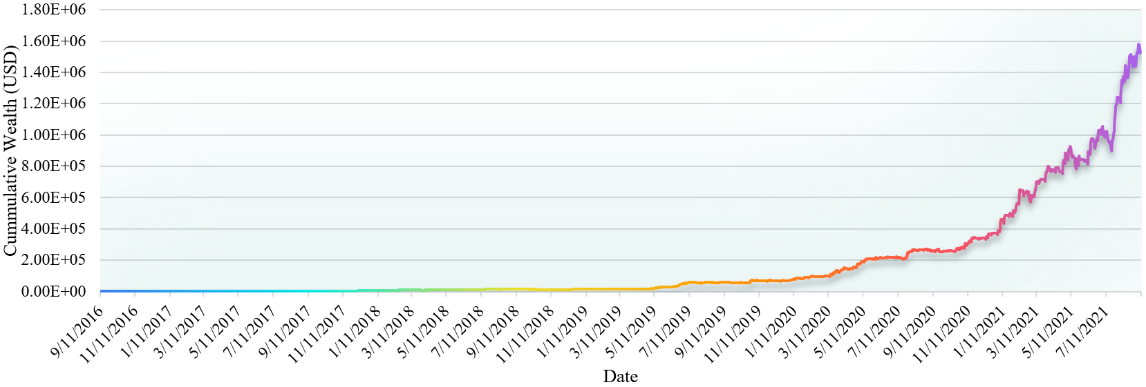

Before telling you about the details of trading strategies, first, allow me to introduce our model—***Greedy Prophet***—to you. The name comes from 1) its ability to accurately predict the next day’s prices of gold and bitcoin, and 2) the *greedy policy* it takes. It can be decomposed into a prediction model and a decision model. The prediction model uses the moving average method for prediction in the first year. Then, from the second year to the end, an ensemble model consisting of XGBoost, LightGBM, and KNN is established. These three models all belong to machine learning models which are widely used in all fields including finance. Metrics have shown that the prediction results are quite close to the true values.



