|  |  |  |
| --- | --- | --- |
| **Problem Chosen** C | **2022 MCM/ICM Summary Sheet** | **Team Control Number** 2200296 |

**Greedy Prophet: Make You the Next Oracle of Omaha**

**Summary**

|  |
| --- |
| Ever since the creation of currency, we humans have never stopped the effort of making value and accumulating wealth. From tangible physical assets to liquid assets that do not necessarily have inherent physical worth or even a physical form, nearly everything is incorporated in the fields of Economics and Finance. However, in the arcane world of investment, the best strategy is an issue in all ages. With various types of assets to choose from, traders are often overwhelmed by the concept and trading rules of assets such as cash, precious metals, stocks, bonds, mutual funds, and bank deposits, let alone decide the perfect portfolio allocation and multiply returns. Every investor is praying for an oracle on investment matters and the “Greedy Prophet” hears them.  To accomplish the tasks required by the trader, we develop a model called Greedy Prophet, which can offer the best daily trading strategy based only on historical records of prices. The trader’s portfolio is made up of cash, gold, and bitcoin, which is a simplified version from that in the real world. Since the market is dynamic and price changes over time, our idea is to first predict future conditions of the market and then solve the portfolio optimization problem. For the prediction model, the moving average approach is applied in the first year due to the lack of training data. From the second year to the end, an ensemble model incorporating XGBoost, LightGBM, and KNN is trained through an online method and used for future price prediction. For the decision model, we set the decision variables as trading amounts of gold and bitcoin, and the objective function as the maximum predicted net profit of the next day. By transformation, we eliminated the absolute value function and turn the optimization problem into linear programming. Then, exact solutions can be easily obtained.  After determining the whole structure of Greedy Prophet, the remaining tasks can be readily solved. To accomplish task 2, we construct five other models and compare the result with that of our Greedy Prophet. Not surprisingly, our model overshadows all the competitors considerably. When it comes to task 3, we create different combinations of gold and bitcoin transaction costs. We re-calculate the ultimate wealth, the number of buys and sales, and the average trading amount of gold and bitcoin, and conduct further analysis. Two interesting findings are discovered. 1) When the transaction cost of gold is larger than that of bitcoin, the model will be forced to buy bitcoin and turn out to make a fortune. This is a result of serendipity since the bitcoin market happens to be a bull market at that time. 2) Transaction costs diminish the number of buys and sales, which discourage investors from excessively frequent trading to some extent. The essence of the model structure, the best strategy, and the corresponding results are represented in a memorandum to the trader.  Admittedly, every market will wax and wane no matter how promising it looks for the time being. Gold is considered to be a safe investment choice for hedging against adverse price movements, while bitcoin is a highly volatile asset that brings about significant returns and risks. That’s why portfolio diversification and allocation are important. Leave the work to Greedy Prophet, and it might make you the next Oracle of Omaha. |

Contents

1 Introduction 3

1.1 Problem Background 3

1.2 Restatement of the Problem 3

1.3 Literature Review 3

1.4 Our Work 4

2 Assumptions and Justifications 5

3 Notations 6

4 Data Description 7

4.1 Dataset Overview 7

4.2 Volatility and Correlation 8

5 Model Structure 10

5.1 The Prediction Model: Ensemble a Prophet 10

5.2 The Decision Model: Greedy Prophet’s selection 12

6 Proof of Optimality 14

6.1 Competitor 1: Sliding Window Trading Strategy 14

6.2 Competitor 2: Long Short-Term Moving Average Trading Strategy 14

6.3 Competitor 3: N-Period Moving Average Trading Strategy 15

6.4 Competitor 4: Radical Disciple Trading Strategy 15

6.5 Competitor 5: Conservative Disciple Trading Strategy 15

6.6 Comparison of various strategies 16

7 Sensitivity to Transaction Costs 17

8 Model Evaluation and Further Discussion 19

8.1 Strengths 19

8.2 Weaknesses 20

8.3 Further Discussion 20

9 Memorandum 20

References 23

# Introduction

## Problem Background

In the realm of finance, the ultimate goal is always to maximize return. However, confronted with uncertainty and volatility, traders often hesitate on buying or selling their assets and struggle with the best portfolio. One of the most common combinations is gold and bitcoin. Gold presents high liquidity and universality and has proven its importance as a safe haven against adverse price movements. It is regarded as one of the secure assets that one would hold mostly during extremely volatile periods in order to reduce portfolio riskiness. Like a digital version of gold, bitcoin is a type of cryptocurrency that allows transactions to happen without a central exchange. It is increasingly gaining popularity among both individual and institutional investors after its’ first debut in Nakamoto’s paper [1], thanks to blockchain technology.

As a rule of thumb, portfolio diversification is of the essence for investors so as to monitor the risk level of their positions. Thus, it’s never an either-or-decision between bitcoin and gold. Learning from historical closing prices, forecasting potential feature trends, and considering transaction cost and other elements, traders are searching for the best strategy for dynamic portfolio selection. With the help of data processing methods, mathematical models, and deep learning algorithms, investors are able to make wise decisions and saved from racking their brains but depleting their assets in the end.

## Restatement of the Problem

Given the five-year trading data from 9/11/2016 to 9/10/2021, we are commissioned by a trader to offer the best portfolio consisting of cash, gold, and bitcoin, with an initial capital of $1000 in cash. This online portfolio selection problem is a sequential decision-making process. To improve the accumulated return, it is necessary to readjust investment strategies according to the change in the financial market. Considering the background information and restricted conditions identified in the problem statement, we need to solve the following problems:

* Develop a portfolio selection model that determines the best daily trading strategy and gives the ultimate worth on 9/10/2021 of the assets. Only the past stream of daily prices to date can be used.
* Prove the optimality of the trading strategy provided by the model.
* Investigate the influence of transaction costs on the strategy and asset value.
* Write a memorandum to describe our model, strategy, and results to the commissioner.

## Literature Review

As a fundamental problem in computational finance, online portfolio selection has been extensively studied. Existing literature mostly formulate it as a sequential decision problem [2], and categorize the strategy principles into five types [3].

Following the “Benchmarks” is the first strategy. The mostly applied ones include the “Uniform Buy-and-Hold” strategy, the “Best Stock” strategy, and the “Constant Rebalanced Portfolios” strategy [4]. The second type is the “Follow the Winner” strategy which relies on the momentum principle and believes that the risky assets performing well currently will still be promising in the future. Oppositely, traders that vote for the third type “Follow the Loser” strategy assume that risky assets having good performance in the past may return to normal or perform badly in the next period. They endorse the mean reversion principle and tend to buy under-performing assets and sell the over-performing ones. On the other hand, the “Pattern Matching” approach simultaneously considers the above two contradictory strategies. It first selects historical price patterns to estimate future returns, and then builds an optimization model to obtain the best portfolio selection. The last type, “Meta-Learning”, constructs a think-tank for portfolio selection. Multiple base experts are defined first. Each of them offers a strategy different from others’ and suggests a portfolio. Then, all the suggested portfolios are integrated into the final strategy.

With the help of big data and machine learning, new techniques are applied in online portfolio selection. Corsaro et al. integrated deep learning in a Markowitz mean-variance framework. They applied the L1 norm to produce sparse solutions [5]. Likewise, Paiva et al. fused the support vector machine method and the mean-variance method for portfolio selection [6]. Despite diverse methods, the main takeaway is to predict the future price and obtain the price distribution, and then, integrate the prediction model with the traditional five strategies mentioned above to maximize the portfolio’s cumulative return.

## Our Work

The whole structure of our work is represented in **Figure 1**. To solve the proposed portfolio selection problem, we first investigate the data, pre-process the missing value, and extract some basic properties of daily prices from 9/11/2016 to 9/10/2021. Then, we calculate price volatility of gold and bitcoin, price correlation between gold and bitcoin, and return correlation between gold and bitcoin to find out suitable models.

Then, we develop the model “greedy prophet” for online portfolio selection. The whole model can be decomposed into two parts: the prediction model and the decision model. In the prediction model, we use the moving average approach in the first year since data is not enough for training machine learning models. Then, from the second year till the end, we propose an ensemble model that integrates XGBoost, LightGBM, and KNN. Metrics show that the ensemble model has better performance than single ones and outputs satisfying results with high accuracy. As to the decision model, the “greedy policy” is applied. We formulate a mathematical optimization problem with the objective to maximize the predicted net profit of the next day. After transformation, this problem can be easily solved and output daily trading strategies.

Next, we prove the optimality of our “greedy prophet” by comparing the ultimate wealth given by five other models. Sensitivity to transaction costs is analyzed under different combinations of commissions of gold and bitcoin. After that, the strengths and weaknesses of our model are listed and further improvements are also discussed. At last, we design a memorandum to introduce the model and show the best strategy and corresponding results to the trader.

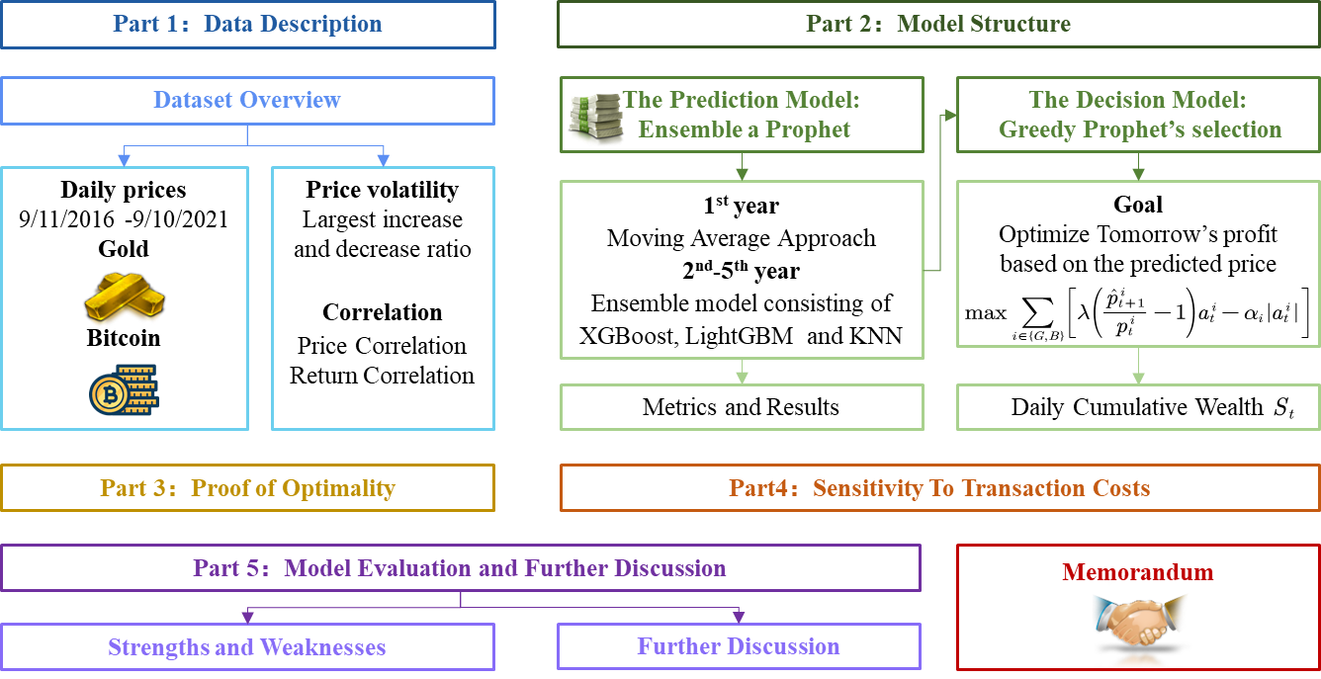

**Figure 1. Structure of our work**

# Assumptions and Justifications

1. **We assume that the records related to prices in the datasets are all closing prices on the indicated day, and the prices do not change within a single day.**

Although prices of risk assets fluctuate over a day in the real world, due to the limited information of data, we are only provided with one value of the day. So, without extra information about market daily volatility, it is better to regard the price as a constant during a day. Besides, the closing price is often the reference point used by investors to compare the performance of an asset. It is also frequently used to construct line graphs that illustrate historical price changes over time. Therefore, we assume the datasets are records of closing prices on the trading day.

1. **We assume that the trading price of an asset is the closing price on that day. The value of the total assets will be reassessed on the same day, i.e., the settlement date is T+0.**

Based on assumption 1, the price is the same over the day and equal to the closing price. Thus, whenever the investor buys or sells assets, the trading price would be the closing price on that day. What’s more, according to market regulations, bitcoin and gold can be transacted and settled on the same day, i.e., the ownership of the asset is transferred on the same day when the trade occurs. So, the total worth of assets will count in the trading volume on that day.

1. **We assume that there are no limits on the minimum trading unit of gold and bitcoin.**

As a cryptocurrency with great flexibility, bitcoin has no universal requirement on the minimum amount that traders should invest. On the other hand, as a commodity asset (physical asset), there is usually a minimum transaction unit of gold. However, since different institutions have different restrictions on the minimum trading unit of gold (e.g., 100 oz, 1 oz, 1 kilogram, 1 gram), it is difficult to nail down a unified regulation. Also, for the simplicity of mathematical modeling, it is reasonable to not constrain the minimum trading unit.

1. **We assume that the total worth of assets is measured by the U.S. dollar (USD) whose value does not change over time.**

In order to measure the worth of our total assets, we choose to adjust them into USD since it is a more universal currency worldwide. However, here we ignore many complex real-world situations such as inflation and deflation. Under these circumstances, the worth of USD is not stable, which means it could fail to be a good measurement of our current assets. So, to simplify the problem and find a general indicator for worth, we hypothesize that the value reflected by USD is consistent.

1. **We assume that the gold and bitcoin market will not be influenced by our decision. Also, decisions are not affected by external factors and information such as incentives of the government or a need for petty cash.**

Although personal beliefs and decisions may influence other investors and change the market in the end, it is often those famous economists and legendary stock-pickers like Warren Buffett who have the power to affect the market direction. Here we assume that we do not have the capability to influence the price movement of gold and bitcoin, and the market is independent of our decisions. In addition, due to the lack of external information, it is not wise to count their impacts. So, we neglect external factors when making decisions.

1. **We assume that on the first week and the last day, the “hold” strategy is applied. Other times, decisions are made out of rationality to pursue maximum cumulative return till 9/10/2021. Once that day arrives, we would exit the market.**

Due to the lack of historical information, it would be imprudent to invest. So, it’s better to watch and wait for the first week. Besides, since we are asked to develop the best trading strategy that can maximize the total worth of assets on 9/10/2021, it is pointless to trade or consider long-term returns on and after that day.

# Notations

The key mathematical notations used in this paper are listed in **Table 1**.

Table 1: Notations used in this paper

|  |  |  |
| --- | --- | --- |
| **Symbol** | **Description** | **Unit** |
|  | Index of assets, | — |
|  | Index of days, | — |
|  | **Table 1: Notations used in this paper (Cont)** |  |
| **Symbol** | **Description** | **Unit** |
|  | Index of days on which gold cannot be traded | — |
|  | Index of days assumed to hold assets, | — |
|  | Closing price of asset  on day | USD |
|  | Predicted Closing price of asset  on day | USD |
|  | Commission rate for each transaction, , | — |
|  | Traded amount of asset  on day ;  for purchase,  for sale | USD |
|  | Holdings of asset  on day | USD |
|  | Cumulative wealth at the end of day | USD |

# Data Description

## Dataset Overview

The datasets include the daily prices of gold and bitcoin from 9/11/2016 to 9/10/2021. Just as mentioned in the assumptions, the “daily price” here refers to the closing price on that day. The gold daily prices dataset (*LBMA-GOLD.csv*) is provided by London Bullion Market Association and includes 1,265 records. Each record is made up of date in mm-dd-yyyy (month-day-year) format and the closing price of a troy ounce of gold in USD on the indicated date. Since gold trading only opens on workdays, the recorded dates are not continuous. The bitcoin daily prices dataset (*BCHAIN-MKPRU.csv*) is offered by NASDAQ and consists of 1,826 records. Each record describes the date and price in USD of a single bitcoin on that day. Different from gold, bitcoin can be traded every day, so the dates are continuous. In order to keep the trading dates of these two assets consistent with each other, we fill in the gaps in the gold daily prices dataset and assume that gold prices won’t change on these days, and the only strategy is to hold.

After careful investigation of the given datasets, we find ten values missing in *LBMA-GOLD.csv*. Their corresponding dates and days are listed in **Table 2**. It can be seen that data would be omitted on Christmas Eve and New Year’s Eve if these two days are working days; or, data would also be missing on the nearest working day before Christmas Day and New Year’s Day if these two days are on weekends. One possible reason could be that trading records on those days would fail to serve as useful references. Due to the uncertainty of the market during long holidays, decisions made by traders on these days are rather subjective, depending on the conservativeness of the investor. Under this circumstance, trading records would be meaningless for investment advice. So, just as most experts suggest, we choose to dismiss the records of these ten days, which means forget about trading and hold the current assets. This strategy will be embodied later in our decision model.

**Table 2. Missing data in the gold daily prices dataset**

|  |  |  |  |
| --- | --- | --- | --- |
| **Year** | **Date (mm/dd)** | | **Day** |
| **Date 1** | **Date 2** |
| 2016 | 12/23 | 12/30 | Friday |
| 2017 | 12/22 | 12/29 | Friday |
| 2018 | 12/24 | 12/31 | Monday |
| 2019 | 12/24 | 12/31 | Tuesday |
| 2020 | 12/24 | 12/31 | Thursday |

## Volatility and Correlation

After statistical analysis, we found some useful features of the data besides the overall trend (which has been illustrated in the problem and thus omitted here). The first kind is the largest increase and decrease ratio to the previous day of bitcoin and gold over the five years, as is shown in **Table 3**. This feature describes the upper bound and lower bound of the price change over a day and reflects the volatility of the two assets. We could draw a preliminary conclusion that the price of bitcoin is more volatile.

**Table 3. The largest increase and decrease of bitcoin and gold**

|  |  |  |  |
| --- | --- | --- | --- |
| **Asset** | **Max decrease (%)** | | **Max increase (%)** |
| Gold |  |  |  |
| Bitcoin |  |  |  |

Besides price volatility, another feature that we are interested in is return volatility. Here we apply log-returns instead of simple returns because it is a better measure and can be added across time periods. After calculating daily log returns, we plot them out as a histogram in **Figure 2**. The wider the distribution, the more volatile it is. It can be seen that gold is mostly within the mean distribution, but bitcoin spreads widely across the x-axis. It is expected that higher return comes with higher risk: bitcoin can have gains up to 20% but may also lose 20%; while the gain or loss of gold is within 5%.

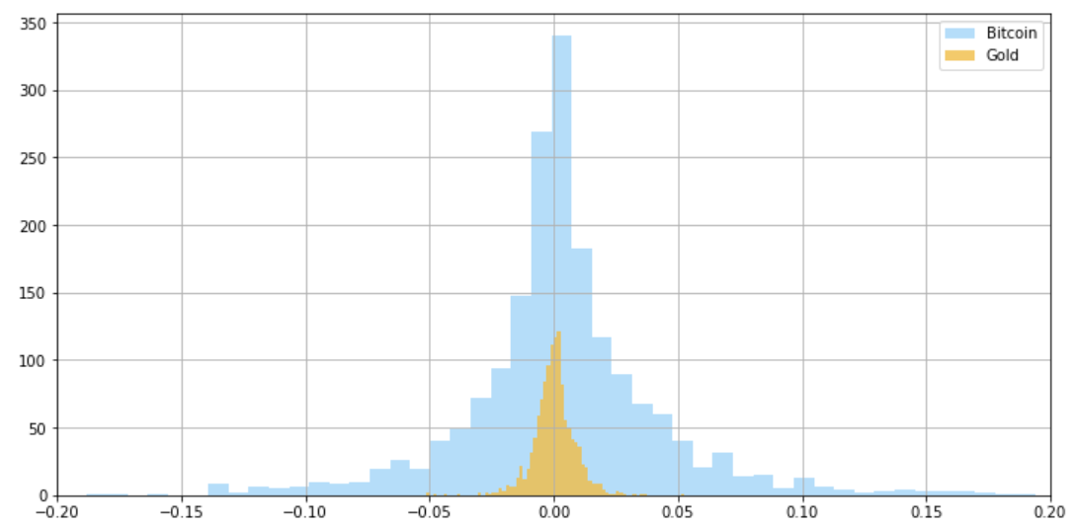

**Figure 2. Histogram of log-returns of bitcoin and gold**

Then, we investigate the correlation between bitcoin and gold, including price correlation and return correlation. **Figure 3** depicts the scatter diagrams of price and return after normalization. The calculated correlation coefficient is 0.65 and 0.05 respectively. Combining the diagrams and correlation coefficient, we could conclude that: bitcoin and gold are correlated in terms of prices, but uncorrelated when it comes to returns. This is explainable since both bitcoin and gold markets are influenced by some common factors such as the overall economic situation, government policies, and so on. So, the moving trend of prices may somehow relate to each other. However, returns on the other hand not only depend on the trend, but also rely on the fluctuation range, i.e., volatility. Since bitcoin is far more volatile than gold and the reasons are too complicated to investigate, the return of it is uncorrelated with that of gold.

|  |  |
| --- | --- |
|  |  |
| (a) price correlation | (b) return correlation |

**Figure 3. Correlation between bitcoin and gold**

# Model Structure

## The Prediction Model: Ensemble a Prophet

Before modeling, we need to pre-process the datasets. Since the data are volatile, we conduct a first difference transformation so as to smooth the noise and make the time series steady. Besides, as has been mentioned before, we have to expand the records of gold prices into 1,826 days, so that the sequence length is the same as that of bitcoin. The interpolation of gold prices simply fills in the missing values with the price the day before. After that, we will make predictions based on the pre-processed time series, which are shown in **Figure 4** and **Figure 5**.

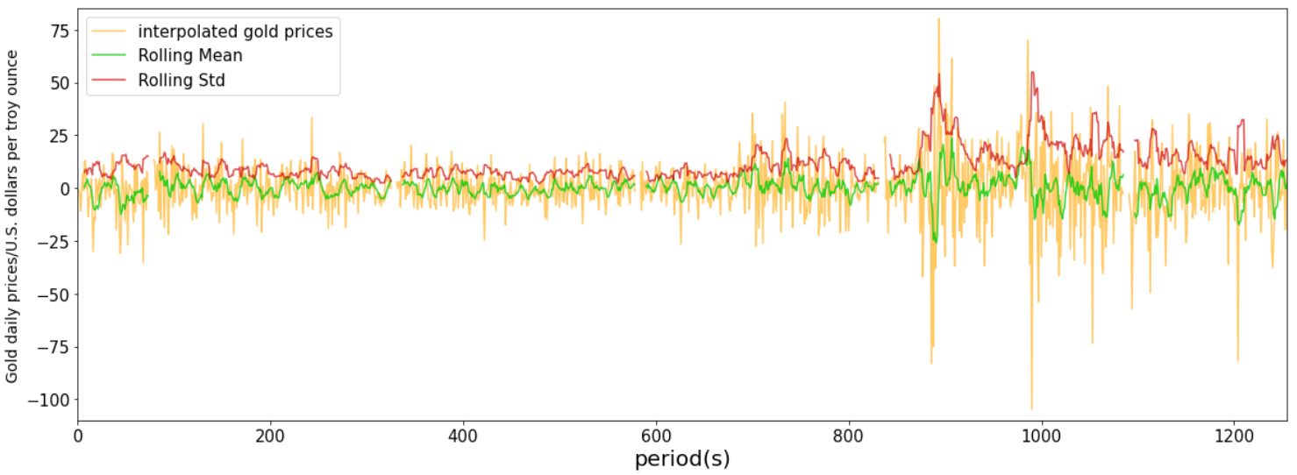

**Figure 4. Preprocessing of gold price data**

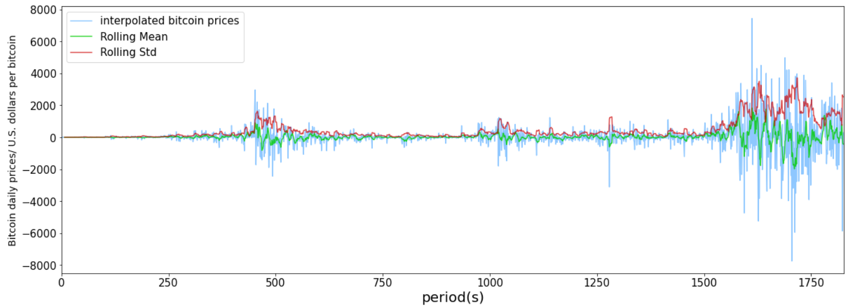

**Figure 5. Preprocessing of bitcoin price data**

The whole process of price prediction is elaborated as follows. Over the first week, since we’ve just entered the market and hardly have any information about current conditions, a wise strategy is to sit tight, watch the market and collect data for the future. Then, from the day after the first week to the end of the first year, we apply the moving average approach for prediction. The reason is that machine learning and deep learning methods rely heavily on big data. However, data volume in the first year is not large enough for model training. Thus, machine learning models are not suitable for prediction over the first year. Here we take seven days as a window to calculate the moving average of prices within this period. After that, this moving average is used as the next day’s predicted price. This method conforms to the mean reversion theory, which is kind of conservative. However, that makes sense since being prudent while not having much knowledge about the market is a smart move.

From the second year to the last, we develop an ensemble forecasting model that integrates XGBoost [7], LightGBM [8], and KNN [9]. The necessity of using an ensemble model instead of a single model will be interpreted later. In order to forecast the price on day  (), data from day  to day  are used for model training. While training, a sliding window of 30 days is defined and the task of the model is to extract certain features from the past 30 days for price forecasting on the 31st day. As the window slides over 365 days, the model will adjust weights according to the loss function and optimize the output after each iteration. Thus, every time we want to predict a new price, we have to train the model all over again, since information the day before should be added into model training for the accuracy of prediction.

Before we come up with the idea to use an ensemble model, we conduct an experiment where a single model is used for gold and bitcoin price prediction respectively. Then, we calculate the residual correlations which are depicted in **Figure 6**. It can be seen that correlations of the three models are not too close to 1, so it would make sense to ensemble the methods and see how they behave. After numerous experiments, we obtain the best weights of XGBoost, LightGBM, and KNN:

* For gold, XGBoost : LightGBM: KNN=0.4 : 0.3 : 0.3
* For bitcoin, XGBoost : LightGBM : KNN=0.7 : 0.1 : 0.2

|  |  |
| --- | --- |
|  |  |
| (a) residual correlation of gold price | (b) residual correlation of bitcoin price |

**Figure 6. Residual correlation of XGBoost, LightGBM, and KNN**

Metrics to measure the performance of XGBoost, LightGBM, KNN, and our ensemble model are listed in **Table 4**. In comparison, our ensemble model has the best outcome.

**Table 4. Metrics for gold and bitcoin prediction**

|  |  |  |  |  |  |  |  |  |  |
| --- | --- | --- | --- | --- | --- | --- | --- | --- | --- |
| **Model** | **Metrics for gold prediction** | | | |  | **Metrics for bitcoin prediction** | | | |
| MAE | RMSE | MAPE | R2 |  | MAE | RMSE | MAPE | R2 |
| XGBoost | 11.842 | 17.805 | 0.0074 | 0.9948 |  | 626.799 | 1244.182 | 0.0374 | 0.9926 |
| LightGBM | 14.330 | 21.791 | 0.0089 | 0.9923 |  | 779.723 | 1612.24 | 0.0442 | 0.9877 |
| KNN | 13.298 | 19.589 | 0.0083 | 0.9938 |  | 663.004 | 1323.479 | 0.0387 | 0.9916 |
| Ensemble | **11.433** | **16.971** | **0.0072** | **0.9953** |  | **586.528** | **1158.152** | **0.035** | **0.9936** |

Results of the whole prediction process are shown in **Figure 7** and **Figure 8**, from which we can conclude that the predicted prices fit the original data well.

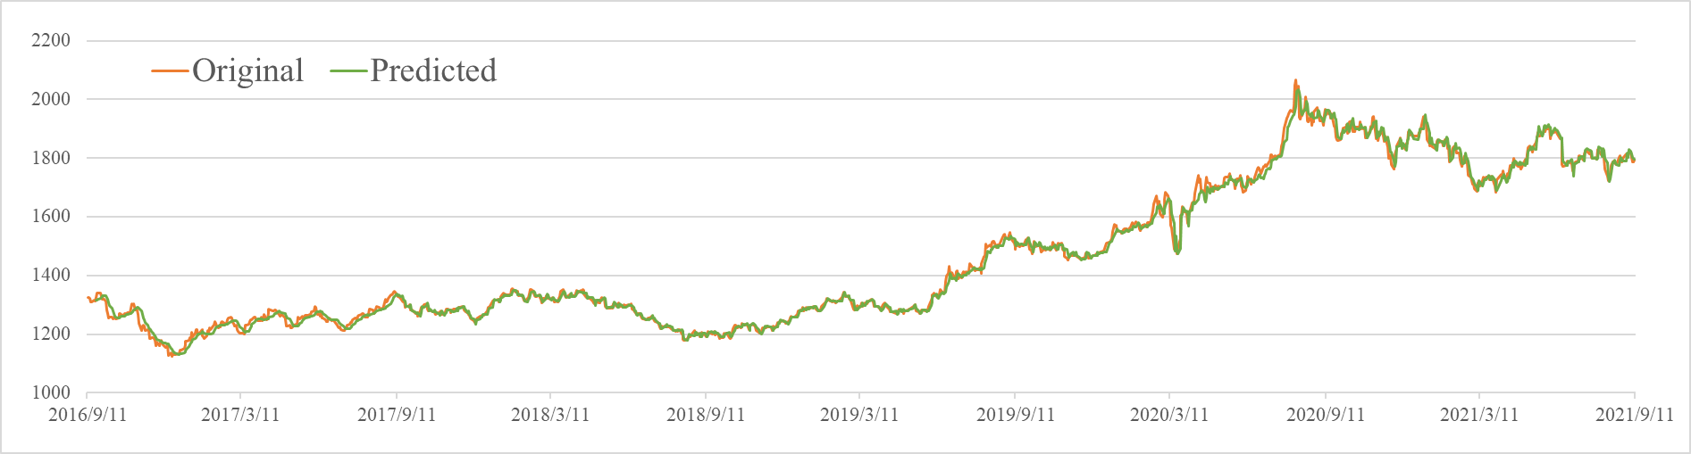

**Figure 7. Comparison of prediction and true gold prices**

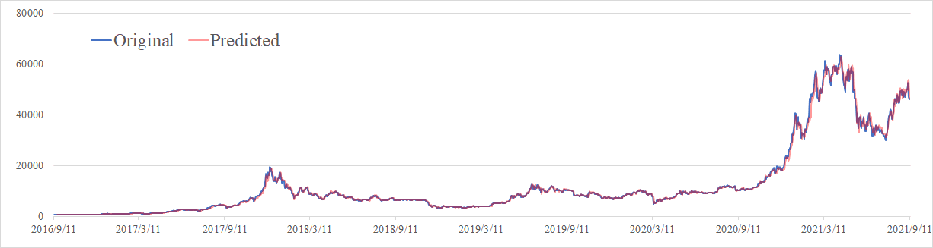

**Figure 8. Comparison of prediction and true bitcoin prices**

## The Decision Model: Greedy Prophet’s selection

We proposed a decision model that takes the greedy strategy: its goal is to optimize tomorrow’s profit based on the predicted price. This scheme fully uses the results of the prediction model which has been proved to have satisfying performance in the former section. So, the strategies seem like those that would be made by a greedy prophet.

The decision model is detailed as follows. The decision variables are trading amounts (USD) of gold and bitcoin on the current day:  and . At the end of the day, the prices of gold and bitcoin,  and , will be revealed. Then, we will update the holdings of cash, gold, and bitcoin respectively:

|  |  |
| --- | --- |
|  | () |
|  | () |
|  | () |

After that, we can calculate the cumulative wealth as:

|  |  |
| --- | --- |
|  | () |

The whole optimization problem could be formulated as:

|  |  |
| --- | --- |
|  | () |

Subject to equation (1)-(4) and:

|  |  |
| --- | --- |
|  | () |
|  | () |
|  | () |
|  | () |
| ，， | () |
|  | () |

Equations (6)-(8) regulate that current assets would be held over the first week and last day; equation (9) stipulates the trading days of gold, (10)-(11) describes constraints on holdings and trading amount so that they have physical meanings.  is a parameter that indicates the conservativeness of the trader. The more conservative the trader, the smaller the value of . Although absolute values seem tricky, they can be eliminated by certain transformations (introducing two nonnegative variables), then the problem becomes linear and can be easily solved.

After trying different degrees of conservativeness, we find that  will give the best outcome. Strategy of buying, selling, and holding gold and bitcoin is depicted in bar charts in **Figure 9**, which is represented as the trading volume (troy ounces for gold; bitcoin numbers for bitcoin) on that day. Total cumulative wealth measured by USD is illustrated in **Figure 10**. Ultimate wealth on 9/10/2021 under our strategy given by the “greedy prophet” is **1,533,432**.

|  |
| --- |
|  |
|  |

**Figure 9. Trading strategy of gold (up) and bitcoin (down)**

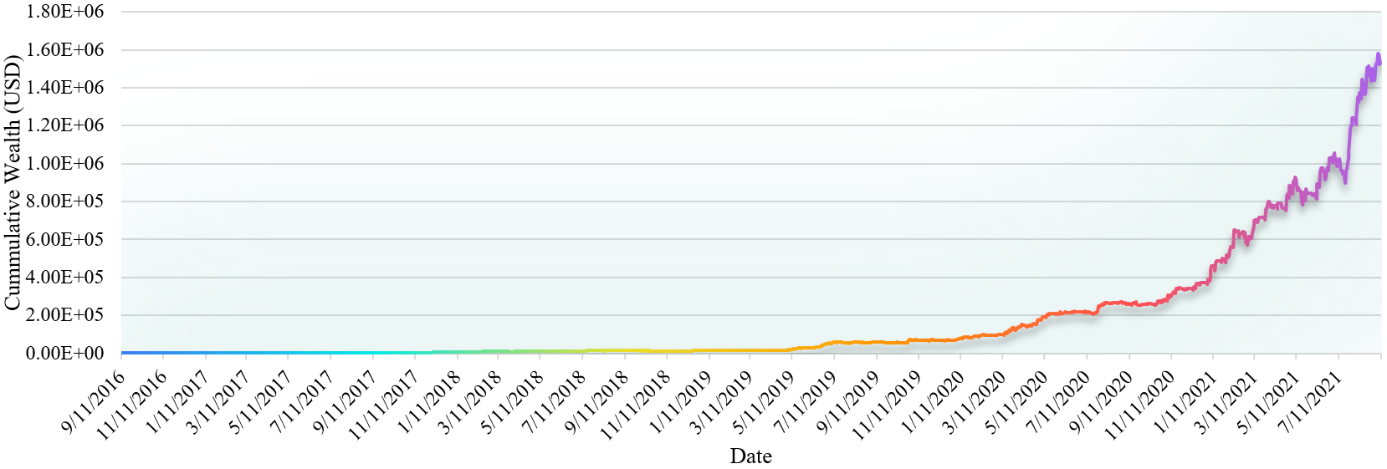

**Figure 10. Total cumulative wealth**

# Proof of Optimality

Several other models that provide various strategies are developed in this section to prove the optimality of our model. To decide a trading strategy on the current day, we need to determine whether to buy, sell, or hold on that day and the amount for trading. Here for simplicity, we assume that these competitors use the same approach to decide the amount for trading: if the asset is to be bought, the buying amount is  () of the current holdings of cash; if the asset is to be sold, the selling amount is  of the current holdings of that asset. The difference between the competitors lies in how they decide whether to buy, sell, or hold.

## Competitor 1: Sliding Window Trading Strategy

The Sliding Window (SW) trading strategy is simply based on the current day’s price and the maximum and minimum prices over the past 30 days. If the current price is larger than the maximum historical price, then a purchase will occur; if the current price is smaller than the minimum historical price, then decision of selling will be made. In other cases, the model will hold current assets.

## Competitor 2: Long Short-Term Moving Average Trading Strategy

Moving average is one of the most popular technical indicators in the Forex market. It works by smoothing out price by averaging fluctuations into a single line that ebbs and flow with them. Based by simple moving average, we developed a Long Short-Term Moving Average (LSTMA) method which combines a short term (7-day) moving average (SMA) and a long term (30-day) moving average (LMA) to make decisions. The trading strategy is set as follows:

* For bitcoin, buy if SMA>1.1LMA, sell if SMA<0.9LMA.
* For gold, buy if SMA>1.02LMA, sell if SMA<0.98LMA.

## Competitor 3: N-Period Moving Average Trading Strategy

The N-period Moving Average (NPMA) is a basic average of price over the specified timeframe. This simple moving average is often used as part of trend-following systems. Price will tend to be above moving averages in uptrends as various lower prices will be baked into the reading from earlier in the trend; while in a downtrend, the moving average will be negatively sloped and price will be below the moving average.

In section 4.2, we’ve investigated the maximum uplift and decline of gold and bitcoin. As to bitcoin, prices fluctuate dramatically, with the largest drop and increase being -39.14% and 21.867% respectively. So, if the prediction is accurate enough, strategy of short term trading (opportunism) is preferable because it can help to speculate with rising prices and avoid potential risks when recession is about to strike. In this case, 5-day moving average (5d-MA) is applied for bitcoin trading. On the other hand, the volatility of gold is relatively small, with the largest drop and increase of -5.128% and 5.268%. With the save haven feature, gold can be regarded as a method for hedge protection; and thus, intermedium or long term trading is more suitable for it. Therefore, 20-day moving average (20d-MA) is applied for gold trading. The right times for selling, buying, and holding bitcoin and gold are analyzed as follows.

For bitcoin, two situations are the best times for selling. The first is when the closing price is far higher than the 5d-MA, i.e., the 5BIAS is too large (we stipulate the threshold as >10%). The second selling opportunity that should be seized occurs when the closing price is below the 5d-MA within 5-10%. For buying, the right time comes when the closing price is below the 5d-MA more than 10% and above the 5d-MA within 5-10%. Finally, when the closing price is below or above the 5d-MA within 5%, it’s better to just hold. While for gold, it’s suitable for sale when the closing price exceeds the 20d-MA too much, i.e., the 20BIAS is too large (we stipulate the threshold as >3%). Opportunities for buying happen when the closing price is below the 20d-MA more than 3%. Holding is suggested when the closing price is below or above the 20d-MA within 3%.

## Competitor 4: Radical Disciple Trading Strategy

The Radical Disciple (RD) trading strategy is based fully on the prediction results given by our “ensembled prophet”. If the “prophet” predicts that price will increase the next day, then the model will buy; while a prediction of price decline will lead to a sale decision. This strategy behaves like a radical disciple of the prediction model, that’s how it got its name.

## Competitor 5: Conservative Disciple Trading Strategy

Although the Conservative Disciple (CD) trading strategy also fully trusts the prediction results given by our “ensembled prophet”, its trading behavior is constrained by the predicted change rate of prices. For asset , its predicted price change rate on day  is denoted as , and it is calculated as . The trading strategy is set as follows:

* For gold, buy if ; hold if ; sell if .
* For bitcoin, buy if ; hold if ; sell if .

## Comparison of various strategies

In order to see how the predetermined trading amount will affect the outcome, we set different values to . From 1 to 10,  increase gradually with a step of 1. Then, from 10 to 50,  becomes larger with a step of 10. We compare the abovementioned five competitors with our “greedy prophet”. The ultimate cumulative wealth (USD) is calculated as an indicator for model evaluation, whose values are shown in **Table 5**.

**Table 5. Comparison results of five competitors and “greedy prophet”**

|  |  |  |  |  |  |  |
| --- | --- | --- | --- | --- | --- | --- |
|  | **SW** | **LSTMA** | **NPMA** | **RD** | **CD** | **Greedy Prophet** |
| 1% | 15521.89 | 11975.57 | **8743.22** | **5509.86** | **1537.59** | **1,533,432** |
| 2% | 18410.24 | 13620.18 | 7517.53 | 4225.17 | 1511.49 |
| 3% | 9231.43 | 13532.33 | 6175.07 | 3535.14 | 1463.19 |
| 4% | 19481.10 | 3137.70 | 5209.56 | 3107.14 | 1422.97 |
| 5% | 9543.64 | 12890.55 | 4524.30 | 2809.47 | 1389.96 |
| 6% | **19529.54** | 12864.40 | 4023.34 | 2587.69 | 1362.37 |
| 7% | 19476.34 | 13022.53 | 3643.32 | 2413.45 | 1339.10 |
| 8% | 19401.68 | 13309.69 | 3344.15 | 2269.89 | 1319.52 |
| 9% | 19317.10 | 13678.07 | 3100.37 | 2146.49 | 1303.16 |
| 10% | 19231.25 | 14091.95 | 2895.62 | 2036.56 | 1289.67 |
| 20% | 18914.24 | 17808.48 | 1732.32 | 1227.94 | 1252.30 |
| 30% | 9094.127 | 19466.26 | 1191.80 | 718.51 | 1285.31 |
| 40% | 19150.56 | **19909.03** | 904.40 | 416.62 | 1329.06 |
| 50% | 19100.36 | 19823.80 | 732.31 | 240.64 | 1371.14 |

It can be discovered that our “greedy prophet” far exceeds other competitors. Among the five competitors, LSTMA has the best performance, though the cumulative wealth under this strategy is 1.3% of that under “greedy prophet”. The second best strategy is given by SW which has an ultimate wealth that is 1.9% lower than LSTMA. Then, NPMA gives an ultimate wealth that is lower than half of that given by the first two competitors. At last, the two methods that rely heavily on prediction results have the worst performance, with CD generating the lowest return. Still, CD is making profits without having any loss of the initial capital.

Possible reasons are given as follows. The first three competitors all consider historical prices but do not use the prediction results of “greedy prophet”. They use different approaches for trend projection and trading decisions. LSTMA has the best performance among the three because it is less conservative than SW and more prudent than NPMA. A lesson could be learned that striking a balance between conservativeness and aggressiveness is essential to investment. The last two competitors exclude historical prices and trust the prediction model blindly. The aftermath is not having satisfying outcomes. Here, RD is making more profits than CD, which indicates that wise investors should avoid being too credulous and conservative simultaneously.

It should be noted that although we tried deep learning models such as LSTM (Long Short-Term Memory) and Informer (a derivative of Transformer which belongs to the Seq2Seq models), their outcomes are not good: the ultimate wealth is worth even less than 1000 USD. The reason is that deep learning models entail massive data for training, while the total number of records that we have is 1826. Therefore, it is not reasonable to use these deep learning models.

Another possible candidate would be reinforcement learning models which are widely used in the field of quantitative transaction. However, reinforcement learning methods are even more desperate for large volume of data than deep learning models. Since “trial and error” is the takeaway of reinforcement learning, it usually requires tens of thousands of records for model training so as to make the model converge and have an acceptable outcome. Hence, reinforcement learning is also not suitable for this problem.

# Sensitivity to Transaction Costs

Transaction costs are costs incurred when making economic transactions. They don’t accrue to any participant of the transaction. In economics, the theory of transaction costs is based on the assumption that people are influenced by competitive self-interest. Typically, transaction costs could involve three types: 1) search and information costs when looking for stockbrokers with the best commission; 2) bargaining costs when drawing up a contract that is agreeable to parties involved; and 3) margin paid to an intermediary when trading assets. In the given context, only the third type is considered, i.e., transaction costs are caused by  and .

To analyze our model’s sensitivity to transaction costs, four situations are designed, which involve various combinations of  and . We solve the corresponding strategies and cumulative wealth for further analysis. The ultimate wealth  is listed along with those combinations for evaluation in **Table 6**. Note that the maximum commission is set as 6%. Besides, the number of buys and sales of gold and bitcoin and the average trading amount for gold and bitcoin every time are computed and listed in **Table 7** to indicate the influence on the trading strategy.

**Table 6. Ultimate wealth under four transaction costs combinations**

|  |  |  |  |  |
| --- | --- | --- | --- | --- |
| **Situation** |  |  |  | **(USD)** |
|  |  | 0 | 0 | — |
|  |  | 0.5% | 1% | 113,729,400 |
|  | **1%** | **2%** | **1,533,432** |
|  | 2% | 4% | 31,500 |
|  | 3% | 6% | 3,153 |
|  |  | 1% | 1% | 87,922,700 |
|  | 2% | 2% | 1,752,545 |
| **Table 6. Ultimate wealth under four transaction costs combinations (Cont)** | | | | |
| **Situation** |  |  |  | **(USD)** |
|  |  | 4% | 4% | 41,184 |
|  | 6% | 6% | 4,254 |
|  |  | 1% | 0.5% | — |
|  | 2% | 1% | 85,441,480 |
|  | 4% | 2% | 2,562,811 |
|  | 6% | 3% | 274,686 |

**Table 7. Number of buys and sales and average trading amount**

|  |  |  |  |  |  |  |
| --- | --- | --- | --- | --- | --- | --- |
|  |  | **Number of buys and sales** | |  | **Average trading amount** | |
| **Bitcoin** | **Gold** |  | **Bitcoin** | **Gold** |
| 0 | 0 | — | — |  | — | — |
| 0.5% | 1% | 680 | 342 |  | 6603969.14 | 7751736.74 |
| 1% | 2% | 487 | 135 |  | 155711.04 | 185329.60 |
| 2% | 4% | 246 | 42 |  | 6934.43 | 7368.98 |
| 3% | 6% | 158 | 7 |  | 1248.44 | 1727.01 |
| 1% | 1% | 675 | 200 |  | 5552938.40 | 5338377.82 |
| 2% | 2% | 500 | 46 |  | 163726.05 | 122800.81 |
| 4% | 4% | 260 | 2 |  | 9041.17 | 897.87 |
| 6% | 6% | 161 | 2 |  | 1557.09 | 879.96 |
| 1% | 0.5% | — | — |  | — | — |
| 2% | 1% | 726 | 97 |  | 5444159.42 | 1801019.27 |
| 4% | 2% | 532 | 4 |  | 223678.96 | 478.06 |
| 6% | 3% | 375 | 2 |  | 41399.99 | 25.89 |

In **Table 6**, it can be found that whatever the relationship between  and , total wealth will decrease as the transaction costs increase, because they diminish returns, and over time, high transaction costs can mean thousands of dollars lost from not just the costs themselves but also profits that could have been earned: the amount of capital available to invest is also reduced by transaction costs. Therefore, the influence of transaction costs on returns and cumulative wealth is unavoidable. An interesting phenomenon is that when the transaction cost of gold increases to a certain degree, the total wealth will become larger than that when the commission of gold is lower. A potential explanation could be that since the commission of trading gold is too high compared to its trivial profit, the model is enforced to trading bitcoin even though it has to shoulder higher risks. Fortunately, the overall trend of bitcoin is upwards, that’s why the ultimate wealth happens to grow larger.

Likewise, the existence of transaction cost also exerts an impact on trading strategies. The number of buys and sales and average trading amount is negative with transaction costs. So, it could be concluded that transaction costs may alleviate excessively frequent trading behaviors in the market, which, on the other hand, could avoid certain risks.

# Model Evaluation and Further Discussion

## Strengths

Our model has the following strengths that make it eclipse others:

1. **Outstanding performance and great applicability**

Prediction results of the “ensembled prophet” are accurate and do not rely on massive data for model training. As has been proved before, the ensemble model has the best performance in comparison with single models, and the metrics are all satisfied. Contrary to most machine learning methods that rely heavily on large volume of data for training, our model is able to provide accurate forecasting based on less than 500 records because the ensemble model also applies moving average apart from XGBoost, LightGBM, and KNN. Besides outstanding performance, the structure of our prediction model is not as complicated as deep learning time series models such as LSTM (Long Short-Term Memory) model or Seq2Seq (like Transformer) models, as well as reinforcement learning methods. Thus, the time for prediction is within 15 seconds, while the other two models take around 30 minutes. With all these features, we can say that our model has great applicability.

1. **Simple to understand and easy to solve**

Obtaining the best trading strategy is represented as a mathematical optimization problem in our decision model. Different from many other theories that directly regulate the trading amount according to experts’ experience or statistical analysis, our model set trading amount as variables only limited by total wealth, with the objective to maximize anticipated return on the next day. The model is simple to understand without involving too many economic concepts or terms. So, even those who are rookie investors can comprehend the principles of it. Also, since transformations are conducted to convert the problem to linear programming, it’s easy to obtain exact solutions and give the optimal cumulative wealth. This strength overshadows many other heuristic algorithms such as genetic algorithm, simulated annealing algorithm, and particle swarm optimization algorithm, which cannot ensure the solutions are optimal.

1. **Hight return and risk resistance**

According to section 6, our model far outperforms the other 5 competitors and gives the highest ultimate wealth of **1,533,432**. This reward is very spectacular. Also, the total cumulative wealth depicted in **Figure 10** suggests that our model has the ability to avoid risks during a bear market (when price keeps declining), to some extent.

## Weaknesses

Admittedly, the “greedy prophet” does have some weaknesses. The first is that always applying greedy policy requires the prediction results to have very high accuracy. Yet, it is impossible to be one hundred percent sure about the predicted price no matter what method is applied, because of the unavoidable uncertainty. So, misjudgment of future prices does exist. As a result, the “greedy prophet” can make wrong decisions about trading and thus lose money. However, since we add a manually adjusted parameter  to constrain the conservativeness and aggressiveness of the model, impulse trading could be alleviated to a certain extent. Still, value of  varies from person to person, finding the optimal  may be an arduous task.

What’s more, since we’re only allowed to use historical records of gold and bitcoin prices, “greedy prophet” is unable to consider other factors which are also essential to trend prediction and portfolio selection. Another weakness caused by the limitation of this problem is that only cash, gold, and bitcoin are involved. In the real world, investment choices could incorporate other assets such as bonds, mutual funds, stocks, and real estate. Thus, due to the limit of information and time, diversity of portfolio is not represented in the model.

## Further Discussion

In future works, analysis on investment risk could be added into our model to reduce the dependency on prediction results. Both the risk of a single asset and the risk of portfolio assets should be taken into account. The former can be reflected by return volatility, which is calculated by the standard deviation of historical returns. The latter can refer to the definition of portfolio risk in Modern Portfolio Theory, which is a function of the variances of each asset and the correlations of each pair of assets.

What’s more, instead of using manual adjustment, deep learning models could be developed to get the optimal value of conservativeness . For each trader, surveys, tests, or big data analysis could be conducted to extract their investment psychology, trading behavior, risk tolerance, expected return, special preferences, and so on. Then, these features are input into the deep learning model to output the corresponding best  for each individual.

# Memorandum

The following memorandum incorporates the introduction of our “greedy prophet”, some essential points of the best strategy, and the ultimate wealth.

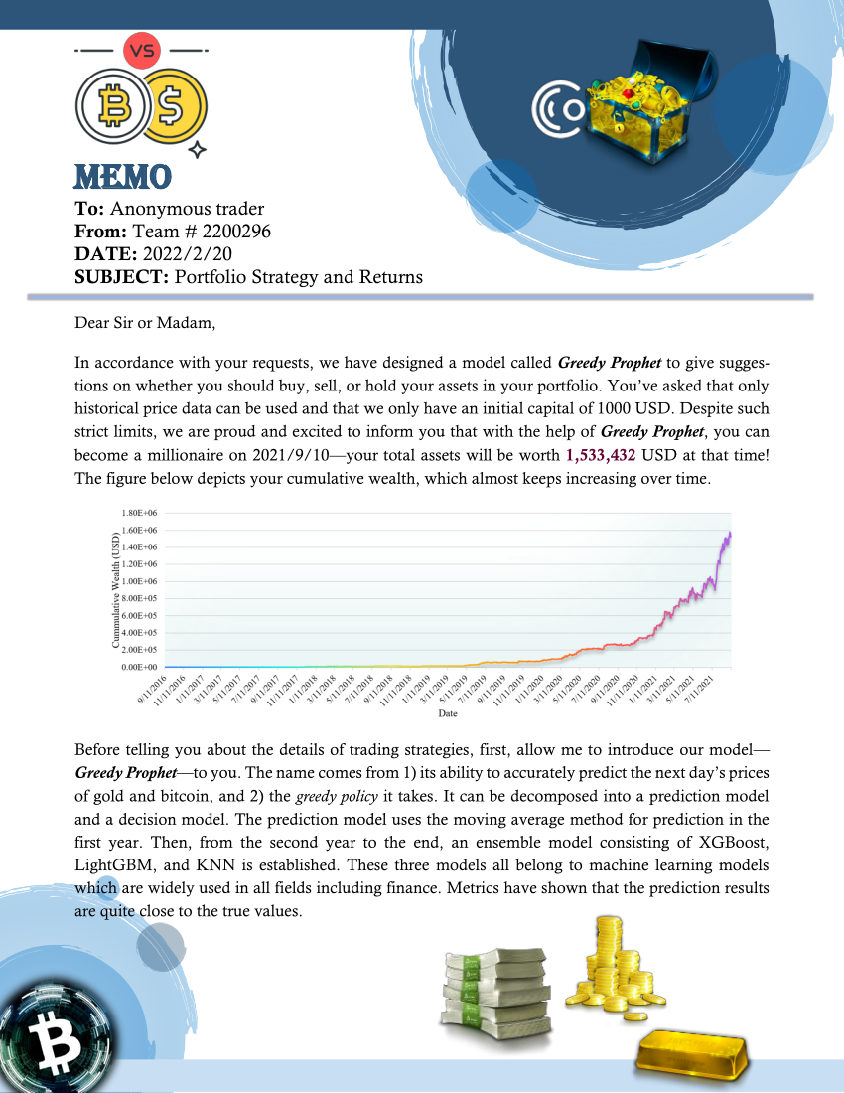



# References

[1] S. Nakamoto, "Bitcoin: A Peer-to-Peer Electronic Cash System," *Cryptography Mailing list at* [*https://metzdowd.com*](https://metzdowd.com)*,* 03/24 2009.

[2] B. Li and S. C. H. Hoi, "Online portfolio selection: A survey," vol. 46, no. 3 %J ACM Comput. Surv., p. Article 35, 2014, doi: 10.1145/2512962.

[3] B. Li and S. C. H. Hoi, *Online portfolio selection: principles and algorithms*. Crc Press, 2018.

[4] S. Guo, J.-W. Gu, and W.-K. Ching, "Adaptive online portfolio selection with transaction costs," *European Journal of Operational Research,* vol. 295, no. 3, pp. 1074-1086, 2021/12/16/ 2021, doi: <https://doi.org/10.1016/j.ejor.2021.03.023>.

[5] S. Corsaro, V. De Simone, Z. Marino, and S. Scognamiglio, "l1-Regularization in Portfolio Selection with Machine Learning," *Mathematics,* vol. 10, 02/09 2022, doi: 10.3390/math10040540.

[6] F. D. Paiva, R. T. N. Cardoso, G. P. Hanaoka, and W. M. Duarte, "Decision-making for financial trading: A fusion approach of machine learning and portfolio selection," *Expert Systems with Applications,* vol. 115, pp. 635-655, 2019/01/01/ 2019, doi: <https://doi.org/10.1016/j.eswa.2018.08.003>.

[7] T. Chen and C. Guestrin, *XGBoost: A Scalable Tree Boosting System*. 2016, pp. 785-794.

[8] G. Ke *et al.*, "LightGBM: a highly efficient gradient boosting decision tree," presented at the Proceedings of the 31st International Conference on Neural Information Processing Systems, Long Beach, California, USA, 2017.

[9] T. Cover and P. Hart, "Nearest neighbor pattern classification," *IEEE Transactions on Information Theory,* vol. 13, no. 1, pp. 21-27, 1967, doi: 10.1109/TIT.1967.1053964.