**DATA ANALYSIS REPORT**

**PRODUCT RETURN RATE**



**Compiled by:**

**Randall Campher**

**Contents**

1. Executive Summary i

2. Introduction 1

3. Project Objective 1

4. Data and Methodology 1

a.Requirements Gathering 1

b.Understanding Data Requirements 1

c.Clean & Prepare Data 2

d.Exploring and Visualising Data 2

e.Analyse Data 2

f.Visualising Results 4

5. Tech Stack 5

6. Recommendations 5

7. Conclusion 6

# 1. Executive Summary

This project investigates the relationship between product quality and product return rates at Take-a-Tech, a leading e-commerce retailer in electronics. Through data analysis and statistical testing, the study aimed to determine if product quality significantly influences return rates.

The results of a Chi-square test indicated no statistically significant correlation between reported quality issues and the rate of returns. This suggests that while quality concerns might influence customer perceptions, other factors could be impacting return rates.

# 2. Introduction

Take-a-Tech, a prominent player in the online electronics retail space, is facing challenges with a high rate of product returns. This study aims to assess whether product quality is a significant driver behind these returns, providing actionable insights to help Take-a-Tech improve its return rate, sales volume, and overall customer satisfaction.

# 3. Project Objective

The objective of this analysis is to explore the relationship between product quality and return rates, helping to identify if quality concerns significantly impact customer return behaviours. The analysis leverages industry-standard metrics like product return rate and sales volume as part of the evaluation.

# 4. Data and Methodology

## a. Requirements Gathering

After a meeting with the Customer Care department, the following requirements were sourced:

* Objective: explore whether product quality is the leading factor leading to the return of products.
* Product return rate is the key performance indicator to focus on:
$$Product Return Rate \left(PRR\right)= \left(\frac{Number of Return Products}{Total Number of Products Sold}\right) ×100$$

* The summation of the analysis to be submitted in excel workbook format.

## b. Understanding Data Requirements

In order to analyse product return rate, data on products, customer feedback and sales will be needed.

* Product Data: Specifications, categories and quality attributes.
* Customer Feedback: Surveys and comments highlighting reasons for returns.
* Sales Data: Records of sales transactions.

## c. Clean & Prepare Data

Addressed missing values, duplicate records and normalised date features for accurate analysis

## d. Exploring and Visualising Data

Descriptive analysis was performed on the data to establish key data statistics such as mean, max, min, etc. Subsequently, different data tables were joined and visualised by means of charts and graphs to establish key trends and patterns.

## e. Analyse Data

Included the calculation of product return rate, performing statistical chi-squared test to investigate any association between product quality and product returns by customers, generation of insights and delivering recommendations.

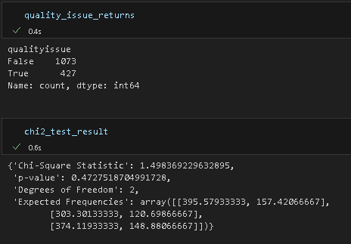

With a p-value of 0.4727, the null hypothesis could not be rejected. This means there is no statistically significant evidence to suggest that product quality issues are strongly correlated with return rates. This outcome suggests that while quality concerns may influence individual cases, they are not the primary driver behind the high return rates at Take-a-Tech.

The graph below showed that "wrong item received" and "changed my mind" were frequent reasons for returns, suggesting a potential gap between customer expectations and product descriptions.

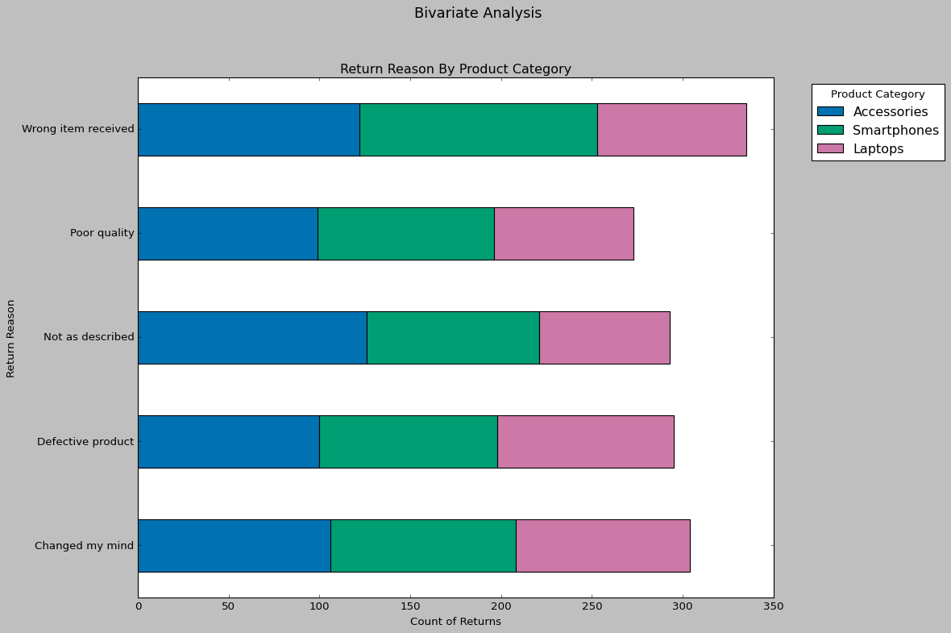

A plot below compares quality issues with return frequencies and do not show a clear negative correlation, implying that even product categories with lower quality issues experienced returns.

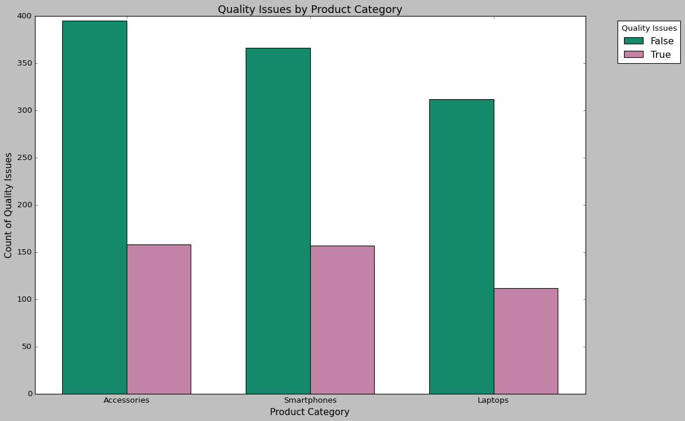

Analysing customer comments revealed that factors like wrong item received, unmet expectations, inadequate descriptions and delays in delivery were common complaints alongside quality. These insights underscore the need to address multiple facets of the customer experience.

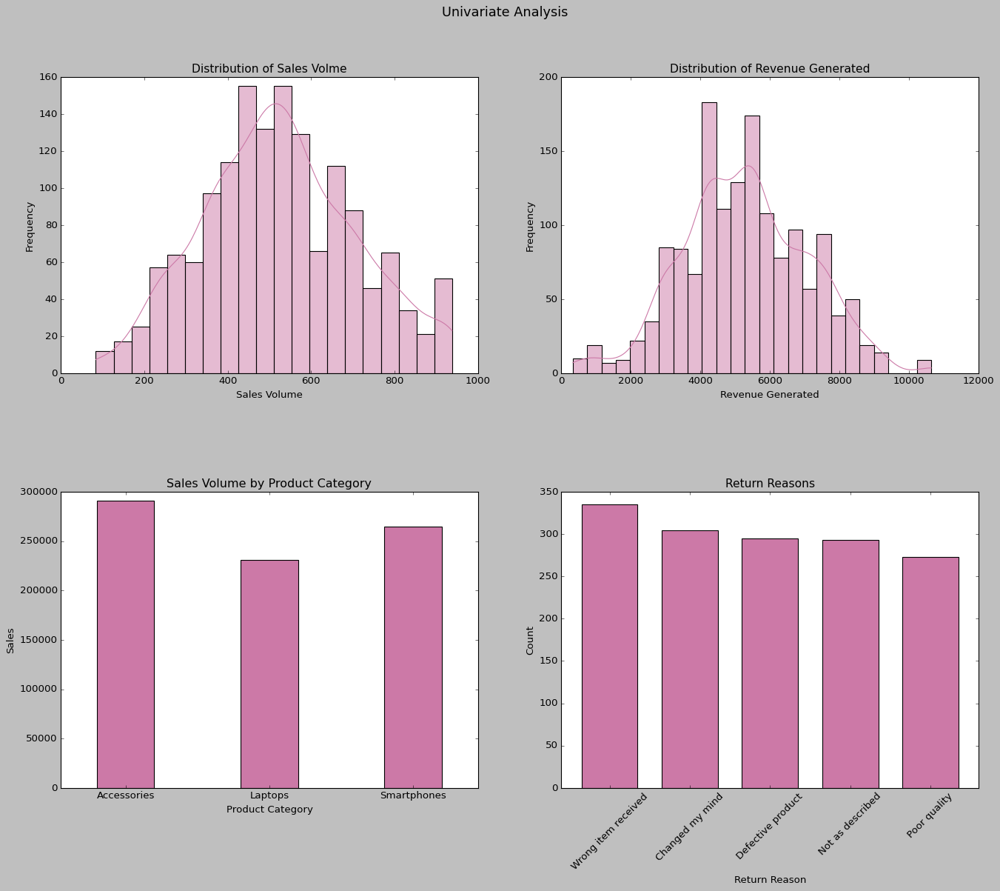

## f. Visualising Results

The summation of the analysis was prepared in excel workbook format as requested.

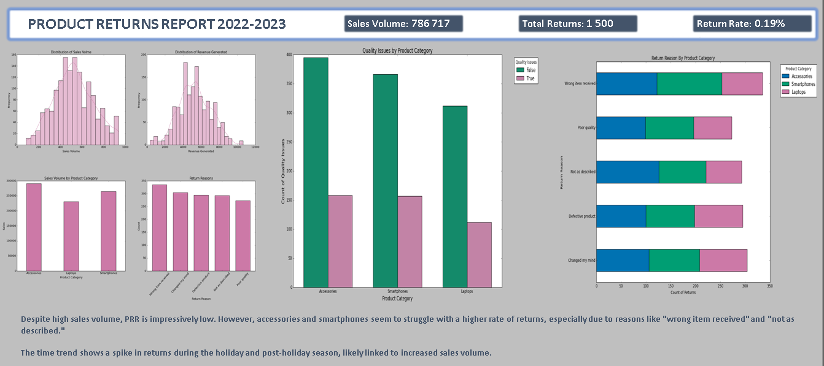

# 5. Tech Stack

Tools- SQL, Python, GitHub and PowerPoint will be used for this project.

MySQL:

✓ Data Collection and Storage

✓ Structured Data Storage

✓ Data retrieval & Manipulation

Python:

✓ Numpy: For performing mathematical operations over data

✓ Pandas & Seaborn: For Data Analysis and Manipulation

✓ Matplotlib.pyplot: For Data Visualisation.

GitHub:

✓ For documenting the analysis.

PowerPoint:

✓ For presenting the analysis.

# 6. Recommendations

Although the direct impact of quality on returns was not significant, reducing the overall product return rate remains critical. Industry benchmarks suggest aiming for a return rate of less than 5% to improve profitability. This can be achieved by addressing other customer pain points like mismatched expectations and providing more detailed product descriptions.

Enhance Product Descriptions to Improve Sales Volume: Improving the transparency and accuracy of product descriptions can help align customer expectations with the product received, reducing returns due to dissatisfaction. Enhanced descriptions may also drive higher sales volume by building customer trust.

Implement NPS Surveys to Track Customer Loyalty: Introduce regular Net Promoter Score (NPS) surveys to better understand customer loyalty and satisfaction levels. Aiming for an NPS score above 50 can serve as a benchmark for strong customer retention and positive word-of-mouth.

Track Customer Satisfaction Scores for Quality Improvement: Conduct post-purchase satisfaction surveys to focus on areas beyond product quality, such as packaging, shipping speed, and customer support. A satisfaction rate above 80% can be targeted as a key performance indicator (KPI) for improving overall customer experience.

# 7. Conclusion

The data analysis did not find a statistically significant relationship between product quality issues and return rates, as indicated by the Chi-square test. This finding suggests that other factors like mismatched customer expectations and inadequate product information may be influencing returns more significantly.

The recommendations provided focus on addressing these aspects through improved product communication and customer feedback mechanisms, Take-a-Tech can work towards reducing return rates, increasing sales volume and enhancing overall customer satisfaction.