Chapter 1 - Git Questions

My github account and address is <http://github.com/randallerasmus>

2

1. C:\Users\User\IdeaProjects\chapter1_2016\git>git init

Initialized empty Git repository in C:/Users/User/IdeaProjects/chapter1_2016/git/.git/

C:\Users\User\IdeaProjects\chapter1_2016\git>

1. C:\Users\User\IdeaProjects\chapter1_2016\git>git status

On branch master

Initial commit

Untracked files:

(use "git add <file>..." to include in what will be committed)

cput.txt

nothing added to commit but untracked files present (use "git add" to track)

**EXPLANATION**

This status shows that that file is untracked and that no commits has been done to the file and that git has not track any files in the folder. This tells git that the file is not in permanent memory.

1. C:\Users\User\IdeaProjects\chapter1_2016\git>git add .

C:\Users\User\IdeaProjects\chapter1_2016\git>git status

On branch master

Initial commit

Changes to be committed:

(use "git rm --cached <file>..." to unstage)

new file: cput.txt

1. C:\Users\User\IdeaProjects\chapter1_2016\git>git commit -m "First Commit"

[master (root-commit) c4ecca9] First Commit

1 file changed, 1 insertion(+)

create mode 100644 cput.txt

C:\Users\User\IdeaProjects\chapter1_2016\git>git status

On branch master

nothing to commit, working directory clean

**EXPLANATION**

This demonstrates that my first change has been tracked in git and are now logged in permanent memory in git.

1. C:\Users\User\IdeaProjects\chapter1_2016\git>git status

On branch master

Untracked files:

(use "git add <file>..." to include in what will be committed)

bellville.txt

mowbray.txt

nothing added to commit but untracked files present (use "git add" to track)

**EXPLANATION**

Files are not tracked yet and not committed to be tracked. This points out that the directory is dirty with untracked files which is not in permanent memory

1. C:\Users\User\IdeaProjects\chapter1_2016\git>git status

On branch master

Changes not staged for commit:

(use "git add <file>..." to update what will be committed)

(use "git checkout -- <file>..." to discard changes in working directory)

modified: cput.txt

Untracked files:

(use "git add <file>..." to include in what will be committed)

bellville.txt

mowbray.txt

no changes added to commit (use "git add" and/or "git commit -a")

1. C:\Users\User\IdeaProjects\chapter1_2016\git>git add .

C:\Users\User\IdeaProjects\chapter1_2016\git>git status

On branch master

Changes to be committed:

(use "git reset HEAD <file>..." to unstage)

new file: bellville.txt

modified: cput.txt

new file: mowbray.txt

**EXPLANATION**

All files in git home directory are tracked now and awaits to be committed to memory. Meaning the files are in read only to the local user on the computer system.

1. C:\Users\User\IdeaProjects\chapter1_2016\git>git commit -m "Commit new files also"

[master e5bf542] Commit new files also

3 files changed, 3 insertions(+), 1 deletion(-)

create mode 100644 bellville.txt

create mode 100644 mowbray.txt

C:\Users\User\IdeaProjects\chapter1_2016\git>git status

On branch master

nothing to commit, working directory clean

1. C:\Users\User\IdeaProjects\chapter1_2016\git>git status –s
2. Emailed problems to Chantel
3. Emailed problems to Chantel
4. C:\Users\User\IdeaProjects\chapter1_2016\git>git rm mowbray.txt

rm 'mowbray.txt'

C:\Users\User\IdeaProjects\chapter1_2016\git>git status

On branch master

Changes to be committed:

(use "git reset HEAD <file>..." to unstage)

deleted: mowbray.txt

Untracked files:

(use "git add <file>..." to include in what will be committed)

.gitignore

EXPLANATION

The status show that one of the files has been deleted and there is one file that still shows untracked.

3. i.

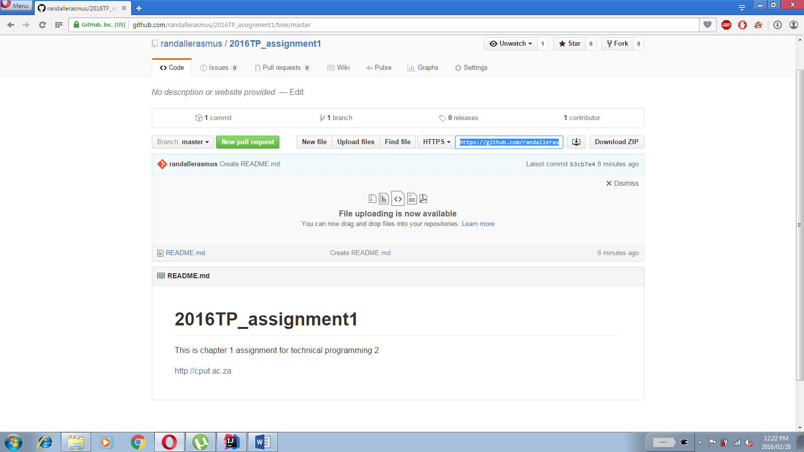

C:\Users\User\IdeaProjects\chapter1_2016>git clone https://github.com/randallerasmus/2016TP_assignment1.git

Cloning into '2016TP_assignment1'...

remote: Counting objects: 3, done.

remote: Compressing objects: 100% (2/2), done.

Unpacking objects: 100% (3/3), done.

remote: Total 3 (delta 0), reused 0 (delta 0), pack-reused 0

Checking connectivity... done.

ii. C:\Users\User\IdeaProjects\chapter1_2016>git remote add origin [git@github.com:randallerasmus/2016TP_assignment1.git](mailto:git@github.com:randallerasmus/2016TP_assignment1.git)

iii. 