Taste System

Software User Manual


Introduction
The Taste System Software is implemented in Matlab and consists of 2 distinct programs (each comprises several modules so the total number of code files is larger)
- TasteExtractData – Extracts experiment data from the recording system (Intan, Davis or TDT photometry system) files and converts them into Matlab files, ready for data analysis.
- TasteAnalysisSW - Data Analysis software designed to generate all sorts of activity presentation graphs, data characterization and statistical analysis reports. In addition the system can export the data into excel files organized in a way that will make it easy to be imported into professional statistical packages.
In addition to the home grown modules, the TasteExtractData software is using Matlab files provided by Intan and TDT to convert their proprietary binary files to Matlab structures which (during the extract process) are repackaged in our proprietary format, and stored in Matlab data files.

Installation
The Taste System SW can be downloaded from GitHub. The Github repository is defined as a private one. In order to download, therefore, a Github account is required and an access permission from Micky.Holtzman@gmail.com
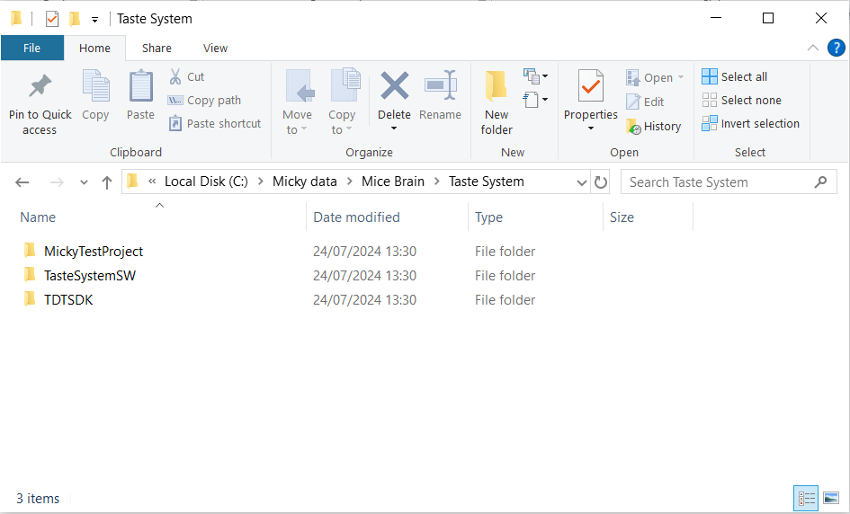
It is organized in a single directory TatstSystemSW which can be placed anywhere in the user space (see example in Figure 1). No special installation and/or registration are required.
Figure 1: SW directory Structure
The TDT software needs to be downloaded from here TDTSDK. The downloaded directory needs (this is what the software is looking for) to be named TDTSDK and placed in the same folder with the TastSystemSW. See Figure 1, for example.

Data Files Organization
The various SW modules expect their input files (and organize their outputs) to be named in a formatted way and stored in a specific directory structure. This is designed to relieve the user from the need to always point the software to the right place and name each input/output file.

Directory Structure
Root Directory
All project data files are stored under one root directory, MickyTestProject in the example above (refer to Figure 2). The directory name is unformatted (free text) and user defined. All the programs will go to this directory for any required input data (with some exceptions - see Additional Data Files section, hereafter). Similarly, all output data will be stored under this directory.
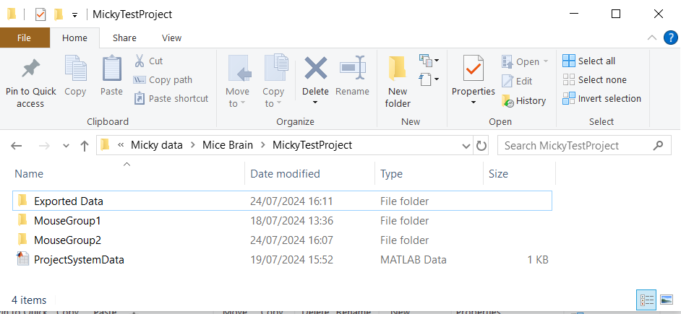
The project root directory includes (see right hand side of Figure 2) the mouse-group directories (MouseGroup1 and MouseGroup2) in the given example, the Exported Data directory and, the ProjectSystemData file, all of which are further described in the following sections.
Figure 2 - Taste system, Data structure
Mouse Group directory
The test subject mice of the taste experiments are organized into groups. All data collected for a mice group is stored under a single Mouse Group Directory. For example see MouseGroup1 and MouseGroup1in Figure 2. The name of the mouse group directory is unformatted (free text) and user defined. The number and size of these mouse groups is user defined, as well.

Mouse Group directories contain the individual mice directories, see Mouse1 directory under the MouseGroup1 directory in Figure 2. Mouse directories are further described in the following sections.
Figure 3: Mouse Directories

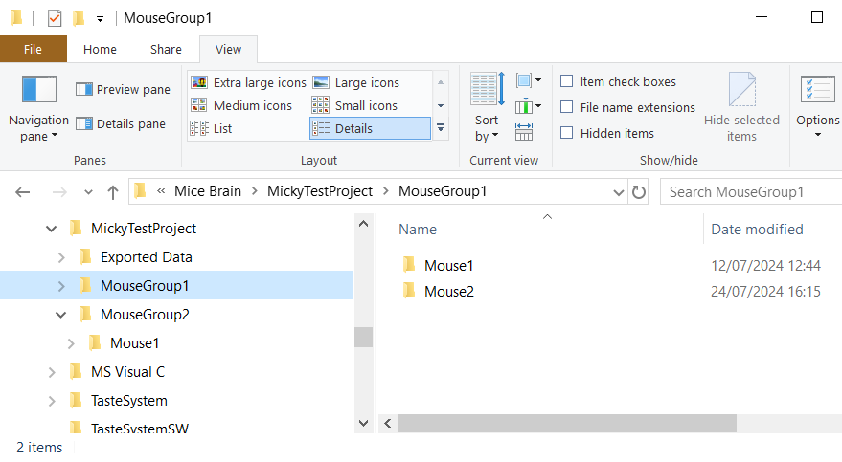
Exported Data Directory
The Taste system is designed to enable exporting the recorded raw-data (in excel format) to be used by other programs (such as SPSS). Data from multiple mice (as well as mouse groups, and or session days) may be exported in a single excel file (see Data Export reports for further information).
The system may store the excel file in different locations in the directory hierarchy based on the mice selected for the Data Export report. When multiple Mouse Groups are selected for export, the output file is stored in this (Exported Data directory under the Project directory) location (see Figure 2). When a single mouse group is selected for export, however, multiple mice, session types or session days are selected, the output file will be stored in the Export Data directory under the selected mouse group directory (such as MouseGroup1 in Figure 4). When a single input file is selected (The experiment, session, mouse and day are all uniquely defined) the data is stored in the Exported Data directory under the selected mouse directory (see Mouse1 in Figure 4).
The directory name is predefined and must be set to the above given name. However, there is no need to generate it manually. The Taste system will generate the Exported Data directory whenever it is needed.
Mouse Directory
All data collected for a given mouse will be stored in a single directory under its mouse group directory. The directory name must be Mouse<n> where <n> is an integer number (for example see Mouse2 in MouseGroup1 (refer to Figure 4). Mouse numbers must be unique per mouse group, but may repeat for different groups such as Mouse1 which appears both in DataCharGrp1 and WaterDrinkingGrp1 (refer to Figure 3).
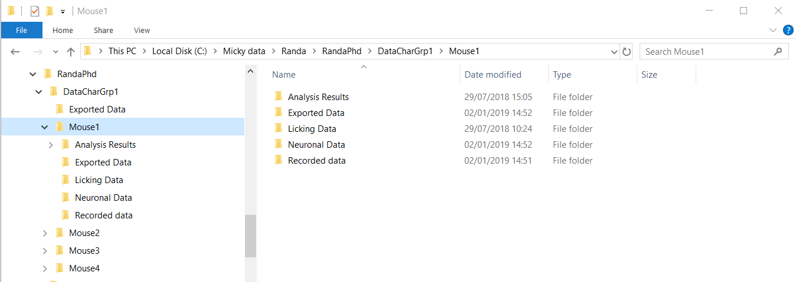
The data associated with a test-subject mouse is organized in four subdirectories: Recorded Data, Licking Data, Neuronal Data, and, Analysis Results.
Figure 4 - Mouse directory
Recorded Data Directory
The Recorded Data directory includes a subdirectory for every Taste test session containing the Recorded data for that session (either Intan *.RHD files, Excel file from Davis, or the TDT data (multiple file types). The directory name is preformatted and follows the following naming convention (refer to Figure 5 for an example):
<date-code>_<session-name>_Day<n> (e.g. 180517_Water_Day1)
<date-code> is a 6 characters date string using the YYMMDD format.
<session-name> is an unformatted, user defined string describing the type (paradigm) of the test performed.
<n> is an integer numeral, used to differentiate multiple runs of the same test session
Creation and naming of these directories is done outside of the Taste System Software, using standard Windows tools. The names of the Intan recording files (.RHD files) is unformatted (free text) and user define (the names generated by the Intan recorded system can be used as well).

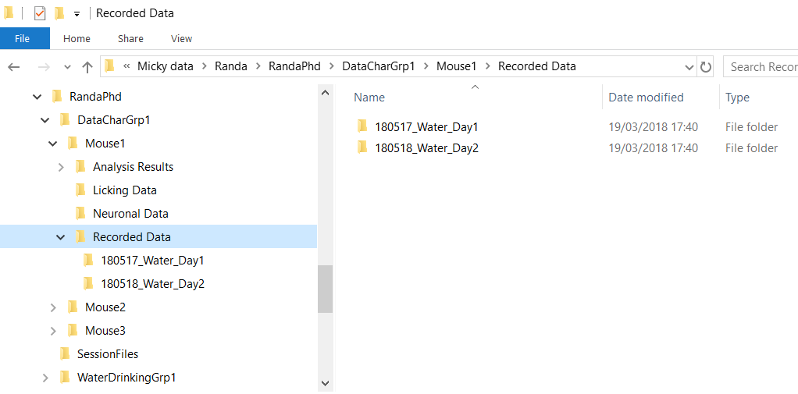
Figure 5 - Recorded data directory

Licking Data Directory
This directory stores Matlab data files (.mat files) containing Licking information.
The file name is formatted (refer to Figure 6) -
<date-code>_<Session-Name>_Day<Day-Number>_behavioral_data.mat
Date-code, Session-name and Day-number have the same meaning and format as for the recorded data sub directories, see that section for more details.
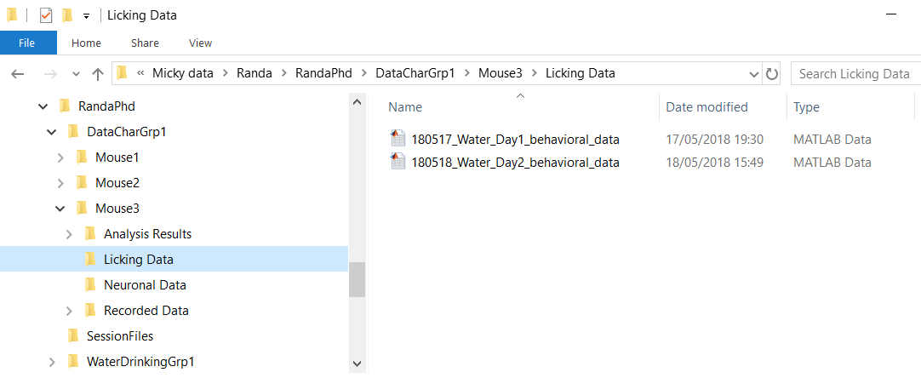
Figure 6 - Licking Data Directory

Neuronal Data Directory

[ To be edited ]

Analysis Results Directory (outdated text)
The system will automatically save two copies of each generated result. The copies are identical in content but differ in file format. While one copy is a picture (.PNG file) the other is a Matlab figure file (.FIG) which can be further edited by Matlab figure editor.
The result files use the standard <date><Session><Day> (see Recorded Data Directory section for more details) and organized into subdirectories, each one of them assigned to one of the result types such as LickingRasterD and LickingRasterS in the following example (refer to
Figure 7).
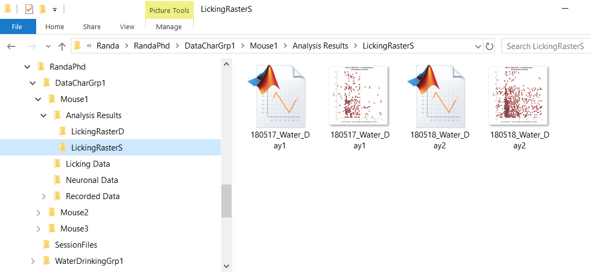
Figure 7 - Analysis Results Directory

Additional, not mouse specific, Data Files
The project data base also includes the following files, which contain management data (as opposed to test results). All of these files are generated by the Taste system software and should not be edited or moved:
- ProjectSystemData.mat – Contains project level configuration information. This file is located in the project root directory.
- TasteProjectDirectory.mat – Points to the root directory of the project. This file is located in the Matlab code directory.
- TasteSWVersions.mat – Contains a list of the current SW version for each of the taste system software modules. This file is located in the Matlab code directory.

Extract Data
The Extract Data module extracts behavioral and neuronal data from the recording system files, converts then into Matlab data (.mat) files which are stored in the relevant directories. This program is using conversion libraries provided by Intan (embedded in our code) and TDT (needs to be copied into the SW directory tree, see Installation section above). Data is extracted from all recorded data present in the recorded data directory. A single Matlab file is generate, for each extraction. A screen shot of the program GUI is provided in Figure 9.
User Interface
Project Parameters
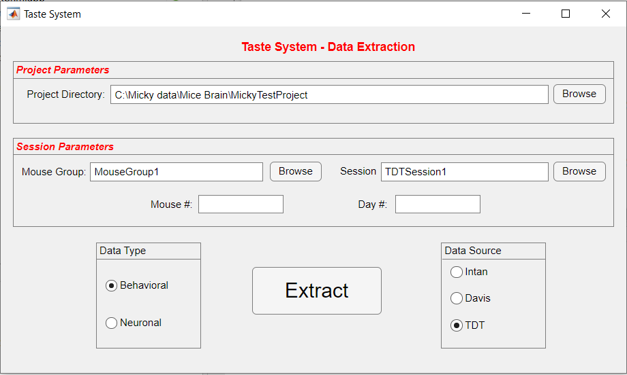
Project Directory – The project directory field points to the Project Directory (refer to the Data File Organization section, for more details). The default value for this field is the last values set on any of the system software modules. So, typically, after these configuration value is decided on and set, there is no need to use these fields. The Browse button can be used to set the value using a windows explorer dialog box.

Session Parameters
Figure 8: TasteExtractData
Session parameters are used to define the input data for the ExtractData program. With the exception of Mouse and Day numbers, the default values for all of these fields are the last ones set.
Mouse Group – The mouse group directory name. It is used to locate the correct directory for the input file. The Browse button can be used to set the value using a windows explorer dialog box.
Mouse # – The ID number for the subject mice. It is used to locate the correct directory for the input file.
Day # – The ordinal number of the session test day. It is used to locate the correct input file.
Session Name – The name selected to describe the session (e.g. Water, WaterNaCl, Test1, etc.). It is used to locate the correct input file. The value can be entered as text, or the Browse button can be used to set the value using a windows explorer dialog box. If Browsing is selected, select any file (not a directory) with a correctly formatted name, and the SW will determine the session name from the file name.
Data Type
Defines the data that needs to be extracted and converted to Matlab Format.
Behavioral Data – Extract and convert Licking data
Neuronal Data – Extract and convert neuron related info (current from Intan or photometry from TDT).
Data Source
Defines the data recording system (hence the input files) to convert from.
Extract
A control button. Clicking on it will activate the extraction process. The Button turns active (“clickable”) after all relevant data had been entered and verified.

Taste Analysis (Outdated text)
The TasteAnalysis module produces a set of reports out of the recorded data. Depending on the requested output, the input may include behavioral and neuronal data from single or multiple mice. The following sections describe the user interface of the module and the reports it is designed to generate. A screen shot of the program GUI is provided in Figure 9.
User Interface
Project Parameters
Project parameters are a set of configuration elements which are used to either find the input data or to configure how to filter it. The default values for all of these fields are the last values set on any of the system software modules. So, typically, after these configuration values are decided on and set, there is no need use these fields.
Project Directory – The project directory field points to the Project Directory (refer to the Data File Organization section, for more details).
Valid Lick or ILI Range – Min and Max values for Lick duration (and ILI) as measured by the beam breaker lickometer. These values are used to filter out debounce artifact caused by the hardware (primarily due to the fact that the sampling frequency used for the Intan recording system is much faster than actual mouse movement). Any transition of the beam breaker and lickometer signals which are faster (or slower) than these limits, are ignored by the software.
Valid Burst ILI – These are configuration parameters for the burst analysis algorithms. They are used to decide when a gap in a Lick burst represents a missing lick, which will impact the burst frequency calculation, as opposed to a gap representing the beginning of a new burst.
Session Parameters
Session parameters are used to define the input data for the requested report. With the exception of Mouse and Day numbers, the default values for all of these fields are the last ones set.
Mouse # – The ID number for the subject mice. It is used to locate the correct directory for the input file.
Day # – The ordinal number of the session test day. It is used to locate the correct input file.
Experiment Name – A synonym for the mouse group directory name. It is used to locate the correct directory for the input file.
Session Name – The name selected to describe the session (e.g. Water, WaterNaCl, Test1, etc.). It is used to locate the correct input file.
Session Plan – The session plan table is used to create a map for analysis. Each line describes a set of trials from the recorded session which can be either included or excluded from the report. The program will start picking up trials from the first one in the recorded file and, match them with the session plan. Extra trials in the session plan are ignored.
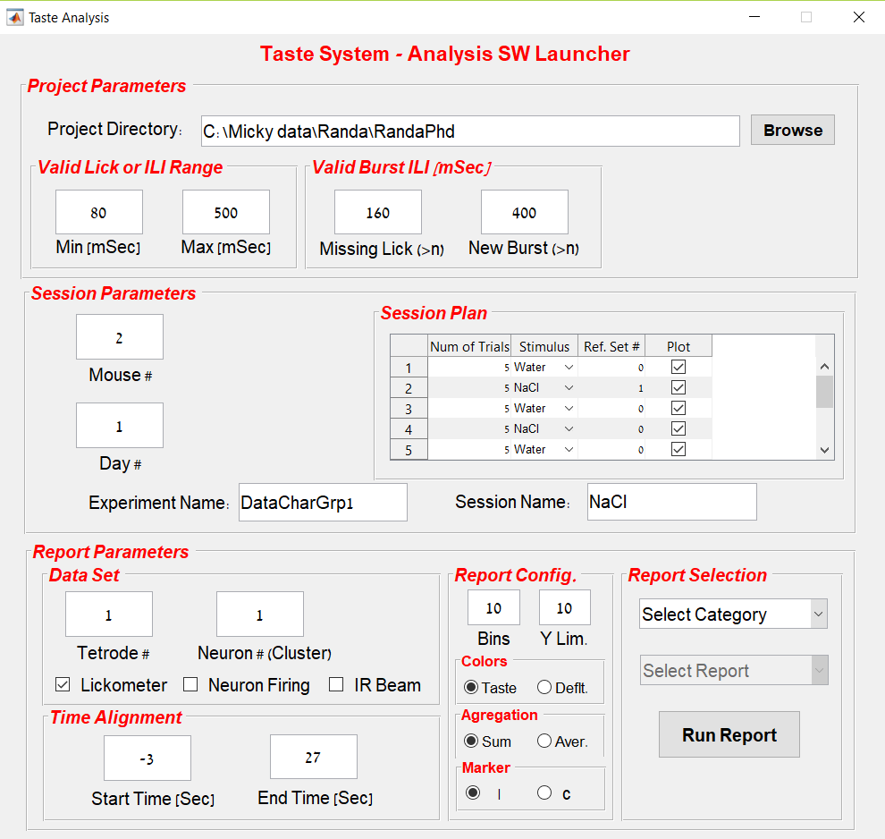
Figure 9 - Taste Analysis GUI
For each line in the session plan:
Number of trials – The number of recorded trials to which this line is referring to. If this is the first line then the number refers to trials 1 through N in the recorded data. Any additional line refers to the group of trials which follow all the trials accounted for in the previous table entries.
Stimulus – The taste stimulus used for this set of trial. This value is used to properly color and title the various output graphs.
Reference set – For reports that compare one group of trials to another, this field identifies the set of trials to be compared with. The number to be used to identify the reference trials is the table line number which appears on the left side of the table.
Plot – This check box denotes whether to include (checked) or exclude (unchecked) the set of trials in the report. It should be used to manually exclude non relevant (e.g. outliers) trials form the analysis.
Report Parameters
Report parameters are used to select the required report and to configure its content and appearance.
Data Set – Identifies the input data set for the requested report. Multiple check boxes can be set in the field, for multiple concurrent data sets. The meaning and usage of this field varies from one report to another. See further details in the report description section, below.
Tetrode # – Used to identify the correct Neuronal data file.
Neuron (Cluster) # – Used to identify the spikes of a specific single Neuron within the tetrode file, as was sorted out by the spike sort tool.
Neuron firing – Use Neuronal spike data as defined by the Tetrode and Neuron fields.
Lickometer – Use licking data from the Lickometer.
Beam breaker – Use licking data from the beak breaker.
Time Alignment – Defines how will the trial time axis be aligned with the stimulus providing time, which is considered as T₀ .
Start and End time – Defines and the origin and max values for the time axis. Typically End minus Start time should be equal to the trial length, otherwise data will be left out (if the difference is shorter) or overlapped between consecutive trial (if the difference is longer)
Report configuration – Used to configure the appearance of the reports.
No. of Bins – Defines the number of (time) bins, which in turns defines the resolutions, of various reports.
Y Lim – Defined the max value for the Y axis of bar graphs. If set to zero, the program allowed Matlab to set the Y axis limits.
Color – a radio button that defines the color scheme for the reports. The two options are:
Taste - Raster and Bar graphs will color the various markers according to the stimulus used for each trials (e.g. Blue for water, Magenta for NaCl, etc.).
Default - all markers will be plotted using the Matlab default color.
Aggregation – a radio button that defines how single trial data is aggregated into trial Sets. The two options are:
Sum – The total accumulated data of all trials in the set is reported
Average – The average, per trial, value is reported.
Marker – a radio button that defines the shape of the marker used in various raster graphs. The two options are:
| – use a vertical bar as marker.
C – use a disc as a marker.
Report selection – Used to identify the requested output.
Select Category – The available report categories are: Activity (Raster), Activity (Bar), Analysis, Statistics, Data Characterization.
Select Report – Once a report category has been selected, the available reports for the selected category are shown in the Select Report pull down menu. The various available reports are described in the next section.
Program Output
Activity (Raster) reports
This activity reports category includes a list of raster graphs designed to provide a visual representation of the mouse activity. They include (Sample graph images are provided in Figure 10):
Lick Raster (Duration) – This raster graph aims to compare the mouse licking data as recorded by the beam breaker and the Lickometer. For each trial, the mouse licking activity is drawn as a function of time. Each lick is depicted as a line from its start to end time. Each trial includes the data both from the Lickometer and the beam breaker.
Lick Raster (Starts) – This raster graph aims to show the mouse licking data as recorded by either the beam beaker, the Lickometer or both (as defined by the Data Set GUI fields). For each trial, the mouse licking activity is drawn as a single marker at the lick start time. ‘+’ is used for beam breaker data while a round disc or a vertical bar (i.e. ‘|’) is drawn for the Lickometer data (as defined by the Marker radio button in the GUI.
Lick Bursts – This raster graph aims to show the mouse licking data as recorded by the Lickometer (only) organized into bursts (series) of licks. A burst contains three or more licks with (two or more) ILIs smaller then indicated by the New Burst field in the GUI. The frequency is calculated as the inverse of the average all ILIs, smaller than the miss-lick ILI GUI field, of the Burst.
Each burst is represented as two lines. The lower, red line represents the Burst length and it is divided into a solid and a dotted portions. The solid section is proportional to the number of licks with ILIs smaller than the miss-lick time limit, and the dotted section is proportional to the number licks greater than that value. The upper, blue, line represents the Burst frequency. The red line may include only the solid or the dotted sections. The absence of dotted section implies that there were no miss-licks in that burst (e.g. all ILIs where below the miss-lick limit value. The absence of the solid section, on the other hand, implies that all licks in the burst had ILIs greater than the miss-lick limit. In this case, the frequency of the burst could not be calculated and the blue line will be missing, as well.
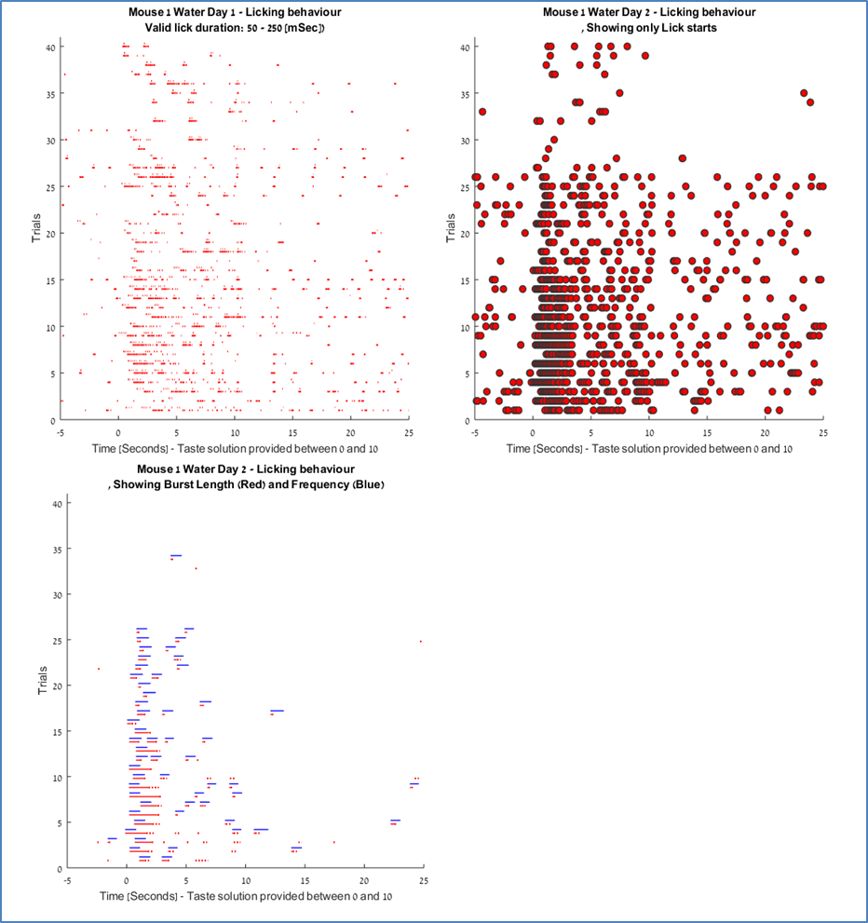
The lines’ lengths are linearly proportional to the measured values (but not identical). Longer bursts will appear longer than shorter ones; Faster (higher frequency) bursts will appear longer then slower ones. There is no relationship between the lengths of the Burst frequency and the Burst length lines. This is designed to provide relative, qualitative, data rather than actual values.
Figure 10 - Activity (Quantitative) Reports, output sample
Activity (Bar) reports
This activity reports category includes a list of bar graphs designed to provide a more quantitative account of the recorded data. They include (Sample graph images are provided in Figure 11):
Lick count – This Bar graph shows mouse lick counts per trial set, per time bin. The number of bins, the graph resolution, is defined in the ‘Bin #’ GUI field. The max value for the Y axis is defined in the Y-Lim GUI field. If Y-Lim is zero the max Y value will be determined, for each graph independently, by Matlab. If a nonzero value is set, all graphs will be set to the selected value. The color can be either the Matlab default value, or derived from the provided stimulus, as indicated by Color radio button. The lick count values can be either the total number of licks (of all trials in the set) per bin, of the per-set average. This selection can be made by the Aggregation radio button.
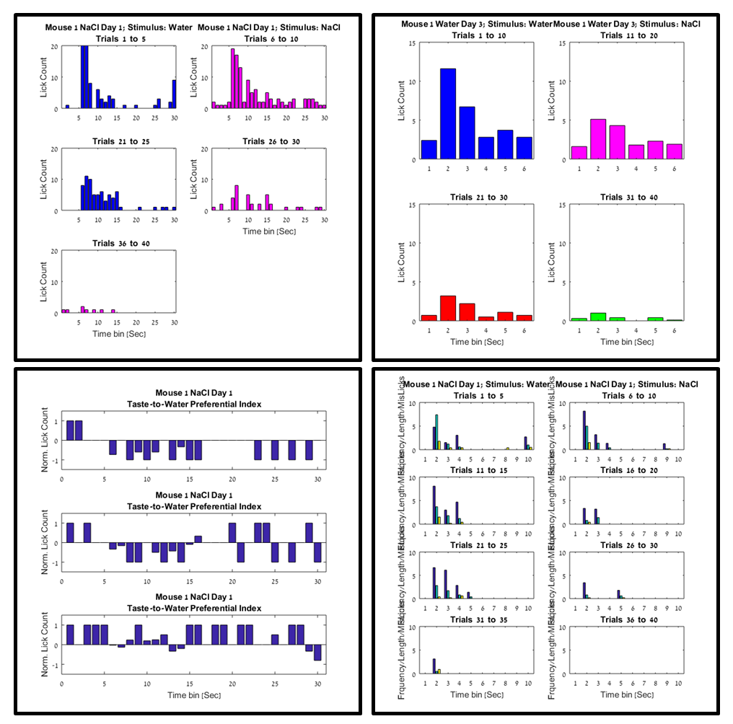
The size of the trial sets are defined by the session plan table. Every line in the table represents a set of trails, starting from trial one of the session and going forward till the last one. The bars are calculated for all trials in the session; however only the sets with the Plot field checked will be included in the graph.
Figure 11 -Activity Bar Graphs, report example
Normalized bar graph can be produced by setting the Ref. field in the session table to a nonzero value. If at least one ref field is set, a normalized bar graph, rather than an absolute one is generated. The normalization method is preferential-index (i.e. (a – b) / (a + B)).
For normalized bar graphs, the Plot column is ignored and only the Sets with a nonzero value in the Ref field will be plotted, and normalized relative the set (line in the session table) indicated in their Reference field.
Lick Burst – In this Bar graph Bins and Y-Lim behave as in the lick count graph. The Color and Aggregation radio buttons has no effect. This report includes three values in every time bin. From left to right: The burst frequency, the number of licks in the burst with ILIs smaller than the miss-lick and the number licks with ILIs greater than that value. The values shown are the average of all bursts within the specific time bin, in all of the trials of the set. A burst is considered to be included in a time bin if it either started or ended within the time span of the bin.

Analysis reports

[ To be edited ]

Statistical reports

[ To be edited ]

Data characterization reports
The data characterization reports category includes a list of histograms designed to showcase the rage of value distribution of a measured datum. They aim to aid in input data filtering, outlier identification, etc. They include (Sample graph images are provided in Figure 12):
ILI distribution – This histogram shows the range of measured valued for mouse Inter Lick Intervals (ILI) – the time gaps between consecutive mouse licks. The Lower and upper limits of values included in the histograms are defined by the Min and Max ILI GUI fields.
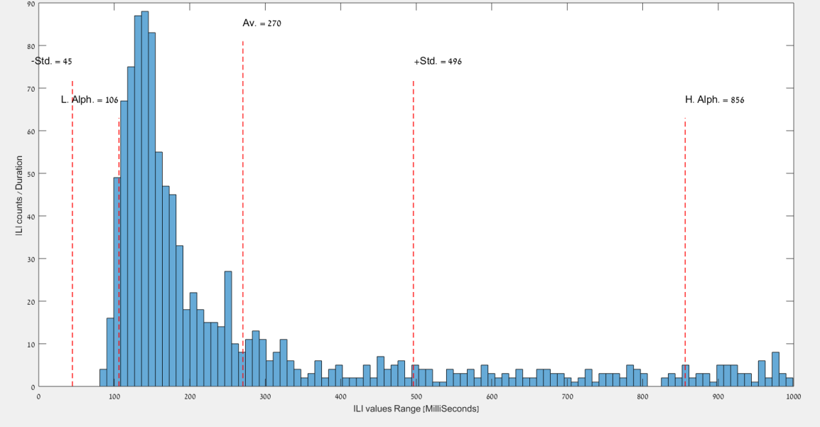
This report can be run for a single mouse or for various mice groups. To define a mice group the keyword ‘all’ should be used in either of the session parameter GUI fields, for example, entering ‘all’ instead of a mouse number will include licking data from all mice. Similarly all days, all sessions and all mice groups can be included. Any combination of specific values and ‘all’ term can be used. For example: an ILI histogram using data from all sessions of the first day of all mice in a specific mice group can be generated by entering specific values in the
Day #, and Experiment Name GUI fields and, ‘all’ in the Mouse # and Session Name Field.
Figure 12 - Data Characterization reports, sample output.

Trouble Shooting
Error Message | Root cause | Corrective Action
Behavioral data file:  Behavioral.mat file was not found | Wrong mouse group, mouse number or, session name are entered in program UI.  Behavioral data was not extracted for the mouse  Behavioral data file was copied manually and was named incorrectly | Check for the correct root cause and fix it.
Behavioral data file:  Multiple Behavioral .mat files for same Session & Day - were found | Behavioral data file was copied manually and was named incorrectly | Double check and correct file name
Directory not found': <directory-name> Directory does not exist. Create? | A required subdirectory of the taste system data file structure is missing.  The project directory data field is not pointing to the right place | Check for correct root casue. If the directory is really missing click “yes” to create it.
Input Data: Recorded data directory not found. | The SW is constructing the Recorded data sub-directory name (one that contains data from a specific session) from the GUI parameters. A directory with the constructed name was not found. | Double check the directory is there (it is created manually when the .RHD files are copied over from the Intan system). Create the directory and copy the data if it was not done already. If the directory exists, double check the Session Parameters section in the TasteExtratData GUI.
Input Data: Multiple files or directories match the selected session | The Recorded Data directory of the selected mouse contains more the one subdirectory with the given Session name and day number (they differ in the date code or some additional name tokens). | Double check the directory names and fix them to allow only one directory for any combination of session name and day number.
Input Data: The selected file is not a directory. | The Recorded Data directory of the selected mouse contains a file with the given name, but it is a data file, not a directory. | No data files are expected in Recorded data directory. Only sub directories containing Intan .RHD file. Delete the redundant files.
Input Data: Recorded data directory does not contain RHD files. | The directory for the selected combination of mouse, session and, day is empty. | Copy the files over, from the Intan system.
Project Data File: Project data file missing or outdated. Create?' | Project system data file is missing from the project root directory (or detected as containing old version of the system data structure). This might happen after SW update or as a result of manual data copy. | Typically this is a warning only and the data can be safely recreated. Respond with ‘yes’ and let the system recreate the file. If however, the file is known to contain sensitive and irreplaceable settings (very unlikely) respond with ‘no’ and recover the file manually.
Project Directory Warning: Project Directory does not exist | The Project Directory field in the Project Parameters sections of the GUI points to a directory that does not exist. | Use the Browse button in the GUI to select the correct Project Directory
Project Directory Warning: TasteProjectDirectory.mat file is missing. | TasteProjectDirectory.mat file does not exist in the MatLab default directory. | Use the Browse button in the GUI to select a Project Directory. This operation will create the missing file.
Project Directory Warning: Project Directory was not selected | An attempt to use GUI to select a Project Directory file was canceled. | Repeat the directory selection operation.
SW Version Error: TasteSWVersion File is missing. Please update. | TasteSWVersion.mat file does not exist in the MatLab default directory. | Make sure the MatLab Default directory is the one where the code files are. Restore the file in the directory.
SW Version Error: <SW module> is outdated. Please update. | The taste system SW module, being executed, is not the latest version. | Update the SW to the latest version.

