**System.js**

There is a special system collection named system.js that can store JavaScript functions for reuse.

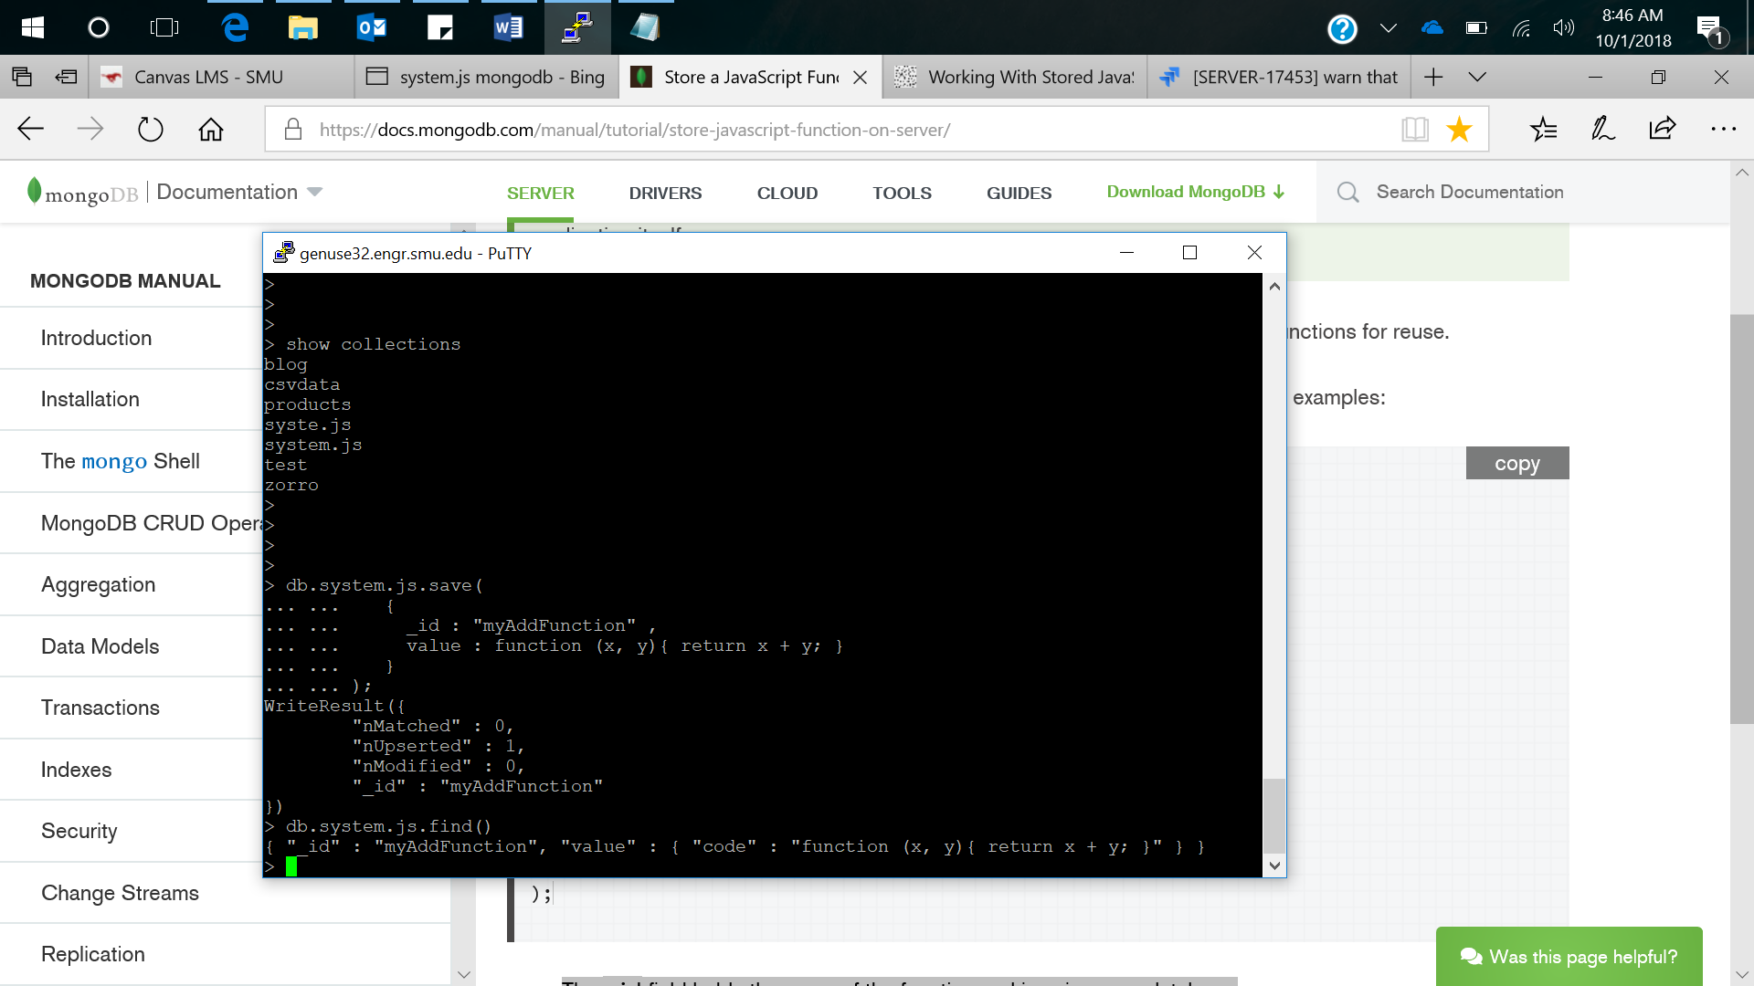  
  
Here, id field holds the name of the function and is unique per database. The value field holds the function definition.  
Once you save a function in the system.js collection, you can use the function from any JavaScript context; e.g. [$where](https://docs.mongodb.com/manual/reference/operator/query/where/#op._S_where) operator or [mapReduce](https://docs.mongodb.com/manual/reference/command/mapReduce/#dbcmd.mapReduce) command.

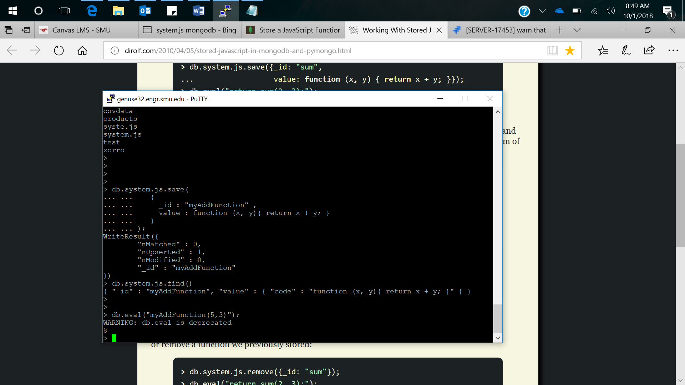

If we want to list the stored functions, we can use below command:

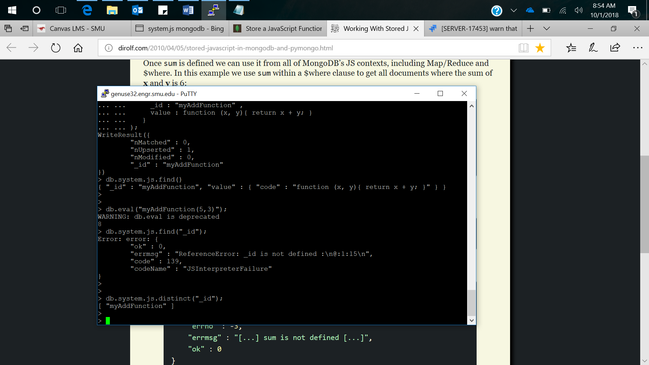

In this example, we use myAddFunction within a **$where** clause to get all documents where the addition of **x** and **y** is 8.  
For that we’ll create a new collection called as test passing different values of x and y.  
example: > db.test.save({x:4, y:2});

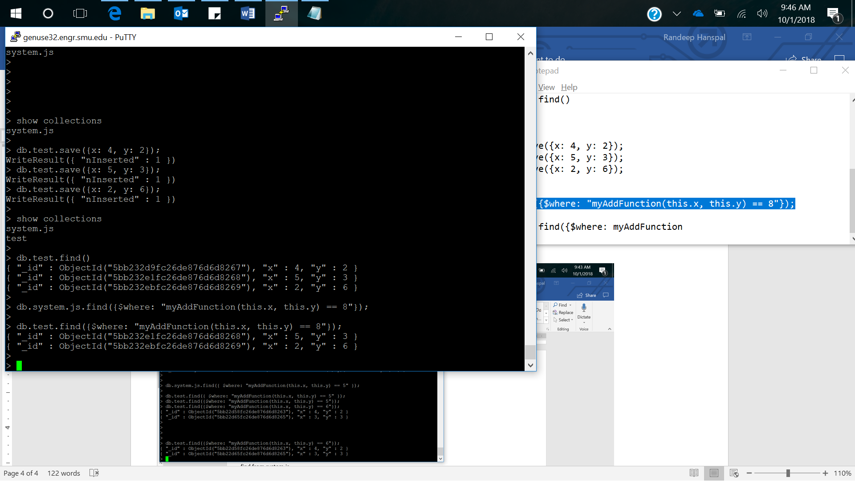



We can also remove the function from system.js:  
> db.system.js.remove({_id:"myAddFunction"});