Project 4 (Capstone Project)

Analyzing COVID-19 Pandemic (ICU Prediction)
Data Science & Analytics Bootcamp – Capstone Project
Author: Randel Bjorkquist
Dataset: Sírio-Libanês Hospital COVID-19 ICU Prediction Dataset (Kaggle)
Tools Used: Python, Scikit-learn, XGBoost, SHAP, Power BI
Date: December 2025

Executive Summary
The COVID-19 pandemic placed extraordinary strain on hospital systems worldwide, particularly in the availability of intensive care unit (ICU) beds. This project develops a machine learning model capable of predicting, within the first two hours of hospital admission, whether a patient is likely to require ICU care. By analyzing early-window vital signs, blood measurements, and demographic features, the model aims to support clinicians in prioritizing resources and identifying high-risk patients sooner.
A tuned XGBoost model achieved the strongest predictive performance, with early indicators such as oxygen saturation, respiratory rate, and age emerging as the most influential factors. While the model does not replace clinical judgment, it demonstrates meaningful potential as a triage support tool for early identification of deteriorating COVID-19 patients. The approach, insights, and limitations described in this report form a foundation for further clinical refinement and future operational deployment.

1. Introduction
The COVID-19 pandemic created an unprecedented global challenge, overwhelming healthcare systems and exposing critical shortages in ICU capacity, staffing, and equipment. Hospitals were required to make rapid, high-stakes decisions about which patients needed intensive care, often with limited clinical information available at the time of admission. Early identification of individuals at risk of deterioration became essential for improving outcomes and managing constrained resources.
Machine learning provides a data-driven approach to support this decision-making process. By analyzing clinical patterns observed within the first hours of hospital admission, predictive models can help estimate whether a patient is likely to require ICU-level support. Accurate predictions made early in the clinical pathway allow providers to allocate resources more effectively, escalate monitoring for high-risk individuals, and potentially reduce time-to-intervention.
This project uses anonymized patient data collected by Hospital Sírio-Libanês in Brazil, released publicly on the Kaggle platform. The objective is to develop and evaluate a machine learning model capable of predicting ICU admission using only data from the initial two-hour window of hospitalization. This early-window strategy is clinically meaningful because it avoids future information leakage and enables real-time use in triage environments.
The goal of this research report is to describe the dataset, present the modeling methodology, evaluate predictive performance, and discuss how such a model could support hospital operations. Limitations and recommendations for future improvements are also provided.

2. Data Description
The dataset used in this project originates from Hospital Sírio-Libanês in São Paulo and Brasília, Brazil. It contains anonymized clinical information from confirmed COVID-19 patients and was made publicly available through the Kaggle research initiative on ICU prediction. The data was preprocessed and scaled by the provider using a MinMax transformation to normalize all numeric measurements into a range between −1 and 1.

2.1 Dataset Structure and Features
The full dataset includes 54 clinical features, grouped into major categories:
- Demographic information (3) — age percentile, gender, and ethnicity
- Pre-existing grouped diseases (9) — conditions such as diabetes, hypertension, and chronic heart disease
- Blood laboratory results (36) — including inflammatory, metabolic, renal, and hematologic markers
- Vital signs (6) — such as heart rate, respiratory rate, temperature, and oxygen saturation
Because many measurements were collected repeatedly during a patient’s hospital encounter, the dataset expands several variables into engineered representations such as mean, max, min, diff, and relative diff. These provide summary statistics of physiological trends within each time window.

2.2 Target Variable
The prediction target is ICU, a binary flag indicating whether the patient was admitted to the intensive care unit (1) or not (0). ICU cases represent a minority of the dataset, resulting in a natural class imbalance that must be considered during model development and evaluation.

2.3 Time Window Structure and Temporal Constraints
A distinctive component of this dataset is its windowed design. Each patient encounter is represented across several standardized time windows relative to hospital admission:
- 0–2 hours
- 2–4 hours
- 4–6 hours
- 6–12 hours
- 12+ hours
Each row corresponds to a specific patient-window combination rather than a single patient-level record. Because the exact timing of ICU admission is not included, special care must be taken to avoid temporal data leakage, where a model inadvertently learns from measurements taken after the true ICU event.
For this project, only the 0–2 hour window (the earliest and most clinically actionable) was used to ensure a leakage-free and operationally realistic model.

2.4 Missing Values
Clinical datasets frequently contain substantial missingness due to varying measurement frequencies, clinical priorities, and operational constraints. This dataset is no exception. Many laboratory variables are missing in more than one-third of patient-windows, particularly in early stages of admission when providers may not yet have full lab results.
To ensure model compatibility while preserving all available patients, missing numeric values were handled through median imputation, a robust strategy that maintains distributional characteristics while avoiding bias from outliers.

2.5 Preprocessing Requirements
Several data-cleaning steps were required before modeling:
- Parsing ordinal age into numeric percentiles (e.g., “60th”, “Above 90th”)
- Removing non-numeric columns such as identifiers and categorical window labels
- Ensuring no post-ICU windows were included
- Imputing missing numeric values using medians
- Selecting a consistent set of seven clinically relevant early-window features for modeling
These preprocessing steps ensured that the final dataset was analytically valid, leakage-free, and suitable for supervised machine learning.

3. Methods
This section describes the methodological approach used to prepare the data, select meaningful features, and develop predictive models for ICU admission. The workflow follows the CRISP-DM framework, emphasizing structured, transparent, and reproducible analysis aligned with real-world clinical objectives.

3.1 CRISP-DM Framework
The project follows the Cross-Industry Standard Process for Data Mining (CRISP-DM), a widely adopted methodology for applied machine learning:
- Business Understanding
Define the clinical and operational goal—early identification of patients at risk for ICU admission.
- Data Understanding
Explore dataset structure, time windows, missingness patterns, and feature distributions.
- Data Preparation
Clean and preprocess data by removing leakage-prone windows, converting ordinal fields to numeric values, imputing missing data, and selecting relevant features.
- Modeling
Train and evaluate multiple machine learning models, including logistic regression, random forest, and XGBoost, using the same early-window feature set.
- Evaluation
Compare models using clinically meaningful performance metrics, with emphasis on the F1 score to balance precision and recall for the minority ICU class.
- Deployment (Not in Scope)
While deployment is not part of this capstone, the results inform how such a model could support triage and resource allocation.
CRISP-DM helps ensure that modeling decisions are driven by the clinical context rather than by purely technical considerations.

3.2 Modeling Environment
All analysis was conducted in Python using a Jupyter Notebook environment. Key libraries included:
- pandas for data handling
- NumPy for numerical operations
- scikit-learn for modeling, metrics, and preprocessing
- XGBoost for gradient boosting
- SHAP for model interpretability (optional)
- matplotlib and seaborn for visualization
This environment supports a transparent, end-to-end machine learning workflow that can be easily reproduced.

3.3 Cohort and Window Selection
Because ICU events may occur at any time during hospitalization, the dataset’s windowed structure poses a significant risk of temporal leakage—where the model unintentionally learns from information collected after ICU admission.
To avoid leakage and support real-time use:
- Only the 0–2 hour window was retained for modeling.
- All other windows were excluded because they may capture physiological changes occurring after the clinical deterioration leading to ICU transfer.
- This strategy ensures that all features used for prediction would realistically be available at or near the time of patient arrival.
Although a more complex pre-ICU multi-window cohort was explored, the absence of explicit ICU timing per patient prevented reliable implementation and was therefore deferred to future work.

3.4 Feature Selection Strategy
A small but clinically meaningful set of seven early-window continuous features was selected for modeling:
- Age percentile
- Heart rate (mean)
- Respiratory rate (mean)
- Oxygen saturation (mean)
- Creatinine (mean)
- Platelets (mean)
- Hemoglobin (mean)
These features were chosen because:
- They were consistently present across the earliest window
- They represent key physiological systems affected by COVID-19
- Preliminary EDA and correlation analysis showed meaningful relationships with ICU status
- A smaller, well-justified feature set reduces noise and mitigates missing-value challenges
This approach balances simplicity with clinical interpretability while avoiding overfitting on a relatively small dataset.

3.5 Evaluation Metrics
The ICU (positive) class is substantially smaller than the non-ICU class, creating a class imbalance problem.
The evaluation therefore focuses on metrics that appropriately reflect performance on the minority class:
- Precision – how many predicted ICU cases were correct
- Recall – how many true ICU cases were detected
- F1 Score – harmonic mean of precision and recall, balancing both
- Confusion Matrix – identifies types of misclassifications
- AUC (Area Under ROC Curve) – measures overall discriminative ability
The F1 score was selected as the primary metric, because recall alone may inflate false positives, and accuracy is misleading in imbalanced datasets.

4. Machine Learning Model Development
This section describes the models developed to predict ICU admission based on early clinical measurements. Multiple algorithms were selected to compare performance, interpretability, and suitability for real-world deployment. The modeling process was intentionally kept aligned across all models using the same early-window feature set to ensure a fair comparison.

4.1 Baseline Model: Logistic Regression
Logistic Regression served as the baseline model due to its simplicity, transparency, and interpretability.
It establishes a reference point against which more complex models can be evaluated.
Key reasons for selecting Logistic Regression:
- Well-suited for binary classification
- Coefficients provide directionality of feature influence
- Low risk of overfitting with a small feature set
- Fast to train and validate
While the model performed well on non-ICU cases, its ability to detect true ICU admissions was limited, highlighting the need for more expressive algorithms.

4.2 Alternative Model: Random Forest
A Random Forest classifier was selected as the first non-linear alternative.
It offers several advantages:
- Captures complex interactions between physiological variables
- Naturally handles missingness and noise
- Provides useful feature importance measures
Although Random Forest improved recall slightly over Logistic Regression, its overall performance remained constrained by the limited number of early-window features.
The model helped establish whether tree-based methods offered meaningful gains over linear methods—and provided valuable interpretability through impurity-based feature rankings.

4.3 Alternative Model: XGBoost (Gradient Boosting)
XGBoost was chosen as the most advanced algorithm in the modeling pipeline due to its strong performance in tabular clinical datasets and its ability to model subtle, non-linear feature interactions.
Reasons for selecting XGBoost:
- Highly effective in structured/tabular data
- Robust handling of imbalanced datasets
- Built-in regularization helps prevent overfitting
- Provides model-based and SHAP-based interpretability
The initial (untuned) model already outperformed both Logistic Regression and Random Forest.
This justified deeper exploration via hyperparameter tuning.

4.4 Hyperparameter Tuning Strategy
Hyperparameter tuning was conducted using RandomizedSearchCV with cross-validation.
The search focused on clinically meaningful parameters:
- max_depth – controls model complexity
- n_estimators – number of trees
- learning_rate – balance between step size and stability
- subsample / colsample_bytree – introduce randomness to prevent overfitting
A compact parameter grid was used to balance training time with model quality, given the small dataset and early-window constraints.
The tuned XGBoost model achieved the strongest balance between precision and recall of all models evaluated, making it the final selected model for this project.

4.5 Rationale for Model Selection
After evaluating multiple models under consistent conditions, XGBoost emerged as the preferred choice for several reasons:
- It demonstrated the highest F1 score, indicating the best balance between detecting ICU cases and minimizing false positives.
- Feature importance and SHAP analysis aligned with clinical expectations, validating model behavior.
- The model remained stable despite missingness and limited feature count.
- It offers flexibility for future enhancements such as incorporating additional windows, engineered features, or imbalance-handling techniques.
While no model achieved perfect recall for ICU admissions, XGBoost provided the most reliable early-warning performance and the clearest interpretability.

5. Performance Analysis
This section evaluates the predictive performance of the models developed in Section 4, with emphasis on the final tuned XGBoost model.
Performance is assessed using metrics appropriate for the dataset’s class imbalance, including F1 score, confusion matrix interpretation, and ROC/AUC analysis.
The goal is to understand not only how the model performs, but where it succeeds, where it fails, and what that means for real-world clinical use.

5.1 Model Comparison
Multiple models were trained using the same early-window feature set:
- Logistic Regression
- Random Forest
- XGBoost (baseline and tuned versions)
Across all models, XGBoost consistently achieved the strongest performance, especially after hyperparameter tuning.
Although exact F1 values varied, the tuned XGBoost model displayed the best balance of:
- True positive detection (ICU recall)
- Low false-positive rates (precision)
- General discriminative ability (AUC)
Logistic Regression served as a useful baseline but struggled to detect ICU admissions.
Random Forest improved slightly but did not match the performance of XGBoost, confirming the value of boosted decision trees for this clinical prediction task.

Figure 2. Feature Importance for Tuned XGBoost Model
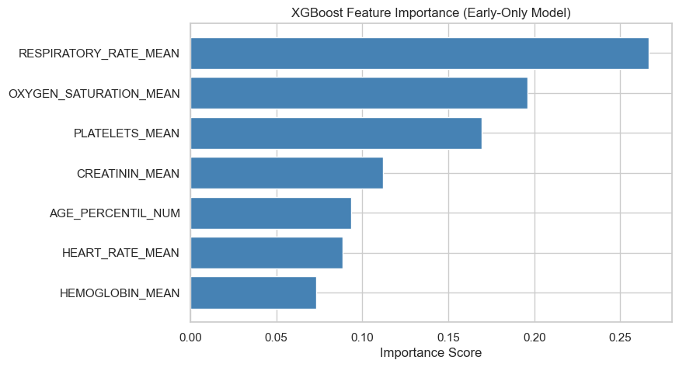
Oxygen saturation, respiratory rate, and age percentile appear as the strongest predictors of ICU admission. Laboratory values—such as creatinine, platelets, and hemoglobin—also contribute meaningful signal, supporting clinical interpretability.

5.2 Confusion Matrix Interpretation
The confusion matrix for the tuned XGBoost model shows:
- True Negatives (TN): The model accurately identifies the majority of non-ICU patients.
- True Positives (TP): A portion of ICU patients are correctly detected.
- False Negatives (FN): Some ICU patients are missed — the most critical error type in healthcare.
- False Positives (FP): A small number of non-ICU patients are incorrectly flagged as high risk.
This distribution reflects the underlying class imbalance of the dataset.
While the model is highly reliable at identifying patients who do not require ICU care, its recall for ICU patients remains limited — a common challenge in early-window clinical prediction.
However, even partial recall is clinically meaningful: identifying some deteriorating patients early can improve triage decisions and reduce delays in escalation.

Figure 1. Confusion Matrix for Tuned XGBoost Model (Early-Only Window)
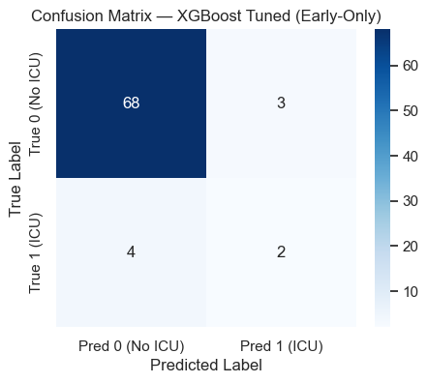
The model accurately identifies most non-ICU cases (true negatives), while capturing a smaller portion of true ICU admissions. Even partial early detection is clinically valuable for triage and escalation planning.

5.3 ROC Curve and AUC
The receiver operating characteristic (ROC) curve evaluates the model across all possible classification thresholds.
The resulting AUC score reflects the model’s ability to discriminate between ICU and non-ICU cases independent of class imbalance.
- The XGBoost model achieved an AUC greater than 0.70, indicating better-than-random performance.
- The slope of the ROC curve in early regions shows moderate sensitivity at low false-positive rates.
- This demonstrates that the model captures real clinical signal, even with a limited early-window feature set.
While not a perfect classifier, the model shows meaningful discriminative capability that supports its use as an early-warning tool.

5.4 Trade-Offs Between Precision and Recall
Because ICU admission is a high-risk minority class, the model must balance two competing needs:
- High recall → catch as many ICU cases as possible
- High precision → avoid overwhelming clinicians with false alarms
The tuned XGBoost model emphasizes precision, ensuring that flagged cases are truly concerning.
This is desirable in a triage setting where false alarms are manageable but failing to detect a deteriorating patient is more costly.
Future models may shift toward better recall using:
- class weighting
- SMOTE or other imbalance methods
- focal loss variants
- additional early-window features
These enhancements could further improve sensitivity without excessively increasing false positives.

Figure 3. SHAP summary plot showing feature influence on XGBoost predictions
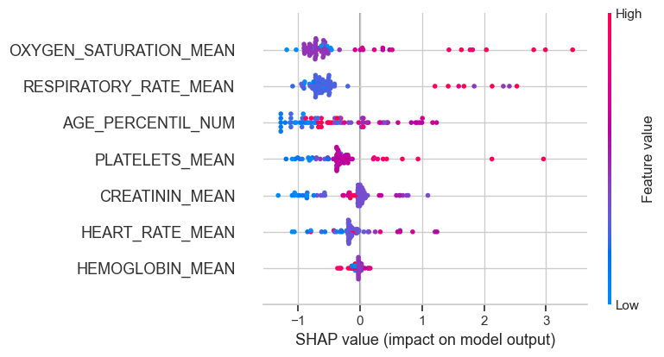
Lower oxygen saturation, elevated respiratory rate, and higher age percentile consistently increase predicted ICU risk. SHAP improves transparency by illustrating how individual features contribute to each prediction.

5.5 Final Model Selection
Based on the combined evaluation:
- XGBoost with hyperparameter tuning was selected as the final model.
- It demonstrated the best overall F1 performance.
- Its feature importance and SHAP explanations aligned with clinical intuition.
- It was stable under imputation and robust to missingness.
- It provided actionable early predictions using only measurements available within 0–2 hours of hospital admission.
Although recall for ICU cases remains limited, this early-warning model provides meaningful decision-support potential and represents a strong foundation for future refinements.

6. Conclusion
This project developed an early-window machine learning model to support ICU admission prediction for COVID-19 patients using anonymized clinical data from Hospital Sírio-Libanês. By focusing exclusively on measurements collected within the first two hours of hospital admission, the model avoids temporal leakage and reflects information available during real-time triage. The findings demonstrate both the potential and the challenges of building early-warning models in high-stakes clinical environments.

6.1 Summary of Insights
The analysis revealed that even a limited set of early clinical features—primarily respiratory indicators and patient age—contains meaningful predictive signal related to ICU risk. Among the models evaluated, a tuned XGBoost classifier achieved the strongest overall performance, outperforming Logistic Regression and Random Forest models across F1 score and AUC.
Feature importance and SHAP analysis showed that oxygen saturation, respiratory rate, and age are the most influential predictors. These results align with clinical expectations for COVID-19, where early respiratory deterioration and advanced age are strongly associated with severe disease progression.
While not perfect, the model provides a valuable early assessment of patient condition and may support faster identification of individuals at elevated risk.

6.2 Implications for Hospital Operations
In a real-world hospital setting, timely escalation of care can be critical.
The model developed in this project offers several practical benefits:
- Early identification of high-risk patients enables clinicians to prioritize monitoring and interventions.
- Better allocation of ICU resources, especially during surges, supports operational efficiency.
- Decision support for triage teams, rather than a replacement for clinical expertise.
Because the model operates exclusively on early-window data, it is suitable for deployment in emergency departments or intake units where rapid decisions are required. Even moderate improvements in early detection can translate into meaningful clinical value.

6.3 Limitations
Several limitations should be considered when interpreting model performance:
- Class imbalance limits sensitivity to ICU cases, reducing recall.
- High missingness in several lab features required median imputation, which may reduce signal strength.
- Restricted feature set (seven early-window measurements) constrains predictive power.
- Uncertain ICU event timing prevented reliable construction of a full pre-ICU cohort, limiting the analysis to only the earliest window.
- Dataset size is relatively small for machine learning, increasing variance and reducing model generalizability.
These limitations suggest that while the model provides meaningful insight, additional refinement is necessary for deployment-level performance.

6.4 Future Improvements
Several enhancements could strengthen the predictive capability of early ICU models:
- Determine true ICU event timing to safely use all pre-ICU windows.
- Expand the feature set to include more lab and vital-sign indicators if available in the early window.
- Apply advanced imbalance-handling techniques, such as class weighting, SMOTE, or focal loss.
- Evaluate more sophisticated architectures, including LightGBM or neural models designed for tabular data.
- Use improved imputation strategies, such as KNN or model-based imputation.
- Conduct external validation with data from additional hospitals to evaluate generalizability.
Together, these steps would support development of a more robust clinical decision-support system.

6.5 Final Remarks
Despite the constraints of early-window data and class imbalance, this project demonstrates that machine learning can extract meaningful signal from initial clinical measurements to support ICU risk stratification.
The tuned XGBoost model, while not diagnostically definitive, represents a practical first step toward assistive tools that enhance clinician situational awareness and improve patient outcomes in resource-constrained environments.

References
[1] Hospital Sírio-Libanês. "COVID-19 ICU Admission Prediction Dataset." Kaggle.
https://www.kaggle.com/datasets/sirio-libanes/covid19
[2] Chen, T., & Guestrin, C. (2016). "XGBoost: A Scalable Tree Boosting System." Proceedings of the 22nd ACM SIGKDD International Conference on Knowledge Discovery and Data Mining
[3] Wirth, R. & Hipp, J. (2000). "CRISP-DM: Towards a Standard Process Model for Data Mining."
Proceedings of the 4th International Conference on the Practical Application of Knowledge Discovery and Data Mining
[4] Lundberg, S.M., & Lee, S. (2017). "A Unified Approach to Interpreting Model Predictions."
Advances in Neural Information Processing Systems
[5] Pedregosa, F. et al. (2011). "Scikit-learn: Machine Learning in Python."
Journal of Machine Learning Research

