INVESTMENT COMMITTEE MEMO  Halyk Bank of Kazakhstan JSC  LSE: HSBK - Kazakhstan's dominant bank at 4.5x earnings and a 13% yield; 2026 is the earnings trough and the ALMEX lock-up expiry is the entry point  Prepared for Investment Committee review | 23 October 2026 | 4.5x  P/E 2026E vs peer median ~7.5x  13.2%  FY26E dividend yield at a 60% payout  US$38.0  12-mo target; ~27% total return incl. dividends; prob-weighted US$38.9
  RECOMMENDATION: BUY |  | 12-MO TARGET: US$38.0 (+14%)
  Reference price | 52-wk range | Mkt cap | P/B (Jun-26)
  US$33.30 / GDR (40 sh) | US$22.90-36.45 | US$9.1bn / KZT4.1trn | 1.12x
  Dividend FY25 | Largest holder | ROAE FY25 / 1H26 | Next event
  KZT58.19 (15.6% yield) | ALMEX ~62% | 32.6% / ~25% | 9M26 results, mid-Nov

EXECUTIVE SUMMARY
  RECOMMENDATION

Buy: a 25% ROE franchise at 4.5x earnings; use the ALMEX overhang to build the position
4.5x  2026E P/E (4.1x 2027E); ~40% below the peer median P/E of 7.5x |  | 13.2%  FY26E dividend yield (60% payout); FY25 paid KZT58.19, +15% |  | 19.0%  k2 = CET1 capital ratio; ~700bp over the 12% minimum; ~KZT850bn surplus [e] |  | US$38.0  12-mo target (+14%); with ~US$4.3 of dividends, ~27% total return |  | 25%  Bear-case probability (US$23.5, -29%); bull US$56.2 (+69%)

Why now - four forces converging  ■ Earnings trough is visible: 1H26 NI -15% (MRR, BNPL rules, 25% bank CIT, VAT on fees); we forecast KZT900bn for 2026E, then +9% p.a.  ■ Rate cuts: NBK down 225bp to 15.75% (23-Oct); deposit costs lag, but volumes and credit quality improve from 2027  ■ Supply event: ALMEX's 365-day lock-up ends ~25-Nov-26; it plans to keep >=51% (~11pp saleable)  ■ Sovereign upgrade: S&P to BBB (Aug-26); Halyk's S&P outlook positive; strong tenge |  | What has to go right  ■ NIM bottoms at ~6.5% in 2027 (6.8% in 1H26), not below 6.2%  ■ Retail NPL 90+ (9.2%) is mostly 'mechanical' - the collector-sale pause - and CoR stays ~1.5%  ■ Payout holds at ~60% (DPS FY26E KZT49.5) despite the new 2% retail buffer  ■ No permanent bank levy: the 2025 10% excess-profit tax stays a one-off

Position sizing: value/income with an event overlay, medium conviction. Buy a third of the position now; add on the 9M26 print (mid-Nov) and any ALMEX placement after ~25-Nov (Nov-25 precedent: ~10% discount, then +31% in six weeks). Review triggers: dividend-policy change, NIM below 6.4%, any profit levy, block above 5% at a >15% discount.

BUSINESS OVERVIEW
  CONTEXT

Halyk at a glance - #1 bank with 28% of assets and half of corporate lending
What it does  ■ The former State Savings Bank. The 2017 rescue-merger with Kazkommertsbank (bought for KZT2) made it the clear #1  ■ Market shares: ~48% of corporate loans, 27% of retail deposits, 17.8% of retail loans; 531 branches; Super App 8.6m MAU  ■ Revenue mix (FY25): NII 73%, fees 8%, insurance 4%, FX/other 15%; cost/income 17.5%  ■ Kazakhstan is ~98% of profit; exited Russia, Tajikistan (2022) and Kyrgyzstan (2024); Georgia and Uzbekistan remain  ■ Controlled by ALMEX (Kulibayev family) ~62%; GDRs ~35%; ~28% of MSCI Kazakhstan |  | Key financials (KZT bn)  Source: Halyk results releases; 2023 restated (IFRS 17).
   | FY23 | FY24 | FY25 | 1H26 | Trend
  Net interest income | 797 | 1,108 | 1,288 | 658 | +2.6% y/y
  Net income | 693 | 921 | 1,058 | 448 | -15.3% y/y
  ROAE | 32.5% | 34.0% | 32.6% | ~25% | Peak passed
  NIM | 6.2% | 7.2% | 7.1% | 6.8% | MRR -40bp
  Cost / income | 19.2% | 17.6% | 17.5% | 19.2% | Guide 18-20%
  Cost of risk | 1.0% | 1.2% | 1.4% | 1.4% | Guide 1.4-1.5%
  NPL 90+ | n/a | 2.6% | 4.3% | 5.3% | Retail 9.2%

The single most distinctive fact: Halyk earned a 30%+ ROE for five straight years with a 17-20% cost/income ratio and a 19% all-CET1 capital ratio, yet trades at 1.1x book and 4.5x forward earnings - the market prices a ~20% sustainable ROE at a 19.5% KZT cost of equity.

THE SETUP
  CONTEXT

Unrest and war (2022), re-rating (2023-25), ALMEX placement (Nov-25), trough earnings (2026)
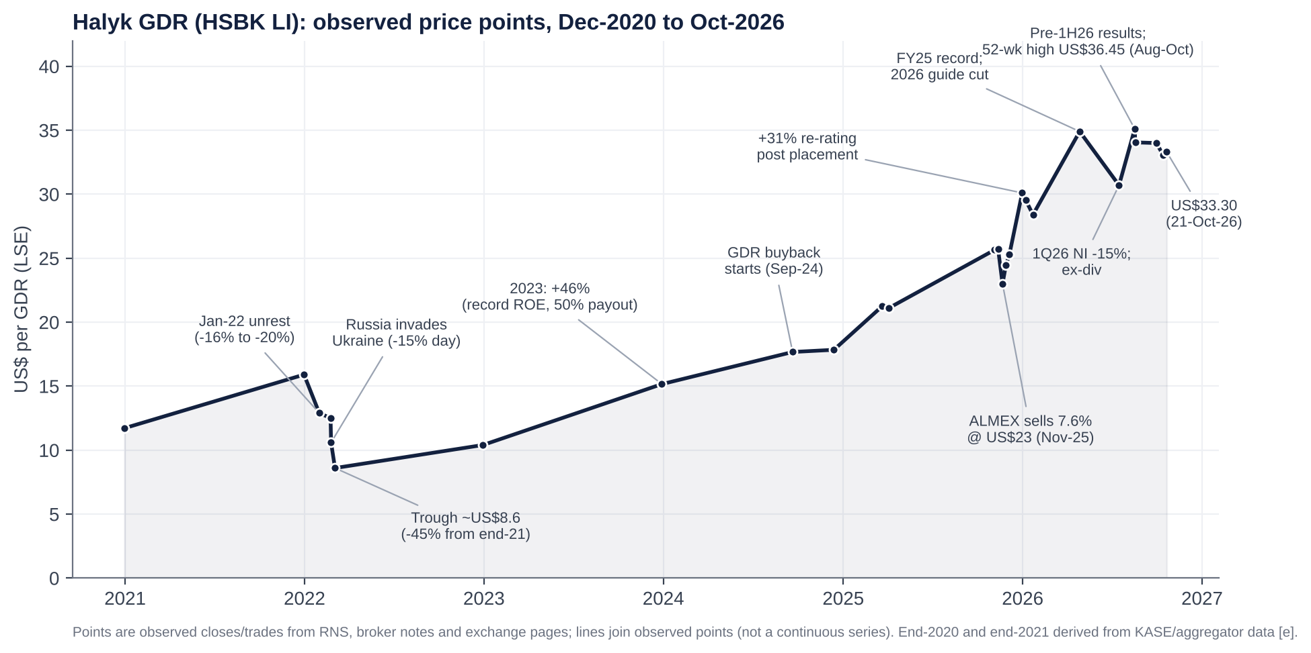 |  | Key catalysts
  Date | Event
  JAN 2022 | Unrest: GDR -16% to -20%
  FEB-MAR 2022 | Russia invades; -45% to ~US$8.6
  DEC 2022 | Exits Russia & Tajikistan
  2023 / 2024 | +46% / ~+29%: record ROE, payout to 60%
  NOV 2025 | ALMEX sells 7.6% at US$23
  DEC 2025 | +31% re-rating to ~US$30
  MAR 2026 | First guided profit decline
  AUG 2026 | 1H26 miss (-14% vs cons.); high US$36.45
  23 OCT 2026 | NBK cuts to 15.75%; GDR US$33.30

QUESTION 1 - IS HALYK UNDERVALUED?
  VALUATION

Cheapest high-ROE bank in the peer set - but at the top of its own range
Metric | Halyk | Kaspi | BCC | Lion Fin. | TBC | OTP | PKO BP | Garanti
P/E (LTM) | 4.2x | ~7.5x | ~3.1x | ~8.0x | 5.9x | ~11.1x | ~14.0x | ~4.1x
P/B | 1.12x | ~3.7x | ~1.0x | ~1.9x | 1.4x | ~2.3x | 2.56x | 1.46x
ROE | ~27% | ~55% | ~36% | 27% | ~24% | 22% | 19.5% | 28%
P/Revenue (bank EV/Sales) | 2.3x | 2.7x | 1.6x | 4.1x | 2.5x | 4.4x | 4.8x | n/a
PBT margin (bank EBIT margin) | 74% | ~42% | 63% | 60% | 49% | 52% | 45% | n/a
Dividend yield | 15.6% | ~8.5% | 0% | n/a | ~6% | n/a | ~5% | n/a
Snapshots Jun-Oct 2026 [u]; FY25 income. P/Revenue = market cap / total operating income. Garanti on IAS 29 (no revenue multiple).

What the comparison shows  ■ ~40% discount to the peer median on P/E (7.5x) and P/B (1.9x), despite a top-half ROE and the highest pre-tax margin (74%)  ■ On the peer P/B-ROE regression Halyk's 27% ROE maps to ~1.55x book (page 7); it trades at 1.1x  ■ Justified P/B ~1.35x (ROE 23.5%, COE 19.5% KZT, g 8%) |  | The honest counter-read  ■ Against its own history it is not cheap: 5-yr average P/E 3.4x and P/B 0.95x; now 4.2x and 1.12x after +314% in 3 years  ■ The discount is partly structural - controlling family, state appetite for bank profits, tenge risk; we do not underwrite peer multiples

QUESTION 1 - IS HALYK UNDERVALUED?
  VALUATION

Regression: highest margin, third-lowest revenue multiple
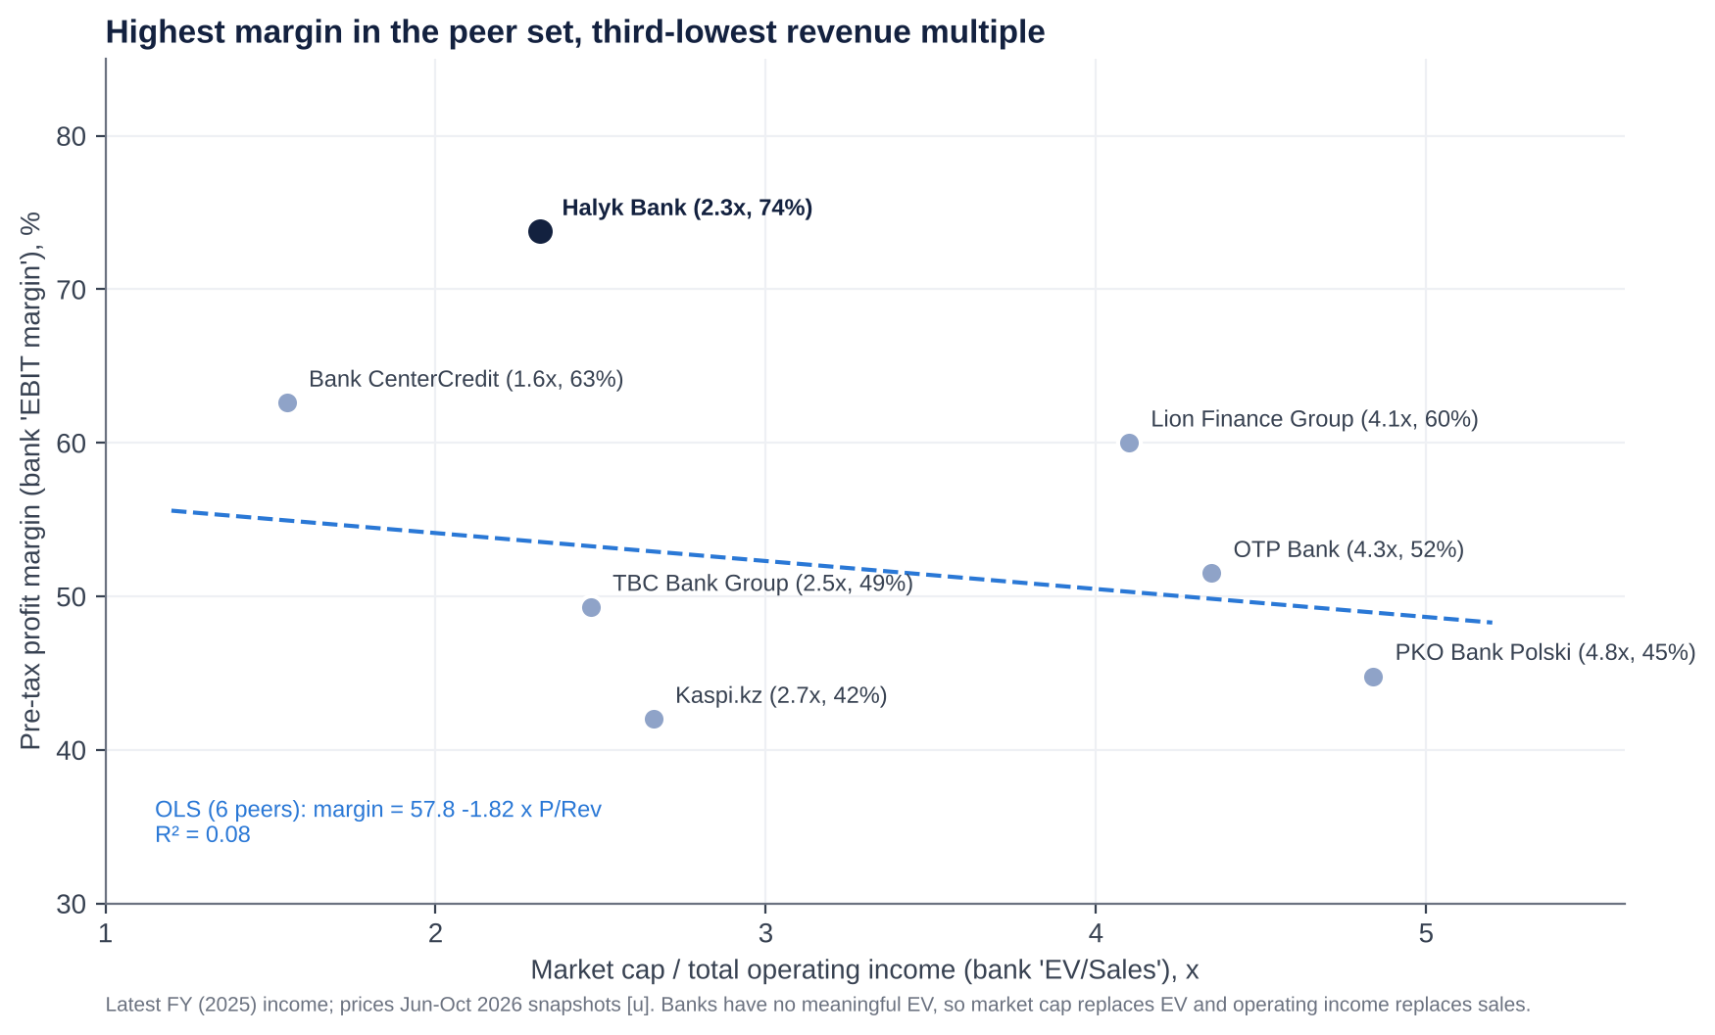 |  | How to read it  ■ As requested: x-axis = 'EV/Sales' (bank version: market cap / operating income); y-axis = 'EBIT margin' (pre-tax margin)  ■ Peer OLS: margin = 57.8 - 1.82 x P/Rev; R2 = 0.08 - no cross-sectional link; country risk, not margin, sets the multiple  ■ Halyk sits ~21pp above the line: at 2.3x revenue, peers' line implies a 53% margin; Halyk earns 74%  ■ P/B vs ROE (bank-standard): see next page - Halyk's ROE maps to ~1.55x book vs 1.12x actual  ■ Conclusion: cheap on every relative screen; the gap is a country/governance discount we expect to narrow only partly

QUESTION 1 - IS HALYK UNDERVALUED?
  VALUATION

Regression: P/B vs ROE - more return per unit of book multiple than any peer
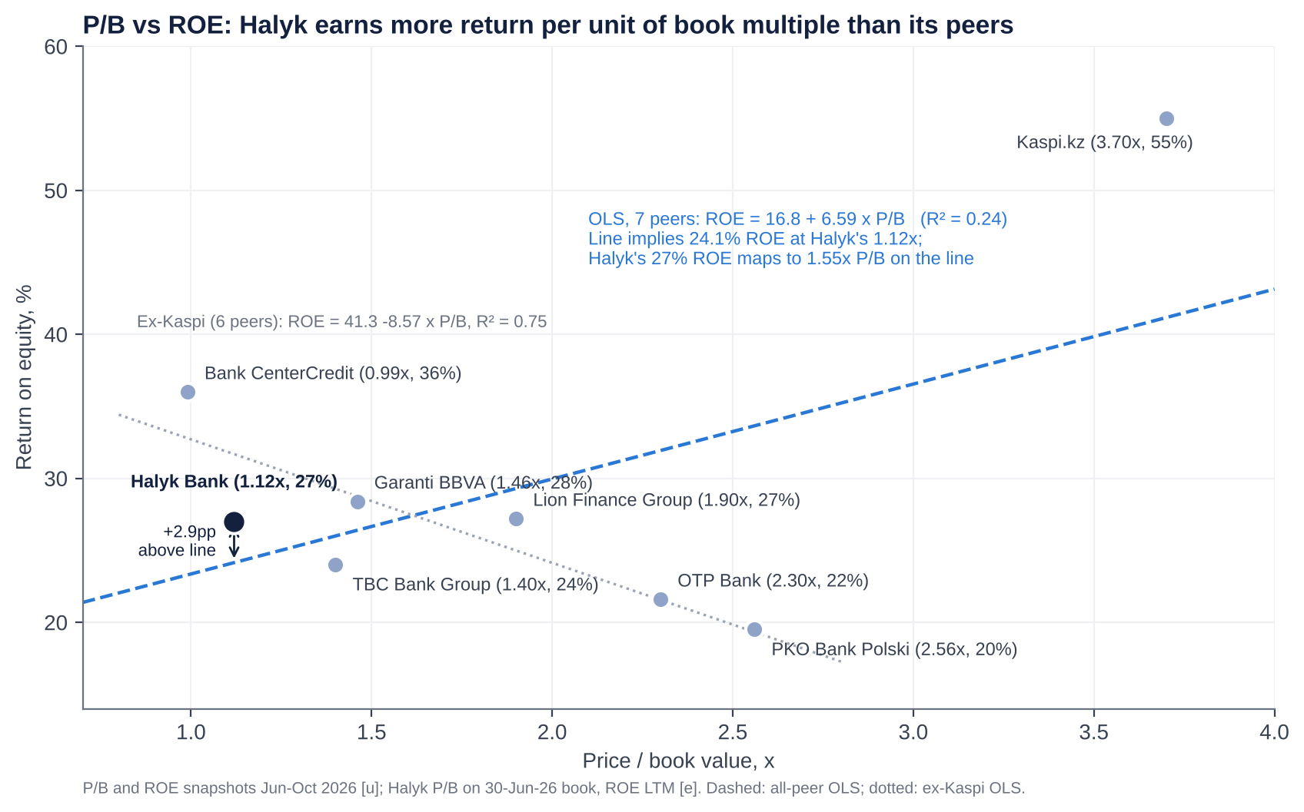 |  | How to read it  ■ x-axis = price / book value; y-axis = return on equity. Points above the line earn more ROE than their P/B implies - i.e. they are cheaper  ■ Peer OLS (7 banks): ROE = 16.8 + 6.59 x P/B; R2 = 0.24  ■ Halyk sits ~3pp above the line: at 1.12x book the peer line implies a 24.1% ROE; Halyk earns ~27% (LTM)  ■ Read the other way: Halyk's 27% ROE maps to ~1.55x P/B on the line - ~39% above today's 1.12x (KZT~520, ~US$46/GDR at spot) [e]  ■ Caveat: Kaspi (3.7x, 55%) drives the positive slope. Ex-Kaspi the line slopes down (R2 0.75): CEE banks with lower ROE trade at higher P/B - country risk dominates  ■ Use: supports a P/B of 1.2-1.55x; our target uses 1.14x 2027E book (and our justified P/B is 1.35x), so we do not underwrite the full gap

WHERE THE VALUE SITS
  VALUATION

Blended value KZT449 (US$38.6); target US$38 rounded down for the overhang
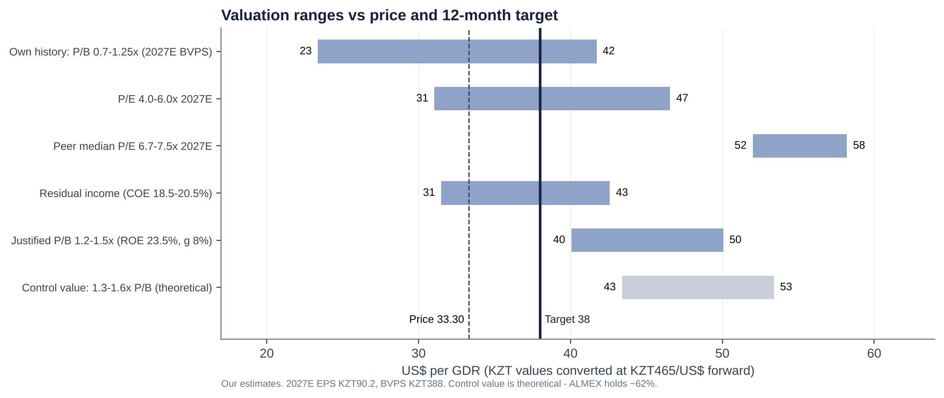 |  | Target build (12-month, KZT per share)  ■ FX: KZT465/US$ 12-month forward (spot 449); a 10% weaker tenge cuts US$ value ~9%  ■ Implied at target: 4.9x 2027E P/E, 1.14x P/B, 12.3% yield  ■ Dividends add ~US$4.3/GDR over 12 months
  Method | Basis | KZT | US$/GDR
  P/E | 5.0x 2027E EPS (KZT90.2) | 451 | 38.8
  P/B | 1.2x 2027E BVPS (KZT388) | 466 | 40.1
  Residual income | COE 19.5%, ROE fade to 21%, g 8% | 431 | 37.0
  Blend | Equal weights | 449 | 38.6
  Target | Rounded down (ALMEX overhang) | 442 | 38.0

QUESTION 2 - VALUE TRAP OR TROUGH?
  EARNINGS

2026 is the trough: four regulatory hits at once, then ~9% EPS growth
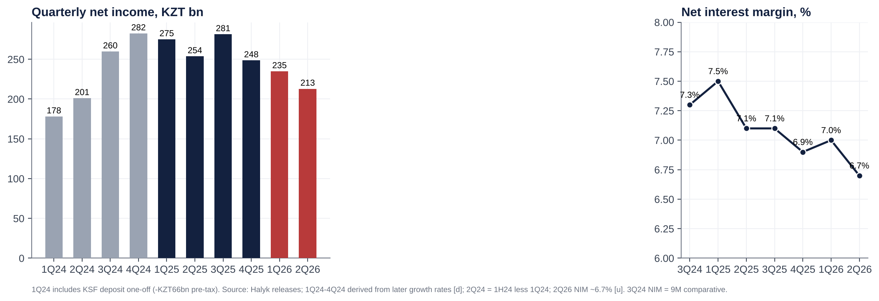 |  | Our estimates [e]. 2H26 needs ~KZT552bn for guidance (~30% above the 2Q run-rate).  ■ 1H26: NI -15.3%; 2Q missed consensus by 13.7% and the lowest estimate by ~10%  ■ Drivers: MRR (-40bp NIM), BNPL/unsecured caps (fees -20%), insurance loss, CIT 25%  ■ We expect the KZT1trn guide to be cut at 9M26; the stock barely reacted to the 1H miss (-3%)
  KZT bn | FY25A | FY26E | FY27E | FY28E
  Total op. income | 1,760 | 1,638 | 1,805 | 1,964
  Net income | 1,058 | 900 | 984 | 1,081
  EPS (KZT) | 97.1 | 82.5 | 90.2 | 99.0
  DPS (KZT) | 58.19 | 49.5 | 54.1 | 59.4
  ROAE | 32.6% | 24.7% | 24.5% | 24.1%
  NIM | 7.1% | 6.75% | 6.5% | 6.4%
  Company guide (NI) | - | ~1,000 | - | -
  Consensus (NI) [u] | - | 950-1,000 | 1,000-1,100 | -

QUESTION 2 - THE MARGIN DEBATE
  DEEP DIVE

NIM rode the rate cycle up; cuts and reserve rules now reverse it
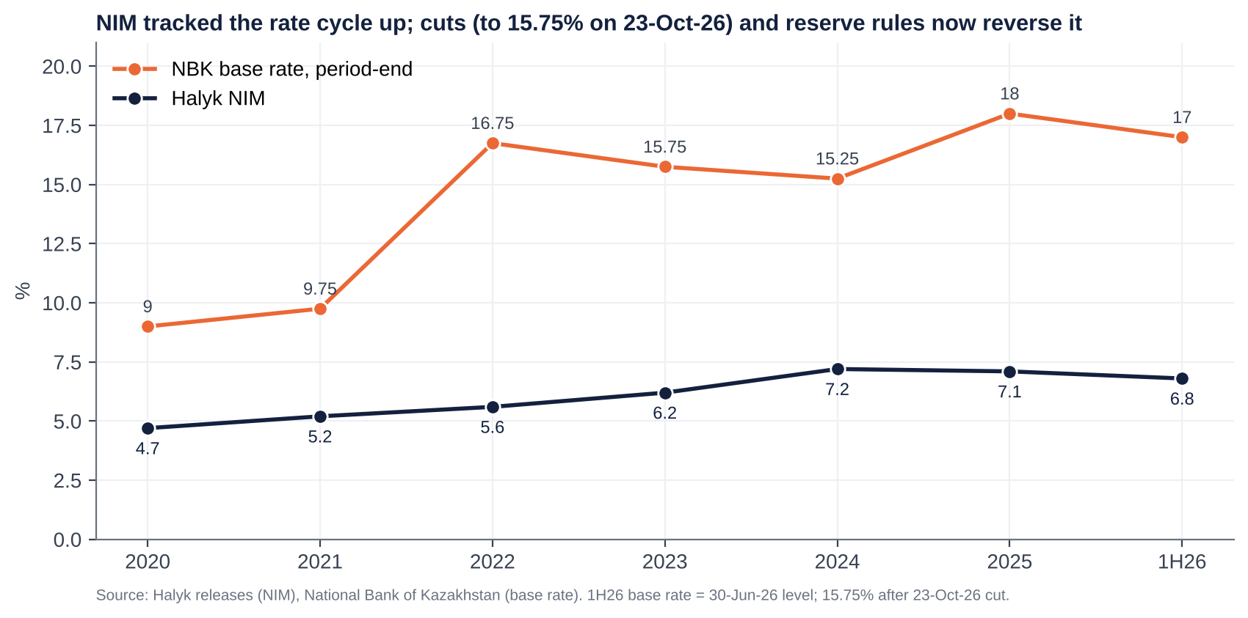 |  | Why NIM falls in 2026-27  ■ Reserve requirements: three-stage MRR increase (Sep-25, Apr-26, Sep-26) sterilises ~KZT4.3trn system-wide; ~40bp drag  ■ Rate cuts: -225bp since June; floating corporate loans and NBK notes reprice before term deposits (avg 9.9%)  ■ Mix: BNPL/unsecured retail curtailed (GEIR cap 46%, 350% risk weights)  Why it should stabilise ~6.5%  ■ Deposit repricing lag works in Halyk's favour from 1H27  ■ Lowest-cost funding base (payroll, current accounts) in the system  ■ SME (+25%) and secured retail growth; each 10bp of NIM = ~KZT20bn PBT

QUESTION 2 - ASSET QUALITY
  DEEP DIVE

NPL 90+ doubled to 5.3% - management says 'partly mechanical'
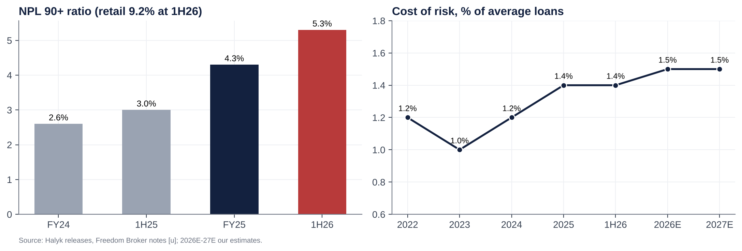 |  | What we know  ■ NPL 90+ KZT715bn (5.3%) vs KZT358bn (3.0%) a year ago; retail 9.2%, SME ~5%, corporate 2.6% (coverage 123%)  ■ Stage 3 8.6%, coverage 58% [u] (from ~73%); provisions 5.0% of loans  ■ Moratorium on selling retail NPLs to collectors ran to 1-May-26 - inflating the stock of NPLs  What to watch at 9M26  ■ NPL sales or write-offs vs new formation  ■ CoR vs the 1.4-1.5% guide (we use 1.5%; bear 2.1%)  ■ ARDFM's Feb-26 sector review flagged reserve 'discrepancies' [u]

BALANCE SHEET & CAPITAL ALLOCATION
  CAPITAL

Over-capitalised and self-funding - the payout is safe, buybacks are token
19.0%  k1-1 = k2 (all CET1), 30-Jun-26; minimum 9.5% / 12.0% incl. buffers |  | 16.5%  Equity / assets; loans / deposits ~94%; deposits ~81% of liabilities |  | ~KZT850bn  Surplus capital over a ~14.5% operating target [e] = ~20% of market cap |  | 2.54bn  Treasury shares (19% of issued) never cancelled; buybacks ~US$20m vs US$50m caps

Capital-allocation record  ■ Good: Kazkom (2017) for KZT2 after the state clean-up; exits from Russia/Tajikistan/Kyrgyzstan; payout raised from 30% to 60%  ■ Poor: BNPL/unsecured push into 2025 (retail NPL 9.2%); KSF deposit one-off (~KZT145bn pre-tax, 2024); Click deal (US$176m for 49%) lapsed  ■ Unclear: auditor switched to EY from 9M26; FY21 dividend first withheld (2022) then paid |  | Priorities we would push for  ■ 1. A CET1 target plus a special-dividend or tender mechanism for capital above it  ■ 2. Cancel the 2.54bn treasury shares  ■ 3. An orderly ALMEX sell-down to 51%, with the bank participating via tender (2011 precedent)  ■ 4. Per-person pay disclosure and an ROE/TSR-linked LTIP

IS THERE AN ACTIVIST IN HERE?
  GOVERNANCE

No - ALMEX's ~62% blocks it; the controlling family's need for liquidity is the catalyst
~62%  ALMEX (Timur Kulibayev & Dinara Kulibayeva via Almex Holding Ltd, AIFC); 51% floor stated |  | ~38%  Free float after the Nov-25 7.6% placement (from ~30.5%) |  | 4 of 7  Independent directors (6 of 8 in 2024); chair no longer independent |  | 0  Activist campaigns, proxy fights or FCA-disclosed short positions found

Why activism is hard here  ■ Every ordinary resolution passes on ALMEX's vote  ■ Systemic bank: any >10% holder needs ARDFM approval; political sensitivity  ■ Owners rely on dividends (ALMEX pays its owners ~KZT462bn) - payout already aligned |  | Where the pressure could come from  ■ ALMEX's own sell-down: placements need investor-friendly capital policy  ■ Index inclusion and free-float growth draw larger EM funds  ■ Governance asks: independent chair, pay disclosure, treasury-share cancellation  ■ Political tail: an independent director sits on the asset-recovery commission

QUESTION 3 - TAKEOVER TARGET?
  M&A

No - control is not for sale; the realistic event is ALMEX selling down to 51%
 |  | What a control price would look like  ■ Theoretical: 25-40% premium = 1.3-1.6x 2027E book = US$43-53/GDR (5.6-6.9x P/E) - a ceiling, above every regional precedent (0.4-1.4x)  ■ Impediments: 62% control and a 51% floor; D-SIB status; antitrust (only Kaspi is big enough); politics; size (US$9bn+)  ■ Plausible acquirers only in theory: Gulf-linked banks (Qatar bought Bereke) or China (CITIC owns 60% of Altyn)  ■ In order of likelihood: (1) ALMEX placements at ~10% discounts; (2) bank-funded tender alongside a placement; (3) strategic minority stake
  Transaction | Date | Value | Multiple / read-across
  ForteBank - Home Credit KZ | 2025 | ~KZT172-274bn | ~0.9-1.4x P/B; healthy retail
  Kim - Jusan (Alatau City) | Jul-25 | Undisclosed | Kaspi-linked capital enters
  Lesha Bank (Qatar) - Bereke | Oct-24 | KZT65bn | ~0.40x P/B; forced exit
  Bank of Georgia - Ameriabank | 2024 | US$303.6m | 0.65x P/B, 2.6x P/E
  Kaspi - Hepsiburada 65% | Jan-25 | US$1.13bn | Kaspi exports its model
  BCC - Alfa-Bank KZ | May-22 | KZT50bn | ~0.37x P/B; bargain
  Halyk - Click 49% (lapsed) | Jul-25 | US$176.4m | Uzbek fintech; not completed
  ALMEX - 7.6% of Halyk | Nov-25 | US$475m | ~0.93x P/B, ~3.1x P/E

SCENARIO ANALYSIS
  VALUATION

Upside/downside skew ~2.4:1 - and the dividend cushions the bear case
 | Bear (25%) | Base (50%) | Bull (25%)
Net income 2027E | KZT800bn (NIM 6.1%, CoR 2.1%) | KZT984bn (NIM 6.5%, CoR 1.5%) | KZT1,120bn (NIM 6.9%, CoR 1.2%)
Payout / DPS FY26 | 50% / ~KZT37 | 60% / KZT49.5 | 65% + special / ~KZT60+
Exit multiple | 0.85x P/B (4.2x P/E) | 1.14x P/B (4.9x P/E) | 1.6x P/B (6.2x P/E)
USD/KZT | 520 | 465 | 450
Per GDR | US$23.5 (-29%) | US$38.0 (+14%) | US$56.2 (+69%)
Plus 12-mo dividends | ~US$3.0 | ~US$4.3 | ~US$5.0+

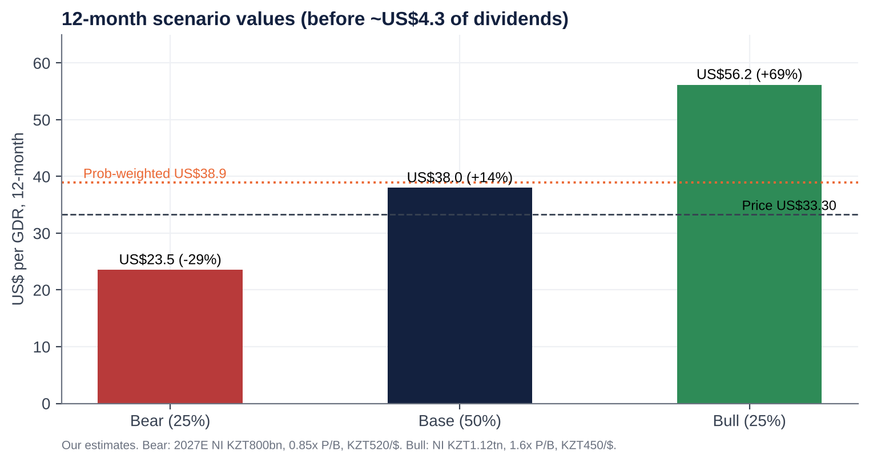 |  | Reading the scenarios  ■ Bear (25%): guidance abandoned, CoR 2%+, payout cut to 50%, a bank levy, tenge to 520 - back to the 2022-24 average 0.85x book  ■ Base (50%): 2026 trough at KZT900bn, ~9% EPS growth from 2027, 60% payout, modest re-rating to 1.14x book  ■ Bull (25%): NIM holds ~6.9%, credit normalises, special dividend or tender alongside ALMEX's sell-down, 1.6x book  ■ Prob-weighted US$38.9 (+17%) before ~US$4.2 of dividends

Downside support: even in the bear case the FY26 dividend (~KZT37) yields ~10% on today's price, and P/B of 0.85x matches the 2022-24 average. Upside driver: a capital-return event (special dividend or tender from ~KZT850bn of surplus capital) alongside ALMEX's sell-down, plus re-rating as free float and index weight rise.

CATALYST CALENDAR
  CATALYSTS

9M26 results and the ALMEX lock-up expiry dominate the next six weeks
9-NOV-26 | Kaspi.kz 3Q26 results | Retail lending and payments read-across | MEDIUM
~13-19 NOV-26 [E] | Halyk 9M/3Q26 results | Fate of the KZT1trn guide; NIM after the Sep MRR step; NPL trend; dividend wording | HIGH
~25-NOV-26 | ALMEX lock-up expiry | Block or placement size and discount; any bank participation | CRITICAL
4-DEC-26 | NBK base-rate decision | NBK signalled a hold at 15.75% | MEDIUM
DEC-26 - FEB-27 | Budget / ARDFM measures | Any bank levy; total-debt cap (8x income); large-loan limits | HIGH
FEB-27 | MSCI quarterly review | Weight change from the higher free float | MEDIUM
MAR-27 | FY26 results and 2027 guidance | NIM, CoR, ROE guide; payout | HIGH
APR-27 | AGM; 2% retail buffer fully phased | FY26 first dividend tranche vs our KZT49.5 total | HIGH

KEY RISKS
  RISKS

What would make this thesis wrong
  01 | State taxes the franchise  A permanent bank levy, profit tax revival or forced lending as oil falls (NBK: US$75 in 2027, US$65 in 2028) pushes sustainable ROE to the high teens
  02 | Margin compression  Further cuts with sticky deposit costs (Freedom's pricing) take NIM to 6.0-6.2%: ~KZT100bn of PBT
  03 | Retail credit  Retail NPL 90+ of 9.2% proves real, not 'mechanical'; CoR of 2-2.5% for two years
  04 | ALMEX overhang  Repeated placements at wider discounts; or a reversal of the sell-down policy
  05 | Political tail  Owners are related to the former president; the asset-recovery law (2023); succession risk at both owner and CEO level
  06 | Tenge and dividend  10% devaluation cuts US$ value ~9%; a dividend cut (payout to 50%) removes the valuation anchor

INVESTMENT COMMITTEE DECISION  Recommendation: BUY  ■ Kazakhstan's dominant bank - 28% of assets, ~48% of corporate loans, the cheapest funding - at 4.5x 2026E earnings and 1.1x book for a ~25% ROE  ■ 2026 is the regulatory/tax trough (NI -15%); we are below guidance at KZT900bn and still see ~9% EPS growth from 2027  ■ A 60% payout is self-funded (19% CET1, ~KZT850bn surplus); the dividend gives a 13% yield and floors the bear case  ■ The ALMEX lock-up expiry (~25-Nov) is the entry point: Nov-25 placed at a ~10% discount and re-rated +31% within six weeks  ■ Main risks are policy, not competition - hence medium conviction and staged entry  Halyk Bank of Kazakhstan JSC | LSE: HSBK | Reference price US$33.30 (21-Oct-2026) | 23 October 2026
  US$38.0 | 4.5x | 13.2% | ~27%
  12-mo target (+14%) | P/E 2026E | FY26E yield | Expected total return
  Sizing & monitoring
  Medium-conviction value/income position with an event overlay. One third now; add on the 9M26 print and any ALMEX placement.
  Hard review triggers: dividend-policy change or payout below 50%; NIM below 6.4%; any bank profit levy; block above 5% at a >15% discount; political action against the owners.
  Track separately: 9M26 results (mid-Nov), ALMEX lock-up (~25-Nov), NBK (4-Dec), 2027 budget measures, FY26 guidance (Mar-27).

