
INVESTMENT COMMITTEE MEMO  Genting Malaysia Bhd  Bursa: GENM MK (4715) - Malaysia's only casino and New York City's only full casino, owned through a levered equity stub that the market has priced for its parent's problems | 6.5x  TEV / NTM EBITDA: bottom decile of its 10-year range (median 8.8x); listed peer median 7.5x; casino control deals 9.2x  ~US$0.56bn  What the market pays for the entire US business if Resorts World Genting is valued at 7x EBITDA. The NYC licence fee alone was US$500m (Jan-26)  RM1.94  Probability-weighted value (+63%): bull RM3.28 / base RM1.86 / bear RM0.76, plus a ~4% dividend yield
  RECOMMENDATION: SPECULATIVE BUY |  | 12-MO TARGET: RM1.85 (+55%)
  Reference price | 52-wk range | Mkt cap | Net debt (incl. leases)
  RM1.19 (21-Oct-26) | RM1.18-2.39 | RM6.7bn / US$1.65bn | RM14.2bn (Jun-26)
  Dividend | Largest holder | Lapsed parent offer | Sell-side
  FY25 7 sen (5.9%) | Genting Bhd 73.84% | RM2.35 (Dec-25) | Affin Sell RM1.00; cons. RM2.19
Prepared for Investment Committee review | 24 October 2026 (update of the 18-Oct-2026 memo)

EXECUTIVE SUMMARY | RECOMMENDATION
Speculative Buy: a casino monopoly plus NYC's only casino, priced for its parent's balance sheet
6.5x  NTM EV/EBITDA (peers 7.5x, own 10-yr median 8.8x); 0.60x book, a record low | −49%  Discount to Genting Bhd's lapsed RM2.35 offer; the independent adviser's SOTP was RM3.48-3.77 | US$126.7m  RWNYC September GGR (~US$1.5bn annualised); 69% of New York's commercial casino GGR | RM1.85  12-mo target (+55%); bull +176% / bear −36%; probability-weighted RM1.94 | 25%  Bear-case probability (NY racing-support tax enforced, RWG de-rates, phase-2 value destruction)

Why now - four forces converging  - Forced, non-fundamental selling: −20% since 9-Oct on the parent's RM1.25bn rights issue and a broker downgrade; no GENM news. Premium to the parent at a 2nd-percentile 0.6x  - New York inflection: live tables since 28-Apr-26; slot tax cut from ~68% to 56%; +1,400 slots in Jul-26. 3Q26 (~19-26 Nov) is the first full quarter  - Minority veto: the parent is 1.16pp from 75% but cannot fund a fair cash offer; a >10% objection blocks a delisting [u]  - Self-help: Miami land (US$1.225bn bid in 2023), NY PropCo sale-leaseback (GLPI/VICI precedents), ~RM848m a year of related-party fees, a US listing of the US business [u] |  | What has to go right  - US & Bahamas adj. EBITDA ≥US$60m a quarter from 3Q26; RWNYC GGR holds ≥US$125m a month  - Racing-support dispute settles at ≤US$50m a year, or is offset by tax equalisation  - Malaysia EBITDA ≥RM2.1bn through the Jun-27 minimum-wage step-up  - No GENM equity raise; non-core sales fund part of the US$3.7bn left to spend  - Any privatisation is priced at or above the RM2.35 anchor

Position sizing: event-driven, low-to-medium conviction. Hold a half position; do not add before the UK Budget (28-Oct) and 3Q26 (~19-26 Nov). Add on a ≥US$60m NY quarter, completion of the parent's rights issue (1Q27) or an asset-monetisation announcement. An optional long GENM / short Genting Bhd pair (subject to borrow) isolates minority value from parent and Malaysian-policy beta.

BUSINESS OVERVIEW | CONTEXT
GENM at a glance - a Malaysian monopoly with a New York growth engine bolted on
What it does  - Resorts World Genting: Malaysia's only licensed casino (since 1969; licence renewed quarterly); ~10,500 rooms, SkyWorlds theme park, mall, cable cars; 28.6m visitors, 98% occupancy  - Resorts World New York City: converted from a VLT racino to a full commercial casino on 28-Apr-26; 242 tables, ~3,900 slots; US$5.5bn masterplan to ~2029-30; US$126.7m GGR in Sep-26  - Also: ~32 UK casinos, Crockfords Cairo, RW Catskills and Hudson Valley (Empire, loss-making), RW Bimini, Hilton Miami and 30 acres of Miami waterfront land  - FY25: revenue RM11.9bn; adj. EBITDA RM3.3bn (RM2.9bn ex-FX); NI RM755m; ~73% of revenue is gaming  - Control: Genting Bhd 73.84% (Lim family via Kien Huat); free float ~26%; EPF, KWAP and PNB have left the register |  | Revenue and adj. EBITDA by division (RM m)  Company basis; adj. EBITDA includes unrealised FX on USD debt, shown ex-FX at group level. Source: GENM AR2025, quarterly reports, S&P Capital IQ.
  Division | FY24 | FY25 | 1H26 | Trend
  Malaysia revenue | 6,823 | 7,134 | 3,434 | +5% FY25; flat 1H26
  - adj. EBITDA | 2,092 | 2,139 | 1,127 | 30-33% margin
  UK & Egypt revenue | 1,896 | 1,994 | 967 | Middle East hit; MGD risk
  - adj. EBITDA | 298 | 322 | 120 | 12-16% margin
  US & Bahamas revenue | 1,980 | 2,566 | 2,228 | +107% 1H26
  - adj. EBITDA | 530 | 472 | 297 | +83% in 2Q26
  Group revenue | 10,912 | 11,884 | 6,720 | FY26E 13.7bn (ours)
  Group adj. EBITDA ex-FX | 2,795 | 2,946 | 1,492 | FY26E 3.1bn (ours)

The single most distinctive fact: in January GENM paid US$500m for New York City's first full casino licence. By September RWNYC was taking in US$126.7m a month (~US$1.5bn annualised). Yet at RM1.19, after valuing the Malaysian monopoly at 7x EBITDA, the market pays ~US$0.56bn for the entire US business, about what the licence cost.

THE SETUP | CONTEXT
Tax hike (2018), Empire (2019), dividend cut (2025), lapsed offer and parent cash call (2026): −75% in ten years
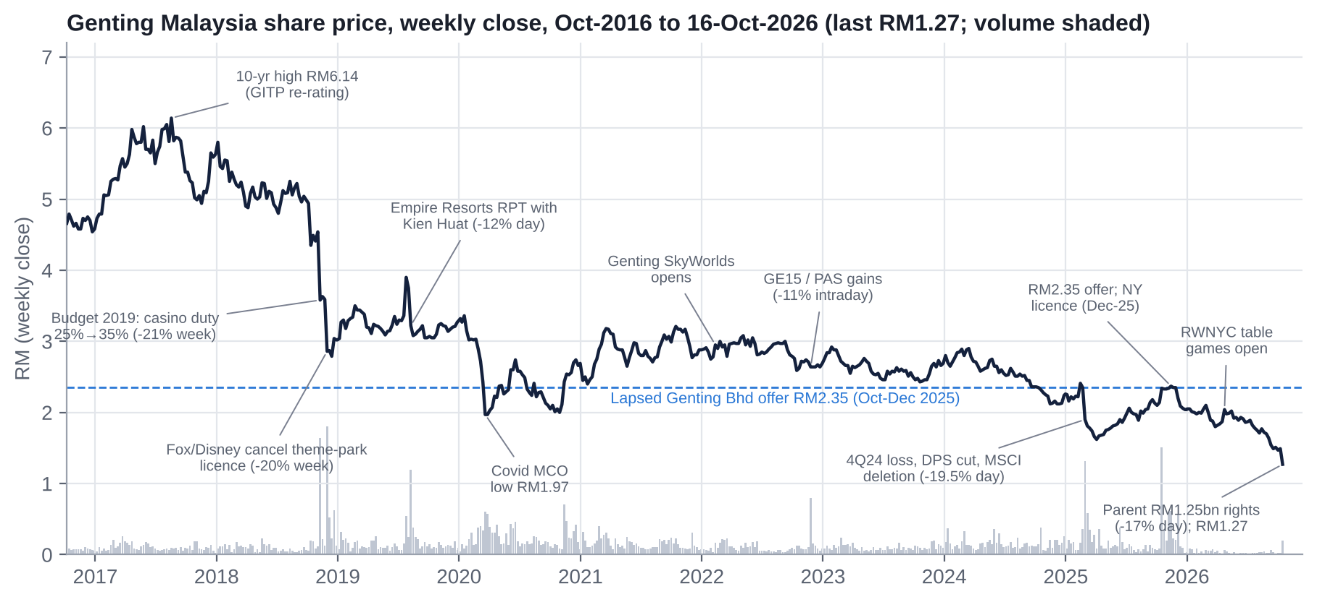  Weekly close to 16-Oct-2026 (last RM1.27); GENM closed at a record-low RM1.19 on 21-Oct (RM1.18 intraday). Only two single-day moves above 10% in five years, both corporate or parent events. Source: S&P Capital IQ, Investing.com. |  | Key catalysts
  Date | Event
  NOV 2018 | Budget 2019 casino duty 25%→35% (−21% wk); Fox/Disney cancel theme park (−20% wk)
  AUG 2019 | Empire Resorts related-party deal with Kien Huat (−12% day)
  28-FEB-25 | 4Q24 loss, DPS 9→4 sen, MSCI deletion (−19.5% day)
  13-OCT-25 | Genting Bhd RM2.35 offer; lapsed at 73.13% on 1-Dec
  15-DEC-25 | NY downstate licence awarded; US$500m fee paid Jan-26
  28-APR-26 | RWNYC opens NYC's first live table games (+16% rally)
  AUG-SEP 26 | 2Q26 NP −89%, no interim; Fitch cut to BBB-
  12-OCT-26 | Parent RM1.25bn rights issue: GENM −17.4% to RM1.23
  21-OCT-26 | Affin Sell (TP RM1.00); record-low close RM1.19

QUESTION 1 - IS GENM UNDERVALUED? | VALUATION
Cheap on EBITDA, sales and book; expensive on earnings - leverage sits between the two
Metric | GENM | Genting Sing. | Genting Bhd | Sands China | Galaxy | MGM China | Caesars | Boyd | Rank | Median (31)
TEV/Sales | 1.52x | 1.81x | 1.78x | 2.23x | 2.71x | 1.45x | 2.66x | 1.96x | 0.61x | 1.86x
TEV/EBITDA (LTM) | 7.9x | 5.6x | 6.4x | 8.5x | 10.1x | 6.2x | 8.4x | 6.0x | 4.0x | 7.9x
TEV/EBITDA (NTM) | 6.5x | 5.1x | 6.1x | 7.8x | 9.2x | 5.2x | 8.3x | 6.6x | 3.9x | 7.5x
TEV/EBIT | 17.8x | 11.7x | 12.4x | 13.7x | 14.1x | 8.5x | 15.1x | 9.7x | 6.6x | 12.8x
P/E (NTM) | 14.0x | 17.0x | 8.8x | 11.3x | 13.2x | 8.3x | n/a | 9.7x | 8.4x | 10.1x
EBITDA margin | 19.2% | 32.4% | 28.0% | 26.3% | 26.9% | 23.5% | 31.6% | 32.6% | 15.2% | 24.7%
EBIT margin | 8.6% | 15.4% | 14.3% | 16.3% | 19.2% | 17.1% | 17.6% | 20.3% | 9.3% | 13.0%
Sales growth (LTM) | 19.1% | 2.2% | 7.9% | 11.5% | 11.1% | 11.6% | 2.4% | 1.8% | 5.0% | 5.9%
Net debt/EBITDA | 5.6x | -3.7x | 3.6x | 2.7x | -0.8x | 1.7x | 6.8x | 2.2x | 1.3x | 4.3x
Dividend yield | 5.9% | 6.6% | 3.5% | 6.5% | 4.5% | 6.8% | 0.0% | 1.1% | 3.9% | 0.8%
FCF yield (CFO − capex) | 7.8% | 2.3% | 4.6% | 14.4% | 7.6% | 17.7% | 10.4% | 0.7% | 20.1% | 10.0%
LTM to 30-Jun-2026; peer prices 16-Oct-2026; GENM re-based to RM1.19 (21-Oct-2026). CIQ TEV includes leases. Median of 31 listed casino peers (ex-GENM, Kangwon Land). FCF yield excludes GENM's US$500m licence fee. Source: S&P Capital IQ.

What the comparison shows  - NTM EV/EBITDA 6.5x vs 7.5x for peers: bottom decile of its 10-year range (median 8.8x); TEV/Sales and P/B at record lows  - GENM's 10-year premium of ~2.5 turns over its parent has collapsed to 0.6x (2nd percentile)  - The RM2.35 offer was 8.1x LTM EBITDA, below every land-based casino precedent (Caesars 9.1x, Golden 9.8x, Crown 11.2x) |  | The honest counter-read  - P/E is 14.0x NTM vs 10.1x for peers and TEV/EBIT 17.8x vs 12.8x: D&A, interest and tax absorb the EBITDA  - Net debt/EBITDA is 5.6x (CIQ) vs 4.3x for peers. Because debt rose RM3.8bn after the offer, EV is down only ~9-13%, so "−49% vs the offer" overstates the de-rating  - Our FY26-28E EPS is 27-42% below consensus (interest, tax, stale broker net debt)

QUESTION 1 - IS GENM UNDERVALUED? | VALUATION
Regression: slightly below the line on today's margins - the upside is margin recovery as New York ramps
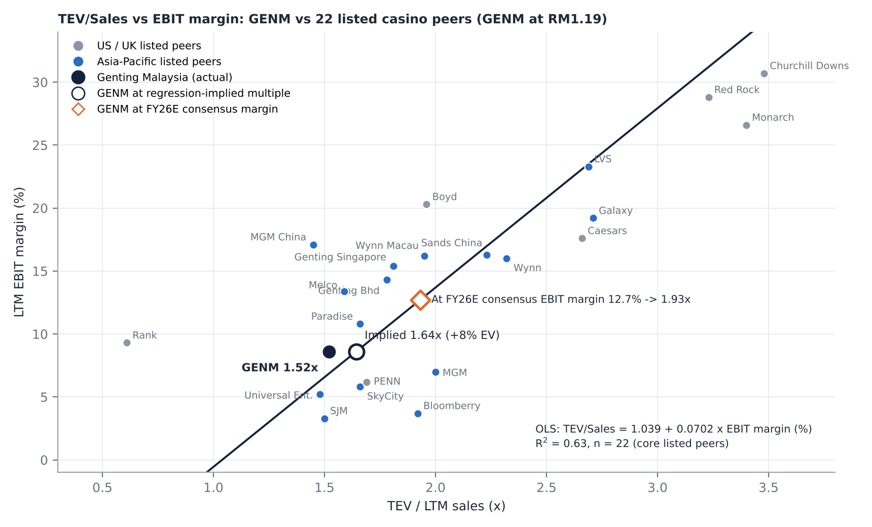  OLS: TEV/Sales = 1.039 + 0.0702 x EBIT margin (%), R² = 0.63, n = 22; reverse fit EBIT margin = −3.9% + 9.0% x TEV/Sales. Peers: S&P Capital IQ (16-Oct-2026); GENM at RM1.19. |  | How to read it  - GENM at 1.52x TEV/Sales sits below the line: OLS implies 1.64x at its 8.6% LTM EBIT margin (+8% EV; RM1.30-1.47 a share, +9% to +24%)  - Slope 0.070x per point of EBIT margin: each 1pp of margin is worth ~RM0.9bn of EV (~RM0.16 a share)  - R² 0.63, t = 5.9 (n = 22 core peers; net-cash, negative-EBIT, micro-cap and double-count names excluded). Full sample R² 0.20  - At the FY26E consensus EBIT margin of 12.7%, the line implies 1.93x, i.e. RM1.96-2.13 a share (+65% to +79%)  - With net debt ~2.1x market cap, small EV gaps become large equity moves. Our base case does not rely on the regression

WHERE THE VALUE SITS | VALUATION
Sum-of-the-parts: RM1.86 per share in the base case, after a 15% control and governance discount
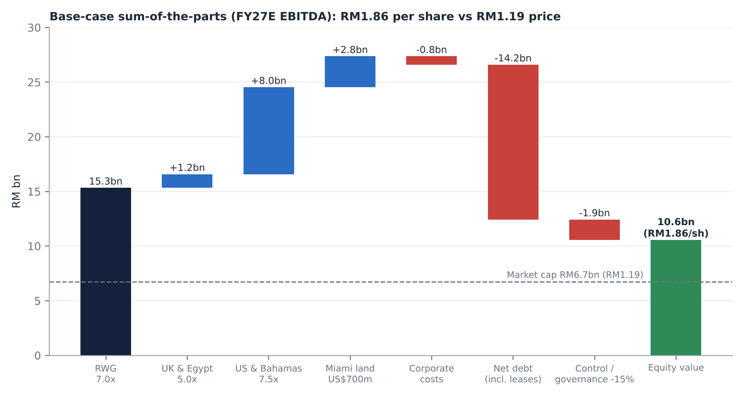 |  | Base-case SOTP (RM m)  - Implied 7.8x FY27E EV/EBITDA before the discount: below the 9.2x deal median and GENM's 8.8x 10-year median  - NY phase 2 (US$3.3bn) treated as NPV-neutral; racing support partially charged (~US$40m a year)  - Market cap (RM6.7bn) is 64% of base-case equity value. Each 1x on group EBITDA = ~RM0.60 a share
  Component | Method | RM m
  RWG / Malaysia | 7.0x FY27E EBITDA (2,190) | 15,330
  UK & Egypt | 5.0x FY27E EBITDA (250) | 1,250
  US & Bahamas | 7.5x FY27E EBITDA (1,060; US$262m) | 7,950
  Miami land | US$700m (2023 bid US$1.225bn) | 2,835
  Corporate costs | 7x (110) | (770)
  Net debt incl. leases | Jun-26 | (14,166)
  Control / governance | −15% of equity | (1,864)
  Equity / per share | 5,667m shares | 10,565 / RM1.86

THE NEW YORK BUSINESS | HIDDEN ASSET
NYC's only full casino until ~2030, running ~US$1.5bn of annualised GGR - valued at ~2.1x EBITDA
242 / ~3,900  Live tables / slots after the Jul-26 expansion; masterplan 800 tables, ~6,000 slots, 2,000 rooms | US$126.7m  September GGR: slots/ETGs US$85.2m, tables US$41.5m; 69% of NY commercial casino GGR (+220% YoY) | 56% → 72%?  Slot tax bid vs the State's view that ~US$150m a year of racing support is owed on top (live dispute) | US$3.7bn  Capex still to spend (Fitch); US$2.0bn Genting Americas facility signed Jun-26 | ~2030  Metropolitan Park (Cohen/Hard Rock) and Bally's Bronx open, paying 25-30% slot tax

*Holding the rest of the base-case SOTP constant, after a 15% discount; USD/MYR 4.05 [e]. |  | What to watch  - NY Gaming Commission data: weekly peak ~US$30.8m (Jul); September ~US$29.6m a week. The October report (mid-Nov) shows whether the fade stabilises  - Racing support: the one-year legislative fix expires in 2027; GENM has threatened to drop the US$3.3bn phase 2  - Returns: no IRR or hurdle rate disclosed for phase 2, the key governance question  - Monetisation: a PropCo sale-leaseback (GLPI paid US$700m for Bally's Lincoln real estate, Feb-26) or a US listing of a combined Genting Americas [u] would fund the build without GENM equity
  US EBITDA (FY27E) x multiple | US value (RM bn) | Equity / share* | vs RM1.19 | Context
  US$150m x 6.0x (racing support in full) | 3.6 | RM1.22 | +3% | Fitch-type downside
  US$200m x 7.0x | 5.7 | RM1.52 | +28% | ~Fitch 2026E level
  US$262m x 7.5x (base) | 8.0 | RM1.86 | +56% | Partial racing support
  US$320m x 9.0x | 11.7 | RM2.42 | +103% | Tax equalisation path
  US$450m x 9.0x (2028) | 16.4 | RM3.13 | +163% | Fitch NY EBITDA by 2028

QUESTION 2 - VALUE TRAP OR GENUINE RECOVERY? | EARNINGS
EBITDA is inflecting with New York - but consensus EPS is 27-42% too high once interest and tax are modelled
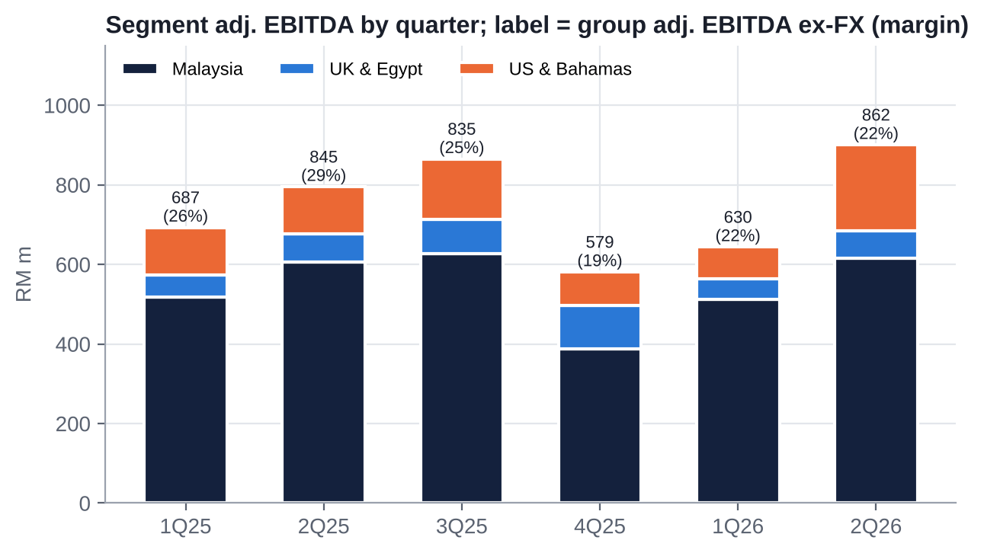 |  | Our estimates [e]; consensus S&P Capital IQ (Oct-2026).  - 2Q26: record revenue (+32%); ex-FX EBITDA +2% YoY / +37% QoQ; NP −89%; no interim dividend  - 3Q26 preview [e]: US&B adj. EBITDA ≥RM250m is the key number; group ex-FX EBITDA ~RM0.88-0.92bn; NI ~RM90-140m before FX  - Finance costs +43% YoY; brokers' FY27E interest (RM910m) and FY26E net debt (RM10.0bn vs RM14.2bn actual) look stale  - Affin's Sell (TP RM1.00) is the first broker call to price the parent overhang; expect consensus to fall
  RM m | FY25A | FY26E | FY27E | FY28E
  Revenue | 11,884 | 13,720 | 15,200 | 16,300
  Adj. EBITDA ex-FX | 2,946 | 3,139 | 3,415 | 3,680
  Consensus EBITDA | - | 2,974 | 3,455 | 3,765
  Net income | 755 | 243 | 485 | 545
  EPS (sen) | 13.3 | 4.3 | 8.6 | 9.6
  Consensus EPS (sen) | - | 7.5 | 11.8 | 14.8
  DPS (sen) | 7.0 | 5.0 | 5.0 | 6.0
  P/E at RM1.19 | 8.9x | 27.7x | 13.8x | 12.4x
  Net debt / EBITDA | 3.5x | 5.0x | 4.9x | 4.7x

QUESTION 2 - DEEP DIVE | DEEP DIVE
The capex cycle: spending quadruples just as leverage peaks - the source of the discount and of the option
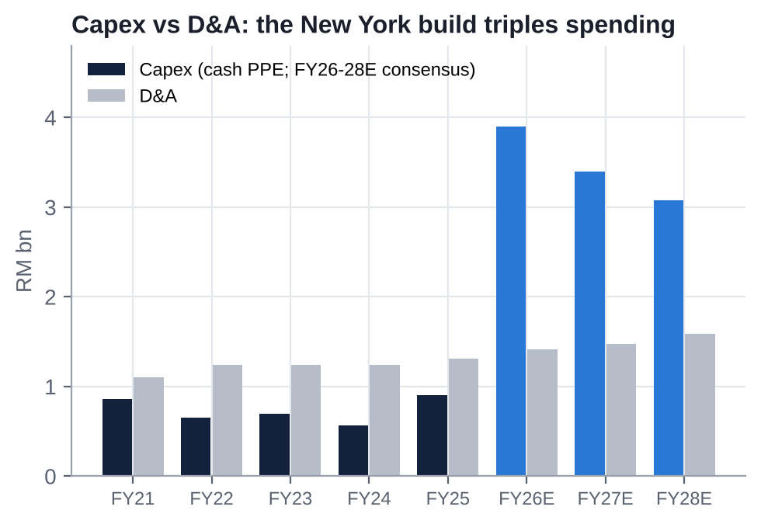 |  | 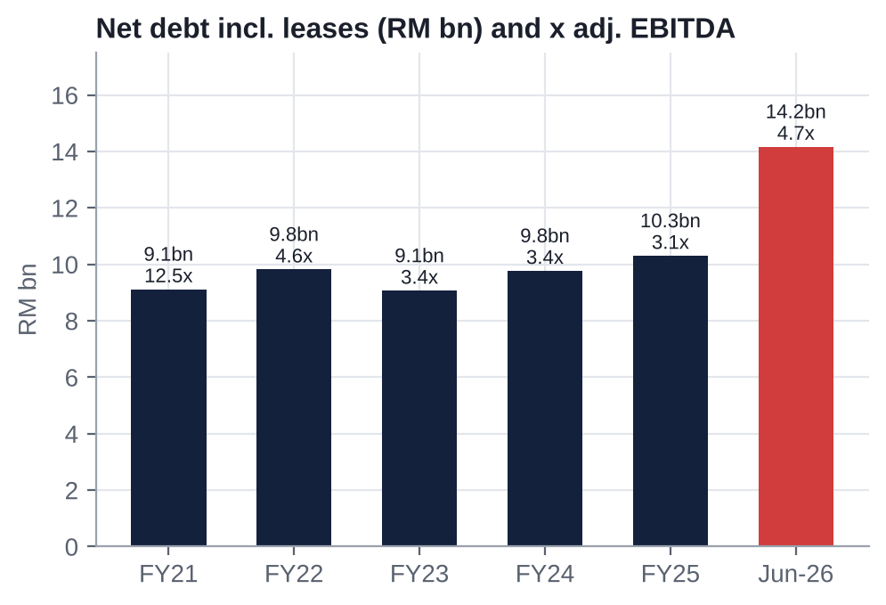 |  | Why returns collapsed - and why they could turn  - A decade of low returns: ROE averaged ~1.6% and ROIC ~3.6% over FY15-25; equity fell from RM19.7bn to RM11.6bn while debt tripled  - Debt-funded dividends: payout 195-226% in FY23-24, largely up-streamed to the parent  - Capex reset: ~RM0.9bn a year historically → RM3.1-3.9bn a year in FY26-28E (consensus) for RWNYC  - The turn: NY EBITDA ramps (Fitch ~US$450m by 2028) while capex rolls off after 2028; FCF turns positive in FY27E (consensus)  Watch  - Fitch BBB- (Sep-26) is the floor; RM1.1bn MTN due Mar-27; 2029 and 2031 bond walls  - Lease liabilities +RM0.78bn in 1H26 (Aqueduct lease remeasured)

MANAGEMENT AND SENTIMENT | EARNINGS CALLS
Tone has moved from "defend Malaysia" to "build New York"; the market has stopped paying for jam tomorrow
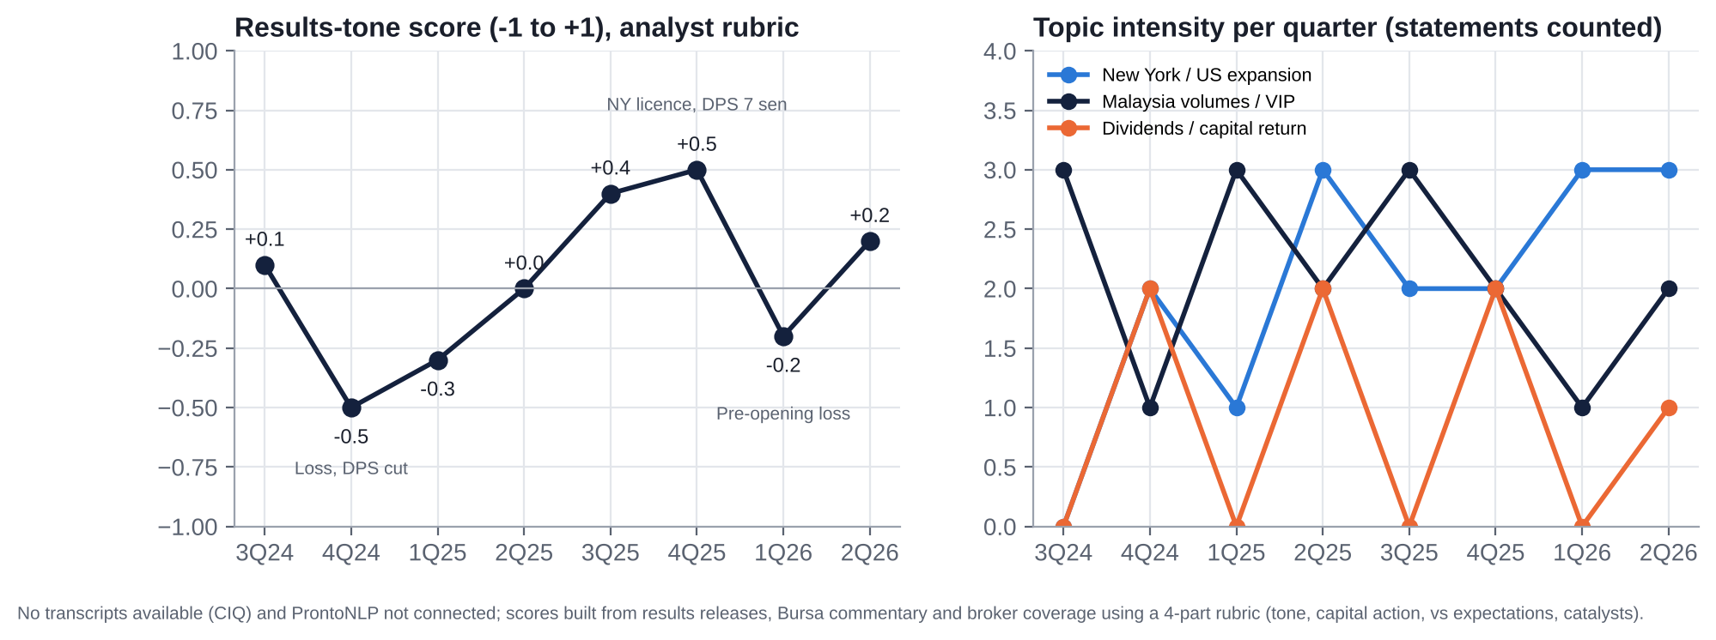  No transcripts on S&P Capital IQ; ProntoNLP not connected. Scores use a disclosed four-part rubric (tone, capital action, vs expectations, catalysts) on results releases and broker coverage, 3Q24-2Q26. |  | What management is focused on  - NY ramp, phase 2 (hotel tower, arena) and the racing-support tax fight dominate every briefing  - Malaysia: cost control, mass-market floor, refurbishment; VIP volatility  - Funding: US$2bn facility, perpetuals, defending BBB-; dividends de-prioritised (no interims in FY25-26); a token buyback (550,000 shares, 12-Oct)  Management  - Tan Sri Lim Kok Thay (CEO; GENM board since 1988): built RWS and RWNYC; also Mashpee, Empire and Genting HK. Paid RM54.7m (FY25)  - Lim Keong Hui (Deputy CEO; third generation)  - Lee Thiam Kit (President since Mar-26, after Lee Choong Yan stepped down); Loh Wai Yee (CFO since Apr-25)  - Insider buying is at the parent only: Kien Huat bought 422,500 Genting Bhd shares and CEO Tan Kong Han bought at ~RM1.42 (Oct-26)

BALANCE SHEET AND CAPITAL ALLOCATION | CAPITAL
Stretched balance sheet and a parent that charges ~RM848m a year: capital allocation is the thesis
RM14.2bn  Net debt incl. leases (Jun-26), 4.9x LTM adj. EBITDA ex-FX; +RM3.8bn in 1H26 (licence fee, capex) | BBB-  Fitch (cut Sep-26); RAM AA1; parent S&P BBB-/Negative with "fallen angel" risk | ~RM848m  FY25 fees to Genting Bhd/RWI (management RM498m, brand RM233m, US IP RM90m): 26% of adj. EBITDA | 7 sen  FY25 DPS (from 15 sen in FY23); no interim in FY25 or FY26; first buyback executions Oct-26 (RM0.7m)

Capital-allocation record  - Good: won the scarce NYC licence; fixed the payout (from 226% to ~50%); refinanced Empire's 7.75% notes early  - Poor: Mashpee notes (RM1.83bn impaired), Empire (~US$765m; serial related-party deals with Kien Huat, each below the 5% vote threshold), Bimini, Fox World, the collapsed Miami sale  - Leakage: related-party fees ~7% of revenue; CEO pay RM54.7m; 3 of 8 directors independent  - Returns: ROE ~1.6% average FY15-25; attributable equity −41% since FY16 |  | Priorities we would push for  1. Sell the Miami land and run a RWNYC PropCo sale-leaseback to fund phase 2 without equity  2. Independent benchmarking of the management, know-how and brand fees; a minority vote on the RRPT mandate  3. Publish the NY phase-2 IRR and hurdle; tie pay to ROIC/TSR  4. Exit or close Empire's upstate assets and Bimini; ring-fence the UK

Is the balance sheet efficient? No. Leverage peaks at ~5x through FY27E while ~RM848m a year flows to the parent in fees. Non-core assets (Miami, Empire upstate, Bimini) and a NY PropCo are the only non-dilutive levers. The 12-Oct buyback (RM0.7m) is symbolic next to RM14.2bn of net debt.

IS THERE AN ACTIVIST IN HERE? | GOVERNANCE
Not a proxy fight - a blocking stake: minorities hold the veto on delisting and on related-party mandates
73.84%  Genting Bhd (Mar-26), 1.16pp (~66m shares, ~RM78m) below the 75% level that reopens a delisting | ~26.2%  Free float; EPF, KWAP and PNB gone; largest outside holder UBS (1.0%), then Vanguard, Dimensional, iShares, Norges | ~10%  Objection level that typically defeats a delisting resolution [u]: ~567m shares, ~RM675m / US$165m at RM1.19 | 0  Activist campaigns ever at GENM; opposition has been passive (2019 Empire backlash, 2025 offer rejection)

Why activism could work here  - A quantifiable "value to unlock": fees of ~RM848m a year (halving them is worth ~RM0.50 a share at 7x), Miami land, NY real estate  - Independent adviser on record that RM2.35 was "not fair and not reasonable" (SOTP RM3.48-3.77)  - Interested parties must abstain on RRPT mandates, so minorities decide the fee mandate each AGM  - No disclosed short interest; a 4-6% dividend yield supports the holding cost |  | Where the limits are  - A 73.84% controller makes board change impossible  - Liquidity of ~2-4m shares a day means building 10% takes months and moves the price  - Malaysian institutions rarely oppose the Lim family publicly; the float is dispersed foreign/retail  - The delisting-objection rule and post-offer creep restrictions need legal confirmation [u]

What an activist would ask for: (1) independent benchmarking and reduction of related-party fees; (2) a Miami sale and a NY PropCo sale-leaseback to fund phase 2 without equity; (3) published IRR hurdles and ROIC-linked pay; (4) an independent board majority; (5) a public floor of RM2.35 for any privatisation, backed by a quiet 5-10% blocking stake.

QUESTION 3 - TAKEOVER TARGET? | M&A
One natural buyer, already at 73.84% - but short of cash; precedents say 9-11x, the last offer was 8.1x
Median 9.2x (n=10). Bally's Lincoln real estate → GLPI US$700m (Feb-26) is the PropCo precedent. Source: S&P Capital IQ Transactions.  Takeout value grid (TEV / FY26E consensus EBITDA of RM2,974m)  Equity = multiple x FY26E EBITDA − net debt incl. leases (RM14,166m, Jun-26); 5,667m shares. |  | What a control price would look like  - RM2.35 today = 9.2x FY26E EBITDA (it was 8.1x LTM when offered, before RM3.8bn of new debt)  - Our realistic takeout range: 8.5-10x = RM1.96-2.75 (+65% to +131%); the independent adviser's RM3.48-3.77 = 11.4-11.9x  - Impediments: the parent's rights issue to repay debt; S&P negative outlook; CreditSights expects no debt-funded GENM buying for 12-18 months; Lim family dilution in a share swap  - Most likely sequence: (1) parent rights done (1Q27); (2) creep past 75% (2027); (3) delisting with an exit offer once NY earnings are visible (2027-28); or asset-level deals first  - Overlooked route [u]: the Nov-2025 offer document flagged combining Genting Bhd's US assets with GENM's US business and listing it in the US, a way to value New York without a cash bid  - Third-party bid: effectively impossible without the Lim family
  Transaction | Date | EV | EV/EBITDA | Read-across
  GENM minority - Genting Bhd | Oct-25 | RM22.9bn | 8.1x LTM | Lapsed at 73.13%; 9.8% premium
  Caesars - Fertitta | May-26 | US$31.7bn | 9.1x | Pending; US regional + LV
  Golden Ent. - VICI / Sartini | Nov-25 | US$1.2bn | 9.8x | OpCo/PropCo split
  SkyCity - Oaktree | Aug-26 | NZ$1.5bn | ~10.8x [e] | Cancelled; single-market casino
  Crown Resorts - Blackstone | Feb-22 | A$9.8bn | 11.2x (FY19) | IR take-private
  Cirsa - Lottomatica | Sep-26 | €4.7bn | 7.1x | Diversified gaming
  OPAP - Allwyn | Oct-25 | €6.6bn | 8.4x | Lottery/betting
  TEV / EBITDA | 7.0x | 8.0x | 9.0x | 9.2x | 10.0x | 11.0x
  Value per share (RM) | 1.17 | 1.70 | 2.22 | 2.33 | 2.75 | 3.27
  Premium to RM1.19 | −2% | +43% | +87% | +96% | +131% | +175%

SCENARIO ANALYSIS | VALUATION
Asymmetric but fat-tailed: −36% bear vs +176% bull; probability-weighted RM1.94
 | Bear (25%) | Base (50%) | Bull (25%)
Malaysia FY27E EBITDA / multiple | RM2,100m / 6.0x | RM2,190m / 7.0x | RM2,300m / 8.0x
US & Bahamas FY27E EBITDA / multiple | US$198m (racing support in full) / 6.5x | US$262m (partial) / 7.5x | US$321m (tax equalisation) / 9.0x
UK & Egypt / Miami land | 4.0x / US$500m | 5.0x / US$700m | 5.5x / US$1.0bn
NY phase-2 NPV; discount | −RM1.0bn; 10% | Neutral; 15% | Neutral; 10%
Revenue CAGR FY26-28E / FY27E EBITDA margin | ~3% / ~20% | ~11% / ~22.5% | ~14% / ~24.5%
Implied EV / FY27E EBITDA | 5.6x | 7.8x | 10.2x (8.2x ex-Miami)
Per share | RM0.76 (−36%) | RM1.86 (+56%) | RM3.28 (+176%)

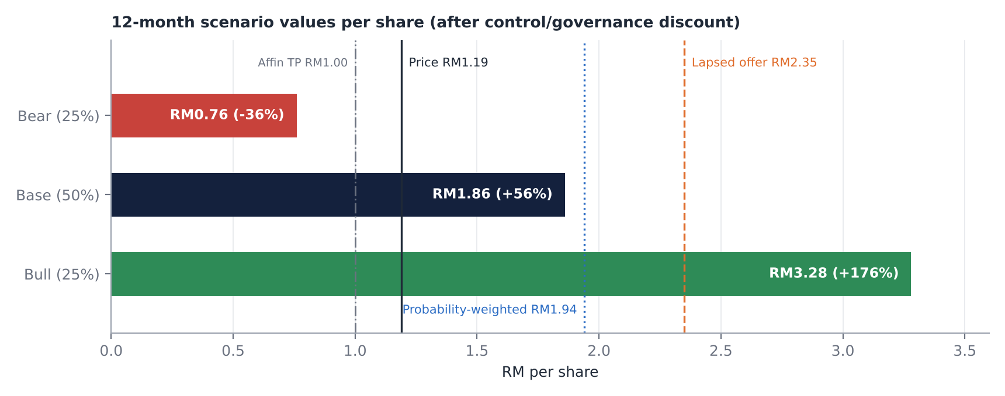
  Downside support: the Malaysian monopoly (~RM2.1bn EBITDA), a ~4% dividend, 0.60x book and the RM2.35 anchor; even the bear case values RWG at 6x. Upside driver: the market putting any value on New York, and the minority's veto over a cheap delisting. Probability-weighted ~RM1.94 (+63%); ~67% expected total return with dividends.

CATALYST CALENDAR | CATALYSTS
UK Budget, 3Q26, the end of the post-offer window and Albany's racing-support decision dominate the next two quarters
28-OCT-26 | UK Autumn Budget | Machine games duty doubling would make 13 of 32 UK casinos unviable; impairments | MEDIUM
MID-NOV-26 | NY October GGR report | Whether the Jul-Sep fade stabilises at ≥US$125m a month | HIGH
MID-NOV-26 | MSCI review | Small-cap deletion or weight cut risk at a 26% float | MEDIUM
~19-26 NOV-26 [U] | 3Q26 results | First full quarter of NY tables; US&B ≥RM250m; any dividend signal | HIGH
~1-DEC-26 [U] | 12 months since the offer lapsed | Genting Bhd free to resume buying; 75% reopens a delisting route | HIGH
4Q26-1Q27 | Genting Bhd rights issue | EGM, books close, completion; parent overhang removed or confirmed | HIGH
JAN-JUN 2027 | NY legislative session | Racing-support fix expires; tax equalisation debate (~US$150m a year swing) | CRITICAL
~25-FEB-27 | FY26 results and final dividend | Consensus 7.3 sen vs our 5 sen; capex and funding guidance | HIGH
31-MAR-27 | RM1.1bn MTN maturity | First refinancing test at BBB- | MEDIUM
JUN-27 | AGM: RRPT and buyback mandates | Minority vote on the related-party fee mandate; minimum wage to RM2,000 | MEDIUM
ANY TIME | Miami sale / NY PropCo / US listing / privatisation | Value crystallisation and deleveraging | CRITICAL

KEY RISKS | RISKS
What would make this thesis wrong
  01 | NY tax and competition  Racing support enforced on top of the 56% slot tax (effective ~72%; >US$500m over four years); rivals open ~2030 at 25-30% slot tax; phase 2 may never earn its cost of capital
  02 | Parent extraction or a low-ball squeeze-out  A cash-strapped Genting Bhd leans on fees (~RM848m a year) and dividends, or delists at a low price if the float disperses below the 10% objection threshold
  03 | Malaysian policy  Quarterly licence renewal; duty raised in 1998 and 2019; service tax in 2024; PAS vow to close RWG if it wins Pahang (GE16 by early 2028)
  04 | Funding and dilution  ~5x leverage through 2027; Fitch BBB-; US$3.7bn of capex left; a GENM rights issue the parent could not take up would be deeply dilutive
  05 | Earnings quality  FX on USD debt inside adj. EBITDA; one-off gains (~35% of FY25 NI); VIP hold swings; consensus EPS too high in our view
  06 | Liquidity and flows  ~26% float, ~2-4m shares a day; out of the KLCI (Dec-24) and MSCI Standard (Feb-25); the first broker Sell (Affin, TP RM1.00) could trigger more downgrades

INVESTMENT COMMITTEE DECISION  Recommendation: SPECULATIVE BUY  - Malaysia's casino monopoly (~RM2.1bn EBITDA) plus NYC's only full casino (~US$1.5bn annualised GGR), at 6.5x NTM EBITDA and 0.60x book, 49% below the lapsed RM2.35 parent offer  - The 20% fall since 9-Oct came from the parent's rights issue and a broker downgrade, not from GENM. The market prices the US business at about the licence fee  - An event-driven asset: the parent wants control but cannot pay a fair cash price; a >10% minority objection can block a cheap delisting, and RM2.35 is the anchor  - Main risks: the NY racing-support tax, parent extraction, Malaysian policy and 5x leverage. Hence half sizing and hard triggers |  | Sizing and monitoring  Event-driven, low-to-medium conviction. Hold half the position; do not add before the UK Budget (28-Oct) and 3Q26 (~19-26 Nov). Add on a 3Q26 NY run-rate of ≥US$60m a quarter, completion of the parent's rights issue, or an asset-monetisation announcement. Consider building towards a 5-10% blocking stake if the parent signals a privatisation.  Hard review triggers: racing support enforced in full with no offset; a GENM rights issue or punitive perpetuals; Fitch below BBB-; Genting Bhd pledging or selling GENM shares; a privatisation proposal below RM1.80.  Track separately: UK Budget (28-Oct), NY October data (mid-Nov), 3Q26 (~19-26 Nov), post-offer window (~1-Dec), parent rights issue (1Q27), Albany session (1H27), FY26 DPS (Feb-27).
  RM1.85  12-mo target (+55%) | 6.5x  NTM EV/EBITDA (10-yr median 8.8x) | ~US$0.56bn  Implied value of the whole US business | RM1.94  Probability-weighted (bear RM0.76)
Genting Malaysia Bhd | Bursa: GENM MK | Reference price RM1.19 (21-Oct-2026) | 24 October 2026

