
INVESTMENT COMMITTEE MEMO  Kangwon Land Inc.  KRX: 035250 - Korea's only casino open to Koreans (licence to 2045), with more net cash than market cap: the market prices the casino at roughly zero | 104%  Net financial assets per share (~KRW14,780 [e]) as a share of the price. Enterprise value is negative (about −KRW0.12tn)  ~0.9x  What the market pays for the casino resort (~KRW305bn LTM EBITDA) after a KRW0.4tn cash reserve. Listed peers 7.4x NTM; casino deals 9.2x  KRW17,300  Probability-weighted value (+22%): bull KRW24,900 / base KRW17,000 / bear KRW10,400, plus a ~6% dividend yield
  RECOMMENDATION: BUY (VALUE / EVENT-DRIVEN) |  | 12-MO TARGET: KRW17,000 (+20%)
  Reference price  KRW14,180 (23-Oct-26) | 52-wk range  KRW13,920-19,590 | Mkt cap (ex-treasury)  KRW2.81tn / US$2.1bn | Net financial assets [e]  ~KRW2.93tn
  Dividend  FY25 KRW950 (6.7%) | Largest holder  KOMIR 36.27% (public 51%) | Treasury shares  7.36% (not cancelled) | Broker targets  KRW18,000-20,000 (all Buy)

EXECUTIVE SUMMARY | RECOMMENDATION

Buy: a statutory monopoly priced at zero, with the controller needing the cash and new laws giving minorities a voice
−KRW0.12tn  Enterprise value: net financial assets (~KRW2.93tn [e]) exceed the KRW2.81tn market cap |  | 0.74x  Price/book [u], the lowest in our data; Value-Up target 1.2x; 6.7% trailing yield |  | −KRW3.16tn  KOMIR's equity (negative): the 36% controller needs dividends; public bodies get ~55% of payouts |  | KRW17,000  12-month target (+20%); bull +75% / bear −27%; probability-weighted KRW17,300 |  | 25%  Bear-case probability: AML rule, levy applies, K-HIT destroys KRW1.3tn

Why now - four forces converging  ■ Casino for free: after a KRW0.4tn reserve the market values ~KRW305bn of EBITDA at ~0.9x; the peer regression implies ~KRW3.0tn for operations alone  ■ Controller wants cash: KOMIR has −KRW3.16tn of equity; Value-Up payout ≥50% / total return ≥60% met two years running; separate dividend taxation from 2026  ■ New minority levers: cumulative voting (from 10-Sep-26), 3% cap on the controller in audit-committee votes, treasury cancellation deadline ~Sep-27 [e]  ■ Levy fear misdirected: the MCST indicated a carve-out (13% mine fund already paid) [u]; Kangwon Land fell 3% vs Paradise 23% in the levy week |  | What has to go right  ■ Carve-out from the 15% tourism-levy bracket, or a cost below ~KRW30bn a year  ■ AML due-diligence rule modified (thresholds) rather than applied to every chip purchase  ■ FY26 DPS ≥KRW850 and Value-Up 2.0 (Feb-27) keeps total return ≥60%  ■ 7.36% treasury stake cancelled by the Commercial Act deadline  ■ K-HIT phased with IRR hurdles; net financial assets ≥KRW2tn through 2030

Position sizing: value / event-driven, medium conviction. Build a full position over 4-6 weeks (liquidity ~KRW4.8bn a day [e]). Add on 3Q26 (late Oct-early Nov), levy carve-out confirmation, FY26 DPS ≥KRW850 or a treasury-cancellation resolution. Optional pair: long Kangwon Land / short Paradise or Lotte Tour isolates the levy carve-out and the net-cash floor from China VIP and won risk.

BUSINESS OVERVIEW | CONTEXT

Kangwon Land at a glance - a state-owned domestic monopoly whose biggest partner is the government
What it does  ■ High1 Resort, Jeongseon (Gangwon): the only one of Korea's 17 casinos open to Korean nationals, under the 1995 Special Act on abandoned mine areas (extended to 31-Dec-2045)  ■ 200 tables and ~1,360 machines (permit to 250 / 1,610 with the second casino, ~2028); ~1,850 rooms [e], 757 under renovation to Nov-27 / Apr-28; ski, golf, water park  ■ FY25: revenue KRW1.48tn (~87% casino), OP KRW235bn, NP KRW316.5bn; ~2.4m casino visits a year [e]  ■ Government take KRW603bn = 42% of gaming sales: tourism fund 10% + mine fund 13% of casino sales + taxes  ■ Control: public bodies 51.01% (KOMIR 36.27%, Jeongseon, Gangwon, Samcheok, Taebaek, Yeongwol); treasury 7.36%; free float ~41.6% |  | Revenue and operating profit (KRW bn)  Consolidated. FY24 NP includes ~KRW123bn of VAT refunds; 2Q26 NP includes a KRW97.3bn valuation gain. FY26E ours. Source: company results via press, brokers.
   | FY23 | FY24 | FY25 | 1H26 | FY26E
  Revenue | 1,388.6 | 1,426.9 | 1,476.7 | 724.5 | 1,454.5
  Growth | +9.3% | +2.8% | +3.5% | −0.4% | −1.5%
  Operating profit | 282.3 | 285.8 | 235.2 | 112.1 | 201.1
  OP margin | 20.3% | 20.0% | 15.9% | 15.5% | 13.8%
  Net profit | 341.0 | 456.7 | 316.5 | 140.0 | 248.0
  DPS (KRW) | 930 | 1,170 | 950 |  | 850E
  Total return (payout + buybacks) | 55% | 60.1% | 62.6% |  | ≥60% target

The single most distinctive fact: Kangwon Land holds ~KRW2.9tn of net financial assets [e], more than its KRW2.81tn market cap. The market is paying nothing for the only legal casino for 52 million Koreans, which earned ~KRW305bn of EBITDA in the last 12 months even after the State took 42% of gaming sales.

THE SETUP | CONTEXT

Hours cut (2018), mine-fund change (2021), D grade (2023), levy and AML scares (2026): −60% in ten years [e]
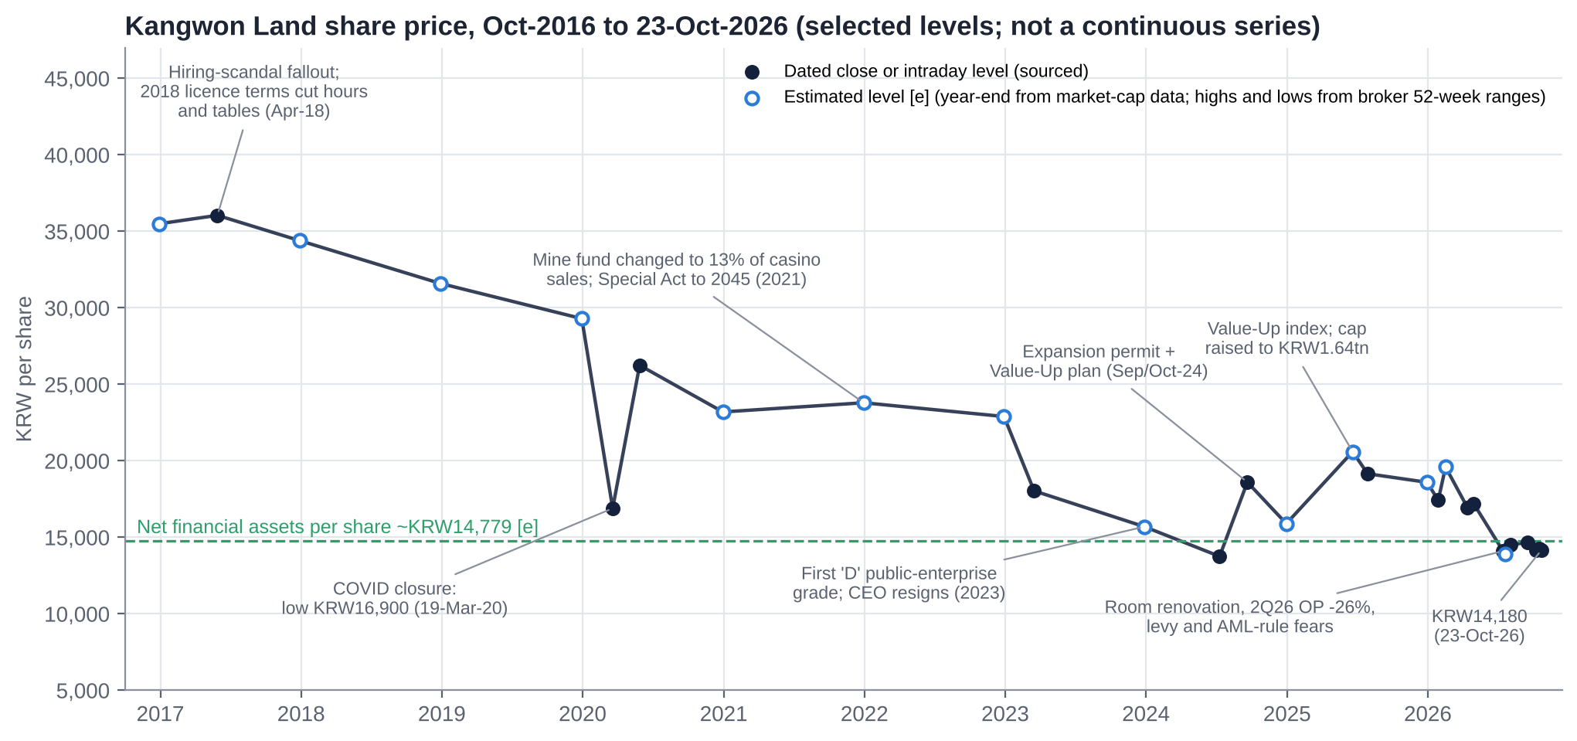 |  | Key catalysts
  2018 | Licence renewal cuts hours by two and tables 180 → 160; hiring-scandal fallout
  MAR-2021 | Special Act to 2045; mine fund changed to 13% of casino sales
  JUN-2023 | First 'D' grade; CEO resigns (Nov/Dec); ~32 months of acting CEOs
  SEP/OCT-2024 | Expansion permit + Value-Up plan: +35% rally
  MID-2025 | Value-Up index; VIP limits 10x; 2025 high ~KRW20,600 [u]
  JUL-2026 | Levy (15%) and AML proposals; peers −11% to −15% in a day
  AUG-2026 | 2Q26 OP −26%; targets cut; ex-general CEO elected
  OCT-2026 | Flat at ~KRW14,200; below net financial assets per share

No single-day move above 10% found in five years (largest +5.7%, May-2020). Peak-to-trough −28% Feb-Jul 2026; 1-year −26% [u] vs KOSPI ~+82% [e]. Chart joins sourced dated levels with estimated year-end levels [e]; not a continuous series.

QUESTION 1 - IS KANGWON LAND UNDERVALUED? | VALUATION

On every enterprise-value measure it is free; on P/E it looks only fair - because half of profit is interest
Metric | Kangwon Land | Paradise | GKL | Genting Sing. | GENM | Sands China | Galaxy | MGM China | NagaCorp | Median (31)
TEV/Sales | −0.08x | 1.66x | 0.33x | 1.81x | 1.56x | 2.23x | 2.71x | 1.45x | 1.64x | 1.81x
TEV/EBITDA (LTM) | n.m. | 9.6x | 1.7x | 5.6x | 8.1x | 8.5x | 10.1x | 6.2x | 2.6x | 8.0x
TEV/EBITDA (NTM) | n.m. | 7.5x | 1.6x | 5.1x | 6.6x | 7.8x | 9.2x | 5.2x | 3.1x | 7.5x
P/E (LTM) | 8.8x | 11.6x | 11.2x | 23.5x | 23.1x | 13.4x | 13.7x | 8.2x | 4.5x | 13.6x
P/E (NTM) | 10.1x | 9.8x | 9.3x | 17.0x | 14.9x | 11.3x | 13.2x | 8.3x | 5.1x | 10.7x
EBITDA margin | 20.7% | 17.4% | 19.8% | 32.4% | 19.2% | 26.3% | 26.9% | 23.5% | 61.9% | 24.6%
EBIT margin | 14.6% | 10.8% | 12.4% | 15.4% | 8.6% | 16.3% | 19.2% | 17.1% | 46.5% | 12.6%
Net debt/EBITDA | −9.6x | 3.0x | −4.3x | −3.7x | 5.6x | 2.7x | −0.8x | 1.7x | −0.8x | 4.4x
Dividend yield | 6.7% | 1.5% | 4.9% | 6.6% | 5.5% | 6.5% | 4.5% | 6.8% | 3.3% | 1.1%
S&P Capital IQ, 16-Oct-2026 (LTM to 30-Jun-2026); Kangwon Land TEV/Sales at KRW14,180 is our calculation. Median of 31 listed casino peers, ex-Kangwon Land.
What the comparison shows  ■ Negative EV: net financial assets ~KRW2.93tn [e] vs market cap KRW2.81tn. After a KRW0.4tn reserve, operations are valued at ~0.9x EBITDA  ■ Ex-cash P/E on FY27E operating NOPAT is ~1.8x [e]; the EBIT margin (14.6%) is above the peer median (12.6%) even after a 42% government take  ■ P/B ~0.74x [u] (2015: 2.60x) and a 6.7% yield, the top of its ten-year range |  | The honest counter-read  ■ P/E (8.8x LTM, 11.3x FY26E ours) is only in line with peers: ~45% of pre-tax profit is financial income and valuation gains  ■ The cash is not fully the minority's: K-HIT targets ~KRW3tn of capex to 2035, and the State can redirect cash by levy or mandate  ■ Growth is below peers (LTM +1.8% vs +6.0%) and OP falls in FY26E (−15%) during the renovation

QUESTION 1 - IS KANGWON LAND UNDERVALUED? | VALUATION

Regression: peers with a 14.6% EBIT margin trade at ~2.1x sales - Kangwon Land's operating business trades at zero
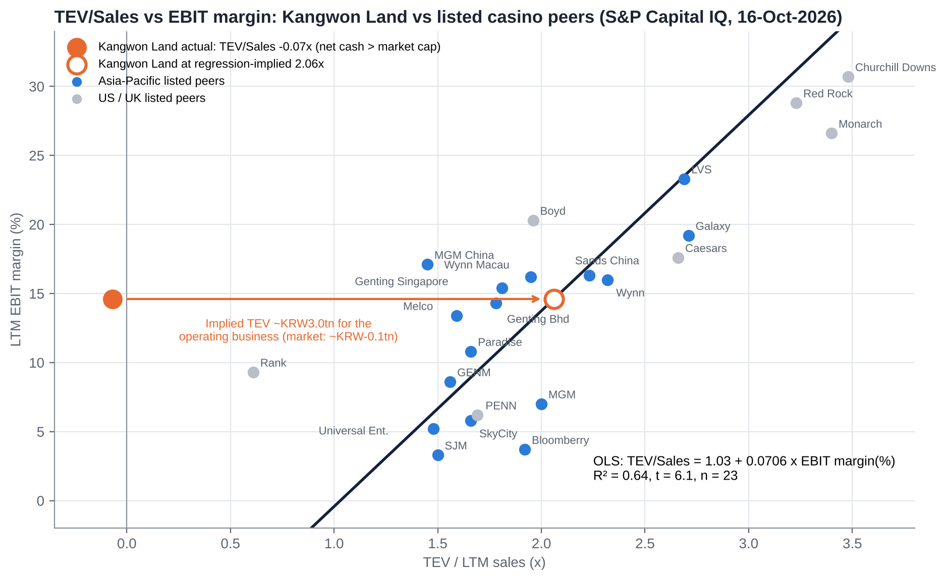 |  | How to read it  ■ Kangwon Land at −0.07x TEV/Sales (orange) sits far left of every peer: net cash exceeds market cap  ■ OLS implies 2.06x at its 14.6% LTM EBIT margin, ~KRW3.0tn for operations, or KRW28,100-30,100 a share with the cash  ■ Slope 0.071x per point of EBIT margin; R² 0.64, t = 6.1 (n = 23 core peers; net-cash, negative-EBIT, micro-cap and double-count names excluded)  ■ Even halving the implied operating value gives KRW20,400-22,400 (+44% to +58%)  ■ We do not use the regression as a target: peers are not state-controlled single-site monopolies with a 2045 sunset

OLS: TEV/Sales = 1.030 + 0.0706 x EBIT margin (%), R² = 0.64. EBITDA-margin cross-check R² 0.67. Source: S&P Capital IQ (16-Oct-2026), our calculations.

WHERE THE VALUE SITS | VALUATION

Sum-of-the-parts: KRW17,000 per share in the base case, after charging KRW0.8tn for K-HIT and a 10% state-control discount
Base-case SOTP (KRW bn)  ■ Implied P/B 0.88x; implied 6.5x EV/EBITDA on operations vs 7.4x Asia-Pac peers and a 9.2x deal median  ■ Each 1x on the operating multiple = ~KRW1,410 a share; each KRW0.5tn of K-HIT charge = ~KRW2,270  ■ Market-implied: KRW14,180 charges the entire excess cash pile (~KRW2.5tn) to future value destruction |  | 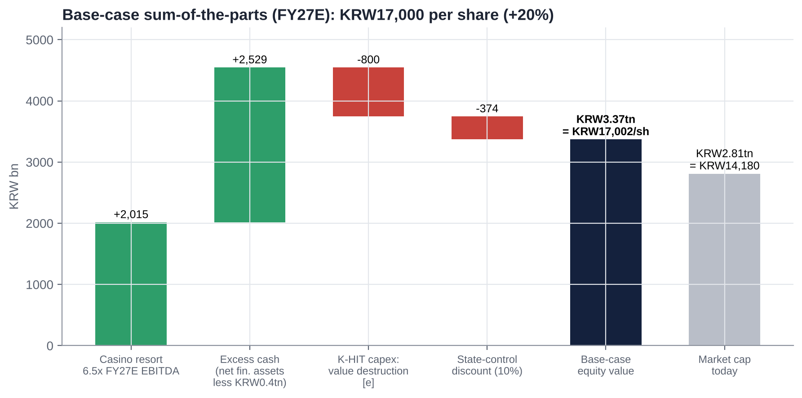
  Component | Method | KRW bn
  Casino resort operations | 6.5x FY27E EBITDA (310) | 2,015
  Net financial assets | S&P CIQ-derived [e] | 2,929
  Operating reserve | Accrued levies, payables, float [e] | (400)
  K-HIT value destruction | ~KRW3tn capex below cost of capital [e] | (800)
  State-control discount | −10% of equity | (374)
  Equity / per share | 198.2m shares outstanding | 3,370 / KRW17,000
  Market cap today | KRW14,180 | 2,810

THE CASH PILE | HIDDEN ASSET

~KRW2.9tn of net financial assets: still above KRW2tn in 2030 even with K-HIT ramping
~KRW2.93tn  Net financial assets [e] (S&P CIQ net debt/EBITDA −9.6x); ~KRW2.8tn current financial assets (IB Tomato, Oct-26) |  | KRW14,780  Net financial assets per share [e]: 104% of the price |  | 466%  Current ratio; liabilities/equity 18%; no meaningful debt |  | ~KRW3tn  K-HIT master plan to 2035 (Nov-25): 13m visitors and KRW3.5tn revenue targeted; feasibility exemption sought |  | KRW2.17tn  Our 2030E net financial assets after K-HIT ramp, dividends and buybacks [e]

Cash path, base case (KRW tn) [e]  Cash and equivalents only KRW162bn (Sep-25): the rest is in short-term financial instruments and funds whose composition is not disclosed in our sources (a diligence item). 1H26 operating cash flow was negative (timing of levies, taxes and bonuses). |  | 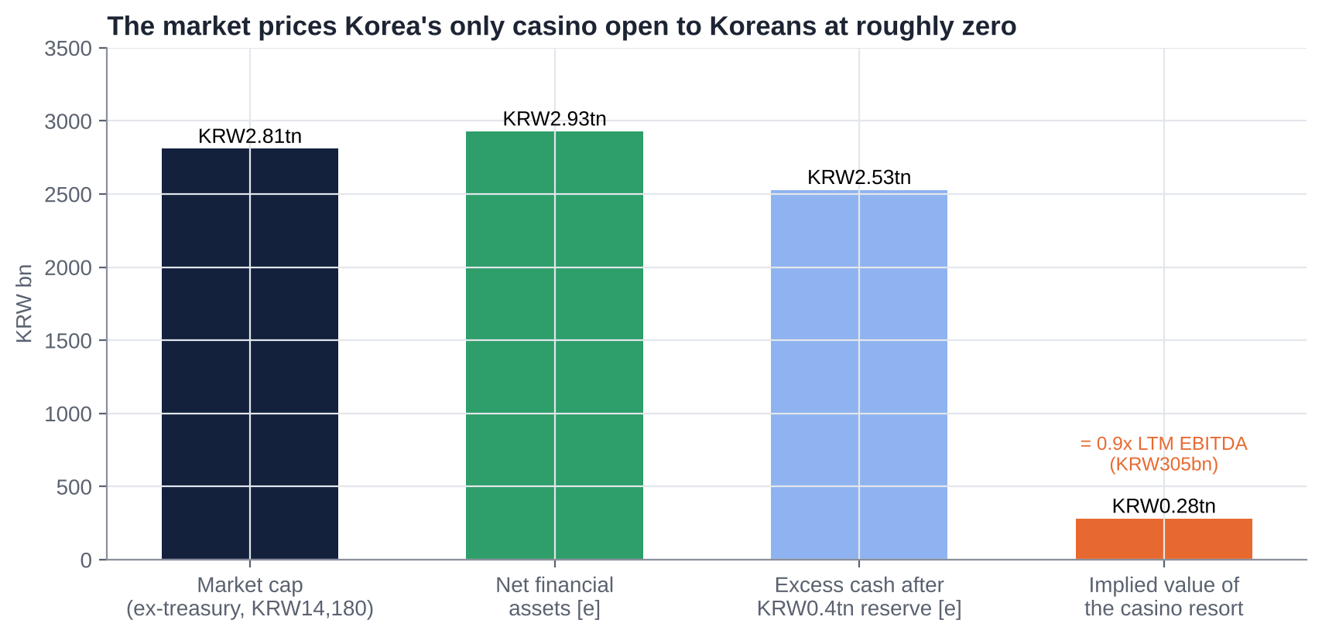
   | 2026E | 2027E | 2028E | 2029E | 2030E
  Operating cash flow | 0.33 | 0.33 | 0.35 | 0.36 | 0.37
  Capex (renovation, second casino, K-HIT) | (0.15) | (0.25) | (0.30) | (0.40) | (0.45)
  Dividends paid | (0.19) | (0.17) | (0.17) | (0.18) | (0.19)
  Buybacks | (0.05) | - | - | - | -
  Year-end net financial assets | 2.88 | 2.79 | 2.67 | 2.44 | 2.17

QUESTION 2 - VALUE TRAP OR GENUINE RECOVERY? | EARNINGS

Earnings trough in 2026-27 during the renovation; consensus still ~17% too high on operating profit
Estimates (KRW bn)  Our estimates [e]; consensus Hana (4-May-26), pre-2Q26. Targets were cut 14-18% in August, so consensus has likely fallen. |  | 2Q26 (4-Aug-26) and what comes next  ■ Revenue −4.2%, OP −26.2% (12% below consensus [u]), NP +59.8% on a KRW97.3bn valuation gain  ■ Casino visits −3.3%; VIP visits +18% but revenue −7.6% (hold); non-gaming −12.3% with 757 rooms offline  ■ Fixed costs amplify: revenue −4% became OP −26% (Kiwoom)  ■ 3Q26 preview (iM, 23-Oct): OP KRW64.2bn vs consensus KRW67.2bn; target cut to KRW18,000  ■ Recovery in 2028: condo (Nov-27) and hotel (Apr-28) reopen; second casino (+25% tables) completes Dec-27; VIP limits already lifted drop +46%
   | FY25A | FY26E | FY27E | FY28E
  Revenue | 1,476.7 | 1,454.5 | 1,480 | 1,560
  Operating profit | 235.2 | 201.1 | 215.0 | 245.0
  Consensus OP (May-26) | - | 246.5 | 260.2 | -
  Net profit | 316.5 | 248.0 | 244.2 | 262.7
  EPS (KRW) | 1,597 | 1,252 | 1,232 | 1,326
  Consensus EPS (KRW) | - | 1,423 | 1,487 | -
  DPS (KRW) | 950 | 850 | 870 | 920
  P/E at KRW14,180 | 8.9x | 11.3x | 11.5x | 10.7x

QUESTION 2 - DEEP DIVE | DEEP DIVE

The State takes 42% of gaming sales before shareholders see a won - and it changed the rules in 2021
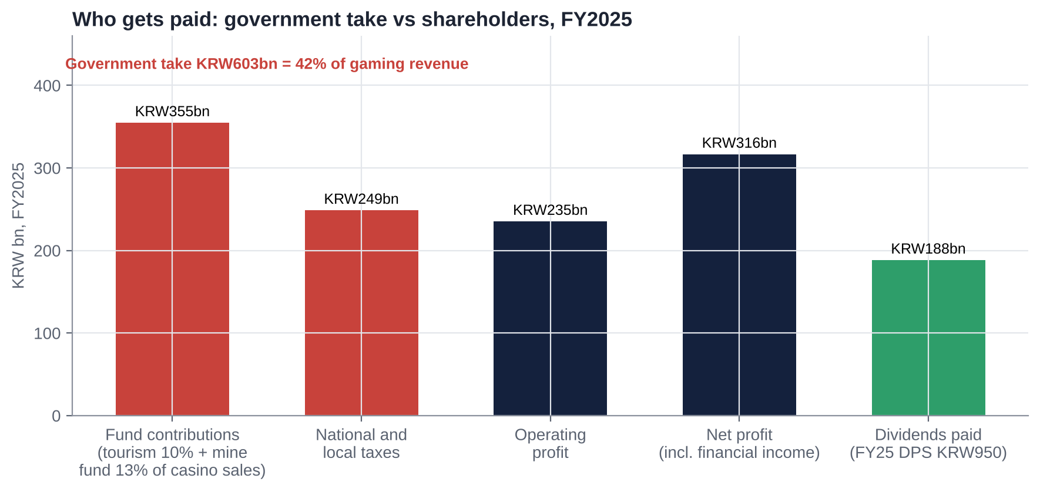 |  | Why margins fell - and what could turn  ■ 2021 mine-fund change: from 25% of profit (~KRW140bn) to 13% of casino gross sales (~KRW200bn), payable even in a loss year; bought the licence extension to 2045  ■ OP margin ~30-35% pre-2021 [u] → 20% (FY23-24) → 14.6% (LTM): labour and bonus creep, D&A, donations, renovation  ■ Proposed 15% tourism bracket (sales >KRW300bn per venue [u]): ~KRW56bn a year if applied [e]; the MCST indicated a carve-out [u]  ■ AML rule: management estimates −25.8% revenue (~KRW330bn); the National Assembly trade-committee chair wants it modified  ■ Upside levers: time-based entry, mass bet limit KRW300k → 1m, longer hours (the President ordered a review, Dec-25)

MANAGEMENT AND SENTIMENT | EARNINGS CALLS

Tone moved from 'deregulation and Value-Up' (2024) to 'renovation, levies and AML' (2026)
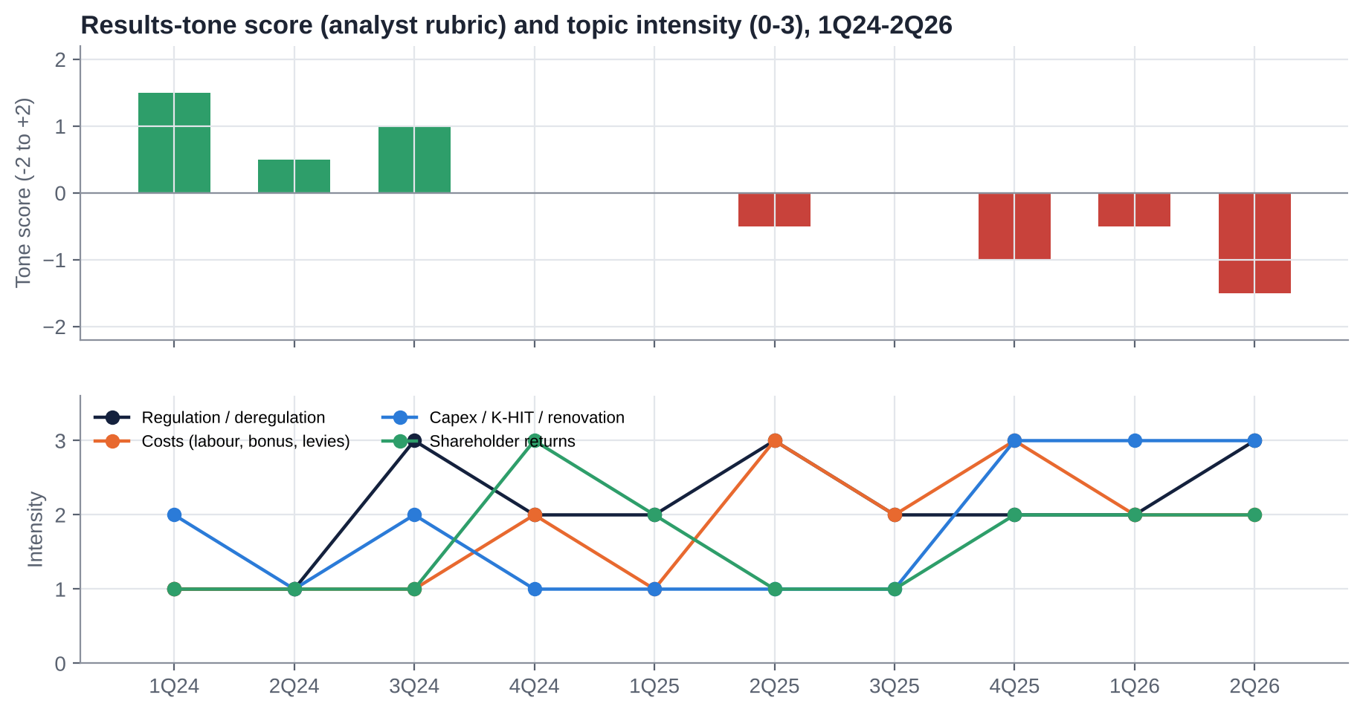 |  | What management is focused on  ■ Capex: renovation, second casino, K-HIT (~KRW3tn) and a feasibility-study exemption  ■ Regulatory reform year: entry rules, bet limits, hours; fighting the AML proposal  ■ Value-Up delivery (total return 60.1% FY24, 62.6% FY25)  Management  ■ Kim Do-kyun (CEO since 2-Sep-26): retired army general, ex-Capital Defense commander; DP Gangwon chair; no casino experience  ■ Yoo Jeong-bae (VP): ex-Korea Coal Corp president  ■ ~32 months of acting CEOs (Dec-23 to Sep-26); 'C' grades FY24-25; Organisational Diagnosis and Innovation Committee to Dec-26

No transcripts available; S&P Capital IQ and ProntoNLP not connected. Scores use a disclosed four-part rubric applied to results releases and press and broker coverage, 1Q24-2Q26.

BALANCE SHEET AND CAPITAL ALLOCATION | CAPITAL

Over-capitalised and under-distributed: capital allocation is the thesis
~KRW2.93tn  Net financial assets [e]; ~9.6x EBITDA; no debt |  | 62.6%  FY25 total return (DPS KRW950, payout 59.2%, plus buybacks); Value-Up target ≥60% |  | 7.36%  Treasury shares (~15.75m); none cancelled; Aug-26 EGM allowed retention or sale |  | ~KRW3tn  K-HIT to 2035 vs ~KRW145bn a year of capex today

Capital-allocation record  ■ Good: first SOE Value-Up plan (Oct-24), met two years; expansion permit and higher VIP limits; no debt  ■ Poor: regional subsidiaries (Sangdong 82% impaired, High1 Entertainment 83% impaired, Choo Choo Park never profitable); O2 Resort donation (directors held liable)  ■ Poor: K-HIT escalated from KRW2.5tn to ~KRW3tn with no IRR; treasury shares bought (KRW77bn) but not cancelled  ■ Leakage: bonus culture tied to SOE grades; >KRW100bn a year of comps; donations below OP |  | Priorities we would push for  ■ 1. Return ~KRW1tn over FY27-29 (~KRW5,000 a share) via special dividends and buybacks with cancellation  ■ 2. Cancel the 7.36% treasury stake at the Mar-27 AGM  ■ 3. Value-Up 2.0: payout ≥70%, DPS floor KRW1,000, buybacks when P/B <1x  ■ 4. K-HIT: phase-by-phase IRR ≥8%, full feasibility study, ~KRW1.5tn cap until returns proven  ■ 5. Link pay to ROIC and TSR

IS THERE AN ACTIVIST IN HERE? | GOVERNANCE

Not control - capital return: the controller needs cash, and the 2025-26 Commercial Act gives minorities real votes
51.01%  Public bodies (legal floor 51%); KOMIR 36.27% capped at 3% in audit-committee elections |  | ~41.6%  Free float (NPS ~6.1% [u], foreigners ~12% [u], from ~30% in 2020) |  | ~55%  Share of every dividend that goes to public bodies (KOMIR 39%, municipalities and Gangwon ~16%) |  | 0  Activist-fund campaigns ever; only civic groups (Solidarity for Economic Reform, Aug-26 EGM)

Why activism could work here  ■ Cumulative voting mandatory from 10-Sep-26 (assets ≥KRW2tn): the 41.6% float can concentrate votes on a minority nominee [e]  ■ 3% cap: KOMIR votes 3%; other public holders ~14.75% (if not related parties [u]) vs a 41.6% float in audit-committee elections [e]  ■ Treasury retention needs annual shareholder approval; the deadline forces a decision by ~Sep-27 [e]  ■ Quantifiable gap: casino valued at ~0x EBITDA; KOMIR's own balance sheet argues for payouts  ■ Precedent: outside directors held personally liable for a value-destroying donation (Supreme Court, 2019) |  | Where the limits are  ■ 51% statutory public floor: no proxy fight for control  ■ MOEF appoints non-standing directors; interplay with the Commercial Act untested [u]  ■ Ruling-party CEO; regional politics favour K-HIT spending over dividends  ■ Liquidity ~KRW4.8bn a day [e]: a 5% stake (~KRW150bn) takes ~160 trading days at 20% of volume  ■ Few like-minded holders today; NPS is the swing vote

What an activist would ask for: (1) ~KRW1tn returned over FY27-29; (2) cancel the 7.36% treasury stake; (3) Value-Up 2.0 with payout ≥70% and a KRW1,000 DPS floor; (4) K-HIT stage-gates with published IRRs; (5) a minority-nominated director and audit-committee member via cumulative voting and the 3% rule. Target the Feb-27 Value-Up 2.0 and the Mar-27 AGM through a quiet coalition (NPS, domestic value funds, civic groups).

QUESTION 3 - TAKEOVER TARGET? | M&A

No - the law fixes 51% in public hands; the events that matter are payout, treasury cancellation and K-HIT scope
Realistic corporate events (12-24 months)  Comparable control deals (S&P CIQ): median 9.2x EV/EBITDA (n=10); land-based casinos 9-11x (Crown 11.2x, Golden 9.8x, Caesars 9.1x). |  | What deal multiples say about the operating business  Theoretical: no takeover is legally possible. Ignores the K-HIT charge and the state-control discount used in our SOTP.  ■ Even at a 6x deal-style multiple the business plus excess cash is worth ~KRW21,600 a share  ■ The gap to the price is the market's charge for value destruction and political leakage
  Event | Likelihood | Effect on minorities
  Higher payout / special dividend (Value-Up 2.0, Feb-27) | Medium-high | Positive: returns excess cash
  Treasury cancellation (7.36%) by ~Sep-27 | Medium | Positive signal
  K-HIT rescoped after the CEO's committee (Dec-26) | Medium | Positive: protects cash
  KOMIR stake transfer or cash used for Korea Coal debt [u] | Low-medium | Negative if outside dividends
  Second Korean-access casino (Saemangeum special act) | Low | Negative for the monopoly
  TEV / FY26E EBITDA (KRW293bn) | 6.0x | 8.0x | 9.2x | 10.0x
  Operations (KRW tn) | 1.76 | 2.34 | 2.70 | 2.93
  + excess cash KRW2.53tn = equity (KRW tn) | 4.29 | 4.87 | 5.23 | 5.46
  Value per share (KRW) | 21,630 | 24,590 | 26,360 | 27,540
  Premium to KRW14,180 | +53% | +73% | +86% | +94%

SCENARIO ANALYSIS | VALUATION

Asymmetric: −27% bear vs +75% bull; probability-weighted KRW17,300 (+22%) plus ~6% yield
 | Bear (25%) | Base (50%) | Bull (25%)
Regulation | 15% levy applies (~KRW56bn); AML partly enforced | Levy carve-out or diluted; AML modified | Carve-out; deregulation; second casino on time
EBITDA basis / multiple | KRW240bn / 5.0x | KRW310bn (FY27E) / 6.5x | KRW345bn (FY28E) / 8.0x
Excess cash (after KRW0.4tn reserve) | KRW2.53tn | KRW2.53tn | KRW2.63tn
K-HIT NPV; state-control discount | −KRW1.3tn; 15% | −KRW0.8tn; 10% | −KRW0.2tn; 5%
FY26E DPS | KRW650-700 | KRW850 | KRW950-1,000
Implied P/B | 0.54x | 0.88x | 1.29x
Per share | KRW10,400 (−27%) | KRW17,000 (+20%) | KRW24,900 (+75%)

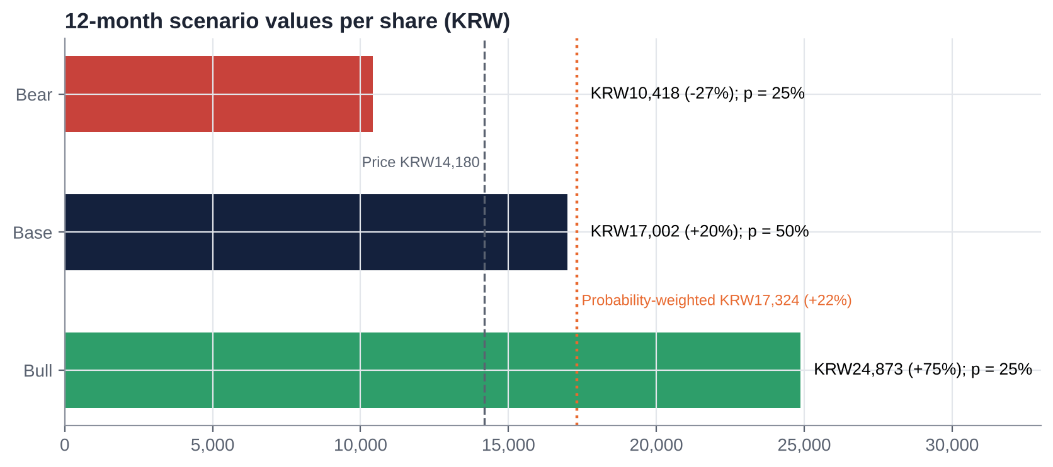 |  | ■ Downside support: net financial assets ~KRW14,780 a share; even the bear case keeps ~KRW1.2tn of cash after K-HIT losses  ■ Sensitivities: +1x operating multiple = +KRW1,410; KRW0.5tn less K-HIT charge = +KRW2,270; levy applied = −KRW1,650; full AML = −KRW5,900 [e]  ■ Expected total return ~28% (price +22% plus ~6% yield)

CATALYST CALENDAR | CATALYSTS

The levy and AML decisions, the K-HIT review and Value-Up 2.0 decide the next two quarters
~28-OCT TO 4-NOV-26 [E] | 3Q26 results | iM: OP KRW64.2bn vs consensus KRW67.2bn; drop and cash flow | HIGH
NOV-DEC 2026 | Tourism Promotion Act / levy decree | Carve-out for Kangwon Land vs a 15% bracket (~KRW56bn a year) | CRITICAL
NOV-DEC 2026 | FIU AML due-diligence decision | Up to ~26% revenue risk (company estimate) | CRITICAL
BY 31-DEC-26 | Organisational Diagnosis and Innovation Committee | K-HIT rescoping vs acceleration | HIGH
DEC-26 | NGCC 2027 sales cap; 2027 budget | Headroom; capex trajectory | MEDIUM
~LATE FEB-27 | FY26 DPS and Value-Up 2.0 (FY27-29) | Payout policy; dividend-tax qualification | CRITICAL
MAR-27 | AGM | Cumulative voting, audit-committee vote (3% cap), treasury retention | HIGH
JUN-27 | Public-enterprise evaluation (FY26) | Bonuses; CEO standing | MEDIUM
~SEP-27 [E] | Treasury cancellation deadline | Cancel 7.36% or seek annual retention | HIGH
NOV-27 TO APR-28 | Condo, second casino, hotel reopen | 2028 earnings recovery | HIGH
ANY TIME | Saemangeum / 'public casino'; KOMIR restructuring | Exclusivity; cash diversion | MEDIUM

KEY RISKS | RISKS

What would make this thesis wrong
01 AML customer due diligence  Full ID checks on every chip purchase: company estimate −25.8% revenue (~KRW330bn); players pushed to illegal online (KRW95.9tn market) |  | 02 Cash spent, not returned  K-HIT ~KRW3tn to 2035 at a remote site; feasibility exemption sought; political CEO; history of 80%+ impaired regional projects
03 Levies and taxes  15% tourism bracket (~KRW56bn a year if applied); the State already takes 42% of gaming sales and changed the mine fund in 2021 |  | 04 Exclusivity and sunset  'Public casino' / Saemangeum IR with Korean access would need a special act; the Special Act sunsets in 2045
05 Earnings and costs  Renovation until 2028; labour and bonus creep ('195% bonus' criticism [u]); ~45% of pre-tax profit is financial income |  | 06 Governance and liquidity  Treasury retention allowed (Aug-26); untested interplay of the Commercial Act with public-institution rules; ~KRW4.8bn a day traded

INVESTMENT COMMITTEE DECISION
Recommendation: BUY (value / event-driven)
KRW17,000  12-mo target (+20%) | ~0.9x  EBITDA paid for the casino after a cash reserve | 104%  Net financial assets per share vs price [e] | KRW17,300  Probability-weighted (bear KRW10,400)

■ Korea's only casino open to Koreans (licence to 2045) at a negative enterprise value: net financial assets of ~KRW2.93tn [e] exceed the KRW2.81tn market cap  ■ The controller (KOMIR, −KRW3.16tn equity) needs dividends; public bodies receive ~55% of payouts; Value-Up total return ≥60% met two years running  ■ New minority levers from the 2025-26 Commercial Act (cumulative voting, 3% audit cap, treasury cancellation) meet Value-Up 2.0 (Feb-27) and the Mar-27 AGM  ■ Main risks: the AML rule, K-HIT capex, levies and a political CEO. Hence medium conviction, SOTP charges for K-HIT and hard triggers
  Sizing and monitoring
  Value / event-driven, medium conviction. Build a full position over 4-6 weeks; add on 3Q26, levy carve-out confirmation, FY26 DPS ≥KRW850 or a treasury-cancellation resolution. Consider joining a quiet coalition (NPS, domestic value funds) ahead of Value-Up 2.0 and the Mar-27 AGM.
  Hard review triggers: AML rule enacted unmodified; a legislated Korean-access casino; FY26 DPS below KRW700 or payout below 50%; K-HIT exempted with no IRR disclosure; treasury shares sold to a related party.
  Track: 3Q26 (late Oct-early Nov), levy decree and FIU decision (Nov-Dec), K-HIT committee (Dec), Value-Up 2.0 and DPS (Feb-27), AGM (Mar-27).

