Rakuten Group (4755 JP) — Activist Thesis & Campaign Plan
15 October 2026 · Prepared for Randel Freeman · Public information only · Not investment advice

Executive summary
Recommendation: accumulate 3–5% and run a low-conflict campaign for a dated deleveraging and governance plan. Rakuten’s listed stake in Rakuten Bank is worth ¥1.77trn, more than Rakuten’s own ¥1.37trn market cap. After about ¥1.75trn of non-FinTech debt and hybrids, the market values Japan’s largest e-commerce ecosystem and a 10.8m-line mobile network at close to nothing.
- Thesis. Good franchises, bad capital structure. Owners have lost ¥1.33trn since FY2019 while the share count rose 60%, and interest plus hybrid coupons take about 45% of non-FinTech EBITDA. Cash flow is now turning (group EBITDA ¥436bn in FY2025, Mobile EBITDA positive); the campaign decides who captures it.
- Value gap. Sum of the parts: ¥839 a share in the base case (+34%), ¥1,444 bull, ¥332 bear. Executing the activist plan yields about ¥1,242 plus ¥20 of dividends by end-2029 (+101%, 26% a year), against ¥710 (+13%) for the status quo.
- Asks.
  - Sell the bank stake down to 50% economic (about ¥500bn), keeping 49.9% of the votes, and adopt a bank payout policy.
  - Make about ¥200bn of non-core disposals.
  - Cap Mobile capex at ¥160bn a year.
  - Bring non-FinTech leverage to 3x by FY2028 and retire the 9.75% and 11.25% USD notes.
  - Create independent nomination and pay committees, appoint an independent chair or lead director, and add three new independents.
  - Pay on ROE and TSR, cap dilution at 1% a year and end retirement payments. Then reset the dividend at ¥10 and buy back ¥150bn.
- Path to influence. The Mikitani bloc (27.4% of shares, 36% of votes cast) blocks any contest. The winnable prize is the independent vote, where 41% opposed him in 2026, plus Japan Post. ISS and Glass Lewis would likely back the governance asks.
- Mechanics.
  - A 3–5% stake costs ¥41–69bn.
  - FEFTA prior notification is needed before 1%, because telecoms is a core sector.
  - Stay below 5% until going public.
  - The six-month holding rule means shareholder proposals start at the March 2028 AGM.
  - The decision point is the FY2026 results in February 2027.
- Main risks.
  - Founder veto.
  - Rakuten Bank’s share price: a 10% move shifts Rakuten’s value 11%.
  - Mobile execution after the KDDI roaming cutback.
  - ¥825bn of maturities in 2027–29.
  - Further dilution.
Prices are as of 14 October 2026. Non-FinTech net debt is our estimate (section 4).

1. Diagnosis: good franchises trapped in a bad capital structure
Rakuten has lost ¥1.33trn for its owners since FY2019 while issuing 60% more shares. Revenue tripled over the decade, but the Mobile bet, the dilution that funded it and an ¥87bn interest bill consumed every yen the core businesses earned.
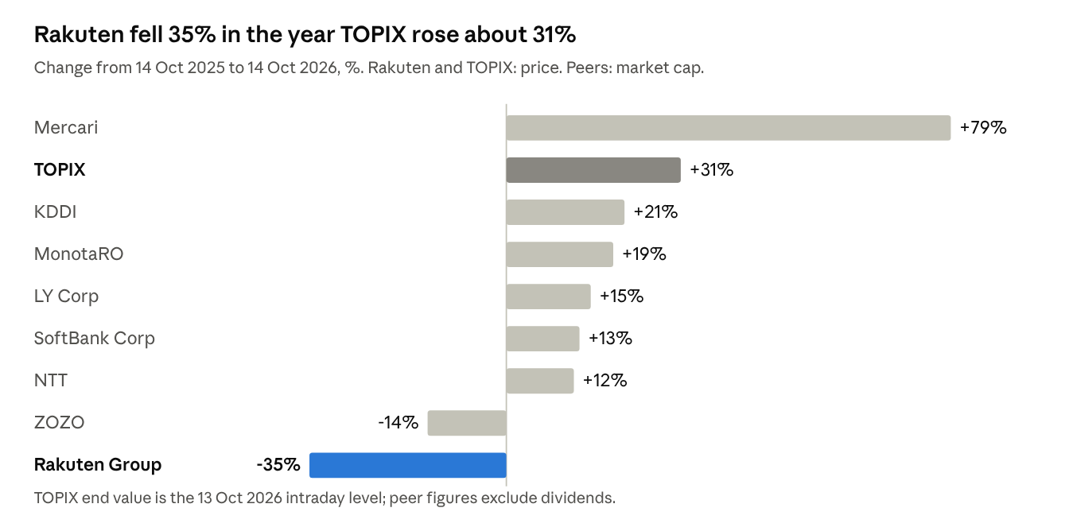
Exhibit 1. One-year change: Rakuten vs TOPIX and peers. Source: ProntoNLP share-price and market-cap data to 14 Oct 2026; TOPIX from Kyodo via Kumanichi.
The five-year record is worse. Rakuten’s own filed TSR index (end-2020 = 100) stood at 101.9 at end-2025, against 213.2 for TOPIX with dividends. At ¥628.5 the stock is 74% below its April 2015 high of ¥2,395 and only 11% above the ¥566 price of the 2023 equity raise.
Metric (FY, Dec year-end) | FY2015 | FY2019 | FY2025 | What changed
Revenue (¥bn) | 713.6 | 1,263.9 | 2,496.6 | 3.5x in ten years
Operating income, Capital IQ basis (¥bn) | 109.2 | (2.5) | 91.2 | Back to 2015 level on 3.5x the revenue
Net income to owners (¥bn) | 44.4 | (31.9) | (177.9) | Seventh straight loss
Profit to minority holders (¥bn) | (0.2) | (1.2) | 54.7 | FinTech minorities now take the profits
Interest expense (¥bn) | 3.6 | 8.7 | 86.7 | 24x; about 21% of EBITDA
Diluted shares (m) | 1,385 | 1,354 | 2,163 | +60% since FY2019
Source: S&P Capital IQ, FY2015–FY2025 (fiscal year = calendar year). Capital IQ standardises line items, so operating income differs from Rakuten’s reported IFRS and Non-GAAP figures.

Why it happened
- Capital allocation. Capex plus capitalised software ran ¥206–440bn a year from FY2019 to FY2025, ¥2.24trn in total, most of it the Mobile network. Net losses to owners over the same seven years total ¥1,332.6bn.
- Funding by dilution and asset sales. Rakuten raised ¥241bn of equity in FY2021 and ¥294bn in FY2023 near multi-year lows. It also sold minority stakes in its best FinTech assets, so their profits now leak to outside holders.
- Empire-building. The group runs 70-plus services across e-commerce, banking, cards, brokerage, insurance, telecom, network software, media, messaging, e-books and two sports clubs. Few clear their cost of capital; management attention is spread across all of them.
- Structure. The profitable FinTech businesses sit beside a cash-hungry telco under one balance sheet. Group earnings are negative, so the market applies a conglomerate discount instead of valuing the parts.
- Governance and incentives. The founder chairs the board and runs the company while his family holds a blocking stake. Pay is not tied to TSR, ROE or per-share value (detail in section 3).
The turn is real but early: Capital IQ EBITDA rose from ¥(87)bn in FY2021 to ¥412bn in FY2025, and capex fell to ¥66bn. The activist question is who captures the free cash flow now arriving — creditors and minority partners, or the owners.

2. Value gap: the bank stake alone is worth more than the company
Rakuten’s 72.35% economic stake in Rakuten Bank is worth ¥1.77trn at market, 29% more than Rakuten’s own ¥1.37trn market cap. The bank look-through is ¥810 per Rakuten share against a ¥628.5 share price. Investors get Japan’s largest e-commerce ecosystem, a 10.8m-line mobile operator, insurance and payments for less than nothing, offset by roughly ¥1.75trn of non-FinTech debt and hybrids.

What the market is paying for the rest (14 Oct 2026)
Item | ¥bn | Basis
Rakuten Group market cap | 1,371 | ¥628.5 × 2,182m shares
Plus non-FinTech net debt, incl. leases | ~1,350 | Our estimate from the company’s 5.6x ratio (March 2026) and ~6x FY2026 target
Plus hybrids and perpetuals | ~400 | ¥479.7bn at Dec-2025 less the ¥81.7bn called in April 2026
Less 72.35% of Rakuten Bank at market | (1,768) | 293.3m shares × ¥6,027
Implied value of Internet, Mobile, Insurance and Payments | ~1,354 | 9.0x Internet EBITDA alone; everything else free
The bank stake follows the FinTech reorganisation effective 1 October 2026. Rakuten Bank now owns Rakuten Card and Rakuten Securities Holdings; Rakuten holds 49.94% of the votes and 72.35% of the economics through non-voting Class A shares.

Sum of the parts today
Component (¥bn) | Bear | Base | Bull | Base-case assumption
Rakuten Bank stake (72.35% economic) | 1,237 | 1,591 | 2,053 | ¥6,027 less a 10% block discount; tax loss carry-forwards over ¥1trn shelter a sale (bear 30% discount; bull ¥7,000, no discount)
Insurance, Payment, Wallet | 150 | 200 | 300 | Our estimate; no segment profit disclosed
Internet Services | 1,088 | 1,425 | 1,705 | 9.5x FY2026E EBITDA of ¥150bn (bear 7.5x ¥145bn; bull 11x ¥155bn). LY Corp trades at 11.5x, ZOZO 12.4x, Mercari 14.9x
Mobile, incl. Symphony | 200 | 540 | 1,000 | About ¥50k per line on 10.75m lines, 1.1x FY2025 segment revenue (bear ¥19k a line; bull ¥93k, a strategic buyer’s view)
Corporate costs | (120) | (100) | (80) | About ¥10bn a year, capitalised
Non-FinTech net debt | (1,400) | (1,350) | (1,300) | Estimate; section 4
Hybrids and perpetuals | (400) | (400) | (400) | Treated as debt: senior to common, called at first call by policy
Equity value | 755 | 1,906 | 3,278
Per diluted share (2,271m) | ¥332 | ¥839 | ¥1,444 | Includes 88.9m ¥0.01 options
vs ¥628.5 | −47% | +34% | +130%
- The equity is a levered stub. A 10% move in Rakuten Bank’s price moves Rakuten’s value by about ¥70 a share, 11%. The bear case is real and argues for hedging the bank exposure (section 7).
- The market’s discount is about Mobile and the balance sheet, not the assets. With the bank stake at market and Internet at a below-peer 9x, the market prices Mobile at zero or less.
- Sell-side consensus sits at ¥915–925 (15 analysts: 7 Buy, 7 Hold, 1 Sell), but recent moves are cuts to ¥770–775.

Three-year scenarios (end-2029)
Scenario | Value per share | Dividends | Total return | Annualised
Status quo: management’s plan, no structural change | ¥710 | — | +13% | 4%
Activist plan: monetise, deleverage, fix governance | ¥1,242 | ¥20 | +101% | 26%
The gap between the two rows is the campaign’s prize: about ¥530 a share, or ¥1.2trn of equity value. Section 4 sets out the plan and the bridge between them.

3. Governance review: founder control without founder-level accountability
The founder chairs the board, runs the company, sets each director’s pay and controls 27.4% of the votes; outside support for him is draining. Mikitani’s re-election approval fell from 94.6% in 2021 to 76.6% in March 2026. Stripping out his own bloc, about 36% of the other votes cast went against him.

Board composition (after the 27 March 2026 AGM)
Director | Role | Independent? | On board since | Relevant experience | Other listed boards | Flag
Hiroshi Mikitani | Chair, President & CEO | No | 1997 | Founder; ex-Industrial Bank of Japan | — | Also chairs Rakuten Mobile, Symphony, Rakuten Medical Japan and both sports clubs
Kentaro Hyakuno | Rep. Director, Senior EVP, COO | No | 2013 (gap 2016–21) | Ex-Toyota | — | Sits on the pay committee
Naho Kono | Director, EVP, CMO | No | 2026 | Rakuten since 2003 | — | —
Eiichi Kaga | Director, finance (CFO from 2026) | No | 2026 | Ex-Ministry of Finance | — | Also a director of Rakuten Medical Inc., a related party
Charles B. Baxter | Outside director | Designated, but not in substance | 2011 (outside since 2023) | Chairman of Rakuten USA, a subsidiary | — | 23% voted against him in 2026
Takashi Mitachi | Outside director | Yes | 2016 | Ex-head of BCG Japan | DMG Mori, Sumitomo Corp | Only independent on the pay committee; reaches 12 years in 2028
Sarah J. M. Whitley | Outside director | Yes | 2019 | Ex-Baillie Gifford partner | — | The board’s only investor voice
Tsedal Neeley | Outside director | Yes | 2023 | Harvard Business School professor | — | —
Takaharu Ando | Outside director | Yes | 2023 | Ex-Commissioner-General, National Police Agency | Amuse, Zensho, Tobu Railway, Nisshin Seifun | Five listed boards in total; Rakuten pays Amuse royalties
Shigeki Habuka | Outside director | Yes | 2023 | Ex-Ministry of Finance; ex-Mitsubishi Chemical | — | —
Source: FY2025 Annual Securities Report, Corporate Governance Report, 27 March 2026, 2026 AGM voting results.
- Independence is 50%, not 60%. Six of ten directors are designated independent, but Baxter chairs a subsidiary. The company reports no controlling shareholder, so the Code’s one-third floor applies and is met on paper.
- No relevant operating depth. No independent director has run a mobile network, a bank or a listed internet platform. Three of the four directors appointed since 2023 are ex-officials or ex-police.
- Committees are cosmetic. There is no nomination committee. A voluntary pay committee formed in December 2025 has one independent (Mitachi) beside Mikitani and Hyakuno, and met once. The board delegates individual director pay to Mikitani.
- Audit oversight is stale. Outside statutory auditor Katsuyuki Yamaguchi has served since 2001. His law firm, Nishimura & Asahi, billed Rakuten ¥296m in FY2025. From February 2026 ISS treats 12-plus years as non-independent for audit roles.
- Board evaluation is a self-assessment questionnaire with no third party. There is no lead independent director.

Executive pay
Fiscal year | Total director pay (¥m) | Base | Bonus | Stock options | Retirement payments
FY2025 | 2,048 | 336 | 123 | 293 | 1,297
FY2024 | 2,090 | 491 | 168 | 354 | 1,078
FY2023 | 980 | 448 | 167 | 365 | —
- Mikitani took ¥186m in FY2025: ¥10m salary and ¥176m in options. His alignment comes from his stake, not his pay.
- Retirement payments dominate. Departing directors received ¥1.3bn in FY2025 (former CFO Hirose ¥685m, Takeda ¥611m) and ¥1.1bn in FY2024 (Hosaka). That is more than all base salaries combined, paid in loss-making years.
- The wrong metrics. Bonuses key off consolidated operating income, unit targets and carbon neutrality. There is no TSR, ROE, per-share or leverage metric.
- Options are free shares. Exercise price is ¥0.01 with no disclosed performance conditions. 88.9m are outstanding, 4.1% of shares; grants run at 1.2–1.7% a year and cost ¥16.8bn in FY2025. Nothing is bought back to offset them.
- Pay has not tracked returns. Filed five-year TSR is 101.9 against 213.2 for TOPIX. Only about 75% of votes backed the 2025 increase in director option limits.

Shareholder rights
Feature | Rakuten | What it means for an activist
Director term | 1 year | Every director is up every March
Staggered board | No | A full slate is possible in one meeting
Poison pill | None | No defence to trigger at any stake size
Share classes | One voting class; authorised non-voting bond-type shares, none issued | No dual-class shield
Vote standard | Simple majority; quorum one-third of votes; special resolutions two-thirds | Low turnout amplifies the founder bloc
Dividend authority | Board only (Companies Act art. 459) | Shareholders cannot table a dividend; pressure must run through director votes or an articles change
Shareholder proposal | 1% of votes or 300 units (30,000 shares), held 6 months, filed 8 weeks before the AGM | About ¥19m of stock suffices; deadline is late January for a late-March AGM
Calling an EGM | 3% held 6 months (about 65.4m shares) | About ¥41bn at ¥628.5

Seven changes a credible activist could push
- Separate chair and CEO; appoint an independent chair or, at minimum, a lead independent director. Puts capital-allocation challenge inside the boardroom. ISS, Glass Lewis and most global holders support it, and Mikitani keeps the CEO role, so it is not a referendum on him.
- Create nomination and compensation committees with independent majorities and chairs; end CEO-delegated pay. Cheap for management to concede and hard to oppose under the Code. A fast first win that proves engagement works.
- Refresh the board with three directors who have run a telco, a bank and a capital-markets M&A process. Replace Baxter and, at its next renewal, the 25-year statutory auditor. Target two-thirds substantive independence; institutions back named, qualified candidates more readily than slogans.
- Rebuild pay around per-share returns. Replace consolidated operating income with ROE above cost of equity (8% by FY2028), relative TSR versus TOPIX and a peer set, and non-FinTech net debt/EBITDA. Add three-year performance vesting to the ¥0.01 options, plus malus and clawback.
- Cap dilution at 1% a year and offset it. Commit to buy back shares equal to option exercises once leverage is on target. Stops the 1–2% annual leak and aligns with every proxy adviser’s dilution test.
- Abolish executive retirement payments. Over ¥2.3bn in two loss years is indefensible to retail and institutions alike. Redirect the budget into performance shares.
- Install an independent related-party committee. It should vet every deal with Mikitani-linked entities (Rakuten Medical, Crimson Group, Mikitani Kosan, Spirit) and Rakuten Bank minority conflicts. Disclose the family’s share pledges. This is the governance ask most aligned with the 2026 Code and the TSE’s cost-of-capital push, where Rakuten has published no response.

4. Capital allocation: ¥2.5trn spent, owners diluted, now a deleveraging story
From FY2015 to FY2025 Rakuten spent ¥2.52trn on capex and capitalised software and ¥0.30trn on acquisitions. It returned ¥0.16trn to shareholders and took ¥0.72trn of new equity from them. The Mobile build took ¥2.24trn of that capex from FY2019; owners got seven straight annual losses.
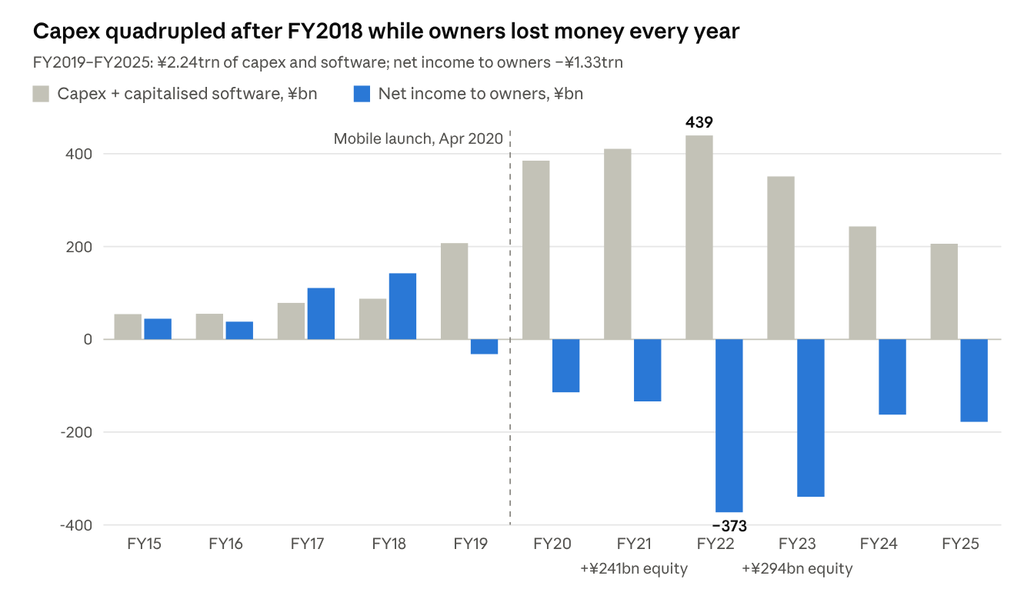
Exhibit 2. Capex and software vs net income to owners, FY2015–FY2025. Source: S&P Capital IQ income and cash-flow statements (December year-end).

What the capital bought
Investment | What happened
Rakuten Mobile network (from 2018) | 10.75m lines and a first full-year EBITDA of ¥12.9bn in FY2025. Segment losses still total about ¥1.3trn from FY2022 to 1H2026; Non-GAAP OI was −¥32bn in Q2 2026
Kobo (2011), PriceMinister (2010) | ¥7.8bn and ¥17.2bn impaired in 2015; Rakuten France closes at end-2026
Viber and Ebates (2014, about $0.9bn and $1bn) | Viber remains sub-scale; Rakuten Rewards (Ebates) earned ¥149.7bn of revenue in FY2025 with no Japan ecosystem link
Altiostar (2021), Robin.io (2022), i.e. Rakuten Symphony | ¥20.5bn Open RAN impairment in FY2025
Online grocery and logistics | ¥27.9bn and ¥10.0bn impaired in FY2025, ¥17.0bn more in 1H2026; owned warehouses fully written off
Venture stakes (Lyft, AST SpaceMobile) | The winners: about ¥110bn gain on Lyft’s IPO; ¥198.8bn of AST sold in 2026 from about ¥30bn invested
Rakuten Bank, Card and Securities (built organically) | The crown jewels, partly sold to fund Mobile: Securities 49% to Mizuho (¥167bn), Card 14.99% (¥165bn), Bank IPO and sell-down (¥144bn)
Acquisition prices for 2010–2014 deals are approximate public figures. Since 2022 Rakuten has raised about ¥675bn from stake sales and ¥170bn from a network sale-and-leaseback, on top of ¥536bn of new equity in 2021 and 2023.

Leverage, interest and rating headroom
Company | Net debt / EBITDA | Interest / EBITDA | Basis
Rakuten Group, non-FinTech | 5.6x (Mar-2026); 6.5x (Dec-2025); 11.7x (Dec-2024) | About 45%: ¥80.6bn cash interest plus ¥28.6bn hybrid coupons in FY2025 | Company KPI; interest share is our estimate
NTT | 4.3x | 6.5% | Capital IQ, FY to Mar-2026
SoftBank Corp | 2.8x | 5.3% | Capital IQ, FY to Mar-2026
KDDI | 2.5x | 1.7% | Capital IQ, FY to Mar-2026
LY Corp | 2.0x | 2.6% | Capital IQ, FY to Mar-2026
- Ratings: S&P BB, stable since May 2024 (cut from BBB- in two steps, 2021–22). JCR A- stable; R&I BBB+. No Moody’s or Fitch rating.
- Headroom is thin. S&P publishes no upgrade trigger. Japanese telecom and internet peers run 2.0–4.3x, so we estimate an S&P BBB- needs sustained non-FinTech leverage near 3x and positive net income. Today’s 5.6x is far from that, and the consolidated equity ratio is 4.2% against the company’s own 5% medium-term target.
- Expensive debt. Parent bonds carry about 6.4% on average, including USD 1.8bn at 11.25% due February 2027 and USD 2.0bn at 9.75% due 2029. A new retail bond (No.26, reportedly up to ¥360bn, 3.8–4.6%) prices on 16 October, likely to refinance the 2027 notes.
- Maturity wall: about ¥290bn in 2027, ¥155bn in 2028 and ¥380bn in 2029, plus a USD 550m 8.125% perpetual callable December 2029.
- The FinTech reorganisation traps cash. Card and Securities profits now sit inside Rakuten Bank, which plans no dividend and runs an 11.3% capital ratio. The parent’s leverage metric counts FinTech dividends and fees as EBITDA, so a bank that pays nothing slows deleveraging.

Under-earning, non-core and listed assets
Asset | Status | Activist ask
Rakuten Bank (5838): 72.35% economic, 49.94% voting | Listed, ¥2.44trn market cap | Sell down to 50% economic (about ¥500bn); adopt a payout policy
Rakuten Insurance Holdings (100%) | Left out of the reorganisation; no profit disclosed | Sell or fold into the bank
Remaining AST SpaceMobile stake | Partly sold for ¥198.8bn in 2026 | Sell the rest
Rakuten Symphony | ¥20.5bn impaired | Strategic review: sale or partner
Rakuten Rewards (Ebates, US) | ¥149.7bn revenue | Sell; no Japan synergy
Kobo, Viber, Rakuten TV and Viki | Sub-scale global media | Sell or wind down
Tohoku Rakuten Golden Eagles, Vissel Kobe | Owned; both chaired by Mikitani | Sell majority; keep sponsorship
Rakuten Medical (affiliate; Mikitani is CEO) | ¥4.6bn impaired in FY2025 | Stop funding and exit

Activist capital-allocation plan
Step | Action | Size | Timing
1 | Cap Mobile capex at ¥160bn a year for FY2027–29, against a >¥200bn FY2026 plan; raise prices by about ¥200 a line | About ¥40bn a year | Announce with FY2026 results, Feb 2027
2 | Sell Rakuten Bank Class A shares down to a 50% economic stake (90.6m shares), keeping 49.9% of votes | About ¥500bn at ¥5,500 | 6–18 months
3 | Sell non-core assets above | About ¥200bn | 12–24 months
4 | Cut costs through AI, marketing and points efficiency, and head office | ¥30bn run-rate in Internet, ¥20bn corporate | By FY2028
5 | Repay the 9.75% and 11.25% USD notes from proceeds instead of rolling them | About ¥700bn of debt retired | 2027–28
6 | Leverage target: non-FinTech net debt / EBITDA at or below 3x by end-FY2028, about 2x by end-FY2029; pursue S&P BBB- | — | Public commitment, Feb 2027
7 | Reset the dividend at ¥10 a share (about ¥22bn), then progressive at a 30% payout | ¥22bn a year | From FY2028
8 | Buy back ¥150bn once leverage is at 3x; offset option dilution every year | ¥150bn | FY2028–29

Pro-forma three-year TSR
If management executes this plan, we estimate value of ¥1,242 a share at end-2029 plus ¥20 of dividends: +101% total return, 26% a year. The status quo delivers about ¥710, +13%, 4% a year, with leverage still near 5x.
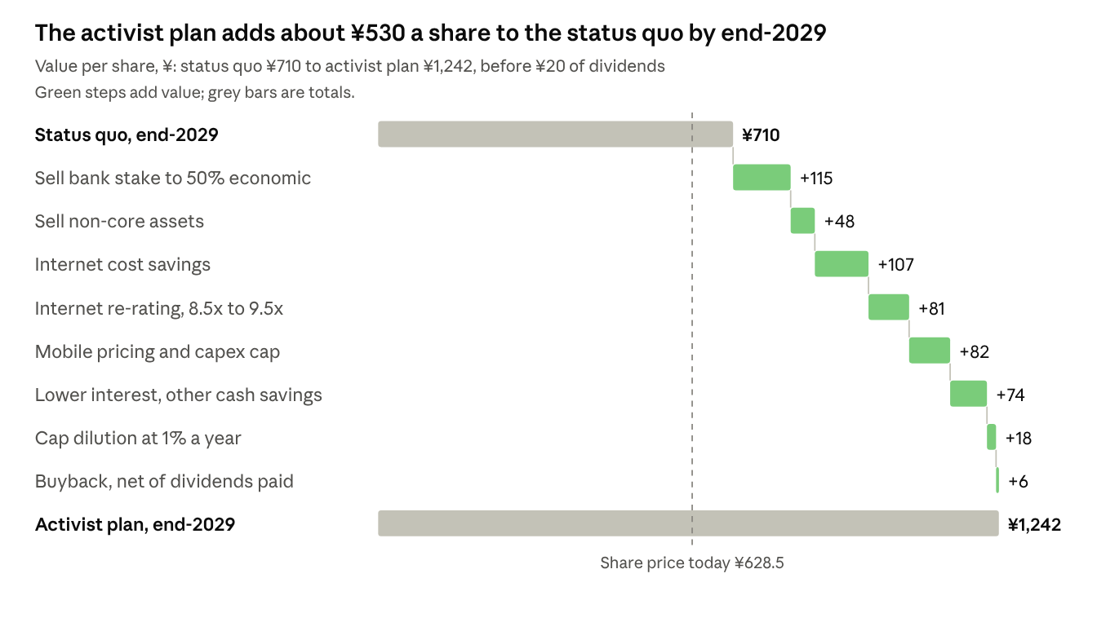
Exhibit 3. Bridge from status-quo value to activist-plan value per share, end-2029. Activist model on public data; steps applied in order; per diluted share.
Key assumptions, both cases: Rakuten Bank at ¥5,984 (11x 85% of its FY3/2030 EPS target), Internet EBITDA growing 5% a year to ¥173bn before actions, Mobile EBITDA reaching ¥100bn. The activist case lifts these to ¥193bn and ¥110bn, uses 9.5x and 6.5x multiples (status quo 8.5x and 6x), and a 10% holding discount (25%). Hybrids stay at ¥400bn in both.

5. Activist levers
The campaign asks for six things, and none requires Mikitani to leave. Balance-sheet repair comes first, then returns, all locked in by board and pay changes. Values are each lever’s step in the section 4 bridge, per share at end-2029.
Lever | Specific proposal | Value per share | Management resistance
Asset sales and spin-offs | Sell Rakuten Bank Class A shares down to a 50% economic stake (about ¥500bn), keeping 49.9% of votes. Sell Rewards, Kobo, Viber, Rakuten TV and Viki, the remaining AST stake and majority stakes in both sports clubs (about ¥200bn). Start a strategic review of Symphony. Alternative if a sale stalls: a partial in-kind distribution of bank shares under Japan’s spin-off tax rules | +¥115 bank, +¥48 non-core | High on the bank (management says it will not sell); medium on non-core
Cost and capex cuts | ¥30bn run-rate savings in Internet and ¥20bn at head office by FY2028 through AI, marketing and points efficiency. Cap Mobile capex at ¥160bn a year. Stop funding Rakuten Medical | +¥107 savings, +¥82 Mobile | Medium; consistent with management’s own “AI-nization” targets
Capital return | Repay high-coupon USD debt first. Reset the dividend at ¥10 from FY2028; buy back ¥150bn once leverage reaches 3x; offset option dilution every year | +¥74 interest, +¥6 buyback | Low once sequenced after deleveraging; credit-positive
Management change | Keep Mikitani as CEO. Appoint an independent chair or lead independent director. Add an external capital-markets and M&A executive alongside the new CFO | Enables the re-rating (+¥81) | High if framed against Mikitani; low as framed here
Board refresh | Three new independents with telco, banking and M&A experience; replace Baxter and, at renewal, the 25-year statutory auditor. Create a nomination committee | Part of the re-rating | Medium
Incentive redesign | Pay on ROE above cost of equity, relative TSR and leverage. Three-year performance vesting on options. Dilution capped at 1% a year. No retirement payments | +¥18 dilution cap | Medium; the 2025 option vote drew 25% opposition

6. Path to influence: persuasion, not a proxy fight
No activist can outvote Rakuten’s founder: his bloc cast 36% of the votes at the 2026 AGM, enough on its own to block any change to the articles. The winnable prize is the independent vote, where 41% already opposed him in 2026. That pressure, plus proxy advisers, Japan Post and the 2026 Code, is how an activist gets the board to the table.

Who you need to win
Holder | Stake | Likely stance | What wins them
Mikitani bloc: Crimson Group 10.4%, Hiroshi 8.1%, Haruko 5.2%, Mikitani Kosan 1.9%, Spirit 1.9% | 27.4% | Opposes anything that loosens control | A plan that keeps the CEO role, 49.9% of bank votes and the ecosystem intact
Japan Post Holdings | 6.0% | Strategic partner (logistics JV); impaired the stake by ¥85bn in 2023 | Recovery on its ¥150bn investment; government-linked, avoids open conflict
Foreign institutions | ~36% | The swing vote; many follow ISS or Glass Lewis. Goldman Sachs and Morgan Stanley client accounts suggest hedge-fund and swap holders | The SOTP gap and governance data
Domestic financial institutions: trust banks, asset managers, life insurers | ~15% | Vote their own stewardship policies, most with ROE screens | ROE and TSE cost-of-capital framing
Retail, excluding the Mikitani family | ~13% | Loyal to the founder; value the free 30GB SIM perk | A restored dividend with perks kept
Other domestic corporates, incl. CyberAgent and Tokyu (2023 placement) | ~2% | Management-friendly | —
Tencent and Walmart (2021 placement) | Not in the top 10; holdings unverified | Passive | —
Register at 30 June 2026; holder-type split at 31 December 2025 (half-year report, FY2025 Annual Securities Report).
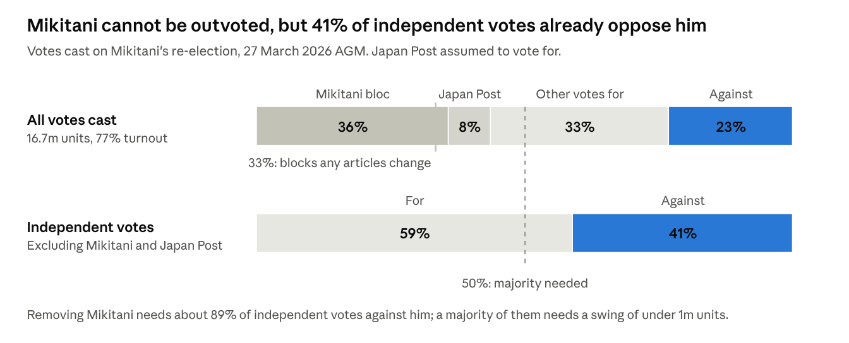
Exhibit 4. Composition of the 2026 vote on Mikitani. Source: 2026 AGM extraordinary report (12.82m for, 3.86m against); Mikitani bloc 27.4% and Japan Post 6.0% of 21.8m voting units.

What the proxy advisers will likely say
- ISS. Its Japan ROE policy recommends against the top executive when five-year average ROE is below 5%; Rakuten has lost money for seven years. ISS has not published its Rakuten Group recommendations, but the 23% vote against Mikitani fits that pattern. ISS already opposed Mikitani at Rakuten Bank in June 2026 for lacking an independent majority. From February 2026 it treats outside auditors past 12 years as non-independent, which catches Yamaguchi.
- Glass Lewis. Its 2026 Japan policy flags tenure over 12 years, expects TSE cost-of-capital action and 20% women on Prime boards (Rakuten has 30%). It backed about 45% of Japanese shareholder proposals early in the 2026 season.
- Net view. Both would likely back disclosure and governance proposals: committees, independence, cost-of-capital disclosure, pay metrics. Neither would back a slate to unseat the founder. Asks framed as minority protection win adviser support; asks framed as a breakup do not.

How much stock an activist needs
- To file a proposal: 300 voting units (30,000 shares, about ¥19m) held for six months. A stake started now cannot file for the March 2027 AGM; the first filing window is late January 2028.
- To requisition an EGM: 3% (about 65m shares, ¥41bn) held for six months.
- To swing the independent vote: about 4–5%. An activist voting 4.9% against Mikitani would have lifted 2026 independent opposition above 50%.
- Recommended: 3–5% (¥41–69bn), staying below 5% until the campaign goes public. At 5% a large-shareholding report is due within five business days, and stating an intent to make important proposals rules out the lighter reporting regime.
- Foreign-investment screening (FEFTA). Telecoms are a designated core sector, so a foreign investor needs prior notification before reaching 1%. The usual exemptions fall away for investors who propose asset disposals or seek board seats. File before crossing 1%.

7. Campaign design
Build 4.9% (about ¥67bn) quietly over two to three months and engage privately up to the FY2026 results in February 2027. Escalate only to a vote-no at the March 2027 AGM. Shareholder proposals wait for March 2028, when the six-month holding rule is met.

Stake, instruments and cost
Element | Plan
Target | 4.9% economic: about 107m shares, ¥67bn at ¥628.5. Stay below 5% until the campaign goes public
Physical shares | At least 3.0% (about 65m shares, ¥41bn). Carries the votes and, after six months, the EGM and proposal rights
Cash-settled swaps | Up to 1.9% for economic exposure. Swaps used to influence the company may count toward the 5% threshold; confirm with Japanese counsel
Listed options | Single-stock options on the Osaka Exchange are thin; use OTC collars only to finance or protect the position
Bank hedge (optional) | Short Rakuten Bank (5838) against part of the position to isolate the conglomerate discount. A full hedge is 0.134 bank shares per Rakuten share, about 14m shares (¥87bn) or 16% of the bank’s free float. Hedge 25–40% at most; borrow and the optics of shorting the subsidiary in question limit it
Credit sleeve (optional) | A small long in the 9.75% 2029 USD notes. The deleveraging-first plan is credit-positive and gives standing with bondholders and S&P
Cost to build | ¥41–67bn of capital. At an assumed ¥10–15bn of daily turnover (verify) and 15% participation, 30–45 trading days. Budget 2–4% market impact (¥1–3bn) plus ¥0.5–1bn for advisers over 24 months

Engagement and escalation
- Prepare (Oct–Dec 2026). File FEFTA prior notification before crossing 1%. Retain Japanese counsel, a proxy solicitor and a financial adviser. Sound out Japan Post, Mizuho and the ten largest domestic asset managers without naming the target publicly.
- Engage privately (Dec 2026–Feb 2027). Send a letter and white paper to Mikitani, CFO Kaga and the six outside directors, starting with Whitley and Mitachi. Ask for five commitments in the FY2026 results: a capex cap, a bank sell-down or payout policy, leverage at or below 3x by FY2028, independent nomination and pay committees, and a dividend framework.
- Go public with a vote-no (late Feb–Mar 2027), only if the results ignore the asks. Publish the SOTP. Recommend votes against Mikitani, aiming for a majority of independent votes, and against Baxter. Brief ISS and Glass Lewis.
- Proposals and coalition (Apr 2027–Mar 2028). File by late January 2028: articles changes for a nomination committee, an independent chair and cost-of-capital disclosure, plus two or three independent director nominees. The articles changes will fail the two-thirds test; a majority of votes cast is the message. Keep the 3% EGM right in reserve.
- Settle whenever the asks are met. Target terms: one or two agreed independent directors, a board capital-allocation committee, and a published plan with dates.

Messaging pillars
Audience | Core message | Proof points | Channel
Institutions | Fix the balance sheet, then return capital; the parts are worth more than the whole | Bank stake ¥1.77trn vs market cap ¥1.37trn; interest about 45% of non-FinTech EBITDA; five-year TSR 101.9 vs 213.2 | White paper, one-to-one meetings, proxy-adviser briefings
Retail (about 780,000 holders) | Bring back the dividend, keep the perks, make Rakuten safe | No dividend since FY2022; ¥10 reset; SIM perk kept | Japanese-language site, business-press interviews, plain Q&A
Employees | The ecosystem stays whole; we are selling distractions, not Japanese jobs | Ichiba, Points, Card, Bank and Mobile all stay; disposals are overseas media and sports | Open letter; no attacks on staff or brand
Media | A constructive owner backing the founder’s vision with a sounder balance sheet | TSE cost-of-capital push; 2026 Corporate Governance Code | Japanese business press first; never the word “breakup”
Bondholders and rating agencies | Deleveraging first is credit-positive | Leverage target of 3x; path to BBB- | Investor calls

Likely company responses and rebuttals
Company response | Rebuttal
“The ecosystem only works together; points and cross-use need the FinTech arms.” | A 50% economic stake with 49.9% of votes keeps control and every ecosystem contract. Synergies do not need 72% of the economics
“Mobile needs capex, especially now that KDDI roaming is being cut back.” | We back Mobile; we oppose funding it with 6–11% debt and dilution. Cap capex, pursue network sharing, raise prices
“We are already deleveraging: 11.7x to 5.6x in 15 months.” | The fall leaned on asset sales and AST’s share price. Interest still takes about 45% of non-FinTech EBITDA, and ¥825bn matures in 2027–29
“We have no intention of selling bank shares.” | Rakuten sold Card, Securities and bank shares in 2022–24. Non-voting Class A shares are built to be monetised without losing control
“This is a short-term activist.” | A three-year plan, debt first, buybacks only at 3x leverage, and an investment-grade goal
“Governance is fine: 60% outside directors, 30% women.” | Baxter chairs a subsidiary; there is no nomination committee; the CEO sets pay; one auditor has served 25 years
“Profits are back: Q2 2026 was positive.” | Q2 leaned on a ¥51.6bn tax benefit from the AST sale and a ¥17.3bn boost from longer equipment lives. The stock fell 35% in a year

KPIs and decision rules
KPI | Today | Escalate if | Settle or hold if | Exit if
Non-FinTech net debt / EBITDA | 5.6x (Mar-2026) | Above 6x at FY2026 | Published path to 3x by FY2028 | New equity raise, or S&P cut to BB-
Mobile capex and EBITDA | >¥200bn FY2026 plan; segment EBITDA ¥6.8bn in Q2 | FY2027 capex guide above ¥200bn | Capex at or below ¥160bn with EBITDA rising | Mobile needs fresh external capital
Bank stake vs market cap | ¥1.77trn vs ¥1.37trn | Gap widens with no action | Sell-down or payout policy announced | Bank derates 30%+, so the stake falls below market cap and the thesis weakens
Independent vote against Mikitani | 41% (2026) | — | Above 50% at the 2027 AGM: leverage for settlement | —
Board response | No contact yet | Refuses to meet the independents | Offers committees plus one or two seats | —
Dilution | 1.2–1.7% a year | New allotment to Mikitani entities | 1% cap adopted | Mikitani bloc rises toward one-third through allotments

8. Playbook: run the low-conflict path with a visible escalation ladder
The low-conflict path is the right one: Mikitani’s bloc defeats any contest, but a deleveraging plan with his name on it is something he can accept. The decisive moment is the FY2026 results in February 2027. Either they contain the capital plan, or the campaign goes public before the March AGM.
 | Low-conflict (recommended) | Confrontational
Stance | Partner to the founder; private first | Public campaign against the founder
Tools | White paper, private meetings, a coalition with domestic institutions, vote-no as a signal | Public letters, vote-no, shareholder proposals, EGM requisition, director nominees, challenges on related parties and the bank structure
Main asks | A dated capital plan, independent committees, one or two agreed independents | Independent chair, activist board seats, forced bank sell-down, CEO succession plan
Odds | Moderate: costs Mikitani no control and gives him a credit story for S&P | Low: his bloc blocks every articles change and any director contest
Cost and time | About ¥0.5bn; 6–12 months | ¥1–2bn or more; 18–24 months
Main risk | Slow or cosmetic concessions | Retail investors and corporate Japan close ranks; lasting reputational cost
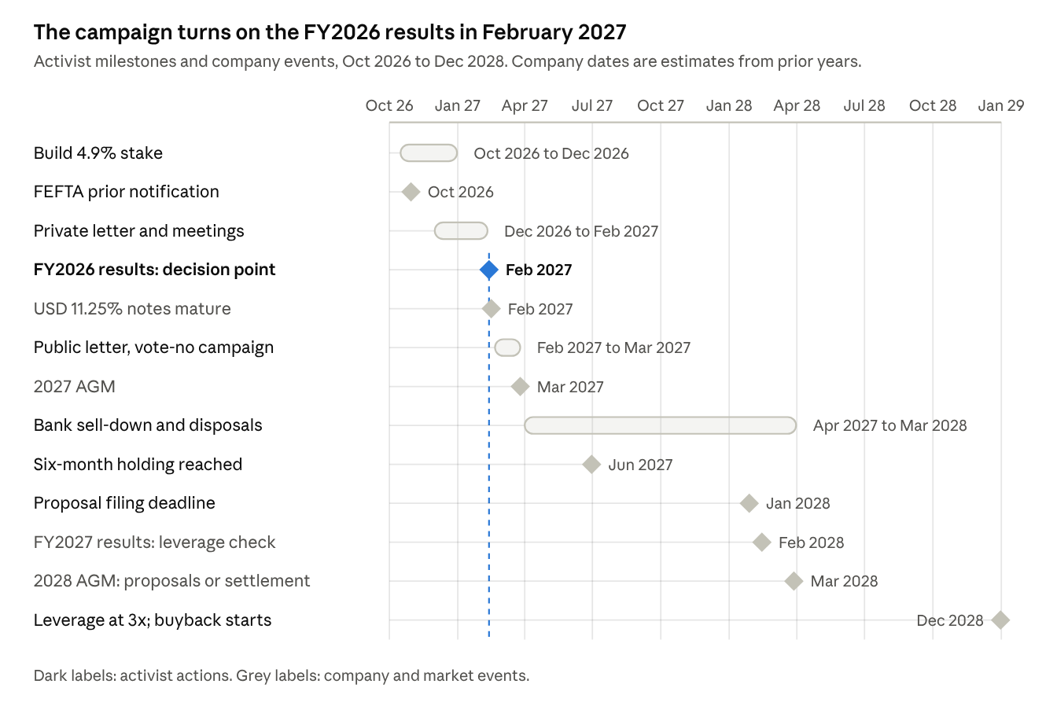
Exhibit 5. Campaign plan: 13 milestones, October 2026 to December 2028.
Everything before February 2027 is private. A public campaign starts only if the FY2026 results omit the capital plan.

Main risks to the campaign
Risk | Why it matters | Mitigant
Founder veto | Mikitani’s 27.4% plus Japan Post’s 6.0% can ignore every ask | Ask for nothing that costs him control; court Japan Post on value recovery
Bank share price | A 10% move in Rakuten Bank moves Rakuten’s value 11%; the bank fell 28% in three days in May 2026 | Partial hedge; size the position to the bear case (¥332)
Mobile execution | KDDI roaming is being cut back from October 2026; capex above ¥200bn; mobile price competition | Capex-cap ask; exit trigger if Mobile needs new capital
Refinancing and ratings | ¥825bn matures in 2027–29; yen rates rising; S&P at BB | Deleveraging-first plan; optional credit sleeve
More dilution | ¥536bn raised near lows in 2021 and 2023, partly to Mikitani vehicles | Dilution-cap ask; exit trigger
Regulation | FEFTA review (telecoms is a core sector), Banking Act limits on bank shareholders, the 5% reporting rule | File early; Japanese counsel from day one
Backlash | A foreign activist against a celebrated founder with about 780,000 shareholders | Constructive framing; lead with the retail dividend
Data gaps | Non-FinTech net debt is our estimate; the reorganisation’s completion has no primary notice yet | Verify both before going public

9. Defensive view: how an activist would attack the board
Advising Rakuten’s board, we would expect ten lines of attack. Management has credible answers on Mobile’s turnaround and the pace of deleveraging. It has weak answers on dilution, governance and the FinTech structure.
# | Criticism | Evidence an activist would marshal | Management’s credible counter
1 | TSR has badly lagged | −35% in the year to October 2026 vs about +31% for TOPIX; filed five-year TSR 101.9 vs 213.2; 74% below the 2015 high | Inflection under way: Mobile EBITDA positive in FY2025, first quarterly profit in Q2 2026; +9% over three years
2 | Returns and margins are sub-par | Seven straight annual losses to owners, negative ROE throughout; Internet Services margin 6.5% (FY2025); Mobile Non-GAAP OI still −¥32bn a quarter | Non-GAAP OI rose from −¥153bn (FY2023) to ¥106bn (FY2025); FinTech OI up 60% in Q2 2026
3 | Mobile was a capital-allocation error | ¥2.24trn capex and software FY2019–25; about ¥1.3trn of segment losses since FY2022; capex rising again to more than ¥200bn | Japan’s fourth network built for a fraction of incumbents’ cost; 10.75m lines; mobile users spend more in the ecosystem
4 | Owners were diluted to fund it | Share count up 60% since FY2019; ¥536bn raised in 2021 and 2023 near lows, partly from Mikitani vehicles; options add 1–2% a year with no buyback | Raises protected the balance sheet when debt markets were shut; founder put in his own money
5 | The capital structure is fragile | Non-FinTech leverage 5.6x; interest and hybrid coupons about 45% of non-FinTech EBITDA; S&P BB; 11.25% and 9.75% USD notes; equity ratio 4.2% | Leverage fell from 11.7x in 15 months; JCR and R&I stable; 2026 maturities covered from cash; target below 5x by FY2027
6 | The portfolio is sprawling | 70-plus services; repeated impairments (Symphony ¥20.5bn, grocery ¥27.9bn, logistics ¥27bn); two sports clubs; France closing | The points and membership ecosystem; most units are small; exits already under way
7 | The FinTech deal shortchanges minorities | Bank stake worth more than the group; non-voting Class A shares with a 50% voting cap; no bank dividend; bank shares fell 28% on announcement; ISS opposed Mikitani at the bank | ¥85bn of synergies and a ¥400bn ordinary-profit target by FY3/2030; independent valuations; Mizuho on board
8 | The board does not oversee the founder | Chair is the CEO; no nomination committee; affiliated outside director; 25-year statutory auditor; CEO sets pay; approval down to 76.6% | 60% outside directors, 30% women; new pay committee; annual board evaluation
9 | Pay and related parties are misaligned | ¥2.4bn of retirement payments in two loss years; no TSR or ROE metric; ¥0.01 options; Rakuten Medical (Mikitani is its CEO) impaired ¥4.6bn; Hakone property sold to Mikitani vehicles; auditor’s law firm paid ¥296m; family share pledges | Mikitani takes a ¥10m salary; options align staff; deals priced on third-party appraisals and disclosed
10 | AI, data and disclosure claims don’t hold up | AI efficiency targets (20% each in marketing and operations) never quantified in the P&L; Q2 2026 profit leaned on a ¥51.6bn tax benefit and ¥17.3bn from longer asset lives; no response to the TSE cost-of-capital request; Mobile account-fraud and trade-secret cases | AI writes about 50% of new code; 100m-member data asset; IFRS-compliant reporting and detailed segment disclosure

The three points that would land hardest with institutions
- The balance sheet and dilution (5 and 4). Every stewardship team can test it: 5.6x leverage, a BB rating, interest at about 45% of EBITDA, and 60% more shares. It also explains who captures the coming cash flow.
- The sum of the parts and the FinTech structure (7). A listed stake worth more than the whole company is a simple, checkable number. Non-voting shares and a dividend-less bank give institutions a minority-protection reason to act.
- Governance below the TSE and ISS bar (8 and 9). ROE-based voting policies already trigger. The lack of a nomination committee and the CEO-set pay are easy votes for any proxy adviser.
The board’s best defence is to adopt pre-emptively what an activist would ask for: a dated leverage plan, a bank payout policy, independent committees and pay on ROE and TSR.

Sources and data notes
Company filings and calls
- FY2025 Annual Securities Report, filed 26 March 2026
- H1 2026 semi-annual report, 10 August 2026
- Q2 2026 results presentation and Q2 2026 earnings call, 10 August 2026
- Q1 2026 earnings call, 14 May 2026
- FY2025 earnings summary and Q4 2025 earnings call, 12 February 2026
- Corporate Governance Report, 27 March 2026
- 2026 AGM voting results
FinTech reorganisation
- Rakuten press release, 20 May 2026
- Mizuho release, 20 May 2026
- Rakuten Bank rebuttal to ISS, 9 June 2026
Credit, ratings and Mobile
- JCR rating list
- No.26 retail bond terms (Nomura)
- Rakuten Card stake sale to Mizuho
- Network sale-and-leaseback (Macquarie)
- KDDI roaming changes (RCR Wireless)
- Opensignal on Rakuten Mobile, October 2026
Governance policy
- ISS 2025 Japan proxy season review
- Glass Lewis 2026 Japan benchmark policy
- Daiwa Institute of Research on the 2026 Corporate Governance Code
Market data
- S&P Capital IQ financials, FY2015–FY2025 and 1H 2026; peer leverage for fiscal years to March 2026
- ProntoNLP share prices and market caps to 14 October 2026
- Sell-side consensus from Kabuyoho and Investing.com
Data notes
- Non-FinTech net debt (about ¥1.35trn) and hybrids (about ¥0.4trn) are our estimates. They are derived from the company’s 5.6x leverage ratio, its bond and lease balances, and the April 2026 hybrid call.
- The 1 October 2026 completion of the FinTech reorganisation is inferred from Rakuten Bank’s new share count; no primary completion notice was found.
- Insurance, Payment and Wallet values are our estimates; the company discloses no profit for them.
- Acquisition prices for 2010–2014 deals are approximate public figures.
- The TOPIX end value is the 13 October intraday level. Peer one-year figures are market-cap changes, not TSR.
- Some governance details come from search extracts of company PDFs and should be checked against the originals before use.

