Coupang, Inc. (NYSE: CPNG): A temporary glitch, priced as a permanent one
Institutional equity research: operations, investment case, valuation, governance and forensic review
12 October 2026
Recommendation: BUY (event-driven, medium conviction) | 12-month target US$21 (+33%) | probability-weighted value US$20.8
Reference price US$15.82 (close 9-Oct-2026; ProntoNLP price series ‡) · 52-week range US$13.35-32.35 ‡ · Market cap ~US$28.5bn [d] · EV ~US$28.0bn [d] · LTM revenue US$35.5bn · LTM EV/Sales 0.79x [d] · Net cash incl. leases US$0.48bn · Dividend: none (#1311) · Control: Bom Kim holds 74.1% of votes (#1187)
Key data |  | Key data
Rating | BUY (event-driven, medium conviction) | 12-month target / upside | US$21 / +33%
Price (9-Oct-2026) ‡ | US$15.82 | Bear / base / bull | US$9.5 / 21.0 / 31.7
Market cap [d] | ~US$28.5bn | EV [d] | ~US$28.0bn
LTM revenue | US$35.5bn | LTM EV/Sales [d] | 0.79x (peer median 1.29x)
FY27E / FY28E GAAP EPS [e] | US$0.14 / US$0.42 | FY28E EV/adj. EBITDA [e] | 10.7x
Next catalyst | Q3’26 results, 3-Nov-2026 | Founder voting control | 74.1% (#1187)
Ticker note. The request referenced “CPHG US”. The only match for Coupang in both S&P Capital IQ (CIQ ID C_704377650, NYSE:CPNG) and ProntoNLP (Coupang, Inc. (CPNG)) is NYSE: CPNG, which this report covers.
Conventions. Every figure is hyperlinked to its S&P Capital IQ document or ProntoNLP sentence where the tool returned a link. ‡ = figure returned by the tool without a source link (“source link unavailable”). [d] = analyst derivation from cited inputs. [e] = analyst estimate. [u] = unverified: not found in S&P/ProntoNLP, shown for context only. Currency is US$ unless stated; FY = December year-end. Data cut-off: S&P FY2025 annual and Q2’26 quarterly statements; ProntoNLP transcripts to the Q2’26 call (4-Aug-2026); prices to 9-Oct-2026. No web browsing or non-S&P/ProntoNLP sources were used. A separate data-provenance document logs every tool call.

1. Executive summary
The debate. On 18-Nov-2025 Coupang discovered that a former employee had accessed personal data on up to 33 million customer accounts (#0, #2). Since then the shares have fallen 61% from the September-2025 high of US$34.08 to a low of US$13.35 (2-Oct-2026) ‡. The Asian Century Stocks newsletter (11-Oct-2026, “A temporary glitch?”) asks whether this is a Vernon-style “glitch”, a temporary market overreaction, or a lasting change. Our answer: at the customer level the evidence says glitch; at the P&L, balance-sheet and regulatory level the damage is real but finite and mostly priced.
What the data shows
- Customers came back.
  - Product Commerce active customers recovered to 24.7m in Q2’26, above the Q4’25 level.
  - WOW membership is above pre-incident levels and at an all-time high (#39, #271).
  - Returners skew to higher spenders and “have not split that spend with other alternatives” (#268).
  - Spend excluding non-returning customers grew ~16% against 8% reported Product Commerce growth (#43). This is a company-defined metric.
- Margins did not come back yet.
  - Product Commerce adjusted EBITDA margin fell from 8.8% (Q3’25) to 5.1% (Q2’26).
  - Consolidated adjusted EBITDA margin fell from 4.5% to 1.8%.
  - GAAP operating losses were -US$242m in Q1’26 and -US$556m in Q2’26. Q2 includes ~US$410m of privacy fines (#8).
  - Management now targets pre-incident Product Commerce margins “by mid-2027” (#220). The recovery date has slipped once already.
- Reported USD numbers understate the business.
  - The KRW hit a 15-year-plus low in Q2’26 (#150) and took 7pts off Product Commerce growth (#60).
  - Consolidated revenue grew +10% in constant currency but +4% in USD (#180).
  - The ~US$1.2bn customer voucher programme was netted against revenue. Redemption ended mid-April 2026 (#16, #17), which flatters 2027 comparisons.
- Valuation is near a five-year low on sales but not on earnings.
  - LTM EV/Sales is 0.79x [d], against year-end readings of 1.10-1.29x in 2022-25 [d] and a peer median of 1.29x.
  - EV/EBITDA and P/E are optically high on trough earnings.
  - On our EV/Sales vs EBIT-margin regression across 14 listed peers, CPNG sits on the line. The market is valuing Coupang as if today’s ~1-2% margins are permanent.
Why BUY now (event-driven framing)
- Catalysts. The Q3’26 print is on 3-Nov-2026 (Q3 2026 Earnings Call). 2027 guidance is promised “towards the end of the year” (#221). The KFTC Eats-WOW bundling decision is pending (#452).
- Downside cushion. Large buybacks: 43.7m shares (US$850m) in H1’26 (#369), with US$907m of authorisation remaining (#140).
- Asymmetry. Bear US$9.5 (-40%) / base US$21.0 (+33%) / bull US$31.7 (+100%), weighted 25/50/25. The probability-weighted value is US$20.8 (+31%) [e].
What must go right
- Product Commerce margin recovers toward ~8% through 2027.
- Developing Offerings losses fall from US$950m-1bn in 2026 (#223).
- No forced Eats-WOW unbundling or night-delivery ban.
- Merchant settlement-period rules from Dec-2026 do not unwind much of the negative-working-capital float (#619).
What would make us wrong
- FCF stays near zero (LTM ~US$99m [d]) while the buyback is funded by the revolver (#165).
- Korean regulators keep fining. Cumulative accrued fines since 2024 are ~US$531m [d].
- Naver and the Chinese cross-border platforms keep the share they won during the incident.
Snapshot (US$m unless stated) | FY2023 | FY2024 | FY2025 | LTM Jun-26 | FY2026E | FY2027E | FY2028E
Revenue | 24,383 | 30,268 | 34,534 | 35,462 | 36,686 [e] | 41,139 [e] | 45,817 [e]
Adj. EBITDA (company) | ~1,100 | ~1,400 | ~1,500 | 872 [d] | 608 [e] | 1,689 [e] | 2,625 [e]
GAAP operating income | 473 | 388 | 498 | -603 | -1,117 [e] | 529 [e] | 1,225 [e]
Net income to CPNG | 1,360 | 154 | 208 | -767 | -1,195 [e] | 256 [e] | 753 [e]
Diluted EPS (US$) | 0.75 | 0.08 | 0.11 | -0.43 [d] | -0.67 [e] | 0.14 [e] | 0.42 [e]
EV/Sales (x) | 1.10 [d] | 1.29 [d] | 1.19 [d] | 0.79 [d] | 0.76 [e] | 0.68 [e] | 0.61 [e]
EV/Adj. EBITDA (x) | 25.0 [d] | 28.7 [d] | 27.6 [d] | 32.1 [d] | 46.0 [e] | 16.6 [e] | 10.7 [e]
Historical EV multiples use year-end prices and S&P diluted shares and net debt (incl. leases). Forward multiples use the current EV of ~US$28.0bn. 2023 net income includes a US$905m valuation-allowance release.

2. A layman’s guide: what Coupang does and how it makes money
In one sentence: Coupang is “the Amazon of South Korea”. It sells almost everything online and delivers it, usually overnight, through its own warehouses and drivers. Most of its loyal customers pay a monthly fee (WOW membership) for free, fast delivery and extras.
How it makes money
- It buys products and resells them (first-party, “1P”). Coupang buys from brands such as CJ CheilJedang (#16), stores the goods in its own fulfilment centres, and earns the gap between selling price and cost. This is gross revenue, so it is big revenue at a thin margin (#1745).
- It rents its shop window and warehouses to other merchants (third-party, “3P”, and Fulfilment & Logistics by Coupang, “FLC”). It earns commissions and fulfilment fees. Only the fee is booked as revenue, so revenue is smaller but margins are higher (#1745, #145).
- It sells advertising to suppliers and merchants who want to appear higher in search. Much of the supplier ad money reduces cost of goods rather than counting as revenue (#1761).
- It charges a membership fee (WOW). WOW includes free Rocket Delivery and returns, Rocket Fresh grocery, Coupang Eats discounts and Coupang Play streaming (#1755).
- It is incubating new businesses (Developing Offerings): Coupang Eats (food delivery), Coupang Play (video), Coupang Pay (payments), Taiwan (a second Rocket Delivery country), Rocket Now (Japan food delivery) and Farfetch (global luxury marketplace) (#28).
How each division contributes (FY2025)
Division | Revenue | Share of revenue | Adj. EBITDA | What it is
Product Commerce (Korea) | US$29.6bn | ~86% [d] | US$2.5bn, 8.4% margin | The profit engine: retail, marketplace, Fresh, ads, WOW
Developing Offerings | US$4.9bn | ~14% [d] | -US$995m | The investment arm, led by Taiwan, Eats and Farfetch
Group | US$34.5bn | 100% | ~US$1.5bn, 4.3% | Over 90% of revenue earned in Korea (#1858)
So the Korean core earns roughly US$2.5bn of adjusted EBITDA, and about 40% of that is reinvested in the new ventures. Investors are really debating two things: how profitable the Korean core can become, and whether Taiwan will repeat the Korean playbook.

3. Historical catalysts: moves of more than 10%
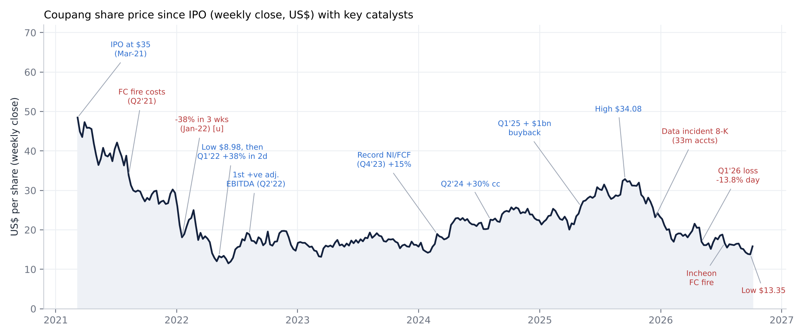
Coupang share price since IPO with key catalysts (weekly close; ProntoNLP price series ‡)
Date / window | Move ‡ | Driver found in S&P/ProntoNLP documents | Evidence
IPO, 11-Mar-2021 | Priced US$35. Opened US$63.50, closed day 1 US$49.25 (+41%), first week -24% from the open | 100m Class A shares at US$35; ~US$3.4bn net proceeds | #1284
Wk 9-Aug-2021 | -12.7% | Q2’21 results absorbed the Deokpyeong fulfilment-centre fire (17-Jun-2021): US$158m inventory and US$138m asset write-offs | #174, #1724
Wk 8-Nov-2021 | -11.2% | Q3’21 adjusted EBITDA loss widened on ~US$95m of COVID labour and operating costs | #117
Jan-2022 (3 weeks) | -38% | No company document in the window. Likely the growth-stock de-rating [u] | n/a
28-Feb to 11-Mar-2022 | -15.6%, then -17.4% | Q4’21: adjusted EBITDA loss widened to US$285m; FY22 guide “below US$400m” loss; material weaknesses reiterated | #128, #1671
Apr-May-2022 | -63% to US$8.98 low | No company document. Market-driven [u] | n/a
12-13 May 2022 | +18.5%, +16.4% | Q1’22: adjusted EBITDA loss narrowed to US$91M (-1.8% margin); Product Commerce turned adjusted-EBITDA positive | #92, #103
Jul-Aug 2022 | +67% | Q2’22: first positive consolidated adjusted EBITDA; Product Commerce US$98m | #46, #156
Wk 7-Nov-2022 | +12.2% | Q3’22: first positive net income, US$91m | #80
Wk 26-Feb-2024 | +15.5% | Q4’23: record net income and FCF; Farfetch acquisition closed 30-Jan-2024 | #30, #2035
Wk 8-Apr-2024 | +16.5% | 10m-share private buyback from Maverick at US$17.79 the prior week; cause of the 12-Apr jump unverified | #0
Wk 5-Aug-2024 | +11.4% | Q2’24: constant-currency revenue +30%; KFTC fine confirmed at US$121m “as expected” | #36, #1
7-May-2025 | +10.8% (day) | Q1’25: +21% cc revenue; first US$1bn buyback authorised | #23, #296
Wk 8-Sep-2025 | +12.1% (to the US$34.08 high) | No company document [u] | n/a
Wk 3-Nov-2025 | -9.7% | Q3’25: Developing Offerings loss of US$292m; FY guide moved to the high end of US$900-950m on Taiwan | #97, #98
Wk 15-Dec-2025 | -9.5% | 8-K on the data incident (up to 33m accounts); Korea CEO resigned 10-Dec; ~US$1.2bn of vouchers | #2, #10
Jan-Feb 2026 | -27% | National Assembly hearings, prosecution referrals, regulator investigations; US class action filed 6-Jan-2026 | #225, #415
6-May-2026 | -13.8% (day) | Q1’26: operating loss of US$242m; adjusted EBITDA margin 0.3%; Q2 margin guide -300 to -400bp | #132, #145
Wk 8-Jun-2026 | +11.0% | PIPC fines of ~US$410m announced (uncertainty removed? [u]) | #0
Wk 13-Jul-2026 | -11.6% | Incheon fulfilment-centre fire; ~US$246m of assets and obligations at the site | #470
Wk 5-Oct-2026 | +14.8% (five up days) | No company document in the window [u] | n/a
Read-across. Results have been the dominant driver of the stock’s large moves, especially the profitability inflection (2022) and its reversal (Q1’26). Several of the steepest falls (Jan-2022, Apr-May 2022, Sep-Oct 2026) have no company-specific trigger in the filings. That fits a stock that trades as a high-beta growth proxy.

4. Business model, key drivers, customers, suppliers, competitors and geographies

4.1 Business model in simple terms
Coupang runs an owned, vertically integrated network of more than 78m sq ft of fulfilment, sortation and delivery space, up from 67m a year earlier (#1145). It is staffed largely by direct employees plus “tens of thousands” of independent delivery partners (#88). Free next-day “Rocket Delivery”, launched “over 10 years ago” (#31), is the customer proposition. The economic loop works like this:
- Selection, speed and price bring in customers.
- Customers raise purchase frequency and spend.
- Each cohort’s spend rises year after year (#69).
- Higher volume lowers cost per unit on the fixed network (#54).
- Lower unit cost funds lower prices.
The weakness of the model is the flip side of that loop. Much of the cost base is fixed and sized ahead of demand, so a demand shock shows up directly in margins (#166, #58). That is exactly what happened in 2026.

4.2 Key business drivers
Driver | How it works at Coupang | Current direction
Volume (active customers × spend per customer) | 24.7m active customers in Q2’26 (#160); revenue per active customer +5% cc (#59) | Recovering. Customers are back, but a lower-spending non-returning cohort persists (#329)
Pricing | 1P retail price discipline; WOW fee raised in 2024 (#248); temporary promotions in 2026 (#167) | Promotional intensity elevated through 2026
Mix | 3P marketplace and FLC are margin-accretive (#145); ads are high-margin; Fresh grows above the group (#148) | Positive structurally
Network utilisation / capex cycle | Capex/revenue: 3.7% (FY21), 4.0%, 3.7%, 2.9%, 3.6% (FY25) [d]; “several billion dollars” of future infrastructure and workforce spend (#138) | Under-utilised in 2026 after the demand shock
Regulation | KFTC (rankings, bundling), PIPC (privacy), labour, settlement periods, night-delivery proposal | Rising headwind
FX (KRW/USD) | Over 90% of revenue in KRW; a 10% adverse move cut 2025 revenue by US$3.0bn and net income by US$173m (#1624) | Headwind at the KRW’s 15-year low; upside if it mean-reverts
Labour cost | Direct-employment model; Korean labour costs rising under workplace-condition scrutiny (#915) | Headwind

4.3 Products and services
Offering | Description | Evidence
Rocket Delivery / Dawn / Same-day | Free next-day delivery, order up to midnight; dawn delivery by 7am | #331
Rocket Fresh | Fresh grocery, growing above the group average | #148
Marketplace + FLC (Rocket Growth) | 3P selection with Coupang fulfilment; “path to tens of millions of products” | #94
Advertising | Per click and per impression | #1754
WOW membership | Bundle of delivery, returns, Fresh, Eats and Play benefits | #1755
Coupang Eats / Rocket Now (Japan) | Food and on-demand delivery; “self-sustaining” on a combined basis | #129
Coupang Play | Streaming, including sports | #530
Coupang Pay | Payments and fintech | #526
Taiwan | Rocket Delivery replicated; triple-digit growth | #94
Farfetch | Global luxury marketplace (acquired Jan-2024) | #1342

4.4 Customers, suppliers, competitors
- Customers. Mass-market Korean consumers: 24.7m active customers. WOW membership was 14m at end-2023, the last count disclosed (#41), and is now above pre-incident levels. No customer concentration exists.
- Suppliers. A broad 1P vendor base. The only named supplier verified in the tools is CJ CheilJedang, which reported record “Coupang 1P sales” after resuming supply (#16, #98). Other named suppliers are AWS for cloud (#695) and Samil PwC as auditor. Large brands (Samsung, LG, P&G and others) are not named for Coupang in the tools [u].
- Competitors. Naver (marketplace plus Plus membership, Kurly N Mart, CJ Logistics fulfilment alliance) (#321, #326). AliExpress and Temu entered Korea in earnest in 2024 (#308). Lotte ON (#92). Shinsegae/Gmarket/SSG, 11st and Kurly [u as named rivals]. In food delivery: Baemin (Delivery Hero, subject to a pending Uber offer (#1089)). In Taiwan: momo.com and others.

4.5 Key markets and geographies
- Over 90% of revenue is booked by Korean entities (#1858). The rest comes mainly from the US, UK (Farfetch), Taiwan, Europe and APAC.
- Korean online retail sales were KRW272.0tn in 2025 (+4.9%). Online’s share of retail rose to 41.5%, from 34.6% in 2022 (Statistics Korea, quoted by Naver; #305).
- The newsletter’s claim of a ~28% Coupang share of Korean e-commerce is not verifiable in S&P/ProntoNLP [u]. The CEO describes “just a small share” of the markets Coupang competes in (#355), and wallet share below US peer levels (#80).

4.6 Contracts and payment terms (as disclosed)
- Supplier payments. Accounts payable were 94 days of COGS at FY25 [d], against inventory of 34 days. The cash conversion cycle has been negative for four years: -42, -64, -54 and -57 days for FY22-25 [d].
- Payables flatter the true terms. Payables include money collected on behalf of 3P merchants (#1745), so the true supplier terms are shorter than the reported days.
- Supplier finance. US$485m (Dec-25) and US$430m (Mar-26) of confirmed invoices sat in a supplier-finance programme on original terms (#366, #1939).
- Regulatory change from Dec-2026. The EFTA amendment and a proposed Large-Scale Retail Business Act change will shorten merchant settlement periods. Management says this “may reduce our accounts payable balances and cash on hand” (#619).
- Other contracts. WOW is a monthly subscription recognised over time (#1761). Open purchase orders are generally cancellable (#1507). No long-term supply contracts are disclosed.

5. Macro and micro factors: tailwinds and headwinds
Factor | Type | Assessment
Online penetration rising (41.5% of Korean retail) | Macro tailwind | Structural share shift continues (#305)
Coupang wallet share still below US peers | Micro tailwind | Runway for frequency and categories (#80)
Korean consumer weak, inflation and rates | Macro headwind | Risk factor (#824); management argues experience matters more than macro (#302)
Demographics: ageing, shrinking population | Macro headwind | #843
KRW at a 15-year-plus low | Macro headwind (translation); optionality | #150
Labour costs and safety scrutiny (Serious Accidents Act) | Micro headwind | #915, #869
Corporate tax rate +1pt from 2026 | Macro headwind | #1413
Chinese cross-border platforms (AliExpress, Temu; >10m users) | Competitive headwind | #308, #344
Data-incident trust deficit | Temporary headwind | Lingering trust issues among non-returners (#478)
AI and automation in fulfilment | Micro tailwind | Lower cost to serve (#90, #390)
Settlement-period rules (Dec-26); night-delivery proposal | Regulatory headwind | #619, #861
Taiwan hyper-growth | Micro tailwind for revenue, headwind for losses | #94, #224
Summary.
- Tailwinds: structural online penetration; mix shift to 3P, FLC and ads; automation; operating leverage on the fixed network once volumes recover; KRW mean-reversion.
- Headwinds: a regulatory overhang that is getting broader, not narrower; labour costs; the Chinese cross-border entrants; a weak Korean consumer; the cost of the Taiwan build-out.

6. Strength of products and services; competitive advantages (moats)

6.1 Perceived value, branding and marketing versus competitors
- Value proposition. Management’s description is “the combination of selection, price and delivery that no one else offers” (#356).
  - The WOW bundle is priced at roughly the cost of two deliveries a month, against 14 benefits (Q2’24 call, #261).
  - The newsletter cites a KRW7,890 monthly fee. The 2024 increase is confirmed (#248), but the KRW amount is [u].
- Revealed preference.
  - Each annual customer cohort keeps spending more over time (#69).
  - After the incident, nearly 80% of the WOW decline had been recovered by end-April 2026 (#36). Membership has since passed pre-incident levels (#39).
- Brand. The brand is built on delivery reliability rather than advertising. The 2026 marketing step-up is described as a “onetime investment to accelerate reacquisition”, to be reduced in 2027 (#420, #55). The data incident damaged trust, and “some trust issues remain” among non-returners (#478).
- Competitors’ propositions.
  - Naver: marketplace aggregator plus Plus membership (Netflix, Game Pass and Uber benefits; #93, #78) and Kurly N Mart dawn delivery (#321). Logistics are asset-light via CJ Logistics and the NFA alliance (#326).
  - Chinese cross-border platforms: compete on price, not speed. Combined users exceed 10m (#344).
  - Naver reported gains in commerce GMV and new members after Coupang’s breach (#298). This is the clearest evidence the moat leaked, at least temporarily.

6.2 Moat scorecard
Category | Rating (1 = none, 5 = very strong) | Assessment and evidence
Brand | 3 (down from 4) | “Rocket” and WOW are synonymous with next-day delivery in Korea. The breach dented trust (#478), but WOW is at an all-time high (#271)
Hard assets | 5 | Over 78m sq ft owned or leased network (#1295); multi-billion capex over years (#138); hard and slow to replicate. Naver chose an asset-light alliance instead
Long-term contracts | 1 | None disclosed with suppliers or customers; POs cancellable (#1507)
Network effects | 3 | Two-sided marketplace plus FLC and ads: more buyers bring more 3P selection, and more selection brings more buyers (#94). Weaker than a pure platform because 1P dominates revenue
Regulatory protection / switching costs | 2 | No regulatory protection; regulation is a net negative. Switching costs are behavioural (WOW bundle, habit): returners did not split wallet (#268). But consumers multi-home easily, and the KFTC may unbundle Eats from WOW (#2009)
Oligopolistic / monopolistic industry | 2 | Korean e-commerce is competitive: Naver, Chinese entrants, Lotte, Shinsegae and others. Coupang claims “a small share” of retail (#355); share of the top few platforms “gradually increasing” (Naver, #310)
Cash-flow predictability | 2 | FCF: US$1.76bn (FY23), US$1.01bn (FY24), US$0.52bn (FY25), ~US$0.10bn LTM [d]. Highly sensitive to working capital and capex
Scalability | 4 | Fixed-cost network gives strong operating leverage on volume (#54); FLC and ads are margin-accretive (#145). The same leverage works in reverse (#58)
Risk / history of government interference | 1 (high risk) | KFTC US$121m fine and criminal case (#1064, #440); PIPC ~US$410m (#8); NTS ~US$208m claim (#345); National Assembly and prosecution referrals (#225); night-delivery ban push (#861); business-group designation (#1007)
Bargaining power over stakeholders | 4 vs suppliers; 2 vs regulators and labour | Scale buyer: CJ CheilJedang returned to record 1P sales after a supply pause (#98, #16); supplier ad payments reduce COGS (#1761). Labour costs are rising (#915) and the regulator is assertive
Moat verdict. The moat is narrow but real. It rests on the physical network, the habit and bundle economics, and supplier scale. It does not rest on regulation, contracts or market structure. The incident showed the moat can leak (Naver GMV gains) but not drain (customers returned with full wallets). The biggest threats to the moat are regulatory rather than competitive: forced Eats unbundling, a night-delivery ban, and settlement-period rules.

7. Supply chain map: from upstream inputs to the end customer
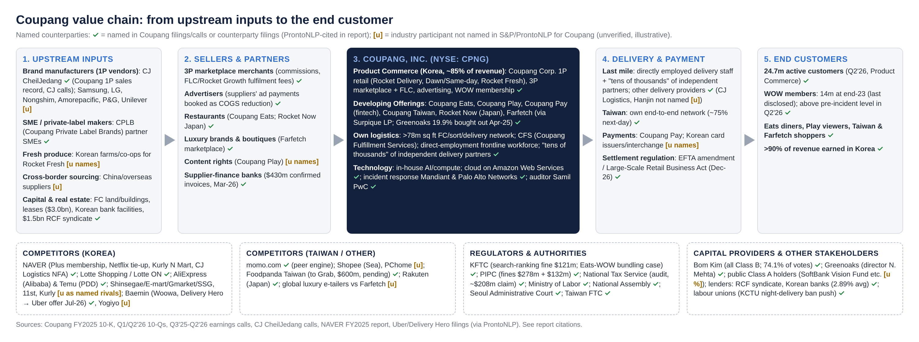
Coupang value chain with named stakeholders (✓ = cited in S&P/ProntoNLP; [u] = not named in tools)
Where Coupang sits. Coupang is unusually vertically integrated for a retailer. It spans procurement (1P buying and private label via CPLB, #74), warehousing and fulfilment (own network, including fulfilment for 3P sellers), last-mile delivery (direct-employment drivers plus independent partners, #88), the consumer interface (app, WOW), and payments (Coupang Pay).
Key external dependencies:
- AWS cloud: “we cannot quickly or easily switch” (#696).
- Korean banks for working-capital lines and supplier finance.
- Landlords: US$3.0bn of lease liabilities and US$689m of signed leases not yet commenced (#1931).
- Card networks: competitors “control… credit card interchange” (#368).
Named counterparties verified in the tools. CJ CheilJedang (supplier), Amazon Web Services (cloud), Mandiant and Palo Alto Networks (incident forensics, #36), Samil PwC (auditor), Greenoaks (co-investor in Farfetch and a related party, #2050), and Farfetch boutiques and brands. Brand names such as Samsung, LG, Nongshim, Amorepacific, P&G and Unilever, and carriers such as CJ Logistics and Hanjin, are commonly cited as part of Korea’s e-commerce supply chain. None is named for Coupang in S&P/ProntoNLP [u].

8. Financial performance by division and geography (FY2021-FY2025)

8.1 Consolidated P&L (S&P Capital IQ, US$m)
 | FY2021 | FY2022 | FY2023 | FY2024 | FY2025 | LTM Jun-26
Revenue | 18,406 | 20,583 | 24,383 | 30,268 | 34,534 | 35,462
Growth (reported / cc) | +54% [d] / n.a. | +11.8% / +26% | +18.5% / +20% | +24.1% / +29% | +14.1% / +18% | +9.9% [d]
Gross profit | 3,109 | 4,710 | 6,190 | 8,715 | 10,141 | 10,055 [d]
Gross margin | 16.9% | 22.9% | 25.4% | 28.8% | 29.4% | 28.4%
EBITDA (S&P, reported) | -997 | 119 | 748 | 821 | 1,015 | -46
Adj. EBITDA (company) | n.a. (Q4’21: -285) | 381 | ~1,100 (4.4%) | ~1,400 (4.5%) | ~1,500 (4.3%) | 872 [d] (2.5%)
Operating income (EBIT) | -1,198 | -112 | 473 | 388 | 498 | -603
EBIT margin | -6.5% | -0.5% | 1.9% | 1.3% | 1.4% | -1.7%
Net income to CPNG | -1,543 | -92 | 1,360 | 154 | 208 | -767
Net margin | -8.4% | -0.4% | 5.6% | 0.5% | 0.6% | -2.2%
S&P EBITDA = EBIT + D&A. Company adjusted EBITDA also adds back stock-based compensation and excludes certain items (2026: “administrative fines”, #339). The S&P FY2025 operating income of US$498m differs from the company’s US$473m (#42) because S&P reclassifies US$25m of restructuring below EBIT. LTM gross profit is the sum of the last four quarters ‡.
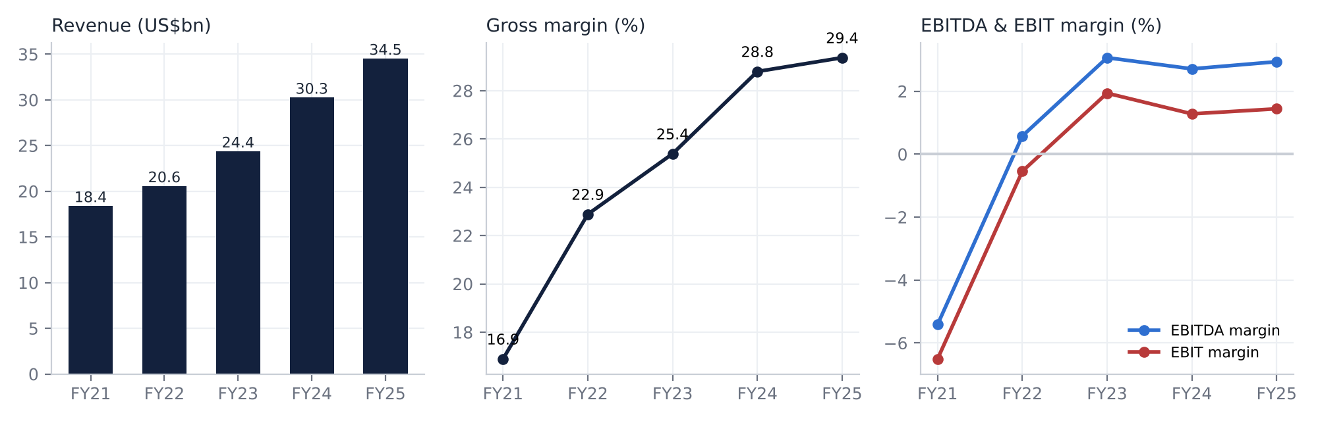
Annual revenue, gross margin and EBITDA/EBIT margins

8.2 By division (segments; company disclosures via ProntoNLP)
US$m | FY2021 | FY2022 | FY2023 | FY2024 | FY2025
Product Commerce revenue | n.d. (segments introduced 2022, #38) | 20,000 (+12%; +26% cc) | 23,600 (+18%; +19% cc) | 26,700 (+13%; +18% cc) | 29,600 (+11%; +16% cc)
PC adj. EBITDA (margin) | n.d. (Q4’21 margin -2.6%) | ~600 [d] (3.0%) | 1,500 (6.5%) | 2,000 (7.5%) | 2,500 (8.4%)
Developing Offerings revenue | n.d. | ~580 [d] | 789 | 3,600 (+352%, Farfetch) | 4,900 (+38%; +40% cc)
DO adj. EBITDA | n.d. | -225 | -466 | -631 | -995
Segment EBIT / net income | Not disclosed. The chief operating decision maker (CODM) measure is segment adjusted EBITDA only; no segment D&A, EBIT or net income is reported (#1868)
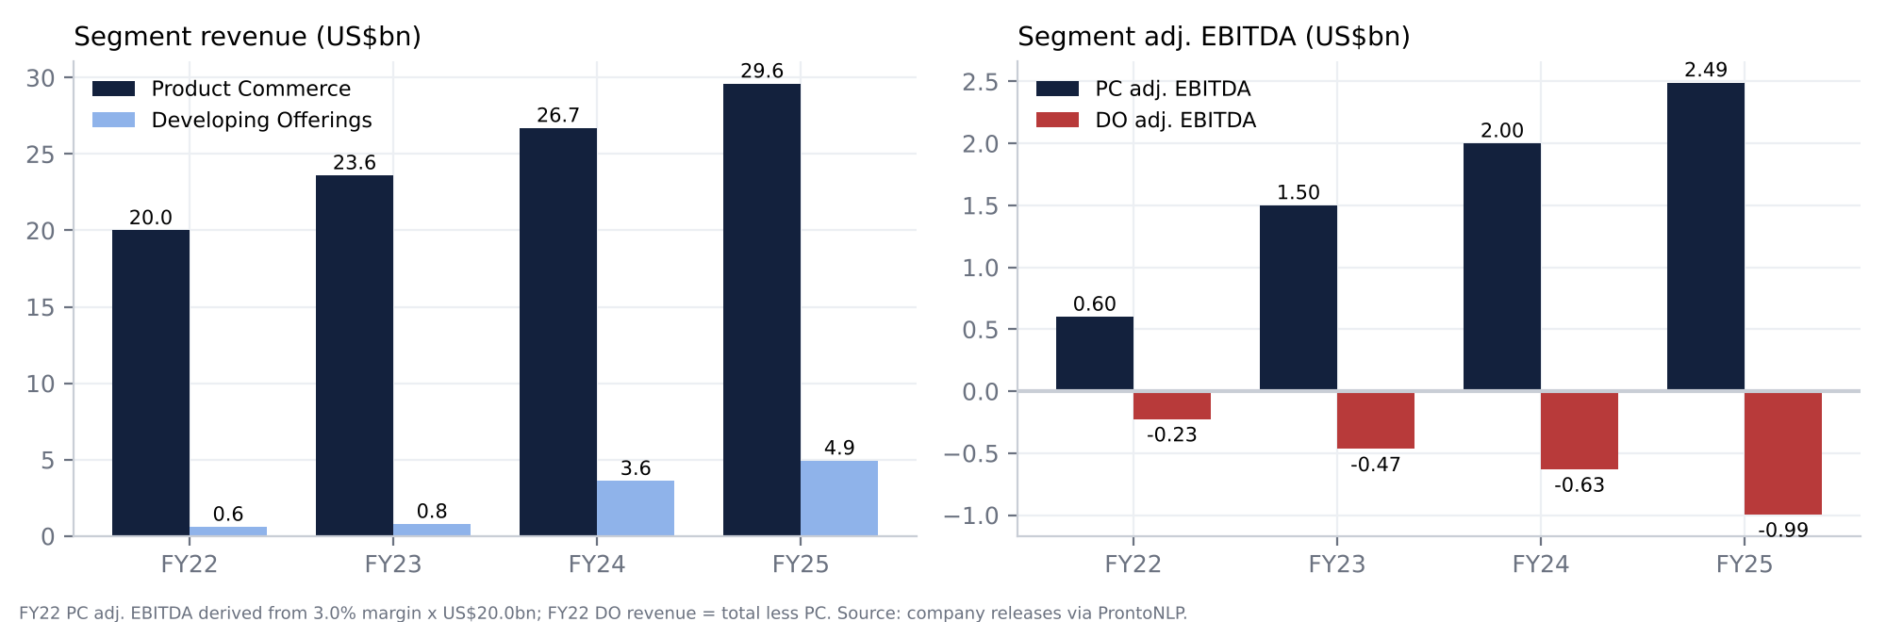
Segment revenue and adjusted EBITDA
Quarterly segment trend (last four quarters)
 | Q3’25 | Q4’25 | Q1’26 | Q2’26
PC revenue (reported / cc growth) | US$8.0bn, +16% / +18% | US$7.4bn, +8% / +12% | US$7.2bn, +4% / +5% | US$7.4bn, +1% / +8%
PC gross margin | 32.1% | 31.9% | 30.3% | 30.5%
PC adj. EBITDA (margin) | US$705m (8.8%) | US$567m (7.7%) | US$358m (5.0%) | US$382m (5.1%)
DO revenue (reported / cc) | US$1.3bn, +32% / +31% | US$1.4bn, +32% / +31% | US$1.3bn, +28% / +25% | US$1.4bn, +20% / +24%
DO adj. EBITDA | -US$292m | -US$300m | -US$329m | -US$219m
Consolidated adj. EBITDA (margin) | US$413m (4.5%) | US$267m (3.0%) | US$29m (0.3%) | US$163m (1.8%)
GAAP operating income | 162 | 8 | -242 | -556
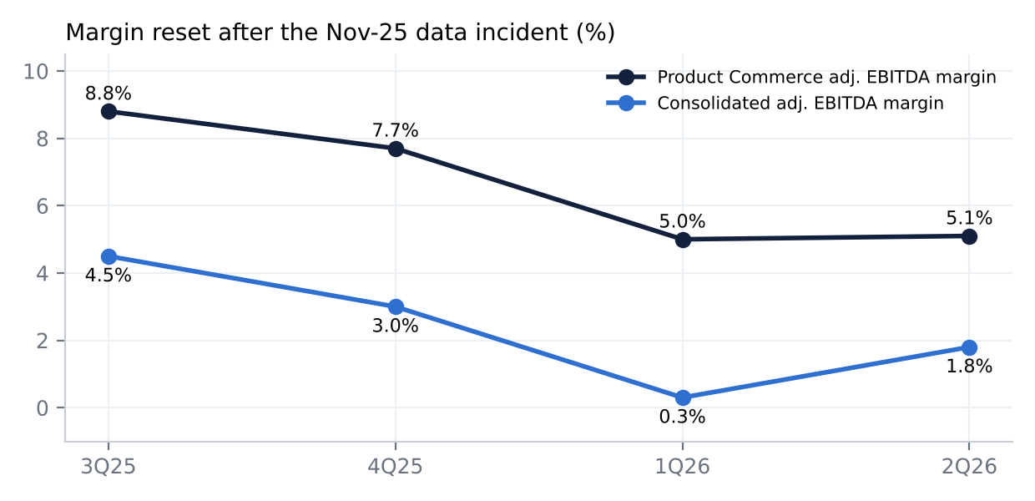
Margin reset after the data incident

8.3 By geography
Coupang does not publish a geographic P&L in prose that ProntoNLP indexes; the geographic table is not retrievable. The disclosed facts:
- Over 90% of net revenue is earned by Korean entities (#1858). The remainder comes from the US, UK, Taiwan, Europe and APAC (#1859).
- Product Commerce is entirely Korean.
- Taiwan sits in Developing Offerings and is growing at triple-digit rates (#94, #98). It is “the largest contributor” to Developing Offerings losses (#224).
- Farfetch’s revenue is global. It was 5% of FY24 revenue and 7% of assets (#1525).
Geographic EBITDA, EBIT and net income are not disclosed ‡.

8.4 Trends: growth and margins, and why
- Growth decelerated from hyper-growth to mid-teens before the incident. Revenue compounded at ~17% a year over FY21-25 [d], with constant-currency growth above reported growth in every year.
  - FY2023 reported growth was depressed by ~520bp when FLC revenue moved to a net basis (#28).
  - FY2024 was boosted by Farfetch; growth ex-Farfetch was 17% against 24% reported (#36).
  - The 2025 USD figures absorbed a 5pt FX drag on Product Commerce (#1389).
- Gross margin expanded by 12.5pts in four years (16.9% to 29.4%). The drivers were mix (3P/FLC and ads), procurement scale and automation, and Farfetch’s higher-margin marketplace model. The incident reversed about 1-2pts in H1’26 through vouchers, promotions and supply-chain inefficiency (#102, #167).
- Product Commerce profitability is the real story. PC adjusted EBITDA margin climbed from ~3% (FY22) to 8.4% (FY25), and 8.8% in Q3’25. Developing Offerings losses grew from US$225m to US$995m over the same years, consuming about 40% of PC EBITDA in FY25.
- The GAAP bottom line is noisy. Items include a US$905m valuation-allowance release in FY23 (#1901) and a US$175m fire-insurance gain and US$121m KFTC fine in FY24 (#1360). Effective tax rates were 86% in FY24 and 64% in FY25 [d], because losses in Taiwan, the US and Farfetch get no tax benefit (#1413).
- 2026 broke the margin trajectory. Revenue held up, at +8% to +10% constant currency. But fixed costs sized for pre-incident demand, extra marketing and vouchers cut the PC margin to ~5% (#170).

8.5 Operational KPIs and recent trends
KPI | History | Latest | Trend / comment
Active customers (PC, m) | ~18 (FY21), >21 (FY23), 22.8 (FY24), 24.6 (FY25) | 23.9 (Q1’26) → 24.7 (Q2’26) | Recovered. The trailing three-month definition lagged the dip (#93)
Revenue per active customer (cc) | +3% to +7% a quarter in 2025 (#1386) | +5% (Q2’26) | Stable
WOW paid members (m) | 6 (2020), ~9 (2021), 11 (2022), 14 (2023) | Above pre-incident; all-time high (#271) | No count since 2023 [u]
PC gross margin | 32.0% (FY25) | 30.5% (Q2’26) | -210bp YoY
PC adj. EBITDA margin | 3.0% → 6.5% → 7.5% → 8.4% (FY22-25) | 5.1% (Q2’26) | Target: pre-incident by mid-2027 (#220)
DO adj. EBITDA loss | -225 → -466 → -631 → -995 (FY22-25) | -219 (Q2’26) | FY26 guide -950 to -1,000 (#223)
Fulfilment footprint | >67m sq ft (FY24, #1145) | >78m sq ft (FY25, #1295) | +16%
Capex intensity (capex / revenue) | 3.7%, 4.0%, 3.7%, 2.9%, 3.6% (FY21-25) [d] | 3.7% LTM [d] | Re-accelerating; “several billion” ahead
Cash conversion cycle (days) | -42, -64, -54, -57 (FY22-25) [d] | n.a. | Negative working capital at risk from settlement rules (#619)
Free cash flow (US$m) | -1,085, -259, 1,756, 1,007, 522 (FY21-25) [d] | ~99 LTM [d] | Collapsing
SBC (% of revenue) | 1.3%-1.4% (FY22-25) [d] | 1.8% (Q2’26) [d] | Rising
Backlog / installed base / churn | Not applicable / not disclosed | WOW churn elevated in Dec-25, then normalised (#139, #140)

9. Earnings calls: what management is focused on, and how sentiment has shifted

9.1 Summary of the last four calls
- Q3’25, 4-Nov-2025, before the incident. Confident and growth-led: “growth and expanding margins yet again” (#22).
  - Product Commerce margin 8.8%. Consolidated margins expanding annually “for the foreseeable future” (#126). PC margins to move “well past the 10%” level (#271).
  - The worry was Developing Offerings losses: guided to the high end of US$900-950m on Taiwan (#98).
- Q4’25, 26-Feb-2026. Opened with an apology (#26) and an incident review by the General Counsel (#35). Palo Alto Networks called it a targeted insider attack, not a systemic failure (#53).
  - Guidance: margin expansion “disrupted” in 2026 but not structurally (#199, #200). Developing Offerings loss guided at US$950m-1bn (#202). No full-year revenue guide (#197).
- Q1’26, 5-May-2026. The recovery case: active customers dipped 3% QoQ on a lagged definition, but nearly 80% of the lost WOW members were back by April (#36).
  - Management explained the fixed-cost structure and chose not to cut capacity (#186).
  - Q2 margin guided -300 to -400bp; annual expansion to resume in 2027 (#147). A further US$1bn buyback was authorised.
- Q2’26, 4-Aug-2026. More confident on customers: WOW above pre-incident levels, and underlying spend +16% (#43).
  - The margin recovery date slipped to “mid-2027” (#220). “Nothing has structurally changed” (#252). Marketing to step down in 2027 (#55).
  - Focus areas: cohort economics, Taiwan’s playbook, and AI across operations (#390).
Where management’s attention has moved. Before the incident it was selection, FLC, automation and Taiwan. After it, the focus is customer retention and trust, the fixed-cost and margin bridge, the regulatory and legal process, and capital return.

9.2 Sentiment analysis (ProntoNLP)
Call | ProntoNLP document sentiment (-1 to +1) | Positive events | Negative events | Net polarity [d] | Tone
Q4’23 | 0.85 | 211 | 15 | 0.87 | Upbeat
Q1’24 | 0.87 | 187 | 10 | 0.90 | Upbeat
Q2’24 | 0.80 | 175 | 20 | 0.79 | Upbeat
Q3’24 | 0.81 | 164 | 17 | 0.81 | Upbeat
Q4’24 | 0.83 | 249 | 24 | 0.82 | Upbeat
Q1’25 | 0.85 | 189 | 13 | 0.87 | Upbeat
Q2’25 | 0.86 | 210 | 14 | 0.88 | Upbeat
Q3’25 | 0.81 | 207 | 22 | 0.81 | Confident
Q4’25 | 0.42 | 193 | 64 | 0.50 | Apologetic, defensive
Q1’26 | 0.34 | 166 | 71 | 0.40 | Trough; recovery narrative
Q2’26 | 0.53 | 254 | 64 | 0.60 | Recovering, but date pushed out
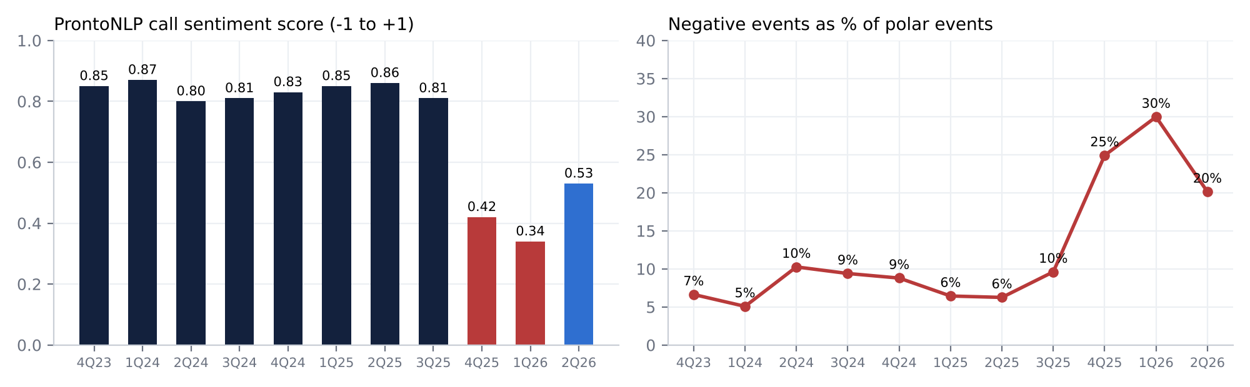
ProntoNLP sentiment per call
Reading the signal
- Sentiment held at ~0.80-0.87 for eight straight calls, collapsed to 0.42 and 0.34 after the incident, and has recovered only partially, to 0.53.
- On the Q2’26 call the main negative event types are OperationalChallenge (12 negative mentions) and FinancialChallenge. CustomerRetention has become a top positive theme (20 positive, 3 negative).
- The “CurrentState” aspect score rebounded from 0.17 (Q1’26) to 0.35 (Q2’26) (CurrentState), against 0.70 before the incident.
The trajectory supports the “glitch” view of demand and a “not yet” view of profitability.

10. Latest result (Q2’26, reported 4-Aug-2026)
Metric | Actual | Consensus (ProntoNLP) ‡ | Surprise
Revenue | US$8,856m | US$8,922m | -0.7% (miss)
Adj. EBITDA | US$163m (1.8%) | US$7m | Beat (consensus dispersion likely included fines in some estimates)
Net income | -US$570m (-US$160m ex-fines, #200) | -US$377m | Miss (fines)
Diluted EPS | -US$0.32 (-US$0.09 ex-fines) | -US$0.27 | Miss by US$0.05 on GAAP; beat ex-fines
Consensus history: revenue missed in four of the last six quarters (1Q25, 4Q25, 1Q26 and 2Q26); GAAP EPS missed in four of the last six. Consensus values come from ProntoNLP getCompanyConsensus, which returns no source links ‡.
Segment drivers
- Product Commerce: +8% constant currency, accelerating from +5% in Q1 (#159), but only +1% in USD because of the 7pt FX hit (#60).
- Developing Offerings: +24% constant currency, led by Taiwan, Eats and Farfetch (#176). The DO loss narrowed by US$110m QoQ (#179). This is the notable acceleration of the quarter.
Margins
- Consolidated gross margin was 28.2%: -188bp YoY but +115bp QoQ (#183).
- PC gross margin was 30.5% (-210bp) on supply-chain dislocation and temporary promotions (#167).
- PC adjusted EBITDA margin was 5.1% (-390bp) because fixed costs are sized for pre-incident demand (#170).
- OG&A was 34.4% of revenue reported and 29.8% ex-fines, +150bp YoY on marketing and Developing Offerings (#187).
Guidance and tone
- Q3’26: +8-9% constant-currency revenue; Chuseok timing is a headwind (#213). Adjusted EBITDA margin -300 to -400bp YoY.
- Recovery path: PC margin back to pre-incident levels by mid-2027 (#220); 2027 guidance by year-end (#221).
- Developing Offerings: loss guide of US$950m-1bn reiterated (#223).
- Tone: firmer on demand, but this is a second deferral of margin normalisation.
- Analysts on the call: Stanley Yang (JPMorgan) asked whether margins return in 2027; management said yes, by mid-2027 (#247). Eric Cha (Goldman Sachs) asked about the gap between 16% underlying and 8% reported growth; management attributed it mostly to lower-spending non-returners (#329). Jiong Shao (Barclays) probed the implied ~6-7% PC growth in Q3 (#432).
Balance-sheet flags
- The US$410m of fines is accrued but unpaid; accrued expenses rose from US$406m to US$876m.
- US$750m is drawn on the revolver (#165); short-term borrowings are US$1,985m, against US$960m at YE25.
- Equity fell to ~US$3.0bn from US$4.6bn at YE25 (#130).
- Inventory fell and payables rose (#142), so working capital helped CFO.
- TTM FCF was only US$105m (#206) while US$459m of stock was repurchased.
- New items: the NTS transfer-pricing claim of ~US$208m (unreserved, #345) and the Incheon fire (~US$246m exposure, #470).
Market reaction. The stock fell 4.6% the next day (US$16.78 to US$16.00 ‡) and recovered 2.2% the day after. Compare -13.8% after Q1. The muted reaction to a large GAAP loss says the fines and the margin trough were priced. What the market did not reward was the slip in the recovery date.
Unusual relative to history
- The first consecutive GAAP operating losses since 2022.
- The first “administrative fines” reconciling item in adjusted EBITDA.
- Tax expense on a pre-tax loss.
- SBC jumped to US$161m from US$113m a year earlier.
- Buybacks funded alongside revolver drawings.

11. EPS estimates, FY2026E-FY2028E
Approach. We build from segments:
- Revenue: Product Commerce and Developing Offerings growth in constant currency, translated at an assumed persistent KRW-weakness drag in H2’26 and flat FX thereafter.
- Margins: Product Commerce margin recovery and Developing Offerings loss reduction.
- Below EBITDA: D&A rising with capex; SBC; one-off items (fines, fire, insurance); net interest; an effective tax rate falling as Taiwan and Farfetch losses shrink; buybacks against SBC dilution.
US$m (base case) | FY2025A | FY2026E | FY2027E | FY2028E
Product Commerce revenue | 29,600 | 30,712 | 34,090 | 37,499
Developing Offerings revenue | 4,934 | 5,974 | 7,049 | 8,318
Total revenue | 34,534 | 36,686 | 41,139 | 45,817
Growth (USD) | +14.1% | +6.2% | +12.1% | +11.4%
PC adj. EBITDA margin | 8.4% | 5.2% [d] | 7.3% | 8.6%
DO adj. EBITDA | -995 | ~-975 (guide midpoint) | -800 | -600
Adj. EBITDA | ~1,485 | 608 | 1,689 | 2,625
Adj. EBITDA margin | 4.3% | 1.7% | 4.1% | 5.7%
D&A | 517 | 593 | 680 | 780
SBC | 475 | 563 | 580 | 620
One-offs (fines, fire, insurance) | -25 | -560 (fines -410, fire -150 [e]) | +100 (insurance [e]) | 0
GAAP EBIT | 473 | -1,117 | 529 | 1,225
Net interest and other | 124 | 30 | 40 | 30
Pre-tax income | 597 | -1,087 | 569 | 1,255
Tax (ETR) | 383 (64%) | 108 (n.m.) | 313 (55%) | 502 (40%)
Net income to CPNG | 208 | -1,195 | 256 | 753
Diluted shares (m) | 1,855 | 1,796 | 1,790 | 1,795
GAAP diluted EPS (US$) | 0.11 | -0.67 | 0.14 | 0.42
Adj. EPS ex one-offs (US$) | ~0.12 | -0.37 | 0.10 | 0.42
Key assumptions and their logic
- H2’26 revenue. Q3: PC +6.5% constant currency (in line with the Barclays-implied 6-7%) less 5pts of FX; DO +20% reported. Q4: an easy December-25 comparison, so PC +12% constant currency less 4pts of FX. That gives US$9.64bn and US$9.69bn.
- H2’26 margins. Q3 adjusted EBITDA margin of 1.2% (the -330bp end of the guide); Q4 3.1%.
- Industry growth and share. Korean online sales grew +4.9% in 2025 (#305). We assume Coupang grows PC at 11% and 10% in FY27 and FY28. That is roughly 2x the market, consistent with past share gains, and reflects recapture of the non-returning cohort and lapping of the vouchers.
- Pricing and cost pressures. Promotions normalise in 2027 and marketing steps down (#55). Labour cost inflation and the night-delivery risk are not in the base case.
- Operating leverage. We take PC margin to 7.3% in FY27, the mid-2027 recovery path, and 8.6% in FY28, roughly the pre-incident level. This is below the “well past 10%” ambition (#271).
- Financing costs. ~US$2.6bn of debt at ~3-4% (Korean lines at 2.89% (#173), term loan at 3.80%, revolver at SOFR+0.75-1.25%) against ~US$5.5-6bn of cash.
- Share count. US$907m of remaining authorisation absorbs SBC dilution; 386m shares remain available under the equity plans (#1886).
- Tax. ETR stays well above the ~25% long-term guide (#120) while Taiwan and US losses get no benefit.
Versus consensus. ProntoNLP’s consensus for 3Q26 and 4Q26 is stale: EPS of US$0.17 and US$0.20 dated March 2025 ‡. No current FY2027 or FY2028 consensus is available from S&P or ProntoNLP, so we cannot quantify the gap to street estimates.
Sensitivities [d]
- Each 100bp of PC margin is ~US$340-375m of EBITDA, or ~US$0.09-0.11 of EPS at a 45-55% ETR.
- A 10% move in the KRW is ~±US$3.5-4bn of revenue and ~±US$0.10 of EPS (scaled from the 10-K sensitivity, #1624).
- Each US$100m change in Developing Offerings losses is ~US$0.03-0.05 of EPS.

12. Capital structure, liquidity, maturities and covenants
Instrument | Amount | Pricing | Maturity | Security / covenants | Source
Revolving credit facility (Parent, USD) | US$1.5bn; US$750m drawn | Term SOFR + 0.75-1.25% | Five-year from Jun-2025 (~2030 [d]) | Unsecured; customary financial covenants | #371, #165
Other credit facilities (mainly Korean subsidiaries, KRW) | US$1.6bn capacity; US$1.2bn drawn | Weighted average 2.89% | Majority within 12 months | Unsecured; financial covenants | #173
New Korean revolvers (Jun-2026) | ~US$193m; undrawn | Korean CD rate + 1.20-1.50% | Jun-2027 | Unsecured | #166
Unsecured term loan (Sep-2025) | US$439m | Fixed 3.80% (average) | ~Sep-2028 | Unsecured; refinanced secured FC loans | #1514
Taiwan RCF | Up to US$199m | TAIBOR + 1.25% | ~2029 | Senior unsecured | #1862
Operating leases | US$560m current + US$2,470m non-current, plus US$689m signed but not commenced | n.a. | 1-10 years | Not applicable | #1931
Total funded debt | US$1,985m short-term + US$618m long-term = US$2,603m [d] | Variable-rate debt US$982m (#194) |  | Covenants in compliance (#377)
Cash | US$6,110m, mostly held by foreign subsidiaries (#129) |  |  | Upstreaming restricted by subsidiary agreements (#140)
Net position (30-Jun-2026) [d]
- Net cash excluding leases: US$3.5bn.
- Net cash including leases: US$0.48bn, matching S&P net debt of -US$477m.
- Net debt/EBITDA: n.m. (net cash).
Interest cost. Interest expense was US$86m in FY25, down from US$140m in FY24 after the expensive Farfetch term loans (SOFR + 6.25%) were redeemed. Interest income still exceeds interest expense. FY25 EBIT interest cover was 5.8x [d]; LTM cover is negative.
Liquidity
- Management states sources are sufficient for at least 12 months (#140).
- Flag: the 10-Q cites only “US$0.3bn available under our credit facilities” (#130). Stated capacity less drawings is ~US$1.15bn [d], so this needs an IR answer.
- Near-term cash calls:
  - PIPC fines of ~US$410m, payable despite the appeal (#7).
  - A possible NTS assessment of ~US$208m.
  - Buybacks (US$907m remaining).
  - Capex (“several billion” over several years).
  - Potential release of payables under the Dec-2026 settlement rules. Each 10 days of DPO is ~US$0.67bn [d].
- Credit rating: none disclosed in filings.
Assessment.
- Solvency is not an issue.
- Coupang has shifted from a cash-rich, self-funding model (FY23 FCF US$1.76bn) to borrowing to fund buybacks while FCF is near zero. Equity has fallen to US$3.0bn.
- If the settlement-period rules bite and margins do not recover, the net cash cushion (including leases) could turn to net debt in 2027 [e].

13. Valuation: peers, history and regression

13.1 Listed peer comparison (LTM to Jun-2026; S&P Capital IQ financials; ProntoNLP prices, 9-Oct-2026)
Company | Ticker | Listed? | Mkt cap (US$bn) | EV/Sales | EV/EBITDA | EV/EBIT | P/E | Net debt/EBITDA | EBITDA margin | EBIT margin | Sales growth | FCF yield
Coupang | CPNG US | NYSE | 28.5 | 0.79 | n.m. | n.m. | n.m. | net cash | -0.1% | -1.7% | 9.9% | 0.3%
Amazon | AMZN US | NASDAQ | 2,861 | 3.85 | 17.7 | 31.9 | 21.2 | 0.8 | 21.8% | 12.1% | 15.8% | -0.4%
MercadoLibre | MELI US | NASDAQ | 96 | 2.94 | 26.5 | 35.5 | 51.4 | 1.9 | 11.1% | 8.3% | 46.0% | 13.0%
Sea Ltd | SE US | NYSE | 62 | 2.07 | 21.4 | 25.1 | 38.1 | net cash | 9.7% | 8.2% | 43.1% | 6.7%
PDD Holdings | PDD US | NASDAQ | 120 | 0.89 | 4.0 | 4.1 | 9.2 | net cash | 22.0% | 21.9% | 10.0% | 13.0%
Alibaba | BABA US / 9988 HK | NYSE / HKEX | 265 | 1.69 | 17.7 | 37.0 | 25.6 | net cash | 9.5% | 4.6% | 4.4% | -4.1%
JD.com | JD US | NASDAQ | 38 | 0.09 | 9.8 | 53.0 | 18.3 | net cash | 0.9% | 0.2% | 3.8% | 10.5%
Vipshop | VIPS US | NYSE | 6 | 0.22 | 2.4 | 2.9 | 4.3 | net cash | 9.1% | 7.6% | -0.8% | n.a.
NAVER | 035420 KS | KRX | 20 | 1.88 | 8.0 | 10.9 | 13.7 | net cash | 23.3% | 17.3% | 14.7% | 5.3%
E-MART | 139480 KS | KRX | 1.4 | 0.41 | 6.9 | 50.4 | 88.4 | 5.8 | 5.9% | 0.8% | -0.9% | n.m.*
Lotte Shopping | 023530 KS | KRX | 2.0 | 1.05 | 8.4 | 22.5 | 15.3 | 6.9 | 12.4% | 4.7% | 1.1% | n.m.*
Rakuten Group | 4755 JP | TSE | 9.4 | 0.53 | 3.1 | 9.5 | n.m. | net cash | 17.1% | 5.6% | 10.9% | 11.4%*
Zalando | ZAL GY | XETRA | 6.8 | 0.44 | 9.0 | 14.1 | 63.3 | net cash | 4.8% | 3.1% | 23.5% | 15.2%*
Allegro.eu | ALE PW | WSE | 13.8 | 4.50 | 16.2 | 23.2 | 31.0 | 0.7 | 27.8% | 19.4% | 16.3% | 4.3%*
Jumia | JMIA US | NYSE | 0.8 | 3.55 | n.m. | n.m. | n.m. | net cash | -25.7% | -25.9% | 27.8% | -5.5%
Walmart | WMT US | NASDAQ | 888 | 1.29 | 21.6 | 32.8 | 40.2 | 1.4 | 6.0% | 3.9% | 6.2% | 1.5%
Peer median |  |  |  | 1.29 | 9.4 | 24.2 | 25.6 | net cash | 9.7% | 5.6% | 10.9% | 8.6%
Sources: S&P Capital IQ LTM revenue, EBITDA, EBIT, net income, net debt (incl. leases), CFO and capex, with statement links in the provenance file; ProntoNLP weekly closes (‡). EV = price × S&P diluted shares + S&P net debt, in each company’s reporting currency. Chinese ADRs converted at CNY7.10/US$ and HKD7.80/US$ [e]. Market caps in US$ use FX implied by ProntoNLP’s USD vs local market-cap fields [d]. *IFRS reporters book lease principal in financing, which inflates CFO-based FCF; treat with caution. Peer fiscal periods are LTM Jun-2026 except Walmart (Jul-2026) and Alibaba (Jun-2026 LTM). Growth is LTM year on year, not organic (Zalando and MELI include M&A or consolidation effects).

13.2 Coupang versus its own history
Year-end | Price ‡ | EV (US$bn) [d] | EV/Sales [d] | EV/Adj. EBITDA [d] | Peer-median EV/Sales [d] | CPNG discount to peers
Dec-2021 | 29.38 | 50.1 | 2.72 | n.m. | 6.00 | -55%
Dec-2022 | 14.71 | 25.3 | 1.23 | 66.3 | 2.00 | -39%
Dec-2023 | 16.19 | 26.9 | 1.10 | 25.0 | 2.34 | -53%
Dec-2024 | 22.42 | 39.0 | 1.29 | 28.7 | 3.03 | -57%
Dec-2025 | 23.37 | 41.0 | 1.19 | 27.6 | 2.95 | -60%
Oct-2026 (LTM) | 15.82 | 28.0 | 0.79 | 32.1 | 1.97 | -60%
The peer set for the history comparison is Amazon, MercadoLibre, Sea, NAVER, E-MART and Lotte Shopping: year-end prices from ProntoNLP (‡); S&P annual revenue, net debt and diluted shares, in local currency.
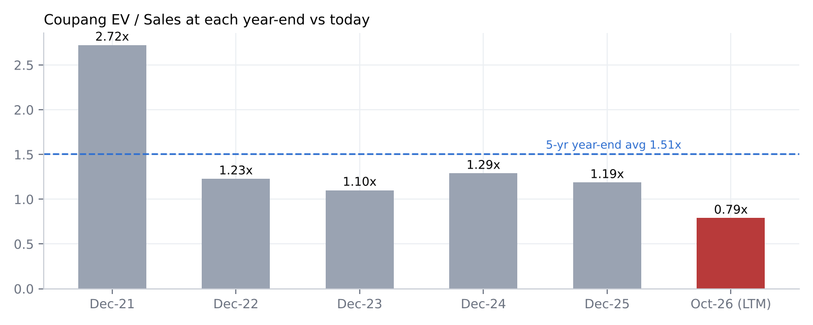
EV/Sales at each year-end vs today

13.3 Regression: EV/Sales vs EBIT margin (14 listed peers)
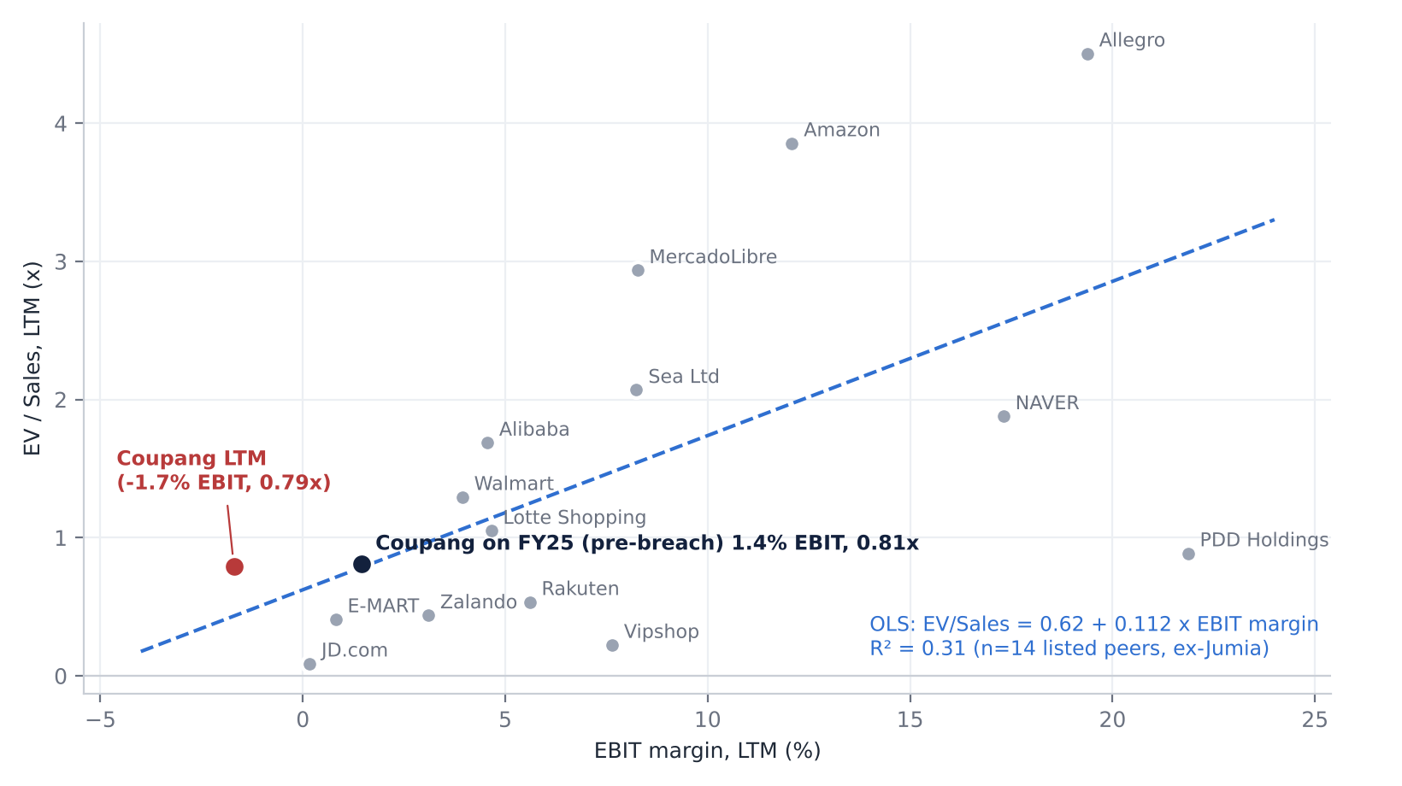
Regression of EV/Sales on EBIT margin
- The fit: OLS on 14 listed peers (ex-Jumia) gives EV/Sales = 0.62 + 0.112 × EBIT margin (%), with R² = 0.31 [d]. That is a moderate fit. PDD (a high-margin outlier on China-specific risk) and Allegro (a high-multiple outlier) flatten the slope.
- Where Coupang sits:
  - LTM EBIT margin of -1.7% implies 0.43x; Coupang trades at 0.79x, above the line.
  - Pre-incident FY25 EBIT margin of 1.4% implies 0.78x, on the line.
  - Our FY28E GAAP EBIT margin of 2.7% implies 0.92x [d].
Verdict: cheap, fair or expensive?
Lens | Reading | Verdict
EV/Sales vs peers (0.79x vs 1.29x median) | -39% | Cheap
EV/Sales vs own history (0.79x vs 1.1-1.3x 2022-25) | Five-year low | Cheap
Regression (EV/Sales vs EBIT margin) | On the line at pre-incident margin; slightly above at the trough | Fair
EV/EBITDA (32x LTM adjusted; 16.6x FY27E adjusted vs 9.4x peer LTM median) | Trough earnings | Expensive on trough, fair on recovery
P/E (FY28E 38x) | GAAP EPS burdened by a 40%+ ETR and SBC | Expensive
Net debt/EBITDA | Net cash, but shrinking | Neutral
FCF yield (0.3% LTM vs 8.6% median) | FCF collapse | Expensive
Conclusion. Coupang is cheap only if margins recover. On sales it trades at a five-year low and a 39% discount to peers. On earnings and cash flow it is expensive. The investment case is a margin-recovery bet, which is exactly the “glitch” debate.

13.4 Competitors and comparables (public and private)
Company | Ticker / owner | Listed? | Relevance
NAVER | 035420 KS | Yes (KRX) | #1 domestic rival: marketplace, Plus membership, Kurly N Mart
E-MART / Shinsegae (Gmarket, SSG.com) | 139480 KS (Gmarket and SSG.com are unlisted subsidiaries / JV [u]) | Parent listed | Owns ex-eBay Korea (Gmarket) (#675)
Lotte Shopping (Lotte ON) | 023530 KS | Yes | Omnichannel rival (#92)
AliExpress (Alibaba) | BABA US / 9988 HK | Yes | Cross-border entrant (#308)
Temu (PDD Holdings) | PDD US | Yes | Cross-border entrant
11st | SK Square subsidiary [u] | No (parent 402340 KS listed [u]) | Domestic marketplace
Kurly (Market Kurly) | Private [u] | No | Fresh grocery; partner of Naver
Musinsa | Private [u] | No | Fashion e-commerce
Baemin (Woowa Brothers) | Delivery Hero (DHER GY); Uber offer pending | Parent listed | #1 Korean food delivery vs Coupang Eats (#1089)
Yogiyo | Private [u] | No | Korean food delivery
Netflix / Tving | NFLX US / CJ ENM subsidiary [u] | Netflix listed | Compete with Coupang Play
momo.com | 8454 TT [u] | Yes [u] | Taiwan e-commerce
Shopee (Sea) | SE US | Yes | Taiwan marketplace
PChome | 8044 TT [u] | Yes [u] | Taiwan e-commerce
Foodpanda Taiwan | Delivery Hero → Grab (pending) | No | Taiwan food delivery (#325)
Amazon, Walmart, MercadoLibre, Allegro, Zalando, Rakuten, JD, Vipshop, Jumia | See table 13.1 | Yes | Global e-commerce comparables

14. M&A in the industry; is Coupang a takeover target?

14.1 Recent industry transactions (last five years)
Announced / closed | Target | Acquirer | Consideration | EV (local) [d] | EV/Sales [d] | EV/EBITDA [d] | Source
Jul-2026 (pending; close H2’27) | Delivery Hero SE (incl. Baemin, Korea) | Uber Technologies | EUR41.50/sh; equity US$14.8bn | ~EUR15.8bn | 1.06x LTM | n.m. (LTM EBITDA EUR144m) | #1089, #84, S&P LTM
Mar-2026 (pending TFTC) | Foodpanda Taiwan | Grab Holdings | US$600m cash | US$0.6bn | n.a. | n.a. | #325
May-2024 (blocked Jan-2025) | Foodpanda Taiwan | Uber Technologies | ~US$950m cash/debt-free; US$236m break fee paid | US$0.95bn | n.a. | n.a. | #2045
May-2025 / closed Oct-2025 | Deliveroo plc | DoorDash | 180p/sh; equity ~GBP2.8bn; fair value US$3,724m | ~GBP2.4bn | 1.15x FY24 | n.m. | #2247, #2063
Feb-2025 | Just Eat Takeaway.com | Prosus | EUR4.1bn (US$4.6bn) | ~EUR4.5bn | 1.26x FY24 | 28.7x FY24 | #379, S&P
Jul-2025 | Ceconomy (MediaMarkt/Saturn) | JD.com | EUR4.60/sh (59.8% for EUR1.3bn) | ~EUR3.8bn | 0.17x FY Sep-24 | 9.6x | #1966, #1971
Dec-2024 / 2025 | ABOUT YOU | Zalando | EUR6.50/sh; ~EUR1.14bn | ~EUR1.14bn | 0.59x FY Feb-24 | n.m. | #4947
Jan-2024 | Farfetch (business and assets) | Coupang 80.1% / Greenoaks 19.9% | Bridge loan (US$500m facility, US$150m drawn) + ~US$300m contributed + up to US$200m committed | n.d. | n.d. (Farfetch FY22 revenue US$2.3bn) | n.m. | #4, #2038
Oct-2022 / Jan-2023 | Poshmark | NAVER | Not returned by tools [u] | n.a. | n.a. | n.a. | #318
Jun-2021 / closed Nov-2021 | eBay Korea (Gmarket, Auction) | E-mart (Shinsegae) | 80.01% for ~US$3.0bn gross cash; implies ~US$3.75bn for 100% [d]; eBay’s retained 19.99% valued at US$728m | ~US$3.7bn | n.a. (target revenue not in tools) | n.a. | #675, #1308
2024-25 | Gmarket / AliExpress Korea joint venture | Alibaba / Shinsegae | Not found in tools [u] | n.a. | n.a. | n.a. | Unverified
Multiples are derived using target financials from S&P Capital IQ: Delivery Hero LTM Jun-26 revenue EUR14.93bn and net debt EUR2.61bn; Deliveroo FY24 revenue GBP2.07bn and net cash GBP0.41bn; JET FY24 revenue EUR3.56bn, EBITDA EUR156m, net debt EUR379m; Ceconomy FY24 revenue EUR22.4bn, EBITDA EUR394m, net debt EUR1.62bn; ABOUT YOU FY24 revenue EUR1.94bn. Delivery Hero equity is converted at EUR/US$1.12, implied by ProntoNLP’s USD vs local market caps [d].
Read-across. Delivery and e-commerce platform control deals have cleared at ~1.1-1.3x sales, with very high or meaningless EBITDA multiples because targets were near break-even. Low-margin omnichannel retail (Ceconomy) clears at 0.2x sales and ~10x EBITDA. Two of these deals land directly in Coupang’s markets. Uber’s offer for Delivery Hero consolidates Coupang Eats’ main Korean rival, Baemin, under a global strategic owner. Grab’s purchase of Foodpanda Taiwan does the same for Taiwan food delivery, after Uber’s US$950m attempt was blocked.

14.2 Is Coupang a takeover target?
Pros
- The valuation is at a five-year low on sales (0.79x) with net cash.
- It is a scarce asset: a dominant owned-logistics network in a large, high-penetration e-commerce market.
- Strategic logic exists for global platforms (Amazon has no direct Korean presence [u]; Walmart; Uber, which is consolidating delivery) and for large private-equity or sovereign capital.
- Developing Offerings assets could be carved out: Farfetch, Eats, Taiwan.
Impediments
- Control. Bom Kim holds all Class B shares and 74.1% of the votes (#1187). No deal happens without him, and the 10-K says his control “will limit or preclude your ability to influence corporate matters… including… any merger” (#1188).
- Size. An EV of ~US$28bn rises to ~US$37bn at a 30% premium [d].
- Korean regulation. There is political and regulatory sensitivity after the breach, a business-group designation (#1007), data-sovereignty concerns, and KFTC merger control.
- No obvious domestic buyer. NAVER’s market cap is ~US$20bn.
- Litigation and regulatory contingencies would need to be priced.
Most plausible path. A founder-led take-private with financial partners, or minority carve-outs. A hostile approach is impossible.
Potential takeout multiples [d]
Method | Multiple | Applied to | Implied EV | Implied value per share
Delivery-platform precedent median | 1.15x sales | LTM revenue US$35.5bn | US$40.8bn | ~US$23
Range of precedents | 0.9-1.3x sales | LTM revenue | US$31.9-46.1bn | ~US$18-26
Premium approach | 30-40% over US$15.82 |  |  | US$20.6-22.1
EBITDA cross-check | ~20x FY25 adjusted EBITDA (~US$1.49bn) |  | US$29.7bn | ~US$17
Conclusion. A plausible control value is ~US$20-26 a share (1.0-1.3x LTM sales). The probability of a bid is low, given the control structure. Takeover premium should not be part of the core thesis. Treat it as a tail option if the founder’s own incentives (personal tax needs; #311) or regulatory fatigue push toward a take-private.

14.3 Coupang’s own acquisitions (last 10 years)
Date | Target / transaction | Consideration | Multiple | Source
Announced 18-Dec-2023; closed 30-Jan-2024 | Farfetch Holdings plc, business and assets, bought out of UK pre-pack administration via Surpique LP (80.1% Coupang) | US$500m bridge facility at 12.5% PIK (US$150m advanced); ~US$300m contributed at close (cash plus loan cancellation); up to US$200m more committed; Farfetch term loans (US$575m) assumed, then redeemed in 2025 | n.d.; Farfetch was 5% of FY24 revenue | #0, #4, #21, #2035, #1950
Feb-2025 | Remaining 40% of Palm Angels (Farfetch-owned brand), then sale of the brand rights | Not disclosed | n.d. | #2050
7-Apr-2025 | Greenoaks’ 19.9% minority interest in Surpique LP (related party) | US$140.1m (US$14.1m cash + 5,465,099 Class A shares); fair value booked US$122m | Implies ~US$0.70bn for 100% of Surpique [d] | #1, #2, #2052
No other business combinations appear in the FY2021-FY2025 10-Ks (#1415). Pre-2021 deals are not covered by the tools [u].

15. Management assessment
Executive | Role and tenure | Track record | Skin in the game | Notes and red flags
Bom Kim (founder) | Founder (2010); CEO and Chairman throughout the listed period (#1710, #1707) | Built Korea’s largest owned e-commerce logistics network from scratch. Took the company public in 2021 at US$35, delivered first adjusted-EBITDA profitability (2022) and GAAP profits (2023). Turned Farfetch to positive economics by Q4’25 (#121). Misses: Japan v1 exit (#72), the scale of Taiwan losses, and the 2025 data incident and regulatory relations | All Class B (29 votes per share): 74.1% of voting power, down from 76.2% in FY21 (#1187, #1160). Economic stake ≥~9% [d]. Pay not available (proxy not indexed) | Adopted a plan to sell up to 15m shares in Aug-2024, citing tax needs (#311). Named in breach suits (#1980). A regulatory “designation” in Korea (#239). Remains CEO and Chair after the breach
Gaurav Anand | CFO, at least since 2021 (appointment agreement 22-Feb-2021, #2080) | Steered the move to profitability, the Farfetch refinancing, and the 2025 RCF and term-loan refinancing (#1514) | 10b5-1 sales plans: up to 301k shares (Dec-2024) and up to 300k shares (Mar-2026) (#1547, #300) | Reassigned to the Korean subsidiary from 1-Nov-2025 (#2080). Sales plan adopted after the breach
Harold L. Rogers | General Counsel and Chief Administrative Officer; interim CEO of Coupang Corp. (Korea) since 10-Dec-2025 (#10) | Led the incident response and regulatory process | 10b5-1 plan for up to 352,602 shares (Mar-2026, #303) | A lawyer running the Korean operating entity; a permanent CEO has not been named [u]
Jonathan Lee | Chief Accounting Officer since 26-Sep-2022 (#0) | Ex-TriNet CAO; Arch Capital deputy CFO (#3) | 10b5-1 plan (May-2026, #294)
Departures | CTO Thuan Pham (2022, #0); TJ Kim (2024, #0); Hanseung Kang ceased to be an officer (Jun-2025, #0); Pranam Kolari (Nov-2025, #0); former Korea CEO (Dec-2025) |  |  | No successor CTO filing was found

15.1 Capital allocation history
ROE and ROIC under the current team [d]. ROE was ~3.7% in FY24 and ~4.5% in FY25. ROIC uses a notional 25% tax on GAAP EBIT, with invested capital defined as equity + debt + leases − cash:
Year | ROIC
FY23 | ~22%
FY24 | ~14%
FY25 | ~13%
LTM | Negative
ROIC looks high because negative working capital funds most of the asset base. That flatters it, and it is exactly what the Dec-2026 settlement rules threaten.
Good decisions
- Reinvesting the Korean cash flow into the logistics network.
- Opportunistic, cheap entry into Farfetch (an administration deal).
- Refinancing expensive Farfetch term loans (SOFR + 6.25%) with cheaper revolver debt (#1403).
- Buying back stock in 2025-26 at an average ~US$20.8 (#369).
Questionable decisions
- Buybacks of US$850m in H1’26 funded alongside a US$750m revolver draw while FCF fell to ~US$0.1bn.
- Ongoing ~US$1bn a year of Developing Offerings losses with no published return hurdle. No ROIC target was found (#424).
- A related-party buyout of Greenoaks at a premium to its contributed capital (Section 25).

15.2 Archetype and implications
Coupang is a founder-controlled, founder-led company. That brings long-term orientation, willingness to absorb losses (Taiwan) and speed. It also carries key-person and governance risk: dual-class shares, no external check on capital allocation, and political exposure in Korea.
At this stage the founder model is an asset operationally: rebuilding trust and fixing utilisation. It is a liability in regulatory diplomacy, where a Korean-resident professional CEO for Coupang Corp. would help. The prolonged “interim” status at the Korean subsidiary is the key management gap to watch.

15.3 Recent senior management changes
- The Korea CEO resigned on 10-Dec-2025; Harold Rogers became interim CEO (#10).
- The CFO was reassigned to Korea from 1-Nov-2025 (#2080).
- VP Search Kolari left (Nov-2025).
- Kang moved to a new role (Jun-2025).

16. Board of Directors
Director | Joined (evidence) | Committees | Background / other affiliations | Independence
Bom Kim (Chair) | Founder; Chair throughout (#1710) | n/a | Founder and CEO | Controlling holder
Neil Mehta (Lead Independent Director per filing context, #4) | On board by FY21 10-K (#1710) | n/a ‡ | Managing Partner of Greenoaks since 2012; Greenoaks is a related party (#2050, #5) | Related-party interest
Benjamin Sun | On board by FY21 10-K | n/a ‡ | Not available in tools ‡ | n/a ‡
Kevin Warsh | On board by FY21 10-K | n/a ‡ | Nominated as Federal Reserve Chair (30-Jan-2026); will resign from the board if confirmed (#0, #1). Former Fed Governor [u] | n/a ‡
Pedro Franceschi | 15-Mar-2022 (#0) | Compensation (#1) | Co-founder of Brex [u] | n/a ‡
Jason Child | 14-Apr-2022 (#0) | Audit (#1) | CFO of Arm Holdings [u] | n/a ‡
Ambereen Toubassy | 8-Mar-2023 (#0) | Audit (#1) | Not available in tools ‡ | n/a ‡
Asha Sharma | 21-Jun-2024 (#0) | Compensation | Technology and operating executive (ex-Instacart; Microsoft) [u] | Independent under NYSE standards (#1)
Board changes in the last five years
- Franceschi joined (Mar-2022; board grew from 6 to 7).
- Child joined (Apr-2022).
- Toubassy joined (Mar-2023; board grew from 7 to 8).
- Harry You, Audit Committee Chair, retired at the June-2023 AGM (#0).
- Sharma joined (Jun-2024).
- Warsh’s contingent departure was announced in Feb-2026; whether he has been confirmed is not in the tools.
Governance
- Bylaw amendments in Jun-2024 narrowed shareholders’ advance-notice disclosure requirements (#1).
- Non-employee directors receive an annual RSU grant of US$300k, plus committee grants (#3).
- Committee chairs, director biographies and the full independence roster are in the 2026 proxy, which is not indexed in the tools ‡.

17. Shareholders, activism and short interest
# | Holder | Type | Stake | Source
1 | Bom Kim | Insider / founder | 100% of Class B; 74.1% of votes; economic stake ≥~9% [d] | #1187
2 | Greenoaks Capital funds (director Neil Mehta) | Institutional / VC (related party) | ~3.2% of Class A (filing context); received 5.47m shares in Apr-2025 | #2, #4, #5, #2050
3 | Maverick Holdings C | Institutional (early investor) | Sold 10m shares back to Coupang at US$17.79 (Apr-2024); residual stake n.a. | #0
4-10 | SoftBank Vision Fund (historically the largest outside holder [u]), index funds, long-only institutions | Institutional | Not available. S&P/ProntoNLP do not index the proxy beneficial-ownership table or 13F/13G filings ‡ | n/a
Analyst note: the full top-10 holder table (with percentages and recent changes) requires the Capital IQ ownership module or the 2026 DEF 14A. Neither is reachable through the connectors used for this report.
Activism. We found no 13D filings, no shareholder proposals (every AGM from 2022 to 2026 carried management proposals only, #1) and no activist campaigns. Say-on-pay passed easily in 2026: 5.49bn votes for, 96m against (#8). The control structure makes activism structurally ineffective. Pressure is coming instead through litigation:
- Securities class action, Lee and Park, filed 6-Jan-2026 (#415).
- Consumer class action in the EDNY, seeking damages for US and Korean residents (#423).
- Derivative suits, including Warga v. Bom Kim, and board demands (#1980).
- The appeal of the dismissed IPO class action (#408).
Short interest. Not available in S&P or ProntoNLP ‡. No short-seller reports or named short sellers were found.

18. Strategic initiatives (last 10 years): success, failure, status
Initiative | Launched | Status (Oct-2026) | Verdict | Evidence
Rocket Delivery (next-day; dawn) | ~2014 | Core franchise; extended to Taiwan | Success. The foundation of the moat | #31, #99
WOW membership | By 2019-20 | 6m (2020) → 14m (2023) → record in 2026 | Success | #63, #271
Rocket Fresh | Pre-2021 | Grows above group; once a drag (2021 under-utilisation) | Success after a costly ramp | #128, #148
Marketplace + FLC / Rocket Growth | ~2022 [u] | Faster than 1P; margin-accretive | Success | #145
Coupang Eats | Pre-2021 | “Self-sustaining” with Rocket Now; KFTC bundling challenge | Partial success. Regulatory risk | #129, #2008
Coupang Play | Pre-2021 | WOW benefit; no standalone KPIs | Unproven (retention tool) | #114
Coupang Pay / fintech | n.d. | Active; EFTA settlement-fund rules from Dec-26 | Unproven; regulatory drag | #616
Japan v1 (quick commerce) | ~2021 | Exited by Q1’23 | Failure | #72
Japan v2 (Rocket Now food) | By Q4’25 | Early | Too early to call | #118
Taiwan | 2021-23 | Triple-digit growth; largest Developing Offerings loss | Promising operationally, costly financially | #94, #224
Farfetch | Jan-2024 | Restructured; positive economics from Q4’25 | Turnaround under way; cheap option | #121
AI and automation | Ongoing | Deployed across operations | Enabler | #390
Share buybacks | May-2025 | US$1.09bn executed under the US$2bn programme | Well timed in 2026 (~US$19.5), but debt-funded | #369

19. Stakes in other companies
We found no material equity-method or minority stakes in listed or unlisted companies in the FY2021-FY2025 10-Ks or the 2026 10-Qs (#1415). The strategically relevant holdings are wholly owned subsidiaries:
- Farfetch / Surpique LP. 100% since April 2025, via the related-party buyout (#2052). Strategically optional, financially small. The implied value of ~US$0.7bn [d] is ~2.5% of EV.
- Coupang Pay. Licensed fintech subsidiary subject to EFTA rules (#2061).
- CPLB (private label) and CFS (fulfilment services). CFS is the subject of the ~US$208m NTS transfer-pricing claim (#345).

20. Dividends, buybacks and treasury shares (last five years)
Period | Dividend per share | Shares repurchased | Amount | Average price [d] | Source
FY2021 | Nil | Nil (US$97m of pre-IPO unit repurchases in FY2020) | n.a. | n.a. | #1453
FY2022 | Nil | Nil | Nil | n.a. | S&P (no repurchase line)
FY2023 | Nil | Nil | Nil | n.a. | S&P
FY2024 | Nil | 10.0m (private, from Maverick) | US$178m | US$17.79 | #0
FY2025 | Nil | 8.8m (Q3 2.8m; Q4 ~6.0m) | US$243m | ~US$27.6 | #1487
Q1 2026 | Nil | 20.4m | US$391m | ~US$19.2 | #373
Q2 2026 | Nil | 23.2m | US$459m | ~US$19.8 | #369
Total since May-2025 programme |  | ~52.5m | US$1,093m | ~US$20.8 | Authorisation US$2bn (May-25 + May-26); US$907m remaining (#140)
Dividend policy. “We have not in the past and do not anticipate declaring or paying any cash dividends in the foreseeable future” (#1311). Korean subsidiary covenants also restrict upstream dividends (#2061).
Treasury shares and cancellations. Whether repurchased shares are retired or held in treasury is not disclosed in indexed text. S&P returns no treasury-stock line ‡. Offsetting issuance: 5,465,099 shares to Greenoaks (Apr-2025, #2), plus the annual evergreen increase to the equity plan through 2031 (#1884).

21. Adversarial deep dive: bull case, bear case, pre-mortem, contrarian view

21.1 Bull case
- The moat survived a stress test.
  - Customers left for alternatives with ample time to try them, then came back “not splitting their prior spend” (#267, #268).
  - WOW is at an all-time high (#271).
  - Physical-network scale (78m sq ft) and cohort economics (#69) are intact. Management: “nothing has structurally changed” (#252).
- Margin recovery is mostly arithmetic.
  - The 390bp PC margin compression came from volume below a fixed-cost demand curve, plus one-off promotions and marketing (#170, #204). Management calls this reversible (#261).
  - Each 100bp of PC margin is ~US$0.35bn of EBITDA [d].
  - Vouchers have finished (mid-April 2026) and marketing steps down in 2027, so 2027 comparisons are easy.
- Secular growth levers.
  - Online is still 41.5% of Korean retail (#305), and Coupang’s wallet share is below US-peer levels (#80).
  - Fresh, FLC and ads are margin-accretive.
  - Taiwan is reaching Dawn Delivery in one year against four in Korea (#99).
  - Farfetch has turned to positive economics (#121).
- Potential earnings surprises.
  - KRW mean reversion: a 10% move is worth ~US$3.5-4bn of revenue.
  - A faster DO loss cut (Q2 losses down US$110m QoQ already).
  - Insurance recoveries on the Incheon fire.
  - A successful PIPC appeal (US$410m accrued).
- Capital allocation. Buying back ~3% of the shares in H1’26 at ~US$19.5 (#369), with US$907m of authorisation left. The founder’s incentives favour long-term value.

21.2 Bear case: three risks that could permanently impair the business
- The Korean regulatory regime turns hostile to the model, not just the incident. Four threats at once:
  - A night-delivery ban would end Dawn Delivery (#862).
  - Forced unbundling of Eats from WOW (#2009).
  - Shortened merchant settlement periods that drain the payables float (#619).
  - Escalating fines and criminal referrals (#465). Cumulative fines are already ~US$531m [d].
- Competitive leakage becomes permanent.
  - Naver’s asset-light alliance (CJ Logistics, Kurly) plus its Plus membership (with Netflix) offers “good enough” speed without the capex. Naver gained GMV and members in January 2026 (#298).
  - Chinese platforms exceed 10m users (#344).
  - Coupang’s 2026 promotions suggest pricing power has weakened (#167).
- The capital-allocation and cash engine breaks.
  - FCF has fallen from US$1.76bn (FY23) to ~US$0.1bn (LTM).
  - Taiwan losses run at ~US$1bn a year with no published hurdle.
  - Buybacks are being funded with debt.
  - If margins stall at ~5% PC and the float shrinks, Coupang becomes a low-return retailer valued like Lotte Shopping or E-MART (0.4-1.0x sales).
Margin compression and revenue deceleration risk. PC growth slowed from +18% cc (Q3’25) to +5-8% cc (H1’26). Management’s Q3 guide implies roughly 6-7% PC growth in constant currency (#432). If the non-returning cohort never comes back and promotions persist, the PC margin could settle at ~6%, not 8%+.
High expectations. Not on revenue: the stock is at 0.79x sales. But the market still assumes a return to profitability. On FY27E the stock trades at 113x GAAP EPS and 16.6x adjusted EBITDA. Any further slip in the recovery date (it has slipped once already) would hurt.

21.3 Pre-mortem: “It is October 2027 and CPNG is at US$9. What went wrong?”
- The Q4’26 guide for 2027 showed PC margin recovering only to ~6.5%, not “pre-incident”, because promotions had to stay to defend share against Naver and Chinese platforms.
- The KFTC ordered Eats unbundled from WOW. WOW churn rose and Eats volume fell.
- The settlement-period rule took ~US$0.7-1.0bn of payables float out in 2027. Combined with capex and the PIPC payment, the company moved to net debt and stopped buybacks.
- The KRW stayed weak and USD revenue growth stayed in mid-single digits.
- A night-delivery bill progressed in the National Assembly.
- Taiwan losses did not fall, and the market started valuing DO at a negative number.
Early-warning indicators: PC margin in Q4’26 and Q1’27; Q4’26 WOW and active-customer disclosure; the KFTC decision; payables days after Dec-2026; the size and pace of buybacks; DO loss guidance for 2027.

21.4 Are multiples too high?
On trough numbers, yes: 32x LTM adjusted EBITDA, n.m. P/E, 0.3% FCF yield. On normalised numbers, no. FY25-level adjusted EBITDA margins (4.3%) on FY27E sales of US$41bn would give ~US$1.8bn of EBITDA, or ~16x [d]. At the FY28E base case the stock is at 10.7x adjusted EBITDA and 0.61x sales. The question is not whether the multiple is high. It is whether margins normalise.

21.5 The contrarian view: what the market refuses to see
The market is treating Coupang’s USD-reported 2026 as the new run-rate. In fact, 2026 combines four temporary distortions:
- A KRW at a 15-year low (-7pts on PC growth in Q2).
- ~US$1.2bn of compensation vouchers netted against revenue.
- A one-off reacquisition marketing spend.
- US$410m of fines and ~US$246m of fire exposure.
Strip these out and Coupang is still a ~10% constant-currency grower, with 24.7m customers and its highest-ever WOW membership.
A second under-appreciated point: the Delivery Hero/Baemin deal re-prices Korean delivery assets. Uber is paying ~1.1x sales for a business whose crown jewel competes head-on with Coupang Eats (#1089), while Coupang as a whole trades at 0.79x sales.
The contrarian bear view the market also refuses to see is the working-capital time bomb. Coupang’s negative-working-capital model (CCC of about -57 days) has funded growth, and Korea’s post-TMON settlement reforms are aimed squarely at it (#619).

22. Scenario analysis (12-month view)
 | Bear (25%) | Base (50%) | Bull (25%)
PC constant-currency growth FY27 / FY28 | +5.5% / +5.5% | +11% / +10% | +14% / +13%
PC adj. EBITDA margin FY27 / FY28 | 5.8% / 6.2% | 7.3% / 8.6% | 8.0% / 10.0%
DO adj. EBITDA FY27 / FY28 (US$m) | -900 / -850 | -800 / -600 | -750 / -450
FY28E revenue (US$bn) | 41.5 | 45.8 | 48.3
FY28E adj. EBITDA (margin) | US$1.27bn (3.1%) | US$2.63bn (5.7%) | US$3.51bn (7.3%)
FY28E GAAP EPS | -US$0.20 | US$0.42 | US$0.79
Valuation multiple (NTM sales at Oct-2027) | 0.45x (Rakuten / E-MART / Zalando band) | 0.85x (below the 0.92x regression value) | 1.20x (FY24-25 average)
Implied EV/FY28E adj. EBITDA | 14.5x | 14.5x | 16.0x
Net debt (cash) assumed | +US$1.2bn (fines, NTS, settlement drain) | +US$0.3bn | -US$0.5bn
Value per share | US$9.5 (-40%) | US$21.0 (+33%) | US$31.7 (+100%)
Key triggers | KFTC unbundling; night-delivery ban; settlement drain; share loss | Mid-2027 margin normalisation; DO losses fall | KRW recovery; faster margins; Taiwan inflects; PIPC appeal win
Probability-weighted value: US$20.8 (+31%) [e]. Upside to the bull case (+100%) is about 2.5x the downside to the bear case (-40%), and the base case alone offers +33%.
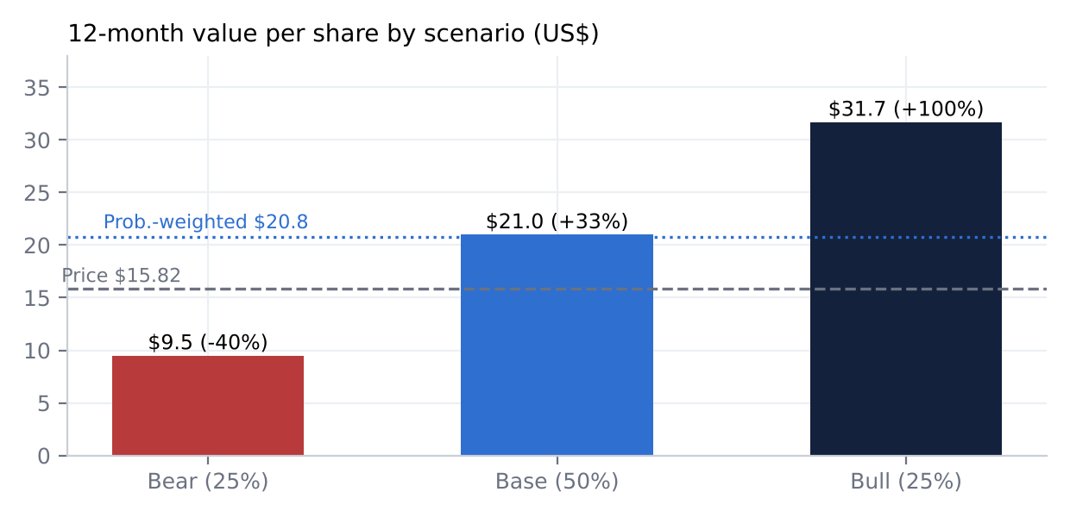
Scenario values

23. Fifteen questions for the CEO / Chairman (ordered by information value)
- The PC margin recovery date moved from “next year” to “mid-2027”. Exactly which levers (volume back on the demand curve, promotions, marketing, network rationalisation) get you there, and what PC margin will the 2027 guide embed?
- How large is the non-returning cohort in accounts and pre-incident spend, and what evidence do you have on where that spend went?
- Quantify the December-2026 settlement-period rules: how much of the US$6.3bn of payables is marketplace settlement float, and what is the cash impact in 2027?
- Why fund US$850m of H1’26 buybacks alongside a US$750m revolver draw when TTM FCF is ~US$0.1bn? What leverage and FCF guardrails govern the remaining US$907m?
- What are the break-even timeline, the investment cap and the kill criteria for Taiwan, and what return hurdle do you apply to Developing Offerings capital?
- If the KFTC forces Eats out of WOW, what happens to WOW retention and Eats volume, and what is your contingency?
- When will Coupang Corp. have a permanent Korean CEO? What does the regulatory “designation” concerning you personally mean for your role?
- What share of volume is Dawn Delivery, and how would you re-engineer the network under a night-delivery ban?
- Is the 10%+ long-term adjusted EBITDA margin target still valid? Why has it not been restated since the incident?
- What is the all-in cost of the incident (vouchers, fines, marketing, security), and what residual exposure remains from US and Korean litigation?
- Why is the ~US$208m NTS transfer-pricing claim unreserved, and does the CFS / Coupang Corp. structure need to change? What does it mean for the effective tax rate?
- What insurance cover applies to the ~US$246m Incheon fire exposure, and when do you expect recoveries? Is Q4 peak capacity constrained?
- How do you measure wallet-share recapture against Naver’s Plus / Kurly / CJ Logistics alliance and the Chinese platforms? Is further price investment needed?
- Will you consider a Class B sunset or succession disclosures? Do you intend to sell further shares after the 15m-share plan?
- With Uber consolidating Baemin and Grab buying Foodpanda Taiwan, would you consider partnerships or separations for Eats, Farfetch or Taiwan to crystallise value?

24. The short-seller’s case (forensic and adversarial)
What could structurally break how Coupang makes money?
- The economics depend on three things: a regulator tolerant of overnight labour, bundled memberships, and long settlement terms.
- Each is now in play: night-delivery ban (#861), Eats-WOW bundling (#2008), and the EFTA / Large-Scale Retail Business Act reforms (#619).
- Remove the payables float and the business needs external capital to grow.
Concentration
- Over 90% of revenue is in Korea (#1858). Product Commerce is ~86% of revenue and more than 100% of adjusted EBITDA.
- A single country’s consumer mood, regulator and currency drive the entire equity.
- If Korean shoppers’ default shifts to Naver’s ecosystem (search, then membership, then delivery), there is no second leg. Taiwan and Farfetch are loss-making or marginal.
Why the moat is weaker than bulls think
- Switching costs are behavioural, not contractual.
- Naver gained members and GMV within weeks of the breach (#298).
- Coupang needed promotions and marketing to win customers back (#420).
- Regulation works against incumbency.
The most dangerous competitor: NAVER
- It owns the top of the funnel (search and price comparison), payments and a membership with Netflix.
- It now delivers dawn grocery via Kurly and CJ Logistics without Coupang’s capex (#321, #326).
- Bulls underestimate it because they benchmark Coupang against retailers, not against the traffic gatekeeper.
Worst capital allocation
- About US$1bn a year of Developing Offerings losses (#56).
- The Japan v1 exit (#72).
- Debt-funded buybacks at ~US$27.6 in 2025 and ~US$19.5 in 2026, against a price now of US$15.82.
- The Greenoaks buyout at ~US$122-140m against US$70m contributed (#1956, #2052).
Related parties, accounting and incentives
- Greenoaks. Director Mehta is its Managing Partner (#2050).
- The “administrative fines” add-back. It is new in 2026 and judgment-based, despite a recurring pattern of fines (#339).
- Vouchers. US$1.2bn was netted against revenue with no accrual at announcement (#16).
- SBC. US$475m in FY25, more than net income, with US$973m unvested (#1886).
- Insider selling plans after the breach. CFO, GC and CAO adopted plans in March-May 2026 (#300, #303, #294).
- Founder selling. Bom Kim adopted a 15m-share plan in 2024 (#311).
What must hold for today’s price [d]. At US$15.82 the EV is ~US$28bn. Assume ~10% revenue CAGR to ~US$54bn in 2030, 20x terminal FCF and a 10% discount rate. Coupang then needs a ~3.8% FCF margin by 2030. That is a return to FY23-24 levels (7.2% and 3.3%), against 0.3% today.
If growth disappoints by 20-30% [d]
Scenario | Revenue CAGR | 2030 revenue | 2030 FCF margin | Implied value per share | Change
Growth -20% | 8% | ~US$50bn | 3.8% | ~US$14.5 | -8%
Growth -30%, margin also slips | 7% | ~US$48bn | 3.0% | ~US$11 | -30%
The stock is far more sensitive to margin than to growth.
The single scenario that would permanently impair the business. A Korean regulatory package that simultaneously:
- bans night deliveries;
- forces membership unbundling;
- shortens settlement terms; and
- reclassifies delivery partners as employees.
That combination would convert Coupang into a low-margin, capital-hungry retailer worth ~0.4-0.5x sales (~US$8-10 a share). Plausibility: low to moderate (~10-15%). Each element exists today, but the full combination would require a political shift against a 100,000-plus employer at a time of weak consumption.

25. Forensic accounting review: red flags
Area | Statement | Finding | Severity | Evidence
Revenue recognition | IS | ~US$1.2bn of vouchers booked as reduced revenue on redemption; no liability accrued at announcement; amount redeemed not disclosed | Medium | #16, #1761
Revenue recognition | IS | Gross (1P) vs net (3P/FLC) mix shifts distort growth (the 2023 FLC net change cost ~520bp of growth); supplier ad payments reduce COGS | Low-Medium | #28, #1745
Segment reporting | IS | New “administrative fines” add-back (US$410m); costs allocated “based on usage”; no segment assets; Farfetch inside DO | High | #339, #1868
Leases | BS | US$3.03bn of operating leases (more than funded debt) plus US$689m signed but not commenced; the Incheon fire was at a leased FC, so ROU impairment is possible | Medium | #1931, #470
Related parties | BS/IS | Greenoaks: contributed US$70m, absorbed ~US$88m of FY24 losses, bought out for US$122m at fair value (US$140m at VWAP) | Medium | #1956, #2052
Contingencies | BS | PIPC US$410m accrued but unpaid; NTS ~US$208m unreserved; KFTC bundling case with no estimate; US class actions with no estimate; criminal complaints against executives | High | #463, #345, #452, #465
Stock-based compensation | IS/CF | US$475m in FY25, more than net income; Q2’26 US$161m; US$973m unvested; 386m shares available; evergreen to 2031 | Medium | #1886
Goodwill / intangibles | BS | Farfetch recorded with goodwill (no bargain gain); intangibles US$167m; no impairment disclosed; small | Low | #2040
Taxes | IS/BS | US$905m VA release (2023) drove FY23 profit; DTA of ~US$0.6bn at risk if Korean losses persist; VA US$1.3bn; NOLs US$4.7bn | Medium | #1901, #1905, #1174
Working capital | BS/CF | CCC about -57 days; supplier finance US$430m; settlement-rule exposure; FX moves cash (-US$564m in FY24) | High | #366, #619
Cash flow quality | CF | FCF from US$1,756m (FY23) to ~US$99m LTM; buybacks of US$1,093m over the same LTM; Q4’25 CFO only US$82m | High | CFO FY25 US$1,773m, #188
Internal controls | — | Material weaknesses pre-2022; inherited Farfetch material weakness “resolved” by divestiture, not remediation; no auditor change (Samil PwC) or restatement | Low-Medium | #1671, #1680
Disclosure consistency | — | Revolver maturity text out of date in the FY25 10-K; “US$0.3bn available” does not reconcile with capacity | Low-Medium | #2064, #130
Insurance gains | IS | US$175m Deokpyeong insurance gain booked in Q4’24 COGS and OG&A flattered FY24 margins | Low-Medium | #1340

26. Timeline of key events and catalyst calendar

26.1 Key past events
Date | Event | Source
2010 | Coupang founded (S&P founding date) | S&P company info ‡
~2014 | Rocket Delivery launched (“over 10 years ago”) | #31
11/15-Mar-2021 | NYSE IPO: 100m shares at US$35 | #1284
17-Jun-2021 | Deokpyeong FC fire | #1724
Jun-2021 | KFTC investigation of Coupang Corp./CPLB opened | #1991
Q2’22 / Q3’22 | First positive adjusted EBITDA; first net profit | #156, #80
Q1’23 | Japan v1 exited | #72
30-Jan-2024 | Farfetch acquisition closed | #2035
Apr-2024 | 10m-share private buyback from Maverick | #0
May-Aug 2024 | WOW fee increase | #248
12-Jun / 7-Aug-2024 | KFTC search-ranking decision; US$121m fine | #0, #0
7-Apr-2025 | Greenoaks stake buyout | #1
6-May-2025 | First US$1bn buyback authorised | #296
Jun-2025 | New US$1.5bn RCF | #0
10-Sep-2025 | IPO class action dismissed (appealed 10-Oct-2025) | #407
18-Nov-2025 | Data incident discovered (up to 33m accounts) | #0
10-Dec-2025 | Coupang Corp. CEO resigns | #10
Dec-2025 | ~US$1.2bn voucher programme announced | #1339
6-Jan-2026 | US securities class action filed | #415
5-May-2026 | Q1’26 loss; further US$1bn buyback authorised | #140
10-Jun-2026 | PIPC fines of ~US$278m + ~US$132m | #0
Jun-2026 | NTS audit claim of ~US$208m | #345
Jul-2026 | Incheon FC fire (~US$246m exposure) | #470
16-Jul-2026 | Uber offer for Delivery Hero (Baemin) | #1089
4-Aug-2026 | Q2’26 results; margin recovery guided to mid-2027 | #220

26.2 Upcoming catalysts
Expected date | Catalyst | What to watch | Importance
3-Nov-2026 | Q3’26 results (listed upcoming) | Guide: +8-9% cc revenue, -300 to -400bp margin; first Incheon fire losses; buyback pace | High
Q4-2026 (date n.a.) | KFTC Eats-WOW bundling decision (hearing tentatively Sep-2026) | Fine and/or forced unbundling | Critical
Dec-2026 | EFTA settlement-fund rules start (≥60% external custody); settlement periods shortened | Payables and cash impact | High
“Towards end of 2026” | 2027 guidance | PC margin path; DO losses; capex | High
Pending | PIPC written decisions; appeal to the Seoul Administrative Court; payment of ~US$410m | Final amounts; cash outflow | Medium
Pending | NTS transfer-pricing assessment | Reserve or settlement | Medium
Pending | KFTC search-ranking appeal (Seoul High Court); criminal trial | Possible refund of US$121m; criminal outcome | Medium
H2-2026 | Grab / Foodpanda Taiwan TFTC review; Uber / Delivery Hero tender process | Competitive structure in Taiwan and Korean food delivery | Medium
Late Feb-2027 [e] | Q4’26 results and FY2027 outlook | WOW / active-customer disclosure | High
H1-2027 | Incheon insurance recoveries | Gains | Low-Medium
~Jun-2027 [e] | AGM | Board composition (Warsh contingency) | Low
Mid-2027 | Management’s PC margin normalisation milestone | Delivery vs promise | Critical
Ongoing | Night-delivery legislation; US class actions; KRW/USD |  | Medium

27. The newsletter’s claims: verification (“A temporary glitch?”, Asian Century Stocks, 11-Oct-2026)
Claim | Verdict | Evidence
Founded by Bom Kim; initially a Groupon-style deals site; HBS dropout | Founder verified; origin story and education [u] | #1181
~28% share of Korean e-commerce | [u]. Not in S&P/ProntoNLP; the CEO says “a small share” | #355
Cohort chart among the strongest; each cohort spends more each year | Verified | #69
WOW at KRW7,890/month; price rise in 2024 slowed growth; ≥14m members | 2024 rise verified; KRW price [u]; 14m verified as end-2023 | #248, #41
~78m sq ft of logistics infrastructure; 108,000 employees | Verified: >78m sq ft; S&P lists 108,000 employees ‡ | #1295
~100% of Korea within 10km of a Coupang centre by 2027 | [u]. Not found | n/a
Five tenets incl. long-term FCF and return-on-capital mindset | Partly verified | #28, #116
Bom Kim controls 100% of Class B at 29x votes | Verified; 74.1% of voting power | #1181, #1187
US$26bn market cap | ~US$25-28.5bn depending on date and share count (ProntoNLP market-cap field US$24.9bn; our price × diluted shares US$28.5bn) | ProntoNLP ‡
“Glitch or lasting change?” | Our view: a glitch for customers; a lasting change for regulatory intensity and the cash model. Net, mispriced to the downside | This report

Appendix: methodology and data notes
- Sources. S&P Global Capital IQ (via the S&P Deterministic Retrieval MCP) supplied financial statements and line items for Coupang, 15 listed peers and transaction targets. ProntoNLP MCP supplied transcripts, SEC and non-SEC filings, prices, consensus, sentiment analytics and peers. No web searches or other sources were used. Five parallel research agents queried ProntoNLP and S&P; their notes and tool logs are summarised in the provenance document.
- Price data. ProntoNLP price series return no source links (‡). The reference price is the 9-Oct-2026 close. EV uses S&P Q2’26 net debt including leases (-US$477m) and diluted weighted shares (1,799m).
- FX. No FX rates are available from the connectors. Chinese ADR peers use CNY7.10/US$ and HKD7.80/US$ [e]. KRW, JPY, EUR and PLN peers are valued in local currency, so no FX is needed for multiples. USD market caps use FX implied by ProntoNLP’s USD vs local market-cap fields [d].
- Consensus. ProntoNLP consensus is used for historical beats and misses only. Forward 3Q26/4Q26 entries are stale (dated March 2025) and are not used.
- Limitations. Proxy contents (executive pay, the beneficial-ownership table), 13F/13G data, short interest, news-driven causes of market-wide moves, and Korean industry deal values are not available through the connectors. These are flagged ‡ or [u] where relevant.
This report is for professional investors. It is not investment advice. Figures marked [e] are the analyst’s estimates and rest on assumptions that may prove wrong.

