LG Uplus Corp. (032640 KS)
Institutional equity research: a ~2x-EBITDA telecom core with an AI data-centre platform attached
Event-Driven & Special Situations | Equity Research
17 October 2026 | Reference price KRW15,510 (close 16-Oct-2026)

Recommendation and key data
Recommendation: BUY (event-driven, medium conviction). 12-month target price KRW20,000 (+29%); probability-weighted value KRW20,800 (+34%); bear case KRW13,000 (-16%); bull case KRW29,800 (+92%). The 4.5% dividend yield adds to the total return.
Item | Value | Item | Value
Share price (16-Oct-2026) | KRW15,510 | 52-week closing range | KRW14,000–17,810
Shares outstanding | 424.43m | Market cap | KRW6.58tn / US$4.9bn
Net debt (ex-leases, Jun-26) | KRW4.51tn | TEV (S&P Capital IQ) | KRW11.29tn / US$8.5bn
TEV / FY26E EBITDA (ours) | 2.9x | P/E FY26E / FY27E (ours) | 9.5x / 8.8x
P/B (LTM) | 0.73x | FY26E DPS / yield | KRW700 / 4.5%
Net debt / LTM EBITDA | 1.22x | Shareholder yield FY26E (div + buyback) | 5.9%
Largest holder | LG Corp 38.7% | Foreign ownership / statutory cap | ~41.9% / 49%
Consensus target (22 analysts) | KRW18,964 | Ratings (Buy/Outperform/Hold/Sell) | 9 / 7 / 6 / 0
Sources: S&P Capital IQ (prices, financials, estimates), company filings (DART via ProntoNLP), company earnings calls. [u] = unverified (single secondary source or search summary); [e] = our estimate. US$ at KRW1,335/US$ (Capital IQ spot, 17-Oct-2026).

Investment summary
- The market prices LG Uplus as an ex-growth telco at 2.9x FY26E EBITDA, the second-lowest multiple among 30 listed telecom peers (median 7.2x). That is broadly in line with KT (3.2x) and with LG Uplus’s own five-year average (3.1x), so the discount is a Korea-wide phenomenon rather than company-specific distress.
- What the multiple ignores is a data-centre (IDC/AIDC) business growing ~30% a year. IDC revenue was ~KRW422bn in FY25 [e] and KRW124bn in 2Q26 (+29% YoY). On top of that sits the 200MW Paju AI data-centre campus (first 50MW building due Jun-2027 and reported fully pre-leased [u]). In August 2026, KKR and IMM paid KRW3.08tn for 49% of SK Telecom’s data-centre carve-out (SK Horizon), roughly 14.6x trailing sales [e]. Valuing LG Uplus’s IDC at only 8x sales (a 45% discount to that mark) implies the telecom core trades at ~1.8x EBITDA.
- Earnings are inflecting on the end of the 5G capex cycle and cost reset. Capex fell from KRW2.51tn (FY23) to ~KRW1.75tn (FY25). The KRW150bn early-retirement programme in 3Q25 removed ~6% of headcount. 1H26 operating profit rose 10% YoY to KRW617bn, and 2Q26 OP was a record KRW344.5bn (9.0% above consensus, although ~KRW20–25bn was one-off).
- Capital returns are credible and rising. The KRW100bn (2021) and KRW80bn (2025–26) buybacks have been cancelled, and a KRW90bn programme runs to 13-Feb-2027. FY26 interim DPS rose 8% to KRW270. Domestic ratings were upgraded to AA+ in Feb–Mar 2026, the first upgrade in 13 years. LG Uplus also qualifies as a “high-dividend company” under Korea’s 2026 separate dividend-tax regime [u].
- Event path. The catalysts we expect, in order of likelihood:
  - Continued buyback cancellations and payout drift to the 60% ceiling.
  - Possible MSCI Korea deletion flows on 30-Nov-2026 [u], which offer a better entry point rather than a thesis risk.
  - An AIDC minority sale or carve-out on the SK Horizon template.
  - LG HelloVision simplification.
  - A first-ever minority-shareholder campaign once mandatory cumulative voting applies to large Korean companies [u].
- What could make us wrong.
  - A large privacy-regulator (PIPC) fine or licence sanction over the 2025 hacking case, in which LG Uplus is under police investigation for wiping servers before the probe.
  - A subsidy war after the July-2025 abolition of the handset-subsidy cap.
  - The ~KRW2tn Paju AIDC programme failing to lease up beyond building 1.

Our estimates vs consensus
KRW bn (Dec YE) | FY2024A | FY2025A | FY2026E | FY2027E | FY2028E
Revenue | 14,625 | 15,452 | 15,329 | 15,591 | 15,955
EBITDA | 3,527 | 3,589 | 3,904 | 3,945 | 4,058
Operating profit (EBIT) | 863 | 892 | 1,137 | 1,185 | 1,268
OP margin | 5.9% | 5.8% | 7.4% | 7.6% | 7.9%
Net income (to parent) | 374 | 524 | 694 | 731 | 789
EPS (KRW) | 871 | 1,221 | 1,641 | 1,756 | 1,927
Consensus EPS (KRW) | – | – | 1,733 | 1,922 | 2,079
Ours vs consensus | – | – | -5% | -9% | -7%
DPS (KRW) | 650 | 660 | 700 | 740 | 780
P/E at KRW15,510 | 17.8x | 12.7x | 9.5x | 8.8x | 8.0x
Actuals: S&P Capital IQ, consolidated K-IFRS. Estimates: ours [e]. Consensus: S&P Capital IQ, 16-Oct-2026. We are below consensus on earnings: we assume a higher tax rate (25% vs ~23%), recurring non-operating losses and less operating leverage. Our upside case therefore rests on asset value, not on an earnings beat.

A layman’s guide to LG Uplus
What it is. LG Uplus (“LG U+”) is South Korea’s third-largest mobile operator and one of its three big telecom companies, alongside SK Telecom and KT. It is controlled by LG Corp, the holding company of the LG Group. It sells phone plans, home internet and IPTV to households, and network, data-centre and AI services to businesses. Virtually all its revenue is earned in Korea.
How it makes money. Think of it as a toll road for data. LG Uplus spends heavily up front on licences to use radio spectrum, base stations, fibre and data centres. It then collects monthly subscriptions from millions of customers, mostly by automatic bank or card debit. Most costs are fixed (depreciation, network upkeep, staff), so each extra subscriber or price increase falls largely to profit. The main recurring variable cost is marketing: handset subsidies and commissions paid to the dealers who sign customers up. The company also sells handsets (mostly Samsung and Apple) at low margin, which inflates revenue but adds little profit.
How each division contributes (FY2025).
Division | What it sells | FY25 revenue (KRW bn) | Share of revenue | Profit contribution and trend
Mobile service | Mobile plans (5G/LTE), roaming, IoT lines, wholesale to budget operators (MVNOs) | 6,371 | 41% | The profit engine. Growing ~2–4% a year; 85% of handset users now on 5G.
Smart Home | IPTV (U+tv) and broadband internet | 2,590 | 17% | Steady +3–4% a year. Broadband growing, IPTV flat.
Enterprise infrastructure | Business lines, solutions, AI call centres, IDC/AI data centres | 1,808 | 12% | The growth division. IDC/AIDC +18% in FY25 and +29% in 2Q26; the highest incremental returns.
Telephony, interconnection, LG HelloVision and other | Fixed voice, fees from other carriers, cable TV (58.6%-owned LG HelloVision) | 1,489 | 10% | Shrinking or flat. LG HelloVision is barely profitable.
Handset sales | Phones sold to subscribers | ~3,194 [e] | 21% | Low margin; swings with phone launch cycles.
Total |  | 15,452 | 100% | EBITDA KRW3.59tn (23.2%); operating profit KRW892bn (5.8%)
Source: company Q4-25 earnings call and DART product tables; handset figure derived as total minus service revenue [e]. Service lines are on the standalone management basis, so rows are indicative.
In one sentence: LG Uplus is a cash-generative, regulated, three-player utility. Its value hinges on keeping its ~20% handset share, holding marketing at ~20% of service revenue, and turning a fast-growing data-centre business into something the market will pay for.

Business model, products, customers, suppliers and competitors

Business model in simple terms
- Recurring subscriptions (~79% of revenue). These are monthly fees for mobile, broadband and IPTV, typically sold on 24-month contracts. Customers choose between a handset subsidy or a 25% tariff discount (the “selective agreement” discount) [u: industry practice]. Bundles (mobile + broadband + IPTV) raise switching costs.
- Handset resale (~21% of revenue). Phones are sold for cash or on 24/36-month instalments. LG Uplus regularly sells the instalment receivables to securitisation vehicles (“U+5G No. xx”). The latest was No. 88 in Aug-2026 for KRW239.9bn, and the programme runs at about KRW1.5tn a year [e].
- Enterprise and wholesale. This covers leased lines, solutions, AI contact-centre (AICC) software and colocation. AIDC revenue has two parts: space rental, where unit prices are rising, and electricity passed through on usage. LG Uplus also hosts ~9.0m budget-operator (MVNO) lines on its network and earns interconnection fees from SK Telecom and KT.

Key products and services
Product / service | Description | Scale (latest)
Mobile (MNO) | 5G/LTE plans under U+, “Simply 2.0” tariff simplification (53 plans cut to 17–18) | 22.4m MNO lines, of which ~11m handsets [e]; 84.9% 5G penetration; 31.5m total lines including MVNO (2Q26)
MVNO hosting | Wholesale access for U+ Mobile (Media Log), Hello Mobile (LGHV), KB Liiv M, Toss Mobile and others | 9.0m hosted lines
Smart Home | U+tv IPTV (Netflix, Disney+ and TVING integrations); gigabit broadband | IPTV 5.76m; broadband 5.64m subscribers (1Q26)
Enterprise infrastructure | Leased lines, solutions, AICC, IDC/AIDC (Pyeongchon, Gasan DBO, Paju) | KRW464bn revenue in 2Q26 (+8.6%), of which AIDC KRW124bn (+28.9%)
AI services | ixi-O on-device AI call agent (voice-phishing detection, call summaries; Google Gemini); ixi-GEN sLLM on LG’s Exaone | ixi-O >1m users (FY25); AICC revenue +30% in FY25
LG HelloVision (58.6%) | Cable TV, broadband, Hello Mobile MVNO, rentals | FY25 revenue KRW1.27tn; operating profit KRW18.7bn

Customers, contracts and payment terms
- Consumers (~11m handset subscribers and ~5.6m broadband households) pay monthly in arrears by auto-debit or card. Contracts are usually 24 months. Early-termination fees apply, and the government can order them waived after a security failure, as it did for KT in Dec-2025/Jan-2026.
- Dealer commissions are capitalised as contract-acquisition costs and amortised over the expected contract life, with claw-back on early churn. This is why marketing expense lags subscriber wars by several quarters.
- Enterprises and government. Named customers include KB Financial, Shinhan Bank and Woori Card (AICC/AI voice bots), Hyundai/Kia/Genesis and Toyota/Lexus (connected car), KG Mobility, public-sector leased-line users and the K-Square Gasan data centre (design-build-operate (DBO) contract). Contracts carry volume/term discounts and service-level guarantees. Colocation contract terms are not disclosed. Paju building 1 is pre-let to tenants whose names have not been disclosed [u].
- Concentration is low by customer and absolute by country: ~100% of revenue is domestic. Revenue is, however, exposed to a single regulator (the Ministry of Science and ICT, MSIT) and to the pricing behaviour of two rivals.

Suppliers and competitors
- Suppliers.
  - Network equipment: Huawei (5G radio in Seoul, northern Gyeonggi and parts of Gangwon), Samsung Electronics Networks, Nokia and Ericsson-LG.
  - Handsets: Samsung Electronics and Apple.
  - Content: Netflix, Disney+, TVING/CJ ENM and the terrestrial broadcasters.
  - IT services: LG CNS, a related party, took ~KRW501bn of LG Uplus spend in 2024 [u], about 3.4% of revenue.
  - Facilities and advertising: D&O and HS Ad.
  - Power: KEPCO.
  - Spectrum: licensed from MSIT.
- Competitors.
  - SK Telecom (#1, with SK Broadband) and KT (#2, with KT Skylife and KT Cloud).
  - Bank and fintech MVNOs (KB Liiv M, Toss Mobile, Woori WON Mobile) operating on all three networks.
  - Cable operators (D’Live, CMB).
  - In data centres: KT Cloud, SK Broadband/SK Horizon, Samsung SDS, Naver Cloud, LG CNS, Equinix and Digital Realty.

Key markets and geographies
Korea accounts for effectively 100% of revenue and non-current assets. Overseas revenue is immaterial (e.g. DACOM America, KRW0.9bn in 1H26). The ixi-O AI agent is being exported as software-as-a-service (SaaS), including to Maxis in Malaysia. The mobile market is a mature three-player oligopoly. On MSIT total-line data (including IoT, excluding MVNO), SK Telecom holds ~42.5%, LG Uplus ~29.8% and KT ~27.7% (Mar-2026). On handsets only, LG Uplus’s share is about 21%.

Key business drivers
Driver | Mechanism | Current direction
Volume (lines) | Net adds from number portability, IoT and MVNO hosting | Positive. MNO lines +7.2% YoY (2Q26), helped by rivals’ security breaches (SKT Apr-25, KT 2025–26)
Price / ARPU | Tariff mix, 5G upgrades and the selective 25% discount | Flat to slightly down. 5G penetration is near saturation (~85%) and the government favours “mid-tier” and lower-cost plans
Mix | Gigabit broadband, premium IPTV, AIDC and AICC | Positive. Giga-tier is 33% of broadband; AIDC +29%
Marketing intensity | Subsidies and commissions (capitalised and amortised) | ~20% of service revenue. The risk is a subsidy war after the July-2025 abolition of the subsidy-cap act (Dansuobeop)
Capex cycle | 5G build (2019–23) → normalised (2024–25) → AIDC (2026–28) | Network capex is down; AIDC capex is up to ~KRW2tn in total over 2025–28
D&A | Lagged capex and spectrum amortisation | Has peaked as a share of revenue; flat in absolute terms to FY28E in our model
Regulation | Spectrum fees, tariff pressure, subsidy rules, privacy fines and foreign-ownership cap | Mixed. 2026 3G/LTE re-allocation (~KRW2.9–3.1tn for the industry [u]); the PIPC case is open
Interest rates | ~KRW5.8tn gross debt; average cost ~3.6–3.7% | Bank of Korea hiked in Jul and Aug-2026 (to ~3.0% [u]). Refinancing costs are drifting up modestly
Labour | ~9,800 standalone staff; ordinary-wage ruling (4Q24) | Early-retirement savings in 2026; wage inflation of ~3–4% a year

Supply chain map
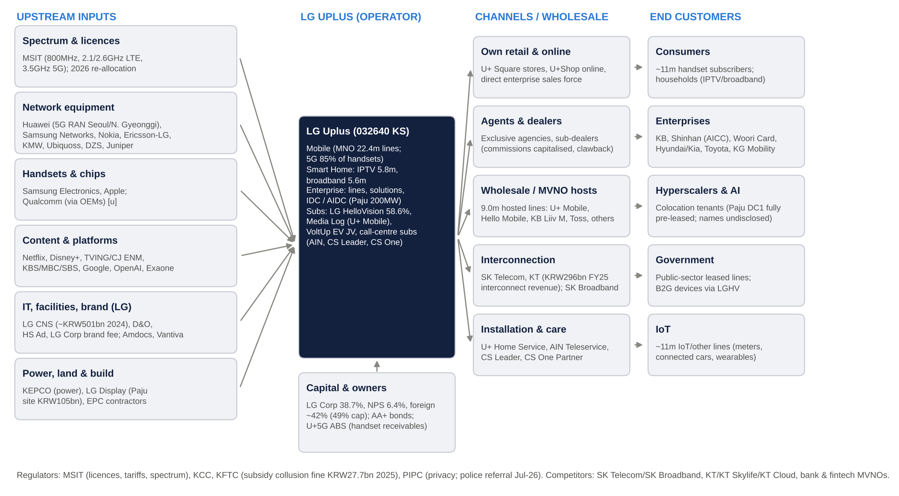
LG Uplus supply chain: from upstream inputs to end customers
Stage | Stakeholders (named) | LG Uplus’s position and leverage
Spectrum & licences | MSIT (800MHz, 2.1/2.6GHz LTE, 3.5GHz 5G; 2026 re-allocation of 370MHz across the industry, of which LG Uplus 100MHz) | Price-taker. Fees are paid in instalments and bank-guaranteed (KB, Woori)
Network equipment | Huawei, Samsung Electronics Networks, Nokia, Ericsson-LG, KMW, Ubiquoss, DZS, Juniper | Moderate leverage. Multi-vendor; the Huawei dependence is a geopolitical overhang
Handsets & chips | Samsung Electronics, Apple (Qualcomm via the handset makers) | Weak leverage. Handsets are near pass-through
Content & platforms | Netflix, Disney+, TVING/CJ ENM, KBS/MBC/SBS, Google, OpenAI, LG AI Research (Exaone) | Moderate. Exclusivity value has faded
IT, facilities, brand | LG CNS, D&O, HS Ad, LG Corp (brand fee up to 0.2% of sales less advertising; ~KRW25–28bn a year [e]), Amdocs, Vantiva | Related-party heavy; reviewed by the internal-transactions committee
Power, land, construction | KEPCO; LG Display (sold the Paju site for KRW105.3bn); EPC contractors | AIDC power cost is passed through to tenants
Capital | LG Corp, NPS, foreign institutions; bond investors (AA+); ABS investors (handset receivables) | Investment grade; ample access
LG Uplus (operator) | Mobile, Smart Home, Enterprise/AIDC; subsidiaries LG HelloVision, Media Log, VoltUp, call-centre and installation subsidiaries (AIN Teleservice, CS Leader, CS One Partner, U+ Home Service) | Owns the network, customer relationship and billing
Channels & wholesale | U+ Square stores, U+Shop online, exclusive agencies and sub-dealers; MVNOs (U+ Mobile, Hello Mobile, KB Liiv M, Toss Mobile); interconnection with SK Telecom and KT | Controls own retail; dealers are commission-driven
End customers | Consumers, enterprises (KB, Shinhan, Woori Card, Hyundai/Kia, Toyota), hyperscale/AI colocation tenants, government, IoT | Fragmented. No customer is material
Regulators | MSIT, KCC, Korea Fair Trade Commission (KFTC), Personal Information Protection Commission (PIPC) | High regulatory dependence

Macro and micro factors: tailwinds and headwinds
Macro.
- Rates. The Bank of Korea raised rates in July and August 2026 after inflation reached 3.2% [u]. The next decision is on 22-Oct-2026.
- Equity market. After a speculative rally, the KOSPI fell ~22% in early October 2026 (KODEX 200 proxy). LG Uplus has behaved as a negatively correlated defensive.
- Policy. The government favours lower household telecom bills, but it has also pushed “value-up” reforms: Commercial Act amendments that extend directors’ duty to shareholders, mandatory cumulative voting [u] and separate taxation of dividends for high-payout companies from 2026.
- Capital flows. Korea remains an MSCI Emerging Market (reviewed Jun-2026). Telecom foreign-ownership caps limit passive weights.
Micro.
- Competition. Rivals have suffered repeated security breaches: SKT’s USIM hack (Apr-2025, PIPC fine KRW134.8bn) and KT’s femtocell breach (PIPC fine KRW54.0bn, Jul-2026). After KT waived termination fees, it lost >238k subscribers [u].
- Cost and investment. The 5G cycle is over and AI data-centre demand is strong. LG Uplus has also cut ~600 staff and simplified tariffs.
- Own security exposure. LG Uplus has its own open hacking case (the APPM server, reported by Phrack in Aug-2025).
Tailwinds | Headwinds
End of the 5G capex cycle; capex/sales 11–14% vs 17% in FY21–23 | Government pressure on tariffs (mid-tier 5G, “data safety-net” plans)
AI data-centre demand; Paju 200MW; SK Horizon valuation mark | Post-Dansuobeop subsidy competition; marketing amortisation lag
Value-up regime: cancellations, dividend-tax reform, Commercial Act | PIPC fine and police probe; possible new evidence-destruction penalty (up to 3% of revenue proposed [u])
Competitors’ breaches drive share gains (MNO lines +7% YoY) | 2026 3G/LTE spectrum re-allocation fees; 5G re-allocation in 2028
Labour reset (early retirement) and digital channels | Rising rates (BoK hikes) on ~KRW5.8tn of debt
AA+ ratings (Feb–Mar 2026); falling leverage (D/E 114%) | Foreign-ownership cap; MSCI/S&P index deletions reduce passive demand
High-dividend status attracts domestic income investors | Bank and fintech MVNOs compress low-end pricing; LG HelloVision decline

Strength of products and services, and economic moats

Product strength vs competitors
- Network and perceived value. LG Uplus has historically been the value challenger: cheaper tariffs, the first IPTV partner for Netflix (2018) and exclusive IPTV partner for Disney+ (2021), and aggressive MVNO hosting. Network quality is broadly at parity in major cities. However, LG Uplus built far fewer 5G base stations early on (~4.3k vs 18.6k at SKT and 12.1k at KT in Jan–Aug 2021 [u]), and its 3.5GHz holding was the narrowest until it won an extra 20MHz (3.40–3.42GHz) for ~KRW152bn [u].
- Branding. The “LG” brand is strong in consumer electronics but carries less premium in telecom than SK Telecom’s “T”. Both rivals’ brands were damaged in 2025–26: SKT’s USIM leak covered 23.2m subscribers, and KT’s femtocell breach led to a fee waiver. LG Uplus gained share from both, but its own reputation is exposed. It had a 2023 leak (~297k records; KRW6.8bn fine), DDoS outages, and the 2025 APPM case in which servers were reformatted before the investigation.
- Marketing. Marketing runs at ~20% of service revenue (FY25 KRW2.31tn), down from 22.5% in FY21. LG Uplus pushes digital/online channels and the ixi-O AI call agent as a retention tool. Rivals spend more in absolute terms. LG Uplus’s churn (~1.0% a month in 4Q25 [u]) is now among the lowest in its history.
- Enterprise/AIDC. Paju (200MW power, 128MW IT load, 200kW/rack liquid cooling) is the largest hyperscale campus under construction in the Seoul metro area. Building 1 is reportedly fully pre-let [u]. LG Uplus competes for colocation and DBO work against SK Broadband/SK Horizon, KT Cloud, Samsung SDS and LG CNS, its own sister company.

Moat assessment
Category | Rating | Evidence
Brand | Moderate | “LG” is trusted, but there is no telecom pricing premium. Value positioning; security incidents in 2023 and 2025 dent trust
Hard assets | Strong | Nationwide 5G/LTE network, fibre, ~KRW10.4tn net PP&E, spectrum licences, Paju 200MW site (land bought from LG Display)
Long-term contracts | Moderate | 24-month consumer contracts with termination fees; enterprise multi-year SLAs; AIDC pre-lets (terms undisclosed). Contracts can be voided by regulators (KT waiver precedent)
Network effect | Weak | No on-net pricing advantage; number portability since 2004; MVNO wholesale open to all
Regulatory & switching costs | Moderate–Strong | Spectrum licensing limits entry: the 4th-carrier attempts failed and the 28GHz licences were revoked [u]. Switching costs come from bundles, handset instalments and family plans, but government-ordered fee waivers can collapse them
Oligopolistic structure | Strong | Three facilities-based MNOs; a merger or new entry is near-impossible (antitrust, spectrum); the KFTC fined all three for subsidy collusion
Cash-flow predictability | Strong | ~79% recurring service revenue; EBITDA KRW3.4–3.6tn every year since FY21 (24–25% margin); dividends never cut
Scalability | Moderate | High fixed-cost operating leverage, but growth is capped by population and pricing; AIDC is scalable but capital-intensive
Risk / history of government interference | High risk (negative) | Tariff interventions (25% discount in 2017; mid-tier 5G 2022; “data safety-net” 2025–26), subsidy rules, spectrum fees, foreign-ownership cap, privacy fines, fee waivers
Bargaining power over stakeholders | Moderate | Strong over dealers and MVNOs; weak over Apple and Samsung, regulators and content owners; limited over unions (ordinary-wage ruling)
Net assessment. The moat is real but regulatory in nature. It is a licence-protected three-player structure with sticky households, and it produces stable, utility-like cash flows. Returns are capped (ROIC ~4–6%) because the state treats telecom as a public good. The company’s best opportunity to earn above its cost of capital is outside the regulated core, in AIDC.

Historical financial performance (FY2021–FY2025, 1H26)

Consolidated income statement summary
KRW bn | FY2021 | FY2022 | FY2023 | FY2024 | FY2025 | 1H26 | LTM 2Q26
Revenue | 13,851 | 13,906 | 14,373 | 14,625 | 15,452 | 7,499 | 15,358
YoY growth | 3.2% | 0.4% | 3.4% | 1.8% | 5.7% | -1.2% | –
Service revenue (consolidated) | 11,068 | 11,411 | 11,636 | 11,843 | ~12,258 [e] | ~6,112 [e] | –
EBITDA (OP + D&A) | 3,420 | 3,532 | 3,569 | 3,527 | 3,589 | 1,994 | 3,684
EBITDA margin | 24.7% | 25.4% | 24.8% | 24.1% | 23.2% | 26.6% | 24.0%
D&A | 2,441 | 2,451 | 2,571 | 2,664 | 2,697 | 1,377 | 2,735
Operating profit (EBIT) | 979 | 1,081 | 998 | 863 | 892 | 617 | 949
OP margin | 7.1% | 7.8% | 6.9% | 5.9% | 5.8% | 8.2% | 6.2%
One-off items in OP | – | – | – | Ordinary-wage charge (4Q) | ERP -150 (3Q) | ~+20–25 (2Q) [u] | –
Net interest expense | -98 | -129 | -185 | -201 | -203 | -94 | –
Asset write-downs / impairments | -27 | -74 | -25 | -176 | -25 | 0 | –
Net income to parent | 712 | 663 | 623 | 374 | 524 | 397 | 535
Net margin | 5.1% | 4.8% | 4.3% | 2.6% | 3.4% | 5.3% | 3.5%
Diluted EPS (KRW) | 1,642 | 1,543 | 1,449 | 871 | 1,221 | 935 | –
DPS (KRW) | 550 | 650 | 650 | 650 | 660 | 270 (interim) | –
Source: S&P Capital IQ (standardised); company OP basis matches annual figures. Quarterly S&P OP differs from company OP in 3Q25/4Q25 because of reclassification; we use company figures for quarters.
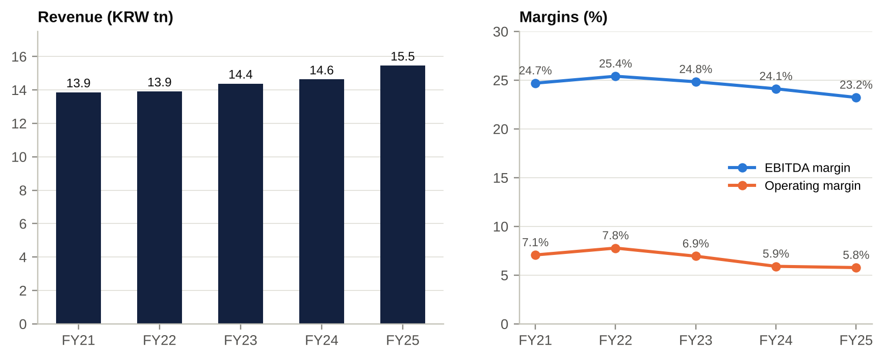
Revenue and margins, FY21–FY25

Segment reporting (K-IFRS operating segments)
LG Uplus reports only two K-IFRS operating segments, LG U+ and LG HelloVision (LGHV). It discloses no segment net income and no geographic split; DART states that revenue comes “almost entirely from customers located in Korea”. Management discloses revenue, but not profit, by product line (next table).
KRW bn | FY2022 | FY2023 | FY2024 | FY2025 | 1H25 | 1H26
LG U+ segment revenue | 12,850 | 13,299 | 13,562 | 14,325 | 6,994 | 7,065
LG U+ segment EBITDA [e] | 3,359 | 3,395 | 3,400 | 3,478 | 1,836 | 1,936
LG U+ segment EBITDA margin | 26.1% | 25.5% | 25.1% | 24.3% | 26.3% | 27.4%
LG U+ segment OP | 1,069 | 984 | 868 | 889 | 554 | 611
LG U+ segment OP margin | 8.3% | 7.4% | 6.4% | 6.2% | 7.9% | 8.6%
LGHV segment revenue | 1,161 | 1,185 | 1,196 | 1,267 | 668 | 500
LGHV segment EBITDA [e] | 173 | 172 | 130 | 116 | 66 | 58
LGHV segment OP | 12 | 11 | -3 | 7 | 9 | 3
LGHV OP margin | 1.0% | 0.9% | -0.2% | 0.5% | 1.4% | 0.6%
Eliminations | -104 | -111 | -133 | -140 | -69 | -66
Consolidated revenue | 13,906 | 14,373 | 14,625 | 15,452 | 7,593 | 7,499
Source: S&P Capital IQ segment data from the K-IFRS segment note; 1H figures from the 1H26 half-year report. EBITDA = segment OP + segment D&A [e]. FY21 segment detail is not available in S&P.

Revenue by product line (management basis)
KRW bn | FY2021 | FY2022 | FY2023 | FY2024 | FY2025 | 2Q26 | 2Q26 YoY | 4-yr CAGR
Mobile service revenue | 5,693 | 5,831 | 5,984 | 6,117 | 6,371 | 1,596 | +1.2% | 2.9%
Smart Home | 2,204 | 2,345 | 2,417 | 2,506 | 2,590 | 664 | +4.3% | 4.1%
– IPTV | 1,256 | 1,326 | 1,325 | 1,328 | 1,327 | 338 | +2.1% | 1.4%
– Broadband | 948 | 1,018 | 1,070 | 1,141 | 1,224 | 325 | +7.6% | 6.6%
Enterprise infrastructure | 1,493 | 1,584 | 1,684 | 1,706 | 1,808 | 464 | +8.6% | 4.9%
– IDC / AIDC | 258 | 281 | 326 | 357 | ~422 [e] | 124 | +28.9% | 13.1%
– Solutions | 489 | 524 | 559 | 527 | ~550 [e] | n/d | +6.8% | ~3%
– Enterprise lines | ~746 [e] | ~779 [e] | 799 | 822 | ~836 [e] | n/d | n/d | ~3%
Handset sales [e] | 2,783 | 2,495 | 2,736 | 2,782 | ~3,194 | 618 | -17.7% [u] | 3.5%
Consolidated revenue | 13,851 | 13,906 | 14,373 | 14,625 | 15,452 | 3,695 | -3.9% | 2.8%
Source: Q4 earnings calls FY21–FY25, FY2024 annual report (restated FY23), 2Q26 earnings release. Rows do not sum to the total because telephony, interconnection, LGHV and other subsidiaries are excluded. In 2026 the company restated 2025 mobile service revenue about KRW10bn per quarter lower (new MSIT basis).
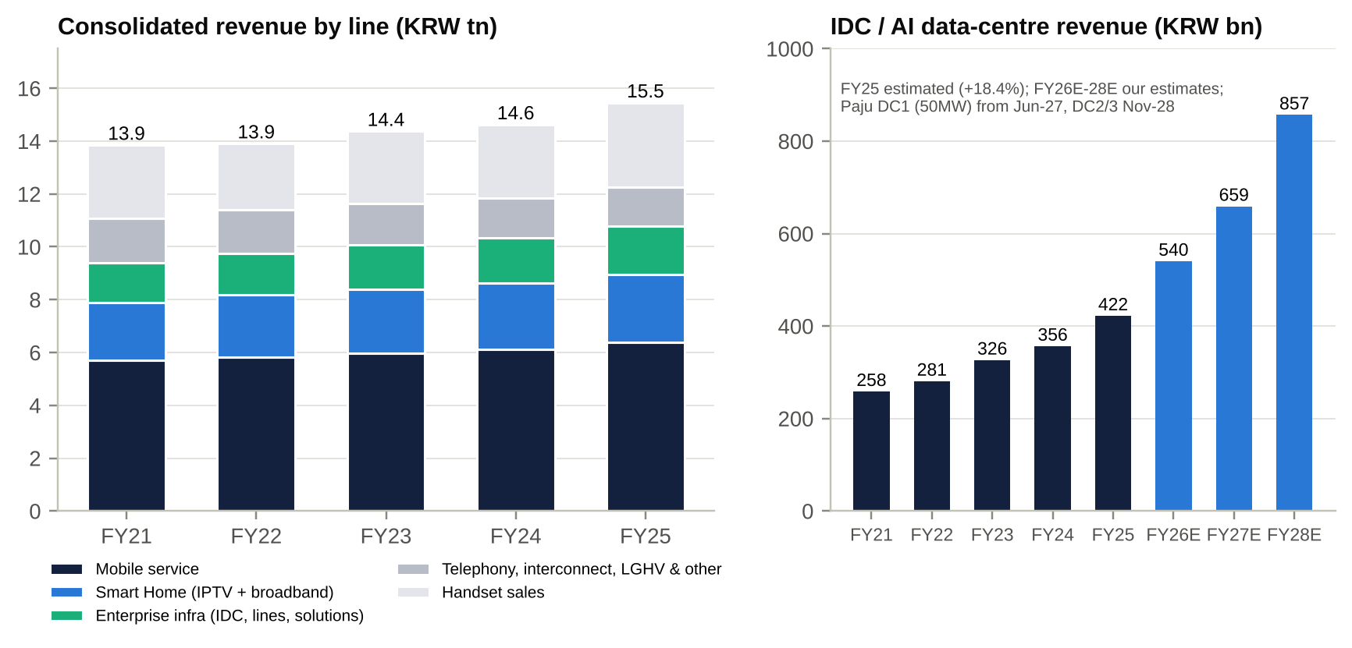
Revenue mix and IDC/AIDC revenue
Trends and drivers.
- Growth was slow and then accelerated in FY25 (+5.7%). FY22–FY24 revenue grew 0.4–3.4% a year, with mobile service revenue at ~2–2.5% as 5G upgrades offset tariff pressure. FY25 jumped because SK Telecom’s April-2025 USIM hack sent subscribers to LG Uplus and KT. Mobile service revenue grew +4.1%, the fastest since 2021, and handset sales rose ~15% [e]. In 2026 that tailwind fades: 2Q26 mobile service revenue grew only +1.2% and total revenue fell 3.9% as handset sales normalised.
- EBITDA has been flat at KRW3.4–3.6tn for five years, while D&A rose by KRW256bn. The 5G build-out (capex ~KRW2.3–2.5tn a year in FY21–23) depreciated through FY24–25. Labour costs also stepped up after the ordinary-wage court ruling in 4Q24. As a result, operating margin compressed from 7.8% (FY22) to 5.8% (FY25), and ROE halved from 9.5% to ~4–6%.
- The inflection came in 1H26. OP rose +10.2% and the EBITDA margin reached 26.6%. The drivers were:
  - roughly KRW60–70bn a year of labour savings from the 3Q25 early retirement of ~600 staff [e];
  - the AIDC mix (+29–31%);
  - lower-margin handset revenue shrinking;
  - D&A contained at +2.6%.
- Segment comparison. The LG U+ segment margin (8.6% OP in 1H26) is ~10x LGHV’s (0.6%). LGHV is in structural decline: cable pay-TV is losing share, MVNO prices are falling, and 2Q26 revenue fell 31% YoY. LGHV is now ~8% of revenue and ~3% of EBITDA. It has generated cumulative impairments (KRW164bn in FY20 at the parent; LGHV-level goodwill impairment in FY24) and is the main reason net income fell 40% in FY24.
- Geography. There is no geographic diversification, which is neither a growth driver nor a currency risk. The only FX exposure is a USD50m floating-rate note, which is swapped.

Quarterly trend (company basis)
KRW bn | 1Q25 | 2Q25 | 3Q25 | 4Q25 | 1Q26 | 2Q26
Revenue | 3,748 | 3,844 | 4,011 | 3,848 | 3,804 | 3,695
Service revenue YoY (consol.) | +1.6% | +2.5% | +4.2% | n/d | +3.3% | +2.0%
EBITDA | 921 | 977 | 831 | 859 [e] | 959 | 1,035
Operating profit | 255.4 | 304.5 | 161.7 | 170.5 | 272.3 | 344.5
OP margin | 6.8% | 7.9% | 4.0% | 4.4% | 7.2% | 9.3%
One-offs | – | – | ERP -150 | – | – | ~+20–25 [u]
Net income (to parent) | 165.7 | 219.5 | 49.7 | 88.9 | 176.9 | 219.7
Marketing expense (standalone) | 555.8 | 540.1 | 585.2 | ~633 [e] | 614.2 | 572.1
Capex (standalone) | 333.1 | 393.3 | 438.1 | ~586 [e] | 317.2 | 477.8
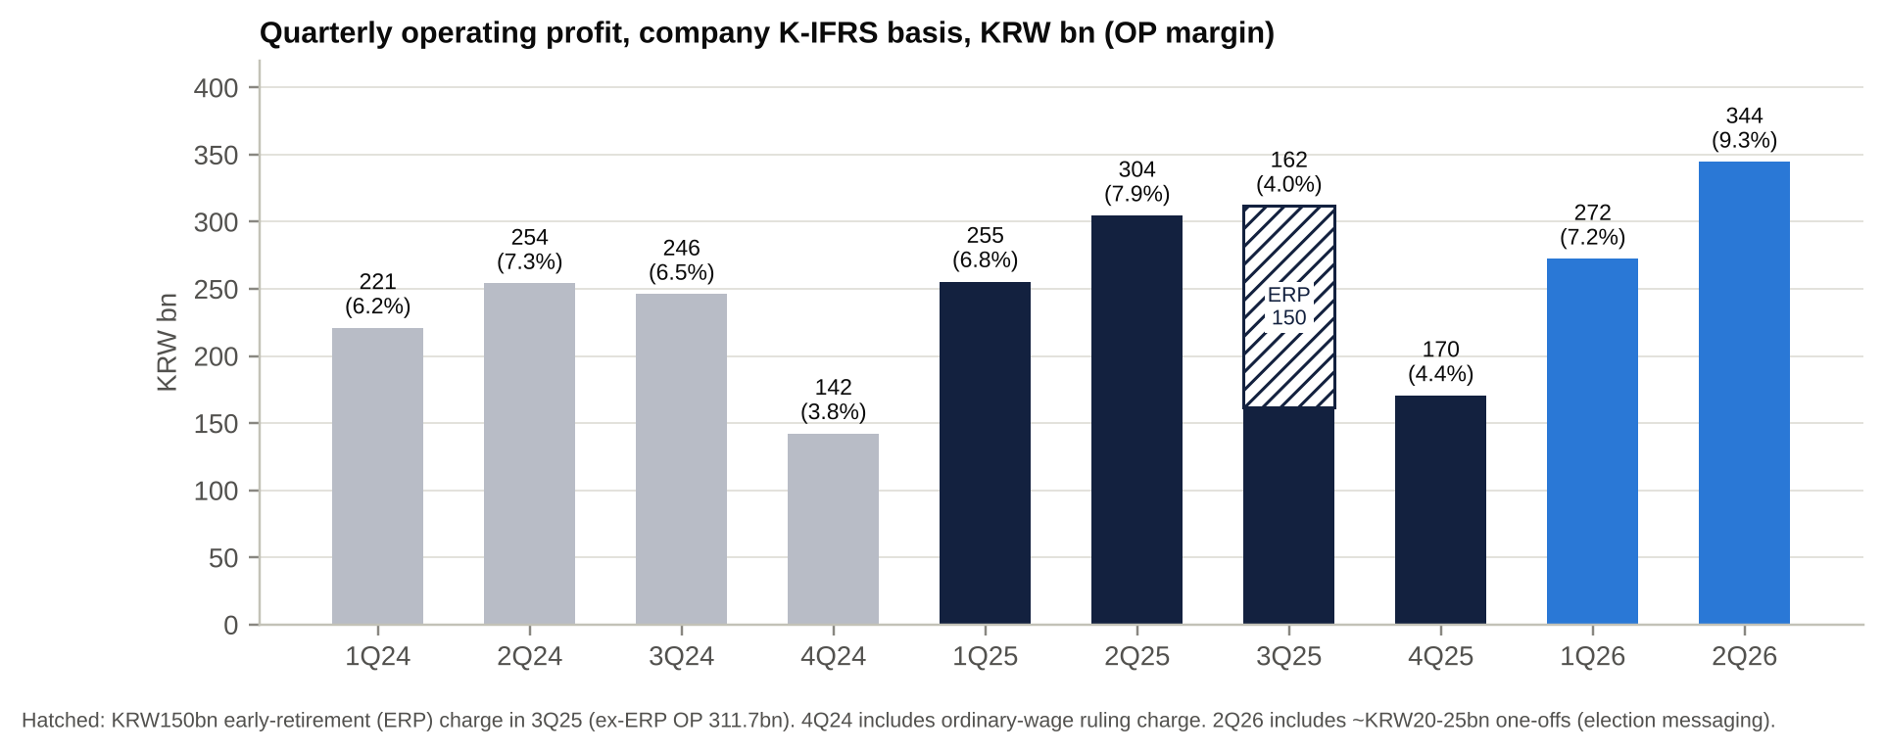
Quarterly operating profit

Operational KPIs
KPI | FY2021 | FY2022 | FY2023 | FY2024 | FY2025 | 2Q26 | Trend comment
Total wireless lines incl. MVNO (m) | 18.0 | 19.9 | 25.1 | 28.5 | 30.7 | 31.5 | +75% since FY21, mostly IoT and MVNO
MNO lines (m) | 15.2 [e] | 16.0 [e] | 18.8 [e] | 20.4 [e] | 21.7 | 22.4 | +7.2% YoY (rival breaches)
Implied handset base (m) [e] | ~11.4 | ~11.4 | ~11.0 | ~10.9 | n/d | ~11.3 | Flat; this is the real “volume”
Hosted MVNO lines (m) | 2.8 | 3.9 | 6.3 | ~8.2 | 9.0 | 9.0 | Plateauing
5G share of handsets | 40.5% | 53.5% | 64.3% | 72.7% | 83.1% | 84.9% | Near saturation; ARPU upgrade lever is exhausted
MNO total-line share (MSIT, incl. IoT) | n/d | 25.0% | 27.6% | 28.5% | 29.5% | 29.8% (Mar-26) | Ahead of KT since Dec-23
Mobile service revenue per MNO line (KRW/month) [e] | ~31,700 | ~31,200 | ~28,700 | ~26,100 | ~25,200 | – | Diluted by low-ARPU IoT lines
Monthly MNO churn | n/d | ~1.08% | n/d | ~1.06% [u] | 1.00% [u] | n/d | Improving
IPTV subscribers (m) | 5.35 | 5.35 | 5.45 | 5.58 | 5.74 | 5.76 (1Q) | +1–3% a year
Broadband subscribers (m) | 4.76 | 4.94 | 5.16 | 5.35 | 5.58 | 5.64 (1Q) | +4% a year; Giga-tier 33%
Marketing / standalone service revenue | 22.5% | 21.7% | 20.2% | 20.1% | 20.2% | 19.9% | Disciplined; watch post-Dansuobeop
Capex (standalone, KRW bn) | 2,346 | 2,420 | 2,514 | 1,921 | ~1,750 | 478 (2Q) | Trough in FY25; AIDC lifts FY26–28
Capex / revenue | 16.9% | 17.4% | 17.5% | 13.1% | 11.3% | 12.9% | Capex intensity halved from peak, then rising
Standalone employees | n/d | n/d | n/d | 10,571 | ~10,000 | 9,811 | -7% after early retirement
Mobile network capacity utilisation | – | – | – | 55.3% | 59.1% | 60.5% | Headroom for growth without new radio capex
Sources: company earnings calls and releases, MSIT statistics via the company, DART. Reported ARPU is not text-indexed in the sources available to us (n/d). There is no order backlog in the classic sense; the closest equivalent is the Paju AIDC pre-leasing and the KRW5tn cumulative AIDC order target by 2030.
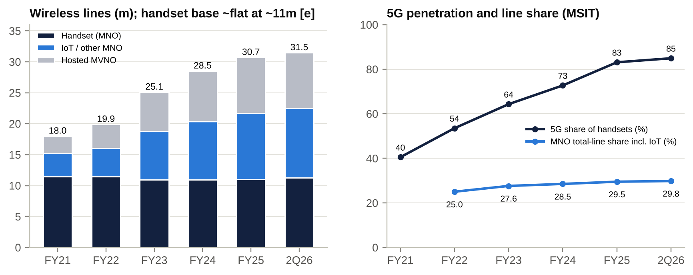
Lines, 5G penetration and line share
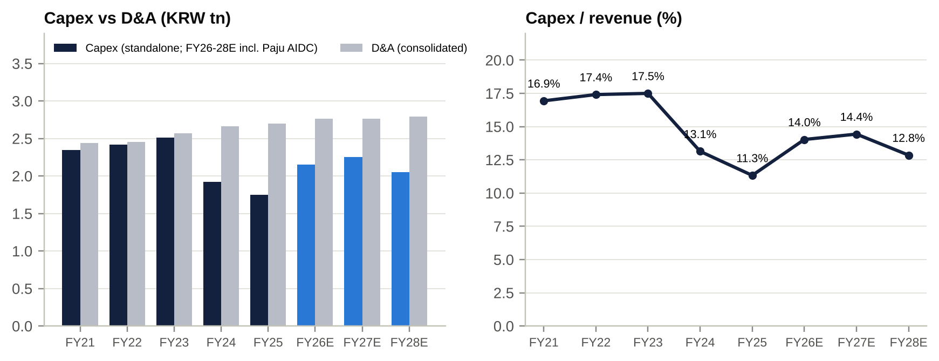
Capex vs D&A and capex intensity
KPI read-across.
- The headline “line growth” story (18m to 31.5m) is mostly low-value IoT and MVNO lines. The handset base has been flat at ~11m for five years, so revenue per line is falling and is not a useful measure of pricing.
- The useful KPIs are:
  - mobile service revenue growth (2–4%);
  - marketing at ~20% of service revenue;
  - capex intensity (at a trough, now turning up for AIDC);
  - AIDC revenue growth (+29–31%).
- Network capacity utilisation of ~60% means volume growth needs little new radio capex.

Historical share-price catalysts (moves greater than 10%, last five years)
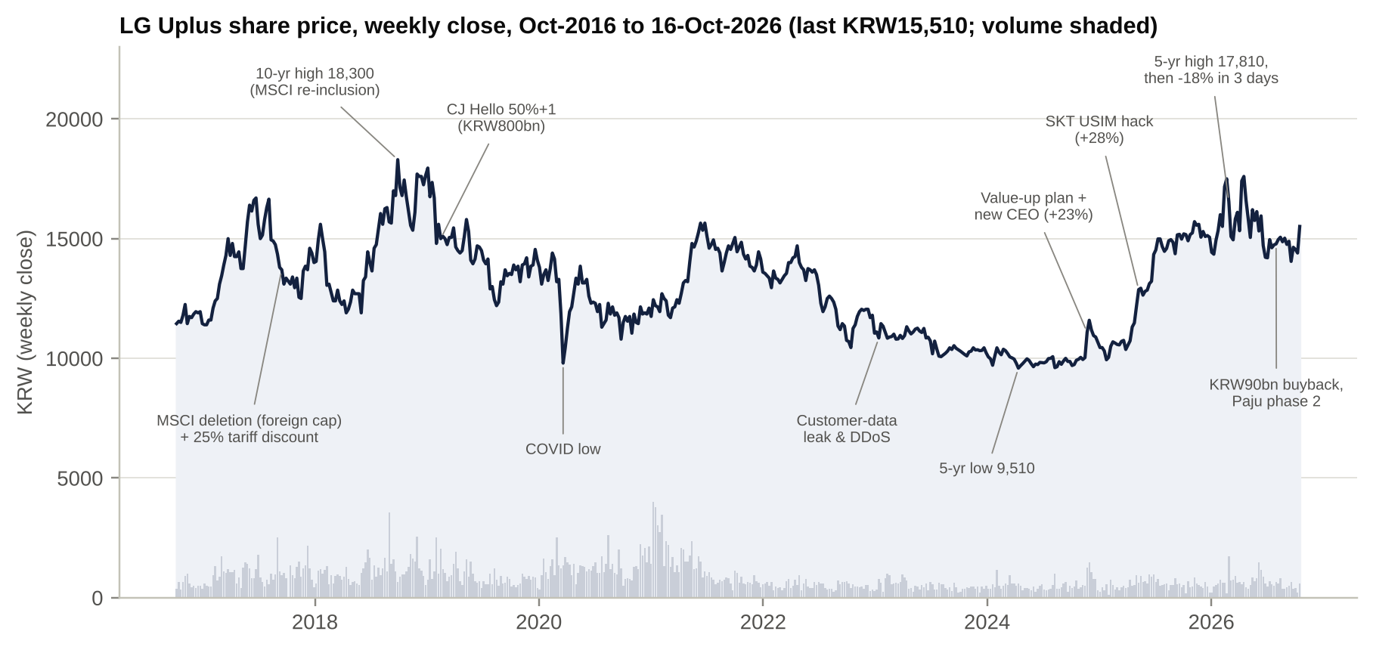
Ten-year share price with key catalysts
LG Uplus has had no single-day move of 10% or more in the past five years. The largest was -9.5% on 4-Mar-2026, a market-wide crash day (KODEX 200 -12.5%). The tradeable moves have come over one to eight weeks, and most were event-driven: capital-return announcements, competitor security breaches, policy and index flows.
Window | Move | Price from → to | KOSPI 200 proxy | Driver | Type
5-Oct-21 → 1-Dec-21 | -11.9% | 15,100 → 13,300 | -0.5% | Post-buyback de-rating; LG year-end CEO change (Hwang Hyun-sik) and 5G tariff pressure [u] | Stock-specific
17-Dec-21 → 27-Jan-22 | -12.1% | 14,450 → 12,700 | -9.0% | Global rate sell-off; ex-dividend (KRW350) | Market
2-Mar-22 → 19-Apr-22 | +12.6% | 13,100 → 14,750 | -0.9% | Record FY21 net income (KRW712bn); Investor Day (6-Apr-22); 3.40–3.42GHz decision [u] | Event
20-Apr-22 → 19-May-22 | -11.2% | 14,700 → 13,050 | -2.3% | Unexplained -6.1% on 27-Apr-22 [u]; 1Q22 results | Unclear
31-May-22 → 15-Jul-22 | -13.7% | 13,850 → 11,950 | -11.3% | 2022 bear market; government push for mid-tier 5G tariffs [u] | Market / policy
9-Aug-22 → 11-Oct-22 | -17.0% | 12,650 → 10,500 | -11.4% | Rates and strong USD; Korean credit scare (Legoland, Sep–Oct 2022) [u] | Market
13-Oct-22 → 23-Nov-22 | +18.5% | 10,250 → 12,150 | +8.4% | Market rebound; 3Q22 results (+4.4% on the day) | Market / event
30-Nov-22 → 12-Jan-23 | -11.6% | 12,100 → 10,700 | +0.7% | Ex-dividend (-4.6%), then the Jan-2023 customer-data leak and DDoS outages (KRW6.8bn PIPC fine) | Event
8-Jun-23 → 26-Jul-23 | -12.3% | 11,300 → 9,910 | +0.5% | MSIT “competition promotion” plan (4th carrier, tariffs) [u]; KFTC subsidy-collusion probe | Regulatory
5-Oct-21 → 16-Apr-24 | -37.0% | 15,100 → 9,510 | -9.4% | Structural de-rating: 5G ARPU maturity, tariff pressure, breach, rising rates | Drawdown
8-Oct-24 → 27-Nov-24 | +22.9% | 9,680 → 11,900 | -5.0% | Value-up plan and new CEO Hong Bum-shik (21–22 Nov 2024): cancellation of the KRW100bn of treasury shares, shareholder return up to 60%, ROE target 8–10% | Event
28-Nov-24 → 23-Jan-25 | -16.4% | 11,800 → 9,870 | +1.3% | Value-up rally faded; 3-Dec-24 martial-law shock | Market / politics
3-Apr-25 → 4-Jun-25 | +27.6% | 10,310 → 13,160 | +8.5% | SK Telecom USIM hack (22-Apr-25) and subscriber migration; 52-week high on 9-May | Event
5-Jun-25 → 22-Jul-25 | +17.7% | 12,850 → 15,120 | +19.8% | Post-election rally; Commercial Act revision; dividend-tax reform push; Dansuobeop repeal; KRW80bn buyback (21-Jul) | Policy / event
9-Sep-25 → 10-Nov-25 | +12.9% | 14,360 → 16,210 | +30.0% | 3Q25 results: ex-ERP beat and dividend-growth guidance (+11.4% over 4–10 Nov) | Event
9-Jan-26 → 26-Feb-26 | +24.1% | 14,350 → 17,810 | +40.1% | Telecom sector rally; FY25 final DPS KRW410 (26-Jan); buyback completed. 5-year high | Event / market
26-Feb-26 → 4-Mar-26 | -18.1% | 17,810 → 14,580 | -20.1% | -7.1% on 27-Feb on ~10x volume (MSCI review implementation; foreign-room “weight reduction” [u]), then the 3–4 Mar market crash | Index flow / market
4-Mar-26 → 17-Apr-26 | +20.7% | 14,580 → 17,600 | -0.1% | Rebound; ex-dividend 30-Mar; unexplained +7.5% on 10-Apr [u] | Rebound
21-Apr-26 → 24-Jun-26 | -19.6% | 17,410 → 14,000 | +46% | Rotation out of defensives into a speculative KOSPI rally; 52-week low | Market (inverse)
24-Jun-26 → 11-Aug-26 | +11.4% | 14,000 → 15,590 | -25.1% | Defensive bid in the KOSPI correction; KRW90bn buyback + interim DPS +8% (29-Jul; +6.6% next day); record 2Q26 OP | Event / market
18-Sep-26 → 16-Oct-26 | +10.4% | 14,050 → 15,510 | -18.8% | End of S&P Global BMI deletion selling (-4.3% on 18-Sep); defensive bid in the October 2026 KOSPI crash | Index flow / market
Source: S&P Capital IQ daily and weekly prices; KODEX 200 ETF used as the KOSPI 200 proxy; event attribution from S&P Key Developments, company calls and press. [u] = attribution not confirmed by a primary source.
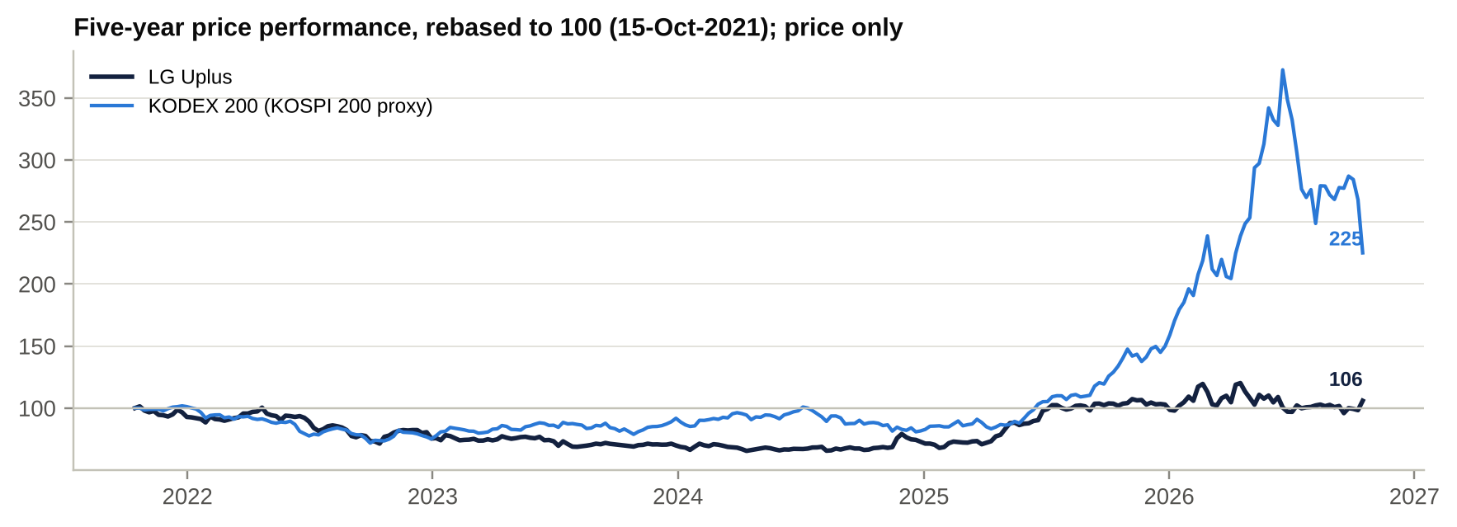
Five-year relative performance
Takeaways.
- The stock reacts most to capital returns (Nov-24, Jul-25, Jul-26), to competitor breaches (Apr-25) and to index flows (Feb-26, Sep-26), and much less to earnings.
- Since 2025 it has traded as a low-beta defensive that is negatively correlated with KOSPI swings. Over five years it is up only ~6% against ~+125% for the KOSPI 200 proxy. That makes it a useful funding or hedge leg in a Korea book.
- Index events are a recurring technical catalyst because foreign room under the 49% cap is tight. One press analysis flags possible deletion from MSCI Korea in the November 2026 review (effective 30-Nov-2026) [u].

Earnings calls: management focus and sentiment

What management is focused on
Quarter (call date) | Headline numbers | Management focus | Tone
3Q24 (8-Nov-24) | OP 246.0bn (-3.2%); service revenue +2.9% | “AX company” pivot; ixi-O launch; value-up plan promised | Cautiously constructive; CFO calls 2024 “the bottom”
4Q24 (6-Feb-25) | FY24 OP 863.1bn (-13.5%); NI -44% (LGHV impairment) | Value-up (40–60% return, ROE 8–10%); exit from loss-making platforms (Idol Plus, Sporki, smart factory, metaverse); Dansuobeop repeal | Most defensive of the eight calls
1Q25 (8-May-25) | OP 255.4bn (+15.6%) | Turnaround; Paju AIDC building 1 (50MW, KRW620bn); cancellation of all 6.78m treasury shares; SKT breach and own USIM security | Relief
2Q25 (8-Aug-25) | OP 304.5bn (+19.9%), first quarter above KRW300bn | SKT spillover; KRW80bn buyback; OpenAI AICC partnership; LG sovereign-AI consortium | Confident
3Q25 (5-Nov-25) | OP 161.7bn incl. KRW150bn ERP; 311.7bn ex-ERP (+26.7%) | ERP savings in 2026; FY25 guidance on track; “progressive” returns; security basics | Second-lowest (one-off charge)
4Q25 (5-Feb-26) | FY25 OP 892.1bn; service revenue +3.5% vs 2% guidance; DPS 660 | FY26 guidance ≥2% service growth; 5G standalone (SA) by end-2026; AICC +50%; Paju phase 2 under review | Positive
1Q26 (7-May-26) | OP 272.3bn (+6.6%); marketing +11.7% (KT fee-waiver war) | “Balanced growth”; AX cost structure; Paju at MWC; cancellation of 5.4m shares | Peak tone
2Q26 (6-Aug-26) | Record OP 344.5bn (+13.1%); revenue -3.9% | Paju brought forward to 200MW (~KRW2tn); capex “within EBITDA”; KRW90bn buyback; PAGO security deal; “One LG” AI | High, with caution on 2H wireless and capex
Source: ProntoNLP and S&P Capital IQ transcripts.
Recurring analyst questions.
- Sustainability of the subscriber gains from rival breaches.
- Size of buybacks and cancellations, and DPS progression.
- AIDC funding, returns and overlap with LG CNS.
- Post-Dansuobeop competition.
- Q&A participation is thinning: only two analysts asked questions on the 2Q26 call.

Sentiment analysis (ProntoNLP)
Quarter | Pronto sentiment (-1 to +1) | Pronto investment score | Events (+ / 0 / -) | Positive share | Key topics | Shift
3Q24 | 0.86 | 0.55 | 152 / 75 / 9 | 94% | ixi-O, AX, IDC, value-up pending | Baseline
4Q24 | 0.62 | -1.00 | 132 / 114 / 25 | 84% | OP -13.5%, wage charge, LGHV impairment, restructuring | Trough
1Q25 | 0.89 | 0.89 | 156 / 95 / 10 | 94% | Turnaround, Paju, cancellation, SKT breach | Sharp rebound
2Q25 | 0.90 | 0.94 | 186 / 88 / 12 | 94% | Record OP, SKT spillover, buyback, AICC | Confident
3Q25 | 0.74 | 0.34 | 143 / 70 / 19 | 88% | ERP charge, regulatory uncertainty, AI vs cost | Second dip
4Q25 | 0.89 | 0.96 | 180 / 78 / 9 | 95% | Guidance beat, AICC +50%, 5G SA, DPS | Recovery
1Q26 | 0.98 | 1.00 | 167 / 74 / 2 | 99% | Balanced growth, Paju, cancellation | Peak
2Q26 | 0.94 | 0.91 | 160 / 69 / 7 | 96% | Record OP, Paju 200MW, capex, buyback | Edging down; forecast events net to zero
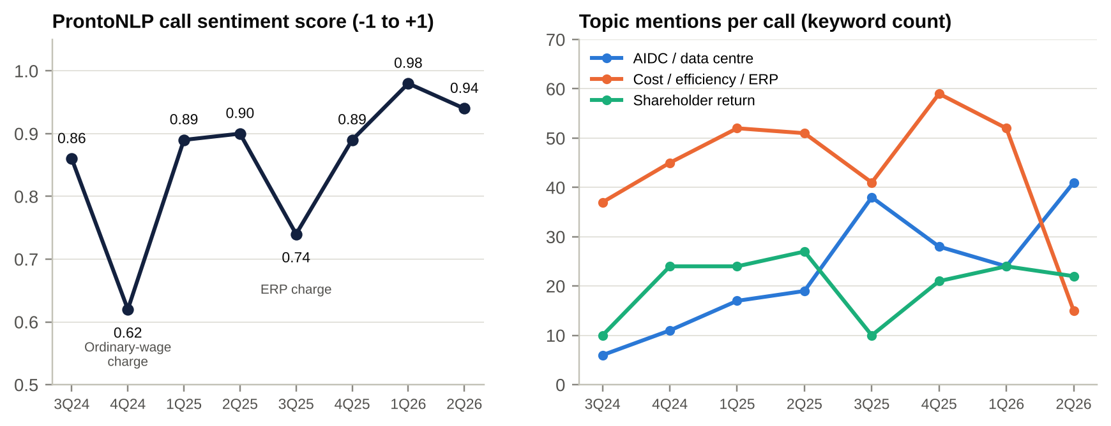
Sentiment score and topic mix
How sentiment has shifted.
- Both troughs (4Q24 and 3Q25) coincide with large one-off labour charges, not with deterioration in the core business, and each rebounded the following quarter.
- Since 4Q25 negative events have stayed in single digits (9, 2, 7), the most consistently positive stretch in the sample.
- Topic mix is more informative than tone.
  - AIDC/data-centre mentions rose from 6 (3Q24) to 41 (2Q26).
  - Cost and efficiency mentions collapsed from 52–59 to 15 once the savings appeared in the numbers.
  - Capex mentions jumped to 17 in 2Q26.
  - Management is now selling an investment story, not a cost story.
- In the 2Q26 event breakdown, “Forecast” events net to zero, cost-challenge scores -0.67 and customer retention -0.5. These map to the guided 2H wireless slowdown and rising data-centre power costs, and are the first early-caution markers in a year.
- Tone does not track beats. The best-toned call (1Q26) missed OP by ~3%; the record 2Q26 beat came with slightly lower tone.

Latest result: 2Q26 (reported 6-Aug-2026)

Revenue and profit vs expectations
KRW bn | 2Q26 actual | YoY | Capital IQ consensus | Beat / miss | Other consensus
Revenue | 3,694.9 | -3.9% | 3,910.2 (13 estimates) | -5.5% | -5.2% (broker) [u]
Service revenue (consolidated) | 3,076.5 | +2.0% | n/a | – | Standalone +2.8%
EBITDA | 1,034.8 | +5.9% | 1,016.5 | +1.8% | –
Operating profit | 344.5 | +13.1% | 316.1 (14; range 292.8–340.3) | +9.0%, above the highest estimate | Yuanta 310.3 (+11%), Hana 306.7 (+12%) [u]
OP ex-one-offs (~20–25bn) | ~320 [e] | ~+5% | 316.1 | ~in line | Company: “above KRW320bn” ex-one-offs
Pre-tax profit | 315.1 | – | 282.0 | +11.7% | –
Net income to parent | 219.7 | +0.1% | 214.2 | +2.6% | Tax rate 30.9%
EPS (KRW) | 517 | – | 498 | +3.9% | –
Interim DPS (KRW) | 270 | +8% | 250 | +8% | –
Verdict. This was an operating beat of moderate quality. OP beat by 9% but about two-thirds of the beat was one-off (election-related bulk messaging). Revenue missed by 5.5% on lower handset sales, and a 30.9% effective tax rate left net income only 2.6% ahead.

Segment drivers
- Mobile service revenue KRW1,595.9bn (+1.2%), a sharp deceleration from +4–5% in 2H25 as the base now includes the SKT-hack inflows. MNO lines were 22.4m (+7.2%) and 5G penetration 84.9%.
- Smart Home KRW663.8bn (+4.3%): broadband +7.6%, IPTV +2.1%.
- Enterprise infrastructure KRW464.4bn (+8.6%), of which AIDC KRW124.1bn (+28.9%). This is the clear acceleration, driven by colocation demand and pricing.
- Handset sales -17.7% YoY [u], the reason group revenue fell. This is low-margin, so profit was unaffected.

Margin trends and why
- OP margin 9.3% (2Q25 7.9%) and EBITDA margin 28.0% (25.4%) [e].
- Drivers of the improvement:
  - Labour costs -2.5% YoY [u] after the 3Q25 early retirement.
  - Mix: AIDC up, low-margin handsets down.
  - D&A only +2.6%.
  - About KRW20–25bn of one-offs.
- Not a driver: marketing rose 7.6% YoY (though it fell 6.9% QoQ), to 19.9% of service revenue, as 2025 acquisition costs are still being amortised.

Guidance and outlook
- FY26: standalone service revenue growth ≥2% (1H26: +3.4%). Management expects a “slight moderation” in wireless in 2H.
- Capex: up YoY because of AIDC, but kept “within EBITDA” with no external financing. Paju phase 2 (up to KRW1,348.9bn) was approved on 29-Jul-2026. The total programme is ~KRW2tn for 200MW across four buildings in 2027–28.
- Shareholder returns: interim DPS KRW270; KRW90bn buyback (trust 14-Aug-2026 to 13-Feb-2027) to be cancelled. The buyback is “flexible” relative to investment needs.
- Tone change: still confident, but more conditional (“AIDC demand challenging to forecast”; buybacks “flexible”).
- 3Q26 consensus (Capital IQ): OP KRW314.2bn, revenue KRW3,972bn and NI KRW182.9bn. Results are expected around 5–7 Nov 2026 [e].

Balance-sheet flags
Item | 2Q26 | Change | Comment
Cash + short-term investments | 1,258bn | +368bn vs YE25 | Strong cash generation; pre-funding of bond maturities
Net debt (ex-leases) | 4,508bn | -9.5% YoY | ND/EBITDA 1.22x; D/E 114% (target ~100%)
Operating cash flow | 998.6bn (1H 1,862bn) | – | 1H26 FCF ~KRW809bn [e]
Long-term receivables (likely handset instalments) | 462bn | +21% since 3Q25 | Rising while handset revenue falls. Monitor credit quality and ABS timing
Inventory | 260bn | +51% QoQ | Probably handset build ahead of 2H launches [u]
Capex (standalone) | 477.8bn | +21.5% YoY | AIDC investment turning up
Effective tax rate | 30.9% | 1Q26 20.9% | Unexplained. Watch for reversal
Treasury shares | 0 | – | All cancelled; new buyback under way

Market reaction and what was priced in
- The stock rose +6.6% on 30-Jul-2026 (1.95m shares, ~2.5x normal), the day after the board approved the buyback, the dividend and Paju phase 2. The PIPC police referral announced the same day did not dent it.
- On results day (6-Aug) it rose only +0.5%, although the KOSPI fell ~4% intraday [u], and it had faded to 14,660 by 20-Aug.
- Signal: investors pay for capital returns and AIDC optionality, not for an operating beat helped by one-offs. The 2H wireless slowdown, rising capex/D&A and the open PIPC case cap the multiple.

Unusual relative to recent history
- This is the first revenue decline in the sample (-3.9%) alongside record OP.
- OP came in above the highest analyst estimate.
- The tax rate was ~31%.
- Capex turned up after two years of decline.
- Long-term receivables and inventory both stepped up.
- Q&A was the thinnest of eight calls (two analysts).

Earnings forecasts: FY2026E–FY2028E

Key assumptions
Driver | FY2026E | FY2027E | FY2028E | Rationale
Mobile service revenue growth | +2.0% | +1.5% | +1.5% | Rival-breach inflows annualise; 5G saturation; tariff pressure. Volume +1–2%, price flat
Smart Home growth | +3.5% | +3.0% | +3.0% | Broadband up-tiering; IPTV flat
IDC/AIDC revenue growth | +28% | +22% | +30% | Colocation pricing; Paju DC1 (50MW) from Jun-2027; DC2/3 from Nov-2028
Other enterprise | +2% | +2% | +2% | Lines and solutions flat to low growth
LGHV and other subsidiaries (service) | -10% | -5% | -3% | Cable decline, MVNO pricing
Handset sales | -11% | flat | flat | Normalisation after the FY25 spike
Market share | Stable ~21% handsets | Stable | Stable | We do not assume further breach-driven gains
Marketing | ~20% of service revenue | +KRW15bn | +KRW15bn | Amortisation of 2025–26 acquisition costs; no subsidy war in base case
Labour | ERP savings | +3.5% | +3.5% | ~KRW50bn a year of wage inflation
D&A | KRW2.77tn | KRW2.76tn | KRW2.79tn | Network D&A declines; AIDC depreciation from mid-2027; spectrum re-allocation roughly neutral
Net interest | -KRW190bn | -KRW185bn | -KRW190bn | Rates up ~50bp; net debt broadly flat as AIDC capex absorbs FCF
Other non-operating | -KRW15bn | -KRW30bn | -KRW30bn | Disposal losses and write-downs (5-year average ex-FY24 about -KRW30bn)
Effective tax rate | 26.0% | 25.0% | 25.0% | Statutory rate up 1pp from 2026; 1H26 actual 26.8%
Average diluted shares | 423.2m | 416.6m | 409.5m | KRW90bn buyback (≈6.0m shares) completes Feb-27; we assume ~KRW100bn a year thereafter, all cancelled
Capex (incl. intangibles / spectrum) | KRW2.15tn | KRW2.25tn | KRW2.05tn | Paju phases 1–2 (~KRW2tn over 2025–28) and spectrum re-allocation

Model output vs consensus
KRW bn | FY2025A | FY2026E | FY2027E | FY2028E | Consensus FY26E | Consensus FY27E | Consensus FY28E
Revenue | 15,452 | 15,329 | 15,591 | 15,955 | 15,539 | 15,889 | 16,203
Service revenue | ~12,258 | 12,479 | 12,742 | 13,106 | – | – | –
EBITDA | 3,589 | 3,904 | 3,945 | 4,058 | 3,850 | 3,926 | 3,983
Operating profit | 892 | 1,137 | 1,185 | 1,268 | 1,149 | 1,232 | 1,296
OP margin | 5.8% | 7.4% | 7.6% | 7.9% | 7.4% | 7.8% | 8.0%
Pre-tax profit | 680 | 932 | 970 | 1,048 | – | – | –
Net income (parent) | 524 | 694 | 731 | 789 | 738 | 817 | 876
EPS (KRW) | 1,221 | 1,641 | 1,756 | 1,927 | 1,733 | 1,922 | 2,079
EPS growth | +40% | +34% | +7% | +10% | +42% | +11% | +8%
DPS (KRW) | 660 | 700 | 740 | 780 | 695 | 738 | 778
Payout (of consolidated NI) | 53.7% | 42% | 42% | 40% | – | – | –
ROE [e] | 6.0% | 7.7% | 7.8% | 8.1% | 8.1% | 8.4% | 8.5%
Operating-profit bridge, FY26E → FY27E (KRW bn): FY26E 1,137 − 2Q26 one-offs 25 + service-revenue growth at ~60% drop-through 158 − labour inflation 50 − marketing 15 − other opex 20 ± D&A 0 = 1,185. FY28E adds KRW200bn of revenue drop-through and subtracts KRW52bn labour, KRW15bn marketing, KRW20bn other opex and KRW30bn of AIDC depreciation, giving 1,268.
Why we are below consensus (-5% to -9% on EPS).
- Tax: we use 25–26% vs ~23% implied in consensus.
- Below-the-line items: we include recurring non-operating losses (consensus implies ~zero).
- Wireless: we assume 2H26 slows as guided.
- AIDC economics: we treat AIDC’s contribution as margin-neutral in FY27, because pre-opening and depreciation costs arrive before full lease-up.
Factors that could make us too low:
- faster AIDC lease-up and pricing (the target is KRW5tn of cumulative orders by 2030);
- marketing falling below 19% of service revenue;
- a reversal of the 2Q26 tax-rate spike;
- larger buybacks (management could lift total returns to 60% of net income).
Financing costs and dilution. There is no equity-linked paper and no stock-based compensation of note: pay is cash-only. Share count falls ~1.4% a year with buybacks. Interest expense is broadly stable. Coupons on new issues (3.4–4.0% in Jan-2026) are close to the ~3.6–3.7% average cost, and gross debt is flat.

Capital structure, debt, liquidity and ratings
KRW bn | FY2021 | FY2022 | FY2023 | FY2024 | FY2025 | 2Q26
Gross debt excl. leases | 6,060 | 6,035 | 6,348 | 6,295 | 5,871 | 5,767
– Bonds (carrying) | n/d | n/d | n/d | n/d | 4,553 | 4,348
– Bank loans and other | n/d | n/d | n/d | n/d | 1,318 | 1,419
Lease liabilities (IFRS 16) | 1,001 | 1,006 | 1,029 | 876 | 1,167 | ~1,120 [e]
Cash + short-term investments | 835 | 871 | 626 | 965 | 890 | 1,258
Net debt (ex-leases) | 5,225 | 5,164 | 5,722 | 5,329 | 4,980 | 4,508
Net debt / EBITDA | 1.53x | 1.46x | 1.60x | 1.51x | 1.39x | 1.22x (LTM)
Net debt incl. leases / EBITDA | 1.82x | 1.75x | 1.89x | 1.76x | 1.71x | ~1.53x
Interest expense (incl. leases) | 153 | 181 | 243 | 276 | 261 | 122 (1H)
EBITDA / interest | 22.3x | 19.6x | 14.7x | 12.8x | 13.8x | ~16x
Liabilities / equity | 143% | 134% | 130% | 125% | 117% | 114%
FCF (CFO − capex − intangibles) [e] | 487 | 665 | 38 | 935 | 982 | ~809 (1H)
Source: S&P Capital IQ; DART 1H26 report; company IR. FCF is before lease principal (~KRW250bn a year).
Debt maturities (public bonds, face value, 30-Jun-2026). LG Uplus has KRW3.80tn of public bonds outstanding. A further KRW480bn of LG HelloVision bonds and a USD50m FRN (swapped; due May-2027) sit alongside them.
Maturity | 2H26 | 2027 | 2028 | 2029 | 2030 | 2031 | 2032 | 2034–36 | 2041–42 | Total
LG Uplus bonds (KRW bn) | 180 | 730 | 840 | 830 | 450 | 330 | 110 | 260 | 70 | 3,800
LG HelloVision bonds (KRW bn) | – | 150 | 190 | 140 | – | – | – | – | – | 480
About KRW1.7tn falls due within 12 months: KRW910bn of bonds and KRW792.5bn of bank loans. Cash alone covers it ~0.74x, rising to ~1.7x including the 1H26 FCF run-rate [e]. The company refinances in the domestic bond market routinely: the January-2026 issue raised KRW500bn at 3.38% (3-year), 3.62% (5-year) and 3.99% (10-year).
Cost of debt.
- Average cost is ~3.6–3.7%.
- Public bond coupons range from 1.89% to 4.60%; long-term loans from 2.43% to 5.46%.
- A KDB facility of KRW162.5bn floats at KDB 6M + 0.87%.
- Bank of Korea hikes add perhaps 10–20bp to the blended cost over two years [e].
Covenants (all public bonds; complied with at YE25).
- Liabilities/equity ≤ 400% (actual 114%).
- Secured debt and guarantees ≤ 150% of equity.
- Asset disposals < 50% of total assets per year.
- Change-of-control clause: the issuer must remain within a “large business group” (the LG Group). This matters in any takeover scenario, which would trigger bondholder put rights or consent requirements.
Liquidity. Cash and short-term investments of KRW1,258bn, plus ~KRW119bn of undrawn bank lines and the A1-rated CP programme. Liquidity is supported by the handset-receivable ABS programme (~KRW1.5tn a year) and an overfunded defined-benefit pension (assets KRW931bn vs obligations KRW831bn).
Ratings. NICE (9-Feb-2026), Korea Investors Service (12-Mar-2026) and Korea Ratings (19-Mar-2026) all upgraded LG Uplus to AA+ from AA, the first upgrade in 13 years, citing the end of the 5G investment cycle. CP is rated A1. We found no Moody’s or S&P rating. LG HelloVision is AA-.
Contingent liabilities.
- 138 lawsuits pending as defendant (2Q26).
- A KRW125.65bn VAT claim by eight card companies.
- KFTC subsidy-collusion fine of KRW27.66bn (final, Jun-2025; paid, under appeal).
- KFTC base-station lease collusion fine of KRW5.81bn.
- The open PIPC/police case over the 2025 hacking incident (no provision disclosed).
- Unexecuted capex commitments of KRW868.7bn.
Assessment. The balance sheet is conservative and improving. AIDC capex will absorb most FCF in 2026–28, but management has committed to fund it “within EBITDA” and without external financing. We expect net debt to stay around KRW4.5–4.8tn and leverage at ~1.2x.

Valuation

Peer comparison (S&P Capital IQ; LTM to 30-Jun-2026; prices at 16-Oct-2026)
(a) Valuation multiples
Company | Ticker | Mkt cap US$m | TEV/Sales | TEV/EBITDA | NTM TEV/EBITDA | TEV/EBIT | P/E LTM | P/E fwd
LG Uplus | 032640 KS | 4,931 | 0.74x | 3.07x | 2.90x | 12.1x | 12.4x | 8.5x
SK Telecom | 017670 KS | 12,512 | 1.46x | 5.70x | 4.56x | 20.0x | 23.0x | 10.8x
KT Corp | 030200 KS | 8,937 | 0.69x | 3.23x | 3.16x | 9.6x | 9.4x | 6.8x
KT Skylife | 053210 KS | 142 | 0.24x | 1.72x | 1.45x | 23.5x | n/m | 8.1x
LG HelloVision | 037560 KS | 88 | 0.47x | 4.61x | 3.69x | n/m | n/m | 4.2x
NTT | 9432 JP | 89,928 | 2.01x | 7.85x | 8.35x | 15.0x | 13.6x | 13.6x
KDDI | 9433 JP | 70,123 | 2.61x | 8.71x | 8.11x | 13.9x | 14.9x | 14.5x
SoftBank Corp | 9434 JP | 74,240 | 2.67x | 10.64x | 9.04x | 19.1x | 21.5x | n/a
Chunghwa Telecom | 2412 TT | 36,555 | 4.75x | 12.87x | 12.48x | 23.3x | 30.1x | 28.4x
Taiwan Mobile | 3045 TT | 12,181 | 2.35x | 10.69x | 10.27x | 20.3x | 25.0x | 24.0x
Far EasTone | 4904 TT | 12,604 | 3.91x | 11.65x | 10.57x | 23.7x | 27.6x | 26.0x
Singtel | ST SP | 53,176 | 5.28x | 12.90x | 18.28x | 21.3x | 19.6x | 19.6x
AIS | ADVANC TB | 29,700 | 5.33x | 9.92x | 9.31x | 17.0x | 18.6x | 18.4x
True Corp | TRUE TB | 13,016 | 4.53x | 8.25x | 7.27x | 19.1x | 23.7x | 14.6x
Telkom Indonesia | TLKM IJ | 10,404 | 1.53x | 3.27x | 3.04x | 6.3x | 10.5x | 9.4x
Maxis | MAXIS MK | 6,780 | 3.37x | 9.55x | 8.18x | 16.6x | 16.8x | 17.2x
CelcomDigi | CDB MK | 7,327 | 3.35x | 6.55x | 7.47x | 11.1x | 19.9x | 17.1x
Globe Telecom | GLO PM | 3,588 | 3.31x | 6.49x | 6.60x | 14.1x | 11.4x | 10.5x
PLDT | TEL PM | 4,281 | 2.81x | 6.26x | 5.44x | 10.8x | 9.3x | 9.7x
China Mobile | 941 HK | 228,033 | 1.27x | 4.53x | 4.09x | 9.7x | 11.6x | 11.3x
China Telecom | 728 HK | 87,711 | 1.09x | 4.46x | 4.17x | 16.0x | 12.6x | 12.0x
HKT Trust | 6823 HK | 11,662 | 3.73x | 12.48x | 9.69x | 17.3x | 17.1x | n/a
Bharti Airtel | BHARTI IN | 125,068 | 6.23x | 10.96x | 9.60x | 19.2x | 39.8x | 27.8x
Telstra | TLS AU | 36,638 | 3.18x | 9.46x | 7.93x | 17.3x | 23.8x | 22.0x
Deutsche Telekom | DTE GY | 139,590 | 2.39x | 6.15x | 5.95x | 11.4x | 14.5x | 10.7x
Verizon | VZ US | 186,092 | 2.73x | 6.63x | 6.91x | 11.8x | 11.7x | 8.8x
AT&T | T US | 160,620 | 2.57x | 6.43x | 6.66x | 11.8x | 7.7x | 9.7x
T-Mobile US | TMUS US | 170,662 | 3.13x | 7.20x | 7.45x | 14.2x | 16.7x | 12.7x
Orange | ORA FP | 43,500 | 2.10x | 6.59x | 5.62x | 15.6x | 11.0x | 11.6x
Swisscom | SCMN SW | 42,027 | 3.43x | 8.66x | 7.54x | 25.4x | 26.3x | 22.5x
Median ex-LGU (29) |  |  | 2.73x | 7.20x | – | 16.6x | 16.9x | 12.7x
Korean MNO average (SKT, KT) |  |  | 1.08x | 4.47x | 3.86x | 14.8x | 16.2x | 8.8x
(b) Operating and financial metrics
Company | EBITDA m. | EBIT m. | Sales g. | ND/EBITDA | Div. yield | P/B | Levered FCF yield
LG Uplus | 24.0% | 6.2% | 1.4% | 1.22x | 4.5% [e] | 0.73x | 13.3%
SK Telecom | 25.8% | 7.5% | -4.4% | 1.86x | 2.1% | 1.08x | 5.6%
KT Corp | 21.0% | 6.8% | -0.3% | 1.33x | 4.8% | 0.65x | 7.2%
KT Skylife | 15.1% | 2.0% | -2.1% | 0.19x | 8.7% | 0.35x | 4.0%
LG HelloVision | 10.2% | 0.8% | -16.5% | 3.56x | n/a | 0.26x | 18.5%
NTT | 25.3% | 13.1% | 7.6% | 4.03x | 3.1% | 1.44x | n/a
KDDI | 29.3% | 18.1% | 3.0% | 2.48x | 2.8% | 2.16x | 13.8%
SoftBank Corp | 25.2% | 14.1% | 7.9% | 3.18x | 3.5% | 4.02x | 10.8%
Chunghwa Telecom | 35.1% | 20.4% | 4.9% | -0.44x | 3.4% | 3.24x | 4.2%
Taiwan Mobile | 19.5% | 11.5% | 1.7% | 1.65x | 3.7% | 4.73x | 7.0%
Far EasTone | 29.8% | 16.3% | 6.8% | 0.85x | 3.4% | 4.75x | 6.1%
Singtel | 23.9% | 10.7% | 2.1% | 2.07x | 4.4% | 2.49x | n/a
AIS | 47.2% | 30.9% | 3.3% | 1.84x | 5.1% | 19.00x | 5.0%
True Corp | 44.2% | 21.9% | -8.6% | 4.15x | 3.3% | 5.48x | 6.7%
Telkom Indonesia | 42.8% | 24.2% | 1.3% | 0.35x | 11.8% | 1.58x | 30.6%
Maxis | 32.2% | 20.4% | 3.2% | 2.33x | 4.5% | 4.41x | 7.1%
CelcomDigi | 41.9% | 30.2% | 1.4% | 2.04x | 5.5% | 1.89x | 7.0%
Globe Telecom | 40.8% | 20.0% | 3.0% | 4.35x | 6.4% | 1.29x | 6.0%
PLDT | 40.2% | 25.8% | 1.0% | 3.53x | 7.4% | 2.03x | 0.5%
China Mobile | 24.9% | 13.1% | 0.6% | -0.76x | 6.8% | 1.07x | 6.9%
China Telecom | 21.3% | 6.8% | -2.2% | -0.37x | 6.2% | 0.78x | 6.3%
HKT Trust | 26.9% | 21.8% | 7.1% | 4.73x | 6.9% | 2.58x | 5.7%
Bharti Airtel | 52.1% | 32.2% | 19.6% | 1.15x | 1.3% | 7.34x | 5.3%
Telstra | 31.1% | 18.3% | -0.8% | 2.30x | 4.4% | 4.19x | 6.5%
Deutsche Telekom | 34.6% | 21.1% | 2.2% | 2.95x | 3.9% | 2.07x | 14.0%
Verizon | 36.8% | 23.1% | 1.4% | 3.35x | 6.2% | 1.79x | 9.4%
AT&T | 35.3% | 21.8% | 2.6% | 2.91x | 4.7% | 1.46x | 6.3%
T-Mobile US | 37.3% | 22.1% | 9.7% | 2.94x | 2.6% | 3.04x | 6.6%
Orange | 29.2% | 14.3% | 3.0% | 3.34x | 5.2% | 1.22x | 16.5%
Swisscom | 29.1% | 13.5% | 13.9% | 2.76x | 3.9% | 3.01x | 7.9%
Median ex-LGU (29) | 29.8% | 18.3% | 2.2% | 2.33x | 4.5% | 2.07x | 6.7%
Korean MNO average (SKT, KT) | 23.4% | 7.2% | -2.4% | 1.60x | 3.5% | 0.87x | 6.4%
Source: S&P Capital IQ. LG Uplus dividend yield on FY26E DPS of KRW700 (Capital IQ’s LTM DPS of KRW930 double-counts the interim). TEV is Capital IQ basis (net debt excludes leases for LG Uplus at 2Q26; EBITDA is post-IFRS 16), so lease-adjusted TEV/EBITDA is ~0.3x higher. n/m = not meaningful.
Screening verdict: CHEAP.
- LG Uplus is the 2nd-cheapest of 30 on TEV/EBITDA and 4th-cheapest on TEV/Sales.
- It trades at ~40% of the global median EV/EBITDA. On forward P/E (8.5x) it is in line with the Korean MNO average (8.8x): below SK Telecom (10.8x), above KT (6.8x).
- Its 13% levered FCF yield and 1.2x leverage are both best-in-class.
- The discount is partly deserved.
  - EBIT margin is a third of the peer median (6.2% vs 18.3%), because Korean regulation keeps pricing low while D&A intensity stays high.
  - ROE has been below the cost of equity for a decade.
- On P/E (12.4x LTM, 8.5x NTM) it is less obviously cheap, because earnings are depressed.

Valuation vs its own history
Multiple (LTM, month-end) | Current | 5-yr average | 5-yr min | 5-yr max | Percentile (5-yr) | 10-yr average | Percentile (10-yr)
TEV / Sales | 0.71x | 0.76x | 0.56x (Feb-25) | 0.91x (Apr-22) | 18% | 0.78x | 15%
TEV / EBITDA | 2.98x | 3.11x | 2.30x (Feb-25) | 3.74x (Apr-26) | 33% | 3.43x | 15%
TEV / EBIT | 11.7x | 11.5x | 8.8x (Oct-23) | 15.3x (Apr-26) | 56% | 12.1x | 39%
P / E | 11.7x | 10.3x | 6.3x (Jan-24) | 19.0x (Feb-26) | 62% | 11.8x | 44%
P / Book | 0.69x | 0.64x | 0.49x (Apr-24) | 0.85x (Oct-21) | 57% | 0.82x | 29%
Source: S&P Capital IQ monthly series; the snapshot and the series differ by ~3–5% on the same date. P/E history is noisy because of EPS step-changes.
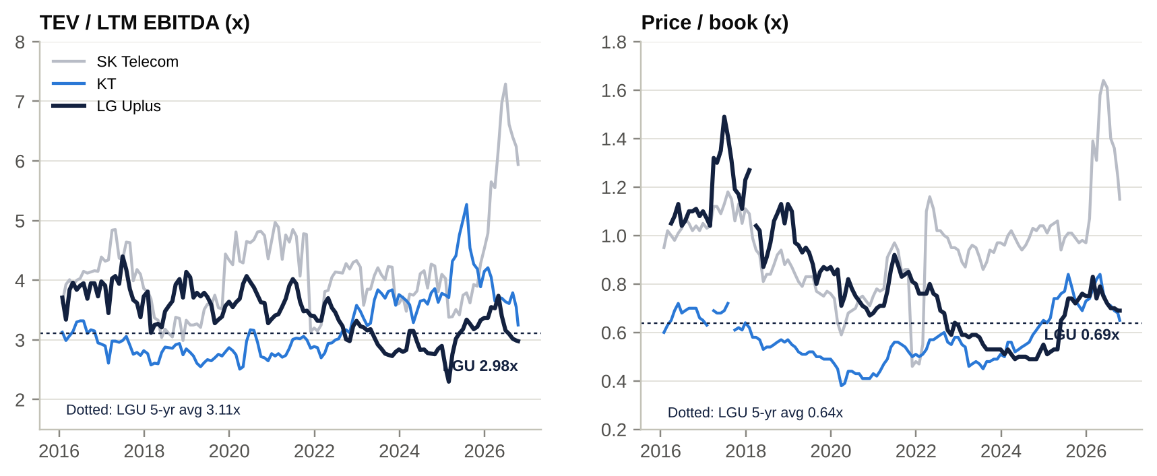
TEV/EBITDA and P/B history vs SKT and KT
Relative to its own history LG Uplus looks cheap on EV-based multiples (15th percentile of ten years) and fair on P/E and P/B. The P/E and P/B readings are depressed by weak earnings rather than a re-rating. Relative to peers, LG Uplus has de-rated against KT since 2023 (TEV/EBITDA ratio 0.92x now vs 1.1–1.45x in 2016–22) and against SK Telecom in 2026 (0.50x). SK Telecom’s re-rating partly reflects depressed LTM EBITDA after its breach, but it also reflects the SK Horizon data-centre mark. That is exactly the re-rating LG Uplus has not yet received.

Regression: TEV/Sales vs EBIT margin
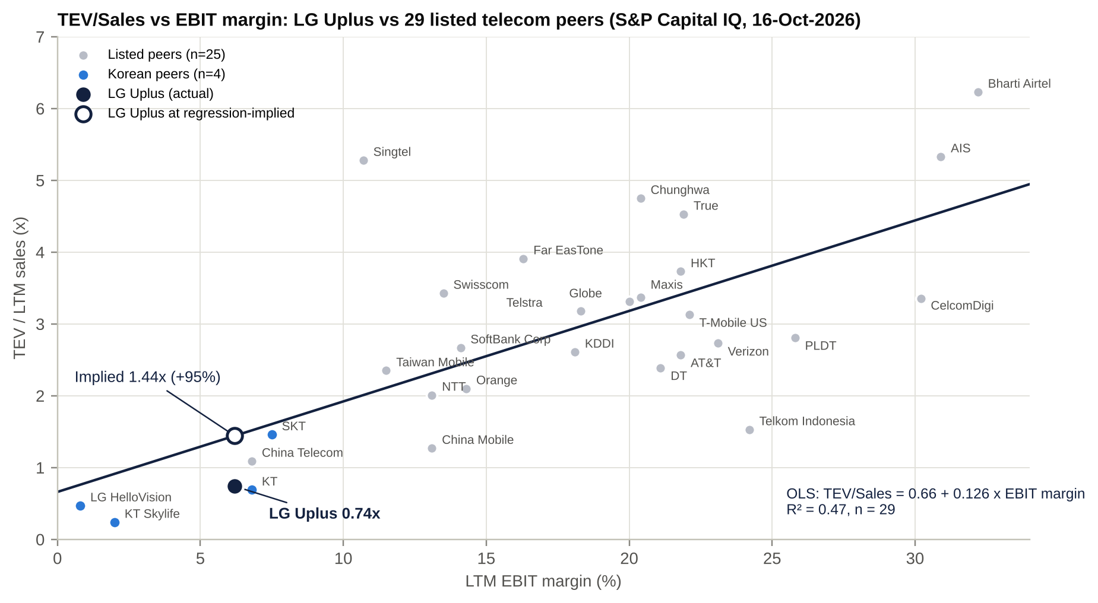
TEV/Sales vs EBIT margin regression
Specification | Intercept | Slope (per 1pp EBIT margin) | Korea dummy | R² | n | Implied TEV/Sales for LG Uplus | vs actual 0.74x
All peers ex-LGU | 0.661 | 0.126 (s.e. 0.026) | – | 0.47 | 29 | 1.44x | +95%
Ex sub-scale cable (Skylife, LGHV) | 0.932 | 0.113 | – | 0.34 | 27 | 1.63x | +121%
With Korea country dummy | 1.291 | 0.098 (s.e. 0.034) | -0.993 (s.e. 0.775) | 0.50 | 29 | 0.90x | +22%
At our FY28E margin (7.9%), simple model | 0.661 | 0.126 | – | – | – | 1.66x | +124%
Reading the regression.
- EBIT margin explains about half of the cross-sectional variance in TEV/Sales. LG Uplus sits ~50% below the line: the market applies no credit for its EBITDA (24% margin) and penalises its D&A-heavy EBIT.
- Every Korean name sits below the line. Adding a Korea dummy halves the gap: the implied multiple is 0.90x, still ~22% above the current 0.74x. So most of the discount is country and regulatory, and the residual ~20% is company-specific (breach overhang, AIDC capex, LGHV).
- Each 1pp of EBIT margin is worth ~0.1x of sales, about KRW1.5tn of EV or ~KRW3,600 per share. Margin expansion from 6.2% to our FY28E 7.9% is worth ~KRW6,000–8,000 per share on the regression (Korea-dummy and simple slopes respectively) [e].

Listed and unlisted competitors
Competitor | Segment | Owner / parent | Listed? | Ticker
SK Telecom | Mobile (#1) | SK Group | Listed | 017670 KS
SK Broadband | Broadband, IPTV, cable (ex-Tbroad), IDC | SK Telecom (100%) | Unlisted | –
SK Horizon | Data centres (318MW) | SK Broadband 51%; KKR 29%; IMM–Stonebridge 20% | Unlisted | –
SK Telink (7mobile) | MVNO | SK Telecom | Unlisted | –
KT Corp | Mobile (#2 handsets), fixed line | Hyundai Motor (largest), NPS | Listed | 030200 KS
KT Skylife (incl. HCN) | Satellite and cable TV, MVNO | KT (~50% [u]) | Listed | 053210 KS
KT Cloud | Cloud and IDC | KT 92.6%; IMM Credit & Solutions | Unlisted | –
KT M Mobile | MVNO | KT | Unlisted | –
LG HelloVision (Hello Mobile) | Cable TV, MVNO | LG Uplus 58.6% | Listed | 037560 KS
U+ Mobile (Media Log) | MVNO | LG Uplus 99.6% | Unlisted | –
KB Liiv M | MVNO (bank) | KB Kookmin Bank | Parent listed | 105560 KS
Toss Mobile | MVNO (fintech) | Viva Republica | Unlisted | –
Woori WON Mobile | MVNO (bank) | Woori Bank | Parent listed | 316140 KS
Sejong Telecom (“Snowman”) | MVNO, fixed, IDC | Independent | Listed | 036630 KS
Free Telecom (freeT) | MVNO | Private [u] | Unlisted | –
D’Live | Cable TV / broadband | MBK Partners (PE) [u] | Unlisted | –
CMB | Cable TV / broadband | Private [u] | Unlisted | –
Samsung SDS | Cloud, IDC, IT services | Samsung Group | Listed | 018260 KS
NAVER (Naver Cloud) | Cloud / hyperscale IDC | NAVER | Parent listed | 035420 KS
Kakao | Captive IDC (Ansan) | Kakao | Listed | 035720 KS
LG CNS | IT services, AIDC design-build | LG Corp | Listed (Feb-2025 IPO) | 064400 KS
Equinix | Colocation (Seoul) | – | Listed | EQIX US
Digital Realty | Colocation (Seoul) | – | Listed | DLR US
Starlink Korea | LEO satellite broadband | SpaceX | Unlisted | –

M&A: industry activity, takeover potential and LG Uplus’s own deals

Comparable transactions (2019–2026)
Target | Acquirer | Announced | Value | EV/EBITDA | EV/Sales | Read-across
CJ Hello (now LGHV), 50%+1 | LG Uplus | Feb-2019 | KRW800bn (EV KRW2.12tn) | 6.3x [e] | 1.8x | Korean cable control deal; value since destroyed
Tbroad | SK Broadband (merger) | Apr-2019 | Tbroad ~KRW1.2tn | n/d | n/d | ~KRW410k per subscriber
Hyundai HCN | KT Skylife | Oct-2020 | KRW491bn | ~5.4x [e] | n/d | ~KRW357k per subscriber
PT Hutchison 3 Indonesia | Indosat (merger) | Sep-2021 | EV US$1.18bn | n/d | n/d | 4→3 consolidation
DTAC | True Corp (merger) | Nov-2021 | EV THB195bn | 11.1x [u] | 2.9x | 3→2 consolidation
Taiwan Star | Taiwan Mobile | Dec-2021 | EV NT$47bn | n/m | 3.7x | Spectrum-driven
Asia Pacific Telecom | Far EasTone | Feb-2022 | EV NT$44bn | n/m | 3.5x | Spectrum-driven
MasMovil / Orange Spain | Orange–MasMovil JV | Jul-2022 | EV €18.6bn | 7.2–8.7x | n/d | 4→3 in Spain
Vodafone UK / Three UK | Vodafone–CK Hutchison | Jun-2023 | 51/49 merger; 2026 buyout implies EV £13.85bn | n/d | n/d | 4→3 in the UK
KT Cloud (13.0%) | IMM Credit & Solutions | May-2023 | KRW600bn (post-money KRW4.6tn) | n/d | n/d | Korean cloud/IDC valuation
Lawson (50%) | KDDI (tender offer) | Feb-2024 | ¥497bn; EV ¥1.6tn | 5.2x | 1.5x | 16% premium
IGIS Hanam DC (40MW) | Macquarie Korea Infrastructure | 2024 | KRW734bn | n/d | n/d | ~KRW18bn per MW
Smartfren | XL Axiata (XLSmart merger) | Dec-2024 | Combined EV US$6.5bn | ~5.3x | n/d | 4→3 in Indonesia
Frontier Communications | Verizon | Sep-2024 | EV US$21.5bn | 9.8–10.1x | 3.7x | Fibre
AirTrunk | Blackstone / CPP | Sep-2024 | EV A$24bn | n/d (very high) | n/d | Hyperscale DC platform
TPG Telecom fibre & EGW | Vocus (Macquarie) | Oct-2024 | EV A$5.25bn | n/d | n/d | Telco fixed-asset monetisation
SK Broadband (24.8% minority) | SK Telecom | Nov-2024 | KRW1.15tn (EV KRW6.47tn) | 4.9x | 1.47x | Closest Korean telecom comp
NTT Data (~42% minority) | NTT (take-private) | May-2025 | ¥2.37tn; EV ¥9.0tn | 13.1x | 1.95x | 34% premium
Cox Communications | Charter | May-2025 | EV US$34.5bn | 6.4x | n/d | US cable
Telefónica Argentina | Telecom Argentina | Feb-2025 | US$1.25bn | n/d | n/d | LatAm exit
Pangyo DC (SK Inc.) | SK Broadband | 2025 | KRW507bn | n/d | n/d | Intra-group IDC consolidation
SK Horizon (49%) | KKR (29%), IMM (20%) | Aug-2026 | KRW3.08tn for 49%; post-money equity ~KRW6.3tn | n/d | ~14.6x pre-money sales [e] | Key AIDC mark for LG Uplus
NTT Docomo (33.8%) | NTT (take-private) | Sep-2020 | ¥4.25tn; EV ¥12.65tn | 8.8x | 2.7x | ~40% premium [u]
Source: S&P Capital IQ Transactions, company releases, press. [e] multiples use S&P standardised EBITDA.
Industry M&A themes.
- In-market consolidation, 4→3 or 3→2, at 5–9x EBITDA: Indonesia, Thailand, Spain, the UK.
- Parent buyouts of listed telecom subsidiaries at 16–40% premia: NTT Docomo, NTT Data, KDDI–Lawson.
- Telecom infrastructure carve-outs priced as infrastructure (fibre, towers, data centres): TPG/Vocus, SK Horizon, KT Cloud.
- In Korea, cable consolidation into the MNOs (2019–21) and SK Telecom’s buyout of SK Broadband minorities at 4.9x.

Is LG Uplus a takeover target?
Our view: a full takeover is unlikely (<10% probability over 24 months [e]). Partial monetisation events are likely. The plausible events are a minority sale of the AIDC business, an LGHV squeeze-out or sale, or a block sale by LG Corp to a strategic investor.
Pros (why a bidder could be interested) | Impediments
2.9x EV/EBITDA vs 4.9–6.3x Korean precedents and 5–9x APAC/EU | LG Corp’s 38.7% control; LG Uplus is the group’s only telecom and its consumer “AX” showcase
Hidden AIDC value: 8–15x sales precedents (SK Horizon) vs a 3x telecom multiple | 49% statutory foreign-ownership cap (~7pp headroom); MSIT public-interest review (2026 amendment allows conditions)
13% FCF yield; AA+ balance sheet with debt capacity for leverage | No domestic strategic buyer: SKT or KT would fail antitrust (2 players)
FTA route: US/EU investors can exceed 49% indirectly via a Korean entity (KT and SKT are excluded from this route; LG Uplus is not [u]) | National-security sensitivity (Huawei 5G gear; 2025 hacking case and police probe)
Non-core portfolio is cleanable (LGHV, VoltUp, Media Log, startup stakes) | Bond change-of-control covenant (must stay within the LG Group); unions; political sensitivity of household telecom bills
LG Corp needs capital for AI, batteries and bio; its own value-up programme | Korea has no mandatory-bid rule: a buyer can deal with LG Corp alone, excluding minorities from any premium
Potential takeout multiples.
TEV / FY26E EBITDA | Implied value per share | Premium to KRW15,510 | Anchor
3.0x | 17,295 | +12% | Current trading level
3.5x | 21,893 | +41% | Japanese parent take-private premia (16–40%)
4.0x | 26,492 | +71% | –
4.9x | 34,770 | +124% | SK Broadband minority buyout (4.9x)
5.4x | 39,368 | +154% | Hyundai HCN (~5.4x), XL–Smartfren (~5.3x)
6.3x | 47,646 | +207% | CJ Hello (6.3x), Charter–Cox (6.4x)
Equity value = multiple × FY26E EBITDA (KRW3,904bn) − net debt (KRW4,508bn) − LGHV minorities at market + 50% of investments. Capital IQ TEV basis.
A realistic control price, if one ever arose, would be ~3.5–4.0x (KRW22–26k). That is a 40–70% premium, yet still well below Korean and APAC precedents. A control buyer could pay up and still buy cheap, which is the core of the event optionality. Sum-of-the-parts on a carve-out basis gives ~KRW20–30k (see Scenario analysis).

LG Uplus’s own acquisitions and disposals (last 10 years)
Date | Target / asset | Type | Consideration | Implied multiple | Outcome
Apr-2017 | KT Music (Genie Music), 15% | Strategic stake | n/d | n/d | Diluted to 9.99%; book ~KRW23bn vs market ~KRW6bn
Feb-2019 (closed Dec-2019) | CJ Hello (LG HelloVision), 50%+1 share | Control acquisition | KRW800bn (KRW20,659/share) | EV/EBITDA 6.3x; EV/Sales 1.8x | Value-destructive. LGHV EBITDA fell from KRW339bn (FY18) to KRW122bn (FY25); KRW164bn impairment in FY20; stake now worth ~KRW69bn
Dec-2019 (closed Aug-2020) | Payment-gateway business → Toss Payments | Disposal | KRW365bn | n/d | Good exit of a non-core business
2021–23 | 18 start-ups (Dream Factory, Monster Studio, Hodoo Labs, Zipdoc, Genie Works, VentaX and others) | Minority / RCPS | ~KRW90bn total | n/d | U+3.0 platform bets; mixed (Zipdoc written off)
Sep-2022 | Obigo (connected-car software), 5% | Minority | KRW7.2bn | Implied EV KRW121bn | Small
2022–May 2023 | Watcha (OTT) | Planned control investment (~KRW40bn) | n/a | n/a | Abandoned; IP dispute (KIPO partly against LG Uplus, Mar-2026 [u])
Jun-2023 / Jun-2024 | LG U+ VoltUp (EV-charging JV with Kakao Mobility), 50%+1 | JV; LG Uplus contributed its charging business (KRW42bn) | KRW50bn cash in total | n/d | Sub-scale
Jan-2024 | 42Maru (AI/LLM) | Minority (RCPS) | KRW10bn | n/d | AICC technology
Apr-2024 | Paju land and buildings (73,712 m²) from LG Display | Real-estate purchase (related party) | KRW105.3bn | n/a | Site for the 200MW AIDC campus
May-2024 | LG HelloVision additional 8.61% | Stake increase to 58.61% | ~KRW20.6bn [e] (~KRW3,090/share) | ~0.15x the 2019 entry price | Cheap consolidation of control
Dec-2025 → Mar-2026 | Revu Corp 8.32% | Disposal (with a PE fund) | ~KRW13.9bn [e] | n/d | Collapsed (buyer failed to perform)
Aug-2026 | PAGO Networks (managed security, SE Asia) | Acquisition | n/d | n/d | In-house security after the 2025 hacking case
Sep-2026 | NEXUS Co. (alongside KT) | Minority | KRW0.48bn | n/a | Ecosystem
Assessment. Outside CJ Hello, LG Uplus has been a small, cautious acquirer, and its one large deal destroyed ~KRW0.7tn of value. Since 2024, capital allocation has moved to organic AIDC investment (Paju) and small security/AI bolt-ons.

Management assessment

Key executives
Executive | Role / tenure | Track record | Skin in the game | Pay
Hong Bum-shik (b. 1968) | CEO and representative director. Named 21-Nov-2024; inside director since Mar-2025. LG Uplus non-executive director (for LG Corp) 2022–25 | Ex-SK Telecom (new business), Bain & Co. (head of Bain Korea; APAC TMT head). Head of LG Corp’s Business Strategy Division from 2019 (group M&A and growth strategy). At LG Uplus: Nov-2024 value-up plan; AX reorganisations (Dec-24, Dec-25); early retirement of ~600 staff; buybacks and cancellations; accelerated Paju AIDC to 200MW; tariff simplification; security rebuild (PAGO). FY25 NI +40%; record 2Q26 OP | 20,000 shares bought on-market (Aug-2025, ~KRW294m), ~0.005% | FY25 KRW1.44bn (salary + allowance; no bonus)
Yeo Myung-hee | CFO and CRO since 2023; inside director since Mar-2023 (re-elected Mar-2026 with 98.3%). Promoted to EVP Nov-2025. LG Uplus’s first female inside director | Career LG Uplus finance (head of accounting, then management planning). Architect of the capital-return programme; delivered the AA+ upgrades | ≥5,000 shares (Mar-2024) | FY24 KRW622m (salary 479m, bonus 140m)
Kwon Yong-hyun | EVP, head of Enterprise / AI B2B (AICC, AIDC) | Ex-LG Economic Research Institute; former LG Uplus CSO; leads the AIDC/DBO push | n/d | n/d
Lee Sang-yeop | CTO; head of AX Tech Platform | CTO through the 2023 breach and DDoS outages (appeared at the public apology) and the 2025 APPM case | n/d | n/d
Yang Hyo-seok | EVP, CHO (HR and labour relations) | Led the 2025 early-retirement programme | n/d | n/d
Lee Jae-won | EVP, head of MX / Digital Innovation (mobile) | Ex-LG Corp management strategy; credited with mobile growth | n/d | n/d
Predecessor: Hwang Hyun-sik | CEO Mar-2021 to Nov-2024; replaced mid-term (term ran to Mar-2027) | First internally promoted CEO. Delivered the first OP above KRW1tn (FY22). U+3.0 platform strategy largely missed. 2023 breach and DDoS outages; FY24 OP -13.5% | ~60.8k shares [e] | FY25 KRW5.75bn incl. KRW4.45bn retirement pay
Predecessor: Ha Hyun-hwoi | CEO 2018–2020 | Ex-LG Corp CEO/vice-chairman. Bought CJ Hello for KRW800bn at a ~75% premium to market; 5G launch; Netflix tie-up; Huawei controversy; sold payments to Toss | n/d | n/d
Sources: LG releases, DART pay disclosures via press, S&P Capital IQ Professionals. Capital IQ lists a “COO Young-Soo Kwon”; this is a data error (Kwon Young-soo was CEO in 2015–18). S&P also lists stale directors.

Capital allocation and returns under each CEO
Regime | Fiscal years | Average ROE | Average ROIC | Key capital-allocation decisions | Verdict
Kwon Young-soo | FY17 | 10.9% | 8.2% | LTE harvesting; Genie stake | Best returns of the decade (pre-5G)
Ha Hyun-hwoi | FY18–FY20 | 6.9% | 5.2% | 5G licence (KRW817bn [u]) and build; CJ Hello KRW800bn; Toss sale | Expanded invested capital ~50% with flat NOPAT: value-destructive
Hwang Hyun-sik | FY21–FY24 | 7.4% | 5.2% | KRW100bn buyback (2021); 5G capex peak; ~KRW90bn start-up bets; Watcha abandoned | Mixed: good opex discipline, poor diversification
Hong Bum-shik | FY25–1H26 | 6.0% (FY25); ~8.8% annualised 1H26 [e] | 4.4% (FY25) | Value-up plan; KRW180bn of buybacks cancelled; ERP; Paju 200MW (~KRW2tn); PAGO | Disciplined on returns and costs; the AIDC bet is the defining call
ROE = net income ÷ average common equity; ROIC = OP × (1 − tax) ÷ average (equity + debt − cash), on S&P data [e].

Red flags
- Security governance.
  - Two breaches in three years.
  - In 2025 affected servers were reformatted or discarded before the government probe, which led to a referral to police for obstruction (Dec-2025 / Jul-2026). Police raided the integrated control centre (mid-2026 [u]).
  - The same CTO remains in post.
- Mid-term CEO removal by the parent (Hwang, Nov-2024) and a KRW4.45bn retirement payout. The CEO is effectively selected in LG Corp’s year-end reshuffle.
- Strategy pivots with each CEO: “5G leader” (Ha) → “U+3.0 platform company” (Hwang) → “AX company” (Hong). Core ROE has not improved through any of them. The “AI” rebranding has some promotional character, although AIDC revenue is real.
- Related-party spending.
  - LG CNS received ~KRW501bn in 2024 (~3.4% of revenue) [u].
  - Brand royalty to LG Corp (~KRW25–28bn a year [e]).
  - Paju land bought from LG Display (KRW105bn).
  - LG CNS also competes with LG Uplus in AIDC design-build.
- Compensation and ownership. Pay is cash-only, with no equity-linked pay disclosed and negligible insider ownership (<0.02% combined). Alignment with minorities comes from the value-up policy, not from incentives.
- Internal controls. In 2022 a team leader embezzled “tens of billions of KRW” through fake multi-line dealer contracts [u].
Archetype: professional chaebol managers, not founders. All recent CEOs have been LG Group professional managers rotated by the parent; two of the last three came straight from LG Corp’s strategy office. For a mature, regulated utility this is appropriate. The CEO is credible with the holding company and executes group priorities, including value-up and AI. The trade-off is that strategic choices that would hurt LG Group interests are unlikely: selling LGHV to a rival, cutting LG CNS spend, or selling the AIDC to outsiders. That is where an outside shareholder could add value.
Recent senior-management changes.
- 21-Nov-2024: Hong replaced Hwang; LG Uplus was the only LG affiliate to change CEO that year.
- 25-Mar-2025: Hong became representative director.
- 27-Nov-2025: Hong retained; Kwon Yong-hyun, Yang Hyo-seok and Yeo Myung-hee promoted to EVP.
- 1-Dec-2025: reorganisation; strategy and AX now report directly to the CEO, and network became a standalone growth axis.
- The next LG Group reshuffle (late Nov-2026) will decide Hong’s continuity. We expect him to stay [e].

Board of directors
Director | Category | First appointed | Term to (est.) | Professional background | Other affiliations / committees
Hong Bum-shik | Inside (CEO) | Mar-2022 (as non-executive); inside from Mar-2025 | ~Mar-2028 | SK Telecom, Bain & Co., LG Corp strategy head | Finance and nominating committees [u]; ex-director at LG HelloVision and LG CNS
Yeo Myung-hee | Inside (CFO/CRO) | Mar-2023; re-elected Mar-2026 | ~Mar-2029 | LG Uplus finance career | Finance committee [u]
Lee Sang-woo | Non-executive (represents LG Corp) | Mar-2026 | ~Mar-2029 | EVP and head of LG Corp’s Business Strategy Division | Nominating committee [u]
Nam Hyung-doo | Independent; board chair since 24-Mar-2026 (first independent chair) | Mar-2022; re-elected Mar-2025 | ~Mar-2028 (6-year cap) | Professor, Yonsei Law School (copyright, IP, content law) | Chair of the Internal Transactions Committee; audit committee
Eom Yoon-mi | Independent; separately elected audit-committee member | 2022 [u]; re-elected Mar-2023 and Mar-2026 | ~Mar-2029 | CSO, Seed Book Culture Foundation; ex-McKinsey; ex-Kakao Impact | Audit committee (ESG)
Kim Jong-woo | Independent | Mar-2021; re-elected Mar-2024 | ~Mar-2027 (6-year cap) | Professor, Hanyang University Business School (data mining, AI) | Audit committee
Song Min-seop | Independent | Mar-2026 | ~Mar-2029 | Professor of accounting, Sogang University; ex-adviser to the Board of Audit and Inspection | Audit committee (accounting expert)
Composition.
- Seven directors, four independent (57%, the legal minimum majority).
- Two women (29%).
- Chair and CEO separated since Mar-2026.
- The audit committee is all-independent (four members).
- Articles amended in Mar-2026: majority independent directors; electronic AGM from 2027; data-centre/DBO business purposes added. The articles also exclude cumulative voting [u], which may become void under the 2025 Commercial Act amendments for large companies [u].
Board changes in the last five years.
AGM | Joined | Left
Mar-2021 | Hwang Hyun-sik (inside/CEO); Yoon Sung-soo, Je Hyun-joo, Kim Jong-woo (independent) | Ha Hyun-hwoi; prior outside directors [u]
Mar-2022 | Nam Hyung-doo (independent); Hong Bum-shik (non-executive, LG Corp) | Kwon Young-soo (LG Corp non-executive; moved to LG Energy Solution) [u]
Mar-2023 | Yeo Myung-hee (inside, CFO) | Lee Hyuk-joo (ex-CFO) [u]; Yoon Sung-soo and Eom Yoon-mi re-elected
Mar-2024 | – (Hwang and Kim Jong-woo re-elected) | –
Mar-2025 | Hong Bum-shik (inside); Kwon Bong-seok (LG Corp COO; non-executive) | Hwang Hyun-sik; Nam re-elected
Mar-2026 | Lee Sang-woo (non-executive, LG Corp); Song Min-seop (independent, audit); Nam named chair | Kwon Bong-seok [u]; Yoon Sung-soo [u]; Lee Jae-ho (6-year cap) [u]
Source: LG Group releases, press, MarketScreener; departures marked [u] are inferred.

Shareholders, activism and short interest

Top shareholders
# | Holder | Type | Shares (m) | % of 424.43m | Date / note
1 | LG Corp | Strategic parent (holding company) | 164.42 | 38.74% | 30-Jun-2026 (DART); rising only through cancellations
2 | National Pension Service | Domestic public pension | 27.13 | 6.39% | 30-Jun-2026 (DART); 7.02% at YE24
3 | Kopernik Global Investors | Foreign value manager | ~18 [e] | ~4.3% [u] | Dec-2025; was 6.1–6.2% in 2024 filings
4 | Vanguard Group (index funds) | Foreign passive | n/d | ~1–2% [u] | Not disclosed (below the 5% threshold)
5 | BlackRock (iShares) | Foreign passive | n/d | ~1% [u] | Not disclosed
6 | Mackenzie Investments | Foreign institution | 1.40 | 0.33% | MarketScreener, Jul-2026 [u]
7 | Research Affiliates | Foreign institution | 1.08 | 0.25% | MarketScreener [u]
8 | State Street Global Advisors | Foreign passive | ~0.8 | ~0.19% | MarketScreener [u]
9 | Niche Asset Management | Institution | 0.73 | 0.17% | MarketScreener [u]
10 | Nordea Investment Management | Foreign institution | 0.57 | 0.13% | MarketScreener [u]
– | Directors and officers | Insiders | ~0.09 | <0.02% | Hong 20k; Yeo ≥5k; Hwang ~60.8k [e]
– | Treasury shares | Company | 0 at 30-Jun-2026 | 0% | KRW90bn buyback buying since 14-Aug-2026 (~6.0m shares by Feb-2027)
– | Aggregate foreign ownership | – | ~178 | ~41.9% | Apr-2026; 49% statutory cap
– | Minority / free float | – | – | ~55% | ex LG Corp and NPS
DART 5% filings and the full register could not be accessed; holders 4–10 are indicative only. Index weights are constrained by the foreign-ownership cap.

Shareholder activism
- No activist campaign, shareholder proposal or proxy fight at LG Uplus has been identified (2018–2026). NPS’s published 2026 “against” votes did not include LG Uplus.
- The closest precedent is LG Chem (Oct-2025 to Mar-2026). Palliser Capital (~1%, backed by Carmignac, with ISS and Glass Lewis support) demanded:
  - sale of ~10% of LG Energy Solution, with buybacks and cancellations;
  - a lead independent director;
  - equity-linked executive pay.
- All proposals were rejected at the 31-Mar-2026 AGM, with NPS voting against.
- Implications for LG Uplus. The demands an activist would make here are easy to frame:
  - Monetise the AIDC through a minority sale on the SK Horizon template, and return part of the proceeds.
  - Lift the payout to the 60% ceiling, with all buybacks cancelled.
  - Simplify LG HelloVision.
  - Publish related-party spend (LG CNS, brand fee) and benchmark it.
  - Introduce equity-linked pay.
- LG Corp’s 38.7% stake makes a proxy win improbable. The leverage comes from the 2025 Commercial Act changes:
  - fiduciary duty to shareholders;
  - separate election of audit-committee members, with the 3% rule;
  - mandatory cumulative voting for large companies [u].
- A coalition of ~10–15% of minorities could plausibly seat one director at the March 2027 AGM.
- Activist success odds: low on control issues, moderate on capital returns. Management has already moved pre-emptively, alongside the LG Group-wide value-up disclosures of Nov-2025.

Short interest
- Short balance: not retrievable from our sources. KRX disclosure was not accessible. LG Uplus does not appear in KRX’s top short-balance lists (May, Aug and Oct 2026), and no holder at or above the 0.5% public-disclosure threshold was found.
- Korea fully resumed short selling on 31-Mar-2025. The KOSPI net short balance hit a record above KRW20tn in May–Jun 2026, concentrated in semiconductors and batteries.
- Our estimate: short interest under 1% of shares [e]. This is a low-beta, high-dividend stock with an ongoing buyback and negative correlation to the market; the shorting that exists is probably pair or hedge activity against KT/SKT or the index. No known short-seller campaign.

Strategic initiatives (last 10 years): success, failure and status
Initiative | Years | What | Result / status | Assessment
Huawei 5G radio | 2018–20 | Only Korean MNO to choose Huawei for 5G | Faster and cheaper roll-out; persistent US pressure (stock -6.4% on one day in May-2019) | Delivered on cost; lasting geopolitical overhang
5G launch | Apr-2019 | World-first commercial 5G | 85% penetration; ARPU uplift now exhausted | Done; neutral
Netflix / Disney+ IPTV exclusives | 2018 / 2021 | First Korean IPTV partner for Netflix; Disney+ exclusive | Helped IPTV net adds; exclusivity value eroded | Tactical success
CJ Hello (LG HelloVision) | 2019– | Become #2 in pay-TV | EBITDA -64% since FY18; impairments; stake worth ~10% of book | Failure
Payments sale (Toss) | 2019–20 | Exit fintech for KRW365bn | Done | Success
“U+3.0” platform pivot | 2022–24 | Four platforms; target 40% non-telecom revenue and KRW12tn EV by 2027 | ~KRW90bn into 18 start-ups; EV ~KRW11tn today; several platforms closed (Idol Plus, Sporki, metaverse) | Largely missed
Smart factory / smart mobility / metaverse | 2021–24 | B2B platform bets | Exited 2024–25 | Failure (small)
EV charging (VoltUp JV with Kakao Mobility) | 2023– | 50%+1 JV | ~10k chargers; sub-scale; partner friction reported [u] | Unproven; candidate for exit
Value-up programme | Nov-2024– | ROE 8–10%; return up to 60%; cancellations; D/E ~100% | KRW180bn cancelled; DPS rising; ROE 6% (FY25) | On track for returns; ROE still a stretch
AX company / ixi-O AI agent | 2024– | On-device AI call agent; AICC; ixi-GEN sLLM | ixi-O >1m users; AICC revenue +30% (FY25); export to Maxis | Retention tool; early-stage revenue
IDC / AIDC (“ACE on Trust”) | 2023–30 | Pyeongchon #2; Gasan DBO; Paju 200MW (~KRW2tn); KRW5tn order target | AIDC +29–31% in 1H26; Paju DC1 sold out [u]; DC2/3 tenants undisclosed | Most valuable initiative; execution risk
Cost reset | 2025 | Early retirement of ~600 staff (KRW150bn); tariff simplification | Labour -2.5% YoY in 2Q26 | Working
Security rebuild | 2023–26 | Security capex pledge; PAGO acquisition (Aug-2026) | 2025 APPM case and police probe remain open | Unresolved
6G / 5G standalone | 2026– | 5G SA by end-2026 (software upgrade) | On plan | Neutral

Stakes in other companies
Holding | Listed? | Stake | Book value (KRW bn) | Market value (KRW bn) | Strategic relevance | Financial relevance
LG HelloVision (037560 KS) | Yes | 58.61% | 656 (separate) | ~69 | Cable TV, Hello Mobile MVNO, B2G; regional broadband | Low (~8% of revenue, ~3% of EBITDA). An impairment risk at parent level; cheap to squeeze out (~KRW50–70bn)
Media Log (U+ Mobile) | No | 99.6% | 64 | n/a | Captive MVNO (low-end defence) | Small
LG U+ VoltUp (EV charging) | No | 50%+1 | 50 | n/a | EV-charging JV with Kakao Mobility | Small; sub-scale
Dacom Crossing | No | 51% (JV) | 17 | n/a | International / submarine capacity | Small
KT Genie Music (043610 KS) | Yes | 9.99% | 23 | ~6 | Music content for bundles | Negligible
Revu Corp (443250 KS) | Yes | 8.3% | 8 | ~5 | Influencer marketing | Negligible (sale collapsed)
Obigo (352910 KS) | Yes | ~5% [u] | n/d | ~3 | Connected-car software | Negligible
CVC funds (LG UPLUS FUND I/II), KB Telecom ESG fund, start-up RCPS | No | various | ~200 | n/a | Ecosystem and AI sourcing | Small
Total listed stakes (market value) |  |  |  | ~KRW82bn |  | ~1.2% of market cap
Source: S&P Capital IQ (1Q25 quarterly report subsidiary table), market prices Oct-2026 [e]; refresh against the FY2025 annual report.
Relevance. Stakes are financially immaterial. The relevant “hidden asset” is not an investment holding but the in-house AIDC business, which has no separate listing or market mark. LGHV matters because of governance and simplification: a squeeze-out would remove a loss-making listed subsidiary, and its minority shareholders, for the cost of roughly one month of FCF.

Shareholder returns: dividends, buybacks and treasury shares
Fiscal year | Interim DPS (KRW) | Final DPS (KRW) | Total DPS | Dividends declared (KRW bn) | Payout (consol. / separate) | Buyback | Treasury shares at year-end | Cancellation
FY2020 | – | 450 | 450 | ~197 | n/d | – | 3 | –
FY2021 | 200 (first interim) | 350 | 550 | ~238 | ~33% / ~35% | KRW100bn (6,783,006 shares, Jun–Dec 2021, ~KRW14,743/share) | 6,783,009 (1.55%) | –
FY2022 | 250 | 400 | 650 | 279 | 42.1% / 42.2% | – | 6,783,009 | –
FY2023 | 250 | 400 | 650 | 279 | 44.9% / 43.2% | – | 6,783,009 | –
FY2024 | 250 | 400 (record 31-Mar-2025) | 650 | 279 | 74.6% / 59.1% | – (value-up plan 22-Nov-2024) | 6,783,009 | –
FY2025 | 250 | 410 (record 31-Mar-2026) | 660 | 282 | 53.7% / 51.9% | KRW80bn (5,400,620 shares, Aug-2025 to Feb-2026, ~KRW14,813/share) | 4,059,811 (0.94%) | 5-Aug-2025: 6,783,006 shares (1.55%)
FY2026 YTD | 270 (+8%; record 13-Aug-2026) | TBD (late Jan-2027) | 700E | ~297E | ~42%E | KRW90bn (14-Aug-2026 to 13-Feb-2027; ~6.0m shares) | 0 at 30-Jun-2026 | 15-May-2026: 5,400,623 shares (1.26%)
Totals FY2021–FY2025. Dividends ~KRW1.36tn plus buybacks KRW180bn, ~53% of cumulative net income (KRW2.90tn). Issued shares fell from 436.6m to 424.4m (-2.8%) and will reach ~418.4m (-4.2%) after the current programme is cancelled.
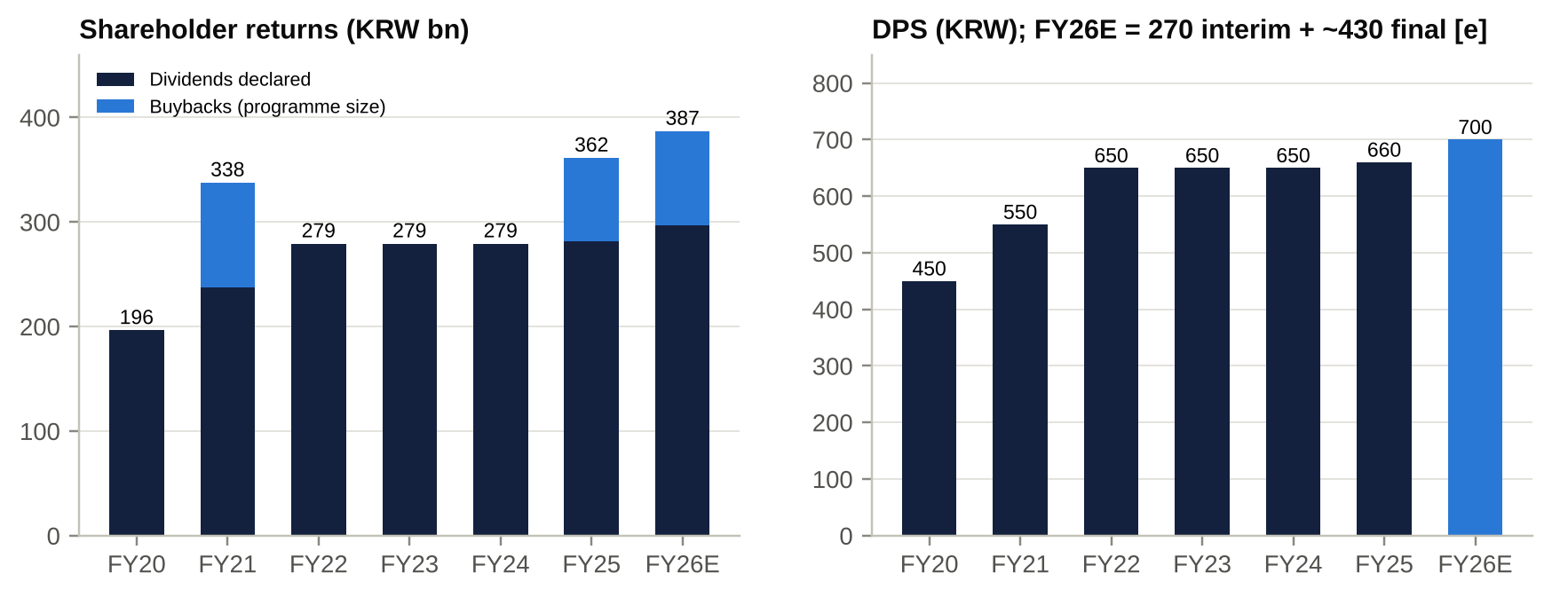
Shareholder returns
Policy.
- Dividends: at least 40% of separate net income excluding one-offs, with DPS no lower than the prior year.
- Buybacks: 0–20% of net income depending on FCF.
- Total return: 40–60%.
- FY25 total return was ~66.6% of separate net income [e], above the ceiling.
- The new dividend procedure (board sets the DPS before the record date, since 2024) and “high-dividend company” status for 2025 support domestic demand under the separate dividend-tax regime [u].

Adversarial analysis: bull case, bear case, pre-mortem and contrarian view

Bull case
- Competitive advantages and moat sustainability.
  - A licence-protected three-player oligopoly with no realistic new entrant: the 4th-carrier attempts failed and 28GHz was abandoned.
  - Sticky bundled households.
  - EBITDA of KRW3.4–3.6tn every year for five years.
  - LG Uplus now leads KT on total lines (29.8% share) and has the lowest churn in its history.
- Growth levers and secular tailwinds.
  - AI data centres: Paju 200MW, DC1 reportedly pre-let, AIDC revenue +29–31%, a KRW5tn order target by 2030. Each 100bn of AIDC revenue is worth ~KRW1,900 a share at 8x sales.
  - AICC (+50% guided) and ixi-O exports.
  - Enterprise lines.
  - Rivals’ security failures are pushing share towards LG Uplus.
- Potential earnings surprises.
  - Labour savings run ~KRW60–70bn a year.
  - D&A should fall as 2019–23 5G capex rolls off.
  - Marketing could normalise below 20% of service revenue.
  - The tax-rate spike should reverse.
  - Together these could take FY27 OP to KRW1.25–1.30tn, versus our KRW1.185tn and consensus KRW1.232tn.
- Capital allocation.
  - Every repurchased share has been cancelled since 2025.
  - DPS is rising (+8% interim).
  - Payout is moving towards 60%.
  - Leverage is falling, with AA+ ratings.
  - Shareholder yield is 5.9% today, rising to ~7% if management goes to the policy ceiling.
- Valuation asymmetry.
  - At 2.9x EBITDA, 0.73x book and a 13% FCF yield, the market is paying little for AIDC.
  - On the SK Horizon mark the AIDC alone could be worth 45–120% of the market cap.

Bear case: risks that could permanently impair the business
- Regulatory “public-good” squeeze.
  - The government can cut tariffs, mandate “data safety-net” plans, order fee waivers and raise spectrum fees at will.
  - The PIPC case is different in kind. LG Uplus is accused of destroying evidence, the PIPC is seeking fines of up to 3% of revenue for that conduct, and the precedents are KRW135bn for SKT and KRW54bn for KT.
  - A fine of KRW100–300bn plus licence conditions is possible. Any of these could cap ROE permanently below the cost of equity.
- AIDC over-investment.
  - ~KRW2tn (30% of the market cap) is being committed to a business in which LG Uplus has less scale than SK Horizon (318MW, with KKR/IMM capital and the AWS Ulsan JV) and KT Cloud, and in which hyperscalers can self-build.
  - Korea’s power-grid constraints and a cooling of AI capex could leave DC2–DC4 under-let, with depreciation arriving before revenue.
- Competitive margin compression.
  - With the handset-subsidy cap abolished in Jul-2025, a recovering SK Telecom could buy back share.
  - Bank and fintech MVNOs (KB Liiv M, Toss) undercut the value segment, partly on LG Uplus’s own network.
  - Marketing is capitalised and amortised, so a subsidy war hurts OP for two to three years.
- Revenue deceleration is already visible.
  - Mobile service growth slowed from +5.2% (3Q25) to +1.2% (2Q26).
  - 5G penetration has saturated.
  - LGHV revenue fell 31%.
- High expectations? Not really. Consensus FY26 OP of KRW1,149bn (+29%) is largely banked by 1H26. The 9x P/E and 4.5% yield do not embed heroic growth. The risk is that FY27–28 consensus (+7% and +5% OP) proves too high.

Pre-mortem: it is October 2027 and the stock is at KRW11,000. What happened?
- PIPC fined LG Uplus ~KRW200bn and imposed security-investment conditions. Prosecutors indicted executives over the server wipe. The ESG and index exclusion that followed pushed foreign ownership down.
- MSCI deleted the stock in Nov-2026. Passive selling met no new buyers because domestic institutions rotated into the KOSPI rally.
- SK Telecom launched an aggressive subsidy campaign around the iPhone 18 launch to recover the share it lost in 2025. LG Uplus marketing rose to 22% of service revenue and FY27 OP fell 10%.
- Paju DC2/DC3 tenants failed to materialise when a hyperscaler chose SK Horizon’s Ulsan campus. Management paused the buyback (“flexible”) to fund capex. The dividend was held flat, so the payout fell back to 40%.
- The government’s 2027 5G re-allocation plan priced 3.5GHz above expectations.
What would we see first? Marketing above 21% of service revenue; any DPS or buyback below the prior year; a PIPC decision above KRW150bn; no Paju DC2 pre-let announcement by end-2027.

Are current multiples too high?
No. On every EV-based multiple LG Uplus is in the bottom quintile of its own ten-year history and of its global peer group. The place where valuation could be “too high” is P/E: 12.4x LTM, against a five-year average of 10.3x. That is because LTM earnings are depressed. If FY27 EPS comes in 20–30% below consensus (KRW1,345–1,538), the stock would trade at 10–11.5x that lower EPS at today’s price, close to its five-year average and not obviously cheap. That is the main valuation risk.

Contrarian view: what the market is refusing to see
- The telecom core is priced at ~1.8x EBITDA once the data-centre business is valued at even a heavily discounted market mark. The market capitalises LG Uplus’s EV of ~KRW11tn as if it were a single ex-growth telecom asset. In August 2026, though, infrastructure investors paid ~14.6x sales for SK Telecom’s data-centre business. LG Uplus has a comparable growth platform (IDC revenue ~KRW540bn FY26E, +28%; a 200MW campus under construction). Even at 8x sales, that is KRW4.3tn of value inside a KRW6.6tn market cap.
- Earnings quality is improving, not deteriorating.
  - The 5G capex cycle that crushed ROE from ~11% to ~4–6% is over: capex/sales has fallen from 17.5% to 11–14%, and that is what drove the AA+ upgrade.
  - D&A has peaked as a share of revenue.
  - Levered FCF yield is ~13% (LTM, Capital IQ) even as AIDC spend ramps.
- The stock is a hedge, not a value trap. It has become negatively correlated with KOSPI risk-on/risk-off swings: +10% in Sep–Oct 2026 while the KOSPI 200 fell 19%. In a portfolio it offers a 5.9% shareholder yield with negative beta.
- Governance optionality is underpriced.
  - Korea’s Commercial Act reforms make the LG Group’s minority-unfriendly choices costlier. Those choices include LG CNS spend, the LGHV structure and an un-monetised AIDC.
  - LG Corp’s own value-up pressure, and the precedent of Palliser at LG Chem, make an AIDC partnership or carve-out more likely than the market assumes.

Scenario analysis
Assumption | Bear (25%) | Base (50%) | Bull (25%)
Core telecom EBITDA (FY26E basis) | KRW3,550bn (subsidy war, tariff cuts) | KRW3,688bn (our estimate ex-AIDC) | KRW3,750bn (marketing <19%, labour savings)
Service revenue growth (FY27E) | ~0% | +2.1% | +3.5%
OP margin FY27E | ~6.0% | 7.6% | ~8.5%
Core EV/EBITDA | 2.4x (KT ex-KT Cloud) | 2.7x | 3.1x (LG Uplus 5-yr average)
AIDC valuation (FY26E sales KRW540bn) | 4x sales, less 30% | 8x sales, less 30% (not yet crystallised) | 10x sales (minority stake sold; ~30% below SK Horizon)
PIPC fine / contingencies | KRW150bn | KRW60bn | None
Equity value (KRW tn) | 5.5 | 8.6 | 12.7
Value per share (KRW) | 12,990 (-16%) | 20,150 (+30%) | 29,820 (+92%)
Implied TEV / FY26E EBITDA | 2.6x | 3.3x | 4.4x
Implied P/E on FY27E EPS | 7.4x | 11.5x | 17.0x
Probability-weighted value KRW20,775 (+34%). With the 4.5% dividend yield, expected 12-month total return is ~38%. Downside is cushioned by the dividend, the FCF yield and negative market beta. The upside depends almost entirely on the market valuing the AIDC.
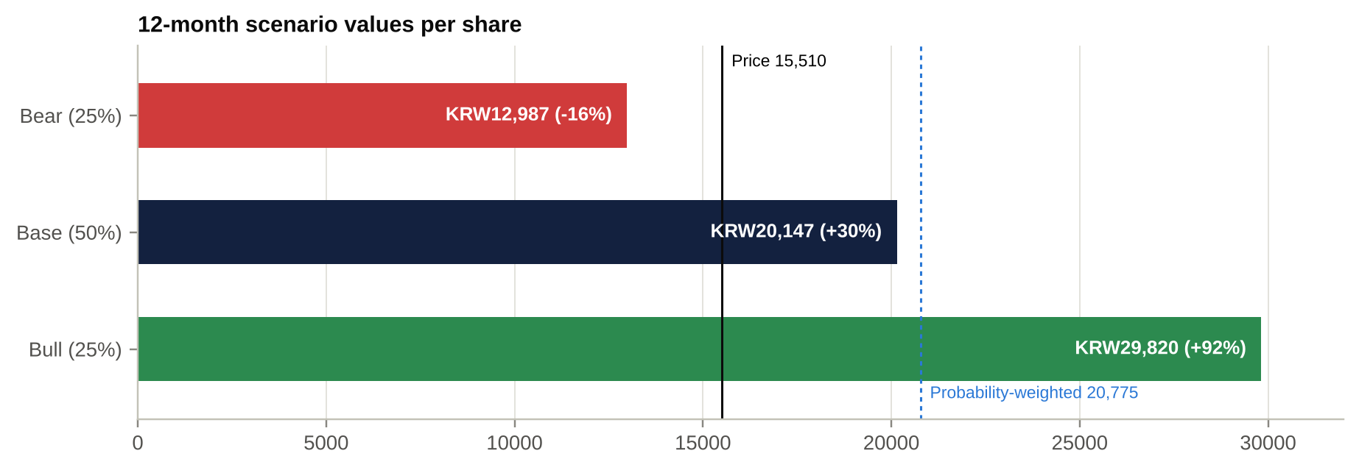
Scenario values
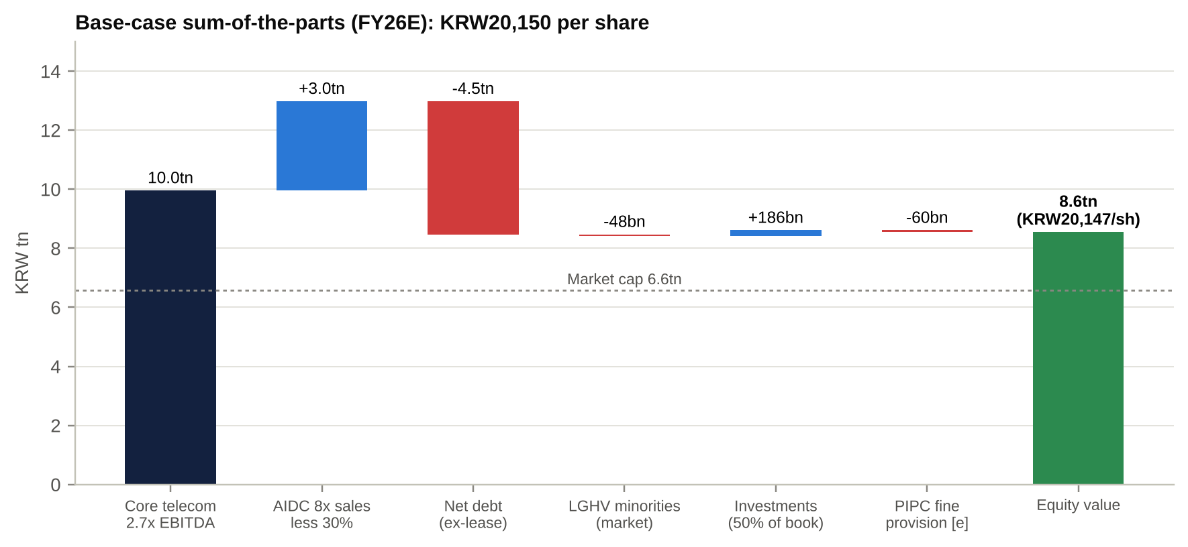
Base-case sum-of-the-parts
AIDC valuation sensitivity (no discount applied).
AIDC EV / FY26E sales | 4x | 6x | 8x | 10x | 14.6x (SK Horizon)
AIDC value (KRW tn) | 2.16 | 3.24 | 4.32 | 5.40 | 7.89
Per share (KRW) | 5,090 | 7,640 | 10,180 | 12,730 | 18,580
% of market cap | 33% | 49% | 66% | 82% | 120%
Implied core TEV/EBITDA at today’s price | 2.4x | 2.1x | 1.8x | 1.5x | 0.8x

Fifteen questions for the CEO / Chairman (ordered by information value)
- AIDC economics.
  - How many MW are contracted at Paju DC1, and what are the term, pricing and tenant mix?
  - What IRR and payback did the board require to approve the KRW1.35tn phase 2?
  - What is the leasing status of DC2–DC4?
- Value crystallisation. SK Telecom sold 49% of its data-centre business to KKR and IMM at ~15x sales. Under what conditions would LG Uplus bring in a financial partner for the AIDC, or separate it into a subsidiary?
- The 2025 hacking case.
  - Who authorised reformatting the APPM servers before the investigation?
  - What liability (PIPC fine, criminal exposure, compensation) do you expect?
  - What has changed in security governance and accountability, including at CTO level?
- Capital-allocation hierarchy. If AIDC demand surprises positively, will you cut buybacks to fund capex, or raise external capital? Is “capex within EBITDA” a hard constraint?
- ROE target. By which year will you reach ROE of 8–10%? What is the bridge (margin, capex, payout, leverage)? Would you commit to returning 60% of net income while ROE is below target?
- Competitive discipline after Dansuobeop. How will you respond if SK Telecom uses subsidies to recover share? What marketing-to-service-revenue ratio is your ceiling?
- LG HelloVision. What is the end-game: merger, squeeze-out of the 41% minority, or sale to another operator? Why keep a listed subsidiary trading at 0.26x book?
- Related parties. What share of IT capex and opex goes to LG CNS, and how is it tendered and benchmarked? How do you manage the overlap with LG CNS in AIDC design-build?
- Spectrum. What is LG Uplus’s expected cost for the 2026 3G/LTE re-allocation, and how is it phased? What do you expect for the 2028 5G re-allocation?
- Pricing and ARPU. What is the ARPU impact of “Simply 2.0”, the government’s mid-tier and safety-net plan push, and the 5G saturation?
- MVNO strategy. Is hosting bank and fintech MVNOs (KB Liiv M, Toss) value-accretive, or does it cannibalise your own retail base?
- Investor base and index eligibility. With foreign ownership near the cap, MSCI deletion risk and the S&P BMI removal, how will you broaden the shareholder base? Will you support relaxation of the foreign-ownership rules?
- AI monetisation. When will ixi-O and AICC become a disclosed revenue line? What is the cumulative AI investment versus the KRW2tn B2B AI revenue target for 2028?
- Governance and incentives.
  - Will you introduce equity-linked pay?
  - Will you raise board independence above the legal minimum?
  - How will you comply with mandatory cumulative voting?
- Labour and cost. Are further early-retirement programmes planned? What remaining liabilities stem from the ordinary-wage ruling? What headcount do you target by 2028?

Short-seller and forensic perspective: dismantling the bull case
What could structurally break the way LG Uplus makes money? The model is a regulated rent on spectrum. If the state decides telecom is a public utility whose returns should be capped, the rent shrinks; it has done so before (2017 tariff discount, 2022 mid-tier 5G, 2025–26 fee waivers). Each intervention transfers value from shareholders to subscribers, and LG Uplus, as #3 with the lowest margins, has the least cushion.
Where revenue is concentrated, and what happens if that shifts. Revenue is 100% Korean and ~41% mobile service, concentrated in ~11m handset subscribers. Two features compound the exposure:
- The FY25 growth spurt came from one-off inflows from rivals’ breaches. If SK Telecom and KT win those subscribers back, mobile service revenue could fall outright. In 2Q26 it grew only +1.2%.
- The AIDC growth story depends on a handful of undisclosed tenants. Losing one anchor tenant at Paju would wipe out a large part of the expected growth.
Why the moat may be weaker than bulls think.
- Regulators override switching costs: KT was ordered to waive termination fees.
- Number portability is instant, so the network is not differentiated.
- Bank and fintech MVNOs use LG Uplus’s own network to sell cheaper plans to LG Uplus’s own customers.
- In data centres LG Uplus has no moat at all. Power allocation, land and capital are the scarce inputs, and its rivals have more of each: SK Horizon has KKR/IMM capital and a 318MW portfolio, KT Cloud has IMM capital, and the hyperscalers can self-build.
The most dangerous competitor bulls underestimate: SK Telecom.
- It lost share after its 2025 breach.
- It now has KRW3.08tn of fresh KKR/IMM capital via SK Horizon.
- The subsidy cap has been abolished.
- It has re-rated to 5.7x EBITDA, and its management has every incentive to buy back share.
In data centres, the same SK Horizon competes directly for the hyperscale tenants Paju needs.
The worst capital-allocation decisions.
- CJ Hello (KRW800bn at a ~75% premium in 2019; worth ~KRW69bn today).
- The ~KRW90bn U+3.0 start-up spree and the platform closures.
- Committing ~KRW2tn to AIDC while ROIC is ~4–5%. That is good if returns exceed the cost of capital, but disclosure of the hurdle rate is absent.
Related parties, accounting and incentives.
- LG CNS takes ~KRW500bn a year of spend.
- The brand royalty goes to LG Corp.
- Land was bought from LG Display.
- Executive pay is cash-only, so management is aligned with LG Corp, which picks the CEO, rather than with minorities.
Assumptions that must hold to justify KRW15,510. Surprisingly few:
- FY27 EPS of at least KRW1,750 at 8.8x;
- the dividend is not cut;
- AIDC capex earns at least its cost of capital.
At today’s price, normalised FCF to equity of ~KRW1.2tn [e] implies the market expects FCF to decline ~9% a year in perpetuity (at a 9% cost of equity). The current price is therefore not demanding. The short case relies on an impairment event, not a de-rating from high expectations.
What happens to the valuation if growth disappoints by 20–30%? Operating leverage is extreme: D&A is ~70% of EBITDA, so a 5% EBITDA miss is a ~17% OP miss and a ~21% net-income miss.
FY27E EPS vs consensus | EPS (KRW) | Value at 8x P/E | Change vs today | Value at today’s multiple (8.8x our FY27E)
-10% | 1,730 | 13,840 | -11% | 15,280
-20% | 1,538 | 12,300 | -21% | 13,580
-30% | 1,345 | 10,760 | -31% | 11,890
The single scenario that would permanently impair the business. A combination of (a) a punitive PIPC/criminal outcome over evidence destruction that leads to licence conditions and loss of public-sector and enterprise contracts, and (b) an AIDC build-out that fails to lease up, leaving ~KRW2tn of stranded capex and no buyback. We put the joint probability at ~10–15% over three years [e]. The PIPC outcome alone is more likely (~50% chance of a fine above KRW50bn [e]) but would be a one-off of KRW50–300bn, or 1–5% of the market cap, not a permanent impairment.

Red flags and accounting risks
Area | Issue | Where it shows | Risk
Revenue recognition | IFRS 15 bundling of handset and service (allocation of transaction price, selective 25% discount, contract assets); handset revenue swings | Income statement / balance sheet (contract assets, long-term receivables +21% since 3Q25) | Medium
Capitalised acquisition costs | Dealer commissions capitalised and amortised. “Change in other net operating assets” outflow of ~KRW3.1tn in FY25 includes capitalised costs, so expensed marketing lags cash marketing | Cash flow; marketing expense | Medium–High in a subsidy war
Segment reporting | Only two K-IFRS segments; no profit disclosure for mobile, Smart Home, enterprise or AIDC. AIDC revenue is management-defined. Mobile service revenue was restated (~KRW10bn a quarter lower) in 2026 | Notes / IR | Medium
Leases | IFRS 16 lease liabilities of ~KRW1.1–1.2tn. Lease costs (~KRW250bn a year) sit below EBITDA, so EV/EBITDA is understated by ~0.3x. Lease lines were not separately shown at 2Q26 in S&P data | Balance sheet / multiples | Low–Medium
Related parties | LG CNS (~KRW500bn), LG Corp brand fee, D&O, HS Ad; LG Display land (KRW105bn). Group transfer pricing | Notes; Internal Transactions Committee | Medium
Contingencies | PIPC case not provided for; KRW125.65bn card-company VAT claim; 138 lawsuits; KFTC appeals; ordinary-wage claims | Notes | High (PIPC)
Stock-based compensation | None disclosed (cash pay only). No dilution, but weak alignment | Remuneration report | Low (accounting) / Medium (governance)
Goodwill / intangibles | Consolidated goodwill KRW320bn. LGHV carried at KRW656bn in the separate accounts vs ~KRW69bn market value. Dividend policy is based on separate net income, so an impairment would hit the dividend base unless excluded as a one-off. Spectrum intangibles (KRW298bn) roll off and will be replaced by 2026 re-allocation fees | Separate financial statements | Medium
Cash-flow quality | ~KRW1.5tn a year of handset-receivable ABS sales accelerate operating cash flow. Spectrum payments sit in investing (intangibles). Lease principal sits in financing, so headline FCF is overstated by ~KRW250bn | Cash flow statement | Medium
One-off framing | Management guides “ex-one-off” every year: wage ruling (FY24), ERP (FY25), and in 2Q26 one-off gains included in reported OP. Effective tax rate swings (20.9% → 30.9%) | Income statement | Medium
Capex definitions | Company “capex” (KRW1.75tn FY25) vs cash PP&E + intangibles (KRW1.98tn); AIDC commitments KRW869bn off balance sheet | Cash flow / notes | Low–Medium

Timeline of key events and catalyst calendar

Key past events
Date | Event
Dec-2015 to Jul-2018 | Kwon Young-soo CEO; LTE leadership; Huawei LTE equipment
Aug-2017 | Deleted from MSCI (foreign-ownership cap); 25% selective tariff discount (Sep-2017)
Jun–Aug 2018 | 5G spectrum (80MHz at 3.5GHz); Ha Hyun-hwoi CEO; MSCI re-inclusion; 10-year high of KRW18,300
Feb–Dec 2019 | CJ Hello 50%+1 for KRW800bn (closed 24-Dec-2019); world-first 5G launch (Apr-2019); payments business sold to Toss
Jun–Dec 2021 | First buyback (KRW100bn); Hwang Hyun-sik CEO (Mar-2021)
Jul-2022 | Extra 20MHz at 3.40–3.42GHz (~KRW152bn [u])
Sep-2022 | “U+3.0” platform strategy
Jan–Feb 2023 | Customer-data leak (~297k) and DDoS outages; KRW6.8bn PIPC fine (Jul-2023)
Apr-2024 | 5-year low of KRW9,510; Paju land bought from LG Display
21–22 Nov 2024 | Hong Bum-shik named CEO; value-up plan
22-Apr-2025 | SK Telecom USIM hack; subscriber inflows to LG Uplus
Jul-2025 | Dansuobeop (subsidy cap) abolished; KRW80bn buyback; Commercial Act amendments
5-Aug-2025 | 6.78m treasury shares cancelled
Aug–Sep 2025 | Phrack report on the LG Uplus APPM server; PIPC probe
5-Nov-2025 | 3Q25: KRW150bn early-retirement charge
Dec-2025 | MSIT/PIPC joint investigation concludes APPM hacked; police referral for server disposal; KT fee waiver (31-Dec to 13-Jan)
Feb–Mar 2026 | AA+ upgrades (NICE, KIS, KR); FY25 DPS KRW660; 5-year high of KRW17,810 (26-Feb)
24-Mar-2026 | AGM: first independent chair (Nam Hyung-doo)
15-May-2026 | 5.4m treasury shares cancelled
29–30 Jul 2026 | KRW90bn buyback; interim DPS +8%; Paju phase 2 (up to KRW1.35tn); PIPC police referral
6-Aug-2026 | Record 2Q26 OP of KRW344.5bn
27-Aug-2026 | SK Horizon: KKR/IMM buy 49% of SK Telecom’s data-centre unit (KRW3.08tn)
21-Sep-2026 | Removed from the S&P Global BMI
Oct-2026 | National Assembly audit questions an alleged hacking cover-up; KOSPI crash; LG Uplus +10%

Upcoming catalysts
Date (expected) | Catalyst | Why it matters | Importance
22-Oct-2026 | Bank of Korea rate decision | Rates and refinancing; defensive-yield appeal | Medium
~19–30 Oct 2026 | MSCI November-review price window | Deletion risk if the free-float market cap is below the threshold [u] | High
~5–7 Nov 2026 [e] | 3Q26 results (consensus OP KRW314bn) | Clean comparison (3Q25 had the ERP); wireless slowdown; AIDC; tax rate | High
~10–12 Nov 2026 (effective 30-Nov) | MSCI Korea review: possible deletion or foreign-inclusion-factor cut | Forced passive selling; entry point | High
Late Nov 2026 | LG Group executive reshuffle; value-up plan update | CEO continuity; payout/ROE targets | Medium
Q4-2026 to 1H-2027 | PIPC sanction decision and police investigation outcome | Fine size (KRW50–300bn range [e]); licence conditions | High
Dec-2026 | 3G/LTE licence expiry and re-allocation; 5G SA deadline | Fee terms and capex/FCF | Medium
Late Jan 2027 | FY26 final DPS decision (consensus ~KRW425 final) | Payout drift towards 60% | High
~4–6 Feb 2027 | 4Q26/FY26 results; FY27 guidance | Service-revenue, capex and AIDC guidance | High
13-Feb-2027 | KRW90bn buyback ends; cancellation follows | ~1.4% EPS accretion | Medium
Mar-2027 | AGM: first AGM under the cumulative-voting regime [u]; director elections (Kim Jong-woo at the 6-year cap) | Minority-shareholder window | Medium
Jun-2027 | Paju AIDC DC1 (50MW) opens; MSCI market-classification review | First AIDC revenue step-up | High
Late Jul 2027 | Interim DPS and new buyback decision | Recurring capital-return catalyst | High
2027–28 | 5G spectrum re-allocation framework (2028 expiries); Paju DC2/3 (Nov-2028) | Fee overhang; AIDC lease-up | Medium
Any time | AIDC partnership or stake sale; LGHV restructuring | Value crystallisation | Critical

Appendix: sources, methodology and caveats
- Sources.
  - Financial data: S&P Capital IQ (via S&P Global Adaptive and Deterministic Retrieval).
  - Earnings-call tone and topics: ProntoNLP (transcripts and analytics for eight calls, 3Q24–2Q26).
  - Company filings: DART half-year report 1H26, FY2024 annual report and quarterly earnings releases (via ProntoNLP-indexed copies).
  - Press: Korea Herald, Korea JoongAng Daily, Korea Times, Yonhap, Edaily, Asiae, Hankyung, MT and others, via web search summaries.
- Limitations. Direct access to DART, KRX and most Korean news sites was blocked in our research environment. Some items rest on a single secondary source and are marked [u]. Our estimates are marked [e]. Key items to verify against primary filings:
  - the size of the 2Q26 one-offs;
  - the AIDC revenue series;
  - LG Uplus’s share of the 2026 spectrum fee;
  - the KRX short balance;
  - the full shareholder register;
  - board departures at the 2026 AGM;
  - the MSCI deletion analysis.
- Valuation basis. TEV on S&P Capital IQ basis (net debt excluding IFRS 16 leases; EBITDA post-IFRS 16). Lease-adjusted multiples are ~0.3x higher. Prices are as of 16-Oct-2026. FX: KRW1,335/US$.
- Disclaimer. This report is for institutional investors and internal investment-committee use only. It is not investment advice or an offer to buy or sell securities. Estimates and opinions are as of the date shown and may change without notice.

