Olympus Corporation (7733 JP)
Institutional equity research: a 70%-share GI endoscopy franchise at a 10-year-low multiple, with a Surgical strategic review and FDA remediation as the event path
Event-Driven & Special Situations | Equity Research
18 October 2026 | Reference price JPY1,690 (close 16-Oct-2026)

Recommendation and key data
Recommendation: BUY (event-driven, medium conviction, high event risk). 12-month target price JPY2,350 (+39%); probability-weighted value JPY2,258 (+34%); bear case JPY1,250 (-26%); bull case JPY3,000 (+78%). The upside/downside ratio is about 1.5x to the target and 3.0x to the bull case. We would build the position in two steps: a starter now, and an add once Olympus’s response to the FDA Warning Letter (due in early November 2026) and the 2Q results show that the letter is not escalating.
Item | Value | Item | Value
Share price (16-Oct-2026) | JPY1,690 | 52-week closing range | JPY1,310–2,187
Shares outstanding (ex-treasury) | 1,062.8m | Market cap | JPY1,796bn / US$11.4bn
Bonds + borrowings less cash (Jun-26) | JPY200bn | TEV (S&P Capital IQ) | JPY1,996bn / US$12.6bn
TEV / LTM EBITDA (CIQ) | 9.35x | TEV / FY3/27E EBITDA (ours) | 9.2x
P/E FY3/27E / FY3/28E (ours) | 18.2x / 14.8x | P/B (LTM) | 2.40x
Leverage (net debt / LTM EBITDA) | 0.92x | FY3/27E DPS / yield | JPY30 / 1.8%
Largest disclosed beneficial holder | Artisan Partners 5.63% (Jul-26) | ValueAct-linked director | Rob Hale (on board since 2019)
Consensus target (13 analysts) | JPY2,123 mean / JPY1,910 median | Ratings (Buy+Outperform / Hold / Underperform) | 4 / 9 / 1
Sources: S&P Capital IQ (prices, financials, estimates, multiples, key developments, transcripts), Olympus tanshin, securities reports and integrated reports via the CapIQ document viewer, TSE disclosures, and web sources cited in the text. [u] = unverified (single secondary source or search summary); [e] = our estimate; n/d = not disclosed. US$ at JPY158/US$ (CIQ, 18-Oct-2026). Fiscal year ends 31 March: “FY3/27” = April 2026 to March 2027. ProntoNLP was not connected in this session, so sentiment is scored from S&P transcripts with a Loughran-McDonald-style dictionary.

Investment summary
- The market is pricing a quality-system failure, not a broken franchise. The shares fell 16.8% in three sessions (JPY2,032 to JPY1,690) after Olympus disclosed, on 13-Oct-2026, an FDA Warning Letter covering six manufacturing sites. The letter criticises the adequacy of Olympus’s responses to inspection findings (“Form 483s”) from late 2025. It does not restrict production, sales or new 510(k) clearances, and it requires no recall. At JPY1,690 Olympus trades on 9.35x LTM EBITDA and 1.91x sales. That is the 6th percentile of its own 10-year range (10-year average 13.7x) and a 32% discount to the median of 33 listed medtech peers (13.7x). Yet its EBIT margin (14.4%) and growth (7.8%) are close to the peer median.
- GIS is a high-quality monopoly-like asset. SIS is sub-scale and loss-making. Gastrointestinal Solutions (GIS, 69% of sales) earned a 19.6% IFRS operating margin in FY3/26 (25.4% in FY3/25), on a roughly 70% global share of flexible GI endoscopy [u] and a ~30% recurring service mix. Surgical & Interventional Solutions (SIS, 31%) lost JPY15bn on JPY313bn of sales. On 12-May-2026 management launched a strategic review of “Surgical” in which “nothing is off the table”. Our base case values GIS at 12x FY3/27E EBITDA and SIS at 1.2x sales. That sum-of-the-parts gives JPY2,389 per share.
- The earnings trough is behind us. Adjusted OP (before other income and expenses) fell to JPY143bn (14.2% margin) in FY3/26. The causes were ~JPY25bn of US tariffs, ~JPY30bn of FDA import-alert and ship-hold losses, and remediation costs. 1Q FY3/27 adjusted OP more than doubled to JPY30.7bn (12.8%, +6.4pp) on revenue of +16% reported (~+5% constant currency). SG&A fell from 59% to 52% of sales after ~2,000 job cuts, which are worth ~JPY24bn a year. CEO Bob White (ex-Medtronic) has set a “3-4-5” plan: 3%, 4% and 5% constant-currency growth in FY3/27–29, with 100bp+ of margin expansion a year towards a 20%+ operating margin.
- Capital allocation is shareholder-aligned, but leverage is rising. Olympus has bought back ~JPY470bn of stock since Dec-2021, including a JPY60bn ToSTNeT-3 block in May-2026 at JPY1,540. Shares outstanding have fallen 17% since Mar-2021. The cost: net debt swung from JPY52bn (Mar-26) to ~JPY200bn (Jun-26). FY3/26 FCF was only JPY13bn. The board is 9 of 10 independent, includes ValueAct’s Rob Hale, and is chaired by an outsider. Artisan Partners disclosed a 5.63% stake in Jul-2026.
- The event path. In order of likelihood:
  - The Warning Letter response (~early Nov-2026) and 2Q FY3/27 results (early-to-mid Nov-2026), where Olympus has announced buybacks at 2Q before.
  - An outcome from the Surgical review: a sale, partnership or carve-out of some or all of SIS.
  - FDA re-inspection and eventual close-out of the 2025 Aizu import alert.
  - A take-private or strategic approach. Precedents include KKR/JIC–Topcon (2025), Blackstone/TPG–Hologic (2025) and Bain–Evident (bought from Olympus itself in 2022). Our illustrative takeout range is JPY2,500–3,300 (13–17x FY3/27E EBITDA).
- What could make us wrong.
  - FDA escalation to a consent decree, wider import alerts or a 510(k) hold. Philips Respironics is the cautionary precedent.
  - A fifth consecutive third-quarter guidance cut (Feb-2027).
  - China (8% of sales, down 34% since FY3/22) and Japan (10%, down every year) keep shrinking.
  - Value-destructive M&A under an “M&A machine” ambition. Olympus’s record includes the Veran write-off (JPY52bn) and the rescinded Taewoong deal.

Our estimates vs consensus
JPY bn (March YE) | FY3/24A | FY3/25A | FY3/26A | FY3/27E | FY3/28E | FY3/29E
Revenue | 925.8 | 997.3 | 1,010.7 | 1,071.9 | 1,118.9 | 1,173.7
Revenue growth (reported) | n/m (restated) | +7.7% | +1.3% | +6.1% | +4.4% | +4.9%
Adjusted OP (pre other inc/exp) | 151.3 | 188.5 | 143.3 | 171.0 | 188.3 | 210.2
Adjusted OP margin | 16.3% | 18.9% | 14.2% | 16.0% | 16.8% | 17.9%
Operating profit (IFRS) | 51.4 | 162.5 | 97.1 | 145.0 | 174.3 | 200.2
EBITDA (OP + D&A) | 116.6 | 228.8 | 164.3 | 216.0 | 248.3 | 277.2
Net income (to owners) | 242.6* | 117.9 | 68.2 | 99.3 | 119.8 | 138.6
EPS (JPY) | 199.91* | 102.99 | 61.32 | 93.1 | 114.1 | 135.2
Consensus EPS (JPY) | – | – | – | 98.0 | 113.9 | 124.8
Ours vs consensus | – | – | – | -5% | 0% | +8%
Consensus EBIT (JPY bn) | – | – | – | 150.4 | 171.7 | 186.5
DPS (JPY) | 18 | 20 | 30 | 30 | 32 | 34
P/E at JPY1,690 | n/m | 16.4x | 27.6x | 18.2x | 14.8x | 12.5x
Actuals: Olympus tanshin (IFRS, continuing operations, restated for the Scientific Solutions and Orthopaedic exits). *FY3/24 includes the JPY216bn after-tax gain on the sale of Evident to Bain Capital; continuing EPS was JPY28.60. Estimates: ours [e]. Consensus: S&P Capital IQ, 14–18 Oct 2026 (12 estimates; CIQ EBIT ≈ IFRS OP). FY3/27 guidance: revenue JPY1,055–1,076bn, OP JPY136.5–155.5bn, EPS JPY89.6–102.2.
How we differ from consensus.
- FY3/27: below consensus (-5%). We add ~JPY5–8bn of extra remediation spend for the Warning Letter, and we hold SIS margins near break-even while ship-holds persist through 1H.
- FY3/29: above consensus (+8%). We give credit for the cost programme, buybacks of ~JPY50bn a year and SIS recovery. Even so, our FY3/29E adjusted margin of 17.9% remains below management’s 20%+ goal.
In short, we think the market is extrapolating the FDA overhang into the out-years.

A layman’s guide to Olympus
What it is. Olympus is a Tokyo-based maker of medical endoscopes: the flexible, camera-tipped tubes doctors use to look inside the stomach, colon, lungs and urinary tract, and to treat disease without open surgery. It once made cameras and microscopes but sold those businesses (cameras to JIP in 2021, microscopes and industrial inspection to Bain Capital in 2023). It is now a pure medical-technology company. About 90% of sales are outside Japan, and North America is the largest market.
How it makes money. Think of Olympus as a “razor-and-blade-plus-service” business built on an installed base.
- The razor. Hospitals buy (or lease) video processors and scopes, such as the EVIS X1 platform. These cost hundreds of thousands of dollars per endoscopy suite and are replaced every 6–8 years [e].
- The blades. Every procedure uses consumable “endotherapy” devices, such as biopsy forceps, snares, clips, stents and ERCP tools.
- The service. Scopes are delicate and break often, so a large repair, maintenance-contract and loaner business (Medical Service, ~30% of GIS revenue) earns a steady annuity.
Because Olympus is the default brand in GI endoscopy (an estimated ~70% global share [u]), physicians train on its equipment. That makes hospitals reluctant to switch.
How each division contributes (FY3/26).
Division | What it sells | FY3/26 revenue (JPY bn) | Share | IFRS OP (margin) | Trend
GIS (Gastrointestinal Solutions) | GI endoscopes and processors (EVIS X1, EDOF scopes), endotherapy consumables, Medical Service (repair, contracts) | 697.4 | 69% | 136.4 (19.6%) | Core franchise; margin hit by tariffs and remediation (25.4% in FY3/25)
SIS (Surgical & Interventional Solutions) | Urology (ureteroscopes, lasers, BioProtect), respiratory (bronchoscopes, EBUS), surgical endoscopy (VISERA ELITE III), energy devices (THUNDERBEAT), ENT, gynaecology | 313.1 | 31% | -15.0 (-4.8%) | Loss-making after FDA ship-holds; under strategic review
Other / corporate | Head-office costs, eliminations | 0.2 | 0% | -24.3 | Flat
Total |  | 1,010.7 | 100% | 97.1 (9.6%); adjusted OP 143.3 (14.2%)
Source: FY3/26 tanshin segment note. Segment OP is IFRS operating profit, including “other income and expenses” (restructuring, impairments and similar items) allocated to each segment.
In one sentence: Olympus is the world’s dominant GI endoscopy franchise, with a recurring service tail, attached to a sub-scale surgical business. Its value depends on fixing a chronic US FDA quality-system problem, and on what it decides to do with Surgical.

Business model, products, customers, suppliers and competitors

Business model in simple terms
- Installed-base economics. Capital placements (processors and scopes) drive pull-through of consumables and service for 6–8 years. GIS combines roughly 55% GI endoscopy capital, ~15% endotherapy consumables and ~30% Medical Service (IR 2025, approximate) [u]. Recurring revenue (service plus consumables) is therefore roughly 45% of GIS and ~40% of the group [e].
- Pricing power through clinical workflow. Olympus image-enhancement features are embedded in clinical practice and training: NBI (narrow-band imaging), TXI, RDI, EDOF (extended depth of field) and AI-assisted detection (CADDIE, OLYSENSE). The US EVIS X1 launch in 2023 lifted North America GI endoscopy by ~44% YoY at its peak (2Q FY3/25).
- Financing as a sales tool. Olympus increasingly places equipment through customer leases. Lease receivables rose from JPY86bn (Mar-24) to JPY137bn (Mar-26). This supports sales, but it uses the balance sheet and inflates receivables (receivable days rose from 75 to 86).
- Cost structure.
  - Gross margin is ~65% (64.7% in FY3/26, down from 68.6%, on tariffs and ship-hold costs).
  - SG&A including R&D is ~50% of sales. R&D is JPY110bn, or 10.9% of sales; FY3/27 guidance is JPY119bn.
  - Manufacturing is concentrated in Japan (Aizu, Hachioji, Hinode, Aomori, Shirakawa). That exposes Olympus to the 15% US tariff on Japanese goods and to FDA inspection risk at a few critical plants.

Key products and services
Franchise | Key products | Position | Comment
GI endoscopy (GIS) | EVIS X1 (CV-1500) platform; GIF-1100 / CF-HQ1100 scopes; EZ1500 EDOF scopes (FDA-cleared May-2025); single-use cholangioscope (pipeline) | #1 globally (~70% [u]); Fujifilm #2, PENTAX (Hoya) #3 | US EVIS X1 launch came ~3 years after Europe and Japan; local GI-scope production started in China in FY3/26
GI endotherapy (GIS) | Biopsy forceps, snares, clips, ERCP tools, GORE VIABIL biliary stent (distributed from Jan-2026), EndoRobotics ESD robot (distribution from May-2026) | Top-3 with Boston Scientific and Cook [e] | China volume-based procurement (VBP) has hit consumable pricing
Medical Service (GIS) | Repair, maintenance contracts, loaners, leasing | Unique scale [e] | ~20% of group revenue [e]; stable growth, especially in Europe
Respiratory (SIS) | Bronchoscopes, EBUS (peripheral EBUS BF-UCP190F, US launch Oct-2026), H-SteriScope single-use | #1 in EBUS [u] | Veran navigation was exited in 2023 (JPY52bn loss)
Urology (SIS) | Ureteroscopes, Soltive laser, iTind (Medi-Tate), BioProtect rectal spacer (US$270m, Jun-2026) | Top-3 with Boston Scientific and Karl Storz [e] | Aizu-made ureteroscopes are under the Jun-2025 FDA import alert
Surgical endoscopy and energy (SIS) | VISERA ELITE III (4K/3D/IR; with Sony’s SOMED JV), THUNDERBEAT II, POWERSEAL | Challenger to Stryker 1788 and Karl Storz | Inside the scope of the strategic review
ENT and gynaecology (SIS) | Sinuscopes, Diego Elite shavers, hysteroscopes | Niche | Inside the scope of the strategic review
Robotics and AI (options) | Swan EndoSurgical JV (endoluminal robotics; call option to buy), OLYSENSE / CADDIE (Odin Vision) | Early stage | Swan cost ~JPY4.4bn of equity-method losses in FY3/26

Customers, contracts and payment terms
- Customers.
  - Hospitals (university, regional and community; A-grade tertiary hospitals in China), ambulatory surgery and endoscopy centres, and GI, pulmonology and urology physician groups.
  - No single customer exceeds 10% of sales (none disclosed).
  - In the US, purchasing runs through group purchasing organisations and integrated delivery networks (Vizient, Premier, HealthTrust) [e: industry structure; Olympus contract terms n/d].
- Contract types.
  - Outright capital sales.
  - Sales-type leases (lease receivables of JPY137bn at Mar-26, plus JPY84bn of non-current trade receivables).
  - Multi-year service and maintenance contracts.
  - Consumables under GPO, tender or VBP pricing.
- Tender cycles dominate in Europe (NHS and public hospitals) and China (provincial tenders and VBP).
- Payment terms. These are n/d. Trade receivable days were 86 in FY3/26 (75 in FY3/25). Including lease and non-current receivables, effective credit is far longer [e]. Japanese and Chinese public hospitals typically pay in 90–180 days [u].
- Revenue recognition. Capital is recognised on delivery or installation. Service contracts are recognised over time. Leases are recognised at commencement (sales-type) with interest income thereafter [e: IFRS 15/16 standard treatment].

Suppliers and competitors
Suppliers and partners (named in filings or CIQ business relationships).
- Imaging: Sony, through Sony Olympus Medical Solutions (SOMED; ~51% Sony / ~49% Olympus [u]), for 4K/3D surgical imaging; the alliance was widened to GI and respiratory platforms in Dec-2023. Canon supplies EUS ultrasound (Aplio i800, US launch May-2026). The endoscope CMOS sensor supplier is n/d.
- Optics and electronics: Ohara (optical glass, previous) [u]; Paltek (current) and Macnica (previous), Japanese semiconductor distributors; STMicroelectronics (previous) [u].
- In-licensed devices: W. L. Gore (VIABIL stent), EndoRobotics (Korea), Endocision (cryocatheter), FluoGuide.
- Logistics: AutoStore (warehouse automation). Contract manufacturers are n/d.
- Risk: the FY3/26 risk factors flag single- and sole-source dependencies.
Competitors.
Competitor | Listed? | Overlap with Olympus
FUJIFILM (endoscopy division) | Listed (4901 JP), division | #2 in flexible GI endoscopy; strong in Japan and China
PENTAX Medical (Hoya) | Listed (7741 JP), division; under strategic review including sale since 31-Jul-2026 | #3 in GI endoscopy
Karl Storz | Private (family-owned) | #1–2 in rigid endoscopy, laparoscopy towers and urology; main surgical rival
Richard Wolf, Erbe | Private | Rigid endoscopy and urology; electrosurgery and ESD knives
Boston Scientific | Listed (BSX) | #1 in GI endotherapy; EXALT single-use duodenoscope; urology
Cook Medical | Private (Cook Group) | GI endotherapy and urology devices
Stryker | Listed (SYK) | Surgical visualisation (1788 platform)
J&J MedTech (Ethicon), Medtronic | Listed | Energy, staplers, laparoscopy; Medtronic GI (PillCam, GI Genius AI)
Ambu | Listed (AMBU B DC) | Single-use bronchoscopes, urology and GI scopes
SonoScape, Aohua, Micro-Tech | Listed (China) | Domestic-substitution challengers in scopes and endotherapy

Key markets and geographies
FY3/26 revenue by customer location:
Region | Revenue | Share | Approx. cc growth [e]
North America | JPY405.5bn | 40% | -1% (after +12% in FY3/25)
Europe | JPY281.1bn | 28% | +3%
Japan | JPY103.9bn | 10% | -6%
Asia/Oceania | JPY102.6bn | 10% | –
China | JPY82.5bn | 8% | -15%
Other | JPY35.2bn | 3% | –
North America became the growth engine on EVIS X1 (34% of sales in FY3/22, 41% in FY3/25). It stalled in FY3/26 on tariffs, ship-holds and EDOF demo delays, then rebounded strongly in Q4.
China has collapsed from 14% to 8% of sales, for three reasons:
- The healthcare anti-corruption campaign (from July 2023).
- VBP on consumables.
- “Buy China” procurement preferences: domestic-substitution targets reach 95% in county hospitals by 2030 [u], and endoscope tender volumes fell 12–21% in early 2026 [u].
Japan is in secular decline, constrained by hospital budgets. Europe and Asia/Oceania are steady growers.
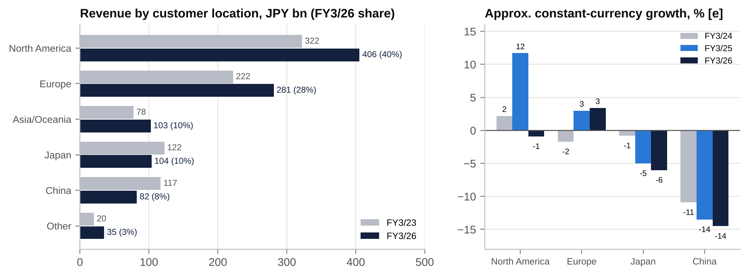
Revenue by region and approximate constant-currency growth

Key business drivers
- Installed-base replacement cycle. EVIS X1 replaces EVIS EXERA III (US) and EVIS LUCERA ELITE (Japan). Procedure growth in colorectal-cancer screening adds volume: the US screening age was lowered to 45 in 2021, and populations are ageing.
- Quality and regulatory status (FDA). Since 2022 FDA actions have cost Olympus revenue (the import alert, ~1% of sales; ~JPY18bn of Q4 FY3/26 ship-hold losses), remediation spend (~JPY20–32bn a year under Elevate) and its multiple. Close-out is the single largest value driver.
- US tariffs and FX. A 15% tariff on Japanese-made goods cost ~JPY25bn of profit in FY3/26. A JPY1 move against the US$ changes revenue by ~JPY2.9bn and OP by ~JPY0.5bn; against the euro, JPY1.7bn and JPY0.5bn [u]. ~90% of sales are overseas while much of the cost base is in yen, so a weak yen is a tailwind.
- China policy: VBP, anti-corruption enforcement, localisation, and the speed of NMPA registration.
- Cost programme. About 2,000 roles cut (1,687 by Apr-2026) for ~JPY24bn of run-rate savings. Restructuring charges were JPY26.9bn in FY3/26. The rule is that SG&A growth must not exceed revenue growth.
- Portfolio. The outcome of the Surgical review. Tuck-in M&A to lift the weighted-average market growth rate (BioProtect). The Swan robotics option.

Supply chain map
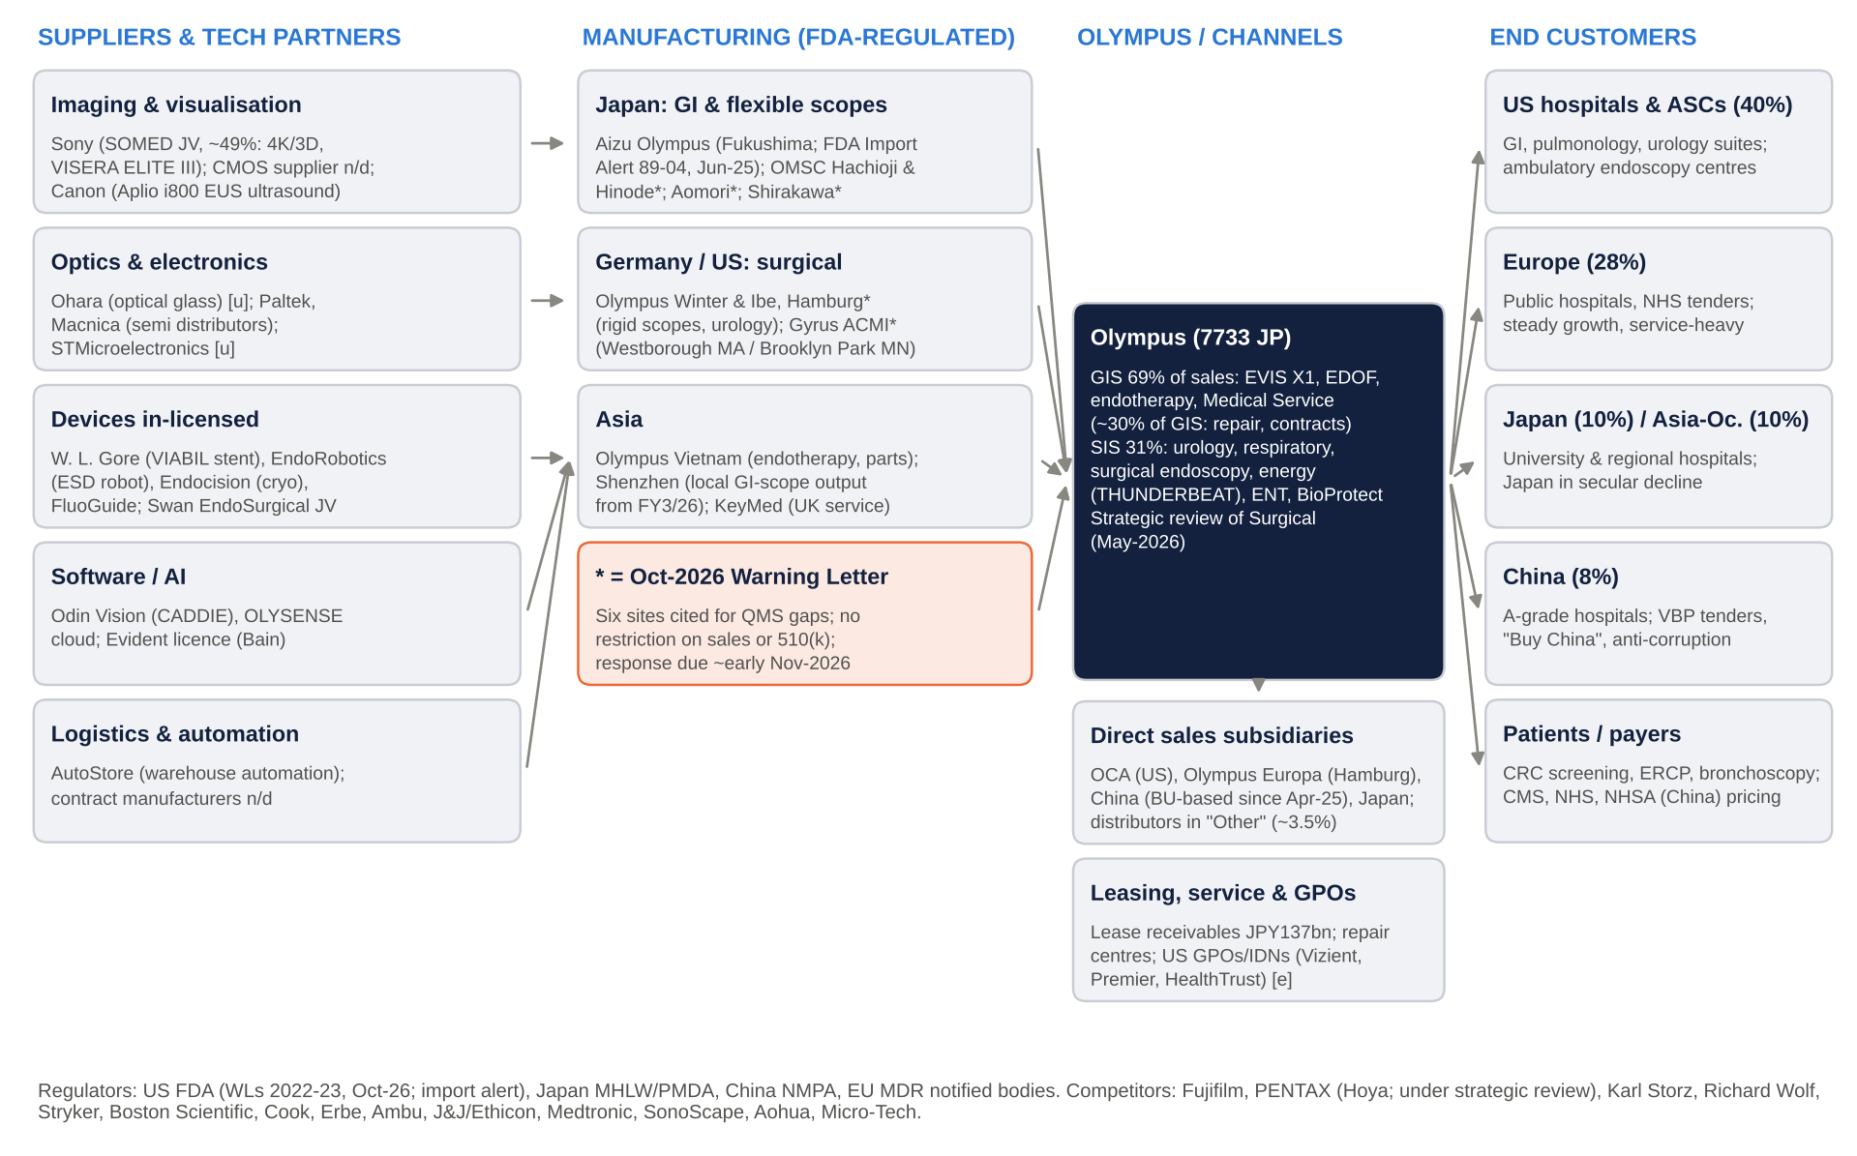
Olympus supply chain: suppliers, manufacturing, channels and customers
Reading the map.
- Manufacturing concentration is the critical link. Flexible scopes are made almost entirely in Japan: Aizu, Hachioji, Hinode, Aomori and Shirakawa. Surgical and urology products come from Hamburg (Olympus Winter & Ibe) and Gyrus ACMI in the US. Five of the six sites named in the Oct-2026 Warning Letter are in this chain, as is the Aizu plant under the 2025 import alert.
- Imaging technology depends partly on Sony through the SOMED joint venture. That is a strategic dependency and a possible change-of-control issue for any acquirer [u].
- Distribution is mostly direct. Wholly owned sales subsidiaries in each region carry the service network, which is a barrier to entry. Distributors are used only in “Other” regions (~3.5% of sales).
- Customers are institutional payers whose budgets are set by public reimbursement: CMS in the US, the NHS, Japan’s national fee schedule and China’s NHSA/VBP. Pricing power exists, but within regulated envelopes.

Macro and micro factors: tailwinds and headwinds
Factor | Direction | Assessment
Weak yen (USD/JPY ~156–158; MoF intervened in Jul-2026) | Tailwind | ~90% of sales are overseas; guidance assumes JPY155/US$ and JPY181/€. Every JPY1 of yen weakness against the US$ adds ~JPY0.5bn to OP [u]. 1Q FY3/27 revenue was +16% reported against ~+5% cc.
BoJ tightening (policy rate 1.25% after the 18-Sep-2026 hike; next meeting 30-Oct) | Mild headwind | Higher yen funding costs (new US$500m notes at 5.526% replace 2.143% paper), a stronger-yen risk, and higher LBO debt costs for any bidder.
US tariffs (15% on Japanese goods; Section 232 medical-device probe opened Sep-2025) | Headwind | ~JPY25bn profit hit in FY3/26, assumed to continue in FY3/27. A sector tariff on endoscopes would be negative. A refund after the Supreme Court’s IEEPA ruling would be cash upside only [u].
US FDA enforcement intensity | Headwind | Three Olympus warning letters in 2022–23, the 2025 import alert and the 2026 letter. The agency’s patience is visibly lower.
China: VBP, anti-corruption, domestic substitution | Headwind | China revenue fell 34% from FY3/22 to FY3/26; 1Q FY3/27 was -17% cc [u]. Local production of GI scopes has started. The 3-4-5 plan only needs low-to-mid-single-digit growth in China.
Demographics and colorectal-cancer screening | Tailwind | Ageing populations; US screening from age 45; AI-assisted detection raises adenoma-detection rates and procedure value.
Hospital capital budgets (US, Europe) | Neutral to positive | US hospital margins have recovered; Europe is steady; Japanese hospitals are budget-constrained.
Single-use endoscopes (Ambu, BSX EXALT) | Mixed | A cannibalisation risk in bronchoscopy and duodenoscopy. Olympus frames it as market expansion.
PENTAX strategic review (Hoya, Jul-2026) | Mixed | A new owner (PE, US or Chinese) could compete harder. A sale price would also set a fresh endoscopy multiple.
Japan governance reforms (TSE P/B push, METI 2023 takeover guidelines, FEFTA amendments of Jun-2026) | Mixed | They raise the odds of buybacks and of serious engagement with bids, but FEFTA tightens screening of foreign acquirers in medical devices.
Micro: cost programme and SG&A discipline | Tailwind | SG&A fell to 52.0% of sales in 1Q FY3/27 from 59.2%.
Micro: management bandwidth (11 executive officers, 8 joined since 2023) | Risk | A largely new US/EU-hired team is running a Japanese manufacturing base under FDA scrutiny.

Strength of products and services, and economic moats

Product strength vs competitors
- GI endoscopy is the strongest franchise in the portfolio. EVIS X1 gives Olympus the broadest imaging toolkit in the market: NBI, TXI, RDI, EDOF, dual-focus and CADDIE AI. Fujifilm (ELUXEO) competes on laser/LED imaging and price. PENTAX is a distant #3 and is itself under strategic review. A share of ~70% globally [u] and ~45% recurring revenue within GIS [e] make this a franchise peers cannot replicate quickly.
- Medical Service is a hidden moat. Olympus repairs and maintains the world’s largest fleet of flexible scopes, and repairs are frequent: scopes are reprocessed after every use. Service contracts tie hospitals in, and third-party repairers capture only part of the market [e].
- Endotherapy is competitive but sticky. Boston Scientific and Cook are strong in ERCP and stents. Chinese challengers (Micro-Tech) win on price under VBP. Olympus’s advantage is bundling consumables with scopes in the same suite.
- SIS is a collection of sub-scale niches. Olympus is a respected #2–3 in ureteroscopes, EBUS and energy (THUNDERBEAT). In laparoscopic visualisation (VISERA ELITE III against Stryker 1788 and Karl Storz) and ENT it lacks scale. SIS margins (4.7% in FY3/25; -4.8% in FY3/26) are far below those of focused peers such as Teleflex, CONMED and Karl Storz [e].
- Quality is the weak point. In late 2025 about 20 products were placed on ship-hold after eight FDA inspections. Recalls followed (ViziShot 2 FLEX with one reported death, PolyLoop, BiCOAG). Olympus’s product reputation with physicians is intact, but its reputation with regulators is not.

Moat assessment
Moat source | Rating | Evidence
Brand | Strong | Olympus is the default name in GI endoscopy. Physicians train on it, and medical societies and key opinion leaders use its imaging modes (NBI) in guidelines and the literature.
Hard assets | Moderate–strong | A Japanese precision-optics manufacturing base (Aizu, Hachioji, Hinode, Aomori, Shirakawa), a global repair network, and an installed base worth multiples of annual capital sales [e]. These assets are also the source of the FDA problem.
Long-term contracts | Moderate | Multi-year service contracts, leases (JPY137bn of receivables) and GPO agreements. Capital sales are lumpy and tender-driven.
Network effect | Weak–moderate | No classic network effect. There is a training ecosystem effect: fellows learn on Olympus, and AI models (CADDIE) improve with more image data.
Regulatory and switching costs | Strong | Switching vendors means retraining staff, re-validating reprocessing, buying new processors and changing service contracts. 510(k)/PMDA/NMPA clearances are a barrier to newcomers. But regulation cuts both ways: FDA actions are Olympus’s biggest risk.
Oligopoly | Strong (GI) / Weak (SIS) | In flexible GI endoscopy, the top three (Olympus, Fujifilm, PENTAX) hold ~95% outside China [u]. Surgical is fragmented, with Karl Storz, Stryker, Medtronic, J&J, BSX and others.
Cash-flow predictability | Moderate | Service and consumables (~40% of the group [e]) are predictable. Capital, tariffs, FDA actions and China make profits volatile: OP guidance was cut in each of FY3/24, FY3/25 and FY3/26.
Scalability | Moderate | High gross margin (~65%) gives operating leverage: 1Q FY3/27 SG&A fell to 52% of sales. But quality and regulatory overhead scales with sites and products.
Government-interference risk | Moderate–high | Risks come from US FDA enforcement and tariffs (Section 232), China VBP and Buy-China procurement, Japan reimbursement, and FEFTA screening of foreign owners.
Bargaining power | Strong vs customers in GI; weak in China and SIS | GI pricing is sustained by differentiation (EDOF, AI). Chinese tenders and VBP compress prices. Supplier power is moderate: Sony imaging and sole-source components.
Overall: a wide moat in GI (brand, switching costs, oligopoly, service network) and a narrow-to-no moat in most of SIS. The quality system is the moat’s weakest wall. The FDA cannot take away share directly, but it can stop products shipping.

Historical financial performance (FY3/22–FY3/26, 1Q FY3/27)

Consolidated income statement summary
JPY bn | FY3/22* | FY3/23 | FY3/24* | FY3/25 | FY3/26 | LTM Jun-26
Revenue | 750.1 | 881.9 | 925.8 | 997.3 | 1,010.7 | 1,044.6
Growth, constant currency | n/d | +4.5% | +0.3% | +3.4% | ~0% | –
Gross profit | 506.7 | 596.8 | 618.4 | 683.7 | 654.1 | –
Gross margin | 67.5% | 67.7% | 66.8% | 68.6% | 64.7% | –
SG&A incl. R&D | 357.5 | 420.5 | 466.8 | 495.7 | 507.1 | –
of which R&D | n/d | 76.9 | 86.4 | 103.9 | 109.9 | –
Adjusted OP (before other inc/exp) | 150.7 [e] | 176.8 [e] | 151.3 | 188.5 | 143.3 | 160.8 [e]
Adjusted OP margin | 20.1% | 20.0% | 16.3% | 18.9% | 14.2% | 15.4%
Net other income / (expense) | (4.5) | +9.8 | (99.9) | (26.0) | (46.2) | –
Operating profit (IFRS) | 146.2 | 186.6 | 51.4 | 162.5 | 97.1 | 109.5 [e]
OP margin | 19.5% | 21.2% | 5.6% | 16.3% | 9.6% | 10.5%
D&A | 57.9 | 63.6 | 65.2 | 66.4 | 67.2 | ~68
EBITDA (OP + D&A) | 204.0 | 250.2 | 116.6 | 228.8 | 164.3 | ~177
Adjusted EBITDA | 208.5 | 240.4 | 216.5 | 254.9 | 210.5 | ~229
Net income – continuing | 110.6 | 138.0 | 35.1 | 117.8 | 68.2 | –
Net income to owners | 115.7 | 143.4 | 242.6 | 117.9 | 68.2 | 78.3 [e]
EPS (JPY), total | 90.22 | 113.22 | 199.91 | 102.99 | 61.32 | ~71
Average shares (m) | 1,282.9 | 1,266.8 | 1,213.4 | 1,144.3 | 1,111.8 | –
Average JPY/US$ | 112.4 | 135.5 | 144.6 | 152.6 | 150.8 | –
Sources: tanshin FY3/22–FY3/26. *FY3/22 restated to exclude Scientific Solutions (Evident); FY3/24 restated to exclude Orthopaedics. Adjusted OP is the company’s measure (gross profit − SG&A + equity-method P&L); FY3/22–23 are recomputed by us [e]. Balance-sheet and cash-flow items are as originally reported. LTM per S&P Capital IQ and our quarterly build [e].
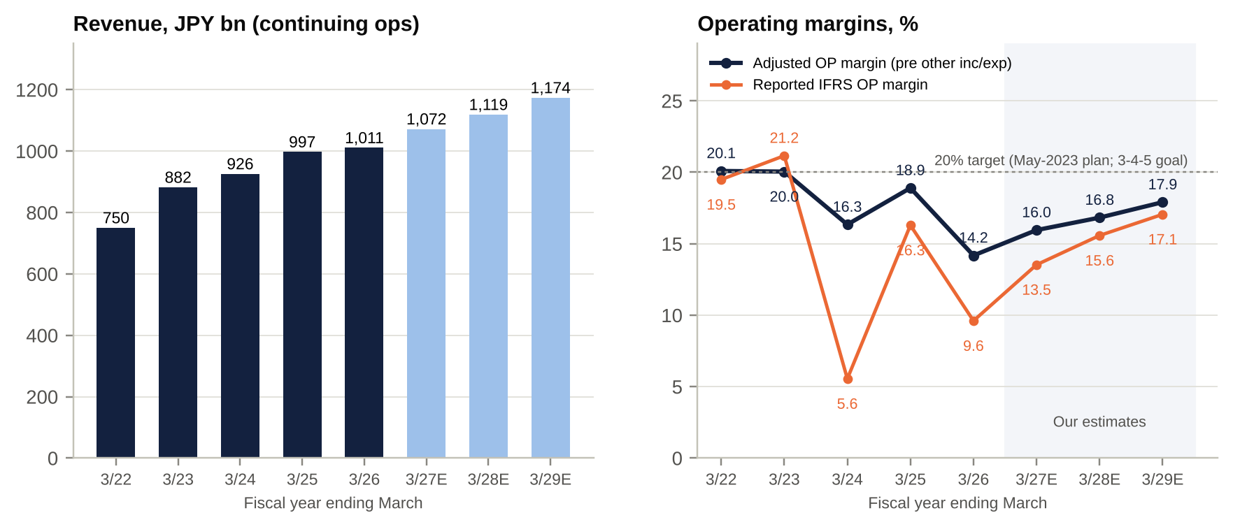
Revenue and operating margins, FY3/22–FY3/29E
What the numbers say.
- Revenue grew 35% over four years, but mostly through FX. Constant-currency growth averaged only ~2% a year from FY3/23 to FY3/26. The yen weakened from JPY112 to JPY151 per US$ over the period.
- Profitability has de-rated, not compounded. Adjusted OP margin went from 20% to 14%. Management missed the May-2023 target of “~20% by FY3/26” by ~580bp.
- “One-offs” recur every year. Net other expense totalled ~JPY167bn over FY3/22–FY3/26 [e]. The main items:
  - Veran (JPY52bn).
  - Quality remediation (JPY23bn in FY3/24, ~JPY10bn below the line in FY3/26).
  - Restructuring (JPY27bn in FY3/26).
  - Impairments.
- Investors should treat part of this as a run-rate cost.

Exceptional items (JPY bn)
Year | Item | Amount
FY3/23 | Gain on sale of Hatagaya (Tokyo) land | +16.4
FY3/24 | Veran Medical exit (impairment 41.7, recall 7.8, inventory 2.3) | (51.9)
FY3/24 | Quality-related (FDA remediation, “Elevate”) costs | (23.0)
FY3/24 | Gain on transfer of Evident to Bain Capital (discontinued operations, after tax) | +216.0
FY3/25 | Career-support programme; impairments | (2.9); (3.6)
FY3/26 | Global organisational reform (~2,000 positions) | (26.9)
FY3/26 | Elevate remediation (~half SG&A, ~half other expenses) | (~20)
FY3/26 | Impairments (development assets, SIS intangibles) | (12.1)
FY3/26 | Swan EndoSurgical JV equity-method loss | (~4.4)
FY3/26 | US tariffs (in cost of sales; analyst figure, not disputed on the call) | (~25)
FY3/26 | Evident licence income (other income) | +6.0

Segment reporting: revenue, OP and EBITDA by division
(a) Old basis: Endoscopic Solutions (ESD) and Therapeutic Solutions (TSD), FY3/22–FY3/25
JPY bn | FY3/22 | FY3/23 | FY3/24 | FY3/25
ESD revenue | 461.5 | 551.8 | 586.6 | 636.1
ESD OP (margin) | 133.2 (28.9%) | 152.8 (27.7%) | 104.7 (17.8%) | 141.4 (22.2%)
ESD EBITDA (OP + D&A) [e] | 166.7 | 190.3 | 146.2 | n/d
TSD revenue | 275.6 | 318.2 | 337.3 | 360.7
TSD OP (margin) | 60.8 (22.1%) | 63.7 (20.0%) | (8.5) (-2.5%) | 61.5 (17.0%)
TSD EBITDA (OP + D&A) [e] | 77.7 | 82.9 | 9.7 | n/d
Corporate and other OP | (47.8) | (29.9) | (44.8) | (40.4)
Group OP | 146.2 | 186.6 | 51.4 | 162.5
(b) New basis: GIS and SIS (FY3/25 restated, FY3/26) and our forecasts
JPY bn | FY3/25 | FY3/26 | FY3/27E | FY3/28E | FY3/29E
GIS revenue | 674.0 | 697.4 | 744.8 | 782.1 | 825.1
GIS OP (margin) | 171.4 (25.4%) | 136.4 (19.6%) | 167.6 (22.5%) | 187.7 (24.0%) | 206.3 (25.0%)
GIS D&A | 38.7 | 38.9 | ~41 | ~42 | ~44
GIS EBITDA | 210.1 | 175.3 | 208.6 | ~230 | ~250
GIS capex | 55.1 | 61.9 | n/d | n/d | n/d
SIS revenue | 322.8 | 313.1 | 326.9 | 336.7 | 348.5
SIS OP (margin) | 15.3 (4.7%) | (15.0) (-4.8%) | 1.6 (0.5%) | 10.1 (3.0%) | 17.4 (5.0%)
SIS D&A | 26.7 | 27.4 | ~29 | ~30 | ~30
SIS EBITDA | 42.0 | 12.4 | 30.6 | ~40 | ~47
SIS capex | 28.6 | 29.5 | n/d | n/d | n/d
Corporate and other OP | (24.3) | (24.3) | (24.2) | (23.5) | (23.5)
Group OP | 162.5 | 97.1 | 145.0 | 174.3 | 200.2
Segment assets GIS / SIS | 604.3 / 500.1 | 735.1 / 555.2 | – | – | –
Segment OP is IFRS OP including allocated other income and expenses. Net income by division is not disclosed; we do not allocate tax and finance costs. Forecasts are ours [e].
SIS has the assets of a major business and the returns of a failing one. It earned a JPY15bn loss on JPY555bn of segment assets (pre-tax ROA about -2.7% [e]). GIS earned JPY136bn on JPY735bn (~18.6%). This gap is the quantitative core of the strategic-review thesis.
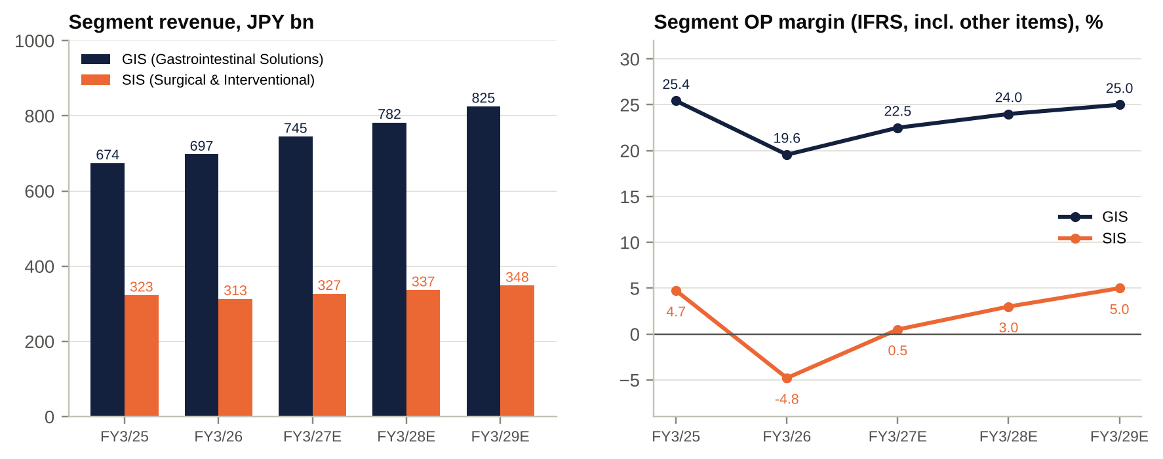
Segment revenue and OP margin

Geography: revenue by customer location (JPY bn)
Region | FY3/22 (incl. SSD) | FY3/23 | FY3/24 (restated) | FY3/25 | FY3/26 | FY3/26 share | Change vs FY3/23
North America | 293.4 | 322.2 | 351.2 | 413.9 | 405.5 | 40.1% | +26%
Europe | 217.9 | 222.2 | 236.6 | 254.6 | 281.1 | 27.8% | +27%
Japan | 135.2 | 122.5 | 116.4 | 110.5 | 103.9 | 10.3% | -15%
China | 125.4 | 117.1 | 105.7 | 95.7 | 82.5 | 8.2% | -30%
Asia/Oceania | 77.5 | 77.8 | 87.9 | 93.7 | 102.6 | 10.2% | +32%
Other | 19.5 | 20.2 | 26.1 | 28.8 | 35.2 | 3.5% | +74%
Total | 868.9 | 881.9 | 925.8 | 997.3 | 1,010.7 | 100% | +15%
Source: CIQ geographic segments and tanshin note 12. FY3/22 includes Scientific Solutions, so FY3/23 is the comparable base. Operating profit by geography is not disclosed. By segment in FY3/26: GIS NA 264.9 / EU 192.0 / JP 79.3 / CN 63.5; SIS NA 140.6 / EU 89.0 / JP 24.4 / CN 18.9.

Quarterly trend (company basis)
JPY bn | 1Q FY3/26 | 2Q FY3/26 | 3Q FY3/26 | 4Q FY3/26 | 1Q FY3/27
Revenue | 206.5 | 247.8 | 261.0 | 295.3 | 240.4
YoY (reported) | -12.1% | +3.6% | +3.9% | +8.5% | +16.4% (~+5% cc)
Gross margin | 65.4% | 65.1% | 63.2% | 65.3% | 65.2%
Adjusted OP | 13.2 | 37.4 [e] | 39.3 [e] | 53.4 [e] | 30.7 [u]
Adjusted OP margin | 6.4% | 15.1% | 15.1% | 18.1% | 12.8%
Operating profit (IFRS) | 16.6 | 29.5 [e] | 24.1 | 26.9 | 29.0
Net income | 9.0 | 20.2 | 14.2 | 24.8 | 19.1
2Q–4Q are derived from cumulative disclosures [e]. 1Q FY3/27 adjusted OP is from Quartr and reconciles with CIQ gross profit, SG&A and equity-method lines.
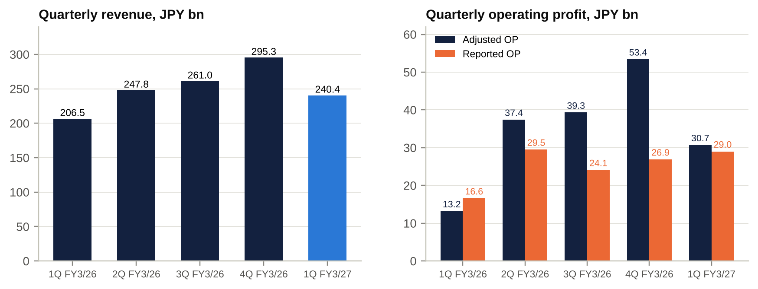
Quarterly revenue and operating profit

Operational KPIs
KPI | FY3/22 | FY3/23 | FY3/24 | FY3/25 | FY3/26 | Latest / comment
Revenue growth, cc | n/d | +4.5% | +0.3% | +3.4% | ~0% | ~+5% 1Q FY3/27; FY3/27 guide ~3%
Gross margin | 67.5% | 67.7% | 66.8% | 68.6% | 64.7% | 65.2% 1Q FY3/27
R&D / sales | n/d | 8.7% | 9.3% | 10.4% | 10.9% | FY3/27 guide JPY119bn
Capital investment / sales | 8.8% | 8.2% | 8.6% | 8.5% | 9.1% | FY3/27 capex guide JPY95bn
Inventory days (on COGS) [e] | 206 | 209 | 223 | 218 | 212 | ~242 at Jun-26 (inventory JPY221bn)
Trade receivable days [e] | 75 | 72 | 77 | 75 | 86 | Plus JPY84bn non-current receivables
Lease receivables (JPY bn) | n/d | n/d | 86.2 | 105.4 | 136.7 | +59% in two years
Employees | n/d | n/d | n/d | n/d | ~28,100 | ~2,000 roles cut (1,687 by Apr-26)
FDA status | WLs 2022 | WLs 2022–23 | Elevate | Elevate (96% done) | Import alert; 8 inspections; ship-holds | New six-site Warning Letter, Oct-2026
China share of sales | 14.4% | 13.3% | 11.4% | 9.6% | 8.2% | -17% cc 1Q FY3/27 [u]
Trend commentary.
- Gross margin compressed ~390bp in FY3/26. The causes were tariffs, mix, and recall and ship-hold inventory costs. Management argues this is not a structural reset, and 1Q FY3/27 supports that view.
- SG&A/sales crept from 47.7% to 50.2% as R&D rose to 10.9% of sales. It is now being cut.
- Working capital is deteriorating. Receivable days rose from 72 to 86, inventory days are ~240 and lease receivables are up ~60%. Growth is increasingly financed on the balance sheet.
- Cash conversion was poor in FY3/26. CFO was JPY100.6bn after ~JPY62bn of tax payments, and FCF was JPY13bn against a JPY57bn consensus.

Historical share-price catalysts (moves greater than 10%, last five years)
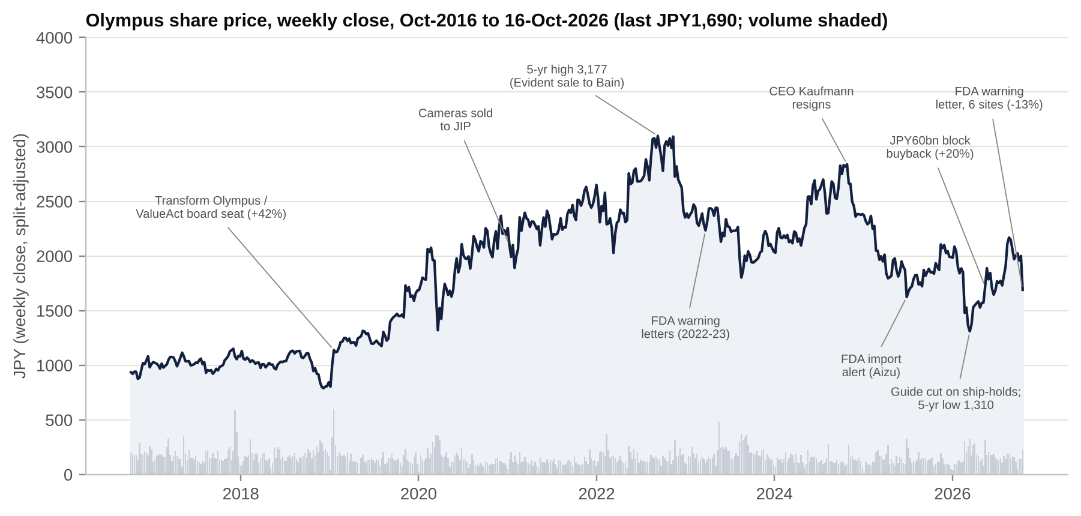
Olympus share price, 10 years, with key events
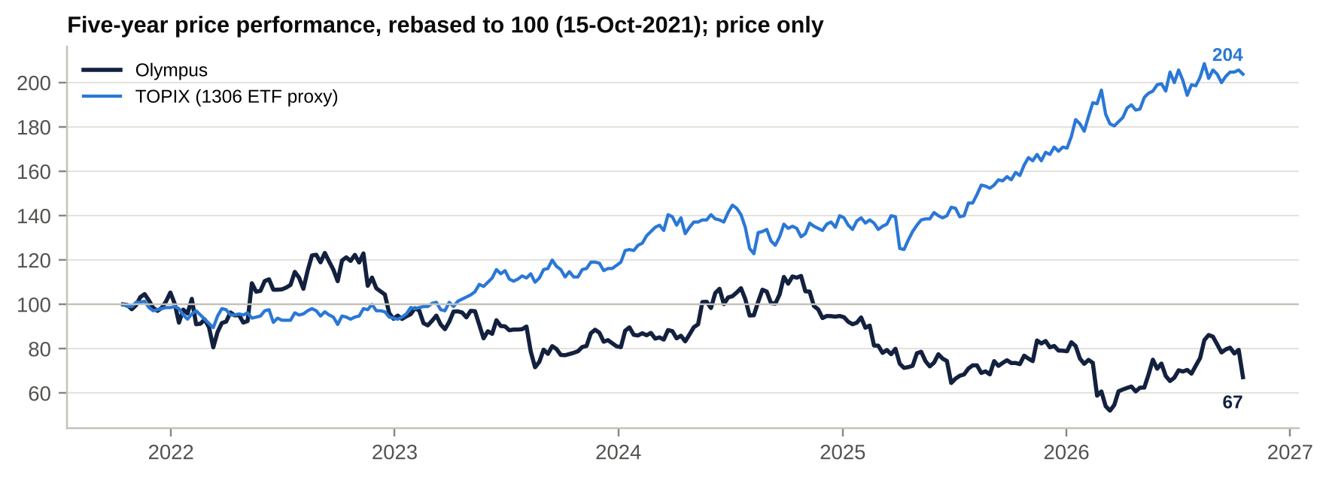
Olympus vs TOPIX (1306 ETF), rebased
Context. At JPY1,690 the stock is below its Oct-2021 level, while TOPIX has roughly doubled. Relative performance has been -137pt over five years and -94pt over three years, even though Olympus spent ~JPY470bn on buybacks. The 5-year closing range is JPY1,310 (13-Mar-2026) to JPY3,177 (12-Sep-2022).
There have been 11 sessions with a move of 10% or more in five years:
- Eight followed results. Olympus releases at 15:30 JST, so the reaction comes in the next session.
- Since Jun-2025, all three ≥10% down days were FDA-driven: the import alert, the ship-hold guidance cut and the Warning Letter.
# | Date(s) | Move | Price (JPY) | TOPIX same window | Driver
1 | 4–8 Feb 2022 | -18.5% | 2,578 → 2,100 | +0.5% | 3Q FY3/22: revenue guide raised only marginally, OP guide held; read as an Endoscopic miss [u]
2 | 11–13 May 2022 | +20.7% | 2,283 → 2,755 | +1.0% | FY3/23 guide: OP JPY206bn (FY3/22 guide JPY144bn); DPS JPY16
3 | Mar–Sep 2022 | +56.7% | 2,028 → 3,177 | +6.4% | Guidance raises; sale of Evident (Scientific Solutions) to Bain for ~JPY430bn (29-Aug-22); weak yen
4 | 11–16 Nov 2022 | -12.6% | 3,093 → 2,704 | -0.5% | 2Q FY3/23: guide rebased ex-Evident; JPY50bn buyback; first FDA Warning Letter (Aizu, 2-Nov-22) in the background
5 | Nov-2022 to Mar-2023 | -29.1% | 3,140 → 2,225 | +6.5% | FDA Warning Letters (Aizu, Hachioji) made public; BoJ YCC tweak; FY guide cut (OP JPY212bn → JPY198bn)
6 | 12–17 May 2023 | -12.2% | 2,438 → 2,140 | +1.8% | FY3/24 guide OP JPY163bn (vs JPY198bn guided for FY3/23), despite a JPY100bn buyback
7 | 10-Aug-2023 (Jun–Aug) | -12.0% (-23.4% window) | 2,346 → 1,798 | -1.7% | 1Q FY3/24 OP fell (no repeat of the land gain; higher personnel costs); China anti-corruption campaign
8 | Aug-2023 to Jul-2024 | +50.9% | 1,798 → 2,714 | +25.5% | JPY100bn + JPY80bn buybacks (~7% of shares); Taewoong closing; FY3/24 results plus JPY100bn buyback (+9.7%)
9 | 18-Jul to 5-Aug 2024 | -19.4% | 2,714 → 2,187 | -21.1% | Market-wide yen carry-trade unwind (Olympus slightly outperformed)
10 | Oct-2024 to Apr-2025 | -42.5% | 2,850 → 1,640 | -4.4% | CEO Kaufmann resigned (28-Oct-24) over an illegal-drug allegation; 3Q FY3/25 guide cut on China (-9.7%); “Liberation Day” tariffs (7-Apr-25 -11.0%)
11 | 7-Apr to 12-May 2025 | +23.2% | 1,640 → 2,021 | +11.1% | Tariff pause; Bob White (ex-Medtronic) named CEO (25-Apr-25)
12 | 25-Jun-2025 | -10.6% (-19.6% window) | 1,892 → 1,692 | 0% | FDA Import Alert 89-04: 58 Aizu-made models (bronchoscopes, ureteroscopes, laparoscopes, reprocessors; ~1% of sales) blocked from US entry
13 | 10-Nov-2025 | +11.5% | 1,872 → 2,088 | +0.6% | New corporate strategy: ~2,000 job cuts, ~JPY24bn savings, 100bp+/yr margin expansion; Executive Chair Takeuchi to step down
14 | 16-Feb-2026 (to 13-Mar) | -12.9% (-38.1% window) | 1,852 → 1,614 → 1,310 | -0.7% | FY3/26 OP guide cut from JPY136bn to JPY75–87bn on SIS ship-holds after eight FDA inspections; CFO change; 5-year low
15 | 13-May-2026 | +19.9% | 1,540 → 1,846 | +1.5% | FY3/27 guide (OP JPY136.5–155.5bn); Surgical strategic review; JPY60bn ToSTNeT-3 buyback (3.5% of shares)
16 | 10-Aug-2026 | +10.1% (+35.7% window) | 1,906 → 2,098 → 2,187 | +0.7% | 1Q FY3/27: revenue +16%, OP +74%, well ahead of consensus; new CQO from Medtronic
17 | 14-Oct-2026 | -13.4% (-16.8% in 3 days) | 2,032 → 1,759 → 1,690 | -0.2% | FDA Warning Letter (dated 7-Oct) covering six sites for inadequate responses to 2025 Form 483s; no restriction on sales or 510(k)s
Source: S&P Capital IQ daily prices (split-adjusted), TOPIX proxy = NEXT FUNDS TOPIX ETF (1306); S&P Key Developments and TSE releases for drivers. Episodes found with a 10% zig-zag filter; drivers marked [u] are inferred.
Pattern for an event-driven investor. The stock tends to overshoot on FDA and guidance shocks, then recover on capital-return and strategy news:
- Import alert -19.6%, then +30% into the Nov-2025 strategy day.
- Feb-2026 cut -38%, then +44% into the May-2026 buyback.
The current -17% drawdown fits that pattern. Whether the pattern holds depends on the FDA not escalating.

Earnings calls: management focus and sentiment

What management is focused on
Theme | Nov-24 | Feb-25 | Aug-25 | Feb-26 | May-26 | Direction
FDA, Elevate, import alert, ship-holds | ■ | □ | ■ | ■ | ■ | Rising: analysts asked in May-2026 whether 483s could become a Warning Letter. They did.
China (anti-corruption, VBP, Buy China) | ■ | ■ | ■ | ■ | ■ | Persistent drag; new China president (ex-Danaher) from Mar-2026
US tariffs | – | – | ■ | – | ■ | 15% assumed in FY3/27 guidance
EVIS X1, EDOF, new products | ■ | ■ | ■ | ■ | ■ | The US EDOF conversion drove a “tremendous” 4Q FY3/26
Margin target and cost transformation | ■ | ■ | ■ | ■ (3-4-5) | ■ | 20%+ OP margin destination reaffirmed
Capital returns | – | □ | □ | – | ■ (JPY60bn) | Buybacks announced at FY or 2Q results
Portfolio and M&A | – | □ (reorganisation) | ■ (Swan JV) | – | ■ (Surgical review) | “Nothing is off the table” in Surgical
CEO and management change | ■ (Kaufmann) | □ | ■ (White) | □ | □ (new CFO) | 8 of 11 executive officers hired since 2023
■ = major theme, □ = mentioned, – = absent. Five calls are in the S&P transcript corpus (Nov-24, Feb-25, Aug-25, Feb-26, May-26). The May-25, Nov-25 and Aug-26 calls were reconstructed from secondary sources [u].
Key quotes and messages.
- Feb-2025 (CFO, after a China-driven cut): “Maybe we were naive. Maybe we were too optimistic.”
- Aug-2025 (White’s first call): results “fell short of expectations”. Tariffs cost a gross JPY26bn (~JPY16bn net). The import alert cost ~JPY15bn of revenue. White’s rule: SG&A growth must not exceed revenue growth. “I think you can trust this plan.”
- Feb-2026 (eight FDA inspections, ~20 products on ship-hold): the new GIS head called the US shortfall “clearly an execution issue”. White: “not lowering margin expectations in our 3, 4 and 5 plan… a mid-single-digit revenue growth player and a 20-plus percent operating margin company.”
- May-2026: FY3/27 guidance of ~3% growth and 100bp+ margin expansion, with a “slower start to a stronger finish”. A strategic review of Surgical. A JPY60bn buyback. On the FDA: “no difference in what the FDA wants and what Olympus wants.” The agency typically responds 4–6 months after an inspection, which turned out to be accurate.

Sentiment analysis (dictionary-based; ProntoNLP not connected)
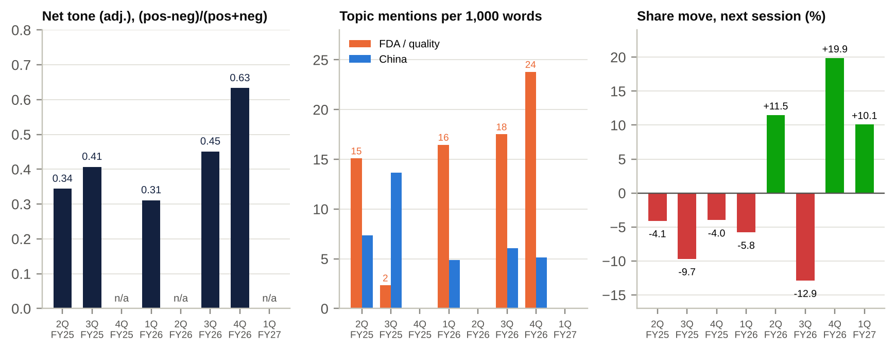
Call sentiment, topic intensity and next-day share reaction
Call | Net tone (adj.) | Negative words per 1k | FDA mentions per 1k | China per 1k | Next-day share move
2Q FY3/25 (Nov-24) | 0.34 | 8.6 | 15.1 | 7.4 | -4.1%
3Q FY3/25 (Feb-25) | 0.41 | 8.0 | 2.3 | 13.6 | -9.7%
1Q FY3/26 (Aug-25) | 0.31 | 11.0 | 16.5 | 4.9 | -5.8%
3Q FY3/26 (Feb-26) | 0.45 | 5.0 | 17.5 | 6.1 | -12.9%
4Q FY3/26 (May-26) | 0.63 | 4.2 | 23.8 | 5.1 | +19.9%
Method: Loughran-McDonald-style dictionary (~150 positive and ~160 negative stems, with negation handling) applied to S&P transcript excerpts of 2.1k–4.8k words per call; net tone = (pos − neg)/(pos + neg); the adjusted score removes pleasantries. Indicative only: the excerpts are query-driven, and the switch from interpreted Japanese to native-English CEO remarks after Jun-2025 inflates later tone.
How sentiment shifted.
- Takeuchi interim (Nov-24 to Feb-25): moderately positive tone, with the topic mix moving from governance and the FDA to China. The words were hopeful; the numbers were not.
- White’s reset (Aug-25): the trough in tone and the peak in negative density (“decreased”, “warning”, “difficult”). The candid framing marked the low point in expectations.
- “Confident operator” phase (Feb-26 to May-26): tone rose to a series high of 0.63, while FDA topic intensity also hit a series high (23.8 per 1k) as analysts pressed on 483s and warning-letter risk.
The signal was the divergence between rising tone and rising FDA intensity, not the tone level. Tone did not predict next-day returns: Feb-26 scored 0.45 and the stock fell 12.9%.

Latest result: 1Q FY3/27 (reported 7-Aug-2026)

Revenue and profit vs expectations
JPY bn | 1Q FY3/27 | 1Q FY3/26 | YoY | CIQ consensus mean (n) | vs consensus
Revenue | 240.4 | 206.5 | +16.4% (~+5% cc) | 228.3 (6) | +5.3%
Gross margin | 65.2% | 65.4% | -0.2pp | 60.1% (2) | +5.1pp
Adjusted OP | 30.7 [u] | 13.2 | +133% | n/a | –
Adjusted OP margin | 12.8% | 6.4% | +6.4pp | – | –
Operating profit (IFRS) | 29.0 | 16.6 | +74% | 12.1 (8) | +139%
Profit before tax | 27.6 | 16.9 | +63% | 2.5 (2) | n/m
Net income | 19.1 | 9.0 | +112% | 3.8 (3) | n/m
EPS (JPY) | 17.76 | ~7.9 | – | 9.62 (2) | +85%
Source: S&P Capital IQ (financials, quarterly estimates), Quartr and Investing.com summaries [u] for adjusted OP and segment colour. The quarterly consensus base was thin and appears stale, so the size of the beat is overstated. Olympus does not guide quarterly.

Segment and regional drivers
- GIS drove the quarter. North America was strong on EDOF scopes and EVIS X1 placements after the 3Q FY3/26 “execution fix”. Comparisons were easy: 1Q FY3/26 was -12% on purchase delays before the EDOF launch. Europe and APAC were described as positive [u].
- SIS: some products stay on ship-hold through 1H, with recovery expected in 2H. BioProtect (~US$14.5m of 2025 revenue) was consolidated from June.
- China: about -17% cc [u], after +6% in 3Q FY3/26 and weak 4Q procurement.
- Segment and regional figures for 1Q FY3/27 are not verified: the Aug-2026 tanshin was not retrievable from this environment.

Margin trends and why
- Gross margin of 65.2% was flat YoY, recovering from the 63.2% trough in 3Q FY3/26 when ship-hold, recall and inventory costs hit. It still absorbs the 15% US tariff.
- Operating leverage did the work. SG&A fell to 52.0% of sales from 59.2%: SG&A grew 2.3% while revenue grew 16.4%. The drivers were the ~2,000-role cut, the end of Elevate one-offs and the SG&A rule.
- Watch item: the gap between adjusted OP and OP was only ~JPY1.7bn in 1Q, against ~JPY24bn guided for the year. Either restructuring and quality costs fall later in the year, or the guide is conservative [e]. We assume the former, plus ~JPY5–8bn of Warning-Letter-related spend.

Guidance and outlook (FY3/27, reaffirmed 7-Aug-2026)
 | Low | High | Midpoint | Consensus | Ours
Revenue (JPY bn) | 1,055 | 1,076 | 1,065.5 | 1,082.2 | 1,071.9
Adjusted OP margin | 15.2% | 16.7% | 16.0% | n/a | 16.0%
Operating profit (JPY bn) | 136.5 | 155.5 | 146.0 | 150.4 | 145.0
Net income (JPY bn) | 95.5 | 109.0 | 102.3 | 105.5 | 99.3
EPS (JPY) | 89.6 | 102.2 | 95.9 | 98.0 | 93.1
DPS (JPY) | 30 | 30 | 30 | 30.6 | 30
FX assumptions: JPY155/US$, JPY181/€, JPY22.5/CNY. A 15% US tariff assumed all year. Capex JPY95bn, D&A JPY68bn, R&D JPY119bn.
Consensus sits above the guidance midpoint and above the top of the revenue range, mostly because of the weak yen [e]. With the Warning Letter not yet in most estimates (CIQ targets are dated 14-Oct), the near-term revision risk is downward. The asymmetry is negative if Olympus only holds guidance at 2Q.

Balance-sheet flags
JPY bn | Mar-26 | Jun-26 | Change | Flag
Cash | 188.0 | 118.5 | -69.5 | JPY60bn buyback + JPY33bn dividend + JPY43bn BioProtect in one quarter
Gross debt (bonds + borrowings) | 239.6 | 318.9 | +79.3 | Short-term borrowings JPY139bn; US$500m 2.143% notes due 8-Dec-2026 pre-funded by US$500m 5.526% notes due 2031 (Sep-2026)
Net debt | 51.5 | ~200 | +149 | ~0.9x LTM EBITDA; still investment grade (S&P BBB+, Moody’s Baa1, R&I A+)
Inventory | 207.1 | 221.3 | +14.2 | ~242 days; watch write-downs on ship-held products
Goodwill | 194.2 | 240.1 | +45.9 | BioProtect (US$270m for US$14.5m of sales)
Treasury stock | (26.6) | (85.5) | (58.9) | 38.9m shares bought at JPY1,540.5; to be cancelled
Quarterly FCF | 23.0 (4Q) | (7.1) |  | ~JPY(50)bn after the acquisition

Market reaction and what was priced in
- The result was rewarded. The shares rose 10.1% on 10-Aug-2026 to JPY2,098, on 2.5x average volume, and reached a 52-week high of JPY2,187 on 20-Aug.
- The gain has since reversed. The Warning Letter (13-Oct) took the stock to JPY1,690 by 16-Oct. That is below the pre-result close (JPY1,906), and below the lowest sell-side target (JPY1,800).
- The market is now paying nothing for the recovery shown in 1Q.

Unusual relative to recent history
- The first clean beat-and-hold in a 1Q since FY3/23. The prior three first quarters brought a fall in OP (FY3/24), a guidance cut (FY3/26) or a weak start.
- Q1 alone used the full JPY60bn buyback, partly funded with short-term debt. Liquidity is thinner just as an FDA matter opens.
- The Surgical strategic review is open with no timetable. No update was given in August [u].
- A sell-side question in May-2026 anticipated the Warning Letter. Management had said it did not expect “a bolus of costs” from the inspections.

Earnings forecasts: FY3/27E–FY3/29E

Key assumptions
Driver | FY3/27E | FY3/28E | FY3/29E | Rationale
GIS revenue growth (reported) | +6.8% | +5.0% | +5.5% | ~4% cc plus FX in FY3/27 (US$ ~156 vs 150.8 average in FY3/26); EDOF/EVIS X1 cycle; China drag fades
SIS revenue growth (reported) | +4.4% | +3.0% | +3.5% | Ship-hold recovery in 2H; BioProtect; FX
GIS OP margin (IFRS) | 22.5% | 24.0% | 25.0% | Restructuring tail fades; savings; FY3/25 was 25.4%
SIS OP margin (IFRS) | 0.5% | 3.0% | 5.0% | Ship-holds, remediation and Warning-Letter spend; back to FY3/25 levels only by FY3/29
Corporate cost | JPY(23.7)bn | JPY(23.0)bn | JPY(23.0)bn | Flat
Adjusted OP − OP gap | JPY26bn | JPY14bn | JPY10bn | Guided ~JPY24bn plus ~JPY2bn for Warning-Letter remediation
D&A | JPY71bn | JPY74bn | JPY77bn | Capex ~JPY92–95bn a year
Net finance cost | JPY(8)bn | JPY(9)bn | JPY(9)bn | Refinancing at 5.5% (US$) and 1–1.6% (yen)
Effective tax rate | 27.5% | 27.5% | 27.5% | FY3/26 27.5%
Buybacks | JPY60bn (done) | JPY50bn at ~JPY1,950 | JPY50bn at ~JPY2,100 | In line with the pattern; leverage < 1x
DPS | JPY30 | JPY32 | JPY34 | “Maintain DPS” policy plus modest growth

Model output vs consensus
JPY bn | FY3/26A | FY3/27E | Cons. | FY3/28E | Cons. | FY3/29E | Cons.
Revenue | 1,010.7 | 1,071.9 | 1,082.2 | 1,118.9 | 1,122.8 | 1,173.7 | 1,166.8
GIS OP | 136.4 | 167.6 | – | 187.7 | – | 206.3 | –
SIS OP | (15.0) | 1.6 | – | 10.1 | – | 17.4 | –
Adjusted OP | 143.3 | 171.0 | – | 188.3 | – | 210.2 | –
Adjusted OP margin | 14.2% | 16.0% | – | 16.8% | – | 17.9% | –
Operating profit (IFRS) | 97.1 | 145.0 | 150.4 | 174.3 | 171.7 | 200.2 | 186.5
EBITDA | 164.3 | 216.0 | 217.8 | 248.3 | 243.8 | 277.2 | 260.3
Net income | 68.2 | 99.3 | 105.5 | 119.8 | 121.8 | 138.6 | 132.2
Average shares (m) | 1,111.8 | 1,067.6 | – | 1,050.0 | – | 1,025.3 | –
EPS (JPY) | 61.32 | 93.1 | 98.0 | 114.1 | 113.9 | 135.2 | 124.8
Ours vs consensus | – | -5% |  | 0% |  | +8%
CFO | 100.6 | 150 | – | 185 | – | 205 | –
Capex | 82.4 | 95 | 94 | 92 | – | 95 | –
FCF | 18.2 | 55 | 63 | 93 | 84 | 110 | 92
Net debt (year-end) | 51.5 | 138 | 84 | 127 | 66 | 100 | 63
Net debt / EBITDA | 0.3x | 0.64x | – | 0.51x | – | 0.36x | –
Consensus: S&P Capital IQ, 14–18 Oct 2026. Our FY3/27E net debt is higher than consensus because the Jun-26 balance sheet already shows ~JPY200bn after the buyback and the acquisition.
Sensitivities (FY3/28E EPS).
- ±1pt of GIS margin = ±JPY5.4 (±5%).
- ±JPY5/US$ = ±JPY1.7 [e, from the ~JPY0.5bn OP per JPY1 sensitivity].
- An SIS sale at 1.2x sales (~JPY390bn) would be ~+4% accretive to FY3/28E EPS if half the proceeds fund buybacks at JPY2,000 and half repay debt, and ~+12% if all go to buybacks [e]. The calculation gives up SIS OP of ~JPY10bn and assumes ~JPY5bn of stranded corporate cost.
- A consent-decree scenario (US sales disruption at selected sites, plus JPY30–50bn a year of remediation) would cut EPS by 25–35% [e].

Capital structure, debt, liquidity and ratings
JPY bn | Mar-22* | Mar-23 | Mar-24 | Mar-25 | Mar-26 | Jun-26
Cash and equivalents | 302.6 | 169.3 | 340.9 | 252.5 | 188.0 | 118.5
Bonds | n/d | n/d | 145.3 | 124.5 | 134.7 | n/d
Borrowings | n/d | n/d | 154.3 | 104.6 | 104.9 | n/d
Gross debt (bonds + borrowings) | 386.1 | 340.1 | 299.6 | 229.1 | 239.6 | 318.9
Net debt / (cash) | 83.6 | 170.7 | (41.3) | (23.4) | 51.5 | ~200.3
Other financial liabilities (incl. leases) | n/d | n/d | 89.9 | 84.6 | 93.6 | n/d
Net debt / EBITDA (reported) | 0.4x | 0.7x | net cash | net cash | 0.31x | ~0.92x (CIQ LTM)
Net debt incl. other fin. liabilities / adj. EBITDA | – | – | 0.22x | 0.24x | 0.69x | ~1.3x [e]
Net retirement benefit (asset) / liability | 40.0 | 20.4 | 20.6 | (20.7) | (31.2) | –
Equity attributable to owners | 510.2 | 640.1 | 757.2 | 751.7 | 812.0 | 747.9
Equity ratio | 37.6% | 42.4% | 49.4% | 52.5% | 52.8% | ~49%
Goodwill | 164.5 | 182.5 | 180.3 | 180.6 | 194.2 | 240.1
Interest cover (CFO / interest paid) | n/d | 18.3x | 8.8x | 45.4x | 24.8x | –
*Mar-22 not restated (includes Scientific Solutions). Mar-24 borrowings include ~JPY60bn of short-term borrowings [e]. Sources: tanshin balance sheets, S&P Capital IQ (Jun-26).
Debt instruments and maturities.
Instrument | Amount | Coupon | Maturity
US$ senior notes (144A/RegS) | US$500m\left( JPY75bn\right)|2.143$ senior notes (issued 9-Sep-2026) | US$500m (~JPY79bn) | 5.526%
28th unsecured yen bond | JPY15bn | 1.237% | 16-Jun-2028
29th unsecured yen bond | JPY15bn | 1.453% | 17-Jun-2030
Other yen bonds | ~JPY30bn [e] | n/d | n/d
Term loans (FY3/26) | JPY20bn / 15bn / 25bn / 10bn | 1.07% / 0.94% / 1.48% / 1.55% fixed | Jun-2028 / May-2029 / May-2032 / May-2035
Short-term borrowings (Jun-26) | ~JPY58bn new in 1Q [u] | n/d | <1 year
Ratings: R&I A+ (a-1 short-term), S&P BBB+, Moody’s Baa1 (Integrated Report 2025; no 2025–26 rating actions found). No financial covenants are disclosed. Commitment lines and the CP programme size are n/d.
Assessment.
- The balance sheet is sound but no longer a war chest. Net debt of ~JPY200bn is ~0.9x LTM EBITDA (~1.3x including lease and other financial liabilities).
- Funding costs are rising. The 2.143% US$ notes roll into 5.526%, and zero-rate yen paper (0.20–0.25%) has been refinanced at 1–1.6%. Interest expense could rise from ~JPY5bn to ~JPY9–10bn [e].
- Capacity remains. At 1.5x EBITDA Olympus could still fund ~JPY120–150bn of additional buybacks or M&A while staying investment grade [e]. An SIS sale would create further capacity.
- Off-balance-sheet items:
  - The Swan EndoSurgical JV options: an Olympus call to buy at a predetermined value, and Revival put options. Up to US$458m of milestone funding is committed jointly.
  - Contingent liabilities around FDA matters and US duodenoscope litigation: no significant change was disclosed.
  - JPY137bn of lease receivables (credit risk on hospital customers).
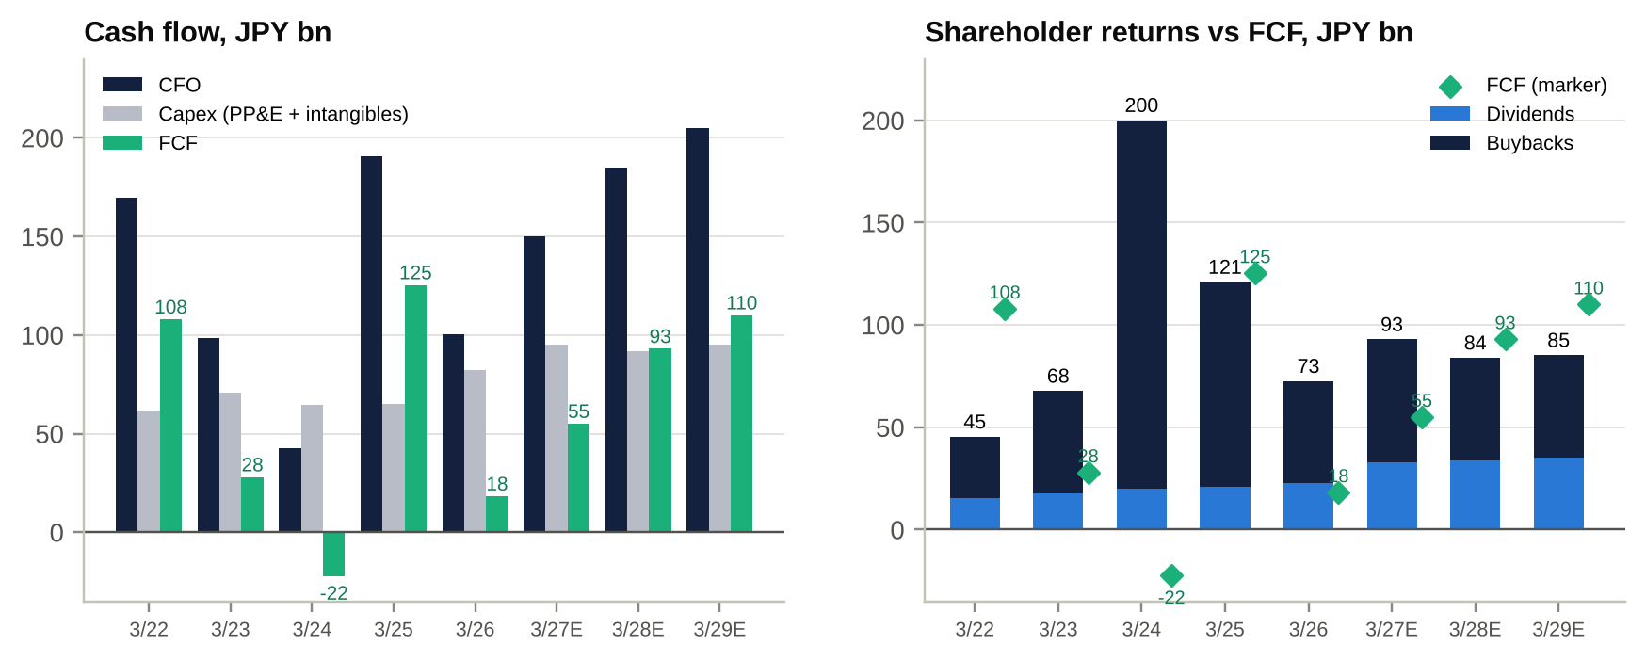
Cash flow and shareholder returns

Valuation

Peer comparison (S&P Capital IQ; LTM, mostly to Jun-2026; prices at 16-Oct-2026)
(a) Valuation multiples
Company | Ticker | Mkt cap US$m | TEV/Sales | TEV/EBITDA | NTM TEV/EBITDA | TEV/EBIT | P/E LTM | P/E fwd | P/B
Olympus | 7733 JP | 11,368 | 1.91x | 9.4x | 8.9x | 13.7x | 23.8x | 15.7x | 2.40x
FUJIFILM | 4901 JP | 25,971 | 1.48x | 10.0x | 8.6x | 15.6x | 15.9x | 13.5x | 1.05x
HOYA | 7741 JP | 54,306 | 8.22x | 20.9x | 18.9x | 24.9x | 32.5x | 29.3x | 8.45x
Terumo | 4543 JP | 21,819 | 3.02x | 11.4x | 11.0x | 15.5x | 21.0x | 21.7x | 2.07x
Sysmex | 6869 JP | 7,098 | 2.16x | 9.9x | 10.0x | 17.1x | 29.1x | 24.8x | 2.31x
Asahi Intecc | 7747 JP | 5,872 | 5.99x | 16.1x | 14.1x | 19.3x | 29.0x | 23.4x | 5.35x
Nipro | 8086 JP | 1,450 | 1.27x | 8.7x | 8.0x | 24.7x | 18.0x | 12.8x | 0.81x
Shimadzu | 7701 JP | 8,032 | 1.96x | 11.7x | 10.3x | 14.9x | 19.3x | 19.9x | 2.21x
Stryker | SYK US | 113,024 | 4.84x | 16.5x | 15.3x | 20.3x | 30.5x | 18.5x | 4.71x
Medtronic | MDT US | 115,987 | 3.62x | 12.7x | 12.4x | 18.0x | 23.3x | 15.8x | 2.41x
Boston Scientific | BSX US | 64,331 | 3.65x | 13.4x | 12.1x | 17.8x | 18.0x | 13.8x | 2.58x
Intuitive Surgical | ISRG US | 150,744 | 13.20x | 34.5x | 25.7x | 42.2x | 48.9x | 37.7x | 8.31x
Johnson & Johnson | JNJ US | 615,874 | 6.48x | 18.8x | 17.5x | 24.5x | 38.8x | 22.4x | 7.24x
Becton Dickinson | BDX US | 52,230 | 3.04x | 10.8x | 12.2x | 18.6x | 32.9x | 14.5x | 2.14x
Teleflex | TFX US | 5,527 | 3.61x | 18.9x | 14.9x | 41.1x | n/m | 14.2x | 1.90x
CONMED | CNMD US | 1,399 | 1.60x | 9.2x | 7.6x | 14.3x | 25.4x | 10.4x | 1.35x
STERIS | STE US | 21,709 | 3.86x | 13.5x | 12.4x | 20.3x | 27.2x | 19.5x | 3.01x
Integra Life. | IART US | 1,027 | 1.70x | 8.2x | 8.0x | 17.2x | n/m | 5.4x | 0.98x
Zimmer Biomet | ZBH US | 18,116 | 2.97x | 9.8x | 8.9x | 17.8x | 23.1x | 10.9x | 1.43x
Edwards Lifesciences | EW US | 49,916 | 7.13x | 22.9x | 20.9x | 25.4x | 51.7x | 27.6x | 4.70x
GE HealthCare | GEHC US | 31,424 | 1.89x | 10.5x | 9.8x | 13.5x | 16.0x | 13.5x | 2.86x
Ambu | AMBU B DC | 3,075 | 3.26x | 21.7x | 12.8x | 28.8x | 40.8x | 23.2x | 3.36x
Smith & Nephew | SN. LN | 12,099 | 2.39x | 9.7x | 8.8x | 14.8x | 19.5x | 12.6x | 2.36x
Siemens Healthineers | SHL GR | 51,846 | 2.54x | 13.9x | 12.3x | 18.2x | 21.0x | 18.0x | 2.42x
Philips | PHIA NA | 25,438 | 1.60x | 10.9x | 8.6x | 16.5x | 20.3x | 14.2x | 1.98x
Coloplast | COLO B DC | 15,985 | 4.55x | 14.5x | 14.0x | 16.9x | 38.5x | 19.3x | 7.95x
Getinge | GETI B SS | 7,186 | 2.35x | 12.5x | 10.7x | 16.8x | 26.6x | 21.0x | 2.30x
Carl Zeiss Meditec | AFX GR | 3,222 | 1.57x | 14.1x | 11.6x | 21.7x | 23.5x | 23.0x | 1.37x
Demant | DEMANT DC | 11,376 | 3.84x | 16.3x | 14.1x | 22.1x | 31.3x | 22.9x | 6.74x
SonoScape Medical | 300633 CH | 1,182 | 2.97x | 30.1x | 19.3x | 53.2x | 49.0x | 27.0x | 2.62x
Shanghai Aohua | 688212 CH | 497 | 4.28x | n/m | 28.5x | n/m | n/m | 103.0x | 2.72x
Mindray | 300760 CH | 30,247 | 5.50x | 16.4x | 15.1x | 19.4x | 25.8x | 22.3x | 5.00x
Micro-Tech (Nanjing) | 688029 CH | 2,183 | 3.88x | 17.0x | 15.3x | 19.8x | 28.6x | 25.2x | 3.49x
MicroPort Scientific | 853 HK | 1,484 | 2.53x | 51.7x | n/m | n/m | n/m | n/m | n/m
(b) Operating and financial metrics
Company | Country | EBITDA margin | EBIT margin | Sales growth | ND/EBITDA | Div. yield | FCF yield
Olympus | Japan | 20.9% | 14.4% | 7.8% | 0.92x | 1.8% | 4.0%
FUJIFILM | Japan | 14.8% | 9.5% | 7.4% | 1.89x | 2.1% | -2.5%
HOYA | Japan | 39.2% | 32.9% | 12.3% | -1.32x | 1.0% | 2.8%
Terumo | Japan | 25.8% | 19.5% | 14.1% | 0.40x | 1.3% | 5.6%
Sysmex | Japan | 22.0% | 12.9% | 4.5% | 0.09x | 2.1% | 5.9%
Asahi Intecc | Japan | 37.1% | 31.0% | 21.2% | -1.07x | 0.7% | 3.4%
Nipro | Japan | 15.0% | 5.6% | 2.7% | 5.57x | 1.6% | -3.3%
Shimadzu | Japan | 16.8% | 13.2% | 6.0% | -1.49x | 1.5% | 3.1%
Stryker | United States | 28.6% | 23.8% | 8.5% | 1.62x | 1.2% | 4.2%
Medtronic | Ireland | 27.7% | 20.1% | 9.8% | 1.84x | 3.2% | 5.3%
Boston Scientific | United States | 27.2% | 20.5% | 13.5% | 2.12x | 0.0% | 5.6%
Intuitive Surgical | United States | 37.9% | 31.3% | 20.7% | -1.25x | 0.0% | 2.1%
Johnson & Johnson | United States | 34.4% | 26.4% | 7.8% | 0.83x | 2.0% | 3.2%
Becton Dickinson | United States | 27.2% | 16.3% | n/m | 2.63x | 2.2% | 5.0%
Teleflex | United States | 17.9% | 8.8% | n/m | 6.47x | 1.1% | 5.9%
CONMED | United States | 16.6% | 11.2% | 3.4% | 3.50x | 0.9% | 9.6%
STERIS | Ireland/US | 27.2% | 19.0% | 8.4% | 0.95x | 1.1% | 4.3%
Integra Life. | United States | 19.2% | 9.9% | 1.6% | 5.60x | 0.0% | 2.5%
Zimmer Biomet | United States | 29.7% | 16.7% | 8.6% | 2.83x | 1.0% | 6.6%
Edwards Lifesciences | United States | 30.7% | 28.1% | 14.6% | -1.79x | 0.0% | 2.9%
GE HealthCare | United States | 16.9% | 14.0% | 6.5% | 2.36x | 0.2% | 5.0%
Ambu | Denmark | 13.9% | 11.3% | 4.7% | -0.14x | 0.5% | 3.6%
Smith & Nephew | United Kingdom | 21.9% | 14.2% | 6.0% | 2.19x | 2.8% | 7.1%
Siemens Healthineers | Germany | 17.4% | 14.0% | -0.9% | 3.14x | 2.4% | 5.7%
Philips | Netherlands | 13.7% | 9.8% | -1.1% | 2.35x | 1.6% | 8.8%
Coloplast | Denmark | 30.3% | 27.0% | 2.1% | 2.67x | 4.9% | 5.9%
Getinge | Sweden | 17.2% | 13.9% | -3.6% | 1.54x | 1.8% | 5.3%
Carl Zeiss Meditec | Germany | 10.0% | 7.2% | 0.1% | 2.56x | 1.8% | 5.9%
Demant | Denmark | 20.2% | 17.2% | 9.1% | 3.78x | 0.0% | 4.4%
SonoScape Medical | China | 9.3% | 5.6% | 22.0% | -3.54x | 1.0% | -0.5%
Shanghai Aohua | China | -0.7% | -7.4% | 20.8% | n/m | 0.2% | -2.9%
Mindray | China | 33.0% | 28.3% | 4.1% | -1.63x | 2.5% | 4.5%
Micro-Tech (Nanjing) | China | 22.3% | 19.6% | 12.0% | -2.45x | 1.9% | 3.1%
MicroPort Scientific | China (HK-listed) | 4.9% | -3.3% | 7.2% | 14.94x | 0.0% | -1.2%
(c) Group medians (excluding Olympus)
Group | TEV/Sales | TEV/EBITDA | NTM TEV/EBITDA | TEV/EBIT | P/E fwd | EBIT margin | Sales growth | Olympus NTM EV/EBITDA discount
Japan medtech | 2.16x | 11.4x | 10.3x | 17.1x | 21.7x | 13.2% | 7.4% | -14%
US/EU large-cap medtech | 3.04x | 12.7x | 12.2x | 18.0x | 14.5x | 16.7% | 8.1% | -27%
Endoscopy / GI / surgical visualisation | 3.76x | 16.5x | 14.0x | 20.3x | 21.3x | 15.2% | 10.3% | -36%
Mid-cap surgical / interventional (SIS comps) | 1.65x | 10.9x | 9.4x | 19.4x | 13.5x | 9.4% | 1.6% | -5%
China medtech | 3.88x | 23.5x | 17.3x | 19.8x | 26.1x | 5.6% | 12.0% | -48%
All peers (n=33) | 3.04x | 13.7x | 12.3x | 18.6x | 19.7x | 14.2% | 7.4% | -28%
Olympus | 1.91x | 9.4x | 8.9x | 13.7x | 15.7x | 14.4% | 7.8% | –
Source: S&P Capital IQ multiples and market data (16-Oct-2026); FX at CIQ snapshot (JPY158/US$). Forward P/E for Japanese names is computed from calendar-weighted consensus net income. US forward P/Es use adjusted EPS, so they are not like-for-like. FCF yield = (LTM CFO − capex)/market cap. MicroPort multiples were computed on FY12/25. n/m = not meaningful.
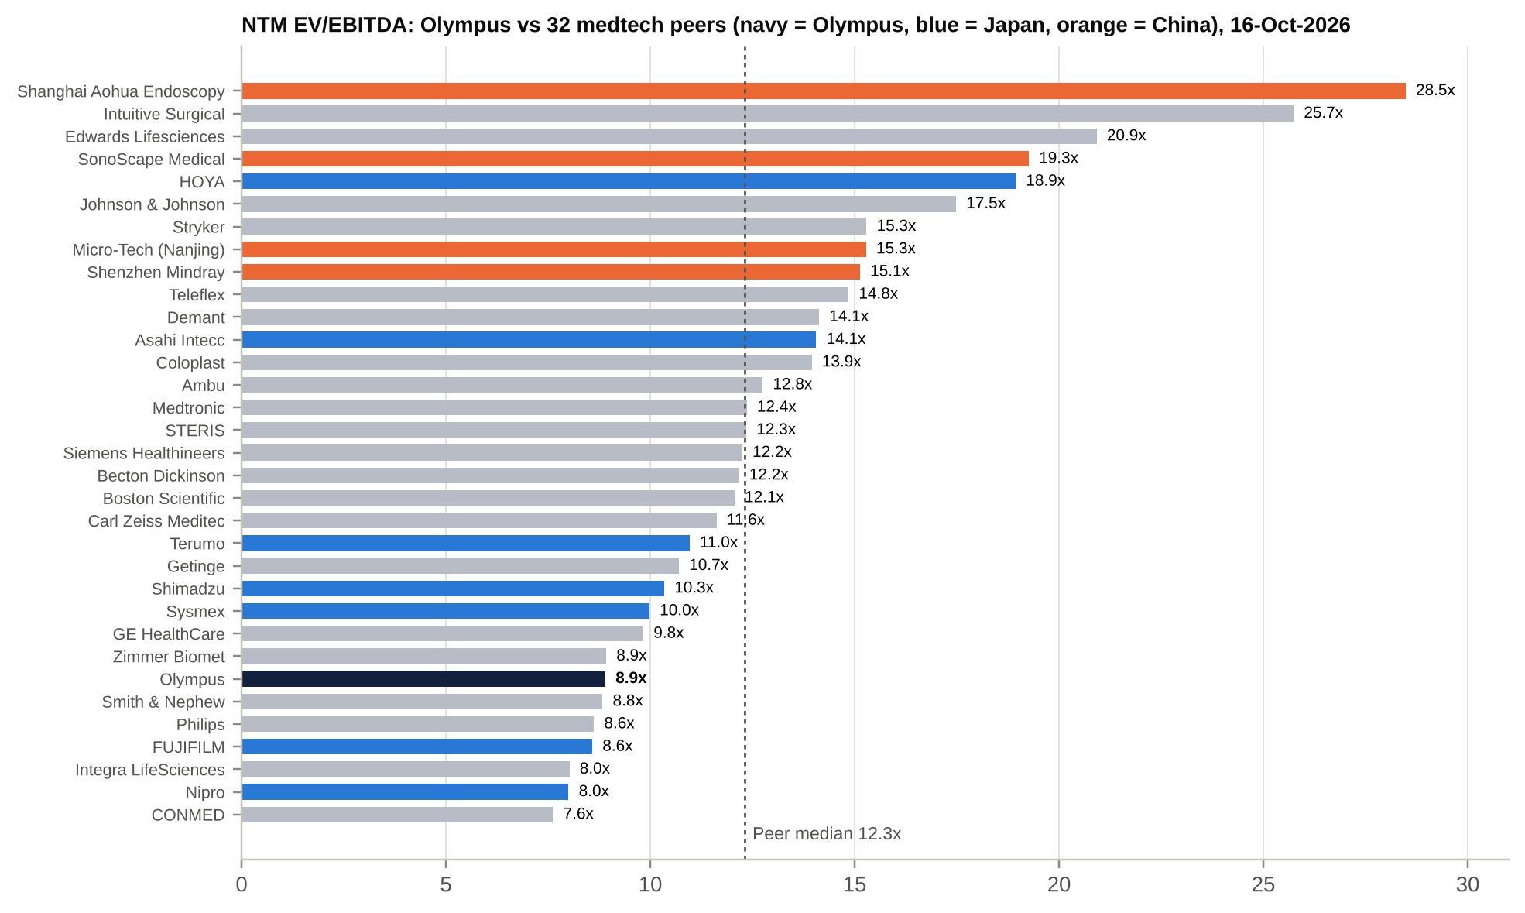
NTM EV/EBITDA: Olympus vs peers
Olympus at our estimates (JPY1,690; TEV JPY1,996bn).
 | LTM | FY3/27E | FY3/28E | FY3/29E
TEV / Sales | 1.91x | 1.86x | 1.78x | 1.70x
TEV / EBITDA | 9.35x | 9.2x | 8.0x | 7.2x
TEV / EBIT (IFRS OP) | 13.7x | 13.8x | 11.5x | 10.0x
P/E | 23.8x | 18.2x | 14.8x | 12.5x
FCF yield (equity) | 4.0% | 3.1% | 5.2% | 6.1%
Dividend yield | 1.8% | 1.8% | 1.9% | 2.0%
Net debt / EBITDA | 0.92x | 0.64x | 0.51x | 0.36x
Read-across.
- Olympus trades 4th-lowest of 33 peers on LTM TEV/EBITDA and 7th-lowest on NTM. It sits alongside FUJIFILM (a conglomerate), Nipro (5.6x levered), Integra, CONMED and Philips. Every one of those companies has either structurally lower margins or its own quality or regulatory crisis. Philips, for example, operates under a Respironics consent decree.
- Against endoscopy and GI peers (BSX, STERIS, Ambu, HOYA, Stryker, Micro-Tech) the NTM EV/EBITDA discount is ~36%. Against US/EU large-cap medtech it is ~27%.
- On growth and margin, Olympus is a median company: EBIT margin 14.4% against a 14.2% median, sales growth 7.8% against 7.4%. The discount is therefore an FDA and execution discount, not a quality discount.

Valuation vs its own history
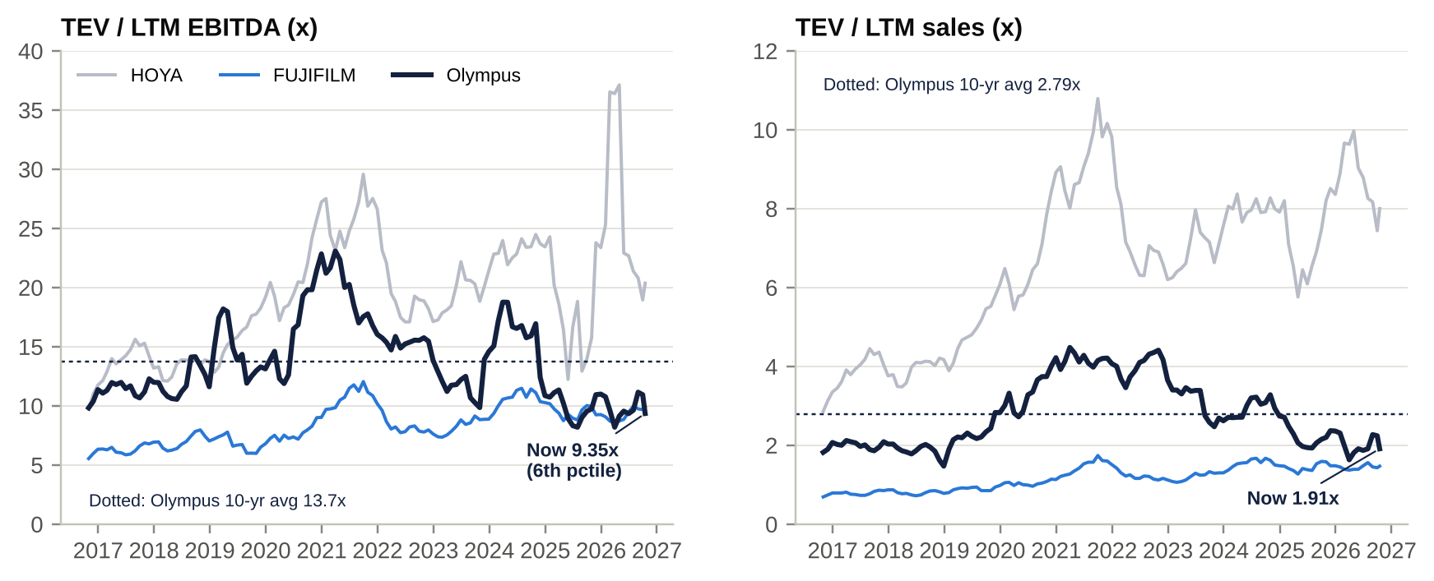
Olympus TEV/EBITDA and TEV/Sales vs HOYA and FUJIFILM, 10 years
Multiple | Current (16-Oct-26) | 3-yr avg | 5-yr avg | 10-yr avg | 10-yr range | 10-yr percentile
TEV / LTM EBITDA | 9.35x | 12.1x | 12.9x | 13.7x | 8.2–23.1x | 6th
TEV / LTM sales | 1.91x | 2.43x | 2.94x | 2.79x | 1.47–4.48x | 13th
TEV / LTM EBIT | 13.7x | 18.8x | 19.2x | 22.6x | 11.4–43.8x | low
P / B | 2.40x | 3.10x | 4.15x | 4.51x | 1.99–8.76x | 4th
P/E (LTM; distorted by low-EPS years) | 23.8x | 44.0x | 37.4x | 44.1x | 16.1–209x | n/m
Source: S&P Capital IQ monthly LTM multiples. The CIQ history point for 16-Oct-2026 still used FY3/26 fundamentals, so we use the CIQ snapshot as “current”. Olympus/HOYA TEV/EBITDA is 0.45x (10-yr mean 0.74x); Olympus/FUJIFILM is 0.94x (10-yr mean 1.67x, 10-yr low 0.93x).
Implied value from mean reversion of TEV/LTM EBITDA (CIQ LTM EBITDA JPY213.5bn).
Reversion to | Multiple | Value per share
3-yr average | 12.1x | JPY2,240 (+33%)
5-yr average | 12.9x | JPY2,400 (+42%)
10-yr average | 13.7x | JPY2,570 (+52%)
Part of the de-rating is structural. After the Evident sale Olympus is a pure medtech business, and its FDA record since 2022 warrants a discount. We therefore anchor on the 3-year average rather than the 10-year.

Regression: TEV/Sales vs EBIT margin
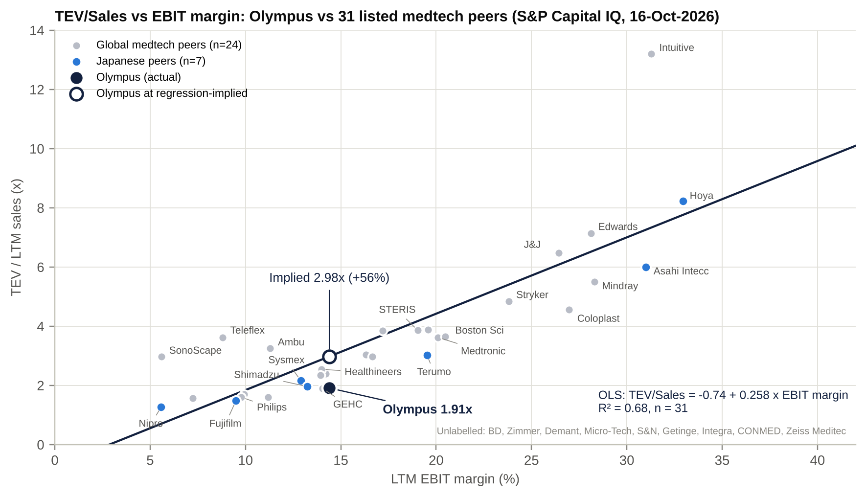
TEV/Sales vs EBIT margin regression
Specification | n | Slope (per 1pt EBIT margin) | R² | Implied TEV/Sales for Olympus | Implied value per share
Simple OLS, all peers | 31 | 0.258 (s.e. 0.033) | 0.68 | 2.98x (+56%) | JPY2,740
With Japan dummy (dummy -0.53, s.e. 0.62; not significant) | 31 | 0.259 | 0.69 | 2.56x (+34%) | JPY2,330
Excluding Intuitive, HOYA and SonoScape | 28 | 0.206 | 0.81 | 2.79x (+46%) | JPY2,555
Simple OLS at our FY3/27E adjusted margin (16.0%) | 31 | 0.258 | 0.68 | 3.39x | n/m (forward)
Peers with negative EBIT (Aohua, MicroPort) are excluded. Implied value = (implied TEV/Sales × LTM sales of JPY1,045bn − net debt of JPY200bn) / 1,062.8m shares.
Conclusion. Every specification puts Olympus 34–56% below the line. The regression explains about two-thirds of peer dispersion with one variable and cannot price an open FDA matter. We use the conservative Japan-dummy result (JPY2,330) as one of four inputs to our target.

Listed and unlisted competitors
Company | Status | Relevance
FUJIFILM endoscopy | Division of FUJIFILM Holdings (4901 JP) | #2 in flexible GI endoscopy; strong in Japan and China
PENTAX Medical | Division of HOYA (7741 JP); strategic review including sale (31-Jul-2026) | #3 in GI endoscopy; a sale price would be the best pure-play comp
Karl Storz | Private (family-owned) | #1–2 in rigid endoscopy, laparoscopy towers and urology
Richard Wolf | Private | Rigid endoscopy, urology
Cook Medical | Private (Cook Group) | GI endotherapy (stents, ERCP), urology
Erbe Elektromedizin | Private | Electrosurgery, ESD knives, argon plasma
Applied Medical, Arthrex | Private | Laparoscopic access and energy; arthroscopy
Boston Scientific, Stryker, J&J (Ethicon), Medtronic | Listed (US) | Endotherapy, single-use duodenoscope (BSX); visualisation (Stryker); energy (J&J); GI AI (Medtronic)
Ambu | Listed (DC) | Single-use bronchoscopes, urology and GI scopes
SonoScape, Aohua, Micro-Tech, Mindray | Listed (China) | Domestic-substitution challengers
Hunan Vathin, Chongqing Jinshan | Private (China) | Single-use endoscopes; capsule endoscopy
Medline | Listed (MDLN US, IPO Dec-2025) | Med-surg supplies; limited direct overlap

Target price derivation
Method | Basis | Value per share
Sum-of-the-parts (base) | GIS 12x FY3/27E EBITDA; SIS 1.2x sales; corporate costs capitalised at 9x; net debt JPY200bn | JPY2,389
P/E | 19x FY3/28E EPS of JPY114 (Japan medtech forward median ~21.7x, discounted) | JPY2,169
EV/EBITDA | 11x FY3/28E EBITDA of JPY248bn, less FY3/27E net debt | JPY2,440
Regression (Japan dummy) | 2.56x LTM sales | JPY2,329
Average (rounded) = 12-month target |  | JPY2,350 (+39%)

M&A: industry activity, takeover potential and Olympus’s own deals

Comparable transactions (2021–2026)
Target (sector) | Acquirer | Announced | EV (US$bn) | EV/LTM sales | EV/LTM EBITDA | Premium
Cantel Medical (endoscope reprocessing) | STERIS | Jan-2021 | 4.42 | 4.4x | 26.9x CIQ (~20x adj. [e]) | ~12% [u]
Hill-Rom (hospital devices) | Baxter | Sep-2021 | 12.41 | 4.2x | 19.8x | ~26% [u]
Intersect ENT | Medtronic | Aug-2021 | 1.10 | 10.7x | n/m | ~37% [u]
Vocera | Stryker | Jan-2022 | 2.99 | 13.3x | n/m | ~26% [u]
Evident (Olympus Scientific Solutions) | Bain Capital | Aug-2022 | ~3.1 (JPY427.7bn) | 3.6x | ~17.3x [e] | carve-out
Abiomed | J&J | Nov-2022 | 18.16 | 18.1x | 64.7x | ~51% [u]
Apollo Endosurgery (GI) | Boston Scientific | Nov-2022 | 0.64 | 9.0x | n/m | ~59% [u]
Axonics (urology) | Boston Scientific | Jan-2024 | 3.36 | 9.8x | n/m | ~23% [u]
Shockwave | J&J | Apr-2024 | 12.92 | 17.7x | 73x | ~5% vs prior close [u]
Silk Road Medical | Boston Scientific | Jun-2024 | 1.17 | 6.3x | n/m | ~27% [u]
Inari Medical | Stryker | Jan-2025 | 4.81 | 8.4x | n/m | n/d
Paragon 28 | Zimmer Biomet | Jan-2025 | 1.32 | 5.4x | n/m | ~28% [u]
Topcon (Japan take-private) | KKR + JIC Capital | Mar-2025 | ~2.9 (JPY430bn) | 2.0x | 16.9x | 5% vs last close; ~100% vs 12-month average
Hologic (take-private) | Blackstone + TPG | Oct-2025 | 18.1 | 4.5x | 14.3x CIQ (~12x adj. [e]) | ~46% vs undisturbed; plus CVR
Teleflex OEM, Acute Care and IU (carve-outs) | Montagu/Kohlberg; Intersurgical | Dec-2025 | 2.03 | n/d | n/d | carve-outs
Penumbra | Boston Scientific | Jan-2026 (pending) | 14.5 | 10.9x | n/m | ~19% vs 30-day VWAP
BioProtect | Olympus | May-2026 | 0.27 | 18.6x | n/m | private
PENTAX Medical (Hoya) | Strategic review incl. sale | Jul-2026 | n/d | n/d | n/d | –
Precedent: Toshiba Medical Systems | Canon | Mar-2016 | ~5.9 | ~1.7–2.3x [e/u] | n/m | auction
Source: S&P Capital IQ Transactions (implied EV at announcement; target LTM financials), company releases. Premiums marked [u] were not verified against merger proxies.
Bucket | Deals | EV/Sales median (range) | EV/EBITDA median (range)
Mature, profitable, scale (closest to Olympus) | Hill-Rom, Cantel, Hologic, Topcon, Evident | 4.2x (2.0–4.5x) | 17.3x (14.3–26.9x CIQ; ~12–20x adjusted)
Growth and high-margin tuck-ins | Axonics, Silk Road, Inari, Shockwave, Abiomed, Paragon 28, Intersect, Penumbra, Vocera, Apollo | ~10.3x (5.4–18.1x) | n/m
Japanese medtech carve-outs | Toshiba Medical, Hitachi imaging, Evident | ~1.1–3.6x | ~17x (Evident)

Is Olympus a takeover target?
Our view: plausible but hard. We put the probability of a credible approach within 24 months at ~15–20% [e]. Two structures are more likely than a whole-company bid: an SIS carve-out, or a PE-sponsored take-private with a Japanese anchor investor.
Arguments for a bid.
- Valuation dislocation. Olympus trades at 9.4x EBITDA, against peers at 12–20x and mature-deal precedents at ~14–20x.
- Franchise quality. About 70% GI share [u], ~45% recurring revenue in GIS, ~65% gross margin, and the largest installed base in the industry.
- No controlling shareholder. Cross-shareholdings are de minimis, the board is 9 of 10 independent, and the management team is US-style. Under METI’s 2023 takeover guidelines, the board must give a bona fide offer “sincere consideration”.
- A ValueAct-linked director (Rob Hale) sits on the board. ValueAct backed and sold into the KKR/JIC take-private of Topcon (ValueAct held ~14%).
- Japanese take-private precedents now exist at scale: Toshiba/JIP (JPY2.2tn EV), Topcon, Taiyo Holdings (KKR, +117% vs the 6-month average), and Fuji Soft.
- The fix-and-flip case is self-help. QMS remediation, the cost-out, China stabilisation and SIS portfolio action are all levers a sponsor can underwrite.
Impediments.
- FEFTA. Medical devices became a core FEFTA sector in 2020. The Jun-2026 amendments add indirect-acquisition capture, post-closing review and stricter treatment of “high-risk” investors. Western PE and strategic buyers should clear, with conditions on Japanese R&D, manufacturing and supply security.
- Antitrust. With ~70% GI share, Fujifilm, PENTAX and other scope makers are excluded. Boston Scientific would face remedies in endotherapy and urology. China SAMR review could be used politically.
- The open FDA Warning Letter (plus the import alert and recalls). Buyers would demand a price discount, a contingent value right (as in Hologic) or regulatory conditions.
- Size and leverage. EV of JPY2.8–3.5tn (US$18–22bn) would be a top-3 Japanese LBO. FCF is thin (consensus FY3/27 ~JPY63bn) and remediation spend competes with debt service.
- Social and political optics for a national “monozukuri” champion. JIC or DBJ co-investment (the Topcon model) mitigates this.
- Change-of-control clauses in the SOMED (Sony) and Swan (Revival) arrangements [u].
Potential acquirers.
Buyer type | Candidates | Fit | Key obstacle
PE / sovereign club | Blackstone, KKR, Bain, EQT, TPG, CVC, Carlyle with JIC, DBJ, GIC or ADIA | Proven playbook (Topcon, Hologic, Evident) | Size; leverage vs remediation; FEFTA
US/EU strategic, no flexible-scope overlap | Medtronic (CEO White is ex-MDT), J&J MedTech, Stryker, Siemens Healthineers, GE HealthCare | GI franchise plus service annuity | FDA liability; capacity (BSX–Penumbra pending)
US strategic with overlap | Boston Scientific | Highest synergy | Antitrust; balance sheet
Japanese “white knight” | Canon (EUS partner), Sony (SOMED partner), Terumo | FEFTA-friendly | Appetite [u]
SIS-only buyers | Karl Storz, Stryker, Teleflex-style PE, Integra, CONMED | Rigid endoscopy, urology, energy, ENT | Price; carve-out complexity

Takeout multiples and implied value
EV / FY3/27E EBITDA | EV (JPY bn) | EV / FY3/27E sales | Value per share (JPY) | Premium vs JPY1,690 | Premium vs JPY2,032 (pre-letter)
11x | 2,376 | 2.22x | 2,047 | +21% | +1%
12x | 2,592 | 2.42x | 2,251 | +33% | +11%
13x (≈ BSX/MDT trading) | 2,808 | 2.62x | 2,454 | +45% | +21%
14x (≈ Hologic, CIQ basis) | 3,024 | 2.82x | 2,657 | +57% | +31%
15x | 3,240 | 3.02x | 2,860 | +69% | +41%
16x | 3,456 | 3.22x | 3,064 | +81% | +51%
17x (≈ Topcon / Evident / mature-deal median) | 3,672 | 3.43x | 3,267 | +93% | +61%
Our FY3/27E EBITDA is JPY216bn (consensus JPY218bn). Net debt is JPY200bn; shares are 1,062.8m.
Central takeout range: JPY2,500–3,000 (13.2–15.7x FY3/27E EBITDA, ~2.7–3.2x sales). A stretch case of ~JPY3,300 (17x) would need a strategic buyer or a credible cost-synergy case.
The “undisturbed” price is contested. A bidder would anchor on the post-letter JPY1,690. Holders would anchor on the 3–6-month VWAP of ~JPY1,950–2,030.
LBO sanity check [e].
- At EV JPY3.0tn, 5.5x LTM EBITDA of debt is ~JPY1.2tn, leaving ~JPY1.8tn (US$11.5bn) of equity. That is comparable to Hologic and the Toshiba consortium.
- It is feasible only as a club deal.

Olympus’s own acquisitions and disposals (last 10 years)
Date | Target / asset | Direction | Value | Outcome
2017 | Image Stream Medical (OR video integration, US) | Buy | n/d | Integrated [u]
Aug-2020 | Arc Medical Design (Endocuff Vision) | Buy 100% | JPY3.5bn | Retained in the adenoma-detection portfolio
Jan-2021 | Imaging (cameras) → OM Digital Solutions (JIP) | Sell 95% | ~JPY47bn loss on transfer | Strategic success (exit)
Nov-2020 | FH Ortho (France) | Buy | n/d | Failed: impaired JPY8.6bn; sold in 2024
Dec-2020 | Veran Medical (EM-navigation bronchoscopy, US) | Buy | US$340m (~12x sales) | Failed: shipments stopped 2023; JPY51.9bn loss
2021 | Quest Photonic Devices (fluorescence imaging, NL) | Buy | €50m | Capability in VISERA ELITE III [u]
2021 | Medi-Tate (iTind, Israel) | Buy remaining 81.5% | ~US$310m implied EV | Mixed: approval delays; CPT codes from 2025
Aug-2022 / Apr-2023 | Evident (Scientific Solutions) | Sell to Bain | JPY427.7bn (3.6x sales, ~17x EBITDA) | Success: funded the JPY180bn FY3/24 buyback
Dec-2022 | Odin Medical (AI for endoscopy, UK) | Buy | £66m incl. earn-outs | CADDIE on OLYSENSE; ongoing
Feb-2023 / Jan-2024 | Taewoong Medical (GI stents, Korea) | Buy → rescinded Mar-2024 | US$370m | Failed: JPY43.6bn paid, JPY31.1bn recovered
Jul-2024 | Olympus Terumo Biomaterials + FH Ortho | Sell to Polaris | JPY3.7bn | Ortho exit
Jul-2025 | Swan EndoSurgical JV (endoluminal robotics) with Revival | Minority + call option | Up to US$458m jointly | Early stage; ~JPY4.4bn equity loss FY3/26
May/Jun-2026 | BioProtect (prostate RT spacer, Israel) | Buy 100% | US$270m (18.6x sales) | Just closed; goodwill +JPY46bn
Scorecard. On the buy side, ~JPY62bn of losses and impairments (Veran, ortho, Taewoong) came on ~US$1.5bn of medical acquisitions since 2020. Disposals (Evident, cameras, ortho) were executed cleanly and at good prices. Olympus is a better seller than buyer. For the SIS review, we read that as encouraging, and it is also why the “M&A machine” rhetoric deserves scepticism.

Management assessment

Key executives
Name | Role | Since | Background | Assessment
Robert J. “Bob” White | Director, Representative Executive Officer, President & CEO | CEO 1-Jun-2025; director 26-Jun-2025 | Medtronic EVP and President, Medical Surgical Portfolio (2020–24); President, Minimally Invasive Therapies; SVP Asia-Pacific. Earlier Covidien, GE Healthcare, IBM. Philips Supervisory Board (since May-2025). | Credible medtech operator. In 16 months: candid reset; ~2,000 job cuts; 3-4-5 plan; Surgical review; JPY60bn buyback. But also two guidance cuts in his first FY and an FDA Warning Letter on his watch. Professional manager, not a founder.
Michael A. Parenti | Executive Officer & CFO | 1-Apr-2026 | J&J 2001–21 (Ethicon Endo-Surgery, DePuy, M&A finance; CFO J&J China; CFO J&J K.K. Japan); Stryker VP and Group CFO, MedSurg & NeuroTech (2021–26) | Strong fit: Japan experience plus US medtech M&A and portfolio finance. He is the right CFO for a carve-out. The third CFO since 2020 (Takeda to Mar-24; Izumi Apr-24 to Mar-26).
Brian R. Barry | Executive Officer & Chief Quality Officer | 1-Aug-2026 | 40+ years in quality and regulatory: C.R. Bard, Covidien, Medtronic Group VP Quality & Regulatory | The third CQO since Apr-2024. He arrived 10 weeks before the Warning Letter, so the response is his first test.
Keith Boettiger | Executive Officer, GIS Division Head | Joined Apr-2025 | Sales, R&D, regulatory [u on prior employer] | Called the FY3/26 US miss “clearly an execution issue”. 4Q and 1Q have since rebounded.
Seiji Kuramoto | Executive Officer, SIS Division Head | Apr-2025 (TSD Head from Apr-2024) | Career Olympus (1988); ex-EVP of Sony Olympus Medical Solutions | Runs the division with the ship-holds and the strategic review. The only Japanese executive officer.
Syed Naveed | Executive Officer & CTO | Apr-2025 | Boston Scientific endoscopy R&D; BD urology R&D
David Shan | Executive Officer & Chief Manufacturing & Supply Officer | Apr-2026 | BD EVP and CQO, then Chief Supply Chain Officer; 3M | Key to FDA remediation at the plants
Tenure and ownership.
- Every executive officer except Kuramoto is an external, largely US/EU, hire. Eight of the eleven joined in 2023 or later.
- Personal shareholdings are small, believed to be <0.01% each [u: the yuho table was not retrievable], and consist mainly of RSU/PSU-delivered stock.
- Dilutive instruments at Dec-2025: 1.24m RSUs, 0.69m PSUs and 0.20m options.
- This is a professional-manager company with no founder or family owner. Alignment comes from the LTI design and from an independent, shareholder-influenced board, not from equity ownership.

Capital allocation and returns under each CEO
CEO | Tenure | Key decisions | Avg ROE / ROIC [e]
Hiroyuki Sasa | Apr-2012 to Mar-2019 | Post-scandal recapitalisation; Sony alliance (2012); medical refocus | 8.9% / 10.6%
Yasuo Takeuchi | Apr-2019 to Mar-2023 (Executive Chair to Mar-2026; interim CEO Oct-24 to May-25) | “Transform Olympus” with ValueAct; cameras sold to JIP; Evident sold to Bain (~JPY430bn); buybacks; FDA problems emerge (2022–23 warning letters) | 16.6% / 16.8% (peak ROIC 23.1%, FY3/22)
Stefan Kaufmann | Apr-2023 to Oct-2024 | Veran exit (JPY52bn loss); Taewoong rescinded; JPY280bn of buybacks at ~JPY2,200; resigned over an illegal-drug allegation (suspended sentence, Dec-2024) | 25.2% (inflated by the Evident gain) / 14.2%
Bob White | Jun-2025 to date | Cost reset; 3-4-5 plan; Surgical review; BioProtect (US$270m); JPY60bn ToSTNeT-3 buyback at JPY1,540 | 8.7% / 12.5% (FY3/26 only)
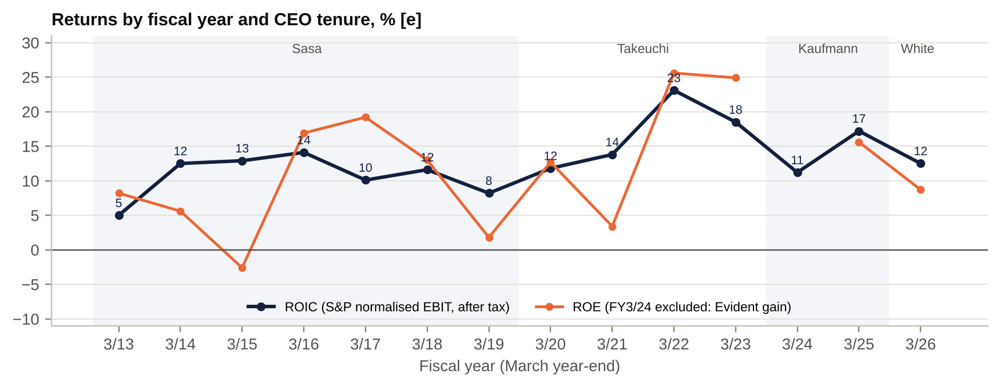
ROE and ROIC by fiscal year and CEO
ROIC = S&P-normalised EBIT × (1 − tax) / average (equity + debt − cash).
Capital allocation verdict.
- Portfolio pruning: excellent. Cameras and Evident were sold, and Olympus is now a pure medtech business.
- Buybacks: generous but badly timed. About JPY280bn was spent between May-2023 and Nov-2024 at ~JPY2,200 per share, ~30% above today’s price.
- Acquisitions: poor. Veran and Taewoong failed. BioProtect was bought at ~19x sales.
- Organic reinvestment in quality: too late and too small. Elevate began in 2023, after the 2022 warning letters.

Red flags
- Quality and compliance culture (HIGH).
  - FDA warning letters in 2022–23, an import alert in 2025 and a six-site Warning Letter in Oct-2026.
  - ~20 products on ship-hold in FY3/26.
  - Recalls, including ViziShot 2 FLEX (one reported death).
  - Three CQOs in about 2.5 years.
  - Historical US settlements: FCPA/AKS ~US$646m (2016) and the duodenoscope-reporting guilty plea (2018) [u].
  - The company again says the Warning Letter has “no financial impact”; the market disagrees.
- Pay vs performance (HIGH).
  - Kaufmann: JPY1,138m in FY3/24 while OP fell 34%.
  - Drewalowski (former GI head): JPY994m in FY3/26, including JPY600m of non-base pay, likely transition and LTI acceleration [u].
  - White: a JPY210m bonus in a year with two guidance cuts (possibly a guaranteed element [u]).
  - At least 12 officers were paid over JPY100m in FY3/26.
  - There is a two-tier pay structure: US/EU hires earn 2.5–8x their Japanese peers.
- Guidance credibility (MEDIUM–HIGH). OP guidance was cut in each of the last three fiscal years:
  - FY3/24: JPY163bn to JPY100bn to JPY57bn.
  - FY3/25: JPY176bn to JPY151bn.
  - FY3/26: JPY150bn to JPY136bn to JPY75–87bn.
- A 3Q cut has come in each of the last four Februaries.
- M&A discipline (MEDIUM). Veran, Taewoong and FH Ortho all failed. The CEO’s Jan-2026 talk of an “M&A machine” leaves room for value-destructive deals.
- Succession and conduct (MEDIUM). The Kaufmann conviction raises questions about vetting, given his earlier roles as CAO and director. A 7-month interim period followed.

Board of directors
Director | Role | Independent | Since | Background | Committees
Masato Iwasaki, PhD | Independent Chair | Yes | Jun-2024 | Takeda Japan Pharma BU President (2015–21); IGPI senior fellow | Nominating (Chair)
Bob White | Director, CEO | No | Jun-2025 | ex-Medtronic | –
Jimmy C. Beasley | Outside director | Yes | Jun-2019 | C.R. Bard Group President (2013–17) | Compensation (Chair)
D. Robert Hale | Outside director (ValueAct) | Designated independent; represents a shareholder | Jun-2019 | ValueAct partner since 2011, Co-CEO since 2023; ex-Bausch Health, MSCI, JSR boards | Compensation; Nominating
Sachiko Ichikawa | Outside director | Yes | Jun-2021 | Lawyer (Tanabe & Partners); Anritsu, Tokyo Electron boards | Audit
Kohei Kan | Outside director | Yes | Jun-2022 | CPA; CEO of Deloitte Tohmatsu (2015–18) | Audit (Chair)
Gary J. Pruden | Outside director | Yes | Jun-2022 | J&J Worldwide Chairman, Medical Devices (2015–17) | Nominating
Luann M. Pendy, PhD | Outside director | Yes | Jun-2023 | Medtronic SVP and Chief Quality & Regulatory Officer | Nominating; Compensation
Jean-Luc Butel | Outside director | Yes | Jun-2026 | Medtronic EVP International; Baxter; BD Japan | n/a [u]
Constantine Saroukos | Outside director | Yes | Jun-2026 | Takeda CFO (2018–24); CSL director; Chair, Mitsubishi Tanabe | n/a (likely Audit) [u]
Company with a Nominating Committee structure (three committees). 10 directors: 9 independent, 7 non-Japanese, 2 women. Source: S&P CIQ Professionals; TSE release of 29-Sep-2026.
Changes over the last five years.
AGM / event | Joined | Left
Jun-2022 | Kohei Kan, Gary Pruden, Yasushi Shingai | Susumu Kaminaga, Atsushi Iwasaki
Jun-2023 | Luann Pendy, Toshihiko Okubo (internal), Tatsuro Kosaka | Nobuyuki Koga, Tetsuo Iwamura
Jun-2024 | Masato Iwasaki | Yasumasa Masuda, Yasushi Shingai, Tatsuro Kosaka
28-Oct-2024 | – | Stefan Kaufmann (CEO; resigned at the board’s request)
Jun-2025 | Bob White, Hiroshi Ishino | Sumitaka Fujita (former Chair)
Jun-2026 | Jean-Luc Butel, Costa Saroukos | Yasuo Takeuchi (ex-CEO and Executive Chair), Toshihiko Okubo
29-Sep-2026 | – | Hiroshi Ishino (health reasons)
Board assessment.
- Strengths: high independence; deep medtech, quality and regulatory expertise (Pendy, Pruden, Beasley, Butel); finance depth (Kan, Saroukos); and shareholder representation (Hale). The board acted decisively in the Kaufmann case.
- Weaknesses:
  - Since Jun-2026 there is no internal director other than the CEO, so the board relies heavily on management reporting about Japanese plants.
  - The Compensation Committee (Beasley, Hale, Pendy) has overseen sharp pay escalation.
  - Churn is high.
  - For an activist, this board is receptive: it has already accepted a ValueAct director, ran a strategic review, and would have to engage seriously with a bona fide bid under the METI guidelines.

Shareholders, activism and short interest

Top shareholders
# | Holder | Shares (m) | % (ex-treasury) | Type
1 | The Master Trust Bank of Japan (trust account) | 210.7 | 19.1% | Domestic custodian (trust banks, pensions, index and active funds)
2 | Custody Bank of Japan (trust account) | 73.8 | 6.7% | Domestic custodian (incl. BoJ ETF and pension money)
3 | State Street Bank & Trust Co. 505001 | 57.4 | 5.2% | Foreign custodian
4 | JPMorgan Chase Bank 385839 | 41.0 | 3.7% | Foreign custodian
5 | JPMorgan Chase Bank 385642 | 17.1 | 1.6% | Foreign custodian
6–10 | Not retrieved (other SSBT/BNY accounts, life insurers and banks historically) [data gap] | – | – | –
– | Artisan Partners (large-holding report, 7-Jul-2026) | 62.7 | 5.63% (~5.9% of current shares) | Active long-only; beneficial owner within the custodian accounts
– | ValueAct Capital | n/d | n/d (5.04% in 2018; partly sold late 2020) [u] | Activist (“constructivist”); board seat
Register at 31-Mar-2026 via third-party aggregators (kabutore, finboard), cross-checked; verify against the FY3/26 yuho, which was not retrievable. Foreign ownership % is n/d; at least 10.5% sits in foreign custodian accounts in the top 5 alone. The ToSTNeT-3 seller in May-2026 (38.9m shares, 3.5%) was not named [u].

Shareholder activism
- ValueAct (2017–present) is a textbook constructive-activist success.
  - It built a 5.04% stake (~JPY67bn) by May-2018, its first Japanese investment.
  - The settlement in Jan-2019 was “Transform Olympus”: Rob Hale and Jim Beasley joined the board, the company adopted the three-committee structure, and it exited non-core businesses (cameras, Evident).
  - ROIC rose from 8% (FY3/19) to 23% (FY3/22).
  - ValueAct partly sold in late 2020 at ~JPY2,000–2,380 (2.1–2.5x its entry price [e]).
  - Hale remains on the board.
- Artisan Partners (5.63%, Jul-2026) bought after the Feb-2026 collapse. There is no public stance [u], but Artisan has engaged with managements elsewhere.
- No shareholder proposals were filed at the 2021–2026 AGMs. No campaigns by Elliott, Oasis, Dalton or others were found.
- Activist angle for our fund. There are three asks we would make:
  - Accelerate the SIS outcome, by sale or JV, with proceeds returned.
  - Tie executive pay to FDA close-out and FCF, not adjusted OP.
  - A standing buyback policy framed as total-return guidance. The current policy keeps DPS flat with “flexible” buybacks.
- The ingredients are a receptive board, a ValueAct director and an Artisan block. That makes a private, constructive engagement more effective than a public campaign.

Short interest
Item | Finding
JPX short-position reports (≥0.5% holders) | Not retrievable from this environment [data gap]; check the JPX daily file and karauri.net for code 7733
Securities lending utilisation | n/d; check JSF and S&P Securities Finance
Margin balances (shinyo) | n/d; check the weekly TSE margin data
Positioning read [e] | Two guidance cuts and three FDA events since Jun-2025 are the classic set-up for event-driven shorts. Offsetting flows: buybacks (JPY60bn in one block) and a new 5% long holder. The -13.4% day on 3.3x volume suggests long liquidation more than fresh shorting [e].

Strategic initiatives (last 10 years): success, failure and status
Initiative | Launched | Status (Oct-2026) | Verdict
Transform Olympus (with ValueAct) | Jan-2019 | Governance overhaul; portfolio now 100% medtech; 9 of 10 directors independent | Success on governance and portfolio; mixed operationally
Corporate strategy to FY3/23 (~20% OP margin) | Nov-2019 | 20% adjusted margin reached once (FY3/23) | Met once
Company strategy FY3/24–FY3/26 (~5% cc CAGR, ~20% margin, ~8% adj. EPS CAGR) | May-2023 | FY3/26 adjusted margin 14.2%; cc growth ~2% a year | Missed
Elevate (quality and regulatory transformation) | 2023 | ~JPY20–32bn a year spent; “96% of FDA commitments complete” (Aug-2025), then the import alert, ship-holds and the Oct-2026 Warning Letter | Not yet successful
EVIS X1 platform | 2020 (EU/JP), 2023 (US) | Drives the GI replacement cycle; EDOF (2025); China local production | Success, late in the US
Single-use endoscopes | 2019 | H-SteriScope (bronchoscopy, ENT); no scale vs Ambu or BSX; Veran failed | Limited
AI and digital (ENDOBRAIN, CADDIE, OLYSENSE) | 2019–25 | Launched EU/US; monetisation n/d | Early
China localisation | 2023–26 | Revenue down from JPY125bn to JPY83bn; new China president from Mar-2026 | Failing so far
Cost restructuring (~2,000 roles, ~JPY24bn) | Nov-2025 | 1,687 roles cut by Apr-2026; SG&A at 52% of sales in 1Q FY3/27 | On track
3-4-5 plan (3/4/5% cc growth; 100bp+/yr margin; 20%+ destination) | Nov-2025 | FY3/27 guide consistent; 1Q ahead | Credibility hit by the Warning Letter
Surgical strategic review | May-2026 | Open; no timetable | Pending: the key catalyst
Robotics (Swan EndoSurgical JV) | Jul-2025 | Build-to-buy option; ~JPY4.4bn of losses absorbed | Long-dated option

Stakes in other companies
Holding | Type | Value | Relevance
Equity-method investments (total) | Associates and JVs | JPY1.4bn (Mar-26) | Small
Swan EndoSurgical (Revival ~55% / Olympus ~45%) | JV; Olympus call option at a predetermined value; Revival puts | n/d (losses ~JPY4.4bn in 9M FY3/26) | Robotics option and a contingent cash call
Sony Olympus Medical Solutions (SOMED) | JV with Sony (~51/49 [u]) | n/d | Imaging co-development; change-of-control consideration
Other non-current financial assets | Listed/unlisted shares, derivatives, call options | JPY35.4bn (Mar-26) | Cross-shareholdings de minimis
OM Digital Solutions | 5% retained at the 2021 sale | n/d [u: still held?] | Immaterial
Evident (Bain) | Licence agreement (no equity) | ~JPY6.0bn licence income in FY3/26 | Possibly non-recurring
Olympus Innovation Ventures | Corporate VC (US$50m fund; Fund II US$150m) | n/d | Deal-sourcing
There is no hidden asset value in stakes. CIQ’s “long-term investments” of JPY178bn is an aggregation of receivables and other financial assets, not an investment portfolio. The hidden value is internal: SIS is valued by the market at roughly zero or less (see Valuation).

Shareholder returns: dividends, buybacks and treasury shares
FY | DPS (JPY) | Dividends paid (JPY bn) | Buyback resolution | Buyback executed (JPY bn; shares; avg price) | Treasury shares at FYE (m) | Shares cancelled | Total return / NI
FY3/21 | 12 | n/d | – | – | 85.3 | 71.6m (Jun-2021) | n/m
FY3/22 | 14 | 15.4 | 17-Dec-2021 (max 16m / JPY30bn) | 30.0; 12.7m; ~JPY2,366 | 26.3 | 13.4m (Jun-2022) | 39%
FY3/23 | 16 | 17.8 | 11-Nov-2022 (max 21m / JPY50bn) | 50.0; 19.7m; ~JPY2,536 | 12.6 | 19.7m (Mar-2023) | 47%
FY3/24 | 18 | 20.1 | 12-May-2023 (JPY100bn) + 9-Nov-2023 (JPY80bn) | 180.0; 88.5m; ~JPY2,034 | 49.5 | 51.0m (Feb-2024) + 37.4m (Apr-2024) | 82%
FY3/25 | 20 | 21.0 | 10-May-2024 (max 60m / JPY100bn) | 100.0; 38.6m; ~JPY2,592 | 11.3 | 38.6m (Jan-2025) | 103%
FY3/26 | 30 | 22.6 | 13-May-2025 (max 36m / JPY50bn) | 50.0; 27.6m; ~JPY1,810 | 13.4 | 24.6m (Nov-2025) | 106%
FY3/27 YTD | 30 (guide) | 33.0 | 12-May-2026 (max 46m / JPY60bn) | 60.0; 38.9m; JPY1,540.5 (ToSTNeT-3, 13-May) | ~52 [e] | Planned by Apr-2027 [u] | n/m
Total FY3/22–FY3/27 YTD |  | ~130 |  | ~470
Sources: tanshin, TSE releases, FilingReader. Payout ratio FY3/26: 48.9% (DOE 4.3%). Dividend policy changed in May-2026 from “stable and gradual increases” to “maintain DPS, with flexible buybacks”.
Assessment.
- Shares outstanding have fallen from 1,285.6m (Mar-21) to 1,062.8m (Oct-26), -17%. That is a ~3.4% annual shrink rate.
- The weighted average buyback price since FY3/22 is ~JPY2,100 [e], so the programme is underwater at JPY1,690. The May-2026 ToSTNeT-3 block at JPY1,540 was well timed, however.
- Buybacks have been announced at FY results (May) in 2023–26 and at 2Q (Nov) in 2022–23. With the JPY60bn programme fully used, a new authorisation at 2Q FY3/27 (early-to-mid Nov-2026) is a live possibility [e]. That would be the most direct way to show confidence after the Warning Letter.

Adversarial analysis: bull case, bear case, pre-mortem and contrarian view

Bull case
- The Warning Letter is a lagging indicator, not a new problem. The letter concerns the responses to Form 483s from inspections in late 2025, and that damage is already in the P&L:
  - ~20 products were ship-held in FY3/26, most since released.
  - ~JPY30bn of FY3/26 impact.
  - It imposes no restriction on sales or 510(k)s.
- Under a new ex-Medtronic CQO and an ex-BD manufacturing chief, a credible corrective-action plan and re-inspection over 12–18 months would remove the single largest discount factor.
- Earnings are inflecting. 1Q FY3/27 adjusted OP more than doubled and SG&A fell 7pp of sales. FY3/26 absorbed ~JPY55bn of tariff and FDA costs that will not fully recur. Our FY3/29E EPS of JPY135 puts the stock on 12.5x.
- SIS optionality is free. At JPY1,690, the market values the whole group at less than our GIS-only value: 12x GIS EBITDA less corporate costs and net debt is ~JPY2,020 per share [e]. A sale of SIS at 1.0–1.6x sales (JPY330–520bn) would crystallise JPY300–490 per share. PENTAX’s sale process will publish a fresh endoscopy multiple.
- Shareholder-aligned governance and an active buyback. The board is 90% independent with a ValueAct director, ~JPY470bn has been bought back since 2021, and a new programme at 2Q is possible.
- Take-private optionality. The Topcon (KKR/JIC) and Hologic (Blackstone/TPG) templates fit. Our 13–17x FY3/27E EBITDA range gives JPY2,450–3,270.

Bear case: risks that could permanently impair the business
- FDA escalation. Olympus has received three warning letters in 2022–23, an import alert in 2025 and a six-site letter in 2026. The next steps up are:
  - A consent decree, which could mean production stoppages, third-party oversight and years of remediation cost. Philips Respironics is the precedent.
  - Wider import alerts covering Hachioji, Hinode, Aomori or Shirakawa, which make the GI scopes.
  - Certificate-to-Foreign-Government and 510(k) holds.
- A GI import alert would hit the 40% of revenue sold in North America.
- Structural share loss in China and single-use cannibalisation. China fell 34% in four years. Domestic substitution targets 95% local share in county hospitals by 2030 [u]. Single-use duodenoscopes and bronchoscopes (BSX, Ambu) could erode the reusable-scope and service annuity.
- Execution and credibility. Guidance has been cut in four consecutive Februaries. The 20% margin target has been “the destination” since 2019, and the adjusted-OP definition excludes recurring “one-offs” (JPY167bn over five years).
- Capital allocation. Buybacks at an average ~JPY2,100 are underwater. Net debt has swung to JPY200bn. M&A ambitions (“M&A machine”) carry the risk of another Veran.
- Tariffs and FX. A Section 232 device tariff, or a sharp yen rebound if the BoJ hikes faster, would hit an export-heavy cost base made in Japan.

Pre-mortem: it is October 2027 and the stock is at JPY1,200. What happened?
- The FDA rejected the corrective-action plan. A re-inspection of Aizu and Hachioji found repeat observations, and the FDA expanded Import Alert 89-04 to GI scopes. US capital sales stalled for two quarters and Olympus took a JPY40bn remediation provision.
- Guidance was cut again in Feb-2027, and FY3/27 OP came in at JPY120bn.
- The Surgical review ended in “retain and fix”. No buyer would pay above 0.8x sales for a business under FDA scrutiny.
- The new CFO paused buybacks to protect the rating after a downgrade to BBB, and the stock de-rated to 7x EBITDA.
What would have warned us:
- No third-party auditor named in the November response.
- New ship-holds announced at 2Q.
- Departure of the CQO or the CMSO.
- Silence on the FDA re-inspection date by the May-2027 results.

Are current multiples too high?
No. On every measure the stock is cheap against peers and its own history:
- 9.35x LTM EBITDA (6th percentile of 10 years) and 1.91x sales.
- 18.2x FY3/27E and 14.8x FY3/28E P/E.
- A 32% discount to the peer median at a peer-median margin.
The risk is not the multiple but the denominator. If FDA action took 20% off EBITDA, the stock would be on ~11.5x, roughly the Japan medtech median. That is why the bear case is JPY1,250 rather than lower: the franchise and the balance sheet put a floor under value.

Contrarian view: what the market is refusing to see
- The market is treating the Warning Letter as the beginning of the FDA problem. We think it is closer to the end.
  - The inspections took place in late 2025.
  - The ship-holds have happened, and ~70% of the products had been released by Feb-2026.
  - The costs are in the base.
  - Management, CQO, CMSO and two board members are now drawn from Medtronic, BD and Bard quality organisations.
- Warning-letter close-outs typically take 1–3 years. The stock usually bottoms well before close-out, when the remediation plan becomes credible [e].
- SIS is valued at roughly zero. The market is pricing a whole-company discount for a problem that is concentrated in SIS. SIS had the ship-holds, includes two of the six cited sites (Hamburg and Gyrus ACMI) and is loss-making. A separation would leave a ~25%-margin GI franchise that deserves a peer multiple of 13–15x.
- Consensus is too low in the out-years. FY3/29 consensus EBIT (JPY187bn) implies no progress beyond FY3/28 on margins. That is despite ~JPY24bn of run-rate savings, ~JPY50bn a year of buybacks and the absence of FY3/26’s one-off costs.

Scenario analysis
Assumption | Bear (25%) | Base (50%) | Bull (25%)
FDA outcome | Escalation: wider import alert or consent-decree talk; GI ship-holds | Corrective plan accepted; re-inspection in 2027; WL closed in 12–18 months | Rapid close-out; Aizu import alert lifted
FY3/28E revenue | ~JPY1,040bn | JPY1,119bn | ~JPY1,150bn
FY3/28E adjusted OP margin | ~13% | 16.8% | ~18.5%
FY3/28E EPS | ~JPY80 | JPY114 | ~JPY130
SIS outcome | Retained; loss-making | Sale or JV at ~1.2x sales | Sale at 1.6x sales plus buyback
Valuation method | 15.5x P/E on FY3/28E (≈ 8x EV/EBITDA) | SOTP: GIS 12x EBITDA, SIS 1.2x sales | Take-private or re-rating at ~15.7x FY3/27E EBITDA (≈ Hologic–Topcon range)
Value per share | JPY1,250 (-26%) | JPY2,390 (+41%) | JPY3,000 (+78%)
Implied TEV / FY3/27E EBITDA | ~7.0x | ~12.7x | ~15.7x
Probability-weighted value JPY2,258 (+34%). Including the 1.8% dividend yield, the expected 12-month total return is ~36%. The bull case needs an event (SIS sale, bid or FDA close-out). The base case needs only that the FDA does not escalate and the 3-4-5 plan stays on track.
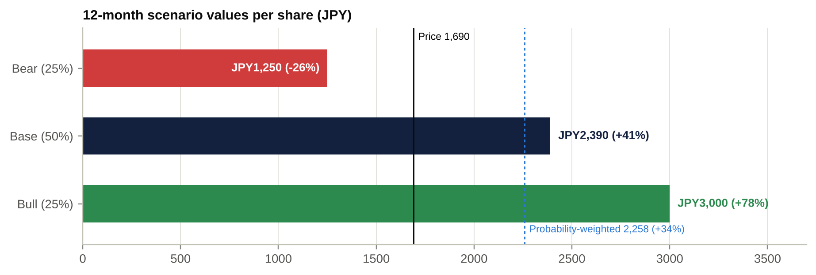
Scenario values
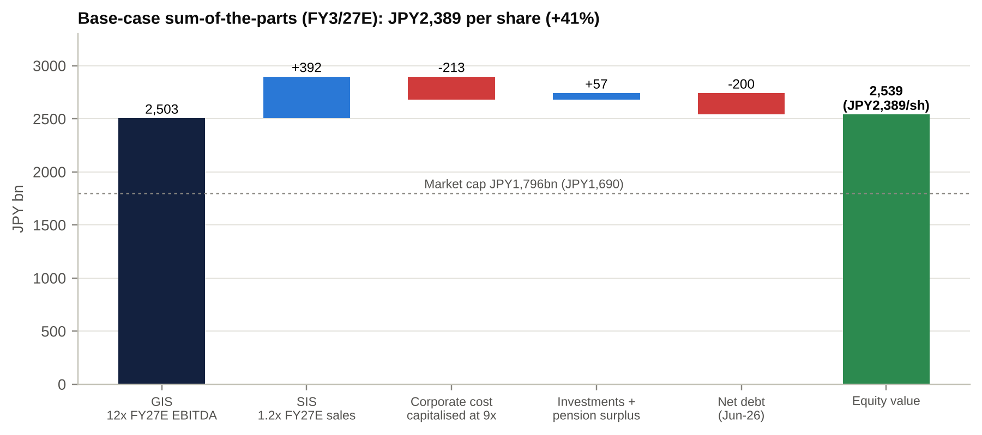
Base-case sum-of-the-parts
SOTP sensitivity (JPY per share).
SIS EV/sales (rows) vs GIS EV/FY3/27E EBITDA (columns) | 9x | 10x | 11x | 12x | 13x | 14x
0.6x | 1,616 | 1,812 | 2,008 | 2,204 | 2,401 | 2,597
0.8x | 1,677 | 1,873 | 2,070 | 2,266 | 2,462 | 2,658
1.0x | 1,739 | 1,935 | 2,131 | 2,327 | 2,524 | 2,720
1.2x | 1,800 | 1,996 | 2,193 | 2,389 | 2,585 | 2,781
1.6x | 1,923 | 2,119 | 2,316 | 2,512 | 2,708 | 2,904
Corporate costs capitalised at 9x; investments, 70% of the pension surplus and Jun-26 net debt included. The bear column at 9x GIS excludes the JPY60bn provision used in our bear SOTP.

Fifteen questions for the CEO / Chairman (ordered by information value)
- Warning Letter scope. Which specific observations did the FDA find inadequate in your Form 483 responses? Do any relate to design controls or complaint handling for GI scopes made at Hachioji, Aomori or Shirakawa?
- Remediation plan. Will you appoint an independent third-party auditor and publish a close-out timetable? What incremental cost (opex and capex) is in FY3/27 and FY3/28 guidance?
- Escalation risk. Has the FDA indicated any intention to seek a consent decree or expand Import Alert 89-04? What is the status of the Aizu re-inspection request?
- Surgical review. Which outcomes are on the table (sale, JV, partial carve-out, closure of product lines)? When will the board decide? Would proceeds be returned to shareholders?
- SIS economics. What is SIS’s margin excluding ship-hold and remediation costs? Which SIS sub-units (urology, respiratory, surgical endoscopy, ENT) earn above the cost of capital?
- 3-4-5 credibility. What revenue growth and margin are you tracking in FY3/27 at constant currency? Why should investors believe the 20%+ OP margin after misses in FY3/23–26?
- Adjusted vs reported. Will the adjusted-OP-to-OP gap really fall from JPY46bn (FY3/26) to ~JPY24bn (FY3/27) and then to near zero? Which “one-off” items do you consider recurring?
- Capital returns. With the JPY60bn programme complete, what leverage are you comfortable with? Will you formalise a total-return or payout policy?
- Cash conversion. Why was FY3/26 FCF only JPY13bn? When will inventory days (~240) and receivable days (~86) normalise? How much of growth is financed through customer leases (JPY137bn)?
- China. What share of China revenue is now exposed to VBP? Is local GI-scope production winning tenders against SonoScape and Aohua?
- Tariffs. What is the FY3/27 net tariff cost after mitigation? Are you moving US-bound manufacturing out of Japan? What would a Section 232 device tariff cost?
- M&A discipline. What hurdle rate do tuck-ins have to clear? Why was BioProtect worth ~19x sales? Will the Swan call option be exercised, and at what price?
- Single-use. What is your single-use revenue today? How do you protect the reusable-scope service annuity from single-use duodenoscopes and bronchoscopes?
- Pay. Why did the CEO receive a JPY210m bonus in a year with two guidance cuts? Will LTI vesting be tied to FDA close-out and FCF rather than adjusted OP?
- Strategic alternatives. If a credible party offered a significant premium for the company, how would the board evaluate it under the METI guidelines? Is the board open to a take-private with a Japanese co-investor?

Short-seller and forensic perspective: dismantling the bull case
The short thesis in one line: a chronically non-compliant manufacturer whose “adjusted” profits exclude recurring costs, whose growth is FX and leasing, and whose buybacks are now debt-funded.
- “Adjusted OP” flatters the business. “Other expenses” were JPY103bn (FY3/24), JPY31bn (FY3/25) and JPY57bn (FY3/26). Restructuring, quality remediation and impairments recur every year. On reported OP, the stock trades on 13.7x FY3/27E EV/EBIT, not “9x EBITDA”.
- Growth is mostly FX. Constant-currency growth was ~0% in FY3/26 and +3.4% in FY3/25. 1Q FY3/27 was +16% reported but ~+5% cc against an easy comparison. Strip out the yen and there is little organic growth.
- Receivables and leasing. Trade receivable days rose from 72 to 86. Lease receivables rose 59% in two years to JPY137bn, and there are JPY84bn of non-current receivables. Customer financing pulls forward capital sales and adds credit risk.
- Inventory. Inventory is ~240 days (JPY221bn at Jun-26, up JPY14bn QoQ). Ship-held SIS inventory may need write-downs.
- Cash flow. CFO was JPY101bn against JPY164bn of EBITDA in FY3/26, and FCF was JPY13bn. Since FY3/22, cumulative buybacks plus dividends (~JPY600bn) exceed cumulative FCF (~JPY260bn) [e]. The gap was funded by the Evident proceeds and now by debt.
- Quality culture. The FDA has repeatedly found Olympus’s corrective actions inadequate. Three CQOs in 2.5 years and a “no financial impact” message on every FDA action suggest a culture that under-reacts. Recalls have involved patient harm.
- Guidance. A February cut came in each of the last four years, and FY3/27 consensus is already above the midpoint.
- Pay. Executive pay has escalated while value has fallen 47% from the 2022 peak.
Our rebuttal.
- Points 1, 2 and 5 are fair and are why we value on forward IFRS OP and use 12x (not 15x) for GIS.
- Point 3 is a real watch item, but it reflects the leasing model rather than channel stuffing: there are no distributors to stuff.
- Point 6 is the core risk and the reason for our 25% bear weight and two-step sizing.
- The short case ignores three things: the franchise’s 65% gross margin and pricing, the sum-of-the-parts asymmetry, and a receptive board under governance pressure. Shorting a 6th-percentile multiple with a buyback-active, ValueAct-influenced board ahead of a strategic review is a poor risk-reward trade.

Red flags and accounting risks
Area | Flag | Severity | What to monitor
Non-GAAP | Adjusted OP excludes recurring other expenses (JPY167bn cumulative FY3/22–26 [e]) | High | Gap between adjusted OP and OP; FY3/27 guide ~JPY24bn
Revenue recognition | Sales-type leases recognised up front; lease receivables +59% in two years | Medium | Lease receivable growth vs revenue growth; credit losses
Working capital | Receivable days 86; inventory days ~240 | Medium | 2Q balance sheet; inventory write-downs
Provisions | FDA, recall and duodenoscope litigation provisions; “no significant change” disclosure | Medium–high | Provision movements after the Warning Letter
Capitalised development | Development-asset impairments (GIS +3.4bn, SIS +2.5bn y/y in FY3/26) | Medium | Capitalisation rate vs R&D expense
Goodwill | JPY240bn after BioProtect (US$270m for US$14.5m of sales) | Medium | SIS goodwill impairment if the review ends in a sale below book (SIS segment assets JPY555bn)
Off-balance-sheet | Swan JV call/put options; up to US$458m of joint milestone funding | Low–medium | Option fair value; equity-method losses
Tax | FY3/26 cash taxes ~JPY62bn (above P&L tax) depressed CFO | Low | Normalisation in FY3/27
Related parties | SOMED (Sony) JV; Evident licence | Low | Yuho related-party note (not reviewed)
Governance legacy | 2011 “tobashi” fraud (~JPY118bn of hidden losses); Shenzhen allegation (2016–18) | Low today | Historical; cited by bears for a governance discount
A potential SIS sale below book is an accounting risk but an economic positive. SIS segment assets are JPY555bn against our base-case value of ~JPY390bn. Selling at our base value would trigger a book loss of ~JPY150–170bn [e] while raising per-share value. The market may initially focus on the headline loss.

Timeline of key events and catalyst calendar

Key past events
Date | Event | Share price impact
Oct–Nov 2011 | Woodford dismissal; “tobashi” loss concealment admitted | ~-80% at trough
Sep-2012 | Sony capital alliance (~JPY50bn for ~11%); SOMED JV | Recapitalisation
2015–18 | US duodenoscope infections; DOJ FCPA/AKS settlement (2016) [u]; guilty plea (2018) [u] | –
11-Jan-2019 | Transform Olympus with ValueAct (Hale, Beasley join the board in Jun-2019) | +41.5% in 2 weeks
1-Jan-2021 | Cameras transferred to JIP (OM Digital Solutions) | –
29-Aug-2022 | Evident sold to Bain (~JPY430bn); closed Apr-2023 | 5-yr high JPY3,177 (Sep-22)
Nov–Dec 2022 | FDA Warning Letters (Aizu, Hachioji) | -29% Nov-22 to Mar-23
Sep-2023 | Veran product line terminated (JPY52bn loss) | -3.9%
Mar-2024 | Taewoong acquisition rescinded | –
28-Oct-2024 | CEO Kaufmann resigns (illegal-drug allegation) | -5.6% (TOPIX +1.8%)
25-Apr-2025 | Bob White named CEO (from 1-Jun-2025) | +1.2%
24-Jun-2025 | FDA Import Alert 89-04 (Aizu, 58 models) | -10.6%
7-Nov-2025 | New strategy; ~2,000 job cuts; 3-4-5 plan | +11.5%
13-Feb-2026 | FY3/26 OP guidance cut to JPY75–87bn (ship-holds) | -12.9%; 5-yr low JPY1,310 (13-Mar)
12-May-2026 | FY3/27 guidance; Surgical strategic review; JPY60bn ToSTNeT-3 buyback | +19.9%
1-Jun-2026 | BioProtect acquisition closed (US$270m) | –
7-Jul-2026 | Artisan Partners discloses 5.63% | –
31-Jul-2026 | Hoya puts PENTAX Medical under strategic review (including sale) | Read-across
7-Aug-2026 | 1Q FY3/27 beat; guidance held | +10.1%
9-Sep-2026 | US$500m 5.526% 2031 notes issued (refinancing) | –
13-Oct-2026 | FDA Warning Letter (six sites) | -13.4%; -16.8% in 3 days

Upcoming catalysts
Expected date | Catalyst | What to watch | Impact
19–21 Oct 2026 | CHEST 2026: peripheral EBUS (BF-UCP190F) showcase | Respiratory messaging | Low
~30-Oct to early Nov 2026 [e] | Olympus response to the FDA Warning Letter (15 business days) | Third-party auditor; corrective plan; timetable; any new ship-holds | High
30-Oct-2026 | BoJ policy meeting | Yen; funding costs | Medium
Early–mid Nov 2026 [e] (likely Fri 6 or 13 Nov) | 2Q FY3/27 results | Guidance narrowing; WL cost; SIS recovery; China; possible new buyback | High
~Mid-Nov 2026 | MSCI semi-annual review | Weight changes | Low
8-Dec-2026 | US$500m 2.143% notes mature (pre-funded) | Non-event | Low
~Mid-Jan 2027 | J.P. Morgan Healthcare Conference | FDA narrative; M&A; Surgical review update | Medium
~12-Feb-2027 [e] | 3Q FY3/27 results | A 3Q guidance cut came in each of the last four years | High
H1 2027 [e] | PENTAX sale outcome (Hoya) | Endoscopy transaction multiple; new competitor owner | Medium
Rolling, 6–24 months | FDA re-inspections; Warning Letter close-out; Aizu import-alert removal | Close-out = major re-rating; new 483s = major negative | High
Rolling | Surgical strategic review outcome | Sale, JV or retain; use of proceeds | High
By Mar-2027 | Completion of ~2,000-role reduction | Margin delivery (100bp+/yr) | Medium
~12-May-2027 [e] | FY3/27 results; FY3/28 guidance; shareholder returns | Buyback (announced at FY results in 2023–26) | High
~25-Jun-2027 | AGM | Director slate (10 seats); pay; possible shareholder proposals | Medium
Unknown | US Section 232 medical-device tariff decision | Sector tariff on endoscopes | Medium
Rolling | China VBP rounds; anti-corruption enforcement | China trajectory | Medium
Rolling | Unsolicited approach or take-private interest | METI-guideline process | High (low probability)

Appendix: sources, methodology and caveats
Primary data (S&P Global).
- S&P Capital IQ financials (company C_681217), estimates (consensus as of 14–18 Oct 2026), multiples and market data (16-Oct-2026 close).
- Key Developments, Transactions, Professionals (management, board and compensation), and earnings-call transcripts (xpf_transcripts_unstructured), all via S&P Global Adaptive Retrieval and Deterministic Retrieval.
- Olympus filings via the CapIQ document viewer:
  - Tanshin FY3/22–FY3/26 (mids 182523037, 204781920, 225526426, 241368482, 259974776).
  - Quarterly reports (mids 246794189, 255532032).
  - Integrated Reports 2024–2025 (mids 235949585, 249336586).
  - Earnings-call transcripts (mids 232617973, 236878718, 248225472, 255481114, 260347193).
Web sources (gap-fill, marked [u] where single-source).
- FDA: Import alerts letter to health-care providers (Jun-2025); OMSC Warning Letter 12-Dec-2022.
- Warning Letter and import-alert coverage: MassDevice; MedTech Dive; Fierce Biotech; MONOIST; Yakuji Nippo.
- Results and strategy: Quartr 1Q FY2027; FilingReader (new strategy, Nov-2025); FilingReader (JPY60bn buyback); MDDI (2,000 job cuts).
- Shareholders: Matsui (Artisan 5% filing); kabutore.
- ValueAct: Investing.com/Reuters.
- Kaufmann case: nippon.com.
- Deal comparables: Hologic; Topcon; KKR–Taiyo; Hoya considers endoscope sale.
- FEFTA: Baker McKenzie.
Methodology.
- Segment and earnings model: our own [e]. GIS and SIS are built separately at the IFRS segment-OP level.
- SOTP: GIS at 12x FY3/27E EBITDA, against a 12.3x all-peer NTM median and 14.0x for endoscopy peers. SIS at 1.2x sales, against the mid-cap surgical median of 1.65x, discounted for losses.
- Regression: OLS on 31 CIQ peers.
- Sentiment: dictionary-based scoring of S&P transcript excerpts.
Caveats.
- The FY3/26 yuho (securities report), the Aug-2026 1Q tanshin and JPX short-position and margin data could not be retrieved, because EDINET, JPX and Olympus IR are blocked from this environment. The gaps are flagged in the text.
- The ~70% GI endoscopy share is widely cited but was not verified in primary sources.
- Deal premiums marked [u] were not checked against merger proxies.
- ProntoNLP was not connected during this session. It needs re-authorisation in the claude.ai connector settings to run filing and earnings-call sentiment through it.
This report is for institutional investors and is not investment advice. Estimates are subject to change.

