
INVESTMENT COMMITTEE MEMO  Cameco  Corporation  NYSE: CCJ / TSX: CCO - the West's tier-one uranium producer and 49% owner of Westinghouse: a great asset base, but priced for a recovery that 2026 has not yet delivered  Prepared for Investment Committee review | 3 November 2026 | ~23x  FY27E EV/EBITDA (ours); ~52x FY27E P/E. Uranium peers ~9x; nuclear-services peers ~26-32x  US$10bn  Our base value for the 49% Westinghouse stake (~30% of market cap); IPO filed confidentially Jul-2026  US$75  Probability-weighted value (-2%): bull US$111 / base US$76 / bear US$39
  RECOMMENDATION: HOLD (EVENT WATCHLIST) |  | 12-MO TARGET: US$76 (-1%)
  Reference price  US$76.91 (30-Oct-26) | 52-wk range  US$73.89-135.24 | Mkt cap  US$33.5bn / C$46.2bn | Net debt  C$0.14bn (Sep-26)
  Dividend  C$0.24 (0.2% yield) | Largest holder  BlackRock ~5% [u] | Ownership cap  15% / 25% (ENL Act) | Buy below  ~US$60

EXECUTIVE SUMMARY
  RECOMMENDATION
Hold: tier-one assets and a Westinghouse option, but no margin of safety at US$77
C$0.00  Q3-26 adjusted EPS vs ~C$0.32 consensus; first adjusted loss in 8 quarters |  | US$96.50  Term uranium price (Q3-26), an 18-year high; spot US$89.63 |  | -43%  Share price vs the 28-Jan-26 high (US$134.10); P/NAV ~1.3x vs 2.3x in Feb [d] |  | US$76  12-mo target (base, -1%); bull +44% / bear -49% |  | 25%  Bear-case probability: operations, contracting stall, Westinghouse slip

The case for owning it  ▪ Scarce assets: McArthur River and Cigar Lake are the world's highest-grade mines; one of three Western UF6 converters  ▪ Contract book reprices: realised US$67/lb vs spot ~US$90; Cameco's table implies US$75-93 by 2030  ▪ Westinghouse: US$80bn US-government term sheet, DOE US$17.5bn loans, US-Korea US$120bn framework, Poland EPC terms, IPO filed  ▪ Balance sheet: net debt C$0.14bn; revolver to 2030; BBB |  | Why we wait  ▪ Execution: flood, Cigar Lake halt, Key Lake outage; 2026 production cut; unit cost C$67-70/lb (raised twice)  ▪ Expensive on earnings: ~52x FY27E EPS (ours C$2.05, ~20-25% below consensus)  ▪ Westinghouse not yet definitive: term sheets, 20% US-government participation above US$17.5bn, equity calls ~US$500m per project  ▪ No takeover put: ENL Act caps holders at 15%/25%

Position sizing: no position at US$77; event watchlist. Accumulate below ~US$60 (probability-weighted +25%), or earlier on a public Westinghouse S-1 showing a valuation of US$25bn+ of equity, or definitive US-government agreements plus named AP1000 FIDs. First review: Q4-26 results and 2027 guidance (~12-Feb-2027).

BUSINESS OVERVIEW
  CONTEXT
Cameco at a glance: mine-to-converter integration plus 49% of the leading Western reactor company
What it does  ▪ Uranium (83% of revenue): McArthur River/Key Lake (69.8%/83.3%), Cigar Lake (~57.4%), JV Inkai 40%. 2026 production 19.5-20.5 Mlb; deliveries 29.5-30.5 Mlb  ▪ Fuel services (16%): Blind River refinery, Port Hope UF6/UO2 conversion, CANDU fuel. 2025 price C$43/kgU (+14%)  ▪ Westinghouse 49% (Brookfield 51%): fuel and services for ~half of world reactors; AP1000/AP300/eVinci. Equity-accounted; ~40% of 2025 adjusted EBITDA  ▪ GLE 49% (laser enrichment; licence early 2027 [u]); 39 utility customers; ~230 Mlb contracted, ~28 Mlb/yr to 2030  ▪ Widely held; no controller; statutory caps (non-resident 15% each, 25% aggregate votes) |  | Financial summary (C$m)  FY23 adjusted figures restated (2024 definitions). FY26E-27E are our estimates. Source: Cameco filings via search extracts.
   | FY23 | FY24 | FY25 | LTM Q3-26 | FY26E | FY27E
  Revenue | 2,588 | 3,136 | 3,482 | 3,479 | 3,330 | 3,740
  Adj. EBITDA | 884 | 1,531 | 1,929 | 1,758 | 1,595 | 2,037
  - Westinghouse share | 53 | 483 | 780 | 638 | 577 | 620
  Adj. net earnings | 383 | 292 | 627 | 496 | 440 | 895
  Adj. EPS (C$) | 0.88 | 0.67 | 1.44 | 1.14 | 1.01 | 2.05
  Production (Mlb) | 17.6 | 23.4 | 21.0 |  | ~20.0 | ~22-23
  Realised price (US$/lb) | n/a | 58.34 | 62.11 | 66.64 (9M) | 66.5 | 72.0

The single most distinctive fact: Cameco sells ~30 Mlb a year but mines ~20 Mlb, under contracts that pay ~US$67/lb while spot is ~US$90. Profits rise only as the contract book reprices (2028-30), but the stock already trades as if that repricing has happened.

THE SETUP
  CONTEXT
Russia (2022), Westinghouse (2022-23), the US$80bn deal (2025), the 2026 operating stumbles
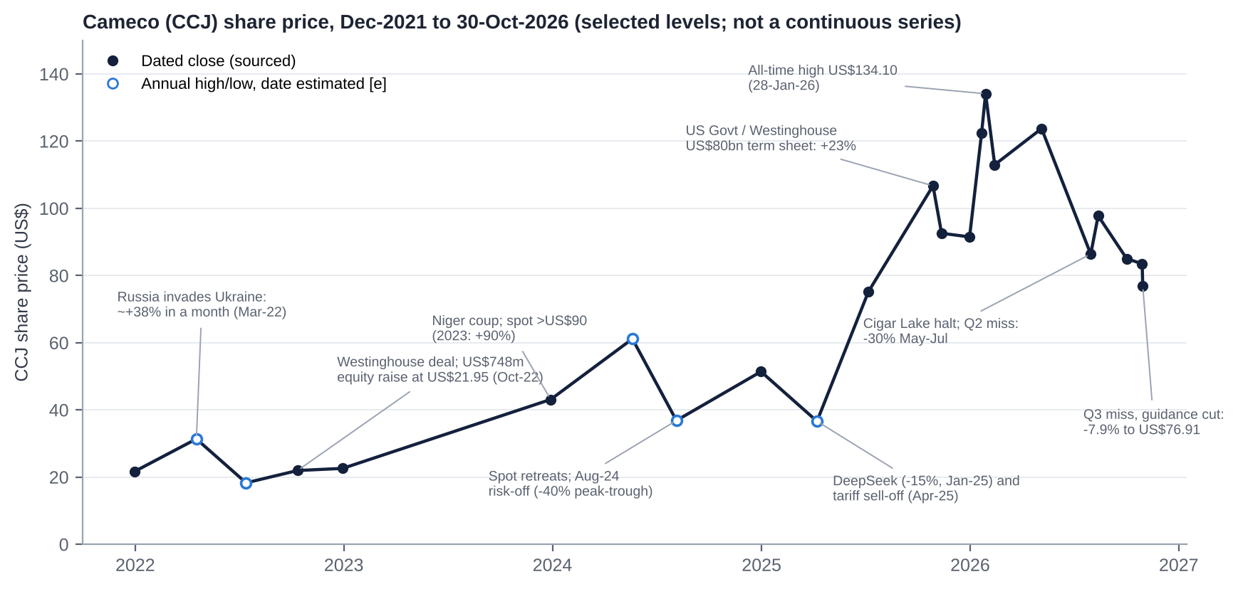 |  | Key catalysts
  Date | Event
  MAR-2022 | Russia invades Ukraine: ~+38% in a month
  OCT-2022 | Westinghouse deal; US$748m raise at US$21.95
  2023 | Niger coup; spot >US$90: +90% in the year
  JAN-2025 | DeepSeek: -15% in a day
  MAY-2025 | US nuclear executive orders: +10%
  OCT-2025 | US-government Westinghouse term sheet: +23%
  JAN-2026 | Spot >US$100; all-time high US$134.10
  MAY-JUL 2026 | Flood, Cigar Lake halt, Q2 miss: -30%
  30-OCT-2026 | Q3 adjusted loss, guidance cut: -7.9%

QUESTION 1 - IS CAMECO UNDERVALUED?
  VALUATION
Expensive vs uranium producers, in line with nuclear-services names; the question is which peer group applies
Metric | Cameco | Kazatomprom | Paladin | CGN Mining | Centrus | BWXT | GE Vernova
Mkt cap (US$bn) | 33.5 | ~19.2 | ~3.0 | ~2.3 | ~3.5 | ~16.0 | ~236
EV/Sales (current FY) | 13.9x | ~5.7x [e] | ~9.2x | ~2.9x [e] | ~6.1x [e] | ~4.6x [e] | ~4.9x [e]
EV/EBITDA | 29.1x (FY27E 22.8x) | ~8.8x (FY25) | ~50x TTM | n/a | ~41x trailing | ~26x | ~32x [e]
P/E | 105x (FY27E 52x) | 13.6x | n.m. | 21.0x | ~97x trailing | ~37x | n/a
EBIT margin | ~18% | 43% | ~6% [e] | ~9% [e] | ~9% [e] | ~13% | ~11% [e]
Net debt/EBITDA | 0.1x | ~0x | net cash | n/a | net cash | ~2x [e] | net cash

Market data Feb-Oct 2026 from secondary sources [u]; re-pull on one date before trading. Cameco on our estimates at US$76.91; USD/CAD 1.38 [e].
What the comparison shows  ▪ vs producers: ~2.5x the peer-median EV/Sales (~5.3x) and ~3x Kazatomprom's EV/EBITDA, at less than half its EBIT margin  ▪ vs nuclear technology and services: ~23x FY27E EBITDA is in line with BWXT (~26x) and GE Vernova (~32x). The market values Cameco as a platform  ▪ vs own history: 5-yr average forward EV/EBITDA ~60x and P/E ~83x (distorted by 2021-23 troughs); long-run 19x / 40x |  | The honest counter-read  ▪ On S&P's Feb-26 NAV (US$25.5bn), the market cap is now ~1.3x NAV vs 2.3x in February, the level of the developers [d]  ▪ Current-year margins are depressed by a one-off outage; FY28E EBIT margin ~31% if the book reprices  ▪ Westinghouse (C$14bn+) sits in EV but not in EBIT, so headline EV/EBIT (~44x FY27E) overstates; ex-stakes ~30x

QUESTION 1 - IS CAMECO UNDERVALUED?
  VALUATION
Regression: no peer relationship explains Cameco - it sits far right of every listed peer
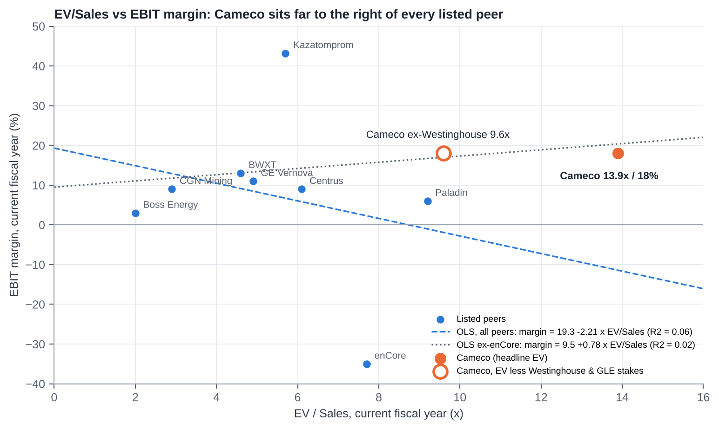 |  | How to read it  ▪ X = EV/Sales, Y = EBIT margin (current FY), 8 listed peers; UEC and Energy Fuels excluded (EV/Sales >40x, losses)  ▪ OLS all peers: margin = 19.3% - 2.21 x EV/Sales, R² = 0.06; ex-enCore R² = 0.02: no meaningful relationship  ▪ Cameco 13.9x / ~18%: 50% above the highest peer multiple (Paladin 9.2x) at a third of Kazatomprom's margin  ▪ Ex-Westinghouse and GLE (C$14.5bn): 9.6x, still at the top of the range  ▪ The premium is a bet on 2028-30 margins (~31% FY28E EBIT) and on Westinghouse
Peer inputs: company filings and aggregators via search [u]; several EV/Sales and margins are our estimates [e].

WHERE THE VALUE SITS
  VALUATION
Sum-of-the-parts: ~C$46bn (US$76/share) in the base case - roughly today's price
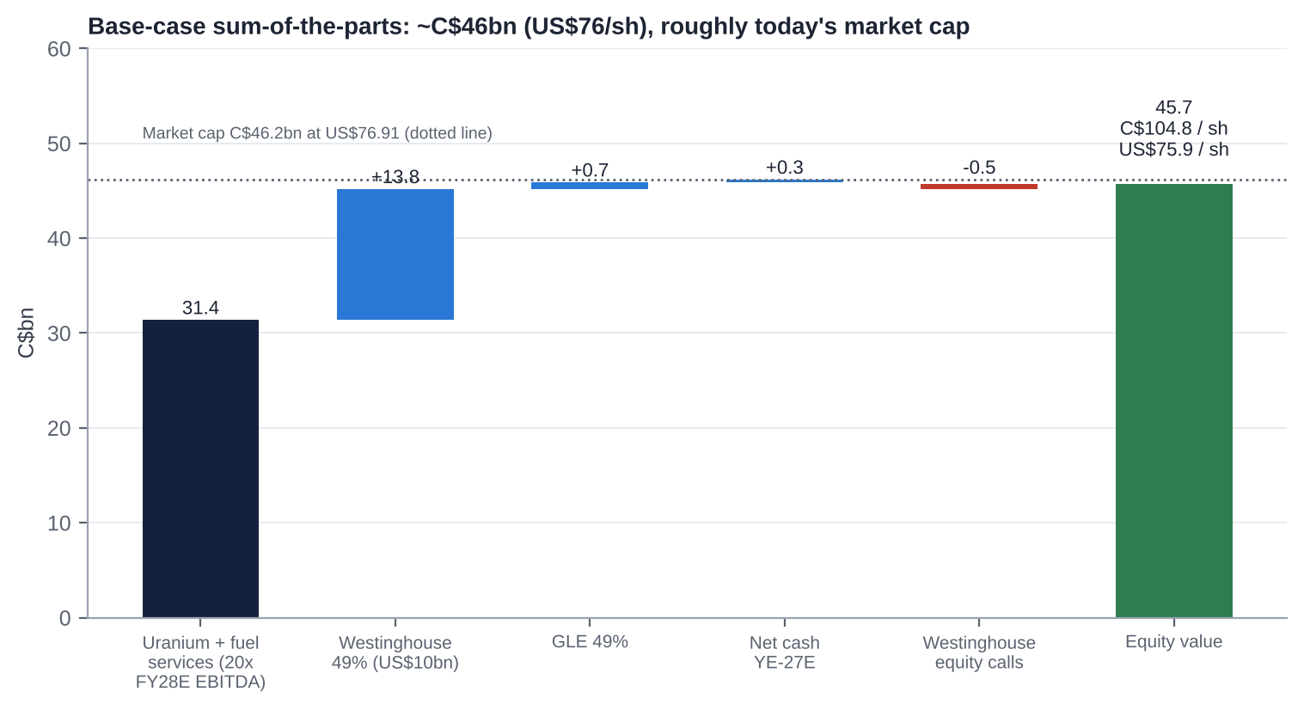 |  | Base-case SOTP (C$bn)  ▪ At US$76.91, the market pays ~20x FY28E EBITDA for uranium and fuel services if Westinghouse = US$10bn (~17x if US$15bn)  ▪ Kazatomprom trades on ~9x; the premium is for jurisdiction, grade and integration
  Component | Method | C$bn
  Uranium + fuel services | 20x FY28E EBITDA ex-Westinghouse (C$1.57bn) | 31.4
  Westinghouse 49% | ~27x FY27E EBITDA; US$10.0bn after US-government share | 13.8
  GLE 49% | Option value [e] | 0.7
  Net cash YE-27E | FCF less dividends | 0.3
  Westinghouse equity calls | New-build equity, PV [e] | (0.5)
  Equity / per share | 436m shares; USD/CAD 1.38 | 45.7 / US$75.9

THE WESTINGHOUSE STAKE
  HIDDEN ASSET
49% of Westinghouse: ~US$2.2bn invested, ~US$5-15bn of value - the IPO decides
49%  Brookfield 51%; equity-accounted; carrying value C$2.93bn (YE-24) |  | C$427m  Cameco share of adjusted EBITDA in 9M-26 (C$569m 9M-25 incl. Dukovany) |  | US$80bn  US-government term sheet (Oct-25): 20% of distributions above US$17.5bn |  | US$17.5bn  DOE conditional loans for up to 10 AP1000s (Jun-26); ~US$500m Westinghouse equity per project |  | 31-Jul-26  Draft S-1 filed confidentially; IPO trigger if ≥US$30bn by Jan-2029

FY27E Westinghouse EBITDA ~US$0.92bn (100%); net debt ~US$4bn [e]. US government: warrant for 20% of equity above US$17.5bn. |  | What to watch  ▪ Public S-1: first full Westinghouse financials and backlog; the size of any Cameco sell-down  ▪ Definitive US-government agreements (still a term sheet one year on); named sites and partners for the 5 DOE-funded projects  ▪ Korea: first two AP1000 construction contracts; a 5-10% Korean stake in Westinghouse under discussion [u]  ▪ Poland: EPC signing by YE-26; long-lead orders already authorised  ▪ Risk: first-of-a-kind overruns (Vogtle ~US$35bn [m]); equity calls up to ~US$1.2bn Cameco share [e]
  IPO EV/EBITDA | WEC equity (US$bn) | US govt share | Cameco 49% (US$bn) | % of mkt cap
  15x | 9.8 | 0 | 4.8 | 14%
  20x | 14.3 | 0 | 7.0 | 21%
  25x | 18.9 | 0.3 | 9.1 | 27%
  ~27x (base) | ~20.4 | ~0.6 | 10.0 | 30%
  30x | 23.5 | 1.2 | 10.9 | 33%
  40x | 32.7 | 3.0 | 14.5 | 43%

QUESTION 2 - IS 2026 A BLIP OR A TREND?
  EARNINGS
2026 is a step back; the 2027 rebound depends on Key Lake and contract repricing
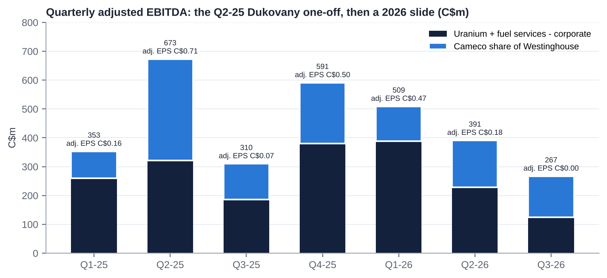 |  | ▪ Q3-26: revenue C$619m vs ~C$725m consensus; adjusted EPS C$0.00 vs ~C$0.32; Key Lake outage cut McArthur River/Key Lake output by half  ▪ Guidance: production 19.5-20.5 Mlb (cut); unit cost C$67-70/lb (second raise); capex cut  ▪ Our FY27E is ~20-25% below consensus; each US$1/lb of realised price = ~C$43m EBITDA
  C$m | FY25A | FY26E | FY27E | FY28E
  Revenue | 3,482 | 3,330 | 3,740 | 3,900
  Adj. EBITDA | 1,929 | 1,595 | 2,037 | 2,250
  EBIT margin | ~22% | ~18% | ~28% | ~31%
  Adj. net earnings | 627 | ~440 | ~895 | ~1,050
  Adj. EPS (C$) | 1.44 | 1.01 | 2.05 | 2.40
  Consensus EPS (C$) |  | ~1.10 | 2.57-2.98 | n/a
  Realised price (US$/lb) | 62.1 | 66.5 | 72.0 | 77.0
  Unit cost (C$/lb) | ~63 | 68.5 | 65.0 | 65.5

QUESTION 2 - WHY DOES A RECORD URANIUM PRICE NOT SHOW UP IN PROFITS?
  DEEP DIVE
The contract-book lag: realised prices trail spot by >US$20/lb and catch up only by 2029-30
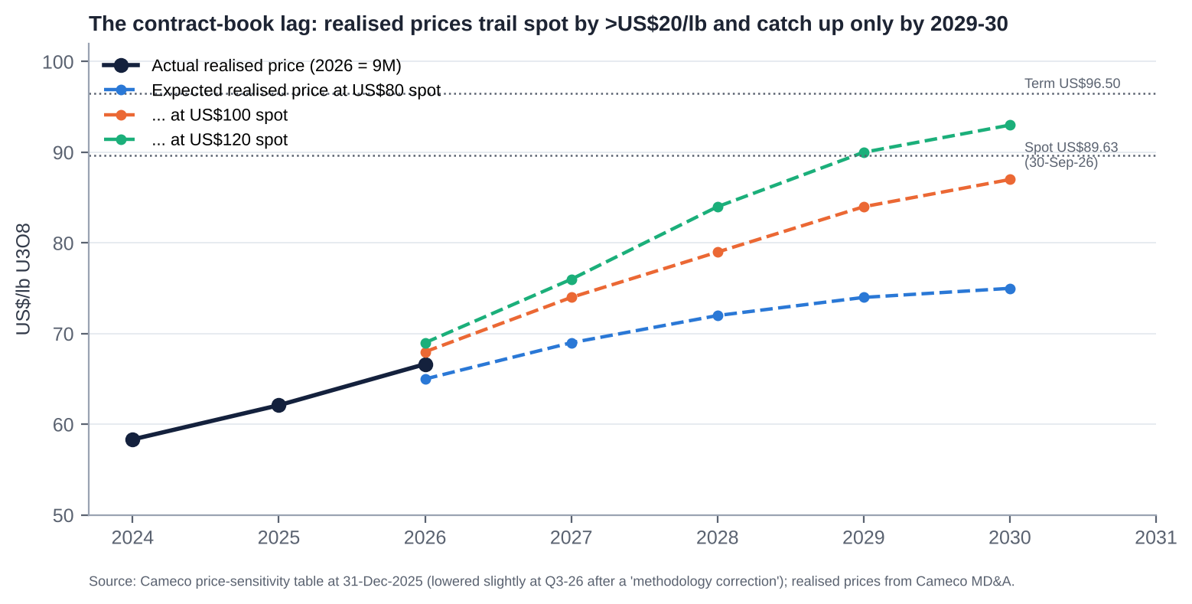 |  | Why the gap  ▪ Legacy contracts: base-escalated prices signed in 2018-22 at US$40-60, and market-related contracts with ceilings; 9M-26 realised +10% vs spot +22%  ▪ Short position: ~30 Mlb delivered vs ~20 Mlb mined; the gap is bought near spot (~US$90) and sold at ~US$67-72  ▪ Correction: the Q3-26 sensitivity table was lowered after a 'methodology correction' on one contract  What changes it  ▪ New contracts at 'three-digit escalated prices' from 2028  ▪ Replacement-rate contracting (~179 Mlb/yr of needs vs ~116 Mlb signed in 2024-25)  ▪ Production recovery (fewer purchased pounds)

BALANCE SHEET & CAPITAL ALLOCATION
  CAPITAL
Conservative and well-funded; the call on capital is Westinghouse new build, not debt
C$0.14bn  Net debt (30-Sep-26): cash C$0.86bn; debentures C$1.0bn (2.95% 2027; 4.94% 2031; 5.09% 2042) |  | C$1.86bn  Liquidity: cash + undrawn C$1.0bn revolver (extended to Oct-2030); DBRS BBB |  | C$1.1bn  FY25 free cash flow (CFO C$1.41bn - capex C$0.33bn); Q3-26 CFO ~C$3m [u] |  | 0  Buybacks in 10 years; DPS C$0.24 (~10% of FY25 FCF); 34m shares issued in 2022

Capital-allocation record  ▪ Good: supply discipline 2016-22; Westinghouse at ~11x EBITDA (now valued ~4-5x cost [u]); Cigar Lake step-ups (2022 C$107m; 2026 TEPCO); CRA tax win (C$300m refund)  ▪ Poor: the Oct-22 equity raise at US$21.95 (~8.5% dilution near the cycle low); Inkai cut to 40% (2018) [m]  ▪ Unclear: giving the US government 20% of Westinghouse distributions above US$17.5bn for conditional financing  ▪ Returns: ROIC ~4-5% (2025) [u], still below the cost of capital |  | Priorities we would push for  ▪ 1. A capital-return framework (buybacks below SOTP) once FCF approaches ~C$1bn/yr  ▪ 2. Commit to partial Westinghouse monetisation in the IPO, with proceeds returned  ▪ 3. Disclose 100% Westinghouse financials, backlog and look-through leverage  ▪ 4. Tie CEO LTI (470% of salary) to production and unit-cost delivery

IS THERE AN ACTIVIST IN HERE?
  GOVERNANCE
No - widely held, statutorily protected, no campaign on record
15% / 25%  ENL Act: max per non-resident / per resident holder; non-resident votes pro-rated to 25% |  | <1%  Insider ownership (~0.24% [u]); CEO held ~C$45m of shares and units (2023) |  | 1.8%  Short interest (7.9m shares, 2.5 days); no short reports found |  | 98%  Say-on-pay support (2024); directors 98-99.8% (2026)

Why activism is hard here  ▪ No control path: Parliament would have to amend the ENL Act; Investment Canada Act and SOE policy on top  ▪ Index and thematic-ETF register (BlackRock, Vanguard, URA, URNM) with little appetite for a fight  ▪ Board refreshed (4 new directors since 2023; 8 of 9 independent); Chair Catherine Gignac since Dec-23  ▪ The stock is not cheap - an activist's economic case is weak |  | Governance watch-points  ▪ CEO Tim Gitzel 15+ years; President & COO Grant Isaac is heir apparent; CFO Shockey retiring end-Q1-27  ▪ 2025-26 departures: COO, CLO, Chief Corporate Officer; CMO changed twice  ▪ CEO pay ~C$11.0m in 2025 [u] vs C$7.6m TDC in 2024; LTI target raised to 470%  ▪ Shareholder proposals window: 8-Dec-26 to 5-Feb-27

QUESTION 3 - TAKEOVER TARGET?
  M&A
Not a target without an Act of Parliament - Cameco is the acquirer, not the acquired
 |  | What a control price would look like  ▪ Legal blocks: ENL Act caps (non-resident 15% each, 25% aggregate votes; resident 25%), majority-Canadian board, ICA national security, 1987 uranium ownership policy, CNSC change of control  ▪ Hypothetical only: a 25-40% premium = US$96-108/share = ~27-30x FY27-28E EBITDA, ~1.7x S&P NAV - far above services precedents (11-14x)  ▪ Likelier moves by Cameco: Athabasca consolidation (NexGen C$11bn, Denison C$4.7bn), Orano minority interests, GLE to 75%, a Westinghouse sell-down or top-up  ▪ No takeover premium in our valuation
  Transaction | Date | Value | Read-across
  Brookfield/Cameco - Westinghouse | Oct-22 / Nov-23 | US$7.875bn EV; ~11x EBITDA | Platform value
  BWXT - Kinectrics | Jan-25 / May-25 | US$525m; ~14x EBITDA | Nuclear services
  Paladin - Fission (PLS) | Dec-24 | C$1.14bn; ~C$12/lb | Athabasca consolidation
  UEC - Rio Tinto Sweetwater | Dec-24 | US$175m; ~US$1/lb | US ISR
  SNURDC/CGN - Kazakh JV stakes | Dec-24 | Undisclosed | Chinese SOEs buy Kazakhstan
  Cameco - Cigar Lake (Idemitsu; TEPCO) | May-22; Jul-26 | C$107m; n/d | Cheap attributable growth
  Constellation - Calpine | 2025-26 | US$26.6bn | Power-sector context

SCENARIO ANALYSIS
  VALUATION
Roughly symmetric: -49% bear vs +44% bull; probability-weighted ~US$75 - no edge at US$77
 | Bear (25%) | Base (50%) | Bull (25%)
Uranium spot / term (US$/lb) | 70 / 80 | 90 / 95 | 120 / 115
Realised price FY28E (US$/lb); unit cost (C$/lb) | ~70; ~70 | ~77; ~65 | ~84; ~62
FY28E EBITDA ex-Westinghouse (C$bn) | 1.18 | 1.57 | 1.87
Multiple on uranium + fuel services | 14x | 20x | 24x
Westinghouse 49% (US$bn) | 4.9 (~15x) | 10.0 (~27x) | 15.0 (~40x)
Equity value (C$bn) | 23.5 | 45.7 | 66.6
Per share (US$) | US$39 (-49%) | US$76 (-1%) | US$111 (+44%)

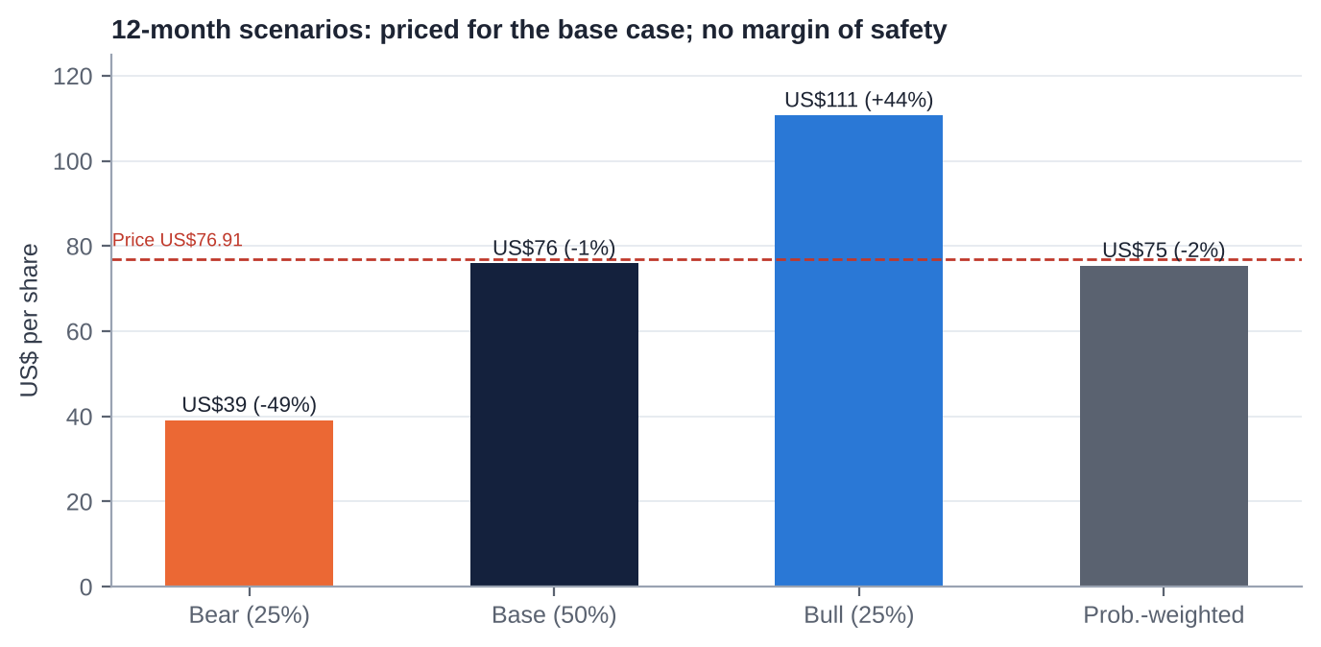
  Downside support: limited. In the bear case the stock returns to its 2025 lows (US$37-39), which shows the multiple, not the balance sheet, is the risk. Upside driver: a Westinghouse IPO at 30-40x plus replacement-rate contracting. Entry discipline: below ~US$60 the probability-weighted value offers ~25% upside.

CATALYST CALENDAR
  CATALYSTS
Key Lake restart, FY27 guidance and the Westinghouse S-1 dominate the next three quarters
Q4-2026 | Key Lake restart | Timing; any further cut to 2026 production (19.5-20.5 Mlb) | HIGH
BY YE-2026 | Poland AP1000 EPC signing | First European AP1000 EPC (Westinghouse-Bechtel) | MEDIUM
H1-2027 | US-Korea phase-1 contracts; DOE loan closings | Named AP1000 sites and partners; Westinghouse equity calls | CRITICAL
EARLY 2027 | GLE Paducah NRC licence | Licence issued; funding plan; Cameco's option to 75% | MEDIUM
~12-FEB-2027 | Q4/FY26 results + 2027 guidance | 2027 production and unit cost; Westinghouse guide; contracting volumes | CRITICAL
BY END-Q1-2027 | New CFO | Internal or external; capital-markets profile ahead of the IPO | MEDIUM
2027 (OPEN) | Westinghouse public S-1 / IPO | 100% financials, backlog, valuation, Cameco sell-down | CRITICAL
~MAY-2027 | Q1-27 results; AGM | Key Lake run-rate; say-on-pay; succession | HIGH
AUG-2027 / 1-JAN-2028 | Kazatomprom 2028 plan; Russian LEU waivers expire | Supply discipline; Western conversion and SWU tightness | HIGH

KEY RISKS
  RISKS
What would make this thesis wrong (in either direction)
01 Saskatchewan operations  Key Lake recovery slips into mid-2027; McArthur River development lags; Orano's McClean Lake mill fails again; costs stay above C$68/lb |  | 02 Contracting stalls  Utilities keep deferring (~100-116 Mlb/yr); Kazakh downflex reverses; NexGen signs contracts ahead of 2030 production; term price stalls ~US$90
03 Westinghouse slips or overruns  No definitive US-government agreements; the IPO is deferred; first-of-a-kind AP1000 overruns; equity calls up to ~US$1.2bn |  | 04 Sentiment and flows  AI-power trade cools; thematic ETF outflows (URA/URNM); rate shock - a high-multiple stock with beta >1.5 [e]
05 Policy and sovereign  Section 232 tariffs on Canadian uranium; Kazakh tax and logistics (Inkai); Saskatchewan royalty changes |  | 06 Upside risk to a HOLD  Replacement-rate contracting plus a Westinghouse IPO at 30-40x could re-rate the stock quickly - hence a watchlist with a defined entry, not a short

INVESTMENT COMMITTEE DECISION
Recommendation: HOLD
▪ Cameco owns irreplaceable Western uranium and conversion assets plus 49% of Westinghouse - the long-term thesis (18-year-high term price, Russian ban, Westinghouse new build) is intact  ▪ But 2026 exposed execution risk (adjusted loss in Q3, production cut, unit cost C$67-70/lb) and our FY27E EPS is ~20-25% below consensus  ▪ At US$77 the market already pays ~20x FY28E EBITDA for uranium and fuel services after US$10bn for Westinghouse - our SOTP equals the price  ▪ No takeover put (ENL Act) and no activist angle; the event is the Westinghouse IPO, likely 2027-28 | Sizing & monitoring  No position at US$77. Event watchlist with a defined entry: accumulate below ~US$60, or earlier on a public Westinghouse S-1 implying US$25bn+ of equity, or definitive US-government agreements plus named AP1000 FIDs.  Hard review triggers: 2027 guidance (Feb-27) with production below 22 Mlb or unit cost above C$66/lb; UxC 2026 term contracting below 100 Mlb; spot below US$75.  Track separately: Key Lake restart, Westinghouse S-1 and US-government agreements, Korea and Poland contracts, GLE licence, CFO appointment.
  US$76  12-mo target (-1%) | ~23x  FY27E EV/EBITDA | US$10bn  Westinghouse 49% (base) | <US$60  Accumulate below
Cameco Corporation | NYSE: CCJ / TSX: CCO | Reference price US$76.91 (30-Oct-2026 close) | 3 November 2026

