INITIATION | EVENT-DRIVEN / SPECIAL SITUATIONS | KOREA TELECOMS
SK Telecom Co., Ltd.
KRX: 017670 | NYSE: SKM - A 4x-EBITDA telco wrapped around an Anthropic call option
Rating | 12-m target | Upside | Price (29-Sep-26) | Mkt cap
BUY | KRW 105,000 | +22% | KRW 86,200 | KRW 18.5tn / US$13.6bn
Thesis: post-breach earnings normalisation is done (2Q26 OP +67% y/y, KRW 830 quarterly DPS restored); the market is now paying ~4.0x EBITDA for the core telco once Anthropic (3.86m shares, KRW 3.5tn book) and other stakes are stripped out, while two hard catalysts - the Anthropic IPO (reported for Nov-26) and the KRW 3.08tn SK Horizon AI-DC sale to KKR/IMM (close 1Q27) - crystallise value.
Key risks: SK Hyper GW-scale AI-DC capital intensity, BoK hiking cycle (3.00%), tariff pressure, Anthropic IPO slippage, SK Group governance.
Equity Research | Report date 29 September 2026 | Prices as of 29-Sep-2026 close (indicative)

Important notes on data and sourcing
This report was compiled on 29 September 2026. Primary filings (DART, SEC EDGAR 20-F/6-K, SKT IR PDFs) could not be opened directly from the research environment; figures were gathered from press, company newsroom and broker summaries via search. We tag data quality as follows:
- Unmarked - reported in company releases or multiple consistent press sources.
- [e] - analyst estimate / derived calculation by us.
- [u] - unverified: single-source, memory-based or internally inconsistent; must be checked against DART / 20-F before trading.
- Peer multiples (Section 10) are indicative ranges (approx. H1-2026 levels, +/-15-20%) and should be refreshed from Bloomberg/FactSet.
Currency: KRW unless stated. FX used: KRW 1,365/US$ (28-Sep-2026). "tn" = trillion, "bn" = billion. FY = calendar year (December year-end).

1. Executive summary
BUY, 12-month target KRW 105,000 (+22%); probability-weighted value ~KRW 107,000. SK Telecom has moved from crisis (April 2025 USIM breach, Q3-25 OP -91%, dividend suspended) to normalisation (1H26 OP KRW 1.10tn, a run-rate above pre-breach 2024) faster than the market expected. The shares have more than doubled from the KRW 51,400 low but have round-tripped 38% from the June 2026 Anthropic-driven peak (139,500 intraday). At KRW 86,200 we think the core telco is again being priced like KT/LG Uplus while the market ascribes little more than book value to Anthropic.

Metric | Value | Comment
EV / EBITDA FY26E | 5.0x (headline) / ~4.0x core [e] | Core strips Anthropic at book and other stakes; 5-yr avg 4.2x
P / E FY26E / FY27E | 14.1x / 13.8x [e] | EPS KRW 6,100 / 6,240 [e]; consensus FY26 EPS KRW 5,661-6,281
Dividend yield | 3.9% | KRW 830/quarter restored in 1Q26 (FY26E DPS KRW 3,320)
Net debt / EBITDA | ~1.6x FY26E (incl. leases) | Domestic AAA; Moody's A3 / S&P A-
Anthropic stake | 3,860,330 shares; KRW 3.505tn book (30-Jun-26) | ~0.26% [e]; ~KRW 7.0tn at a US$2tn IPO value = 38% of mkt cap
SK Horizon | KRW 3.08tn for 49% (KKR 29%, IMM-Stonebridge 20%) | Implies ~KRW 6.3tn equity for 318MW AI-DC/cable platform

Why now - four forces converging
- Earnings reset is behind us: 2Q26 OP KRW 566bn (+67% y/y, 13.0% margin, beat consensus by 3.5%); churn back to 0.8%; ~210k handset net adds in 1Q26 helped by KT's own breach and fee waiver.
- Hard catalyst #1 - Anthropic IPO: confidential S-1 filed 1-Jun-26; WSJ (18-Sep-26) reports a November 2026 listing at up to ~US$2tn. SKT's stake has compounded ~24x per share since the US$100m August 2023 entry.
- Hard catalyst #2 - SK Horizon: the 27-Aug-26 sale of 49% of the AI-DC/subsea-cable platform to KKR and IMM-Stonebridge for KRW 3.08tn marks SKT's data-centre estate at a private-market price, and funds growth off balance sheet.
- Sentiment reset: the 28-Jul-26 -16% day on SK Hyper capex fears and a BoK tightening cycle (2.75% to 3.00%) have taken out the June froth; foreign ownership (~40%) is well below the 49% cap.

What has to go right
- Anthropic prices its IPO at or above the Series H mark (US$965bn post-money) and SKT keeps the stake visible (and ideally sets out a monetisation / distribution policy).
- MNO revenue stabilises (flat-to-up) as 5G penetration rises and post-Dantong-beop subsidy competition stays rational.
- SK Hyper's GW-scale ambition is funded with partner capital (as SK Horizon was) without diluting the KRW 3,320 DPS floor.
- No material adverse ruling in the breach litigation (PIPC-fine suit; ~15,900-plaintiff civil suits) and the 3G/LTE spectrum re-allocation lands at the ~KRW 2.9-3.1tn industry cost already flagged.
Position sizing: event-driven, medium conviction. The core is a low-beta, 4% yielder; the equity is now a levered play on a single private-market AI asset whose IPO timing is outside management's control. Size as an event position with a hard review after the Anthropic pricing and 3Q26 results.

2. Layman's guide - what SK Telecom does and how it makes money
SK Telecom is Korea's largest mobile network operator - the "Verizon of Korea" - and part of the SK chaebol (SK Inc. owns 30.6%). It sells monthly mobile plans to ~23 million handset users (about 39% of the market), home broadband and pay-TV through its 100%-owned SK Broadband, and increasingly rents data-centre space and GPU computing power to companies building AI. It also owns a small but now very valuable slice of Anthropic, the US AI company behind Claude.
Division | What it sells | ~Share of FY25 revenue | ~Share of FY25 OP | How it makes money
Mobile (SKT standalone / MNO) | 5G & LTE plans, MVNO wholesale, roaming, handset sales via PS&Marketing | ~70% (KRW 12.05tn) | ~76% (KRW 0.81tn) | Monthly subscription fees (ARPU x subscribers); 24-month instalment handset sales; very high fixed costs, so incremental subscribers are highly profitable
Fixed & media (SK Broadband) | FTTH broadband (~7.2m lines), B tv IPTV & cable TV, enterprise leased lines | ~27% (KRW 4.54tn) | ~27% (KRW 0.29tn) | Monthly fees; bundles with mobile reduce churn; ad/VOD/home-shopping carriage fees
AI data centres (inside SKB/SKT; to become SK Horizon) | Colocation, GPU-as-a-Service (Gasan/Lambda), Ulsan AI DC with AWS | ~3% (KRW 0.52tn), growing ~90% y/y in 1H26 | small, rising | Multi-year leases per MW; GPU hours; hyperscaler anchor tenants
AI services / AIX | A. (Adot) assistant, A.X LLM, enterprise AI transformation | <1% | loss-making | Mostly strategic - builds data, loyalty and B2B contracts
Other subs & investments | SK Telink (MVNO), SK Stoa (for sale), Anthropic, Hana Financial, Rebellions | small | (-) / equity income | Dividends, fair-value gains; eventual monetisation
Entity split from company FY25 results (standalone rev 12,051bn/OP 812bn; SKB rev ~4,541bn/OP 289bn); consolidated revenue KRW 17.10tn, OP KRW 1.07tn. Percentages are before eliminations and therefore do not sum to 100%.
In one sentence: SKT is a regulated, cash-generative subscription utility (~30% EBITDA margin, ~12-13% capex/sales) that is using its balance sheet, its network sites and SK Group's chip ecosystem (SK hynix) to build an AI-infrastructure business - and whose single most valuable non-telecom asset today is a ~0.26% stake in Anthropic.

3. Historical share-price catalysts (moves of ~10% or more, 2021-2026)
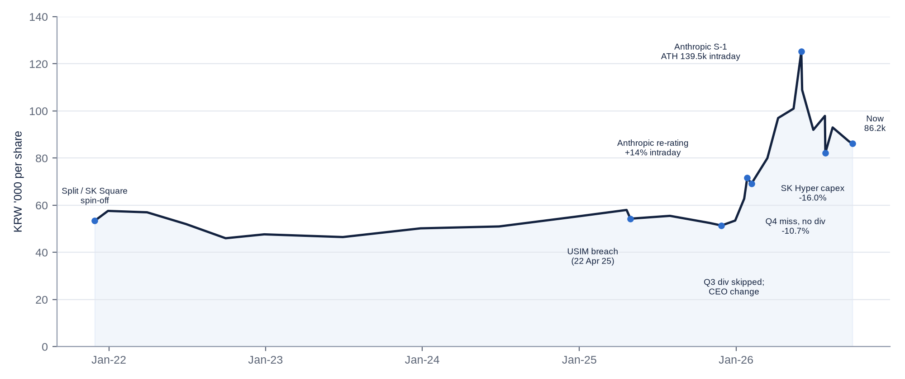
Levels reconstructed from reported closes and press; post-split (Nov-2021) basis. Pre-2025 year-end closes are [u].
Date | Move | Catalyst
29-Nov-21 | Opened KRW 53,400 vs 61,900 base (-14%) | Relisting after 5:1 split and spin-off of SK Square (SK hynix stake, 11st, Tmap, One Store, Wavve moved out); split ratio 60.7:39.3
CY2022 | ADR -17.8% (no single ±10% day) | BoK/Fed hiking cycle; government push for 5G mid-tier plans; defensive rotation
CY2023-24 | +11.6% / +2.9% (ADR) | Steady 7%-ish dividend yield; KRW 3,540 DPS; Value-Up programme; no single ±10% day
22-30 Apr 2025 | -6.4% (28-Apr alone -6.75%); cumulative drift to KRW 51,400 low by late 2025 (~-11% from pre-breach 58,000) | USIM breach disclosure (26.96m IMSI records); SIM shortages; new-subscriber sales suspended May-Jun 25; ~0.8m subscriber loss
28-Aug / 30-Oct-25 | Weak (not quantified [u]) | PIPC record KRW 134.8bn fine; Q3-25 OP KRW 48bn (-91%), first-ever skipped dividend; CEO Ryu replaced by Jung Jai-hun
20-27 Jan 2026 | +6% (20-Jan) then +14% intraday to 71,600 (27-Jan); ADR +12% | Anthropic Series G (US$380bn) re-rating - UBS note; Wellington crossed 5.01%; SKT mkt cap passed KT
6-Feb-26 | -10.7% to 69,200 | Q4-25 OP KRW 119bn (-53%), FY25 year-end dividend cancelled
9-Apr to May-26 | +9% day (9-Apr), first close above KRW 100,000 in May | Q1-26 beat (OP KRW 538bn), KRW 830 DPS reinstated, Anthropic IPO reports
1-2 Jun-26 | +11.5% and +11.6% (intraday ATH 139,500) | Anthropic Series H at US$965bn post-money; confidential S-1 filing
4-Jun-26 | -13.0% to 108,900 | Profit-taking; retail-driven froth unwound through June (~90k by month-end)
28-Jul-26 | -16.0% to 82,200 | Board approves SK Hyper (KRW 750bn to 2030, 5-15GW AI-DC ambition) plus related-party capital injections; dividend-sustainability fears; same-day Asian AI/chip sell-off
14-Aug-26 | +7% open | Reports Anthropic IPO could value it at ~US$2tn; 1H26 stake book value KRW 3.5tn
Sep-26 | ~KRW 85-88k range | BoK hike to 3.00%; Anthropic IPO pushed to November (WSJ 18-Sep); prospectus shows US$42bn 2025 net loss (29-Sep, stock -2 to -4%)

Read-across: since January 2026 the stock has behaved as an Anthropic proxy (beta to AI-private-market headlines far exceeds beta to telco fundamentals). Of the ten >10% moves in the period, six were Anthropic- or AI-capex-driven, three breach/earnings-driven and one structural (the 2021 split).

4. Business model, key drivers, customers, suppliers and competitors

4.1 Key drivers
Driver | Mechanism | Current direction | Sensitivity [e]
Volume - handset subscribers | 22.0m handset / 31m MNO subs; share 39.0% (Apr-26) vs 42.9% (2021) | Recovering: +210k net adds 1Q26 (KT breach), -41k in 2Q26; target ~40% share | ±1pt share ≈ ±KRW 0.25-0.3tn revenue, ~50% drop-through
Pricing / ARPU | 5G mix (18.0m 5G = ~82% of handsets); government-led "Lite" and KRW 20k-range 5G plans (Apr-26 declaration) | Flat to slightly down; mix gains offset by regulated tariff cuts | 1% ARPU ≈ KRW 0.1tn OP
Marketing / subsidies | Handset Distribution Act (Dantong-beop) repealed 22-Jul-25; subsidies uncapped | Muted so far; 1Q26 marketing +7% y/y (KRW 741bn) | Every +5% marketing ≈ -KRW 0.15tn OP
Capex cycle | Capex/sales fell from ~18% (2021-23) to ~12.5% (2025) post-5G build | 5G SA mandate + indoor cells for spectrum rebate; AI-DC capex moving off balance sheet (SK Horizon) | Telco capex ~KRW 2.1-2.4tn p.a.
Spectrum | 370MHz 3G/LTE re-allocation (Jun & Dec 2026 expiries); industry ~KRW 2.9-3.1tn; SKT holds 155MHz | SKT share ~KRW 1.2-1.3tn [e], paid over licence life | Amortisation broadly replaces expiring licences
Regulation / security | PIPC, MSIT; post-breach security spend KRW 700bn over 5 years | Elevated costs through 2029 | ~KRW 0.14tn p.a.
AI-DC growth | Revenue KRW 136bn in 2Q26 (+92.5% y/y); Ulsan 41MW (Nov-27) to 103MW (Feb-29); SK Hyper 5GW by 2029+ | Strongest growth line; minorities (49%) from 1Q27 | +KRW 0.2-0.3tn revenue p.a.
Rates | Bond-proxy valuation; ~KRW 10tn gross debt incl. leases | BoK hiking (3.00%, tightening bias) | +100bp ≈ -KRW 50-70bn pre-tax (fixed-rate book dampens)

4.2 Products, customers and geographies
- Consumers (~75% of revenue): post-paid 5G/LTE plans, family bundles (mobile + FTTH + IPTV), T membership, A. (Adot) AI assistant, handset sales on 24-month instalments. Payment is monthly in arrears via auto-debit/card; handset instalment receivables are a meaningful working-capital item.
- Enterprise/public (~20%): leased lines, IoT, private 5G, cloud/MSP, data-centre colocation (hyperscalers, AI labs, GPUaaS clients), AIX consulting. Contracts are typically 1-5 years (DC leases 5-15 years; the Ulsan AWS partnership is 15 years).
- Wholesale (~5%): MVNO hosting (SK Telink, KB Liiv M, Toss etc. - SKT hosts only 1.8m of ~10.5m MVNO lines vs LGU+ 4.6m and KT 4.0m), roaming, interconnection.
- Geography: effectively 100% South Korea. International exposure is via investments (Anthropic, Penguin Solutions, Lambda, Syntelligence AI) and the Aster AI-agent pilot in the US.

4.3 Suppliers and competitors
Category | Names
Network equipment | Samsung Electronics (Networks), Ericsson, Nokia; fibre: LS Cable, Taihan; maintenance by SK O&S (subsidiary)
Handsets | Samsung Electronics (dominant), Apple; distribution via PS&Marketing and third-party dealers
AI compute / cloud | Nvidia (GPUs, via Lambda and Penguin Solutions), SK hynix (HBM, affiliate), Rebellions (NPUs, ~18% owned via SAPEON), AWS (Ulsan AI zone)
AI models / apps | Anthropic (Claude, equity partner), OpenAI (exclusive Korean telco partner Sep-25; Stargate Korea MOU Oct-25), Perplexity, Google Gemini, own A.X K1/K2
Related-party services | SK AX (ex-SK C&C) IT services; SK Inc. brand royalty (0.2% of revenue ex-advertising); SK Shieldus (security, now EQT-controlled)
Direct competitors | KT Corp (030200 KS / KT US), LG Uplus (032640 KS), MVNOs (18% share: KB Liiv M, Toss Mobile, Woori WON Mobile, Hello Mobile/LG HelloVision 037560 KS), cable (D'Live, CMB - unlisted)
AI/cloud competitors | Naver Cloud (035420 KS parent), Kakao (035720 KS), Samsung SDS (018260 KS), NHN Cloud (181710 KS), KT Cloud (unlisted), AWS/Microsoft/Google

Contract and payment terms: not disclosed in detail. Consumer billing is monthly; handset instalments run 24-36 months (receivables sit on balance sheet, sometimes securitised); equipment suppliers are typically paid on 30-90 day terms [u]; spectrum fees are paid in instalments over the licence term.

5. Macro and micro environment - tailwinds and headwinds
Factor | Current state (Sep-2026) | Impact
Korean GDP | BoK raised 2026 forecast to 3.3% (2027: 2.9%) on record AI-chip exports | Mildly positive (enterprise, DC demand)
Rates | BoK hiked 16-Jul (2.75%) and 27-Aug (3.00%), tightening bias | Negative for bond-proxy multiples and AI-DC funding costs
Inflation | CPI 3.1% Aug-26 (flattered by SKT's own Aug-25 50% bill-discount base effect) | Political pressure on telecom tariffs
FX | KRW 1,365/US$; foreigners net sellers of KOSPI in late September | GPU/equipment import costs; foreign-flow driven volatility
Government policy | Lee Jae-myung administration: AI "G3" ambition, KRW 100tn growth fund, sovereign-AI model project; simultaneous push for cheaper 5G and data safety | Positive for AI-DC; negative for ARPU
Regulation | Dantong-beop repealed (Jul-25); 5G SA mandatory; spectrum re-allocation; PIPC enforcement much tougher | Mixed
Competitors' breaches | KT (femtocell fraud; PIPC fine KRW 54bn Jul-26; fee waiver drove 200k+ users to SKT) and LG U+ (obstruction referral) | Positive - SKT no longer the outlier
Power/grid | GW-scale AI-DC depends on KEPCO grid access and industrial tariffs | Key execution risk for SK Hyper

Tailwinds
- AI-infrastructure demand in Korea (hyperscalers, sovereign AI, SK hynix ecosystem) and a private-capital market willing to fund it (SK Horizon at ~KRW 20bn/MW).
- Normalisation of breach costs: FY26 OP guided above pre-breach levels; FY27 compares cleanly.
- Industry discipline: three-player market, shared regulatory scrutiny, all three carriers with security incidents.
- Anthropic value creation and IPO, Rebellions IPO (1H27), Hana Financial stake - a growing pool of monetisable assets.

Headwinds
- Structural ARPU pressure from government-led tariff cuts and MVNO growth (MVNOs now 18% of handsets).
- Rising rates and a heavy capex agenda (spectrum ~KRW 1.2-1.3tn, security KRW 0.7tn, SK Hyper KRW 0.75tn) competing with the dividend.
- Lasting reputational damage from the 2025 breach; ongoing civil suits and PIPC-fine litigation.
- Key-asset concentration: ~20-40% of market cap tied to one private AI company with a US$42bn 2025 loss.

6. Competitive position and economic moats
SKT has the strongest consumer brand in Korean telecoms (historically #1 in the NCSI customer-satisfaction index for 20+ years), the largest spectrum holding (155MHz of the 370MHz being re-allocated) and the highest-value customer base. The 2025 breach damaged the "premium network" perception and cost ~1pt of share, but KT's and LG U+'s own incidents have largely neutralised the relative damage.
Moat category | Assessment | Strength
Brand | Premium #1 carrier brand; dented by 2025 breach (~0.8m users lost) but churn back to 0.8%/month | Moderate-Strong
Hard assets | Nationwide 5G/LTE network, FTTH, 8+ data centres, subsea cables; spectrum licences - very costly to replicate | Strong
Long-term contracts | Consumer plans short-dated but bundled; DC leases 5-15 yrs (AWS Ulsan 15 yrs) | Moderate
Network effect | Limited (interconnection is regulated); some within-family bundle effects | Weak
Regulatory barriers & switching costs | Licensing, 49% foreign cap, failed 4th-carrier (Stage X cancelled Jul-24); switching costs lowered by MNP & subsidy liberalisation | Strong (entry) / Moderate (switching)
Oligopoly structure | 3-player market (SKT 39%, KT 23%, LGU+ 20%, MVNO 18% handset share) | Strong
Cash-flow predictability | Subscription revenue ~90% recurring; EBITDA margin ~31-33% | Strong
Scalability | Core telco low-growth; AI-DC scalable but capital-intensive | Moderate
Government interference risk | High: tariff "guidance", forced compensation, record fines, spectrum pricing | Negative factor
Bargaining power vs stakeholders | Strong vs handset dealers and MVNOs; weak vs Samsung/Apple and vs government; moderate vs hyperscalers | Moderate

Product comparison vs competitors
Attribute | SK Telecom | KT | LG Uplus | MVNOs
Perceived value | Premium price, best network perception (pre-breach) | Mid-premium; strongest fixed-line | Value / youth marketing | Cheapest, bank-bundled
Brand | Strongest, damaged 2025 | Damaged by 2025-26 fraud/cover-up | Damaged by 2025 breach | Fintech brands (Toss, KB)
Fixed/Media | #2 broadband (28.7%), #2 pay-TV (~26%) | #1 (40%+) incl. Skylife | #3 | n/a
AI positioning | Most aggressive: Anthropic, OpenAI, A.X, AI-DC, SK hynix links | Microsoft partnership, KT Cloud | Exaone via LG AI Research | n/a

7. Supply chain map - from inputs to end customer
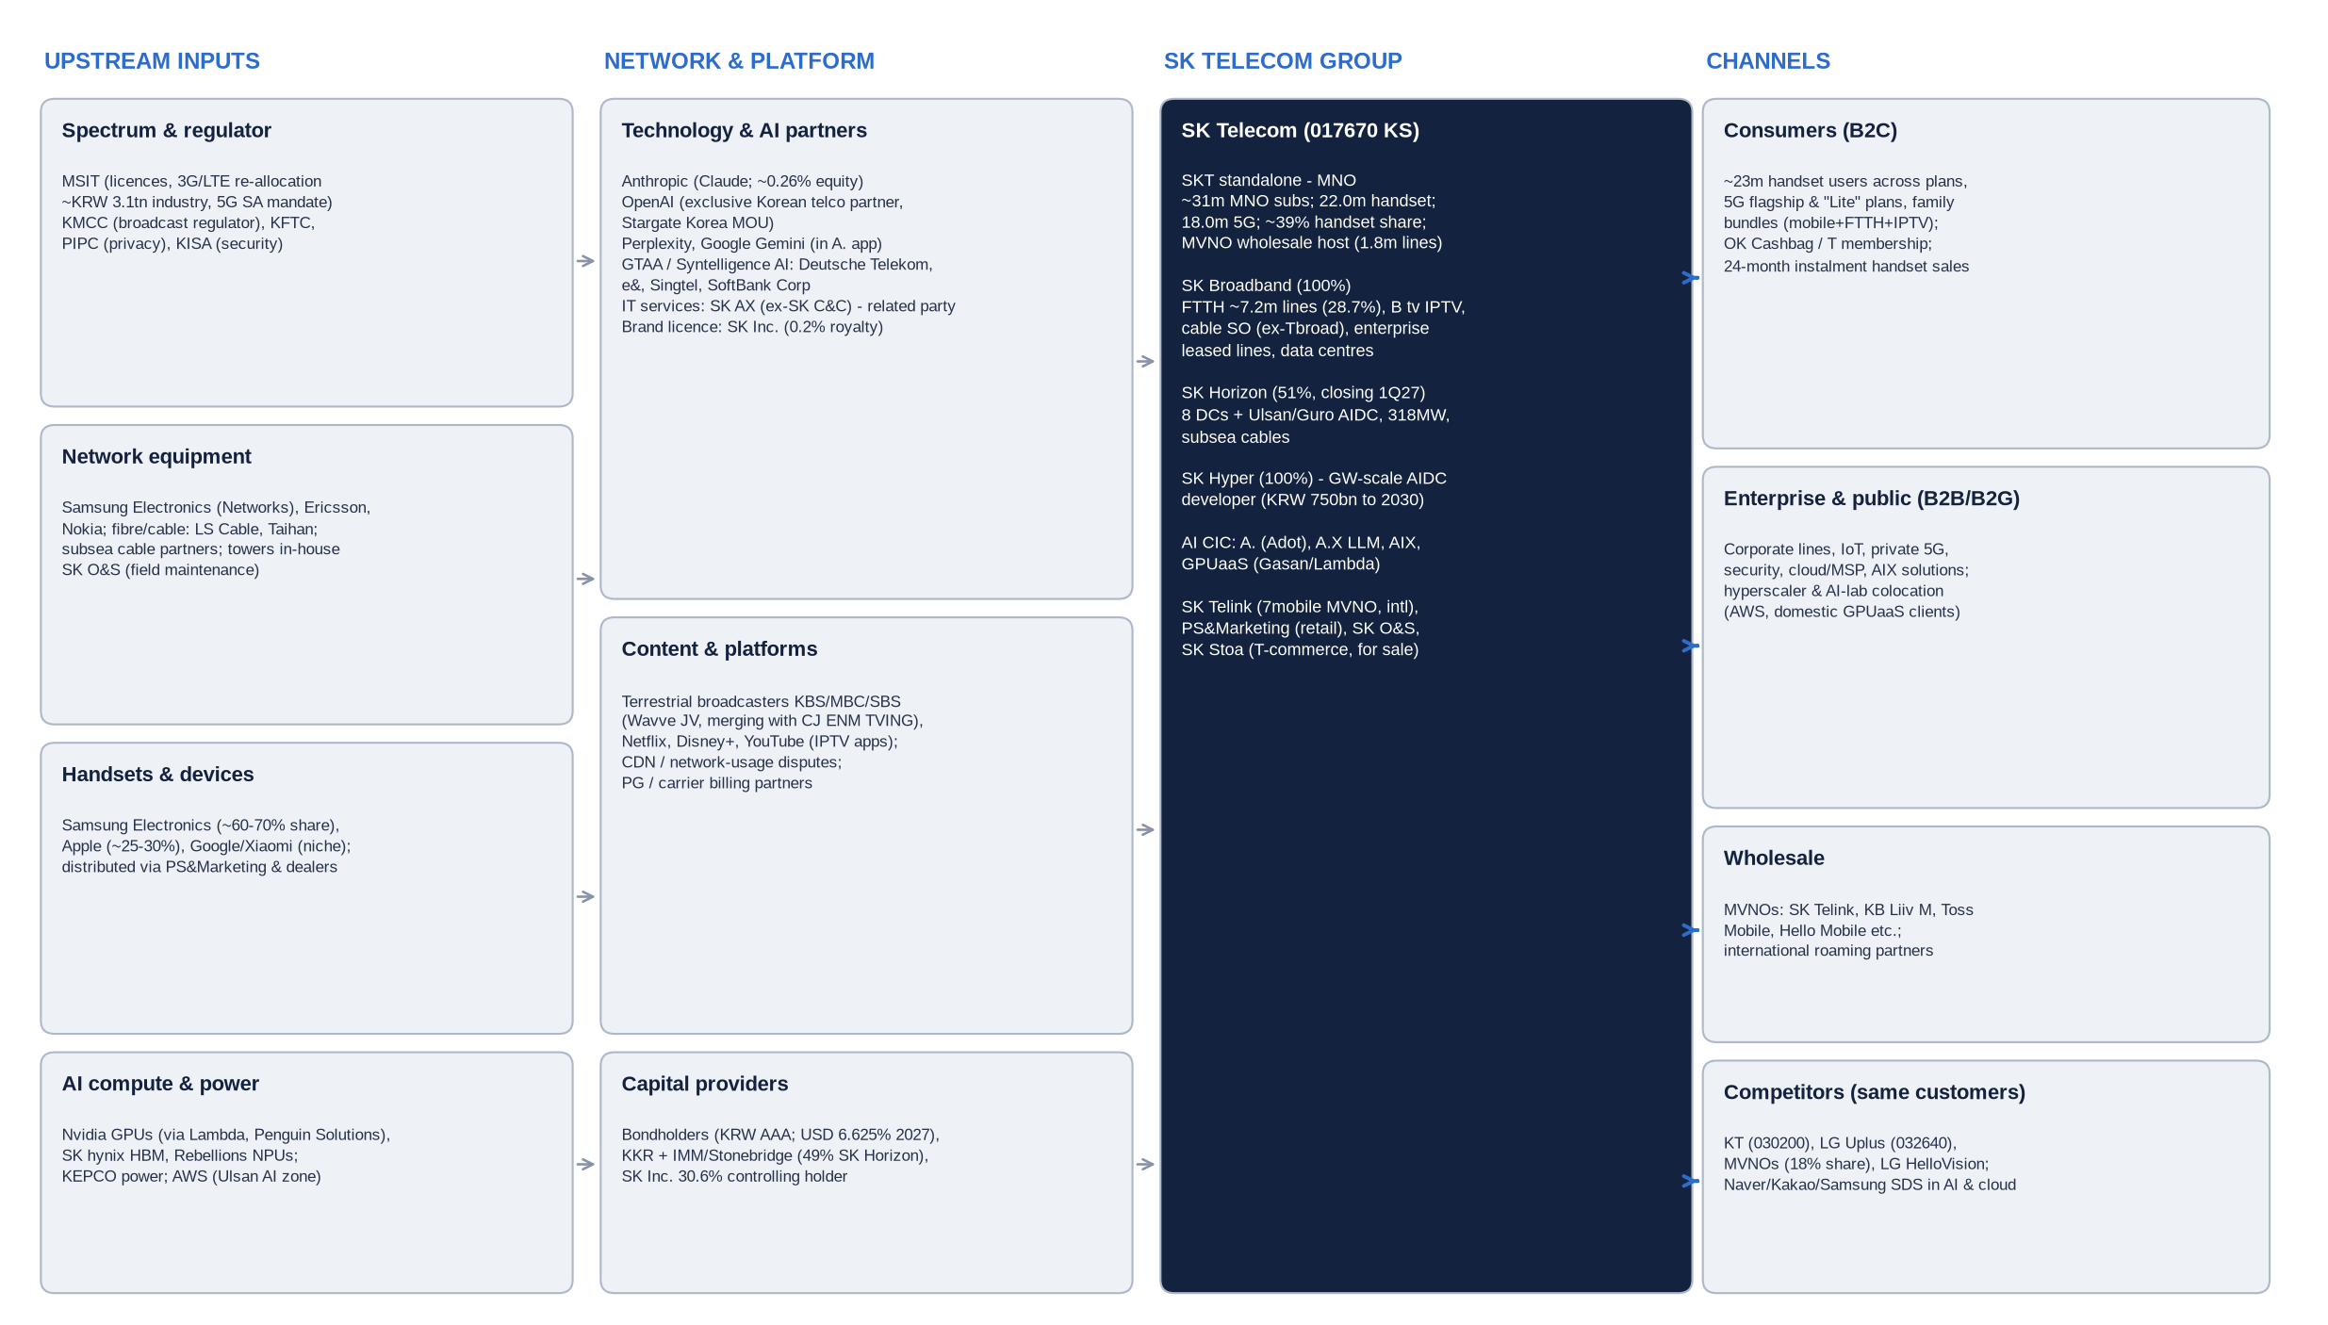
Source: company disclosures, press; compiled by us. Market-share and ownership figures as cited elsewhere in this report.
- Where the power sits: upstream, Samsung/Apple and the government (spectrum, tariffs) hold the pricing power; midstream, SKT controls network, billing and the customer relationship - where the margin is earned; downstream, dealers and MVNOs depend on SKT's network and subsidies.
- New AI stack: SKT positions itself as the Korean "AI infrastructure layer" - buying Nvidia GPUs and SK hynix HBM, hosting AWS/AI labs, and reselling Anthropic/OpenAI/Perplexity models through A. to 23m consumers.
- Related parties are embedded: SK Inc. (brand, control), SK AX (IT outsourcing), SK hynix (memory), SK Square (former sister portfolio).

8. Financial analysis - five-year history by division and geography

8.1 Consolidated P&L, FY2021-FY2025 (K-IFRS, KRW bn)
KRW bn | FY2021 | FY2022 | FY2023 | FY2024 | FY2025 | 5-yr trend
Revenue | 16,749 | 17,305 | 17,609 | 17,941 | 17,099 | CAGR +0.5%; FY25 -4.7% (breach)
growth y/y | +4.1% | +3.3% | +1.8% | +1.9% | -4.7% | Decelerating even pre-breach
EBITDA | ~5,207 [u] | ~5,367 [u] | ~5,504 | ~5,520 | ~4,663 | Flat ex-2025
EBITDA margin | ~31.1% | ~31.0% | 31.3% | 30.8% | 27.3%
Operating income (EBIT) | 1,387 | 1,612 | 1,753 | 1,823 | 1,073 | Peak FY24; -41% FY25
EBIT margin | 8.3% | 9.3% | 10.0% | 10.2% | 6.3% | +190bp FY21-24 via lower D&A/marketing
Net income (total) | 2,419* | 948 | 1,146 | 1,439 | 375 | *incl. SK Square disc. ops
NI attributable | ~2,407 [u] | ~912 [u] | 1,094 | 1,250 | ~390 [u]
EPS (KRW) | 7,191 [u] | 4,118 | 4,954 | 5,780 | 1,825
DPS (KRW) | ~3,320 eq. [u] | 3,320 | 3,540 | 3,540 | 1,660 | Q3/Q4-25 skipped
Capex | ~3,001 [u] | ~3,035 [u] | ~3,140 | ~2,742 (SKT+SKB) | ~2,129 | Capex/sales 18% to 12.5%
Free cash flow | n/a | n/a | ~1,870 [u] | ~2,530 [u] | ~1,720 [u]
Net debt incl. leases | n/a | n/a | ~9,200 [u] | ~8,740 [u] | ~9,100-9,280 [u] | ND/EBITDA ~1.6-2.0x
Source: company releases, 20-F, Hankyung/FnGuide, aggregators. EBITDA definitions differ across sources (FY24 quoted 5.50-5.86tn).
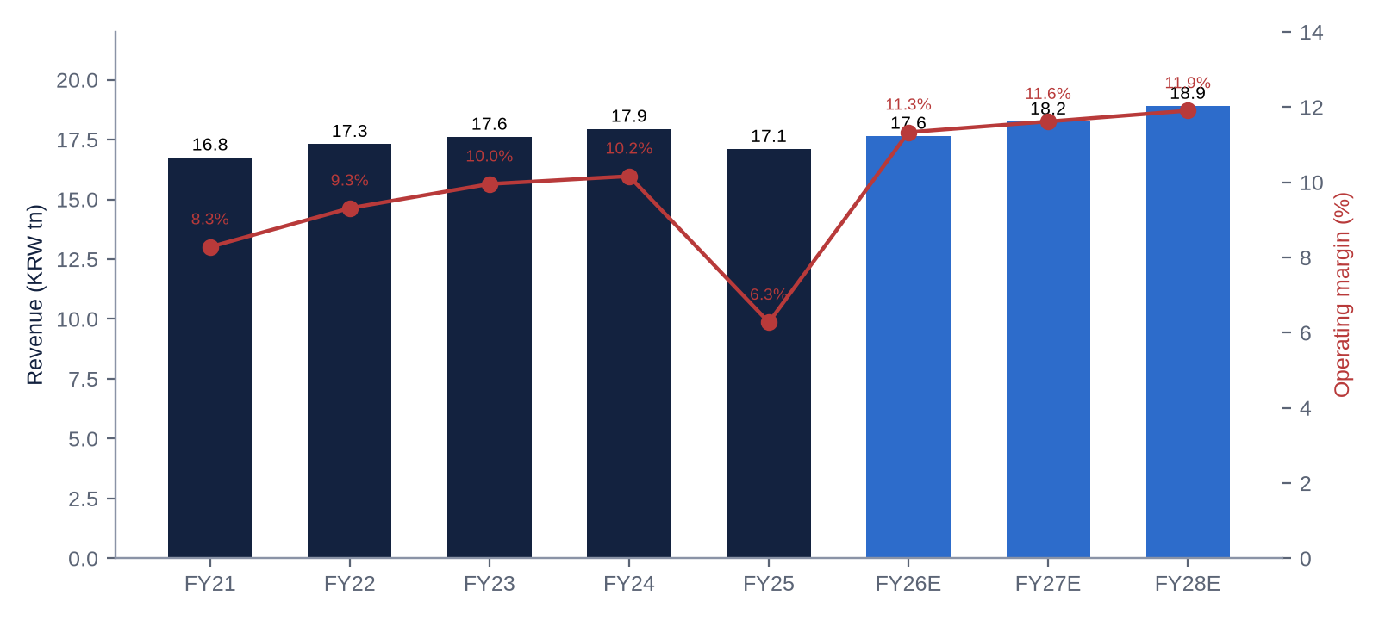
FY26E-FY28E are our estimates.

8.2 By division (entity basis, KRW bn)
Division | Metric | FY2021 | FY2022 | FY2023 | FY2024 | FY2025 | Comment
SKT standalone (Mobile/MNO) | Revenue | ~12,100 [u] | ~12,410 [u] | ~12,585 | 12,774 | 12,051 | -5.7% FY25: 50% Aug bill discount, 0.8m subs lost
 | Operating income | ~1,250 [u] | ~1,390 [u] | ~1,456 | 1,523 | 812 | Margin 11.9% to 6.7%
 | Net income | n/a | n/a | n/a | 1,332 | n/a | 3Q25 standalone NI -207bn
SK Broadband (Fixed/Media/DC) | Revenue | ~4,060 [u] | ~4,140 [u] | ~4,280 [u] | 4,415 | ~4,541 | Steady +3%; DC & enterprise the driver
 | Operating income | ~270 [u] | ~300 [u] | ~310 [u] | ~352 | 289 | FY25 hit by VRS & content costs
AI DC (memo, cross-entity) | Revenue | n/a | n/a | n/a | ~385 | 520 | +35% FY25; +89-93% in 1H26
Other subs / eliminations | Revenue | n/a | n/a | ~744 | ~752 | ~507 | SK Telink, PS&M, SK Stoa, O&S
 | Operating income | n/a | n/a | ~-13 | ~-52 | ~-28
SKT does not disclose EBITDA or net income by segment consistently; FY21-23 entity figures are approximations [u].

8.3 Geography
SKT is a single-country business: >99% of revenue, EBITDA, EBIT and assets are in South Korea. Foreign exposure is limited to (i) US-dollar AI investments (Anthropic, Penguin, Lambda, Perplexity, Syntelligence), (ii) USD-denominated GPU/equipment purchases and (iii) a legacy USD 400m 6.625% bond due July 2027. A geographical segment table is therefore not meaningful.

8.4 Trends and explanations
- 2021-2024 - margin expansion without growth: revenue grew ~2% p.a. as 5G migration lifted ARPU, while EBIT margin rose from 8.3% to 10.2% on falling D&A (post-5G build), lower marketing and headcount discipline.
- 2025 - the breach year: revenue -4.7% (50% August bill discount worth ~KRW 0.4tn, 0.8m subscribers lost, sales suspension), OP -41% (customer package KRW 500bn, USIM replacement, PIPC fine below OP line, VRS in 4Q), NI -73%.
- 2026 - rebound: 1H26 OP KRW 1,104bn (vs 906bn 1H25 and 1,037bn 1H24); 2Q26 EBITDA margin 33.1% - the highest in the series - on lower marketing, headcount cuts (30% fewer executives, VRS) and AI-DC operating leverage.
- Quality of growth: almost all incremental revenue since 2023 comes from AI-DC and enterprise; mobile service revenue is flat at best.
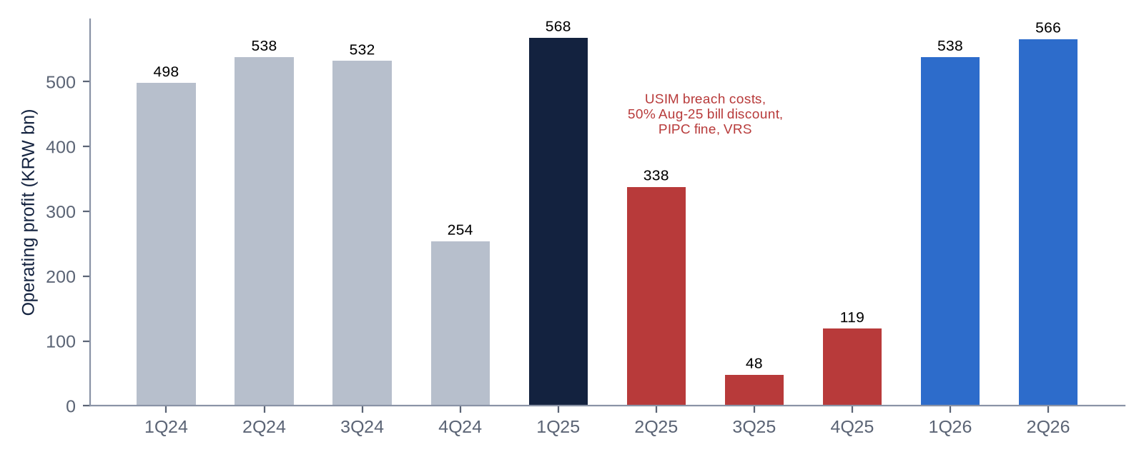

8.5 Operational KPIs
KPI | Latest | Prior | Trend / comment
Handset market share | 39.04% (Apr-26) | 40.4% (2024); 42.9% (2021) | Structural -1pt p.a.; breach cost ~1pt; recovery target ~40%
MNO subscribers | 30.93m (2Q26) | 31.0m (1Q26), 31.9m (1Q25) | -41k in 2Q26 after +122k in 1Q26
Handset subscribers | 21.97m (2Q26) | ~22.0m (2Q25) | Flat y/y
5G subscribers | 17.97m (2Q26) | 17.26m (3Q25) | ~82% of handsets; runway to ~90%
Monthly churn | 0.8% (2Q26) | 1.6% (2Q25) | Normalised
Marketing cost | KRW 741bn (1Q26, +7.1%) | KT 687bn, LGU+ 614bn | Post-Dantong-beop competition contained
Capex / sales | ~11% (2Q26 capex 487bn) | ~17-18% (2021-23) | Structural decline; AI-DC capex moving to SK Horizon/Hyper
AI-DC revenue | KRW 136bn (2Q26, +92.5%) | KRW 131bn (1Q26, +89%) | Ulsan 41MW Nov-27; SK Horizon 318MW
SKB FTTH lines / share | ~7.17m / 28.7% (Jun-25) |  | #2 behind KT
Pay-TV share (SKB IPTV+SO) | ~26.4% (1H25) |  | #2; pay-TV market shrinking (36.15m)
EBITDA margin | 33.1% (2Q26) | 27.3% (FY25) | Record high
Installed base value (Anthropic book) | KRW 3.505tn (Jun-26) | KRW 1.376tn (Dec-25) | Revalued with each funding round
ARPU and IPTV subscriber series not retrievable [u]; check 2Q26 investor briefing.
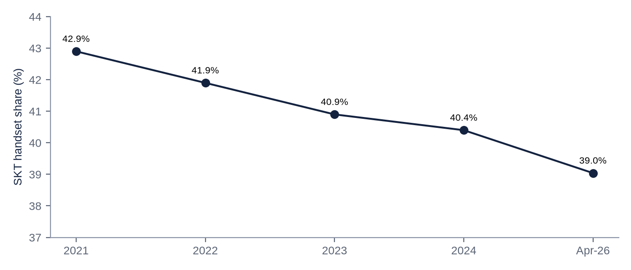
SKT handset subscriber share (MSIT data via press).

9. Earnings calls, sentiment and the latest result

9.1 What management is focused on
- Trust recovery and security: KRW 700bn/5-yr security plan; CISO reporting to the CEO; CISO/CPO split.
- "Earnings above pre-breach levels" in 2026 - repeated on every 2026 call; revenue recovery acknowledged to be slower.
- AI infrastructure: AI-DC growth, SK Horizon (asset-light via PE partners), SK Hyper (GW-scale developer), GPUaaS, sovereign AI model A.X K2 (Phase 3).
- Dividend continuity: KRW 830/quarter explicitly ring-fenced from AI-DC spend (2Q26 call).
- Cost structure: two-CIC organisation (MNO, AI), 30% fewer executives, voluntary retirement.

9.2 Sentiment trajectory
Call | Tone (1-5) | Key messages | Analyst focus
2Q25 (Aug-25) | 1.5 - defensive | Crisis containment, compensation, security investment; AI as offset | Size of hit, subscriber loss
3Q25 (30-Oct-25) | 1.0 - trough | OP KRW 48bn; first-ever dividend skip; "absorbing one-offs" | When do dividends resume? Remaining one-offs?
4Q25 (5-Feb-26) | 2.5 - reset | FY25 DPS 1,660; VRS; "2026 earnings above pre-breach" | Normalised OP; payout policy
1Q26 (7-May-26) | 3.5 - recovery | DPS 830 reinstated; +210k handset adds; OP back to pre-breach; AI-DC +89% | Sustainability of share gains from KT
2Q26 (5-Aug-26) | 4.0 - growth/offence | SK Hyper (KRW 750bn; 5GW), SK Horizon pending; record margin | AI-DC funding vs dividend; MNO revenue still flat

Shift: language moved from "responsibility" and "customer trust" (2025) to "normalisation" (early 2026) and "AI infrastructure", "GW" and "partners" (mid-2026). The risk is that management tone is now ahead of the evidence in the core business: MNO revenue has not yet grown y/y.

9.3 Latest result - 2Q26 (reported 5-Aug-2026)
KRW bn | 2Q26A | Consensus | Beat / miss | 2Q25A | y/y
Revenue | 4,359.1 | 4,413.3 | -1.2% miss | ~4,338 | +0.5%
Operating income | 566.0 | 547.0 | +3.5% beat | 338.3 | +67.3%
OP margin | 13.0% | 12.4% | +60bp | 7.8% | +520bp
EBITDA | 1,442 | n/a |  | ~1,232 | +17%
Net income | 466.0 | n/a |  | 83.2 | +460%
SK Broadband revenue / OP | 1,160.3 / 132.5 | n/a |  |  | +3.6% / +44.3%
AI-DC revenue | 136.2 | n/a |  | 70.7 | +92.5%
Capex | 487 | n/a
DPS (quarterly) | KRW 830 | KRW 830 | in line | 830 | flat

- Drivers: y/y growth is mostly the base effect of 2Q25 breach costs plus lower marketing and headcount; SKB (+44% OP) and AI-DC were the genuine growth engines. Mobile revenue was flat.
- Margins: record 33.1% EBITDA margin; opex discipline rather than pricing.
- Guidance: no numeric guidance; reiterated FY26 earnings above pre-breach (FY24 OP KRW 1.82tn) - implies 2H26 OP of at least ~0.72tn; we model 0.90tn.
- Balance-sheet flags: debt/equity 1.09x; new commitments of ~KRW 1.49tn (SK Hyper 750bn - 330bn upfront; plus KRW 738bn reportedly linked to an SK hynix NAND-related investment/capital injection [u]) - the related-party element is the most unusual item in the quarter and needs disclosure clarity.
- Market reaction: the stock had already fallen 16% on 28-Jul when the investments were disclosed; the beat did not reverse it - the market is discounting capital allocation risk, not earnings.

10. Earnings estimates, FY2026E-FY2028E
KRW bn | FY2025A | FY2026E | FY2027E | FY2028E | Key assumptions
Revenue | 17,099 | 17,650 | 18,250 | 18,900 | Mobile +0.5-1% (5G mix, share recovery vs tariff cuts); SKB +3%; AI-DC +40-35%
growth | -4.7% | +3.2% | +3.4% | +3.6% | Industry growth ~1%; share gains ~0.3pt p.a.
EBITDA | 4,663 | 5,620 | 5,850 | 6,100 | Margin 31.8% / 32.1% / 32.3%; marketing +3% p.a.; security capex/opex ~KRW 140bn p.a.
D&A | ~3,590 | 3,620 | 3,730 | 3,850 | Spectrum re-allocation (~KRW 1.25tn SKT share) amortised; AI-DC depreciation rising
EBIT (OP) | 1,073 | 2,000 | 2,120 | 2,250 | Margin 11.3% / 11.6% / 11.9% - operating leverage from flat fixed cost base
Net finance cost |  | -330 | -360 | -380 | Avg cost of debt ~3.3%, BoK at 3.0%+
Equity method / other |  | 50 | 50 | 50 | Excludes Anthropic fair-value gains (treatment [u])
Pre-tax profit |  | 1,720 | 1,810 | 1,920
Tax (24%) |  | -410 | -430 | -460
Minorities |  | -10 | -50 | -70 | SK Horizon 49% outside holders from 1Q27
NI attributable | ~390 | 1,300 | 1,330 | 1,390
Diluted shares (m) | ~213 | 213.0 | 213.0 | 213.0 | No buybacks assumed; SBC dilution negligible
EPS (KRW) | 1,825 | 6,100 | 6,240 | 6,530 | Consensus FY26: 5,661-6,281
DPS (KRW) | 1,660 | 3,320 | 3,400 | 3,500 | Payout ~54%
P/E at KRW 86,200 | 47x | 14.1x | 13.8x | 13.2x

Sensitivities: each 1pt of handset share = ~KRW 280bn revenue / ~KRW 140bn OP (~KRW 500 EPS). A 5% rise in marketing costs = -KRW 150bn OP. +100bp on floating debt = ~-KRW 50bn pre-tax. If Anthropic is carried at FVTPL, each US$100bn change in Anthropic valuation moves pre-tax profit by ~KRW 0.35tn (~KRW 1,250 EPS) - this could make reported EPS highly volatile after the IPO.

11. Capital structure, debt, liquidity and credit
Item (consolidated) | Value | Comment
Cash & short-term investments | ~KRW 1.68tn (Dec-25) | Jun-26 figure not retrieved [u]
Gross debt incl. leases | ~KRW 10.8tn (Dec-25) [u] | Mostly fixed-rate KRW bonds (AAA), bank loans, IFRS-16 leases (DCs, sites)
Net debt incl. leases | ~KRW 9.1-9.3tn | Source figures internally inconsistent (9.09 vs 9.28tn)
Net debt / EBITDA | 2.0x FY25 (trough) / ~1.6x FY26E | Comfortable for AAA; headroom ~1.0x before 2.5x
Debt / equity | 1.09x (Jun-26, definition [u])
Interest expense | ~KRW 0.35-0.45tn p.a. [u] | Average cost ~3.0-3.5% [e]
USD bonds | US$400m 6.625% notes due 20-Jul-2027 | Legacy 2007 issue; refinancing need in 2027
KRW bonds (examples) | 2.84% due Nov-2027; 1.865% due Jan-2040 | Nov-24 deal: KRW 150bn book, KRW 1.255tn demand, 3yr -3bp to curve
Recent market access | Nov-25 KRW 150-240bn deal withdrawn (govt yields spiked) | No 2026 public issue found - funded from FCF and SKB/asset sales
Hybrid capital | None found for SKT [u] | Hybrid considered in 2025
Ratings | Moody's A3 / S&P A- / KIS-NICE-KR AAA (stable) | Domestic AAA affirmed post-breach (H1-25 and Jul-26)
Covenants | No financial maintenance covenants typical for Korean public bonds | Standard negative pledge / disposal limits
Committed outflows | SK Hyper KRW 750bn (to 2030); spectrum ~KRW 1.2-1.3tn [e]; security KRW 700bn (5 yrs); SK hynix-linked KRW 738bn [u]
Committed inflows | SK Horizon KRW 3.08tn (KKR/IMM, close 1Q27); SK Stoa ~KRW 110bn (pending); Joby partial sale KRW 131bn (done) | Horizon cash largely retained at Horizon for build-out [u]

Indicative maturity profile [e/u]
Year | 2026 (rem.) | 2027 | 2028 | 2029 | 2030 | 2031+
Bonds & loans (KRW tn, indicative) | ~0.3 | ~1.6 (incl. US$400m) | ~1.3 | ~1.1 | ~0.9 | ~3.0
Not obtained from DART note; shown as a typical ladder for SKT's ~KRW 8-9tn funded debt - verify before use. Liquidity (cash + undrawn bank lines + AAA market access) comfortably covers 2027 maturities.
Assessment: the balance sheet is conservative for a telco (1.6x ND/EBITDA vs 2.3-3.0x at DT, NTT, Verizon). The pressure points are (1) the stacking of spectrum, security and AI-DC commitments in 2026-28, (2) a rising-rate environment and (3) potential PE-style exit rights granted to KKR/IMM at SK Horizon, which could become quasi-debt. None threaten the AAA near term.

12. Valuation - vs peers and vs own history

12.1 SKT multiples: now vs five-year history
Multiple | FY2021 | FY2022 | FY2023 | FY2024 | FY2025 | 5-yr avg | Current (FY26E) | Verdict
EV / Sales | ~1.6x | ~1.4x | ~1.2x | ~1.1x | ~1.2x | ~1.3x | 1.59x | Expensive vs history
EV / EBITDA | 5.1x | 4.4x | 3.8x | 3.7x | 4.3x | 4.2x | 5.0x (core ~4.0x) | Fair on core
EV / EBIT | ~19x | ~15x | ~12x | ~11x | ~19x | ~15x | 14.0x | Fair
P / E | 8.5x | ~9.5x | ~9.8x | ~9.4x | 28.1x | ~9.5x (ex-FY25) | 14.1x | Expensive headline
P / B | 1.1x | ~1.0x | ~1.0x | 1.0x | 1.0x | 1.0x | ~1.45x | Expensive (Anthropic in book)
Dividend yield | 4.6% | ~6.5% | 7.1% | 6.4% | 3.1% | 5.5% | 3.9% | Low vs history
Net debt / EBITDA | ~1.7x | ~1.7x | ~1.7x | ~1.6x | ~2.0x | ~1.7x | ~1.6x | Stable
EBITDA margin | 31.1% | 31.0% | 31.3% | 30.8% | 27.3% | 30.3% | 31.8% | Improving
EBIT margin | 8.3% | 9.3% | 10.0% | 10.2% | 6.3% | 8.8% | 11.3% | Record
Sales growth | +4.1% | +3.3% | +1.8% | +1.9% | -4.7% | +1.3% | +3.2% | Rebound
FCF yield (on mkt cap) | n/a | n/a | ~17% | ~21% | ~14% |  | ~11% [e]
Historical multiples from broker tables (Daishin, Eugene, FnGuide) and our derivation; sources disagree by ±0.3x [u]. Current: price KRW 86,200, mkt cap KRW 18.5tn, EV ~KRW 28.0tn.
Conclusion: on headline multiples SKT screens expensive vs its own history (P/E 14x vs ~9.5x; yield 3.9% vs 5.5%), because the market now capitalises Anthropic. Stripping out Anthropic (book KRW 3.5tn) and other investments (~KRW 1.9tn), the core telco trades on ~4.0x FY26E EBITDA - in line with its 4.2x average and at a discount to regional peers.

12.2 Peer comparison (indicative, FY26E / NTM)
Company | Ticker | Listed | Mkt cap US$bn | EV/Sales | EV/EBITDA | EV/EBIT | P/E | EBITDA mgn | EBIT mgn | Sales gr. | ND/EBITDA | Div yld
SK Telecom | 017670 KS / SKM | KRX, NYSE | 13.6 | 1.6x | 5.0x | 14.0x | 14.1x | 32% | 11% | +3% | 1.6x | 3.9%
KT Corp | 030200 KS / KT | KRX, NYSE | ~10 | ~0.6x | ~3.7x | ~10x | ~10x | ~20% | ~7% | 1-3% | ~1.3x | ~4.5%
LG Uplus | 032640 KS | KRX | ~4.5 | ~0.8x | ~3.5x | ~12x | ~9x | ~25% | ~6.5% | 1-2% | ~1.6x | ~5%
NTT | 9432 JP | TSE | ~90 | ~1.7x | ~6.8x | ~15x | ~11.5x | ~27% | ~12% | 2-3% | ~2.8x | ~3.3%
KDDI | 9433 JP | TSE | ~67 | ~1.8x | ~6.0x | ~11x | ~13.5x | ~33% | ~18% | 2-4% | ~1.0x | ~3.0%
SoftBank Corp | 9434 JP | TSE | ~67 | ~2.2x | ~8.0x | ~15x | ~19x | ~28% | ~15% | 3-5% | ~2.8x | ~4.0%
Chunghwa Telecom | 2412 TT / CHT | TWSE, NYSE | ~33 | ~4.0x | ~11.5x | ~20x | ~25x | ~37% | ~20% | 1-3% | net cash | ~3.8%
Taiwan Mobile | 3045 TT | TWSE | ~11.5 | ~2.0x | ~11.5x | ~20x | ~21x | ~22% | ~11% | 2-5% | ~2.0x | ~4.0%
Far EasTone | 4904 TT | TWSE | ~10.5 | ~3.0x | ~10.5x | ~20x | ~23x | ~33% | ~15% | 2-4% | ~1.2x | ~3.7%
Singtel | Z74 SP | SGX | ~52 | ~5.0x* | ~14.5x* | ~30x* | ~20x | ~27% | ~12% | 0-3% | ~2.5x | ~4.0%
Telstra | TLS AU | ASX | ~38 | ~2.3x | ~8.0x | ~16x | ~24x | ~36% | ~17% | 1-3% | ~1.8x | ~4.0%
China Mobile | 941 HK | HKEX, SSE | ~295 | ~1.1x | ~3.8x | ~9x | ~11.5x | ~32% | ~13% | 0-2% | net cash | ~6.5%
Telkom Indonesia | TLKM IJ | IDX, NYSE | ~19 | ~1.4x | ~4.5x | ~8x | ~11x | ~50% | ~28% | 0-2% | ~0.5x | ~6.0%
Axiata | AXIATA MK | Bursa | ~5.5 | ~1.8x | ~5.5x | ~15x | 20x+ | ~45% | ~15% | 2-4% | ~2.0x+ | ~3.5%
Verizon | VZ | NYSE | ~180 | ~2.5x | ~7.0x | ~12x | ~9x | ~36% | ~22% | 1-2% | ~2.5x | ~6.5%
T-Mobile US | TMUS | NASDAQ | ~265 | ~3.9x | ~10.5x | ~17x | ~20x | ~39% | ~23% | 4-6% | ~2.3x | ~1.7%
Deutsche Telekom | DTE GY | XETRA | ~178 | ~2.6x | ~6.8x | ~13x | ~14x | ~40% | ~20% | 2-4% | ~2.3x | ~3.0%
Peer median (ex-SKT) |  |  |  | ~2.2x | ~7.0x | ~15x | ~14x | ~33% | ~15% | ~2% | ~2.0x | ~4.0%
Indicative ranges (approx. H1-2026 levels, ±15-20%) compiled from memory/aggregators because terminals and filings were not accessible [u]. *Singtel consolidated multiples inflated by regional associates. Refresh from Bloomberg before use.

Private / unlisted competitors
Company | Segment | Status
Toss Mobile (Viva Republica) | MVNO | Unlisted
Freet (Free Telecom) | MVNO | Unlisted
KB Liiv M / Woori WON Mobile | Bank MVNOs | Parents listed (105560 KS / 316140 KS)
D'Live, CMB | Cable SO | Unlisted
KT Cloud | Cloud / DC | Unlisted (KT subsidiary)
Naver Cloud | Cloud / AI | Unlisted (Naver 035420 KS)
Anthropic / OpenAI | AI models (partners & potential competitors in AI services) | Pre-IPO / unlisted
Watcha / TVING-Wavve | OTT | Unlisted / merging (CJ ENM 035760 KQ)

12.3 Regression - EV/Sales vs EBIT margin (listed peers)
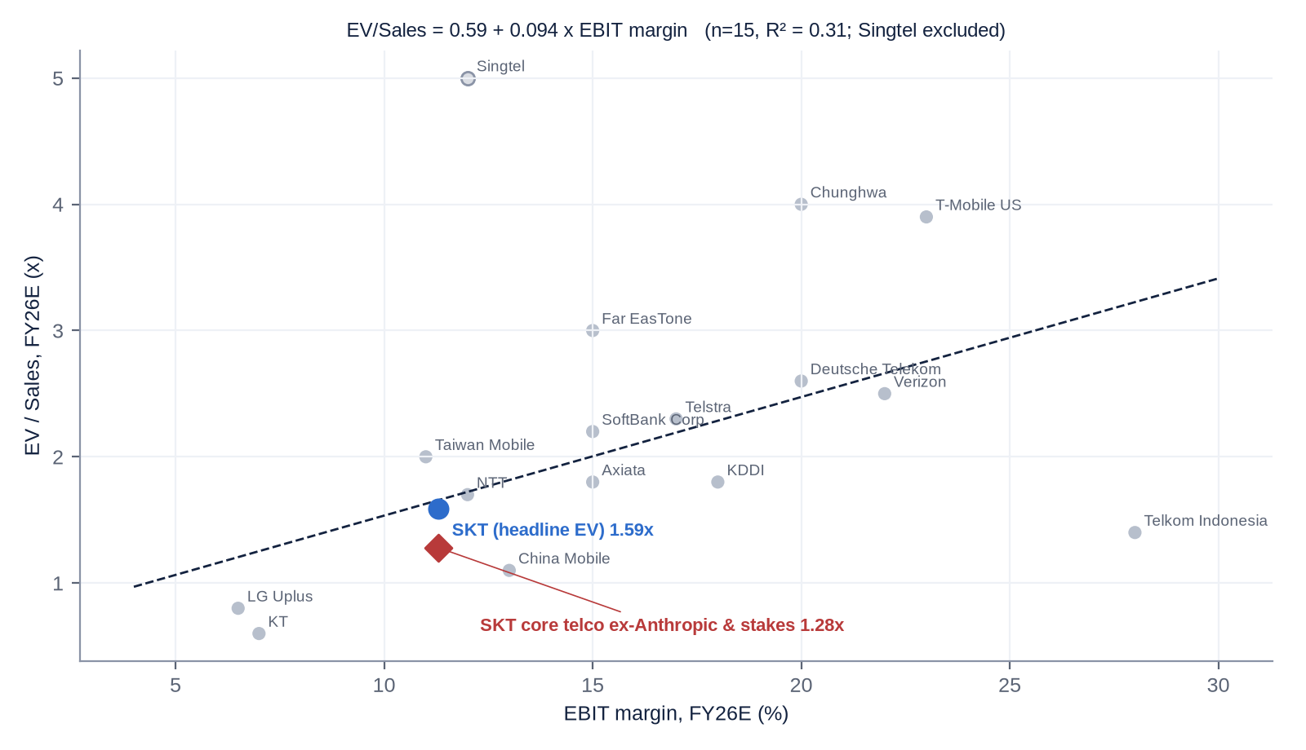
Indicative peer data (FY26E). Regression excludes Singtel (associate-inflated EV).
- Regression: EV/Sales = 0.59 + 0.094 x EBIT margin (%), R² = 0.31 across 15 peers - a moderate fit (country risk premia, growth and tower/fibre structures explain the residual).
- At SKT's FY26E EBIT margin of 11.3% the line implies a fair EV/Sales of ~1.66x vs 1.59x headline - fairly valued on the headline EV.
- On a core basis (EV less Anthropic book value and other stakes) SKT trades at ~1.28x - ~23% below the regression line, i.e. the market is giving the telco a KT/LG U+ style "Korea discount".
- The Korean trio sits below the line as a cluster - regulation, tariff intervention and the governance ("Korea") discount are systemic; the Value-Up programme has so far narrowed but not closed the gap.

12.4 Sum-of-the-parts (base case, 12-month)
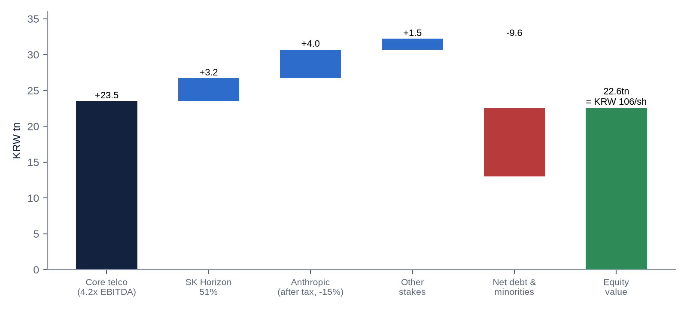
Component | Method | KRW tn | Per share
Core telco (MNO + SKB ex-DC) | 4.2x FY27E EBITDA ex-AI-DC (KRW 5.6tn) - in line with 5-yr average | 23.5 | 110,300
SK Horizon (51%) | KKR/IMM transaction value (KRW 3.08tn for 49%) | 3.2 | 15,000
Anthropic (3.86m shares) | US$1.75tn IPO value, 24% tax on gain, 15% holdco discount | 4.0 | 18,800
Other stakes | Hana Financial, Rebellions (look-through), Penguin, Joby, Lambda etc. at 80% | 1.5 | 7,000
Net debt & minorities | Dec-25 net debt incl. leases + minorities | -9.6 | -45,000
Equity value | 213.0m shares | 22.6 | ~106,000

13. M&A - industry transactions, takeover potential and SKT's own deals

13.1 Relevant industry transactions, 2021-2026
Target | Acquirer | Date | Value | Multiple | Relevance
SK Horizon (49%; SKB AI-DC + subsea cables, 318MW) | KKR (29%), IMM-Stonebridge (20%) | Aug-26 (close 1Q27) | KRW 3.08tn | ~KRW 20bn/MW; ~6.3tn equity for 100% [e] | Direct - marks SKT's DC estate
SK Broadband 24.8% minority | SK Telecom (from Taekwang, Mirae Asset) | Nov-24 / May-25 | KRW 1.15tn | KRW 4.6tn for 100% equity; ~5x EBITDA [e/u] | Korean fixed-line benchmark
SK Shieldus (68%) | EQT (from SK Square/Macquarie) | 2023 | ~KRW 2tn (EV ~3.3tn) | ~11x EBITDA [u] | Former SKT asset
HCN (cable SO) | KT Skylife | 2021 | ~KRW 490bn | n/a | Korean pay-TV consolidation
NTT Data minorities | NTT (take-private) | 2025 | ~¥2.4tn | n/a | Asian telco group simplification
Lawson (~50%) | KDDI tender offer | 2024 | ~¥500bn | n/a | Telco diversification
TIM NetCo (fixed network) | KKR | Jul-24 | up to €22bn EV | ~9-10x EBITDA [u] | Infra carve-out comp
Orange Spain + MásMóvil (MasOrange) | Merger (Orange / KKR, Cinven, Providence) | Mar-24 | ~€18.6bn EV | ~6-7x EBITDA [u] | In-market consolidation
Vodafone UK + Three UK | Merger (Vodafone 51% / CKH 49%) | May-25 | ~£15bn combined EV | ~6x EBITDA [u] | In-market consolidation
Frontier Communications | Verizon | Sep-24 (closed 2026) | US$20bn EV | ~9.5x EBITDA [u] | Fibre/convergence premium
UScellular wireless ops | T-Mobile US | May-24 | US$4.4bn | n/a | Spectrum/subscribers
XL Axiata + Smartfren (XLSmart) | Merger | Apr-25 | n/a | n/a | Asian 4-to-3
Indosat + Hutchison 3 | Merger (Ooredoo/CKH) | Jan-22 | ~US$6bn combined | n/a | Asian 4-to-3
Celcom + Digi (CelcomDigi) | Merger (Axiata/Telenor) | Dec-22 | n/a | n/a | Asian consolidation
Asia Pacific Telecom / Taiwan Star | Far EasTone / Taiwan Mobile | Dec-23 | n/a | n/a | Taiwan 5-to-3
Values and multiples outside SKT-specific deals are from memory/press and marked [u]; verify with Mergermarket/Bloomberg.

13.2 Is SKT a takeover target?
Short answer: no, not in any conventional sense. SKT is a chaebol-controlled, licence-protected national champion. The realistic "corporate-control" events are intra-group (SK Inc. restructuring, a merger with SK Square, a holding-company conversion) or asset-level (SK Horizon-style carve-outs, Anthropic monetisation).
Pros / attractions | Impediments
Core telco priced at ~4.0x EBITDA vs 6-10x paid for control of telco/infra assets globally | SK Inc. holds 30.57% and must keep ≥20-30% under holding-company rules - no seller
Stable ~KRW 2tn p.a. FCF; conservative 1.6x leverage - LBO-able on paper | Foreign ownership cap of 49% (Telecommunications Business Act; FTA carve-out excludes SKT); ~40% already foreign-held
Hidden assets (Anthropic, SK Horizon, Hana, Rebellions) worth ~KRW 9-10tn at marks | MSIT public-interest review for ≥15% stakes or change of largest shareholder; KMCC approval for SKB/IPTV
Precedent: SK Group sells minority stakes in infrastructure to PE (SK Horizon, SK Shieldus) | Political sensitivity post-breach; national-security (network, sovereign AI) considerations

Theoretical takeout value: at 6.5x FY26E core EBITDA (a typical control multiple for integrated incumbents) plus SK Horizon, Anthropic (after tax) and other stakes, less net debt, SKT would be worth ~KRW 165,000/share (+90%) [e]. This is a valuation cross-check, not a probable outcome. The more realistic "special situation" angles are: (1) SK Group merging SKT and SK Square (re-uniting SK hynix exposure), (2) a spin/distribution of the Anthropic stake, and (3) further PE-funded carve-outs (SK Hyper).

13.3 SK Telecom's own acquisitions and disposals (2016-2026)
Target | Date | Consideration | Stake | Multiple / outcome
CJ HelloVision | Nov-15 / blocked Jul-16 | ~KRW 500bn | 30% | Blocked by KFTC - failed
ADT Caps (with Macquarie) | Oct-18 | EV ~KRW 2.97tn; SKT equity ~KRW 0.7tn | 55% of holdco | ~13-14x EBITDA [u]; moved to SK Square; sold to EQT 2023
ID Quantique (quantum) | 2018 | ~US$65m [u] | Majority | Later absorbed by IonQ (2025) [u]
Kakao share swap | Nov-19 | KRW 300bn each way | ~2.4% of Kakao | Exited Apr-25 (block trade, 10.8m shares)
Tbroad merger into SK Broadband | Apr-20 | SKB shares (Taekwang 16.75%, Mirae 8.01%) | 100% of Tbroad | Minorities bought out 2025 for KRW 1.15tn
Tmap Mobility / Uber JV | Dec-20 / Apr-21 | Uber invested US$150m | n/a | Moved to SK Square; UT stake sold to Uber 2025
Hana Card to Hana Financial swap | Jul-22 | KRW 330bn | ~3.1% of Hana Financial | Value-accretive (Hana re-rated with Value-Up)
Joby Aviation | Jun-23 | US$100m | ~2% | 66% sold for KRW 131bn (2026); ~5m shares retained
Anthropic | Aug-23 + Jun-26 | US$100m + KRW 139.9bn | ~0.26% (3.86m shares) | ~24x per-share gain; book KRW 3.5tn
Lambda / Perplexity | Feb-24 / Jun-24 | US$20m / US$10m | Minority | Strategic (GPUaaS, A. app)
SAPEON Korea into Rebellions | Dec-24 | Share swap | ~18.2% look-through | KRW 1.4tn to KRW 3.4tn valuation; IPO 1H27
Penguin Solutions (PENG) | Dec-24 | US$200m convertible preferred | ~10% as-converted | Conversion price US$32.81
SK Communications / F&U / SK M&Service | Dec-24 | KRW 7bn (SK Comms) | 100% / 50% / 100% | ~5x EBITDA; non-core exit
SK Broadband minorities | Nov-24 to May-26 | KRW 1.15tn + share swap | 24.8% to 100% | ~5x EBITDA [e/u]
Syntelligence AI (GTAA JV) | Aug-25 | Share of US$37.5m | 20% | Early-stage
SK Stoa (disposal) | 2026 (pending) | ~KRW 110bn | 100% (may be partial) | Buyer's first filing withdrawn Jul-26
SK Horizon (49% disposal) | Aug-26 | KRW 3.08tn | 49% | Crystallises AI-DC value

13.4 SK Telecom's exact holding in Anthropic
Item | Detail
Initial investment | US$100m, August 2023 (Anthropic valued ~US$4-5bn); book KRW 132.1bn
Stake history | ~2% at entry (press; thebell says ~1%) - 0.7% / 0.58% (1H25 report) - ~0.3% (Hana Securities, Jun-26)
Follow-on | Series H (May/Jun-26): 157,189 shares for KRW 139.9bn (~KRW 890k / ~US$640 per share)
Holding at 30-Jun-2026 | 3,860,330 shares; carrying value KRW 3,505.0bn (H1-26 half-year report)
Implied % ownership [e] | ~0.26% of ~1.51bn shares implied by US$965bn post-money / ~US$640 per share
Fair-value uplift | +KRW 2,128.8bn in 1H26; cumulative ~KRW 3.2tn on ~KRW 272bn invested
Accounting | Revalued each funding round (FVOCI or FVTPL - not confirmed) [u]; deferred tax on gains ~24%
Value at IPO scenarios [e] | US$965bn: KRW 3.5tn | US$1.5tn: KRW 5.2tn | US$2.0tn: KRW 7.0tn (38% of mkt cap) | US$2.5tn: KRW 8.7tn
Commercial ties | Claude-based multilingual telco LLM (2023); Claude inside A. app; SKT in Anthropic's "Project Glasswing" security programme (2026)
Monetisation | No sale plan announced; Series H top-up signals strategic intent; typical 180-day IPO lock-up would push any sale to 2H27

14. Management assessment
Executive | Role / tenure | Background & track record | Pay / ownership
Jung Jai-hun | CEO since 30-Oct-25; representative director since 26-Mar-26 | Former judge (SNU law); SKT Legal Group head 2020; SK Square founding member / investment support; SKT president external affairs (Dec-23); Chief Governance Officer. First lawyer to run SKT. Led post-breach trust response. Chairman of KAIT (Feb-26) | FY25 KRW 2.08bn; shareholding not verified (likely token)
Han Myung-jin | President, head of MNO CIC; inside director since Mar-26 | SK Group / SK Square executive [u]; tasked with subscriber and trust recovery; effectively covers finance after CFO exit | n/a
Kim Yang-sub | CFO Dec-23 to late-25 (retired) | Group finance specialist [u] | FY25 KRW 2.34bn incl. KRW 1.2bn severance
Jung Seok-geun / Yoo Kyung-sang | Co-heads, AI CIC (Sep-25); Jung also CEO of SK Hyper | AI/DC build-out; ~40% of AI CIC executives removed Nov-25 | n/a
Lee Jong-hyun | CISO / Integrated Security Center (reports to CEO) | External hire post-breach | n/a
Cha Ho-beom | CPO (split from CISO) | Former AI governance head | n/a
Ryu Young-sang (former CEO) | CEO Nov-21 to Oct-25 | Built the "AI company" pivot (AI Pyramid, Anthropic, GTAA, AI-DC); breach occurred on his watch (intrusion from 2021-22). Now heads SUPEX AI Committee; SK Square NED | FY24 KRW 3.08bn; FY25 KRW 3.41bn
Park Jung-ho (former CEO) | CEO Dec-16 to Nov-21 | Architect of Hynix acquisition (2012), ADT Caps, Tbroad, 11st/Wavve/Tmap vehicles and the 2021 split; later SK hynix vice chairman | n/a

Assessment
- Track record: Jung is untested as an operator - a lawyer/governance executive with no P&L history. Early actions (two-CIC structure, 30% executive cut, SKB to 100%, KRW 1.7tn reserve reclassification for tax-free dividends, SK Horizon with KKR/IMM, Anthropic top-up) are sensible and capital-light, but SK Hyper and the SK hynix-linked investment raise questions about who sets capital allocation.
- Tenure & skin in the game: CEO tenure 11 months; executive holdings are negligible - typical of Korean chaebol professional managers. Alignment runs through SK Group career incentives, not SKT equity.
- Capital allocation: ROE ~8-11% in 2022-24, ~3% in 2025, ~10-11% FY26E; ROIC mid-single-digit [u]. Good decisions: 2021 split, Anthropic (~24x), SKB minorities at ~5x, disposals of non-core assets. Poor: CJ HelloVision, ifland metaverse (shut 2025), repeated FI-funded ventures with put rights (11st, One Store - now SK Square's problem), under-investment in security.
- Red flags: (1) group-directed CEO appointments via the SK reshuffle rather than a board search; (2) pay up while performance collapsed (Ryu +10% to KRW 3.41bn in the breach year); (3) related-party flows to SK Inc. (0.2% brand royalty), SK AX (IT) and the KRW 738bn SK hynix-linked commitment [u]; (4) three strategy narratives in a decade ("New ICT" to "AI company" to "trust + AI"); (5) AI promotion running ahead of AI revenue (<5% of sales).
- Archetype: professional managers inside a founder-controlled group (Chey Tae-won). Implication: continuity and dividend discipline, but strategy is set at group level and minority interests can be subordinated to group needs (e.g. supporting SK hynix or SK Inc. deleveraging).

15. Board of Directors
Director | Type | Since | Background | Other affiliations
Kim Chang-bo | Outside - Board Chair | Mar-25 (Chair Mar-26) | Former Chief Judge, Seoul High Court (2019-21) | Lawyer, Daeryuk Aju
Jung Jai-hun | Inside - CEO | Mar-26 | Former judge; SKT/SK Square legal & governance | Chairman, KAIT
Han Myung-jin | Inside | Mar-26 | Head of MNO CIC | SK Group
Yoon Poong-young | Non-executive (SK Group nominee) | Mar-26 | President, SK SUPEX Council; ex-CEO SK AX (SK C&C); ex-SKT CFO [u] | SK SUPEX Council
Oh Hye-yeon | Outside (Audit) | Mar-23 (re-elected Mar-26) | KAIST computer science professor (AI/NLP) | KAIST
Noh Mi-kyung | Outside (Chair HR & Comp; Audit) | ~Mar-24 [u] | Finance / governance [u] | n/a
Lee Sung-yeop | Outside (Audit) | Mar-26 | Korea Univ. Grad. School of Technology Mgmt; ex-civil servant; ex-Kim & Chang; data/AI law | Korea University
Lim Tae-seop | Outside (Audit) | Mar-26 | SKK GSB; former Korea CEO of Goldman Sachs and Macquarie Securities | Sungkyunkwan University
8 directors: 2 inside, 1 non-executive, 5 outside (62.5% independent). CEO and Chair separated since 2009; outside-director chair since 2012.

Board changes, 2021-2026
Date | Change
Oct-21 EGM | Demerger into SKT and SK Square approved (effective 1-Nov-21)
Mar-22 AGM | Kim Seok-dong (ex-FSC chairman) re-elected [u]; Kim Yong-hak (ex-Yonsei president) and Kim Joon-mo (KAIST) serving since 2020
Mar-23 AGM | Oh Hye-yeon elected outside director
Mar-24 AGM | Noh Mi-kyung elected [u]; SK Inc. nominee as NED [u]
Mar-25 AGM | CFO Kim Yang-sub (inside), Kang Dong-soo (SK Inc., NED), Kim Chang-bo (outside) elected; Kim Seok-dong left after 6 years [u]
30-Oct-25 | CEO Ryu Young-sang replaced by Jung Jai-hun (SK Group reshuffle)
Mar-26 AGM | Jung, Han, Yoon, Lee, Lim elected; Oh re-elected. Departures: Ryu, Kim Yang-sub, Kang Dong-soo, Kim Yong-hak and Kim Joon-mo (6-yr limit). Kim Chang-bo becomes Chair
Pending EGM | Approval of SK Horizon carve-out (target completion 1Q27)

Observation: 5 of 8 directors are new in 2026 and the board is dominated by lawyers and academics; telecom-operating, capital-markets and cyber-security expertise is thin (Lim Tae-seop is the only capital-markets professional).

16. Shareholders, activism and short interest
# | Shareholder | Type | ~% of issued | Comment
1 | SK Inc. | Controlling strategic (chaebol holdco) | 30.57% | 65.67m shares; Chey Tae-won controls SK Inc. (~17-18%)
2 | National Pension Service | Domestic public pension | ~7-8% [u] | Historically largest domestic institution
3 | Citibank N.A. (ADR depositary) | Custodian for SKM ADR holders | ~5-8% [u] | ADR ratio ~5/9 share per ADS [u]
4 | Wellington Management | Foreign institution | 5.01% | Crossed 5% 21-22 Jan-26 (Anthropic thesis)
5 | BlackRock | Foreign institution (passive/active) | ~2-3% [u]
6 | Vanguard Group | Foreign passive | ~2% [u]
7 | Norges Bank IM | Sovereign wealth | ~1% [u]
8 | Samsung Asset Mgmt / Mirae Asset (funds) | Domestic institutions | ~1% each [u]
9 | Hana Card | Strategic (2022 swap) | ~0.5-0.7% [u] | KRW 68.4bn of SKT shares bought in 2022
10 | Treasury shares | Company | ~0.8% (~1.8m) [e] | Derived from dividend total vs issued shares
Foreign ownership ~40% (May-26) vs 49% statutory cap. Insider (executive) holdings negligible. Verify against DART and the latest 20-F.

Activism
- No activist campaign against SKT in the 2020s. The 30.6% SK Inc. stake, foreign-ownership cap and licence regime make a conventional campaign impractical.
- Historical: 1998-99 - PSPD/Jang Ha-sung minority-shareholder governance campaign at SKT; Tiger Management built ~6-7% and sold back at a premium [u]. 2003-05 - Sovereign Asset Management took 14.99% of SK Corp (SKT's parent), fought Chey Tae-won at two AGMs, lost the board votes but forced governance reforms, and exited in 2005 with ~US$0.8-0.9bn profit [u].
- Potential future angle: as Anthropic grows to 20-40% of market cap, SKT becomes a quasi-holding company - a classic set-up for an activist to demand a distribution, buyback or tracking stock. We would expect Korean or global event-driven funds (not a proxy fight) to push via engagement.

Short interest
Korea banned short selling from 6-Nov-2023 to 30-Mar-2025. Since resumption, disclosure applies to positions ≥0.01% and ≥KRW 1bn (KRX ). We could not retrieve current SKT short balances; historically SKT has had very low short interest (well below 1% of float) given its yield profile. The more relevant "short" is likely hedging flow (long Anthropic exposure / short SKT spread trades) around the IPO. No known activist short seller has published on SKT. [u]

17. Strategic initiatives, 2016-2026 - scorecard
Initiative | Period | Outcome / current status | Verdict
CJ HelloVision acquisition | 2015-16 | Blocked by KFTC; pay-TV scale later achieved via Tbroad (2020) | Failure
"New ICT" / ICT holding portfolio (11st, Wavve, Tmap, One Store, ADT Caps) | 2016-21 | Value partly realised via 2021 split; many ventures later marked down at SK Square; One Store IPO pulled (2022), 11st IPO failed | Mixed
SK Hynix stake (2012) / SK Square split | 2012-21 | SK hynix transformative; split unlocked ~KRW 20tn+ of value but left SKT as pure telco | Success
Tbroad merger / SKB scale | 2020-26 | SKB #2 in broadband & pay-TV; minorities bought out 2025-26; now 100% | Success
ADT Caps / SK Shieldus | 2018-23 | Bought ~KRW 3tn EV, sold via SK Square to EQT (~KRW 3.3tn EV) | Neutral
ifland metaverse | 2021-25 | Shut down 31-Mar-25 | Failure
Joby / UAM | 2023-26 | US$100m; 66% of stake sold for KRW 131bn; UAM commercialisation distant | Modest gain
Quantum (ID Quantique) | 2018-25 | Folded into IonQ [u] | Neutral
AI Pyramid / "Global AI company" | 2023- | A. assistant (5.5m+ users 2024); A.X K1/K2 in sovereign-AI Phase 3; AI still <5% of revenue | In progress
Anthropic partnership & stake | 2023- | ~24x per-share value creation; KRW 3.5tn book | Clear success
Global Telco AI Alliance / Syntelligence | 2023- | JV formed 2025 with DT, e&, Singtel, SoftBank (US$37.5m); limited traction yet | Early
SAPEON to Rebellions | 2016-26 | Merged 2024; Rebellions valued KRW 3.4tn; IPO 1H27 | Success (financial)
AI data centres (Gasan, Ulsan with AWS, SK Horizon, SK Hyper) | 2024- | Revenue +90% y/y; 49% sold to KKR/IMM; 5GW ambition by 2029+ | Promising / capital-intensive
Aster (US AI agent) | 2024- | Beta 2025; no 2026 traction disclosed | Unproven
Security overhaul (post-breach) | 2025- | KRW 700bn plan; CISO to CEO; churn normalised | In progress

18. Stakes in listed and unlisted companies
Holding | Stake | Value (approx.) | Strategic relevance | Financial relevance
SK Broadband | 100% | KRW ~4.6tn (2025 buyout price) [e] | Core: fixed, media, DC | High
SK Horizon (to be formed) | 51% post-deal | KRW ~3.2tn (deal value) | AI-DC / subsea platform | High
SK Hyper | 100% | KRW 750bn committed to 2030 | GW-scale AI-DC developer | Rising (capital sink)
Anthropic (unlisted, IPO pending) | ~0.26% (3.86m sh) | KRW 3.5tn book; 5-8.7tn at IPO scenarios | Model partner; A. app | Very high - 19-47% of mkt cap
Hana Financial Group (086790 KS) | ~3.1% (9.13m sh) | ~KRW 0.8tn [u] | Payments / fintech partner | Medium (dividend income)
Rebellions (unlisted, via SAPEON 62.5%) | ~18.2% look-through | ~KRW 0.6tn at KRW 3.4tn round | Domestic AI chips (NPU) | Medium; IPO 1H27
Penguin Solutions (PENG US) | ~10% as-converted (US$200m pref) | ~KRW 0.27tn at cost | GPU cluster integration | Low-medium
Joby Aviation (JOBY US) | ~5.0m shares | ~KRW 0.07tn [u] | UAM option | Low
Lambda / Perplexity / Scatter Lab / Allganize | Minority | US$20m / US$10m / KRW 15bn / US$4m at cost | GPU cloud, A. app models | Low (Lambda upside)
Syntelligence AI (GTAA JV) | 20% | Share of US$37.5m | Telco LLM with DT, e&, Singtel, SoftBank | Low
SK Telink, PS&Marketing, SK O&S | 100% | Operating subs | MVNO, retail, field ops | Low
SK Stoa | 100% (sale pending) | ~KRW 110bn | Non-core T-commerce | Low
Total investments in other companies KRW 8.26tn book at end-2025 (incl. subsidiaries). SK hynix, 11st, One Store, Tmap, Wavve moved to SK Square in 2021 and are not SKT assets.

19. Shareholder returns - dividends, buybacks and treasury shares
Year | Q1 DPS | Q2 DPS | Q3 DPS | Year-end DPS | Total DPS (KRW) | Total cash dividends | Buybacks / cancellations
FY2021 | 2,500 pre-split (~500 adj.) | 2,500 pre-split (~500 adj.) | 830 [u] | 830 [u] | ~2,660-3,320 adj. [u] | n/a | May-21: cancelled 8,685,568 treasury shares (10.8%, ~KRW 2.6tn) pre-split; Nov-21 5:1 split
FY2022 | 830 | 830 | 830 | 830 | 3,320 | ~KRW 0.72tn | Share count 218.8m post-spin
FY2023 | 830 | 830 | 830 | 1,050 | 3,540 | ~KRW 0.76tn | Buyback & cancellation (part of ~4.0m shares cancelled 2022-24) [u]
FY2024 | 830 | 830 | 830 | 1,050 | 3,540 | KRW 753.6bn | ~KRW 0.25-0.3tn programme, cancelled [u]; issued shares 214,790,053
FY2025 | 830 | 830 | 0 | 0 | 1,660 | KRW 353.6bn | None post-breach
FY2026 YTD | 830 | 830 (paid 17-Sep) | Board ~late Oct; record ~30-Nov [e] | Feb-27 [e] | 3,320E | ~KRW 0.71tn E | KRW 1.7tn capital reserve reclassified for tax-free dividends (Mar-26 AGM)
Treasury shares currently ~1.8m (~0.8%) [e]: KRW 176.8bn Q2-26 dividend / KRW 830 = ~213.0m shares outstanding vs 214.79m issued. Policy: ≥50% of consolidated adjusted NI (2024-26), Value-Up ROE target ~10% by 2030 [u].
Observation: no buyback since the breach and none flagged for 2026 - capital is being directed to AI-DC and Anthropic. A buyback funded by SK Horizon proceeds or Anthropic monetisation is a potential upside catalyst.

20. Adversarial analysis - bull case, bear case, pre-mortem, contrarian view

Bull case
- Moat intact: 3-player, licence-protected market; SKT has the largest spectrum holding, #1 brand and highest-value base. KT's and LG U+'s own breaches erased SKT's relative stigma - SKT was the net winner of KT's fee-waiver window (+200k).
- Operating leverage: fixed-cost network + flat headcount means every point of revenue growth drops ~50% to EBIT; 2Q26 EBITDA margin 33.1% is a new high and FY27 is a clean comparison.
- AI-DC flywheel with other people's money: SK Horizon (KRW 3.08tn from KKR/IMM) proves private capital will fund SKT's DC build at ~KRW 20bn/MW; SK Hyper can repeat it at GW scale; SK hynix, AWS and OpenAI (Stargate Korea) give it anchor demand.
- Anthropic optionality: each US$500bn of Anthropic valuation = ~KRW 1.75tn (~KRW 8,200/share) pre-tax. A US$2-2.5tn IPO would make the stake worth 38-47% of today's market cap.
- Earnings surprise potential: consensus FY26 EPS as low as KRW 5,661; FVTPL treatment (if applicable) of an Anthropic IPO mark could produce a very large one-off NI and "special dividend" pressure.
- Capital allocation turning shareholder-friendly: tax-free dividend capacity (KRW 1.7tn reserve reclass), 830/quarter restored, non-core disposals (Kakao, Joby, SK Comms, SK Stoa).

Bear case - three risks that could permanently impair value
- 1. Capital-allocation drift into group priorities: SK Hyper (5-15GW), the SK hynix-linked KRW 738bn commitment and potential support for SK Inc. could turn SKT from a 50%-payout utility into a group funding vehicle - the 28-Jul -16% day was the market voting on exactly this.
- 2. Regulatory and political erosion of the core: tariff "guidance", 5G Lite plans, MVNO wholesale cuts, spectrum fees and record fines are cumulative; the government has shown it will extract value from carriers during crises (50% bill discount, fee waivers).
- 3. Anthropic disappointment: an IPO delay, a down-round or a post-IPO drawdown (2025 net loss US$42bn; existential-risk disclosures) would remove the bulk of the 2026 re-rating; a 180-day lock-up means SKT cannot react.
- Margin compression / deceleration: subsidy war after Dantong-beop repeal, security opex, rising D&A from AI-DC and the 49% minority leakage from 2027 could cap EPS growth at low-single digits.
- High expectations: consensus TP ~KRW 116k assumes both the Anthropic IPO and AI-DC scaling go right.

Pre-mortem - "it is September 2027 and the stock is at KRW 60,000. What happened?"
- Anthropic priced below the Series H mark in a risk-off AI tape (or delayed to 2027), and SKT's P/E de-rated back to ~9-10x on core earnings.
- SK Group used SKT to fund SK Hyper (and group AI projects) through equity injections; the dividend was held at 830 but the market priced it as "at risk" - yield-buyers left.
- BoK took rates to 3.5%; bond-proxy telcos de-rated; Korean equities saw foreign outflows.
- A civil-suit ruling extended per-capita damages to the full 23m breach population (tail: KRW 100k x 23m = KRW 2.3tn).
- Government forced another tariff cut before the 2027 budget cycle; MNO revenue declined 1-2%.

Are current multiples too high?
Headline P/E 14x and P/B 1.45x look full for a ~1% organic-growth telco in a rising-rate environment. But ~KRW 5.4tn of market value (29%) is backed by marked investments; ex-stakes the telco trades on ~9-10x core P/E and ~4.0x EV/EBITDA. The multiple is only too high if Anthropic is worth less than its last private round.

Contrarian view - what the market is refusing to see
The market treats SKT as either a telco or an Anthropic tracker. It is missing that SKT has become an AI-infrastructure asset originator: it builds DC capacity on its own land, power and fibre, then sells minorities to PE at private-market marks (KRW ~20bn/MW - equivalent to ~20x+ EBITDA) while keeping control, operating fees and consolidation. Repeat the SK Horizon playbook once more at SK Hyper scale and the value created per won of SKT equity is far higher than the market fears - the 28-Jul sell-off priced SK Hyper as capex, not as a fee-earning development platform.

21. Scenario analysis (12-month)
 | Bear | Base | Bull
Probability | 25% | 50% | 25%
Revenue growth FY27E | +1% | +3.4% | +5%
EBITDA margin FY27E | 30% | 32.1% | 33.5%
Core EV/EBITDA | 3.6x (Korea-discount trough) | 4.2x (5-yr avg) | 5.0x (Asian peer discount narrows)
SK Horizon 51% | KRW 2.8tn | KRW 3.2tn | KRW 3.8tn
Anthropic valuation | US$0.9tn (IPO slips / flat round); 30% discount | US$1.75tn IPO; 15% discount | US$2.5tn post-IPO; no discount
Anthropic value to SKT (after tax) | KRW 1.7tn | KRW 4.0tn | KRW 6.7tn
Net debt & minorities | -KRW 10.0tn | -KRW 9.6tn | -KRW 9.6tn
Equity value | KRW 14.8tn | KRW 22.6tn | KRW 31.6tn
Value per share | KRW 69,500 (-19%) | KRW 106,000 (+23%) | KRW 148,000 (+72%)
Implied FY26E P/E | 11.4x | 17.4x | 24.3x

Probability-weighted value: ~KRW 107,000 (+24%). Skew is asymmetric: downside ~-19% (supported by a 4% yield and ~4x core EBITDA), upside +72%. We set a 12-month target of KRW 105,000.

22. Fifteen questions for the CEO / Chairman (ordered by information value)
- 1. What is the explicit policy for the Anthropic stake after the IPO - hold, partial monetisation, or distribution to shareholders - and will any proceeds be ring-fenced for buybacks/special dividends?
- 2. What exactly is the KRW 738bn SK hynix-linked commitment approved in July, who initiated it, and what return hurdle and independent-director review did it pass?
- 3. For SK Hyper's 5-15GW ambition, how much SKT equity will be required beyond KRW 750bn, and will every phase be co-funded SK Horizon-style by third-party capital?
- 4. What exit rights, IRR guarantees, puts or drag-alongs did KKR and IMM-Stonebridge receive at SK Horizon, and how would they be accounted for?
- 5. What is the minimum dividend you will commit to for 2027-28 regardless of AI-DC capex - is KRW 3,320 a floor?
- 6. Is Anthropic carried at FVOCI or FVTPL, and what is the deferred-tax liability on the gain today?
- 7. What mobile market share and ARPU trajectory underpin "earnings above pre-breach levels", and what share do you expect to hold at end-2027?
- 8. What is SKT's exact share of the 3G/LTE re-allocation fee, the payment schedule, and your indoor-5G build commitment to reach the lower KRW 2.9tn tier?
- 9. What are the realistic worst-case outcomes of the ~15,900-plaintiff civil suits, the PIPC-fine lawsuit and the criminal referral - is a class-wide per-capita award possible?
- 10. How does the board - with a group NED and five new directors - independently assess group-originated transactions and CEO succession?
- 11. Would SK Group consider merging SKT and SK Square, or converting SKT into an intermediate holding company? Under what conditions?
- 12. What contracted revenue and customer concentration exist at the AI-DCs (AWS share at Ulsan; GPUaaS utilisation and pricing)?
- 13. How will you prevent a post-Dantong-beop subsidy war now that KT is weakened - what marketing-to-revenue ratio do you target?
- 14. Why is the Aster US agent still in the portfolio, and what are the kill criteria for AI services that do not reach scale?
- 15. What independent verification (red-team, third-party audit) now confirms that no dormant intrusions remain in the core network and HSS systems?

23. The short-seller's case - forensic review

23.1 What could structurally break how SKT makes money?
- Revenue concentration: ~70% of revenue and ~75% of OP come from one product (Korean mobile service) sold to one population under one regulator. If the government mandates a structural tariff cut (e.g. universal KRW 20k 5G plans) the core loses pricing power permanently; MVNOs (18% share, bank-backed and subsidised) are the channel through which that happens.
- Concentration shift: the growth narrative has moved to AI-DC - a business where SKT has no technological edge over hyperscalers, depends on a few anchor tenants (AWS at Ulsan) and on power access. If AWS or AI labs self-build, utilisation and pricing fall.
- Asset concentration: 20-40% of market cap rides on Anthropic - a loss-making (US$42bn 2025 net loss) private company whose valuation rose ~190x in three years.

23.2 Why the moat may be weaker than bulls think
- The "premium network" brand was breached for four years without detection; in the data-privacy era trust is part of the product.
- Dantong-beop repeal removed the subsidy cap that protected the incumbent's economics; switching costs are low (MNP, e-SIM, bank MVNOs).
- Regulator behaviour in 2025 (forced fee waivers, 50% bill discount) shows the licence moat is shared with the state.

23.3 The most dangerous competitor bulls underestimate
Bank- and fintech-owned MVNOs (Toss Mobile, KB Liiv M, Woori WON Mobile). They acquire customers at near-zero marginal cost through super-apps used daily by 20m+ Koreans, cross-subsidise telecom with financial products, and ride government support for wholesale-rate cuts. They take the least-loyal, lowest-cost customers first and compress ARPU across the market. SKT hosts only 1.8m of ~10.5m MVNO lines - it loses both retail and wholesale economics.

23.4 Worst capital-allocation decisions
- Under-investment in security (2021-25) - the most expensive decision in company history (~KRW 1.2tn of compensation/security spend plus ~KRW 0.4tn of lost revenue and a halved dividend).
- CJ HelloVision (blocked) and ifland (closed) - management time and capital on ventures that did not survive.
- Serial FI-funded ventures with IPO puts (11st, One Store, Tmap) - value destruction largely parked at SK Square after the split.
- Potentially SK Hyper and the SK hynix-linked commitment (2026) - GW-scale ambitions announced before contracted demand [u].

23.5 Related parties, accounting and incentives - red-flag checklist
Area | Observation | Risk
Revenue recognition | Handset bundles split between equipment and service (K-IFRS 1115); subsidies and contract costs capitalised and amortised - shifts in subsidy mix can flatter near-term margins | Medium
Contract-acquisition costs | Capitalised dealer commissions (a multi-trillion-won asset) amortised over ~2 years; post-repeal subsidy spikes will show up with a lag | Medium
Segment reporting | AI-DC revenue definitions change between releases (3Q25 KRW 149.8bn vs 70.7bn in 2Q25 and 131.4bn in 1Q26); SKT does not disclose segment EBITDA/NI consistently | Medium
Investments at fair value | Anthropic revalued with each private round (Level 3); FVOCI vs FVTPL not confirmed; book value up KRW 2.1tn in six months - equity, P/B and ROE are optically affected | High (optics)
Leases (IFRS 16) | Data-centre, site and shop leases inflate EBITDA vs cash; lease liabilities ~KRW 1.5-2tn [u] - use EBITDA-after-leases for comparisons | Medium
Related parties | SK Inc. brand royalty (0.2% of revenue ex-ads); SK AX IT outsourcing (large, board-approved); KRW 738bn SK hynix-linked investment [u]; group-appointed CEO | High
Contingencies | PIPC fine (paid/accrued, under appeal); ~15,900-plaintiff civil suits (KRW 500k each claimed); criminal referral; Consumer Agency KRW 100k/person proposal rejected (tail ~KRW 2.3tn) | Medium (tail high)
Minority puts / exit rights | SK Horizon terms with KKR/IMM not disclosed - possible IPO/drag/put rights = quasi-debt | Medium
"One-offs" | VRS, security, compensation described as one-off for three consecutive quarters; watch for recurring "non-recurring" items | Medium
Goodwill / intangibles | Goodwill from Tbroad/SKB; spectrum licences (new ~KRW 1.2-1.3tn) - impairment risk low but amortisation rising | Low
Stock-based compensation | Small stock options/PSUs; immaterial | Low
Cash flow | FCF supported by lower capex (12.5% of sales) - sustainability questionable with 5G SA mandate and indoor-cell build | Medium

23.6 What must hold for today's price - and what if growth disappoints?
- At KRW 86,200 the market implicitly assumes: core telco ~4.0x EBITDA (flat margins), Anthropic ≥ its Series H mark, SK Horizon closes, dividend of KRW 3,320 maintained.
- Growth 20-30% below our base (FY27E EBITDA 4-6% lower; EPS ~KRW 5,200-5,600): core value falls ~KRW 5-6k/share at a constant multiple; with a de-rating to 3.6x the share would be worth ~KRW 72-78k (-10 to -16%) before any Anthropic change.
- Single scenario that permanently impairs the business: a government-mandated structural price reset (universal low-cost 5G + wholesale-rate cuts) combined with a second major security incident - it would turn SKT into a price-regulated utility with no premium. Plausibility: low-to-moderate (~10-15%) over three years.

24. Timeline of key past events and catalyst calendar

24.1 Key events, 2016-2026
Date | Event
Jul-2016 | KFTC blocks CJ HelloVision acquisition
2018 | ADT Caps acquired with Macquarie; ID Quantique stake
2019 | Wavve launched; Kakao share swap
Apr-2020 | SK Broadband-Tbroad merger completes
1-Nov-2021 | SK Square spin-off; 5:1 split (relisting 29-Nov)
Aug-2023 | US$100m Anthropic investment; Global Telco AI Alliance formed (Jul)
Dec-2024 | SAPEON-Rebellions merger; Penguin Solutions US$200m; SK Comms sold
22-Apr-2025 | USIM breach disclosed (26.96m IMSI records)
Jun/Jul-2025 | SK-AWS Ulsan AI-DC (20-Jun); investigation results, KRW 500bn package, KRW 700bn security plan (4-Jul); Dantong-beop repealed (22-Jul)
28-Aug-2025 | PIPC fine KRW 134.8bn
Sep/Oct-2025 | OpenAI exclusive telco partnership; Stargate Korea MOU; 30-Oct: CEO change, Q3 dividend skipped
Jan-2026 | SKT sues to cancel PIPC fine; KT fee-waiver window - SKT gains ~200k; Anthropic Series G re-rating
6-Feb-2026 | FY25 results; year-end dividend cancelled (-10.7%)
26-Mar-2026 | AGM: new board, CEO Jung representative director; KRW 1.7tn reserve reclassified
May-2026 | 1Q26 beat; DPS 830 restored; SKB 100%; Anthropic Series H (SKT +157k shares)
1-2-Jun-2026 | Anthropic confidential S-1; SKT all-time high 139,500 intraday
28-Jul-2026 | SK Hyper & related investments approved; stock -16%
5-Aug-2026 | 2Q26: OP +67%, record margin
27-Aug-2026 | SK Horizon: 49% to KKR / IMM-Stonebridge for KRW 3.08tn; BoK hikes to 3.00%
17/18-Sep-2026 | First hearing in PIPC-fine lawsuit; WSJ: Anthropic IPO moved to November
29-Sep-2026 | Anthropic prospectus details (US$42bn 2025 net loss) reported

24.2 Upcoming catalysts (Oct-2026 to end-2027)
Timing | Catalyst | Importance
Late Oct / early Nov-26 [e] | 3Q26 results & Q3 dividend declaration (first clean y/y compare vs 3Q25 OP KRW 48bn) | HIGH
Late Oct - early Dec-26 | SK Group annual reshuffle (last year 30-Oct) | MEDIUM
Nov-26 (reported) | Anthropic IPO pricing - mark-to-market of 3.86m shares; lock-up terms | CRITICAL
~30-Nov-26 [e] | Q3 dividend record date (KRW 830 expected) | MEDIUM
Dec-26 | 1.8/2.1/2.6GHz licence expiry and re-allocation payments; 5G SA compliance | MEDIUM
31-Dec-26 | TVING-Wavve price-freeze condition expires; merger closing | LOW
4Q26-1Q27 | SK Horizon EGM, regulatory approvals and closing (KRW 3.08tn) | HIGH
Ongoing | PIPC-fine lawsuit; civil suits (Seoul Central District Court); criminal probe | MEDIUM
Ongoing | SK Hyper site/power/customer announcements (Ulsan GW cluster, Chungcheong, Honam) | HIGH
Ongoing | Sovereign-AI project Phase 3 evaluation (A.X K2 vs LG, Upstage) | MEDIUM
Early Feb-27 [e] | FY26 results; year-end DPS; 2027 outlook | HIGH
1H-27 | Rebellions KOSPI IPO (~18.2% look-through) | MEDIUM
Late Mar-27 | AGM (capital return policy 2027-29 likely) | MEDIUM
~May-27 [e] | Anthropic lock-up expiry window (if 180 days) - monetisation optionality | HIGH
Jul-27 | USD 400m 6.625% bond maturity - refinancing | LOW
Nov-27 | Ulsan AI-DC Phase 1 (41MW) go-live | MEDIUM
Ongoing | BoK rate path; government tariff policy (low-cost 5G); KT/LG U+ remediation | MEDIUM

25. Investment conclusion
BUY - 12-month target KRW 105,000 (+22%), event-driven sizing. The core telco has normalised and trades at ~4.0x EBITDA ex-stakes; the Anthropic IPO (Nov-26) and SK Horizon closing (1Q27) are dated catalysts that force the market to mark ~KRW 7-10tn of non-core value. Primary risks are group-driven capital allocation (SK Hyper), Anthropic IPO slippage and regulatory tariff pressure. Review triggers: (1) Anthropic prices below US$965bn; (2) any SKT equity commitment to SK Hyper beyond KRW 750bn without co-investors; (3) quarterly DPS below KRW 830.

Monitoring checklist
- Anthropic IPO: price vs Series H; SKT lock-up; accounting treatment disclosed in 3Q26 report.
- 3Q26: OP ≥ KRW 500bn, churn ≤1%, handset share ≥39%, AI-DC revenue ≥ KRW 140bn.
- SK Horizon: EGM approval, KKR/IMM exit-rights disclosure.
- Capital return: 2027-29 policy at the March-27 AGM; buyback potential from asset monetisation.
- Regulation: spectrum payments, low-cost 5G roll-out, litigation rulings.

Sources (principal)
SK Telecom newsroom and IR releases (FY21-FY25, 1Q26, 2Q26); SK Telecom 20-F / 6-K (SEC CIK 1015650); DART/KIND H1-26 half-year report (13-Aug-2026, via press summaries); Korea Herald, Korea Times, Korea JoongAng Daily, Yonhap, Hankyung, Maeil/MT, Newspim, Asiae, Edaily, Etoday, Bizwatch, Asiatoday, ZDNet Korea, TheBell, InvestChosun, Dealsite; Anthropic (Series H announcement); TechCrunch, CNBC, Bloomberg, WSJ (via PYMNTS/Investing.com), Fortune; Business Wire (SK Horizon, Penguin Solutions); RCR Wireless, Light Reading, TelecomTV, DCD; broker notes (Meritz, IBK, SK Securities, Samsung Securities, Daishin, Eugene, Hana, UBS) as reported; Bank of Korea. Items marked [u] were not verifiable against primary filings at the time of writing.
This report is for professional investors and is provided for information only. It does not constitute investment advice or an offer to buy or sell securities. Estimates are the author's and subject to change.

