Exercise #10:
- Display the sum of ages of employees working at Bignet.
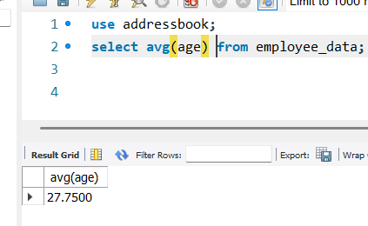
- How would you calculate the total of years of service the employees of Bignet have in the company?
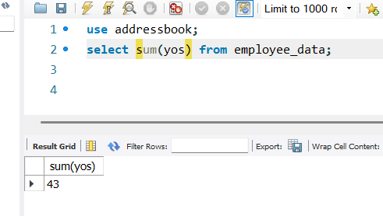
- Calculate the sum of salaries and the average of employees who hold “Programmer” title.
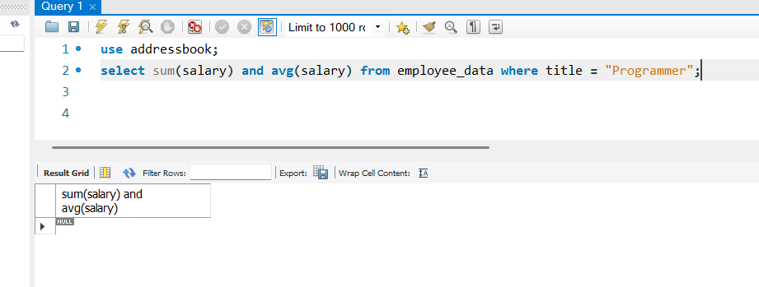

- What do you understand from the following statement?
Select (SUM(perks) / SUM(salary) * 100) from employee_data;
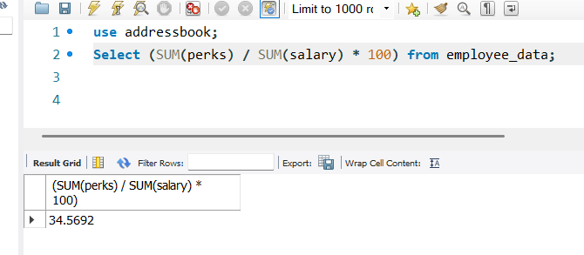
The statement gets the sum of all employees perks and the sum of all employees salaries and divides both then multiplies the result with 100.

