Exercise #11:
- Count the number of employees who have been with Bignet for four or more years.
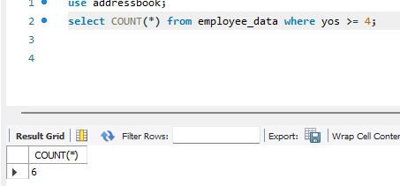

- Count employees based on their ages.
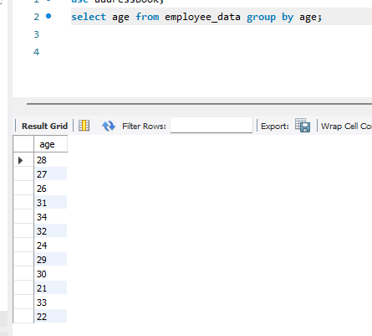

- Modify the above so that the ages are listed in a descending order.
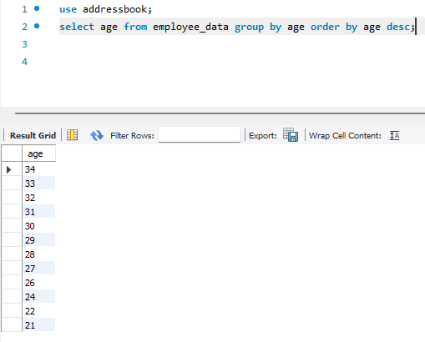
- Find the average age of employees in different departments(titles).
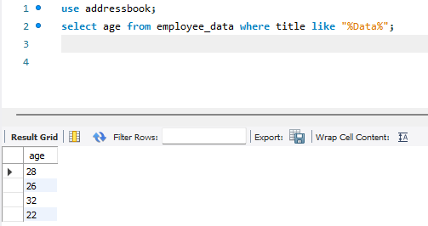
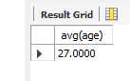
There is 4 in Data department with an average age of 27.
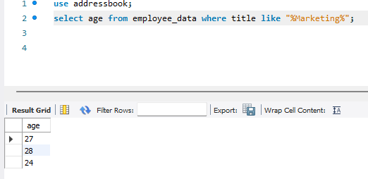
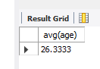
There is 3 in Marketing department with an average age of 26.

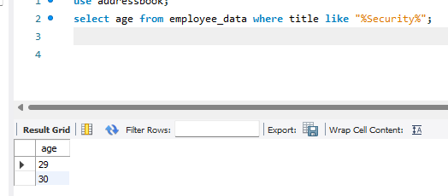
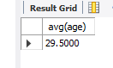
There is 2 in Security with an average age of 29.
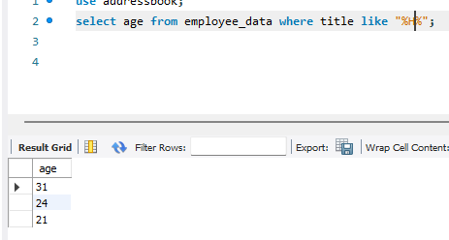
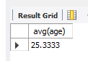
And there is 3 in HR/HE department with an average age of 25.
- Change the above statement so that the data is displayed in a descending order of average ages.
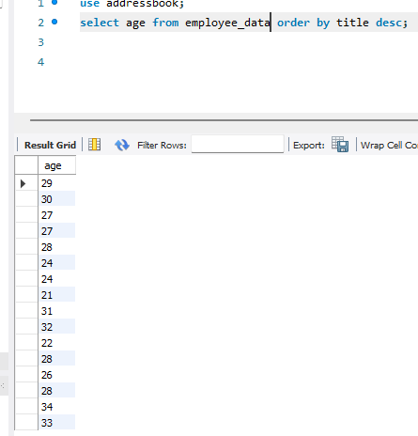
- Find and list the percentage perk (perk/salary * 100) for each employee with the % perks sorted in a descending order.
