Exercise #13:
- Which command displays the MySQL version?
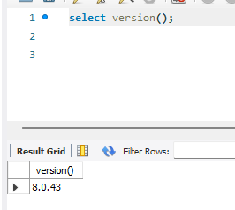
- Use the SELECT command to evaluate 4 X 4 X 4 and name the column Cube of 4.
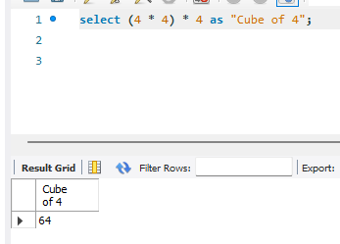
- Display your name with SELECT.
