Exercise #17
- Find and list the ids and spouse names of all employees who are married.
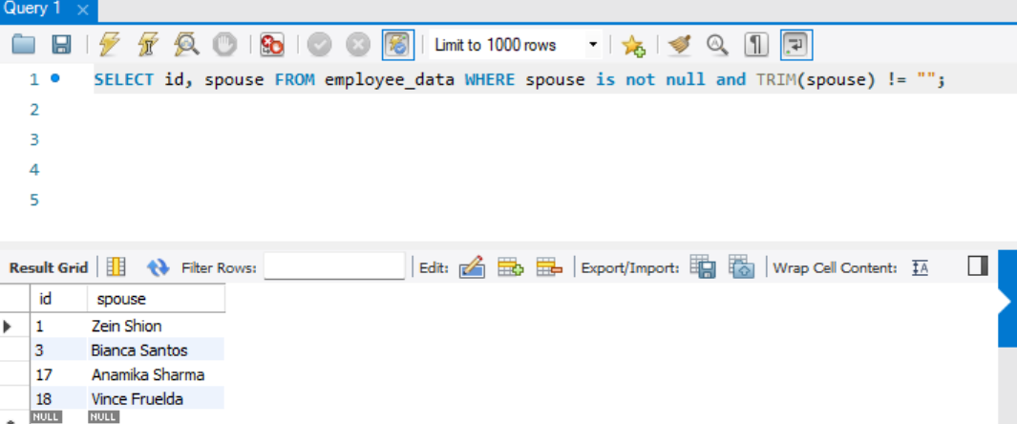
- Change the above so that the display is sorted on spouse names.
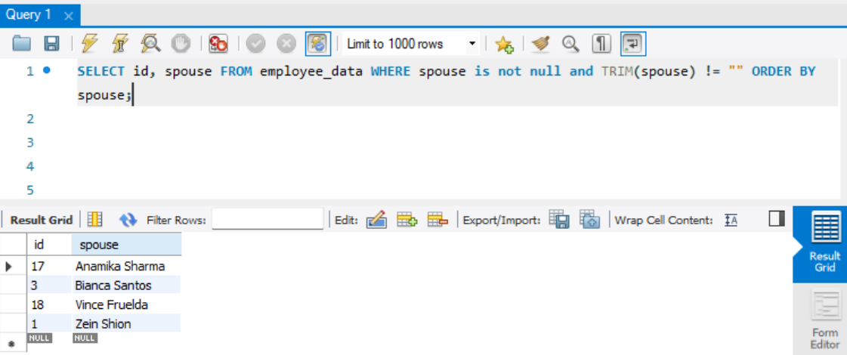
- How many employees do we have under each(male and female)
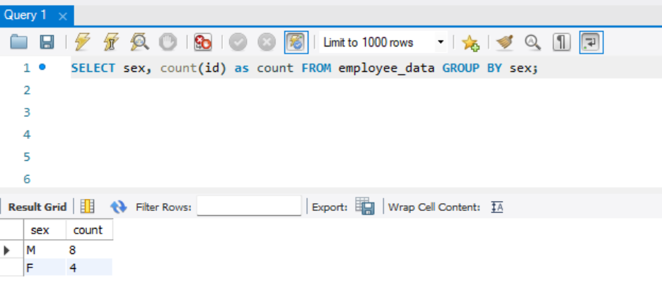

- How many of our employees are married and unmarried.
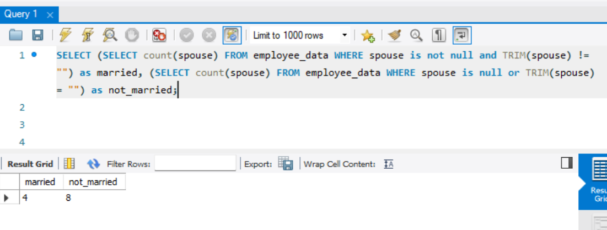
- Find the total number of children.
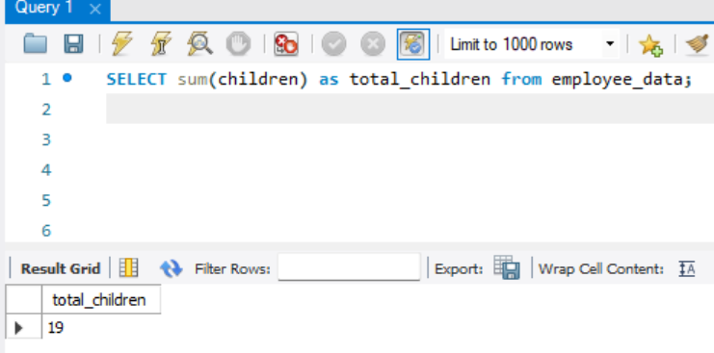
- Make unique groups of children and find the number in each group. Sort the display with the group having maximum children, at the top.
