Exercise #1:
- Write the complete SQL statement for creating a new database called addressbook.
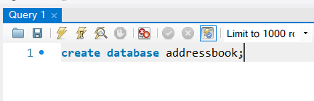

- Which statement is used to list the information about a table? How do you use this statement?
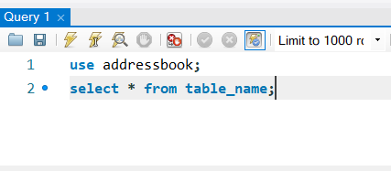
To list the information about a table we use the SELECT statement.
Others would change how the SELECT statement would list information from the table by changing the ‘*’ with a column name from the table.

- How would list all the databases available on the system?
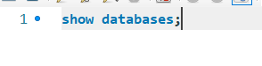
By using the SHOW statement to show all the available databases.
- Write the statement for inserting the following data in employee data table:
First name: Rudolf
Last name: Reindeer
Title: Business Analyst
Age: 34
Years of Service: 2
Salary: 95000
Perks: 17000
Email: rudolf@bugnet.com
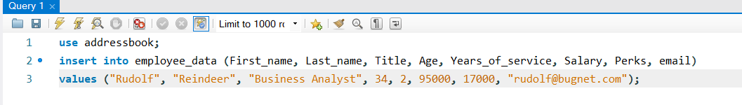

- Give two forms of the SELECT statement that will list all the data in employee_data table.
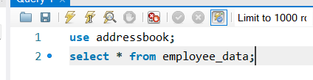
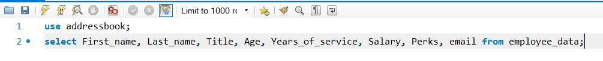

- What will select f_name,email from employee_data display;
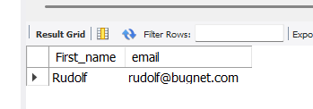

- Write the statement for listing data from salary,perks, and yos columns of employee_data table.
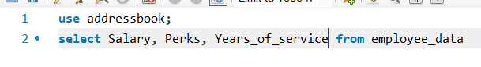
- How can you find the number of rows in a table using SELECT statement?
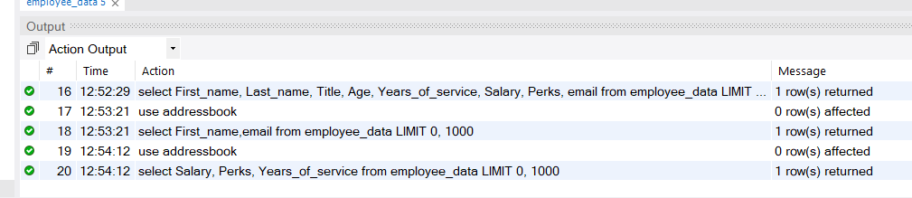
In the Action Output Section in the Message column.
- What will select salary, l_name, from employee_data display?
