Exercise #2:
- Write the SELECT statement to extract the ids of employees who are more than 30 years of age.
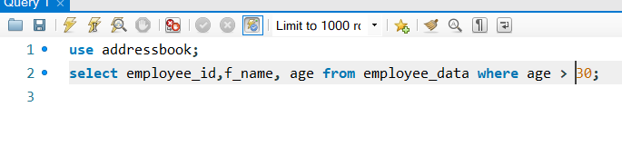
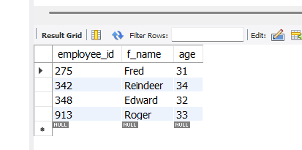
- Write the SELECT statement to extract the first and last name of all web designers.
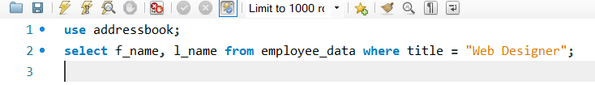
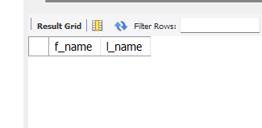
When I made the table I didn’t add any web designers to any of the employees so nothing will show when I run the statement.

- What will the following SELECT statement display:
SELECT * from employee_data where salary <= 100000;
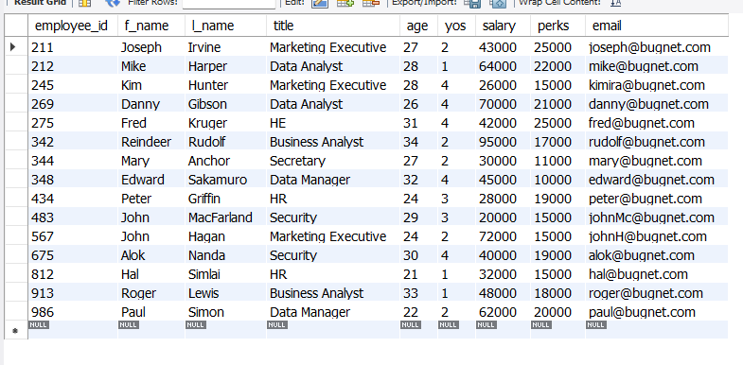
Every employee with a salary less than or equal to 100k will be displayed.

- How will you display the salaries and perks for employees who have more than $16000 as perks?
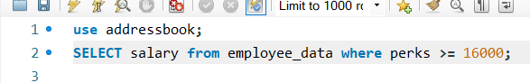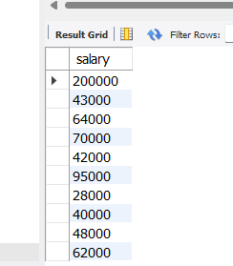
- List all employees names (last name followed by first name) who hold the title of Marketing Executive.
