Exercise #3:
- List all employees whose last name begin with p.
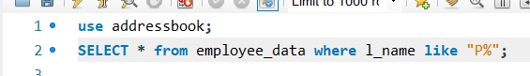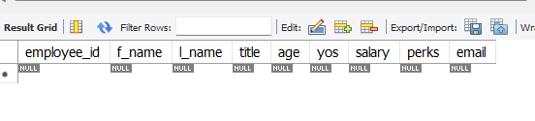
- Display all names of all employees in the marketing division
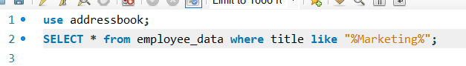
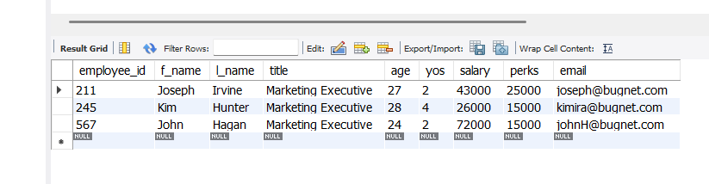
- What will the following statement display:
SELECT f_name, l_name, salary from employee_data where f_name like ‘%k%’;
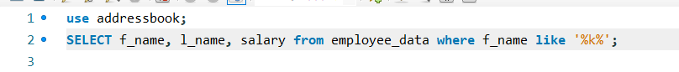
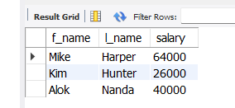
The statement displays all employees that contain the letter “k”.

- List the last names and titles of all programmers.
