Exercise #4:
- List the first and last names of all employees who draw less than or equal to $90000.
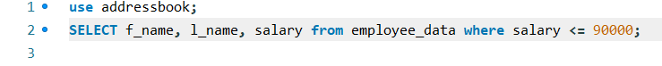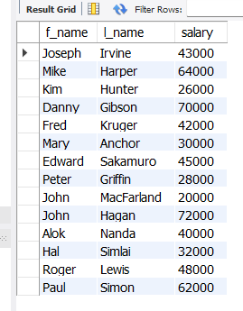

- What is displayed by the following statement?
SELECT l_name, f_name from employee_data where title NOT LIKE ‘%marketing%’
AND age < 30;
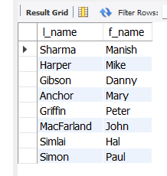

- List all ids and names of all employees between 32 and 40 years of age.
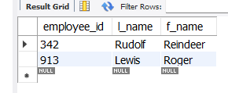
- Select names of all employees who are 32 years of age and are not programmers.

