Exercise #6:
- Order all employees on the basis of the salary they draw.
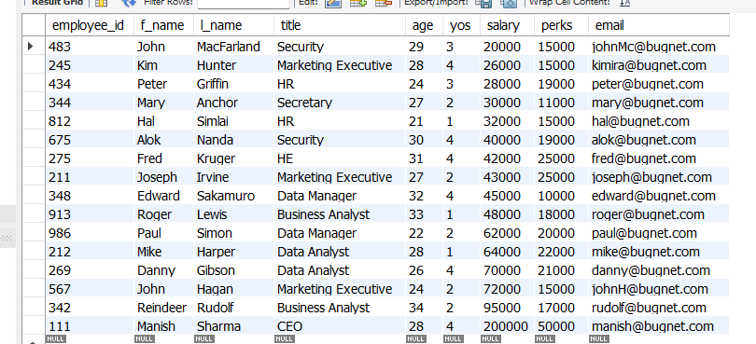
- List all employees in descending order of their years of service.
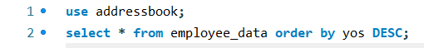
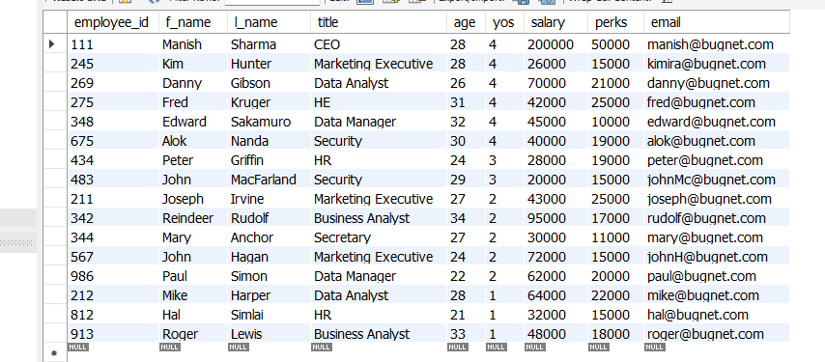

- What does the following statement display?
SELECT emp_id, l_name, title, age from employee_data ORDER BY title DESC, age DESC
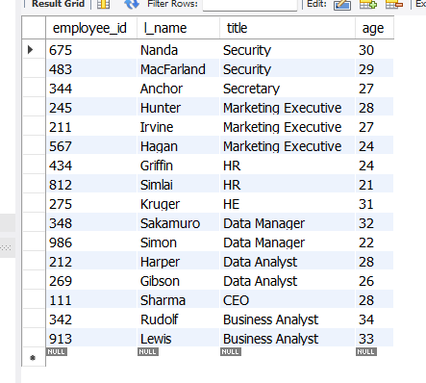

The statement displays the employees first and last name with their employee ids in descending order by their age.

- Display employees (last names followed by first names) who hold the title of either “Programmer” or “Web Designer” and sort their last names alphabetically.
