Exercise #7:
- List names of 5 youngest employees in the company.
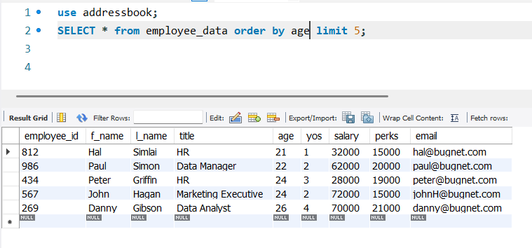
- Extract the next 5 entries starting with the 10 row.
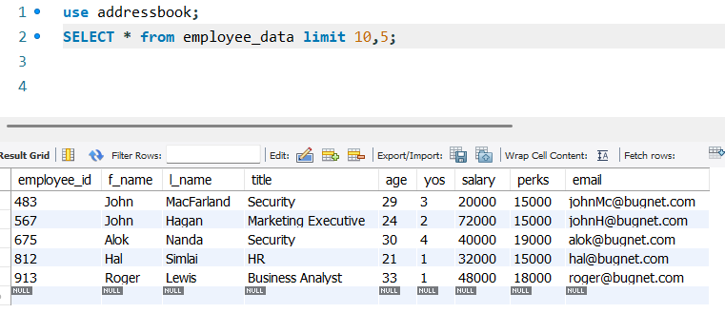
- Display the names and salary of the employee who draws the largest salary.
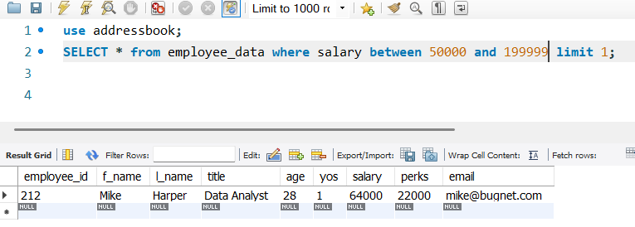
I made the condition to be lower than the CEO which is 200k and limit it to 1 employee.
- What does the following statement display?
SELECT emp_id, age, perks from employee_data ORDER BY perks DESC LIMIT 10;
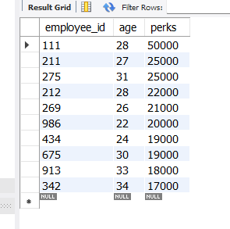
The statement displays the employees ids, age, and perks which are in descending order from their perks and is limited to 10 employees.

