Exercise #8:
- How many unique salary packages does our company, Bignet, offer? List them in descending order?
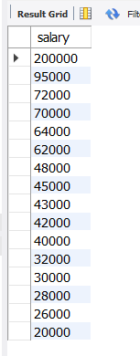
There are 16.
- How many distinct first names do we have in our database?
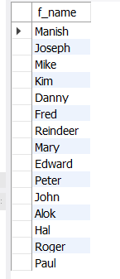
There are 15.

