Exercise #9:
- List the minimum perks package.
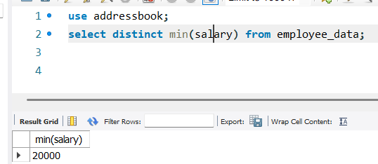
- List the maximum salary given to a “Programmer”.
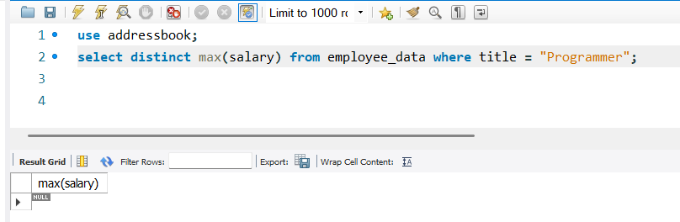
- Display the age of the oldest “Marketing Executive”
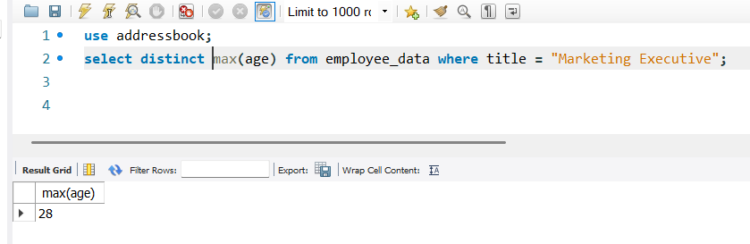
- (Tricky!) Find the first and last names of the oldest employee.
