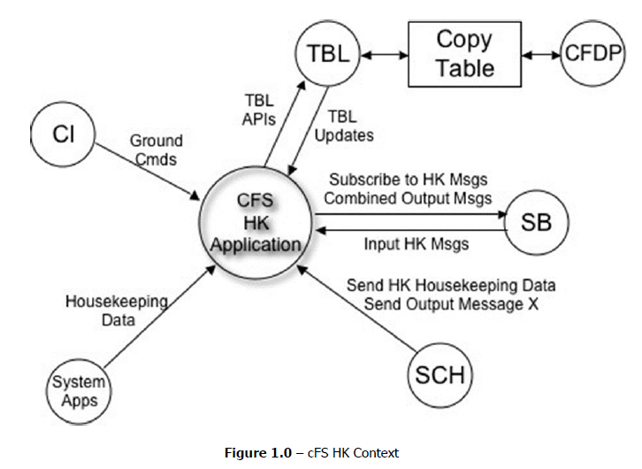

负责接收其他app的遥测信息，然后统一整和成一个，再通过消息总线发送出去，（TO订阅这个消息，从总线取数据，然后下发）

目的是减小发送的带宽

运行假设

A scheduler or similar application will send out a housekeeping request at a periodic rate.

• A scheduler or similar application will send commands to inform HK to send the output messages.

• cFE API’s are available for use.

• OSAL API’s are available for use.

• Housekeeping is not responsible for uploading or downloading files. Files generated by or loaded for Housekeeping are transferred using a file transfer application such as CFDP.