Business Plan
Business Name: Quest AI
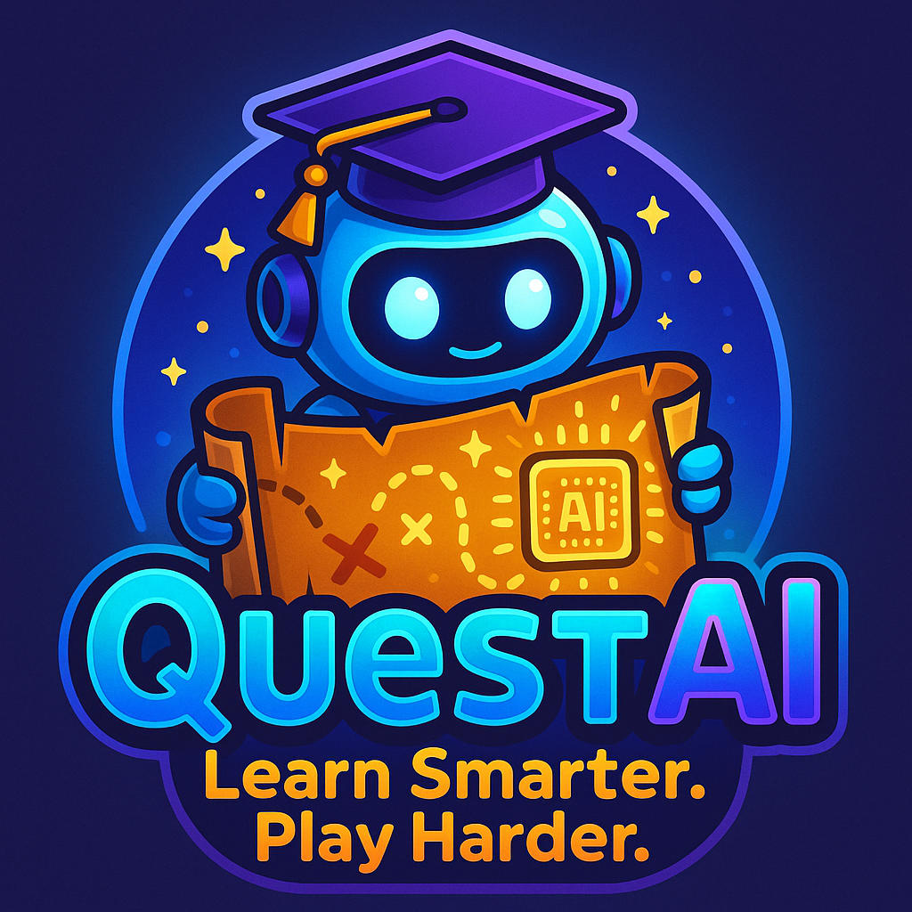
Business Mission:
To make learning more effective and enjoyable for students by turning education into a fun, AI-powered adventure
Business Description:
QuestAI is a fun, gamified learning app designed and created to help students learn more effectively and efficiently with the same personalisation as a personal teacher. It uses artificial intelligence to personalise lessons and study questions based on each student’s strengths and weaknesses and their question history, making the learning experience feel like an adventure. Students complete quests and can earn points, unlock levels, and receive rewards and prizes as they progress through the curriculum. QuestAI is made and designed for primary and high-school students who enjoy interactive, game-style learning and need that extra motivation to stay engaged. By combining adaptive AI technology with fun challenges, QuestAI makes studying way easier, more enjoyable, and way more effective.

Product Description:

Goods/Services and Key Features
QuestAI provides an learning app that helps students study through fun, game-styled activities. The app includes personalised lessons, practice questions, quizzes, and AI-generated feedback based on each student’s learning level that is analysed by the AI. Key features include a points and level-up system that is also connected to a world leaderboard, daily quests, streak rewards, progress tracking, and a personalised study path that updates automatically after each question based on the student’s results and question history.

Product Differentiation (How QuestAI is Different)
QuestAI is different from other learning apps because it uses real-time adaptive AI to personalise every lesson and question automatically. Other apps normally use fixed levels, generic worksheets, or the same questions for every student. QuestAI adjusts difficulty instantly, just like a real teacher would and can generate unique Questions based on the students needs.
Another difference is the strong gamification system — points, levels, badges, and mini-quests — which keeps students motivated to help them stay engaged longer.
References (for differentiation):
- Duolingo uses gamification to increase learning motivation (Duolingo Research).
- Khan Academy uses adaptive practice but does not include game quests or rewards (Khan Academy, 2024).
These show that existing tools focus on skills or practice but do not combine both AI adaptiveness and full gamified learning like QuestAI.

Benefits:
QuestAI gives students a fun, engaging way to study while improving their learning outcomes.
Key benefits include:
- More engagement: Students stay focused because learning feels like playing a game.
- Personalised learning: The AI gives questions based on what the student knows or struggles with.
- Confidence boost: Completing quests and levelling up builds motivation and confidence.
- Efficient study: Students learn faster because the app targets weak areas immediately.
- Progress tracking: Students, parents, and teachers can see improvements through dashboards.
ADD IMAGES ADD IMAGES ADD IMAGES ADD IMAGES ADD IMAGES ADD IMAGES

Entrepreneurship:
Improving Productivity
QuestAI improves business productivity by using automated systems to reduce workload, save time, and streamline operations. The AI automatically generates questions, updates difficulty levels, and manages large amounts of student data without needing manual input. This reduces the time developers and staff spend on updating content or creating new worksheets. The business also improves productivity by using cloud servers to handle most processing, which lowers hardware costs and reduces maintenance time. Automated reporting tools help the team track bugs, performance, and user activity efficiently.
Real-world examples (References):
• Duolingo increases productivity by using streaks and XP to keep learners active for longer (Duolingo Research, 2023).
• Google Classroom improves productivity through automation, auto-marking quizzes, and personalised recommendations (Google for Education, 2024).
Managing the Workforce
QuestAI operates with a small, organised team where each member manages a specific part of the business. Developers focus on creating and updating the learning app, designers handle the visual layout, and support staff assist students, parents, and schools with any issues. Clear roles and responsibilities help the business run smoothly. To improve communication and keep tasks on schedule, the team uses digital tools such as Trello and Slack to plan projects, assign tasks, and track progress.

Real-world examples (References):
• Canva uses collaborative platforms such as Slack and Trello to keep their teams coordinated and productive (Canva Business Blog, 2024).
• Khan Academy operates with specialised teams that manage different parts of the platform to ensure updates and improvements happen consistently (Khan Academy Annual Report, 2023).

Marketing
QuestAI is aimed at:
• Primary students (ages 8–12)
• High-school students (ages 13–18)
• Students who enjoy game-style learning
• Learners who need more motivation to study
• Parents seeking modern educational tools
• Schools wanting digital learning options

Demographics:
• Location: Australia (with possible global expansion)
• Income: Middle-income families that can afford learning apps
• Requirements: A phone, tablet, or computer with internet access

Two Main Factors Influencing Decisions
Personalised Learning:
Students and parents prefer learning tools that adapt to the student’s level and offer feedback that makes studying easier.

Gamification & Rewards:
Points, levels, streaks, and leaderboards encourage students to keep studying by making learning fun.

Relationship Between the Factors:
The two factors work together—personalised content helps students improve, and gamification keeps them motivated to continue. Without both, the learning experience becomes less effective.

Short-Term Effects:
• Higher engagement
• Faster improvement in weak subjects
• More motivation from rewards
• More consistent study habits

Long-Term Effects:
• Better academic results
• Stronger study habits
• Improved confidence
• Clearer progress tracking for parents and teachers

Market Research

Competitors:
• Duolingo – Great gamification but limited to language learning
• Khan Academy – Strong lessons but not focused on game-style learning
• Mathletics – Curriculum-based but less adaptive
• Quizlet – Good revision tools but no quest or reward system

Gap in the Market:
There is no major platform combining:
• Adaptive learning
• Gamification
• Curriculum-based lessons
• A fun, adventure-style learning experience

Current Trends:
• Gamified learning is becoming more popular in schools (EdTech Magazine, 2024).
• Personalised digital learning tools are in increasing demand (Education Review Australia, 2023).
• Schools are using more digital tools after COVID (ABS Education Data, 2024).

SWOT Analysis
Strengths:
• Adapts learning to each student
• Highly engaging through quests and rewards
• Works for a wide age range
• Covers multiple school subjects
• Works on most devices
• Tracks student progress clearly
• Has a unique combination of learning features

Weaknesses:
• Requires internet for full features
• Some students may be distracted by game elements
• Development and updates are costly
• No existing user base
• Might face strong competition

Opportunities:
• Growing demand for digital learning tools
• Partnerships with schools and tutors
• Expansion into more subjects and year levels
• Large global market for ed-tech
• New features such as multiplayer quests

Threats:
• Strong competitors
• Fast-changing technology
• Data privacy risks
• Some parents or teachers may prefer simple learning tools
• School budgets may limit purchases

Should QuestAI Have an Online Presence?
Yes, QuestAI must have an online presence to work properly and reach students. The learning system needs online access for updates, progress syncing, and cloud-based features.

Reasons:
• The platform relies on online processing
• Student progress updates instantly
• Teachers and parents can check progress from anywhere
• Competitors already operate online
• Online access makes updates and new features easier to deliver

Conclusion:
QuestAI needs an online presence to stay competitive, accessible, and functional while also supporting long-term business growth.

Managing the Workforce
QuestAI operates with a small, organised team where each member manages a specific part of the business. Developers focus on creating and updating the learning app, designers handle the visual layout, and support staff assist students, parents, and schools with any issues. Clear roles and responsibilities help the business run smoothly. To improve communication and keep tasks on schedule, the team uses digital tools such as Trello and Slack to plan projects, assign tasks, and track progress.

Real-world examples (References):
• Canva uses collaborative platforms such as Slack and Trello to keep their teams coordinated and productive (Canva Business Blog, 2024).
• Khan Academy operates with specialised teams that manage different parts of the platform to ensure updates and improvements happen consistently (Khan Academy Annual Report, 2023).

Marketing
QuestAI is aimed at:
• Primary students (ages 8–12)
• High-school students (ages 13–18)
• Students who enjoy game-style learning
• Learners who need more motivation to study
• Parents seeking modern educational tools
• Schools wanting digital learning options

Demographics:
• Location: Australia (with possible global expansion)
• Income: Middle-income families that can afford learning apps
• Requirements: A phone, tablet, or computer with internet access

Two Main Factors Influencing Decisions
Personalised Learning:
Students and parents prefer learning tools that adapt to the student’s level and offer feedback that makes studying easier.

Gamification & Rewards:
Points, levels, streaks, and leaderboards encourage students to keep studying by making learning fun.

Relationship Between the Factors:
The two factors work together—personalised content helps students improve, and gamification keeps them motivated to continue. Without both, the learning experience becomes less effective.

Short-Term Effects:
• Higher engagement
• Faster improvement in weak subjects
• More motivation from rewards
• More consistent study habits

Long-Term Effects:
• Better academic results
• Stronger study habits
• Improved confidence
• Clearer progress tracking for parents and teachers

Market Research

Competitors:
• Duolingo – Great gamification but limited to language learning
• Khan Academy – Strong lessons but not focused on game-style learning
• Mathletics – Curriculum-based but less adaptive
• Quizlet – Good revision tools but no quest or reward system

Gap in the Market:
There is no major platform combining:
• Adaptive learning
• Gamification
• Curriculum-based lessons
• A fun, adventure-style learning experience

Current Trends:
• Gamified learning is becoming more popular in schools (EdTech Magazine, 2024).
• Personalised digital learning tools are in increasing demand (Education Review Australia, 2023).
• Schools are using more digital tools after COVID (ABS Education Data, 2024).

SWOT Analysis
Strengths:
• Adapts learning to each student
• Highly engaging through quests and rewards
• Works for a wide age range
• Covers multiple school subjects
• Works on most devices
• Tracks student progress clearly
• Has a unique combination of learning features

Weaknesses:
• Requires internet for full features
• Some students may be distracted by game elements
• Development and updates are costly
• No existing user base
• Might face strong competition

Opportunities:
• Growing demand for digital learning tools
• Partnerships with schools and tutors
• Expansion into more subjects and year levels
• Large global market for ed-tech
• New features such as multiplayer quests

Threats:
• Strong competitors
• Fast-changing technology
• Data privacy risks
• Some parents or teachers may prefer simple learning tools
• School budgets may limit purchases

Should QuestAI Have an Online Presence?
Yes, QuestAI must have an online presence to work properly and reach students. The learning system needs online access for updates, progress syncing, and cloud-based features.

Reasons:
• The platform relies on online processing
• Student progress updates instantly
• Teachers and parents can check progress from anywhere
• Competitors already operate online
• Online access makes updates and new features easier to deliver

Conclusion:
QuestAI needs an online presence to stay competitive, accessible, and functional while also supporting long-term business growth.

