D.Y. Patil College of Engineering &
Technology, Kolhapur


Department of Computer Science & Engineering

Class: T. Y (A, B) (Sem.-V)
Lab Manual
Name of the Subject
Advanced Java Technologies
2025-2026

D. Y. Patil College of Engineering & Technology, Kolhapur

Department of Computer Science & Engineering

Name of the Course – Advanced Java Technology

Class – T.Y (CSE) (Div. A, B) Semester-V

Practical -2 Hrs/Week Year: 2025-26

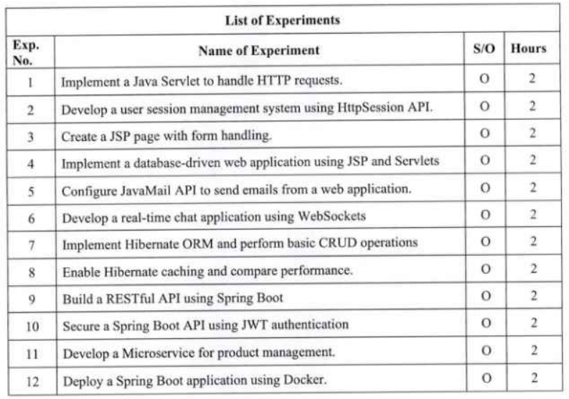
Prepared by: Checked by: Verified by: Approved by:

Course Module Program HOD CSE

Coordinator Coordinator Coordinator
ExperimentNo.1

Aim:

Implement a Java Servlet to handle HTTP Request.

Theory:
Java Servlet is a Java program that runs on a Java-enabled web server or application server. It handles client requests, processes them and generates responses dynamically. Servlets are the backbone of many server-side Java applications due to their efficiency and scalability.

Key Features:
- Servlets work on the server side.
- Servlets are capable of handling complex requests obtained from the web server.
- Generate dynamic responses efficiently.

Prerequisites

- Install JDK (Java Development Kit)
- Install Apache Tomcat server (e.g., version 9 or 10)
- Install an IDE like Eclipse or IntelliJ IDEA
- Download the Servlet API JAR (already included in Tomcat)

Creating Servlet in MyEclipse

Step 1: Create a Dynamic Web Project

Open MyEclipse, in the top menu, go to File -> New -> Web

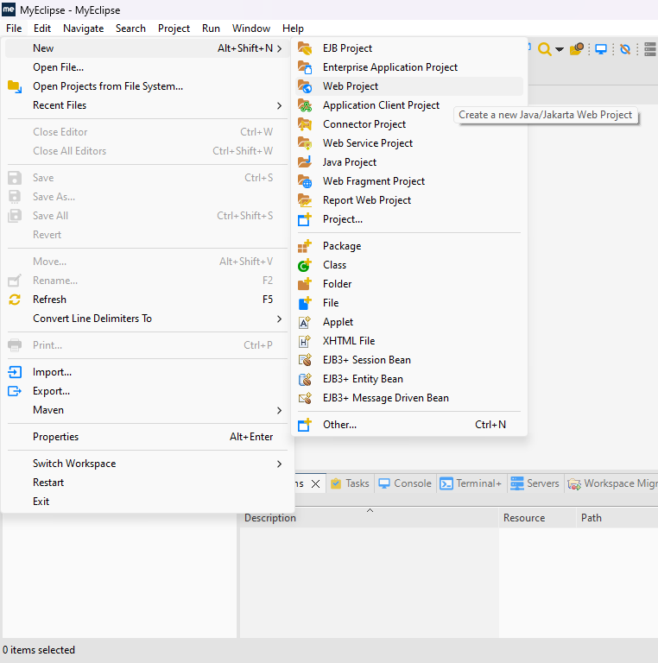

- After Clicking on Web Project, a new dialog box will be opened like the below image.
- Enter the project name.
- Configure the Java EE version, Java version and JSTL version by clicking the dropdown menu.
- If you need to change the runtime of the project you can do that by selecting the target runtime.
- In case you need to add a new runtime within MyEclipse you can click the Add New Runtime Button.
- After entering all the details, click on next.

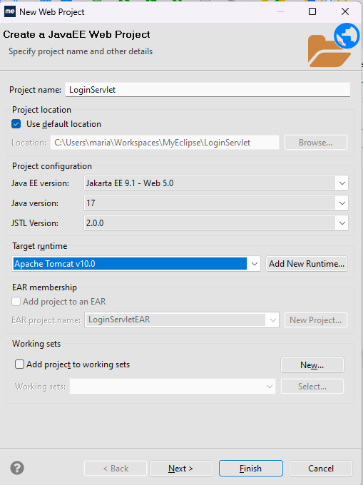

- After that another content will be displayed with sources folder on build path and the classes folder, leave as it is like the below image and click next.

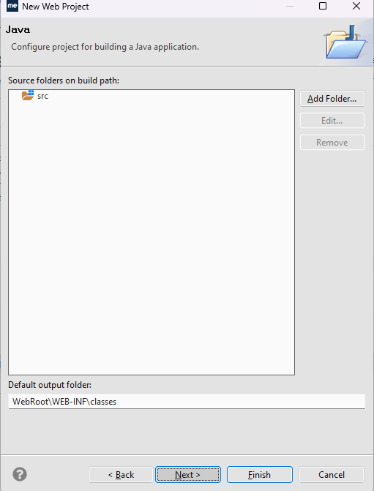

- After that, a dialog box will be asking you for context root and directory, you can leave that default.
- Click the checkbox with text as Generate web.xml Deployment Descriptor, if you want to use the web.xml to configure the servlets and servlets mapping, this basically lets the servlet container to know which servlet to call for the url pattern entered.
- We can also configure the servlet and servlets mapping using the @WebServlet() annotation
- For demonstration purpose we have chosen the generate web.xml file, but it will be much easier to work with annotation based configuration than the xml based configuration, so we will use the annotation based configuration to make it simple.

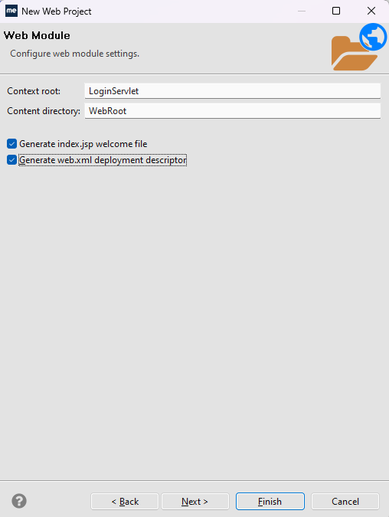

Step 2: Create Servlet Class

- Now, click on the Java Resources in the project tree of your project.
- Right Click on the src/main/java folder and go to New -> Servlet.

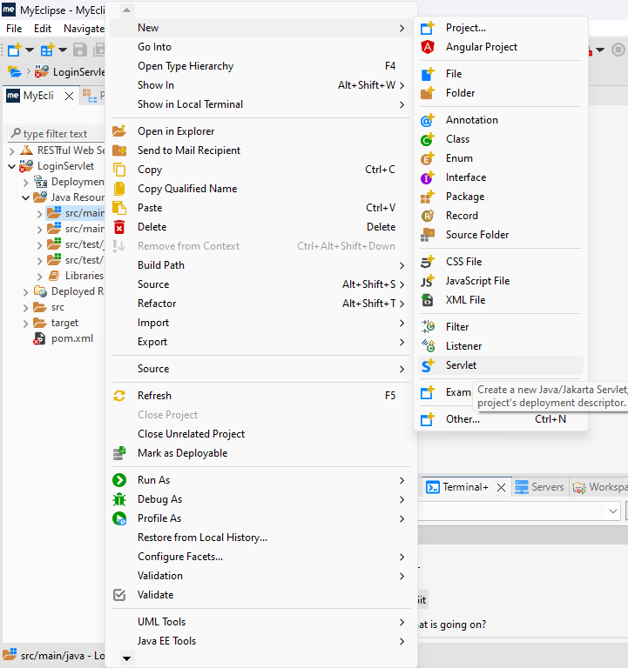
- Now, a new dialog window will be opened
- Enter the package details, its always advisable to use good packaging style like controllers for controlling the app, repository for dealing with database.
- So, for this basic demo, we have used a sample package name.
- Enter the servlet name under the package.
- Every servlet we are creating has to be a subclass of jakarta.servlet.http.HttpServlet superclass.
- Note: javax is being used instead of jakarta in the older versions Java EE, so just replace jakarta to javax, if you are working with older Java EE versions.
- Click On Next.

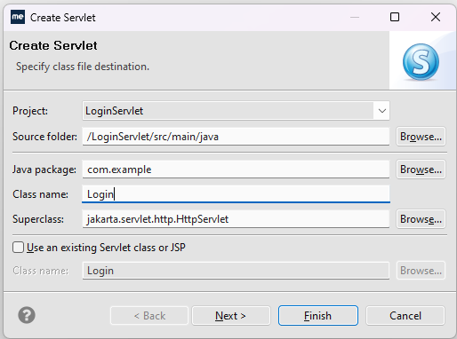

- After that, you will be provided with a window to enter the servlet description.
- You can add any other URL patterns for the servlet here, I'm leaving it as default here.
- Click on next.

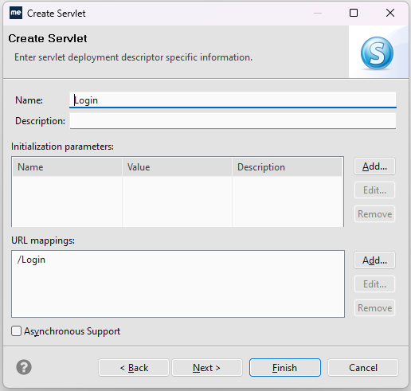

- Now, you have to configure the HTTP methods that you are going to use in the servlet.
- So that MyEclipse IDE can provide you with boilderplate code for that method implementation.
- Each method will be coming from the abstract class jakarta.servlet.http.HttpServlet.
- We have to implement those methods based on our usecase, check only the methods that you are going to implement in your project.
- If you want to accept a HTTP GET request with your servlet then, the method you have to implement is,
  - doGet() method
- Like this, every HTTP method has its own methods based on the HTTP verb.
  - doPost() method for HTTP POST
  - doPut() method for HTTP PUT
  - doDelete() method for HTTP DELETE
- Some other methods also available like init() for initializing and destroy() to execute those methods based on the Servlet Lifecycle.
- Click on finish to create the servlet.

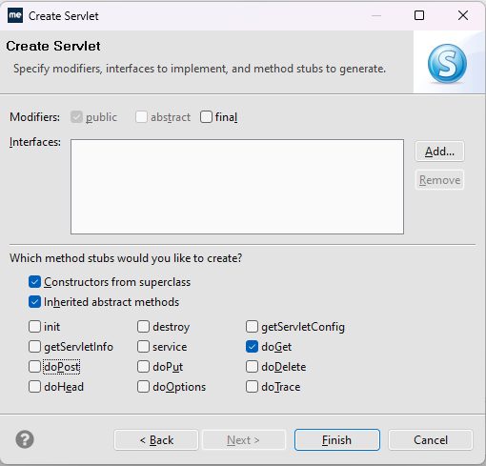
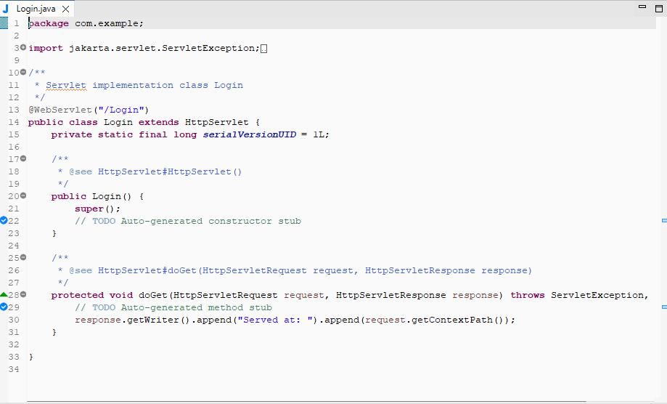

Step 3: Defining the servlet logic.
- The servlet creation is over, now we have to configure the welcome page of our application to display a welcome page.
- The welcome page will get a username and password through input tags and send it to the servlet using a get request.
- Open the default index.html which can be found in the path: src -> main -> webapp -> index.html
- Add the below html content to the index.html to define the login page.

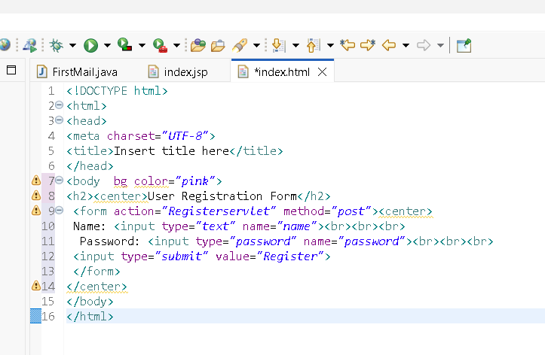

- Now open the Servlet file you have just created.
- Add the code that gets the username and password from the url parameter and displays it in the page using servlet.
- So, we have done with our code implementation and used a index.html page to display the login form.
- Through the HTMLpage we have called our servlet using the given url mapping to the Login Servlet.

Step 4: Running our project.

- To run the project, right click on the project.
- Go to Run as -> MyEclipse Server Application
- Once you clicked the run button, you could see some logs in the console tab in MyEclipse IDE from the tomcat server.
- If you done installed and configured the server correctly in MyEclipse IDE, your project will be published to the Tomcat server without any errors.

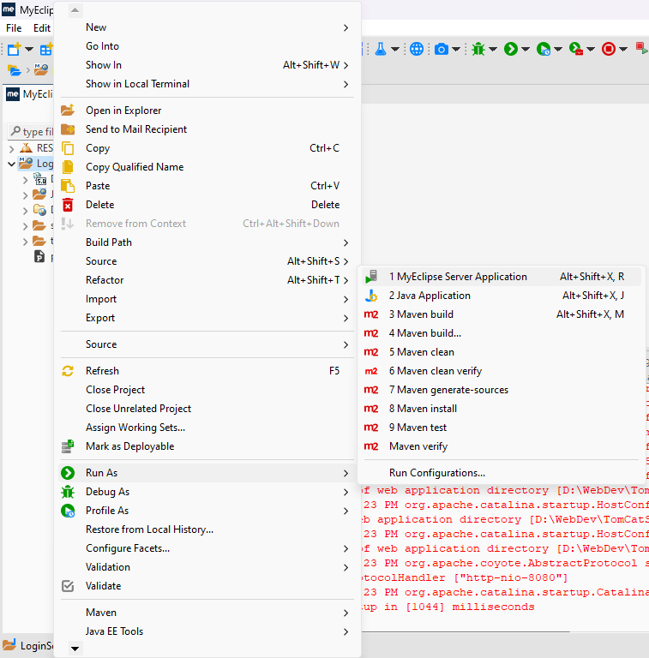

Output

- Once you run the project, it will be running in the tomcat server, it may open a tab in your default browser automatically.
- If not use the below format to see your project running.
- URL format : http://localhost:8080/project_name/servlet_url_mapping
- So here, the project name is LoginServlet.
- As we have configured a welcome file using index.html, we can omit the
- servlet_url_mapping to see the welcome file first.

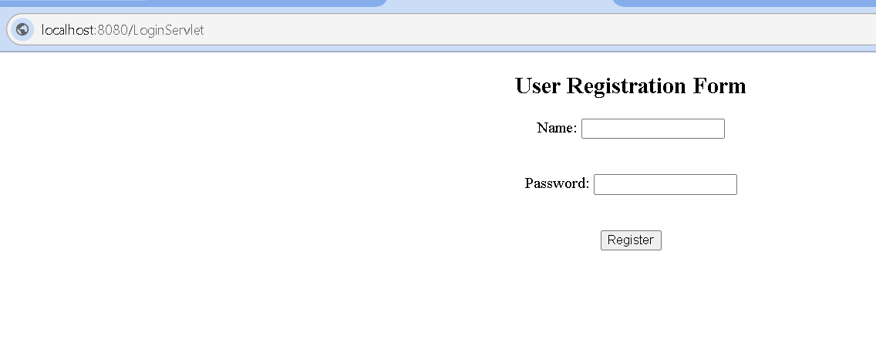

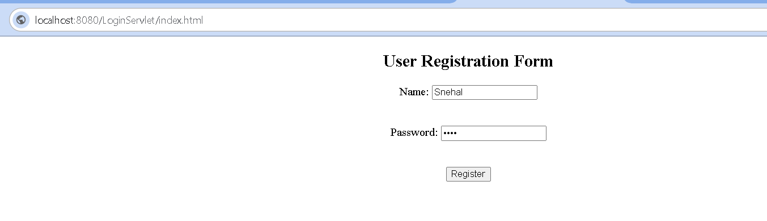

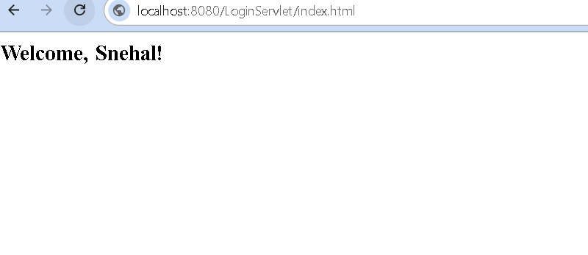
ExperimentNo.2

Aim:

Develop user session management system using HttpSession API.

Objective:

- To understand how to use Servlets for handling form data.
- To demonstrate how HttpSession stores and retrieves user information across multiple requests.
- To develop a multi-step form submission system using Java Servlets.

Theory:

In Java Servlets, HttpSession is an interface that allows you to store user-specific data (like login info, preferences, or shopping cart items) across multiple requests.
Since HTTP is stateless, the server doesn’t remember users between requests. HttpSession solves this by creating a unique session for each user.
Servlets are Java programs that run on a web server and handle client requests (usually from HTML forms).
HTTP is stateless, meaning it does not remember data between requests.
HttpSession is used to store data across multiple requests for a specific user.
With session.setAttribute(key, value) we can store data, and with session.getAttribute(key) we can retrieve it.
In this experiment, we use 3 servlets to handle data from 3 different forms and save all user details in a session.

Software Requirements
- JDK (Java Development Kit) 8 or above
- Apache Tomcat Server (v9.0 or above)
- Eclipse IDE (or any other Java IDE)

Steps To Implement:

- Create a Dynamic Web Project in Eclipse.
- Create 3 HTML forms:
- personal.html → name, age
- contact.html → email, phone
- education.html → degree, university
- Create 3 servlets:
- PersonalServlet → gets data from personal form & stores in session.
- ContactServlet → gets data from contact form & stores in session.
- EducationServlet → gets data from education form, stores in session, and then displays all saved details.
- Deploy the project on Tomcat server.
- Run personal.html and follow the flow → contact.html → education.html.
- Check that all user details are displayed at the end.

Sample Output

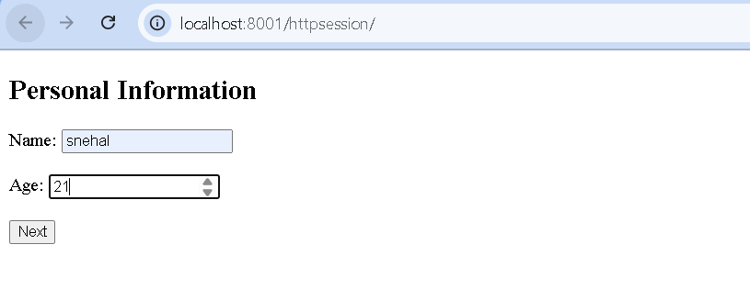
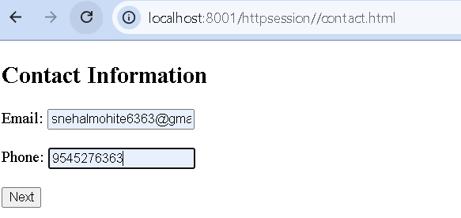

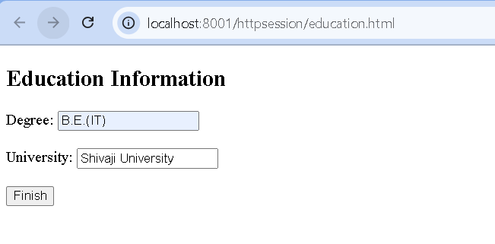
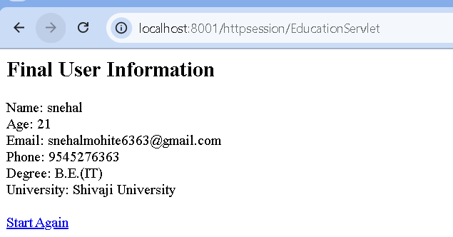
ExperimentNo.3

Aim:

Create JSP page for form handling.

Objective:
To understand how to handle form data in JSP using request implicit object.
To demonstrate how JSP can dynamically generate responses based on user input.
To show conditional rendering using JSP scriptlets.
Theory:
JavaServer Pages (JSP) is a server-side technology that creates dynamic web applications. It allows developers to embed Java code directly into HTML pages and it makes web development more efficient.JSP is an advanced version of Servlets. It provides enhanced capabilities for building scalable and platform-independent web pages.
Prerequisite:
- Install Java JDK (8 or above)
- Install Eclipse IDE (or any IDE with web support)
- Download and configure Apache Tomcat server in Eclipse
Step 1: Create a Dynamic Web Project
- Open Eclipse -> File ->New ->Dynamic Web Project
- Enter project name (e.g., JSPDemo)
- Select Target Runtime (Apache Tomcat)
- Finish setup and Eclipse will generate basic project structure
Step 2: Create a JSP File
- Right-click on WebContent or webapp folder -> New ->JSP File
- Name your file (e.g., hello.jsp)
- Add HTML and Java code (example below):
<!DOCTYPE html>
<html>
<body>
Hello! The time is now <%= new java.util.Date() %>
</body>
</html>
The <%= %> tags enclose a Java expression.

Expression
This tag is used to output any data on the generated page. These data are automatically converted to a string and printed on the output stream.

Syntax:
<%= "Anything" %>

Scriplets
This allows inserting any amount of valid Java code. These codes are placed in the _ jspService() method by the JSP engine.
Syntax:

<%

// Java codes

%>

Directives

A JSP directive starts with <%@ characters. In the directives, we can import packages, define error-handling pages or configure session information for the JSP page.

Syntax:

<%@ directive attribute="value" %>

Declarations
This is used for defining functions and variables to be used in the JSP.
Syntax:
<%!
//java codes
%>

Example:
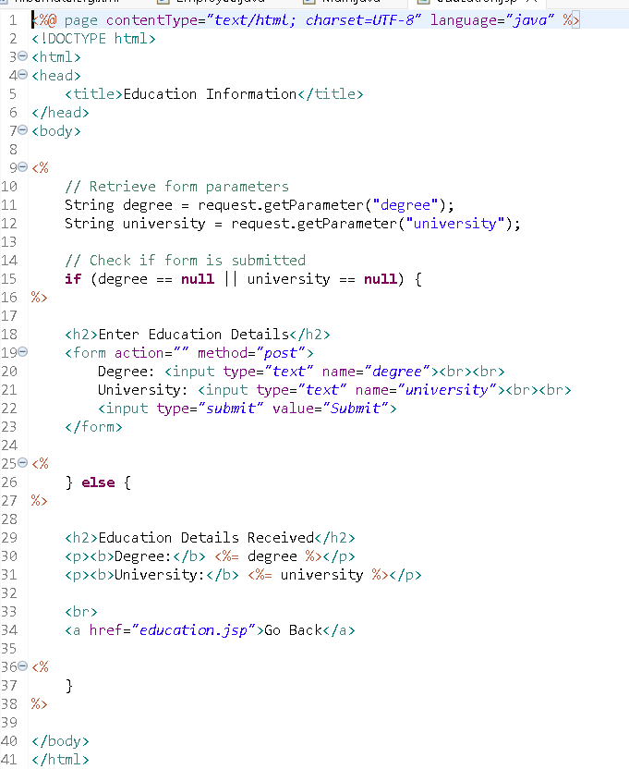
Output:

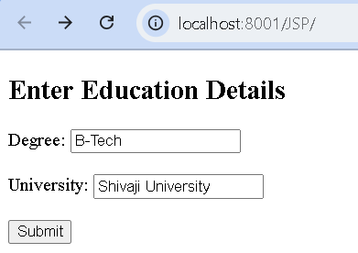

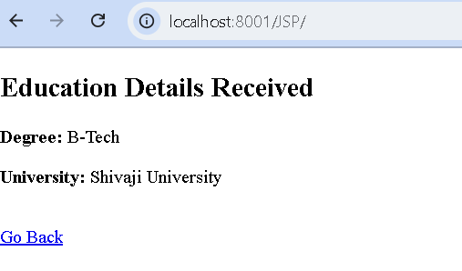

ExperimentNo.4

Aim:
Implement a Database-driven web application using JSP and Servlet.
Objectives:
- To understand the integration of JSP, Servlet, and JDBC.
- To demonstrate database connectivity in a Java web application.
- To perform data insertion and retrieval from a database using JDBC.
Theory:
A database-driven web application is one where dynamic content is generated based on data stored in a database.
In Java EE, Servlets act as controllers handling requests, while JSP pages act as views displaying responses.The connection between Java and a database is achieved using JDBC (Java Database Connectivity) API, which provides classes and interfaces for querying and updating relational databases.
The general workflow:
- User submits data via an JSP form.
- The request is sent to a Servlet.
- The Servlet uses JDBC to insert/retrieve data from a database (e.g., MySQL).
- The Servlet forwards the result to a JSP page for display.
JDBC Interface and Classes:
Class/Interfaces | Description
DriverManager | Manages JDBC drivers and establishes database connections.
Connection | Represents a session with a specific database.
Statement | Used to execute static SQL queries.
PreparedStatement | Precompiled SQL statement, used for dynamic queries with parameters.
CallableStatement | Used to execute stored procedures in the database.
ResultSet | Represents the result set of a query, allowing navigation through the rows.
SQLException | Handles SQL-related exceptions during database operations.
Steps to Establish a JDBC Connection
Step 1: Import the JDBC Package
import java.sql.*;
Step 2: Load or Register the Driver
1.Class.forName(“com.mysql.cj.jdbc.Driver”);
Step 3: Establish a Connection
Connection con = DriverManager.getConnection(url,user,password)
String url = “jdbc:mysql://localhost:3306/testdb”
User=MySql User name
Password=Mysql Password
Step 4: Create a Statement
Statement st = con.createStatement();
Step 5: Execute SQL Query
ResultSet rs = stmt.executeQuery("SELECT * FROM students");
while (rs.next()) {
System.out.println(rs.getString("name"));
}
Step 6: Close the Connections
con.close();
Prerequisites
Database Installed and Running:
- Install a relational database (e.g., PostgreSQL, MySQL).
- Create a database and a user.
JDBC Driver (Connector JAR):
Download the JAR or add Maven dependency
Follow these steps to download MySQL Connector/J:
- Search for MySQL Community Downloads.
- Go to Connector/J.
- Select Platform Independent.
- Download the ZIP Archive
- Extract the ZIP file.
- Locate the JAR file.
mysql-connector-java-8.0.20.jar
Step 1: Create a Database
Log in to MySQL and create a database (e.g., mydb):
Step 2: Create a Table
Create a table in the database
Step 3: Set Up Project Directory
Create a main project folder
- src -> To store Java source files
- lib -> To store the MySQL connector JAR

Step 4: Create JSP Page Register.jsp
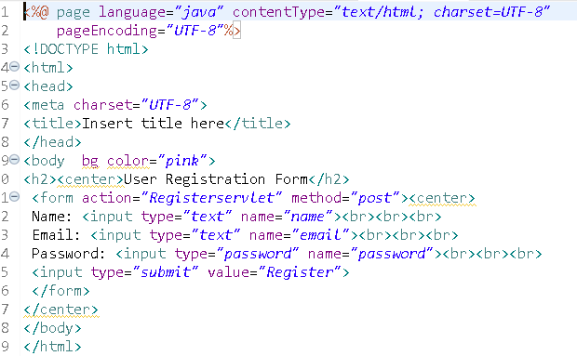
Step 4: Create Servlet Regiterservlet.java
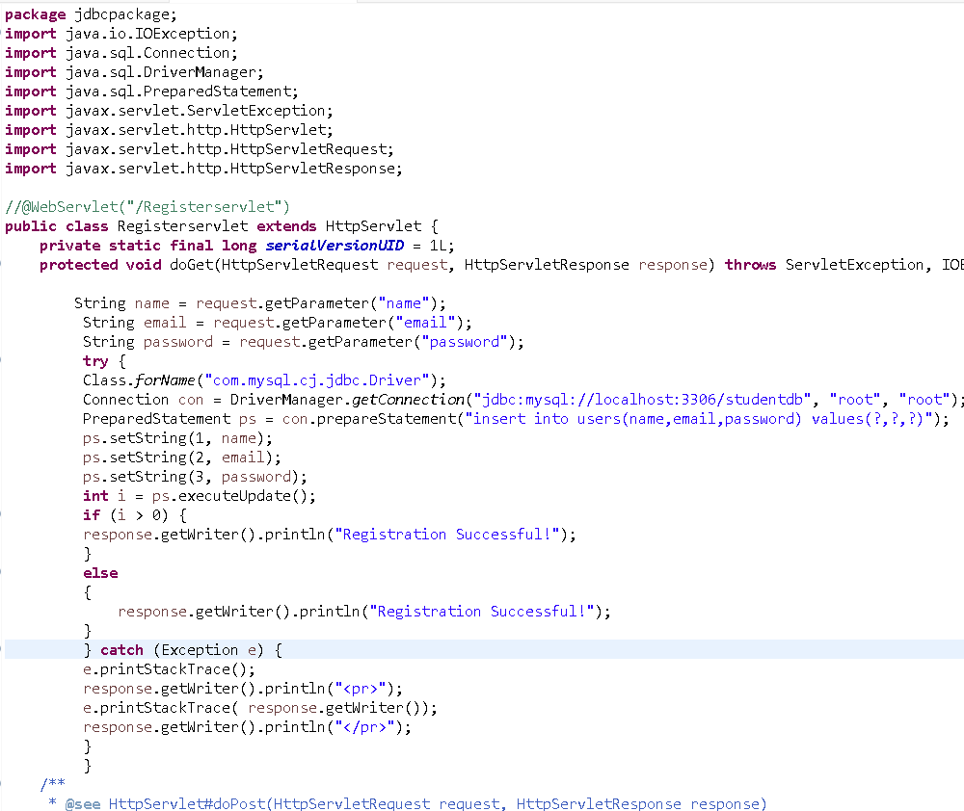
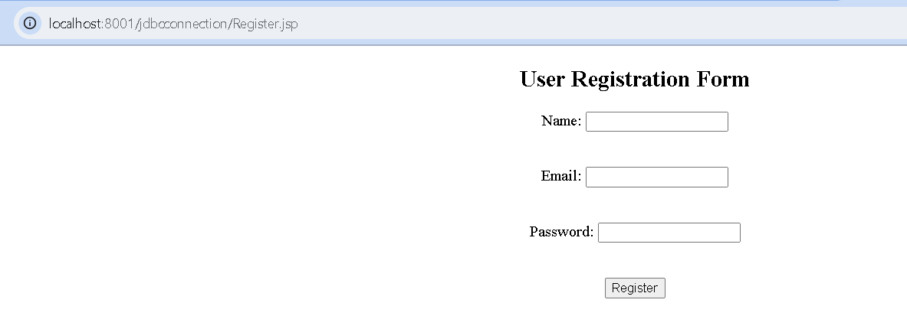
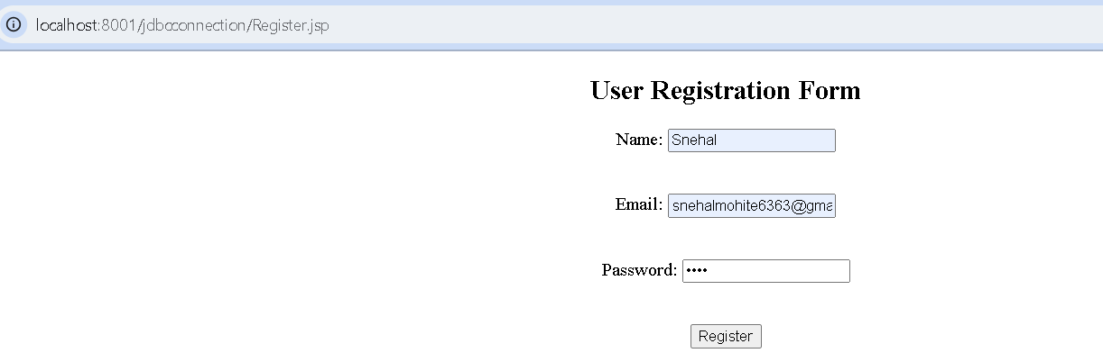
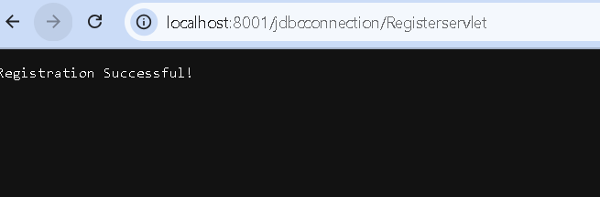

ExperimentNo.5

Aim:
Configure Java Mail API to send email from web application.
Objectives:
To configure and implement the Java Mail API in a web application to enable automated email sending functionality, allowing the application to send notifications, confirmations, or alerts to users directly through SMTP (Simple Mail Transfer Protocol) using Java EE or Jakarta EE components.
Theory
The JavaMail API is a Java library that allows developers to send and receive emails from Java applications. It can be integrated into both standalone and web-based applications.
Key Components:
  - Session: Represents a mail session that holds configuration details like SMTP host, port, and authentication.
  - Message: Represents an email message (subject, sender, recipient, content).
  - Transport: Handles the actual sending of the email via SMTP.
  - Authenticator: Used for authentication when connecting to a mail server.

Working Process:
- The application configures a mail session with SMTP settings.
- It creates a MimeMessage object representing the email content.
- The Transport class sends the email to the specified recipient via the SMTP server.

Common SMTP Servers:
- Gmail: smtp.gmail.com
- Outlook: smtp.office365.com
- Yahoo: smtp.mail.yahoo.com

Required Jar Files:
- javax.mail.jar (or jakarta.mail.jar for newer versions)
- activation.jar (for handling attachments or MIME types, older versions)

Software Requirements
- Operating System: Windows / Linux / macOS
- IDE: Eclipse / NetBeans / IntelliJ IDEA
- Server: Apache Tomcat
- Mail Account: Gmail or any SMTP-enabled email account

Steps to Implement
1 Set up the Project:
- Create a new Dynamic Web Project in Eclipse.
- Add the required JavaMail API and Activation JAR files to the project’s WEB-INF/lib folder.
2 Configure SMTP Settings:
- Use Gmail or another SMTP server.
3. Create a JSP Page

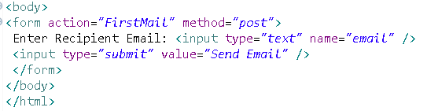
- Create a Servlet
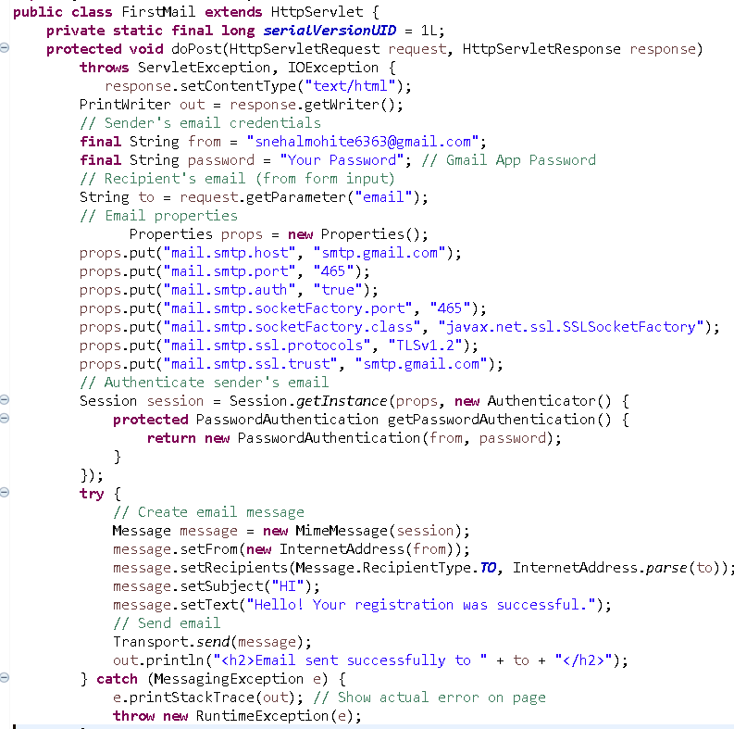

Output:

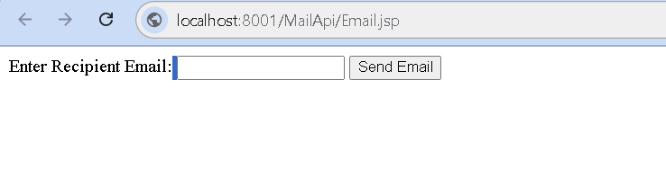
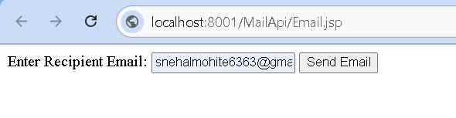

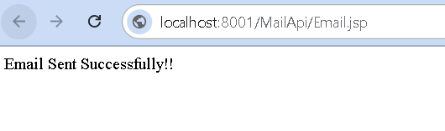

Experiment No.6

Aim:
Develop real time Chat Application using WebSocket.
Objectives:
To design and implement a real-time chat application using WebSockets that enables instant, bi-directional communication between clients and server in a web environment.
The objective is to understand the working of the WebSocket protocol, how to establish a persistent connection, and how to broadcast messages to all connected clients.

Theory:

What is a WebSocket?

A WebSocket is a communication protocol that provides a persistent, full-duplex channel between a client and a server over a single TCP connection.
Unlike HTTP, where the client must poll the server for updates, WebSocket maintain an open connection that allows real-time data exchange without re-establishing the connection.

WebSocket Lifecycle

1.Handshake: The client initiates a WebSocket connection through an HTTP request.
2.Connection Established: The server upgrades the connection to WebSocket protocol.
3.Message Exchange: Both sides can send and receive messages anytime.
4.Connection Closed: Either client or server can close the connection when done.

@ServerEndpoint: Annotation that defines a WebSocket server endpoint.
@OnOpen: Method called when a client connects.
@OnMessage: Method triggered when a message is received.
@OnClose: Method called when a client disconnects.
@OnError: Handles errors during communication.

Software Requirements
- Operating System: Windows / Linux / macOS
- IDE: Eclipse / NetBeans / IntelliJ IDEA
- Server: Apache Tomcat 8.0+ (supports WebSocket API)
- Language: Java (JDK 8 or above)
- Web Technologies: HTML, JSP, JavaScript

Steps to Implement
Set up the Project:
- Create a new Dynamic Web Project in Eclipse.
- Create Project folder Package
- Create PackageClass (java file for server)
- Create HTML file in Webapp
Write Javascript in HTML file
Chat.html
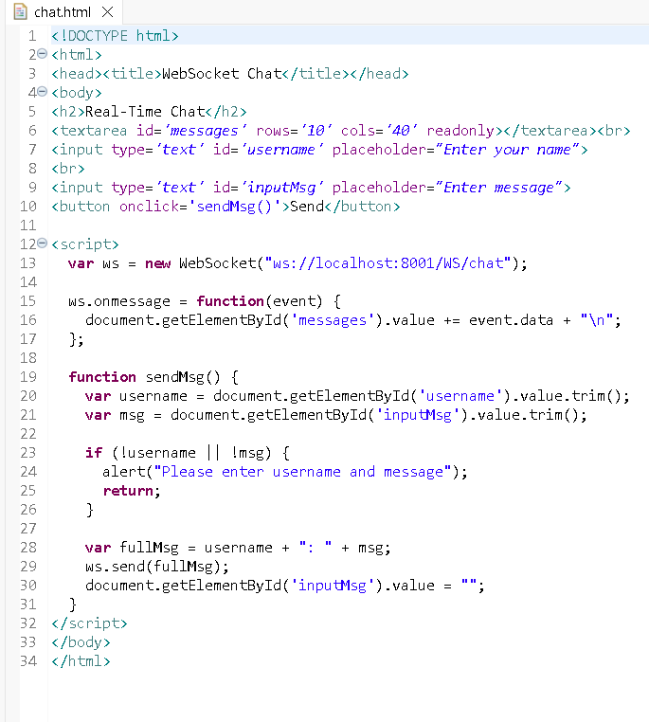

ChatServer.java
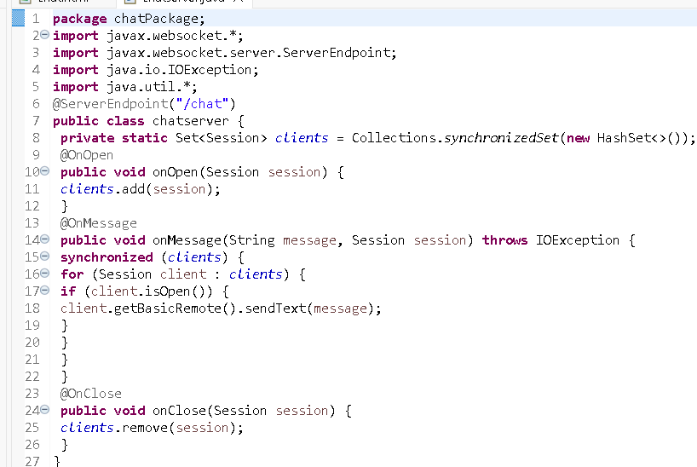

Output:
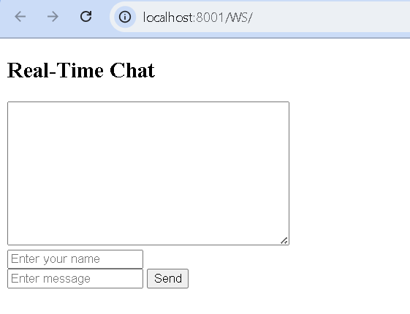
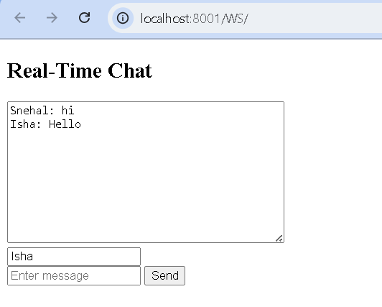

ExperimentNo.7

Aim

Implement Hibernate ORM and perform basic CRUD operations.

Objective

To configure and use Hibernate ORM in a Java application for performing basic CRUD operations on a database table, demonstrating how Hibernate automates SQL generation and manages the mapping between Java classes and relational tables.

Theory

What is Hibernate?

Hibernate is a powerful Object Relational Mapping (ORM) tool for Java that maps object-oriented domain models to relational database tables. It eliminates most of the repetitive JDBC code, manages transactions automatically, and provides query capabilities through HQL (Hibernate Query Language) and Criteria API.
ORM (Object Relational Mapping)
ORM is a programming technique for converting data between incompatible systems (objects in Java and tables in a database). It enables developers to interact with the database using Java objects rather than SQL statements.

Key Components of Hibernate
- Configuration: Reads the hibernate.cfg.xml file to set database connection and mapping details.
- SessionFactory: A factory class used to create Session objects; it is thread-safe and created once per application.
- Session: Represents a single unit of work with the database (similar to a JDBC connection).
- Transaction: Used to ensure atomicity of database operations.
- Query / HQL: Hibernate Query Language, used to perform operations on database objects in an object-oriented way.
CRUD Operations
Create: Insert new data into the table using session.save().
Read: Retrieve data using session.get() or session.load().
Update: Modify existing records using session.update().
Delete: Remove records using session.delete().
Software Requirements
- JDK (Java Development Kit)
- MySQL Database
- Hibernate ORM Library
- IDE (Eclipse/NetBeans/IntelliJ)

Steps to Implement
1.Create a Maven project and add Hibernate Dependencies.
2. Configure Hibernate using hibernate.cfg.xml.
3. Create an entity class mapped to a database table.
4. Write a Hibernate utility class to manage sessions.
5. Implement CRUD operations using Hibernate methods.

Database Setup

CREATE DATABASE

Hibernate Configuration (hibernate.cfg.xml)
<?xml version='1.0' encoding='utf-8'?>
<!DOCTYPE hibernate-configuration PUBLIC
"-//Hibernate/Hibernate Configuration DTD 3.0//EN"
"http://hibernate.sourceforge.net/hibernate-configuration-3.0.dtd">
<hibernate-configuration>
<session-factory>
<property name='hibernate.connection.driver_class'>com.mysql.cj.jdbc.Driver</property>
<property
name='hibernate.connection.url'>jdbc:mysql://localhost:3306/hibernatedb</property>
<property name='hibernate.connection.username'>root</property>
<property name='hibernate.connection.password'>yourpassword</property>
<property name='hibernate.dialect'>org.hibernate.dialect.MySQL8Dialect</property>
<mapping class='com.example.Student'/>
</session-factory>
</hibernate-configuration>

Entity Class (Student.java)
import javax.persistence.*;
@Entity
@Table(name="student")
public class Student {
@Id
@GeneratedValue(strategy = GenerationType.IDENTITY)
private int id;
private String name;
private String email;
// getters and setters
}
CRUD Example (Main.java)
import org.hibernate.*;
import org.hibernate.cfg.Configuration;
public class Main {
public static void main(String[] args) {
SessionFactory factory = new Configuration().configure().buildSessionFactory();
Session session = factory.openSession();
Transaction tx = session.beginTransaction();
// Create
Student s = new Student();
s.setName("John");
s.setEmail("john@example.com");
session.save(s);
// Read
Student st = session.get(Student.class, 1);
System.out.println(st.getName());
// Update
st.setEmail("newemail@example.com");
session.update(st);
// Delete
session.delete(st);
tx.commit();
session.close();
}
}

Run the Application
- Hibernate automatically creates or updates the table (based on hbm2ddl.auto property).
- Output will show SQL queries executed in the console.

ExperimentNo.8

Aim

Enable Hibernate Caching and compare performance.

Objective

Enable Hibernate caching (first-level and second-level).Use a caching provider .Measure and compare the performance with and without caching (e.g., response time, query execution). Show how caching improves database interaction performance.
Theory
Hibernate has two types of caches:
First-level cache: Enabled by default. Works per session.
It stores entities that are currently being used by a specific Hibernate session.
When an entity is loaded or updated for the first time in a session, it is stored in this cache.
Any subsequent request to fetch the same entity within the same session is served from the cache, avoiding a database query.
Enabled by default and cannot be disabled.
Second-level cache: Must be explicitly enabled. Works across sessions.
It stores data frequently used across different sessions, reducing database queries.
It can be configured with various caching providers such as Ehcache, Infinispan, Hazelcast, JBoss Cache and Caffeine.
Unlike the first-level cache, the second-level cache is optional and must be explicitly enabled.

Steps To Implement
configure the second-level cache
Step 1: Choose a cache provider
Step 2: Add Provider to Classpath
Step 3. Configure Hibernate Properties
To enable the Ehcache provider, you can add the following properties to the hibernate.cfg.xml file:
<property name="hibernate.cache.use_second_level_cache">true</property>
<property name="hibernate.cache.region.factory_class">
org.hibernate.cache.ehcache.EhCacheRegionFactory
</property>

Step 4. Configure entity caching

Annotate Entities
import javax.persistence.Cacheable;
import org.hibernate.annotations.Cache;
import org.hibernate.annotations.CacheConcurrencyStrategy;
@Entity
@Cacheable
@Cache(usage = CacheConcurrencyStrategy.READ_WRITE)
public class Student {
@Id
private Long id;
private String name;
// Getters and Setters
}

Comparing Performance

Session session = sessionFactory.openSession();
long start = System.nanoTime();
Student student = session.get(Student.class, 1L);
long end = System.nanoTime();
System.out.println("Time taken (no cache): " + (end - start));
session.close();

With Caching (second-level)
Session session1 = sessionFactory.openSession();
Student student1 = session1.get(Student.class, 1L); // DB Hit
session1.close();

Session session2 = sessionFactory.openSession();
long start = System.nanoTime();
Student student2 = session2.get(Student.class, 1L); // Should use cache
long end = System.nanoTime();
System.out.println("Time taken (with cache): " + (end - start));
session2.close();

Conclusion
Without caching, Hibernate always hits the DB, increasing latency.
With second-level caching enabled, performance significantly improves for repeated reads.
Caching is highly useful for read-heavy applications but may not be ideal for write-intensive systems without careful configuration.

ExperimentNo.9

Aim

Build REST full API using Spring Boot.

Objective

Ensure API endpoints return expected responses.
Verify HTTP status codes, headers, and payloads.
Validate integration between client and server.
Ensure security and error handling mechanisms work as intended.

Theory

Spring Boot is built on top of the conventional Spring framework, providing all the features of Spring while being significantly easier to use. Here are its key features:

1.Auto-Configuration: Automatically configures components (like Hibernate, JPA) based on dependencies. No need for manual XML setup.

2. Easy Maintenance and Creation of REST Endpoints: With annotations like @RestController, @GetMapping and @PostMapping, creating REST endpoints is straightforward.

3. Embedded Tomcat Server: Embedded Servers: Spring Boot includes an embedded Tomcat server, eliminating the need for manual setup. It also supports Jetty and Undertow, offering flexibility for different application needs.

4.Easy Deployment: Spring Boot applications can be packaged as JAR or WAR files and deployed directly to servers or cloud environments. By 2025, it offers seamless integration with Docker and Kubernetes for easier cloud-native deployment and scaling.

5. Microservice-Based Architecture: Spring Boot is well-suited for microservice architecture, where applications are split into independent, modular services. Unlike monolithic systems, this approach improves scalability, maintainability and deployment flexibility.

Spring Boot - REST

Modern web applications follow the Client-Server Architecture, where the frontend (client) communicates with the backend (server) using the HTTP protocol. Servers expose services (APIs) that clients can call via HTTP requests. REST (Representational State Transfer) is a set of architectural principles for building these services.
REST uses standard HTTP methods to perform CRUD operations:
- POST-> Create
- GET -> Read
- PUT -> Update
- DELETE -> Delete

Software Requirements
- Operating System: Windows / Linux / macOS
- IDE: Eclipse / NetBeans / IntelliJ IDEA
- Language: Java (JDK 8 or above)
- Web Technologies: HTML, JSP, JavaScript
- Postman
- MySQL

Steps To Implement

Step1: Create Database in MySQL.
Step2: Create spring boot project Folder using Spring Initializr. Go to this link and create a Spring Boot project

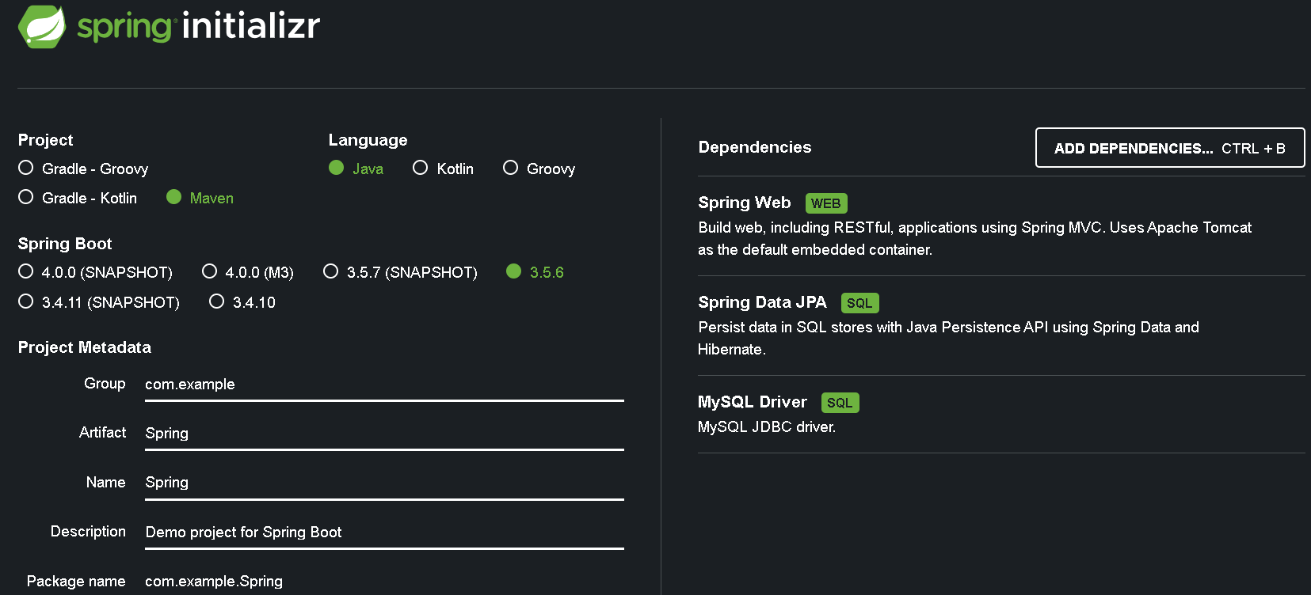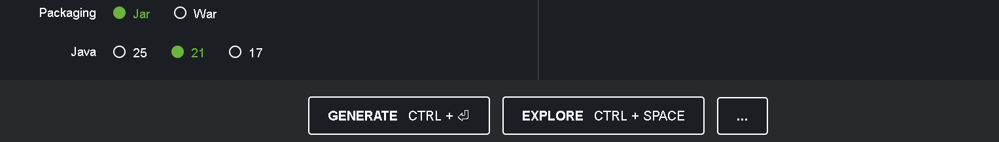

Select the options as shown in above Fig. and click Generate CTRL button and extract the downloded folder. It creates Spring project Floder with all dependencies in pom.xml file.

Step3: Open Eclipse and in Fileimport MavenExisting Maven ProjectFinish
This will create a springboot project in Eclipse.
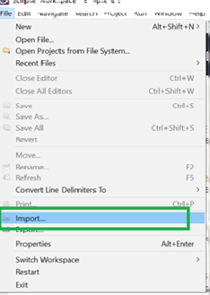

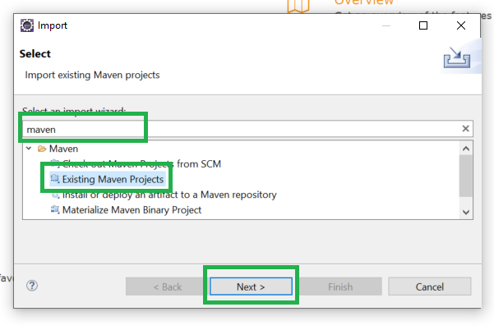
Step4:Now click on the Browse button and select the extracted zip file that has been generated.

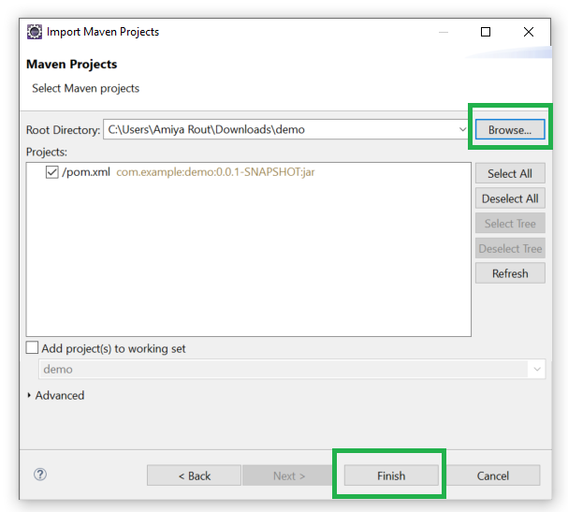

Step5:In src/main/java folder you have one package which already contains main java class file(RestDemoApplication.java).inside same package create student.java class file for Entity and studentController.java class for performing all operations,Students have to write all logic for GET,POST,UPDATE and DELETE HTTP methods.
And create one interface for repository (StudentRepository.java).Right click on packageNewInterface.

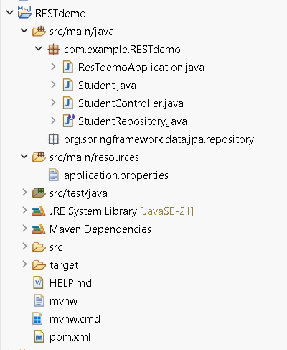

Step5: Open src-->main-->resoures-->application.properties and write your database URL,Name,Password,Port Number.You are using.

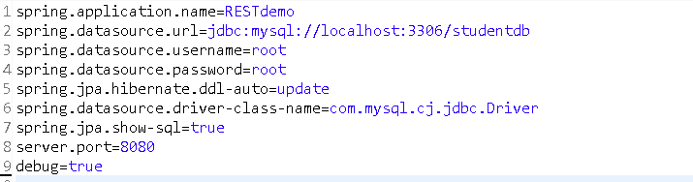

Now run the RestDemoApplication.java file which is main file as java application
And check the output in postman with proper URL..

ExperimentNo.10

Aim

Secure Spring Boot API using JWT (JSON Web Token) authentication.

Objective

User logs in with username/password.
Spring Boot generates a JWT and returns it to the user.
User includes the JWT in the Authorization header for future API requests.
Spring Boot validates the token and allows or denies access.
.
Theory
JWT (JSON Web Token) is used to secure APIs by validating tokens with each request.
Securing REST APIs is a part of building enterprise applications. Spring Security uses session-based authentication, but in modern distributed systems, JWT (JSON Web Token) is preferred as it provides a stateless, scalable and secure way of handling authentication.

In this project, we will build a Spring Boot 3.0 application that integrates Spring Security with JWT and connects to a MySQL database for user management. With this implementation, you will be able to:
- Register new users and securely store their credentials in the MySQL database (with password encryption).
- Authenticate users and generate JWT tokens based on valid login credentials.
- Use the generated JWT token to access secured REST endpoints.
- Implement role-based access control (e.g., ROLE_USER, ROLE_ADMIN) so that different roles can access different API endpoints.
- Secure your APIs in a stateless manner, meaning the server does not store session information.

Software Requirements
- Java 11+ or 17
- Maven or Gradle
- Basic knowledge of Spring Boot, Spring Data JPA, Spring Security
- (Optional) PostgreSQL or H2 for convenience

Steps To Implement

Step 1: Create a Spring Boot Project
Create a Spring Boot Project in Spring Initializr. For this project, choose the following options:
- Project: Maven
- Language: Java
- Packaging: Jar
- Java: 17/21

Please choose the following dependencies while creating the project.
- Spring Web
- Spring Security
- MySQL Driver
- Spring Data JPA
- Lombok
Project Structure:
Before moving to the project here is the complete project structure.

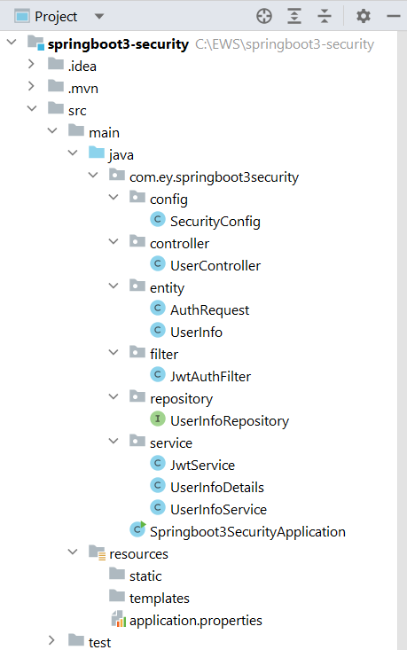

Step 2: Create a Controller
Go to the src > main > java > controller and create a class UserController . In this, we have created a simple REST API in our controller class.
Go to the src > main > java > config and create a class SecurityConfig .
Step 4: Create Entity Classes
Go to the src > main > java > entity and create a class UserInfo .
Step 5: Create Filter Class
Go to the src > main > java > filter and create a class JwtAuthFilter
Step 6: Create a Repository Interface
Go to the src > main > java > repository and create an interface UserInfoRepository
Step 7: Create Service Classes
Go to the src > main > java > service and create a class JwtService
Similarly, create a class UserInfoDetails
create a class UserInfoService

Step 8: application.properties
Make the changes in the application.properties file:
Output
Now run your application and test it out. Hit the following URL:
http://localhost:8080/auth/addNewUser

It will add the user to the database.
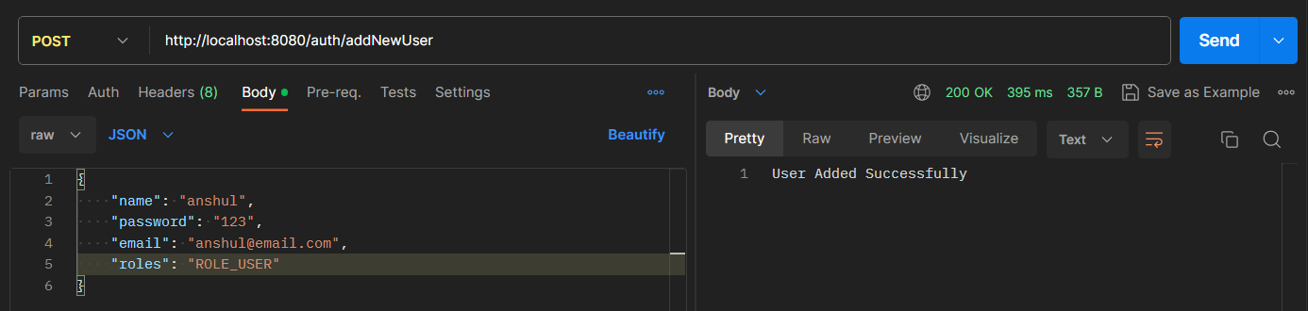
Now, hit the following URL to generate the token.
http://localhost:8080/auth/generateToken

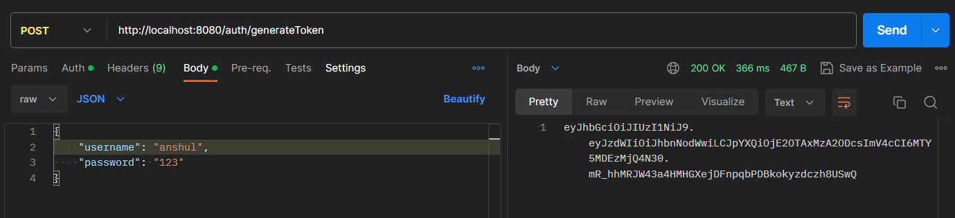

Now using this take we can access our endpoint according to the ROLE. Hit the following URL and put the Bearer token.
http://localhost:8080/auth/user/userProfile
