- Clone the repo https://github.com/stacksimplify/retail-store-sample-app-aws.git
- Change directory to /src/ui where Dockerfile is located
- docker builder prune –all
- docker build -t retail:9.0.0 . 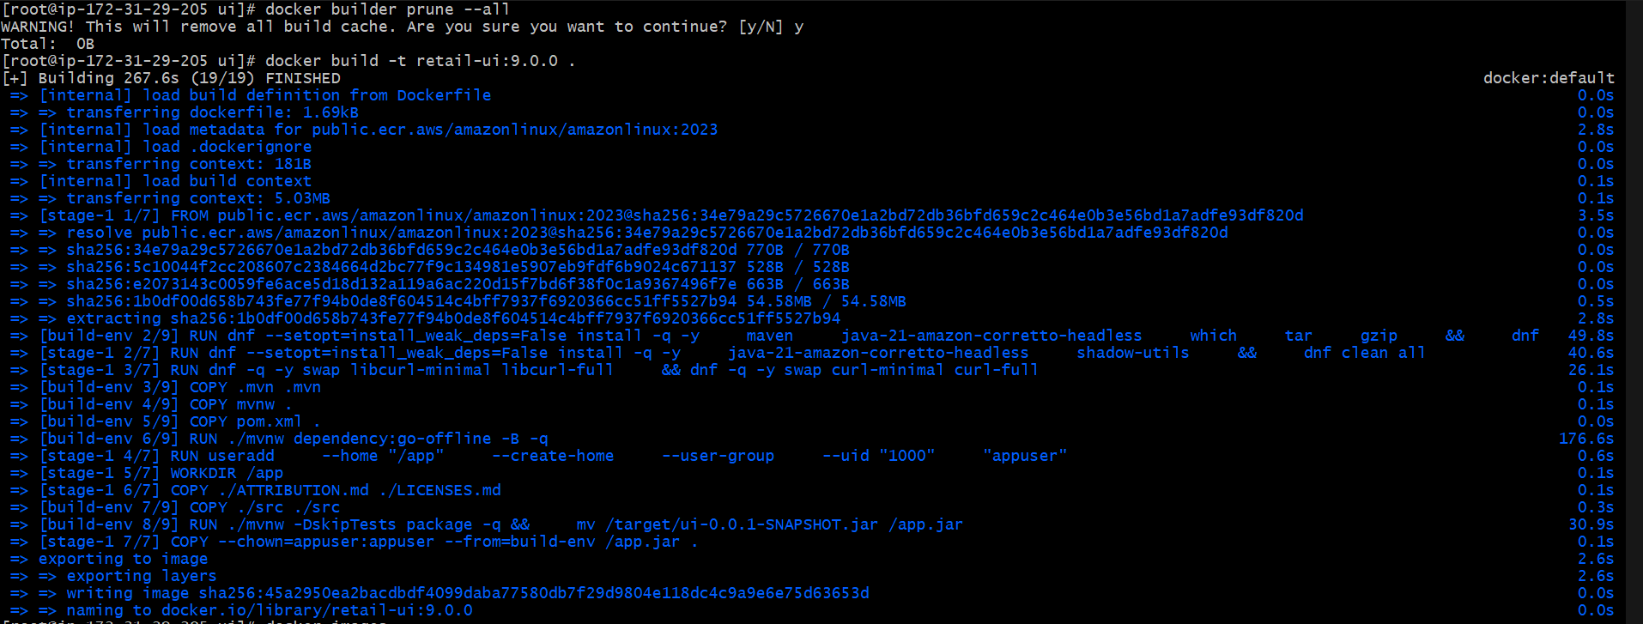
- docker run --name myapp1-v9 8080:8080 -d retail-ui:9.0.0
- Access the app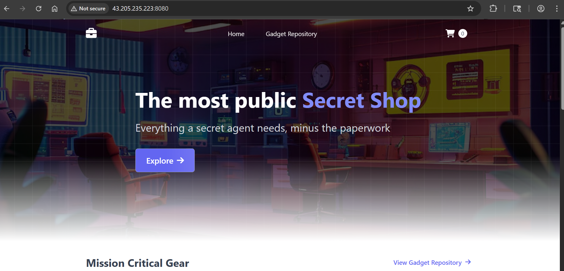
- 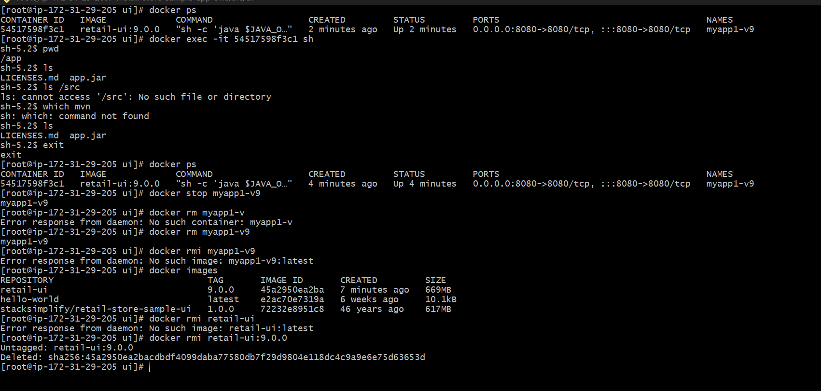
- 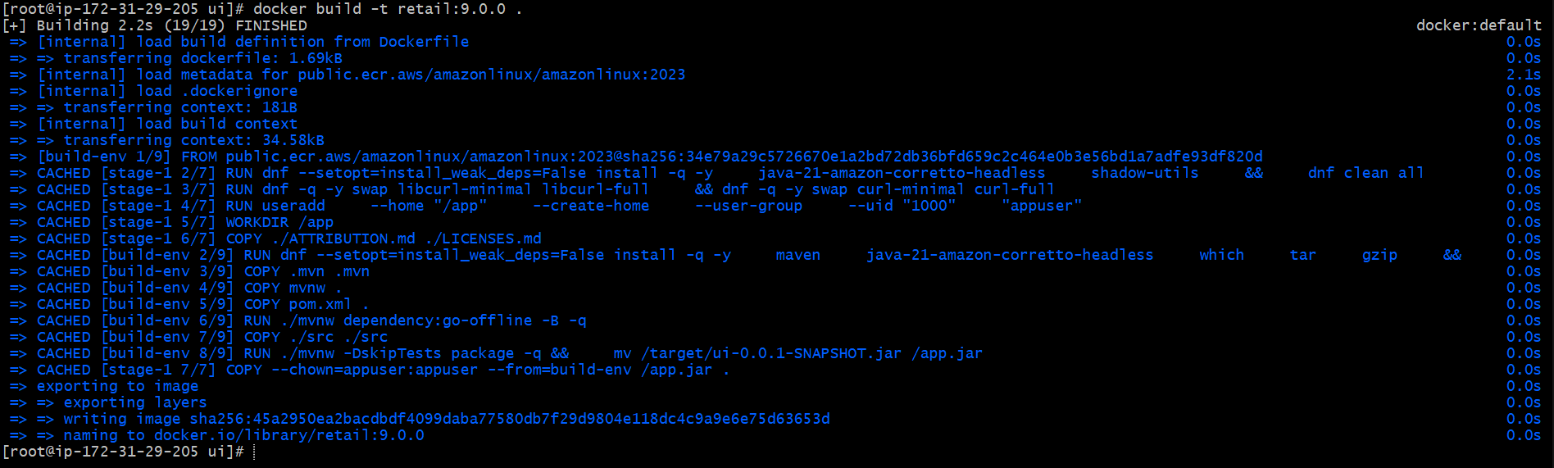
- Without using the cache 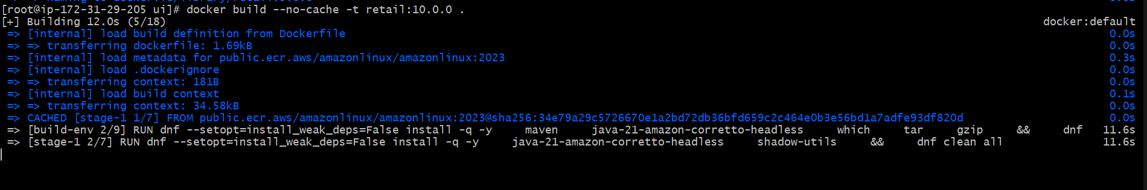
- docker system prune

