# Create the CLI plugin directory
sudo mkdir -p /usr/local/lib/docker/cli-plugins

# Download the latest Docker Compose v2 binary (always pulls the newest release)
wget https://github.com/docker/compose/releases/latest/download/docker-compose-linux-x86_64 -O docker-compose

# Make it executable
chmod +x docker-compose

# Move it to the CLI plugins directory
sudo mv docker-compose /usr/local/lib/docker/cli-plugins/docker-compose

# Verify install
docker compose version
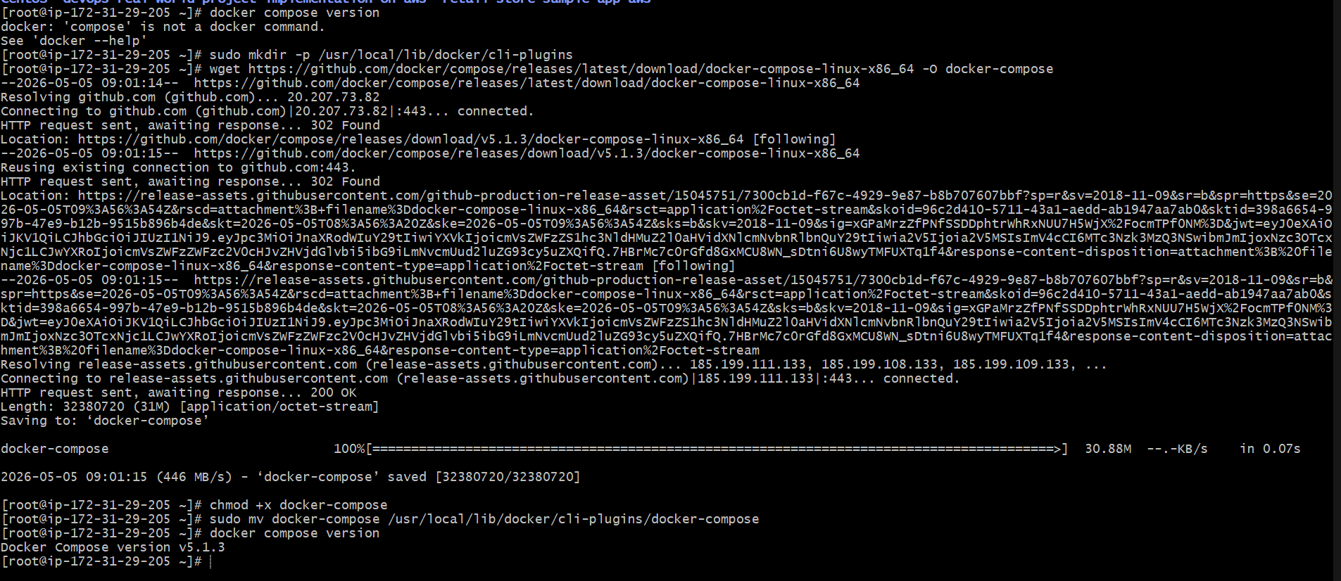
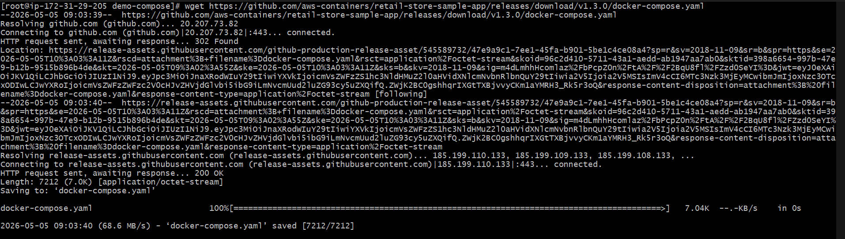

docker compose -f docker-compose.yaml up
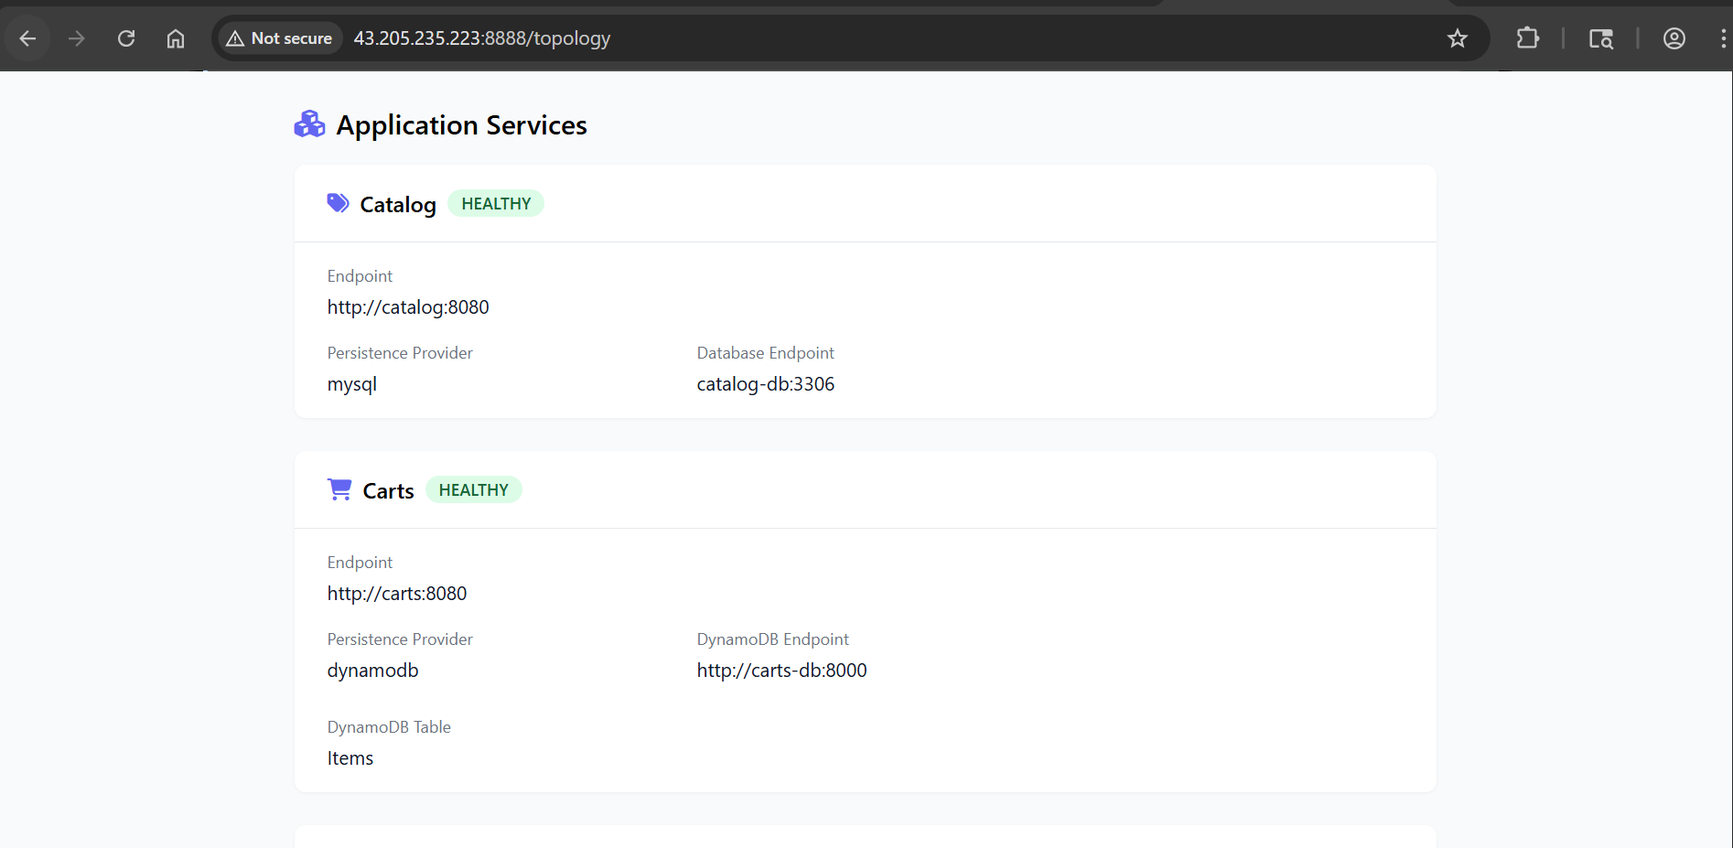
docker compose stop orders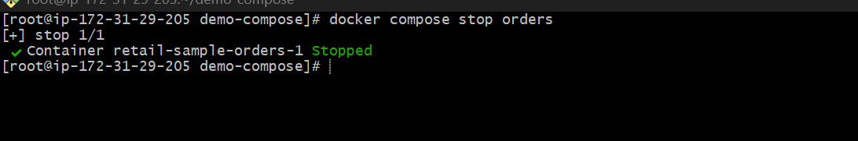
docker compose start order
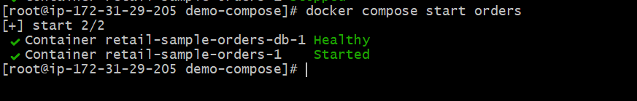
docker compose logs
docker compose logs checkout
docker compose logs -f checkout 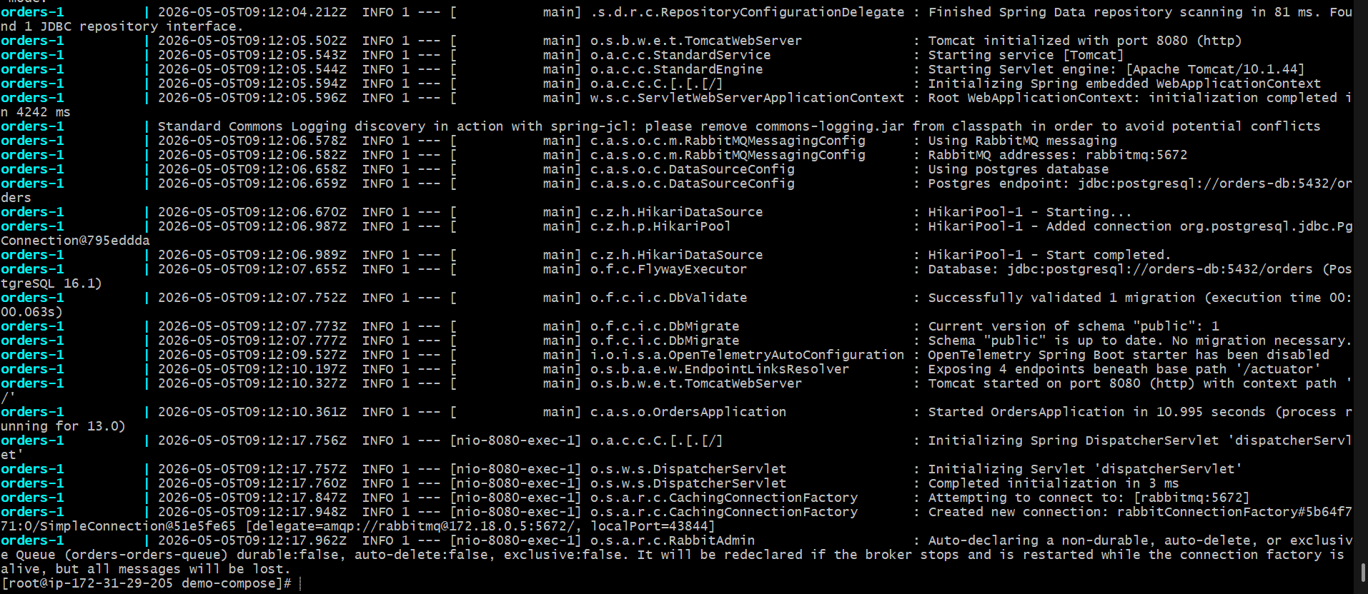
docker compose exec ui sh 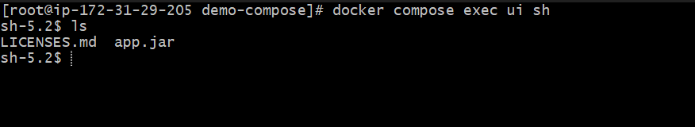
docker compose stats
docker compose top checkout / 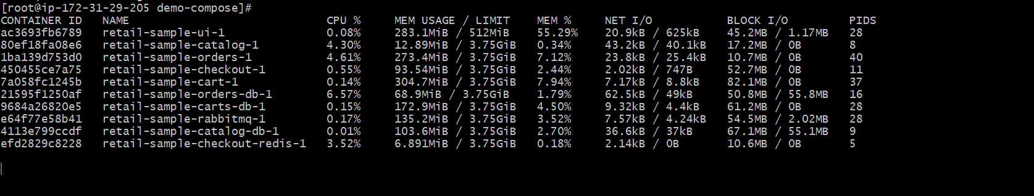

docker compose up -d –force-recreate ui
docker compose down
docker compose up -d

# Stop and remove containers, networks
docker compose down

# List Docker Containers
docker ps
docker ps -a

# List Docker Images
docker images

# Prune all unused Docker objects (careful!)
docker system prune -a --volumes -f

# List Docker Images
docker images

