docker run --privileged --rm tonistiigi/binfmt --install all
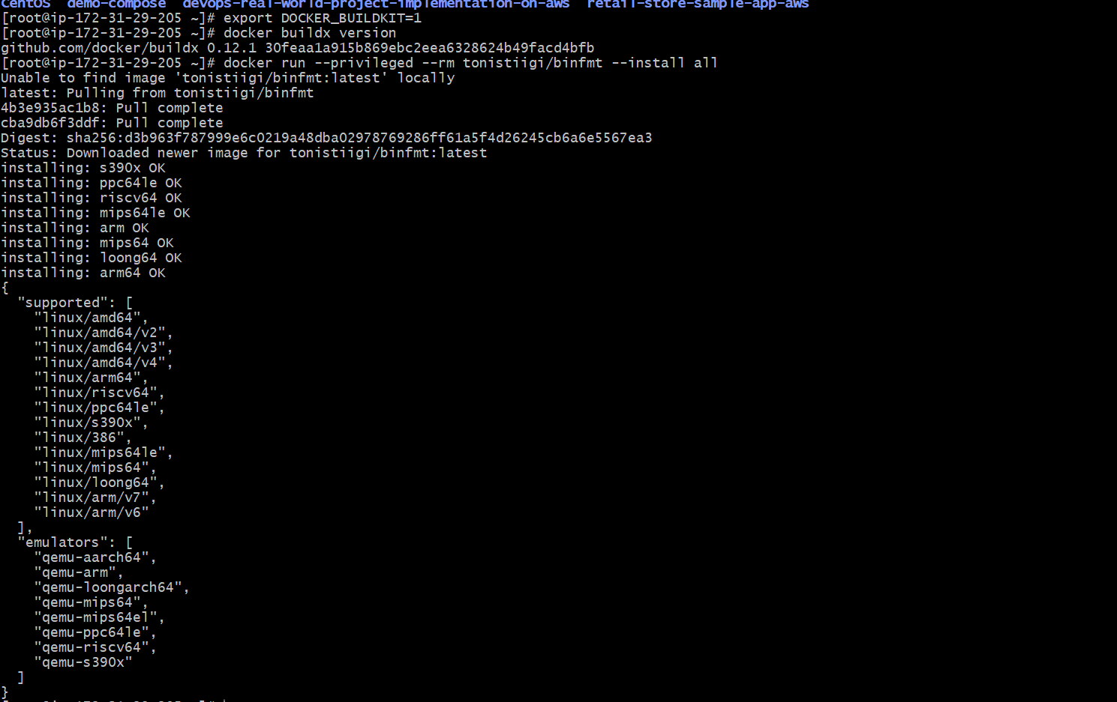
docker buildx ls
docker buildx create --name multiarch --driver docker-container --use
docker buildx ls
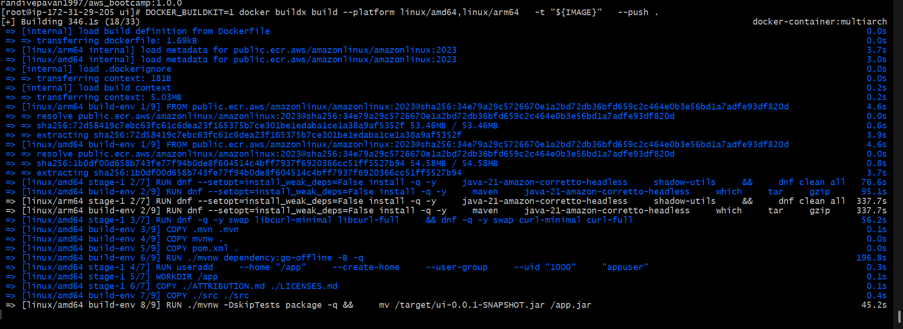
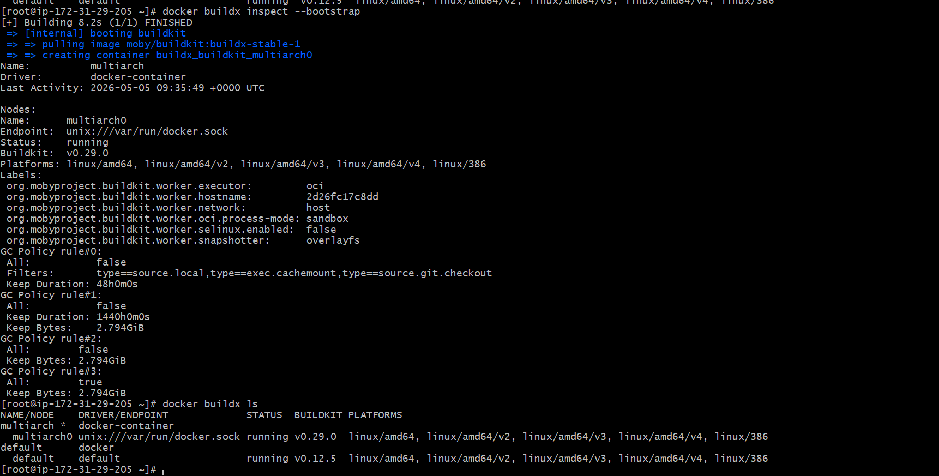
export DOCKERHUB_USER="randivepavan1997" # CHANGEexport DH_REPO="aws_bootcamp" # repo name under your namespaceexport TAG="1.0.0"

docker images
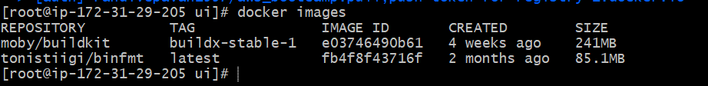
# List Docker Containers
docker ps

# Run Docker Container using new Docker Image
docker run --name myapp1-arm64 -p 8889:8080 -d ${IMAGE}

# List Docker Images
docker images

# List Docker Containers
docker ps

# Access in browser
http://<EC2-Public-IP>:8889
